OUTPUT:

• 2 PERSON CAN PLAY THIS GAME

• LET’S GIVE PERSON1 AS “X” AND GIVE PERSON 2 AS “0”

• LET’S START WITH “X”

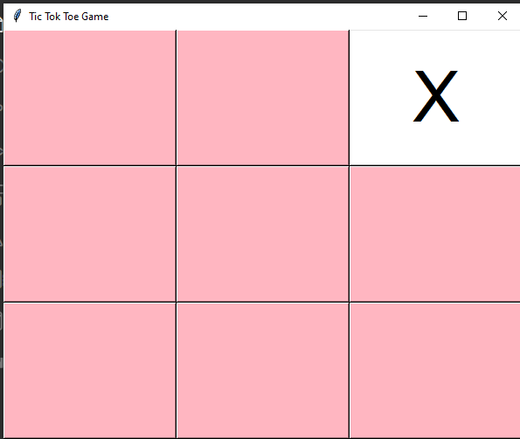

• Next, turn is of “O “.

• It will run this cycle until X or O will win the game

• Then , if the person1 as “X” win then it will show the message .

• if the person2 as “O” win then it will show the message .

