**Publishing Java Application in Ubuntu Software Center**

**Submitted by: Imdad Ullah Soomro**

**Date: 13 November, 2014**



**Table of Contents**

Introduction 3

Login and Register 3

Account Details 6

Your App 7

Finding Your App 8

Showing Your App 9

License and Support 10

Preview and Submit 11

Running the app 13

Challenges Faced 13

Conclusion 13

**Table of Figures**

Figure 1 - Register 4

Figure 2 – Apps for environment 5

Figure 3 – Overview of apps 5

Figure 4 – Account Details 6

Figure 5 – Your app 7

Figure 6 – Finding your app 8

Figure 7 – Showing your app 9

Figure 8 - Licensing 10

Figure 9 - Summary 11

Figure 10 - Summary 12

Figure 11 – Pending Review 13

# Introduction

Ubuntu Software Center is part of Ubuntu (Linux) Operating System. It allows you to add and manage software applications. Applications can be downloaded using the basic Add/Remove Applications.

Ubuntu Software Centre also gives you instant access to thousands of great applications, some free and some available commercially. You can also search for apps directly from the Dashboard. If you see something you like, you can get more information and then install it in just a couple of clicks.

There are several departments in Ubuntu software center under which you can publish your application. Those departments include Accessories, Education, Fonts, Games, Graphics, Internet, Office, Science & Engineering, Sound & Video, Themes & Tweaks, Universal Access, Developer Tools and System.

This article with illustrations will guide you through the entire process to publish Java app in Ubuntu Software Center.

# Login and Register

The first step is to register on **Ubuntu One** to get started. Open your browser and go to the URL <https://login.ubuntu.com/> and register yourself.

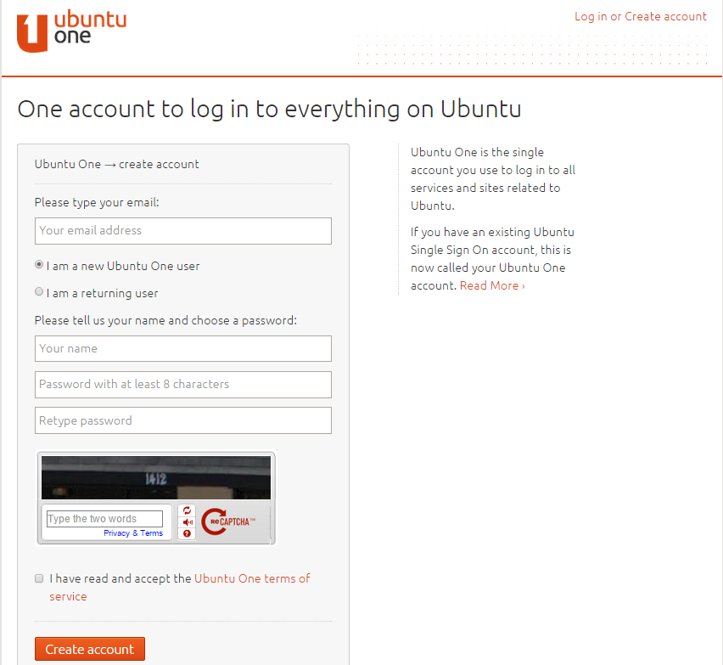

Figure - Register

Provide email address, username and password on the above screen and click ‘Create Account’. An email will be sent on your provided email address on the registration page to verify your account. Click on the confirmation link in the email to complete the registration process.

Once you verify your email address, you can log in to your account. Go to the following URL to start the application publishing process:

<https://myapps.developer.ubuntu.com/dev/>

Click on ‘Apps for Ubuntu Desktop’ on the following screen.

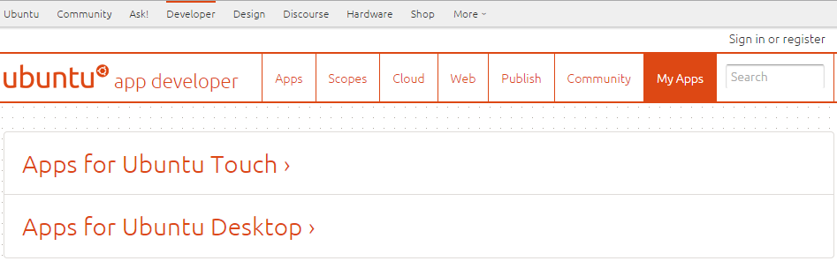

Figure – Apps for environment

Following is the screen that appears next. Click on ‘Submit a new application’.

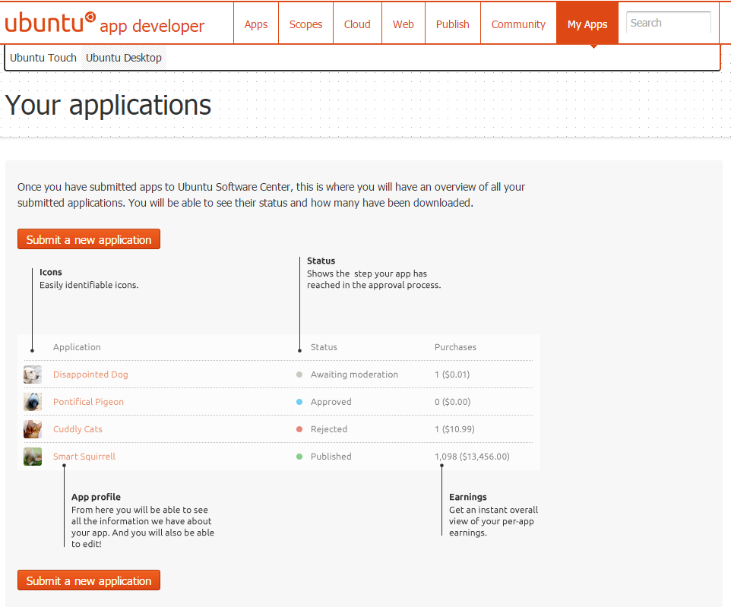

Figure – Overview of apps

# Account Details

You will be asked to log in and agree to the terms and conditions. After this step, provide your account details in following screen. You can leave blank the optional fields whereas fill out the mandatory fields to proceed further.

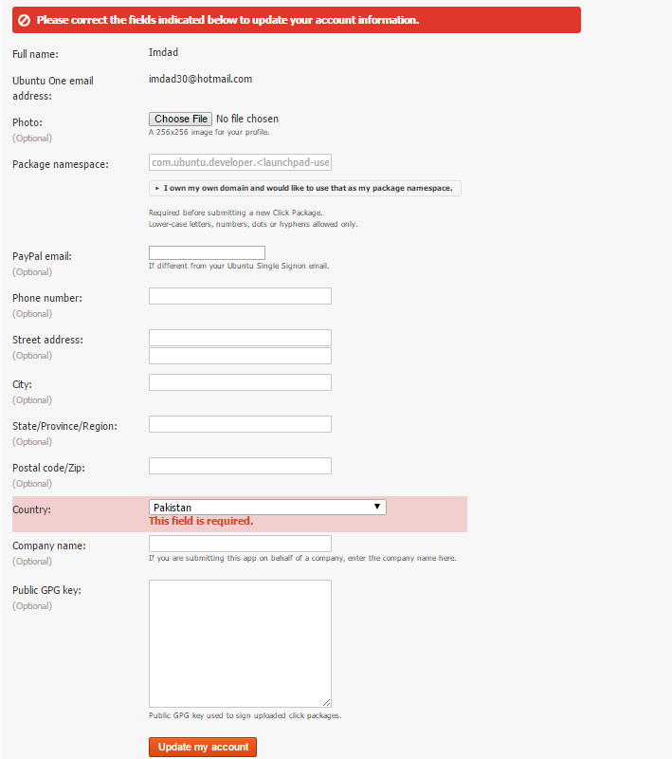

Figure – Account Details

Click on update ‘my account’ after filling the data to save your details.

# Your App

Now, your application uploading process starts. Fill out the needed data in following screen like your application name, you application files that include .jar and start.sh (Bundle them in an archive file). You can make your application free for users to download or charge them with few bucks.

Click ‘Next’:

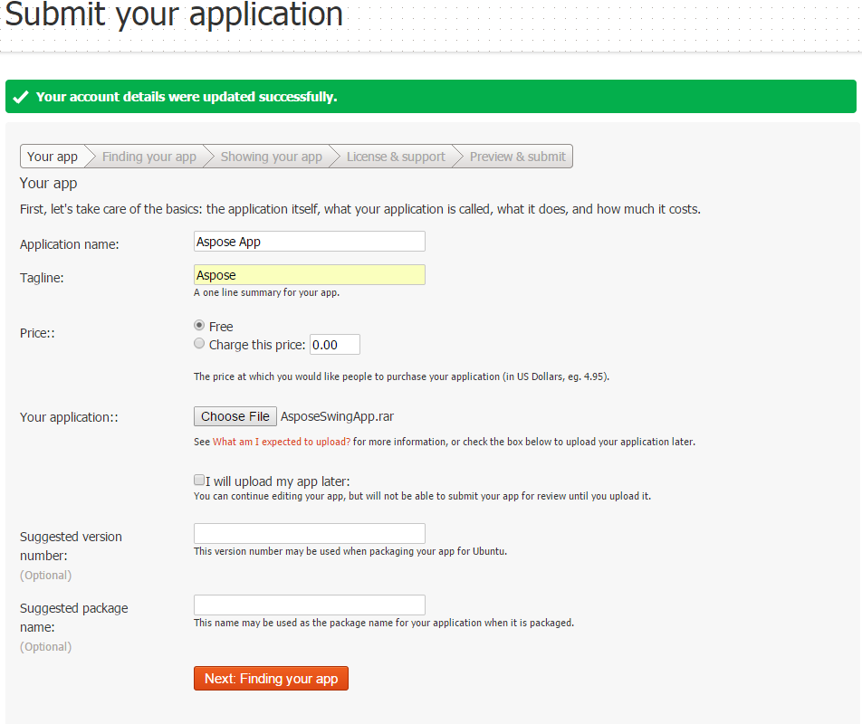

Figure – Your app

# Finding Your App

This screen is very vital in terms of finding your application. Provide the details that can help users find your application in the Ubuntu Software Center.

Select the department under which you want to publish your application. In my case, it is Developer Tools. The description field should have all the necessary information about your app and user should be able to know what the app is all about and what its purpose is. Keywords are extremely important to search your app. These words searched by users will make you app appear in the search results.

Click ‘Next’ when you finish filling the fields.

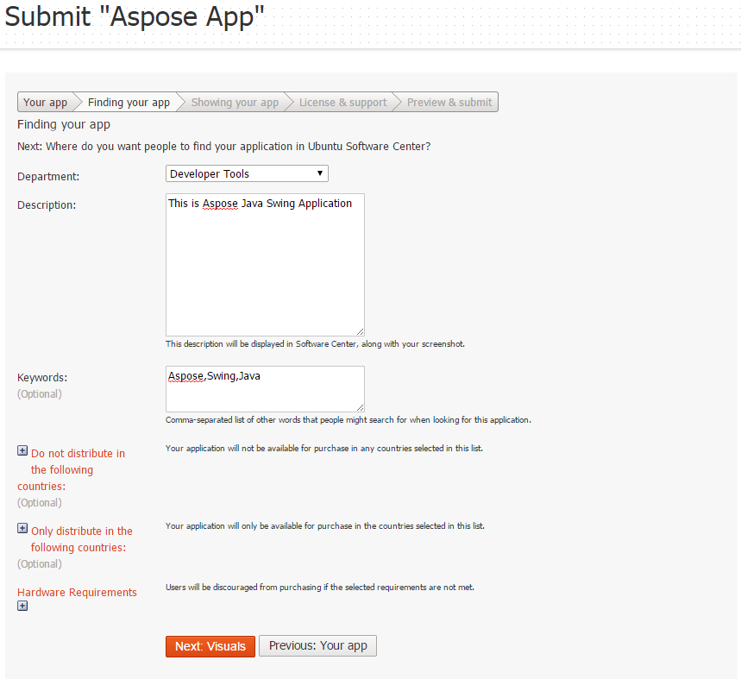

Figure – Finding your app

# Showing Your App

In the following screen, you need to provide icon (logo) that represents your application. The icon is pictorial representation of your app in Ubuntu Software Center. You can provide multiple icons but the only mandatory icon here is 64x64. You can also provide the screenshot of your app as well. Upload the video URL for the demo of your app if you have made one. Video demo URL is optional field.

Proceed to next step when you finish filling the fields.

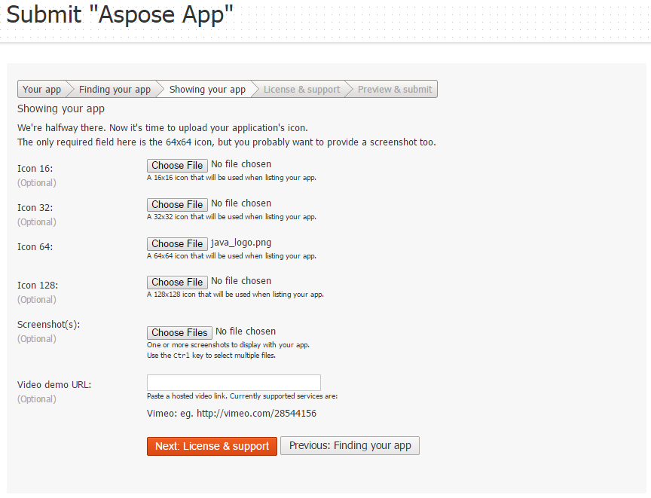

Figure – Showing your app

# License and Support

Provide information related to licensing in the following screen and proceed to summary of your provided data:

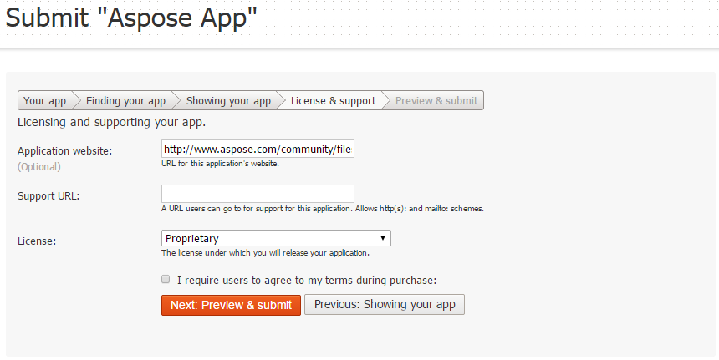

Figure - Licensing

# Preview and Submit

This screen will show you the summary of your data provided.

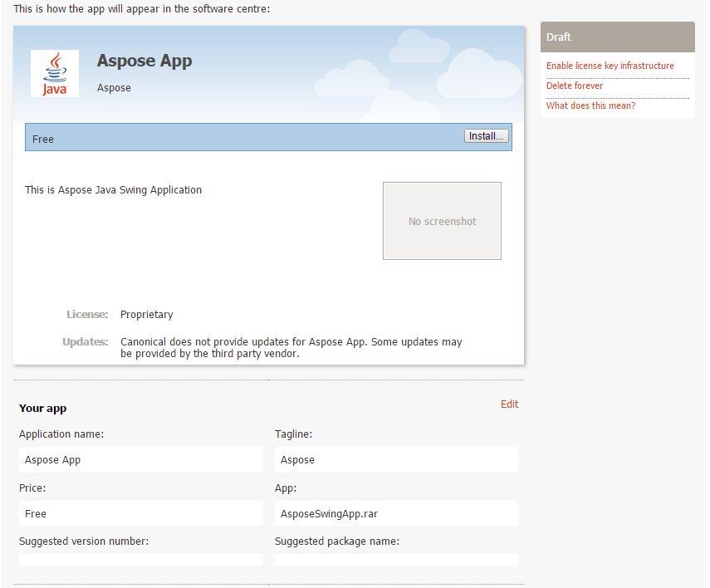

Figure - Summary

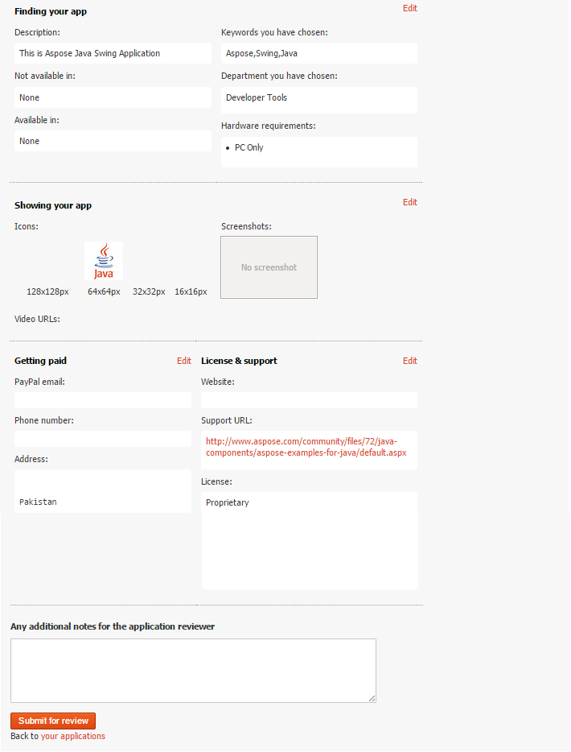

Figure - Summary

Your application will be submitted for review when you submit it. It will be available in Ubuntu Software Center when it gets approved.



Figure – Pending Review

# Running the app

After the publishing of you application in Ubuntu Software Center, you can run it from there. You need to install Ubuntu Operating System to access Ubuntu software center. In my case, I installed Oracle VM Virtual Box in Windows and installed Ubuntu on that VM. Virtual Box lets you install some other OS such as Ubuntu within your existing OS like windows. Once Ubuntu is installed on your VM, you can go to Ubuntu Software Center and search your application. They keywords you had provided at the time of registration will help you find your app in software center. Once you find it, you can launch it.

# Challenges Faced

Although the entire process is pretty smooth, there are few things that need to be taken care of. The choice of downloading right version of virtual box and Ubuntu setup compatible with your system requirements is critical. The main hurdle that one can face is of getting the app approved. They usually take fair bit of time to approve your app so you need to be patient on that step.

# Conclusion

Ubuntu Software Center is very good place to host the applications especially for developers. You can make your apps and publish them for the world to use them. You can also make your earnings by developing commercial applications.

Happy Coding!!!