**Week 2 Assignment**

## **Question 1**

Write a code that will:

1. Prompt the user to enter their name, age, email, and favorite number.

2. Stores these inputs in a dictionary with appropriate keys.

3. Validate the email format (contains "@" and ".").

4. Displays a message using these variables, formatted as: "Hello [name], you are [age] years old, your email is [email], and your favorite number is [favorite number]."

**Output:**

## 

## **Question 2**

Write a code for a function `Is_even(number)` that will:

1. Takes an integer as an input.

2. Returns True if the number is even, otherwise False if the number is odd.

3. Print whether the number was even or odd ***hint: use conditions***

***Output:***



## **Question 3**

Write a function `convert_temperature(temp, scale)` that:

1. Takes a temperature value and a scale ("C" for Celsius, "F" for Fahrenheit) as inputs.

2. Converts the temperature to the other scale.

3. Returns the converted temperature.

4. Display the converted temperature.

## **Output**





## **Question 4**

Write a code that will:

1. Contains a function `find_max_min(numbers_list)` that takes a list of numbers and returns both the maximum and minimum numbers in the list.

2. Prompts the user to enter 5 numbers, stores them in a list, and then uses the `find_max_min` function to find and display the maximum and minimum numbers.

**Output:**

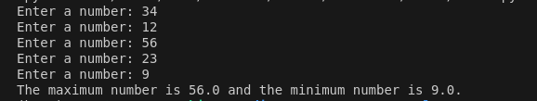

**Question 5**

Write a code that will:

1. Prompt the user to enter details of 3 students: name, age, and grade.

2. Stores these details in a list of tuples, with each tuple containing the name, age, and grade of a student.

3. Convert this list of tuples into a dictionary with the student name as the key and the tuple (age, grade) as the value.

4. Displays an appropriate output.

## **Code:**

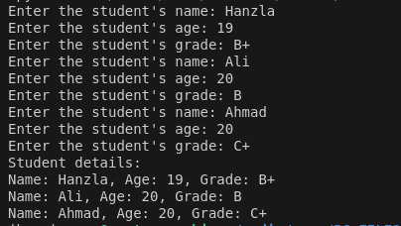

## **Question 6**

Write a code for function `update_inventory(inventory_dict, item, quantity)` that will:

1. Take a dictionary where keys are item names and values are quantities, an item name, and a quantity to add or remove.

2. Updates the inventory by adding or removing the specified quantity (use negative values for removal).

3. Ensures that the quantity of any item does not go below zero.

4. Returns the updated dictionary.

Use this function to

1. Initialize an inventory dictionary with at least 5 items.

2. Prompt the user to update the inventory by adding or removing quantities of 3 items.

3. Display the updated inventory.

**Output:**

