RIPHAH INTERNATIONAL UNIVERSITY GG CAMPUS



**Software Testing Report: Weather App**

**Submitted to:** Ma’am Shummaila Iqbal

**Course:** Software Quality Engineering

**Submitted by:**

**Hanzla Alvi – 47583**

Department - BSSE

47583@studets.riphah.edu.pk

Department of Computing

Date: 23rd May, 2025

Contents

1. Introduction: 2

2. Features: 2

3. Software Requirements 3

4. Equivalence Partitioning (ECP) for Weather Alerts: 5

**Feature: Weather Alert System** 5

5. Boundary Value Analysis (BVA) for Weather Alerts 6

1. **Temperature Boundary Tests** 6

2. **Wind Speed Boundary Tests (10 m/s)** 6

3. **Weather Condition Tests** 6

6. Test cases: 8

7. Usecase Diagram: 10

8. Use Case Fully Dress for “Receive Weather Alerts” 10

9. White Box Testing: 13

**Weather App**

1. Introduction:

## This smart weather app gives you everything you need to know about current and upcoming weather conditions in the simplest way possible. Just enter any city name, and it instantly shows you accurate weather information including temperature (which you can see in both Celsius and Fahrenheit), humidity levels, wind speed, visibility, and atmospheric pressure. The app automatically detects whether it's sunny, cloudy, rainy, or stormy, and displays beautiful matching icons so you can understand the weather at just a glance.

## One of the best features is the 5-day forecast that helps you plan your week ahead. You'll see how the temperature changes day by day, whether rain is expected, and even the exact times for sunrise and sunset. The app can also warn you about extreme weather conditions like heat waves, heavy rains, or strong winds through instant alerts.

## For those who prefer listening, there's a voice report feature that speaks the current weather conditions aloud in clear English. You can even email the full weather report to your friends or family with just one click. The interface is super user-friendly with options to switch between light and dark themes, making it comfortable to use any time of day. All your frequently checked locations are saved automatically, so you don't have to search them again and again.

## Unlike complicated weather websites, WeatherVision keeps things simple while still providing all the important details you need to dress appropriately, plan outdoor activities, or just decide whether to carry an umbrella. It's like having a personal weather assistant right on your computer

1. Features:

|  |  |
| --- | --- |
| Feature | Description |
| Real-Time Weather | Shows current temperature (°C/°F), humidity, wind speed, and conditions (sunny/rainy) |
| 5-Day Forecast | Scrollable daily predictions with high/low temps and weather icons |
| Voice Reports | Speaks weather aloud in English (temperature + conditions) |
| Weather Alerts | Notifies about extreme conditions (heatwaves, storms, heavy rain) |
| Sunrise/Sunset | Displays exact day/night transition times |
| Light/Dark Mode | Toggle between white (day) and black (night) themes |
| Email Reports | Sends full weather details via email (Gmail/Outlook) |
| Temperature Graph | Weekly trend chart showing rising/falling temperatures |
| Saved Locations | Remembers frequently searched cities for quick access |
| Unit Converter | Switch between Celsius (°C) and Fahrenheit (°F) instantly |
| Offline Access | Shows last fetched data without internet |
| No Ads | Clean interface without pop-ups or banners |
| ****Data Backup & Export**** | Saves location in a table and can be exported to device in csv file. |

1. ****Software Requirements**** 
   1. **Real-Time Weather:**

**SRS.1.1** System shall display live temperature, humidity, wind speed, pressure, and visibility within 3 seconds of API fetch.

**SRS.1.2** All numerical values shall update dynamically when unit conversion is triggered (°C/°F for temperature, m/s/kmph for wind speed).

* 1. **5-Day Forecast:**

**SRS.2.1** The system shall display forecast data for 5 consecutive days with date, temperature range, and weather condition icons.

**SRS.2.2** The forecast panel shall support horizontal scrolling when content exceeds container width.

* 1. **Voice Reports:**

**SRS.3.1** The system shall generate audible weather reports in English when the voice button is clicked.

**SRS.3.2** Audio output shall include city name, temperature, humidity, and wind speed.

* 1. **Weather Alerts:**

**SRS.4.1** System shall trigger alerts for Temperature (<5°C or >35°C).

**SRS.4.2** System shall trigger alerts for Wind >10 m/s.

**SRS.4.2** System shall trigger alerts for Thunderstorm/Extreme conditions.  
**SRS.4.4** – Alerts shall display as desktop notifications with 10s timeout.

**SRS.4.5** Users shall view all alerts in a consolidated dialog.

* 1. **Sunrise/Sunset:**

**SRS.5.1** The system shall display accurate sunrise/sunset times in HH:MM format, calculated from the city's geographical coordinates.

* 1. **Light/Dark Mode:**

**SRS.6.1** The system shall provide theme toggling with smooth transitions between color schemes with all UI elements (text, cards, buttons) within 0.5 seconds.

**SRS.6.2** Weather icons shall invert colors in dark mode.

* 1. **Email Reports:**

**SRS.7.1** System shall generate emails with City name, country, Current weather metrics, Timestamp in ISO format.

**SRS.7.2** The system shall compose HTML emails containing current weather data when the email report feature is activated.

**SRS.7.3** Users shall input recipient email and subject before sending.

* 1. **Temperature Graph:**

**SRS.8.1** The system shall plot 30-day temperature trends using matplotlib.  
**SRS.8.2** The system shall Graph window include title, labeled axes, and grid lines.

* 1. **Saved Location:**

**SRS.9.1** The system shall store locations in a file (i.e. saved_locations.json) that should be a JSON file with case-insensitive deduplication.

* 1. **Unit Convertor:**

**SRS.10.1** The system shall instantly convert the temperature from Celsius °C to Fahrenheit °F within 1 second of user request.  
**SRS.10.2** The system shall instantly convert the Wind from meter per second (m/s) to kilometer per hour (km/h) within 1 second of user request.

* 1. **Offline Access:**

**SRS.11.1** The system shall display cached data from weather_history.csv with an "Offline Mode" watermark.  
**SRS.11.2** Cached data shall show its last update timestamp.

* 1. **No Ads**

**SRS.12.1** The application shall not contain any advertising SDKs, pop-ups, or sponsored content.

* 1. **Data Backup & Export**

**SRS.13.1** The system shall automatically create ZIP backups (saved locations + weather history) and export data to Excel/CSV with timestamped filenames.  
**SRS.13.2** Users shall view historical data in a scrollable table.

1. ****Equivalence Partitioning (ECP)**** for Weather Alerts:

### **Feature: Weather Alert System**

**Purpose**: Automatically detect and notify users about extreme weather conditions (temperature, wind speed, severe weather) to ensure safety and preparedness.

|  |  |  |
| --- | --- | --- |
| Input Condition | Valid Equivalence Classes | Invalid Equivalence Classes |
| Temperature | 1. -50°C to 5°C (Low temp alert) | 1. Below-50°C(Invalid) |
| 2. 5°C to 35°C (Normal) | 2. Non-numeric values |
| 3. 35°C to 60°C (High temp alert) | 3. Missing temperature data |
| Wind Speed | 1. 0-10 m/s (Normal) | 1. Negative values |
| 2. >10 m/s (High wind alert) | 2. Non-numeric values |
| Weather Condition | 1. Clear/Clouds (Normal) | 1. Empty array |
| 2. Thunderstorm/Extreme (Alert) | 2. Invalid condition types |
| Data Completeness | 1. All required fields present | 1. Missing mandatory fields |
| Temperature Unit | 1. "metric" (Celsius) | 1.Unsupported unit strings |
| 2. "imperial" (Fahrenheit) | 2. Null/undefined |

**Bug Report:**

|  |  |
| --- | --- |
| Bug ID | ECP_WeatherAlerts_001 |
| Tester | Quality Assurance Team |
| Date (submitted) | 2023-05-12 |
| Title | WEATHER ALERT SYSTEM - Incomplete ECP Test Coverage |
| Bug Description | |
| URL | ECP.py |
| Summary | The Equivalence Partitioning tests for weather alerts do not fully cover all specified valid and invalid equivalence classes. |
| Screenshot |  |
| Platform | Python 3.12.5 |
| Browser | File://weatherapp |
| Administrative | |
| Assigned To | Hanzla Alvi |
| Assigned At | 2025-05-15 |
| Priority | High |
| Severity | Medium |

1. ****Boundary Value Analysis (BVA) for Weather Alerts****

### **Temperature Boundary Tests**

#### ****Low Temperature Alert (5°C Boundary)****

|  |  |  |  |
| --- | --- | --- | --- |
| **Test Case** | **Input Data (**temp**)** | **Expected Alert** | **Reason** |
| test_temp_4.9 | 4.9°C | True | 4.9 < 5 → Alert |
| test_temp_5.0 | 5.0°C | False | 5.0 is **not** < 5 |
| test_temp_5.1 | 5.1°C | False | Normal range |

#### ****High Temperature Alert (35°C Boundary)****

|  |  |  |  |
| --- | --- | --- | --- |
| **Test Case** | **Input Data (**temp**)** | **Expected Alert** | **Reason** |
| test_temp_34.9 | 34.9°C | False | Normal range |
| test_temp_35.0 | 35.0°C | False | 35.0 is **not** > 35 |
| test_temp_35.1 | 35.1°C | True | * 1. > 35 → Alert |

### **Wind Speed Boundary Tests (10 m/s)**

|  |  |  |  |
| --- | --- | --- | --- |
| **Test Case** | **Input Data (**wind_speed**)** | **Expected Alert** | **Reason** |
| test_wind_9.9 | 9.9 m/s | False | Normal range |
| test_wind_10.0 | 10.0 m/s | False | 10.0 is **not** > 10 |
| test_wind_10.1 | 10.1 m/s | True | 10.1 > 10 → Alert |

### **Weather Condition Tests**

|  |  |  |  |
| --- | --- | --- | --- |
| **Test Case** | **Input Data (**weather**)** | **Expected Alert** | **Reason** |
| test_weather_thunderstorm | "Thunderstorm" | True | Thunderstorm →Alert |
| test_weather_clear | "Clear" | False | No alert |
| test_weather_empty | [] | Error | IndexError (no [0]) |

Bug Report:

|  |  |
| --- | --- |
| ****Field**** | ****Details**** |
| ****Bug ID**** | BVA-WeatherAlerts-001 |
| ****Tester**** | Hanzla Alvi |
| ****Date (Submitted)**** | 2025-05-12 |
| ****Title**** | BVA Implementation Missing Proper Boundary Handling in Weather Alerts |
| ****Bug Description**** | check_weather_alerts() function does not correctly handle **exact boundary values** for temperature and wind speed. Edge inputs cause alerts to misfire or go untriggered. |
| ****URL / File**** | src/gui.py (inside WeatherApp class – check_weather_alerts() method) |
| ****Summary**** | Current BVA tests miss verifying exact thresholds (like 5.0°C, 35.0°C, 10.0 m/s). Also, the app doesn’t handle edge cases like empty weather data and negative wind speed. |
| ****Screenshot**** | if temp < 5 or temp > 35:  (Boundary values like 5.0 or 35.0 are not included in alerts) |
| condition = data['weather'][0]['main']  (Crashes if *weather* list is empty) |
| wind_speed = data['wind']['speed']  (No check for negative wind speed) |
| ****Platform**** | Python 3.12.5 |
| ****Browser**** | file://weatherApp |
| ****Assigned To**** | Hanzla Alvi |
| ****Assigned At**** | 2025-05-15 |
| ****Priority**** | High |
| ****Severity**** | Medium |

1. Test cases:

|  |  |  |  |  |  |  |
| --- | --- | --- | --- | --- | --- | --- |
| Test Case ID | Test Case Scenario | Test Steps | Test Data | Expected Output | Actual Output | Test Status |
| TC-01 | No alerts for normal conditions | 1. Create test data2. Call check_weather_alerts() | { 'main': {'temp': 20}, 'weather': [{'main': 'Clear'}], 'wind': {'speed': 5} } | No alerts generated | No alerts generated | PASS |
| TC-02 | High temperature alert (>35°C) | 1. Create test data2. Call check_weather_alerts() | { 'main': {'temp': 36}, 'weather': [{'main': 'Clear'}], 'wind': {'speed': 5} } | "High temperature warning: 36°C" | "High temperature warning: 36°C" | PASS |
| TC-03 | Low temperature alert (<5°C) | 1. Create test data2. Call check_weather_alerts() | { 'main': {'temp': 4}, 'weather': [{'main': 'Clear'}], 'wind': {'speed': 5} } | "Low temperature warning: 4°C" | "Low temperature warning: 4°C" | PASS |
| TC-04 | Thunderstorm alert | 1. Create test data2. Call check_weather_alerts() | { 'main': {'temp': 20}, 'weather': [{'main': 'Thunderstorm'}], 'wind': {'speed': 5} } | "Weather alert: Thunderstorm" | "Weather alert: Thunderstorm" | PASS |
| TC-05 | Extreme weather alert | 1. Create test data2. Call check_weather_alerts() | { 'main': {'temp': 20}, 'weather': [{'main': 'Extreme'}], 'wind': {'speed': 5} } | "Weather alert: Extreme" | "Weather alert: Extreme" | PASS |
| TC-06 | High wind alert (>10 m/s) | 1. Create test data2. Call check_weather_alerts() | { 'main': {'temp': 20}, 'weather': [{'main': 'Clear'}], 'wind': {'speed': 11} } | "High wind warning: 11 m/s" | "High wind warning: 11 m/s" | PASS |
| TC-07 | Multiple simultaneous alerts | 1. Create test data2. Call check_weather_alerts() | { 'main': {'temp': 36}, 'weather': [{'main': 'Thunderstorm'}], 'wind': {'speed': 11} } | 3 alerts: temp, thunderstorm, wind | 3 alerts: temp, thunderstorm, wind | PASS |
| TC-08 | Alerts button style changes | 1. Create test data2. Call check_weather_alerts()3. Check button | { 'main': {'temp': 36}, 'weather': [{'main': 'Clear'}], 'wind': {'speed': 5} } | Button style = 'Warning.TButton' | Button style = 'Warning.TButton' | PASS |
| TC-09 | No alerts button style | 1. Create test data2. Call check_weather_alerts()3. Check button | { 'main': {'temp': 20}, 'weather': [{'main': 'Clear'}], 'wind': {'speed': 5} } | Button style = 'TButton' | Button style = 'TButton' | PASS |
| TC-10 | Notification generated | 1. Mock notification2. Create test data3. Call check_weather_alerts() | { 'main': {'temp': 36}, 'weather': [{'main': 'Clear'}], 'wind': {'speed': 5} } | Notification sent once | Notification sent once | PASS |
| TC-11 | Incomplete weather data (missing 'main') | 1. Create test data2. Call check_weather_alerts() | { 'weather': [{'main': 'Clear'}], 'wind': {'speed': 5}, 'sys': {} } | No alerts generated, no crash | No alerts generated | PASS |
| TC-12 | Unexpected weather condition | 1. Create test data with unknown condition2. Call check_weather_alerts() | { 'main': {'temp': 20}, 'weather': [{'main': 'Alien Invasion'}], 'wind': {'speed': 5}, 'sys': {} } | No alerts generated | No alerts generated | PASS |

1. Usecase Diagram:

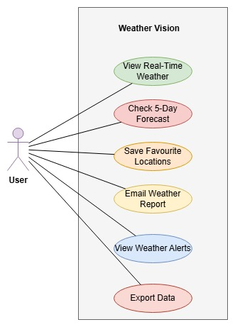

Figure 1 Weather Vision Use Case Diagram

1. Use Case Fully Dress for “Receive Weather Alerts”

|  |  |
| --- | --- |
| Section | Content |
| Designation | UC-07 |
| Name | Receive Weather Alerts |
| Authors | Hanzla Alvi |
| Priority | High |
| Criticality | Medium |
| Source | System detects extreme weather conditions |
| Responsible | WeatherAPI, Notification System |
| Description | System monitors weather conditions and alerts user when extreme conditions are detected |
| Trigger Event | Weather data update with extreme conditions |
| Actors | User, System |
| Pre-condition | 1. Weather data is available 2. Notification system is operational |
| Post-condition | User is notified of extreme weather conditions |
| Result | User is aware of potential weather hazards |
| Main Scenario | 1. System checks weather data 2. Detects extreme conditions 3. Generates alert notification 4. Updates alerts button 5. User views alerts when clicked |
| Alternative Scenario | 1a. No extreme conditions detected - continue monitoring |
| Exception Scenario | 3a. Notification fails - log error and retry |
| Qualities | Reliability, Timeliness, Visibility |

Bug Report:

|  |  |
| --- | --- |
| ****Field**** | ****Details**** |
| ****Bug ID**** | UC07-AlertFailure-001 |
| ****Tester**** | Hanzla Alvi |
| ****Date (Submitted)**** | 2025-05-23 |
| ****Title**** | USE CASE UC-07: Weather Alerts Not Triggering on Boundary or Invalid Input |
| ****Bug Description**** | The weather alert system fails to trigger notifications when weather conditions are at the exact boundary values or contain invalid data such as empty weather list or negative wind speed. |
| ****Related Use Case**** | UC-07 – Receive Weather Alerts |
| ****Module**** | Notification System, WeatherAPI |
| ****Summary**** | Use Case defines timely notification to user, but system fails to alert at 5.0°C, 35.0°C, 10.0 m/s, and on missing/invalid input, which contradicts the post-condition and main scenario. |
| ****Source**** | System detects extreme weather conditions |
| ****Responsible**** | WeatherAPI, Notification System |
| ****Trigger Event**** | Weather data update with extreme conditions |
| ****Expected Result**** | User receives clear and timely alert if extreme weather is detected |
| ****Actual Result**** | No alert is triggered at boundary values; app crashes on empty weather[]; negative wind speed is accepted silently |
| ****Steps to Reproduce**** | 1. Send weather data with temp = 5.0, 35.0, or wind = 10.0  2. Send data with empty weather[] or wind speed = -5 |
| ****Screenshot Code**** | if temp < 5 or temp > 35:  condition = data['weather'][0]['main']  wind_speed = data['wind']['speed'] |
| ****Platform**** | Python 3.12.5 |
| ****Browser**** | file://weatherapp |
| ****Priority**** | High |
| ****Severity**** | Medium |
| ****Post-condition Failure**** | User is **not** notified of extreme weather due to logic issues |
| ****Exception Failure**** | Notification failure not handled properly when weather data is incomplete |
| ****Qualities Affected**** | Reliability, Timeliness, Visibility |

1. White Box Testing:

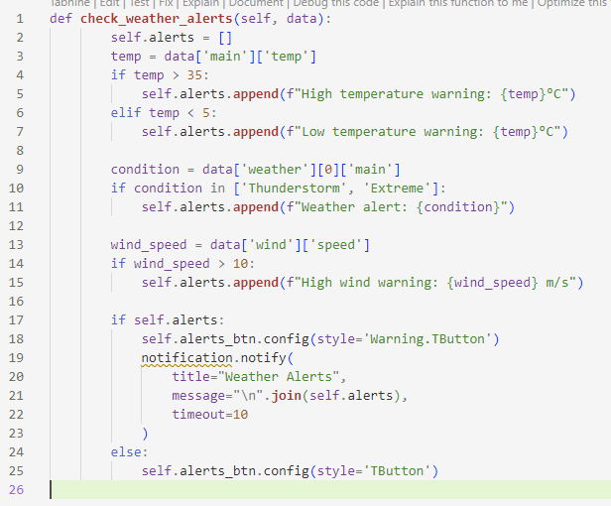

* + - 1. **CFG:**

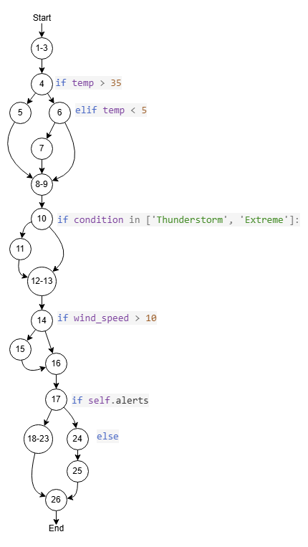

* + - 1. **Perform decision coverage**

|  |  |  |  |  |
| --- | --- | --- | --- | --- |
| Test ID | Test Data | Steps | Expected Outputs | Actual Outputs |
| T-1 | 1,2,3,4,5,8,9,10,12,13,14,16,17,18,19,20,21,22,23,26 | Temp = 36, Condition = “Clear”, Wind=5 | High temp alert only | High temp alert only |
| T-2 | 1,2,3,4,6,7,8,9,10,11,12,13,14,15,16,17,18,19,20,21,22,23,26 | Temp = 4, Condition = “Thunderstorm”, Wind = 11 | Low temp + weather alert | Low temp + weather alert + wind alert |
| T-3 | 1,2,3,4,6,8,9,10,12,13,14,16,17,24,25,26 | Temp = 10, Condition = “Clear”, Wind=5 | No alerts | No alerts |

**Statement Coverage: (Number of statements Exercised / Total number of statements) *100**

Statement Coverage: (26 / 26) *100% = 100%

* + - 1. **Critical path coverage**

|  |  |  |  |  |
| --- | --- | --- | --- | --- |
| Step | Condition Checked | Input Value | Result | Action Taken |
| 1 | temp > 35 | temp = 38 | True | Add "High temperature warning" |
| 2 | temp < 5 (skipped due to el-if) | temp = 38 | False | No action |
| 3 | condition in ['Thunderstorm', 'Extreme'] | condition = Thunderstorm | True | Add "Weather alert" |
| 4 | wind_speed > 10 | wind_speed = 12 | True | Add "High wind warning" |
| 5 | if self.alerts | 3 alerts in list | True | Style button red + show notification |

**Test data:**

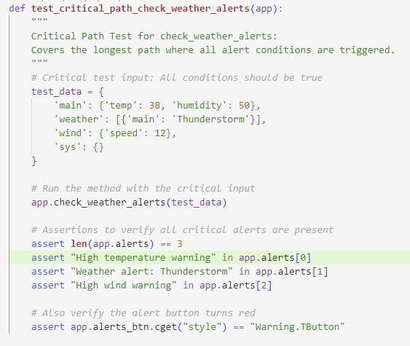

**Test Result:**

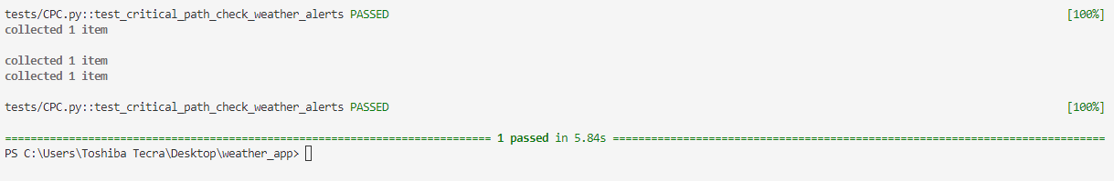

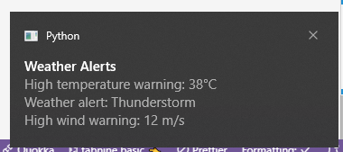

* + - 1. Data Flow Analysis:

|  |  |  |  |
| --- | --- | --- | --- |
| Variable | Definition Node | Usage Nodes | Anomalies Detected |
| temp | 3 | 4,5 | None |
| condition | 8 | 10 | No check for weather[0] existence |
| wind_speed | 12 | 14 | Negative values not handled |
| self.alerts | 1 | 17,18,23 | Duplicates possible |

Github link: <https://github.com/HanzlaAlvi/Weather-App.git>