**MIAN**

**COMPOSING**

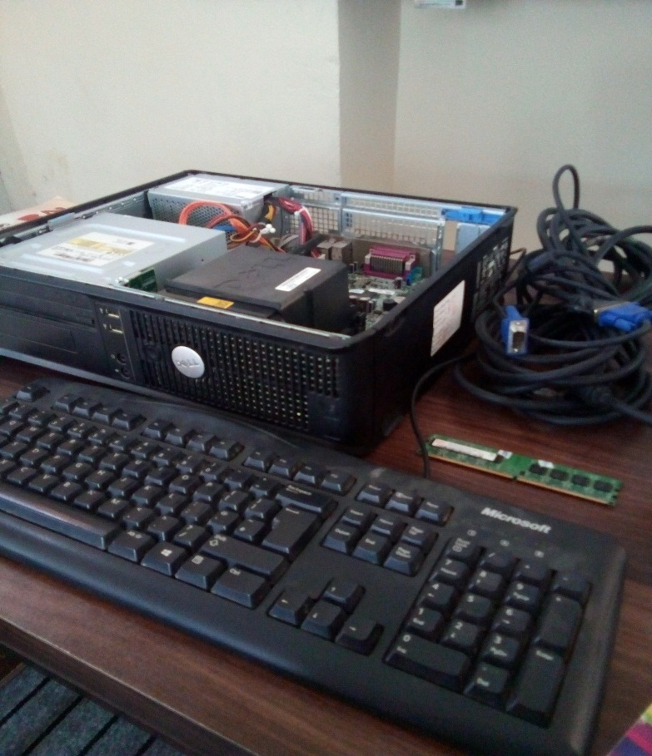 **CENTER**

P h # 92+ 3440788005