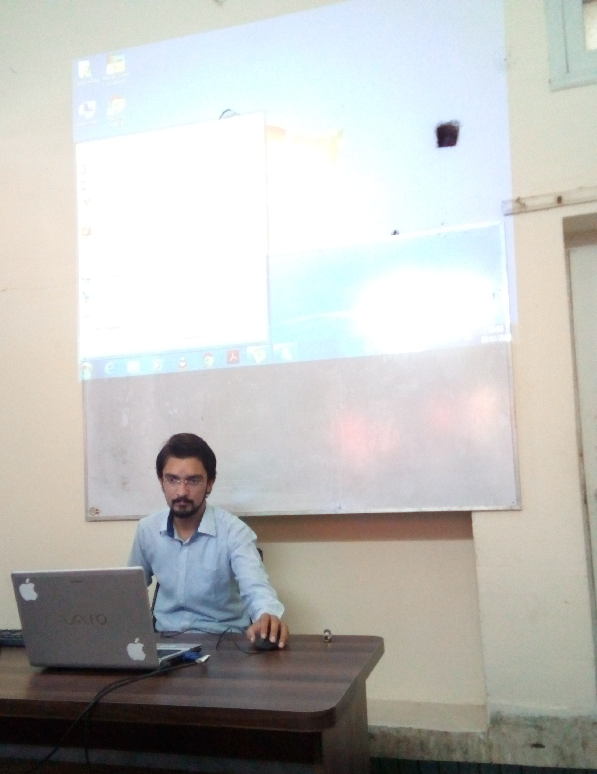

~~MY BEST TEACHER~~

1. Mr. Jamal is my best teacher.
2. He is our class in charge.
3. He teaches us MS Office 2013.
4. His way of technique is very good.
5. He lives in city Jaranwala.
6. He gets up early in the morning.
7. He goes to Vnum I.T center in Jaranwala.
8. He is very handsome.
9. He is very healthy.
10. He is very regular.
11. He says his prayers.
12. He helps a poor.
13. He always speaks the truth.
14. He is a very good Muslim.
15. He is a good player of gym.
16. I like him very much.

I LOVE MY GOOD WORK AND MY GOOD TEACHER