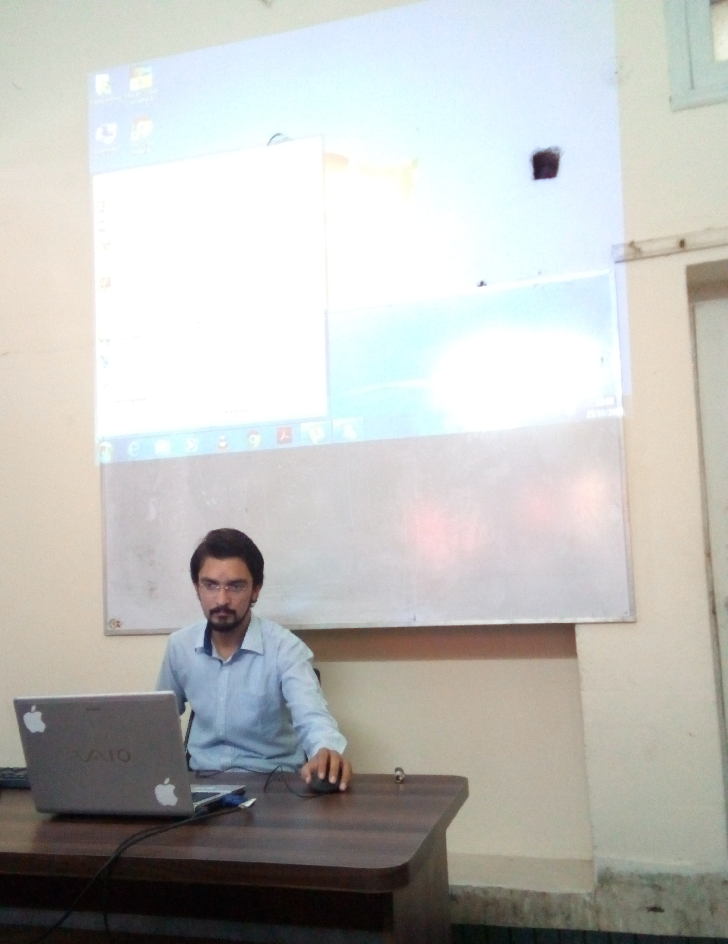

~~MY BEST TEACHER~~

1. Mr. Jamal is my best teacher.
2. He is our class incharge.
3. He teaches us MS Office 2013.
4. His way of technique is very good.
5. He lives in city Jranwala.
6. He gets up early in the morning.
7. He goes to Vnum I.T center in Jranwala.
8. He is very handsome.
9. He is very healthy.
10. He is very regular.
11. He says his prayers.
12. He helps a poor.
13. He always the speak the truth.
14. He is a very good Muslim.
15. He is a good player of badminton.
16. I like him very much.

I LOVE MY GOOD WORK AND MY GOOD TEACHER