CSIT314 Software Development Methodologies – Group Project
Sprint 4 – US25: Add Past IDP
Interior Design Platform – Interior Designer

User Story # | User Story Description
#25 | As an interior designer, I want to add a past IDP so that I can show customers my completed work.

Use Case Diagram | Taiga Task ID: #187
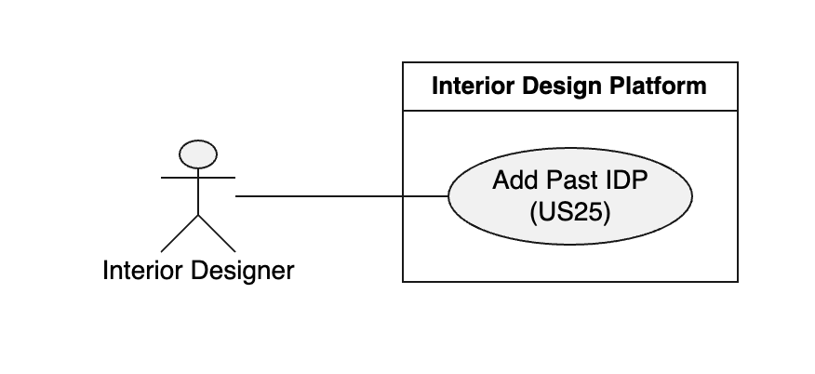

Use Case Description |  | Taiga Task ID: #187
Use Case Name: | Add Past IDP
Actor: | Interior Designer
Triggering Event: | The interior designer wants to add a previously completed IDP to showcase their work to customers.
Brief Description: | This use case allows an interior designer to enter and submit information about a previously completed IDP project so that customers can view their completed work.
Pre-condition(s): | 1. The interior designer has access to the platform. 2. The Add Past IDP feature is available.
Post-condition(s): | 1. The past IDP information is successfully submitted and saved. 2. The completed project information is available for customers to view, subject to the platform's display rules.
Main Flow: | - The interior designer accesses the platform.  - The interior designer selects the Add Past IDP function.  - The system displays the Add Past IDP form.  - The interior designer enters the project title.  - The interior designer selects an IDP category.  - The interior designer enters the project description.  - The interior designer enters the project location.  - The interior designer clicks the Submit button.  - The system validates the submitted information.  - The system saves the past IDP information.  - The system displays a successful submission confirmation.
Alternative Flow(s): | A1 – Missing required information: If required information is missing, the system displays a validation message and asks the interior designer to complete the required fields.  A2 – Cancel submission: If the interior designer clicks Cancel, the system cancels the operation and returns to the previous page without submitting the information.  A3 – Submission failure: If the system cannot save the information, it displays an error message and allows the interior designer to try again.

BCE Diagram | Taiga Task ID: #195
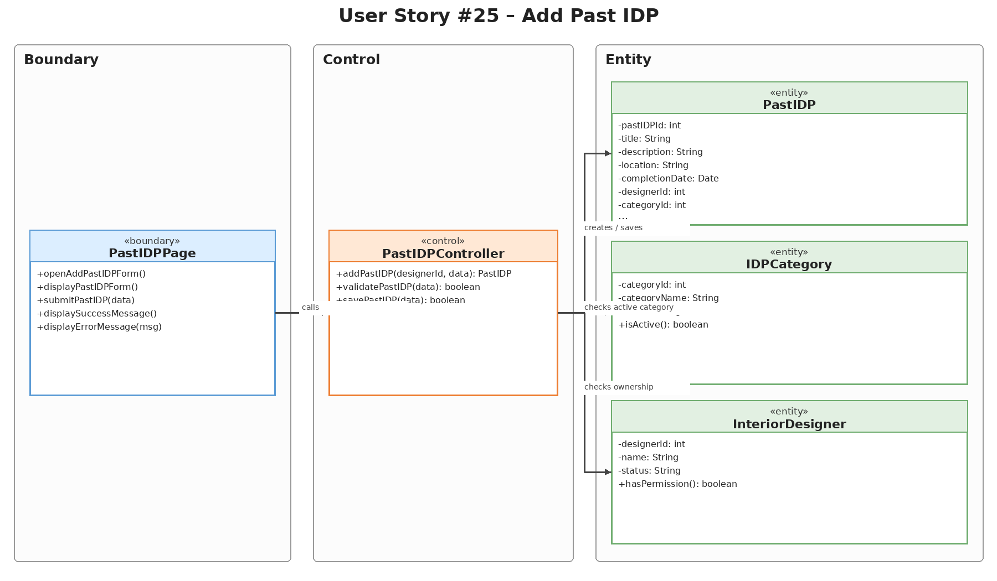

Sequence Diagram | Taiga Task ID: #195
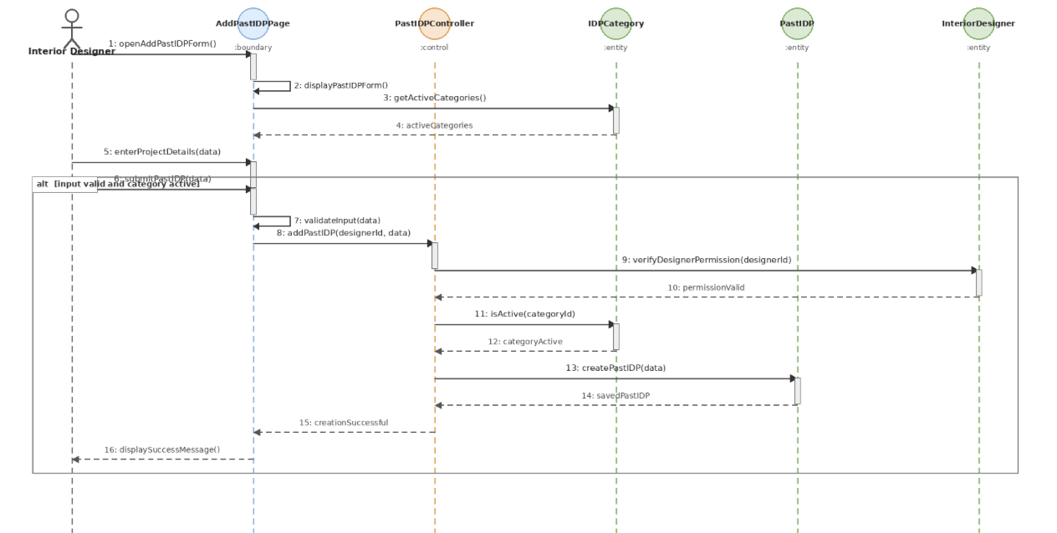

Wireframe | Taiga Task ID: #247
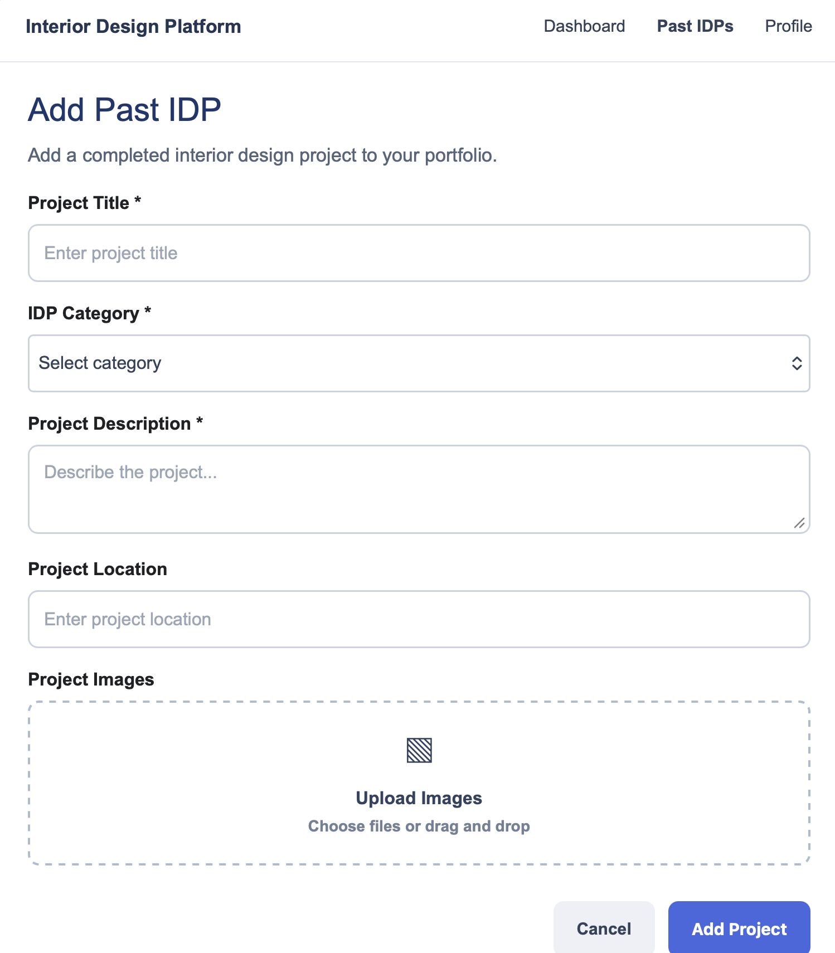

Test Case Documentation |  | Taiga Task ID: #262
Test Case: | Add Past IDP (Success Path)
Test ID: | TC25.1
Test Case Description: | Verify that an authorised interior designer can successfully create and publish a Past IDP with valid details.
Test Case Procedure: | Log in as an Interior Designer.  On the designer dashboard, click + Add Past IDP.  Enter a unique project title, description, select an active category, and enter a valid location.  Click Add Past IDP and check the dashboard message.
Test Data: | Title: Modern 4-Room HDB Resale Transformation  - Category: Living Room  - Description: Complete overhaul of a 20-year-old resale flat featuring open-concept layout and minimalist styling.  - Location: Tampines GreenVerdant
Expected Output: | The dashboard displays "Past IDP added successfully" and the new project is saved as a Past, Active IDP owned by the logged-in designer.
Actual Output: | Passed
Test Date: | 2 Nov 2026
Result:
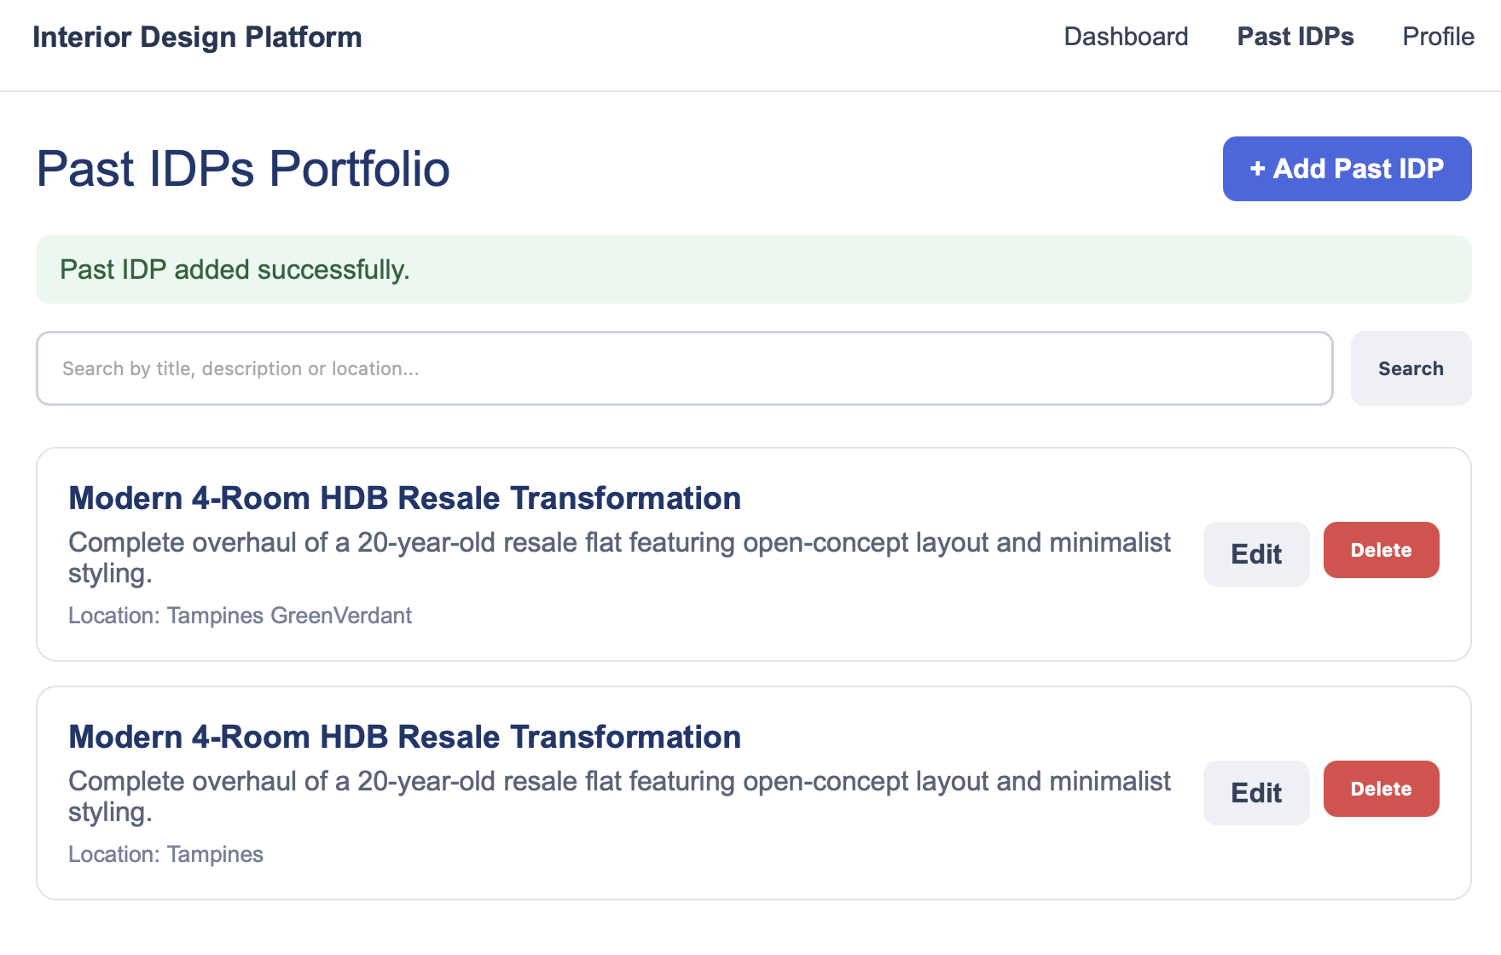

Test Case Documentation |  | Taiga Task ID: #262
Test Case: | Add Past IDP (Validation Failure)
Test ID: | TC25.2
Test Case Description: | Verify that the system prevents adding a Past IDP when mandatory fields (such as Title) are missing.
Test Case Procedure: | Log in as an Interior Designer.  On the designer dashboard, click + Add Past IDP.  Leave the Title field blank while selecting an active category and entering a description.  Click Add Past IDP and check the validation message.
Test Data: | - Title: Modern 4-Room HDB Resale Transformation  - Category: empty  - Description: Complete overhaul of a 20-year-old resale flat featuring open-concept layout and minimalist styling.  - Location: Tampines GreenVerdant
Expected Output: | The system blocks submission, re-renders the form with typed inputs, and displays "Please fill in all required fields."
Actual Output: | Passed
Test Date: | 2 Nov 2026
Result:
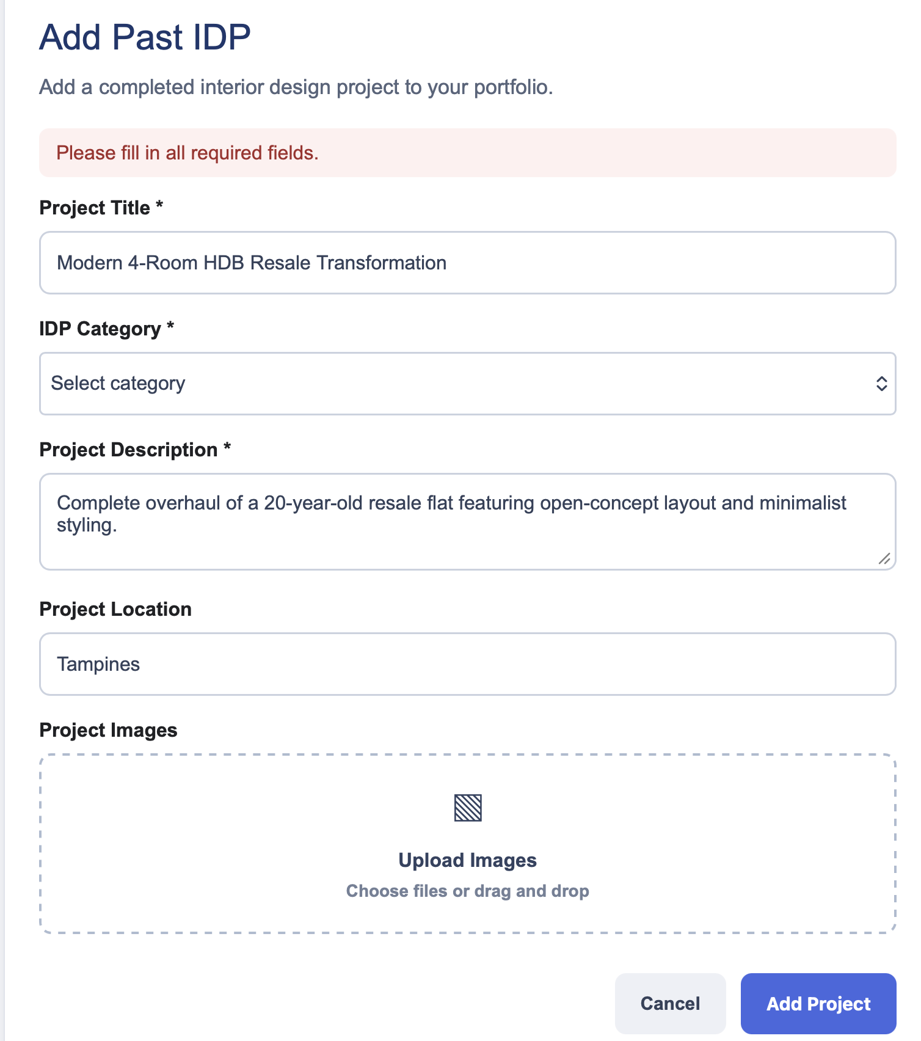

8. Source and Scope Notes
This separate US25 report is based on the supplied SprintReport.pdf (pages 3–8) and the supplied Sprint4.zip US25 diagram assets. The report preserves the source terminology, task IDs, test data, expected outputs, actual outputs and test date. No additional test results or implementation details have been assumed.

