CSIT314 Software Development Methodologies – Group Project
Sprint 4 – US25: Add Past IDP
Interior Design Platform – Interior Designer

1. User Story
User Story ID | #25
User Story | As an interior designer, I want to add a past IDP so that I can show customers my completed work.
Actor | Interior Designer
Taiga Task ID – Use Case | #187
Taiga Task ID – BCE and Sequence Diagrams | #195
Taiga Task ID – Wireframe | #247
Taiga Task ID – Test Cases | #262

2. Use Case Diagram
The use case is Add Past IDP (US25). The actor is the Interior Designer.
Interior Designer ───────── ( Add Past IDP )
Source reference: SprintReport.pdf, page 3.

3. Use Case Description
Use Case Name | Add Past IDP
Actor | Interior Designer
Triggering Event | The interior designer wants to add a previously completed IDP to showcase their work to customers.
Brief Description | This use case allows an interior designer to enter and submit information about a previously completed IDP project so that customers can view their completed work.
Pre-conditions | 1. The interior designer has access to the platform. 2. The Add Past IDP feature is available.
Post-conditions | 1. The past IDP information is successfully submitted and saved. 2. The completed project information is available for customers to view, subject to the platform’s display rules.

Main Flow
- The interior designer accesses the platform.
- The interior designer selects the Add Past IDP function.
- The system displays the Add Past IDP form.
- The interior designer enters the project title.
- The interior designer selects an IDP category.
- The interior designer enters the project description.
- The interior designer enters the project location.
- The interior designer clicks the Submit button.
- The system validates the submitted information.
- The system saves the past IDP information.
- The system displays a successful submission confirmation.

Alternative Flows
- A1 – Missing required information: If required information is missing, the system displays a validation message and asks the interior designer to complete the required fields.
- A2 – Cancel submission: If the interior designer clicks Cancel, the system cancels the operation and returns to the previous page without submitting the information.
- A3 – Submission failure: If the system cannot save the information, it displays an error message and allows the interior designer to try again.

4. B-C-E Class Diagram
The supplied B-C-E diagram identifies PastIDPPage as the boundary and PastIDPController as the control. The entity area shows PastIDP, IDPCategory and InteriorDesigner. The controller is shown creating/saving the PastIDP, checking that the category is active, and checking designer ownership/permission.
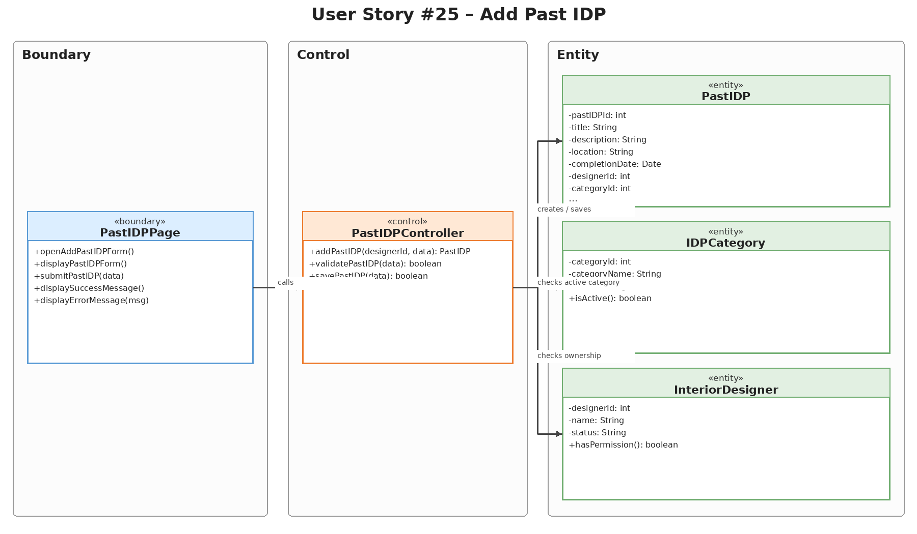
Figure 1. B-C-E class diagram for US25 – Add Past IDP.

5. Sequence Diagram
The supplied sequence diagram shows the Interior Designer opening the form, the page displaying the form and retrieving active categories, and the designer entering and submitting project details. The page validates the input before calling the controller. In the valid-input path, the controller verifies designer permission, checks that the category is active, creates and saves the PastIDP, and returns a successful creation result. The note states that missing or invalid required information produces validation errors and the project is not saved.
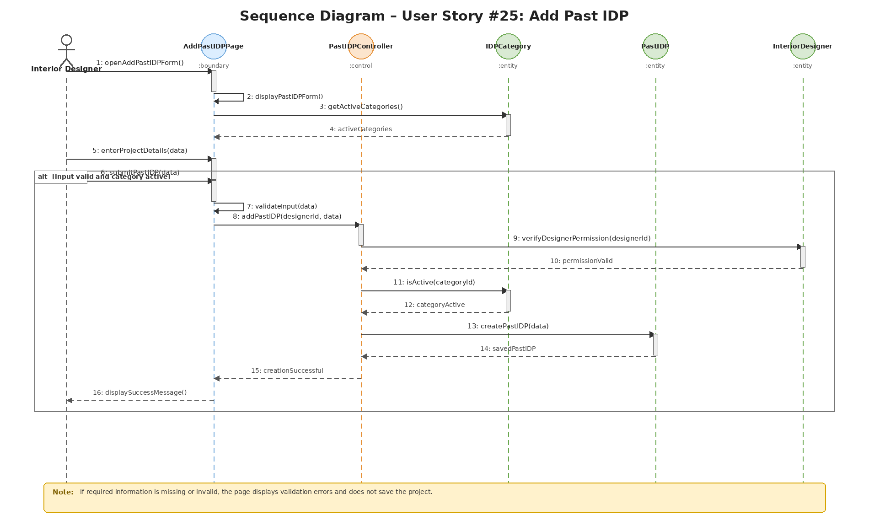
Figure 2. Sequence diagram for US25 – Add Past IDP.

6. Wireframe
The supplied Sprint 4 report includes the Add Past IDP form wireframe. It shows fields for Project Title, IDP Category, Project Description and Project Location, an image-upload area, and Cancel and Add Project buttons. The image-upload area is shown in the US25 wireframe.
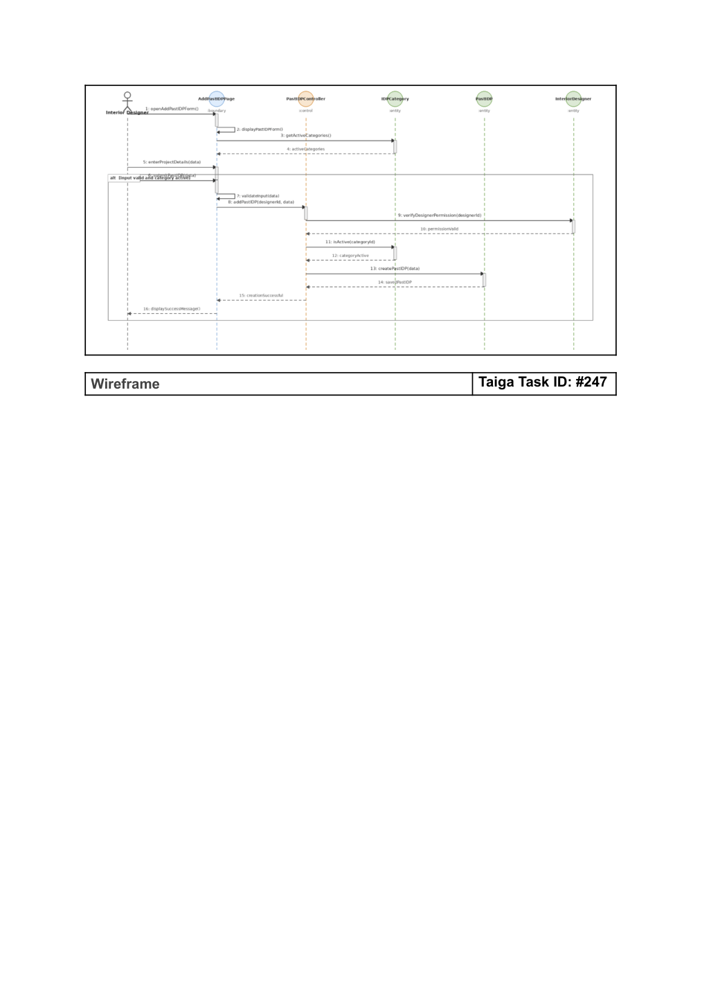
Figure 3. Wireframe source page from SprintReport.pdf, page 5.

7. Test Case Documentation
The supplied Sprint 4 report documents two system test cases for US25. Both show an Actual Output of Passed and a Test Date of 2 Nov 2026.

TC25.1 – Add Past IDP (Success Path)
Taiga Task ID | #262
Test Case Description | Verify that an authorised interior designer can successfully create and publish a Past IDP with valid details.
Test Case Procedure | 1. Log in as an Interior Designer. 2. On the designer dashboard, click + Add Past IDP. 3. Enter a unique project title, description, select an active category, and enter a valid location. 4. Click Add Past IDP and check the dashboard message.
Test Data | Title: Modern 4-Room HDB Resale Transformation; Category: Living Room; Description: Complete overhaul of a 20-year-old resale flat featuring open-concept layout and minimalist styling.; Location: Tampines GreenVerdant.
Expected Output | The dashboard displays “Past IDP added successfully” and the new project is saved as a Past, Active IDP owned by the logged-in designer.
Actual Output | Passed
Test Date | 2 Nov 2026

TC25.2 – Add Past IDP (Validation Failure)
Taiga Task ID | #262
Test Case Description | Verify that the system prevents adding a Past IDP when mandatory fields (such as Title) are missing.
Test Case Procedure | 1. Log in as an Interior Designer. 2. On the designer dashboard, click + Add Past IDP. 3. Leave the Title field blank while selecting an active category and entering a description. 4. Click Add Past IDP and check the validation message.
Test Data | Title: blank (the source report’s displayed test-data list also includes “Modern 4-Room HDB Resale Transformation”); Category: empty; Description: Complete overhaul of a 20-year-old resale flat featuring open-concept layout and minimalist styling.; Location: Tampines GreenVerdant.
Expected Output | The system blocks submission, re-renders the form with typed inputs, and displays “Please fill in all required fields.”
Actual Output | Passed
Test Date | 2 Nov 2026

8. Source and Scope Notes
This separate US25 report is based on the supplied SprintReport.pdf (pages 3–8) and the supplied Sprint4.zip US25 diagram assets. The report preserves the source terminology, task IDs, test data, expected outputs, actual outputs and test date. No additional test results or implementation details have been assumed.

