CSIT314 Software Development Methodologies – Group Project
Sprint 4 – US26: View Past IDP
Interior Design Platform – Interior Designer
User Story # | User Story Description
#26 | As an interior designer, I want to view my past IDPs so that I can check how they look to customers.

Use Case Diagram | Taiga Task ID: #188
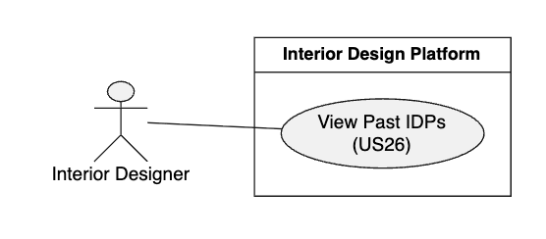

Use Case Description |  | Taiga Task ID: #188
Use Case Name: | View Past IDPs
Actor: | Interior Designer
Triggering Event: | The Interior Designer selects the Past IDPs option from the designer dashboard.
Brief Description: | The Interior Designer views a list of completed interior design projects previously added to the platform.
Pre-condition(s): | 1. The Interior Designer is logged in. 2. The designer has an active account and profile.
Post-condition(s): | 1. The system displays the designer's past IDPs. 2. The designer can review the information and details of each project.
Main Flow: | - The Interior Designer opens the designer dashboard.  - The designer selects Past IDPs.  - The system retrieves the past IDPs belonging to the logged-in designer.  - The system displays the list of past IDPs.  - The designer selects a project from the list.  - The system displays the selected project's details.  - The designer reviews the project information.
Alternative Flow(s): | A1 – No Past IDPs Available: If the designer has not added any past projects, the system displays a message indicating that no past IDPs are available.  A2 – Project Not Found: If the selected project cannot be retrieved, the system displays an error message.  A3 – Loading Failure: If the system cannot retrieve the project information, it displays an error message and allows the designer to try again.

BCE Diagram | Taiga Task ID: #196
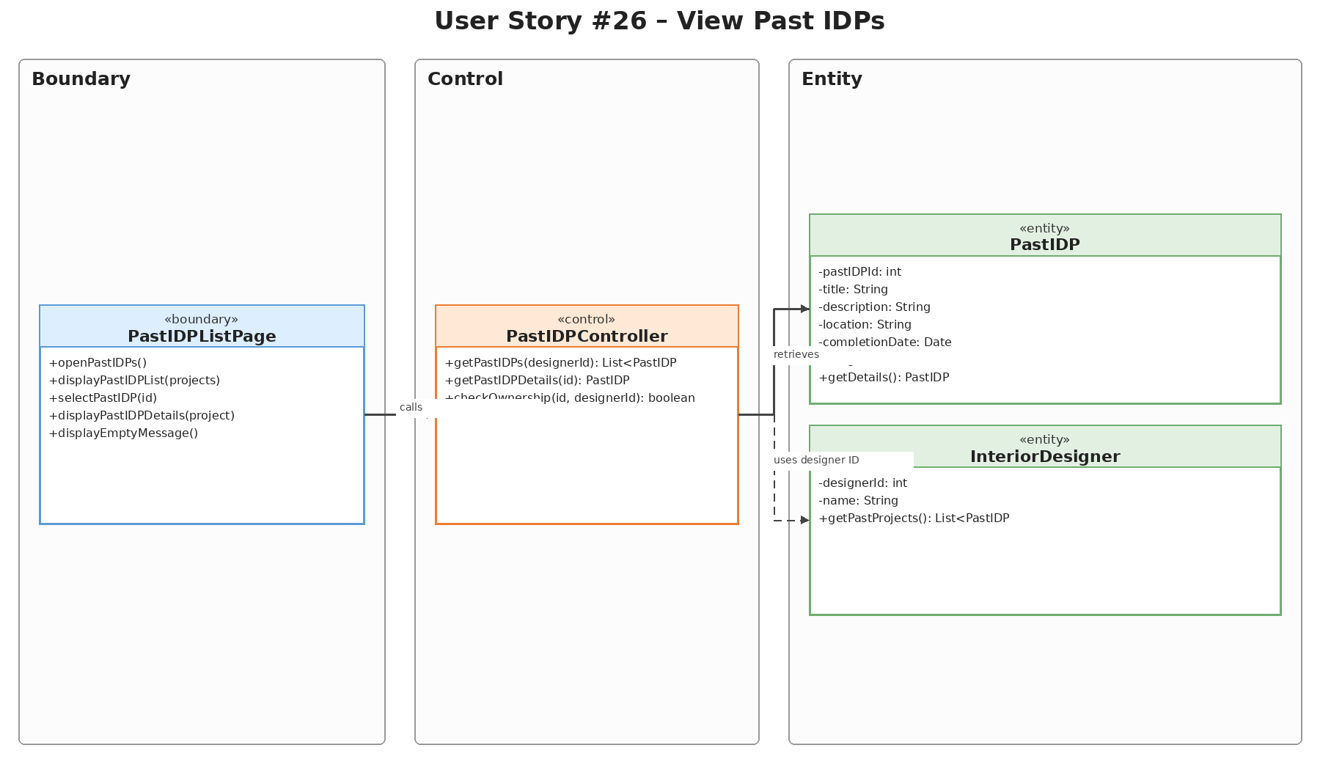

Sequence Diagram | Taiga Task ID: #196
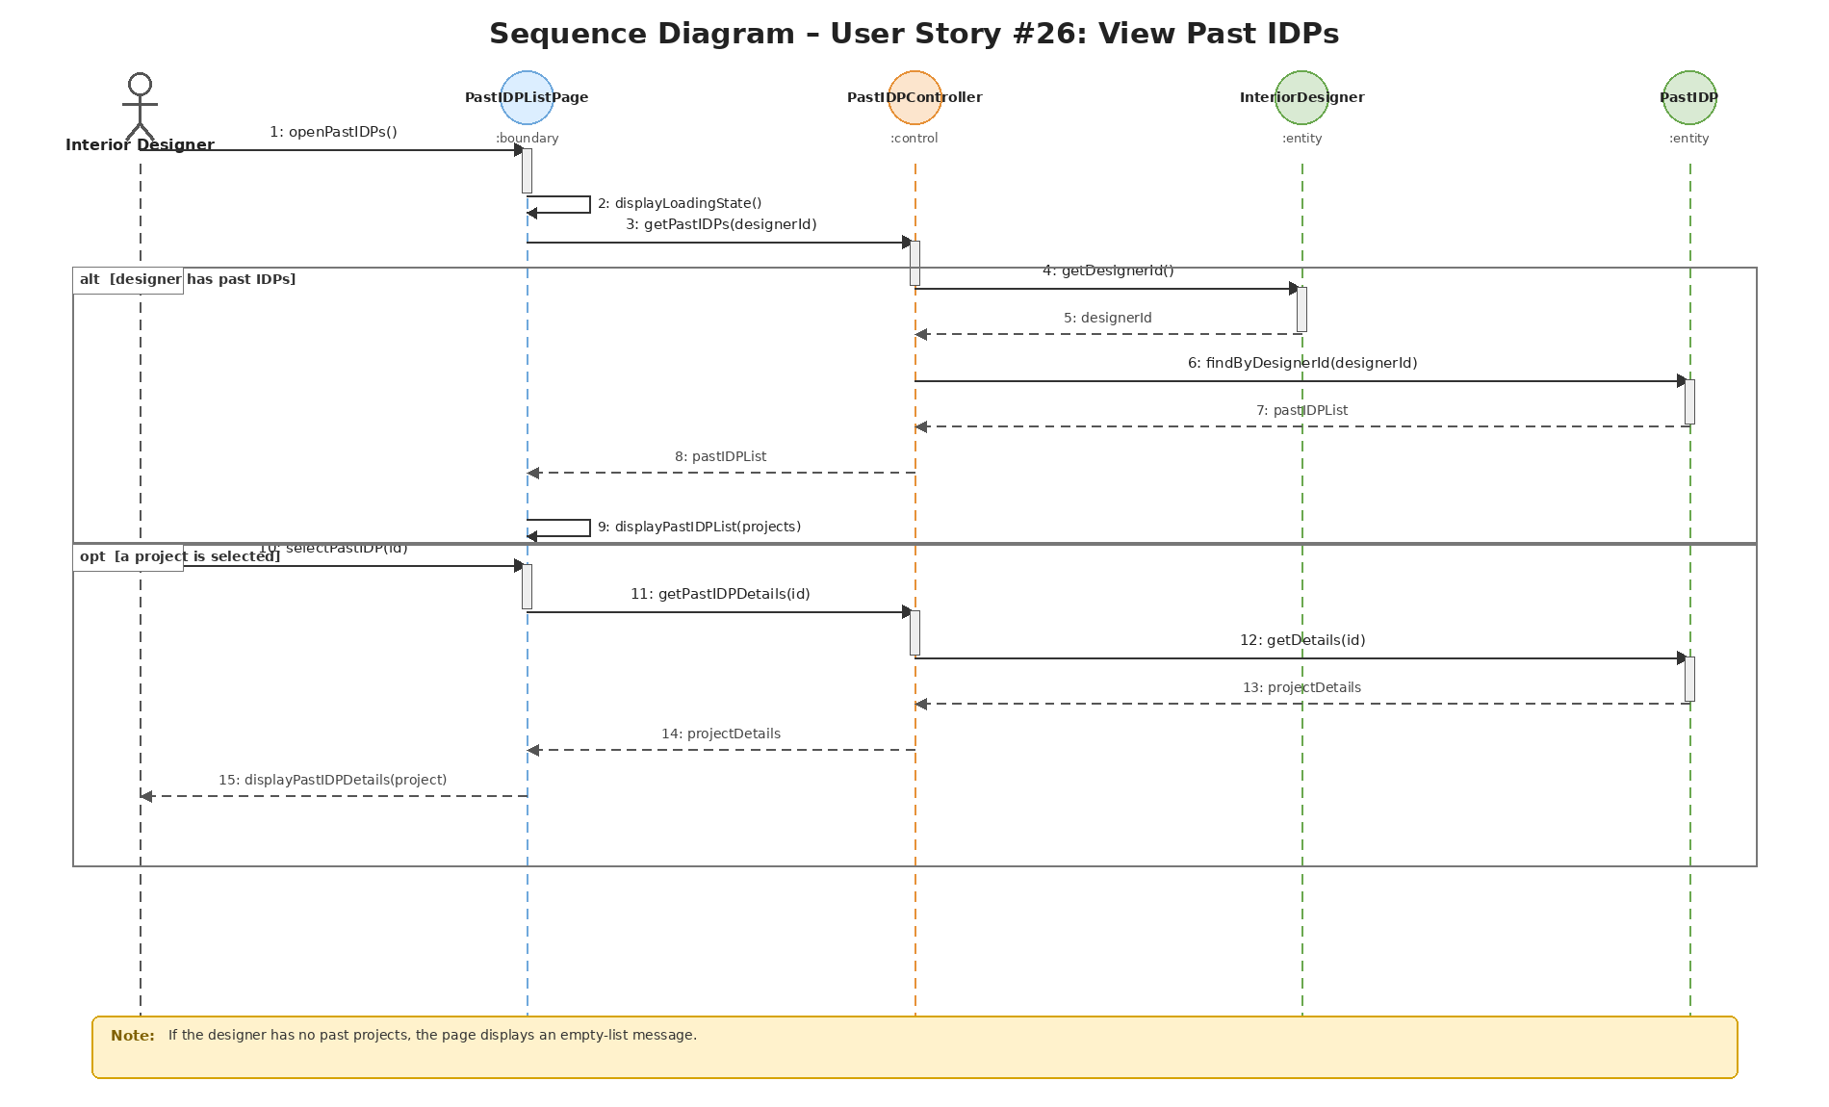

Wireframe | Taiga Task ID: #248
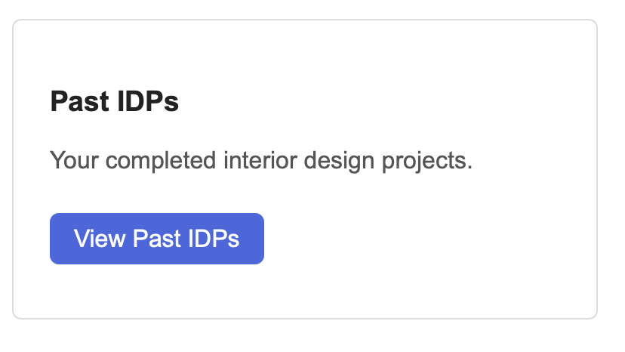

Test Case Documentation |  | Taiga Task ID: #
Test Case: | View Past IDP
Test ID: | 26.1
Test Case Description: | Verify that an interior designer can open the Past IDPs page and view the past interior design projects displayed in their portfolio.
Test Case Procedure: | 1. Log in using an interior designer account.  2. Select Past IDPs from the navigation menu.  3. Check that the Past IDPs Portfolio page is displayed.  4. Review the project cards and confirm that available project details are visible.
Test Data: | Account: Valid interior designer account  Page: Past IDPs  Expected content: Previously saved past IDP records
Expected Output: | The Past IDPs Portfolio page is displayed. The designer can view saved past IDP records and their available details. If no records exist, an appropriate empty-state message is shown.
Actual Output: | Passed
Test Date: | 02 Nov 2026
Result:
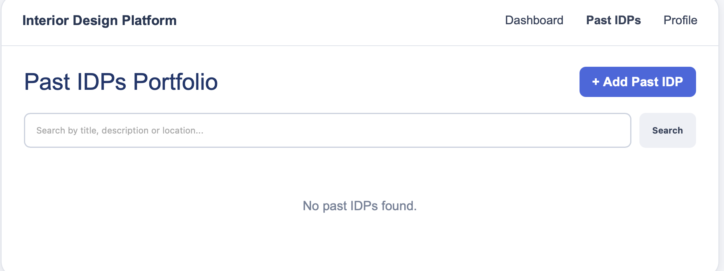

8. Source and Scope Notes
This separate US26 report is based on the supplied SprintReport.pdf (pages 9–12) and the supplied Sprint4.zip US26 diagram assets. The report preserves the original use case description, source terminology, task IDs, test procedures, test data, expected outputs, actual outputs and test date. No additional test results or implementation details have been assumed.

