CSIT314 Software Development Methodologies – Group Project
Sprint 4 – US27: Update Past IDP
Interior Design Platform – Interior Designer
User Story # | User Story Description
#27 | As an interior designer, I want to update a past IDP so that its details are correct.

Use Case Diagram | Taiga Task ID: #189
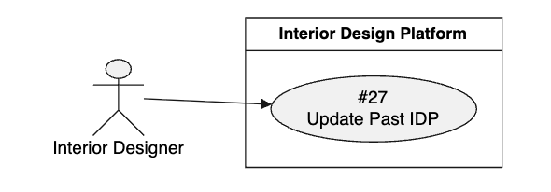

Use Case Description |  | Taiga Task ID: #189
Use Case Name: | Update Past IDP
Actor: | Interior Designer
Triggering Event: | The Interior Designer selects the Update option for an existing past IDP.
Brief Description: | The Interior Designer updates the information of a previously added completed project to ensure that its details remain correct and up
Pre-condition(s): | 1. The Interior Designer is logged in. 2. The designer has an active account. 3. The selected Past IDP exists and belongs to the logged-in designer.
Post-condition(s): | 1. The Past IDP is updated successfully. 2. The updated information is stored in the system. 3. Customers can view the latest project details.
Main Flow: | - The Interior Designer opens the Past IDPs section.  - The system displays the designer's past projects.  - The designer selects the project they want to update.  - The system displays the selected project's existing information.  - The designer clicks the Update option.  - The system displays the update form with the existing information.  - The designer modifies the required project details.  - The designer submits the updated information.  - The system validates the updated information.  - The system saves the changes.  - The system displays a successful update confirmation.  - The system displays the updated project information.
Alternative Flow(s): | A1 – Invalid Information: If the designer enters invalid information, the system displays validation messages.  A2 – Missing Required Information: If required fields are empty, the system asks the designer to complete them.  A3 – Cancel Update: If the designer cancels the update, the system returns to the project details without saving changes.  A4 – Project Not Found: If the selected project no longer exists, the system displays an error message.  A5 – Update Failure: If the system cannot save the changes, it displays an error message and allows the designer to retry.

BCE Diagram | Taiga Task ID: #197
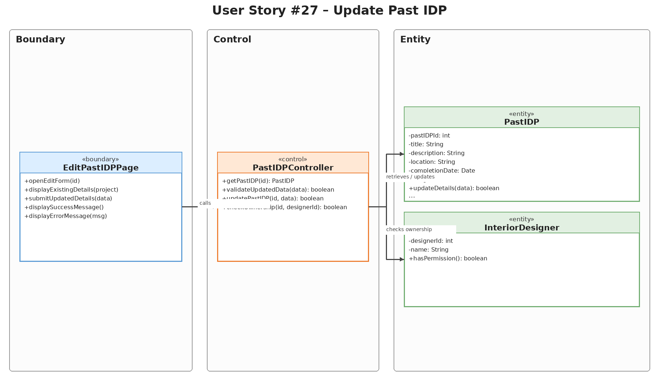

Sequence Diagram | Taiga Task ID: #197
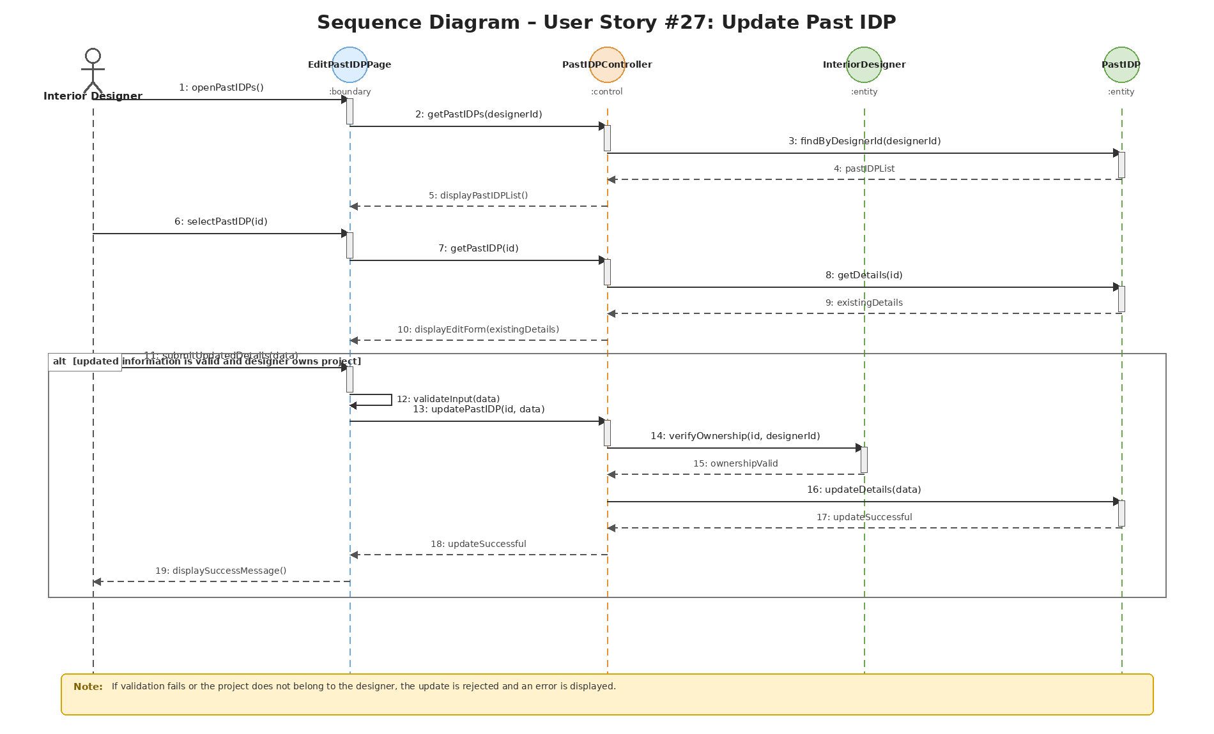

Wireframe | Taiga Task ID: #249

Test Case Documentation |  | Taiga Task ID: #
Test Case: | Update Past IDPs
Test ID: | 27.1
Test Case Description: | Verify that an interior designer can edit an existing past IDP and save the updated project details.
Test Case Procedure: | 1. Log in using an interior designer account.  2. Open the Past IDPs Portfolio page.  3. Locate an existing past IDP and select Edit.  4. Change one or more details, such as title, category, location or description.  5. Select Update IDP.  6. Return to the portfolio and confirm the revised details.
Test Data: | Existing project: Modern 4-Room HDB Resale Transformation  Updated title shown in evidence: Condominium 1-bedroom studio  Category: Kitchen  Location: Bugis  Description: near mrt
Expected Output: | The system saves the revised details, displays a success message and shows the updated project in the Past IDPs Portfolio.
Actual Output: | Passed
Test Date: | 02 Nov 2025
Result:
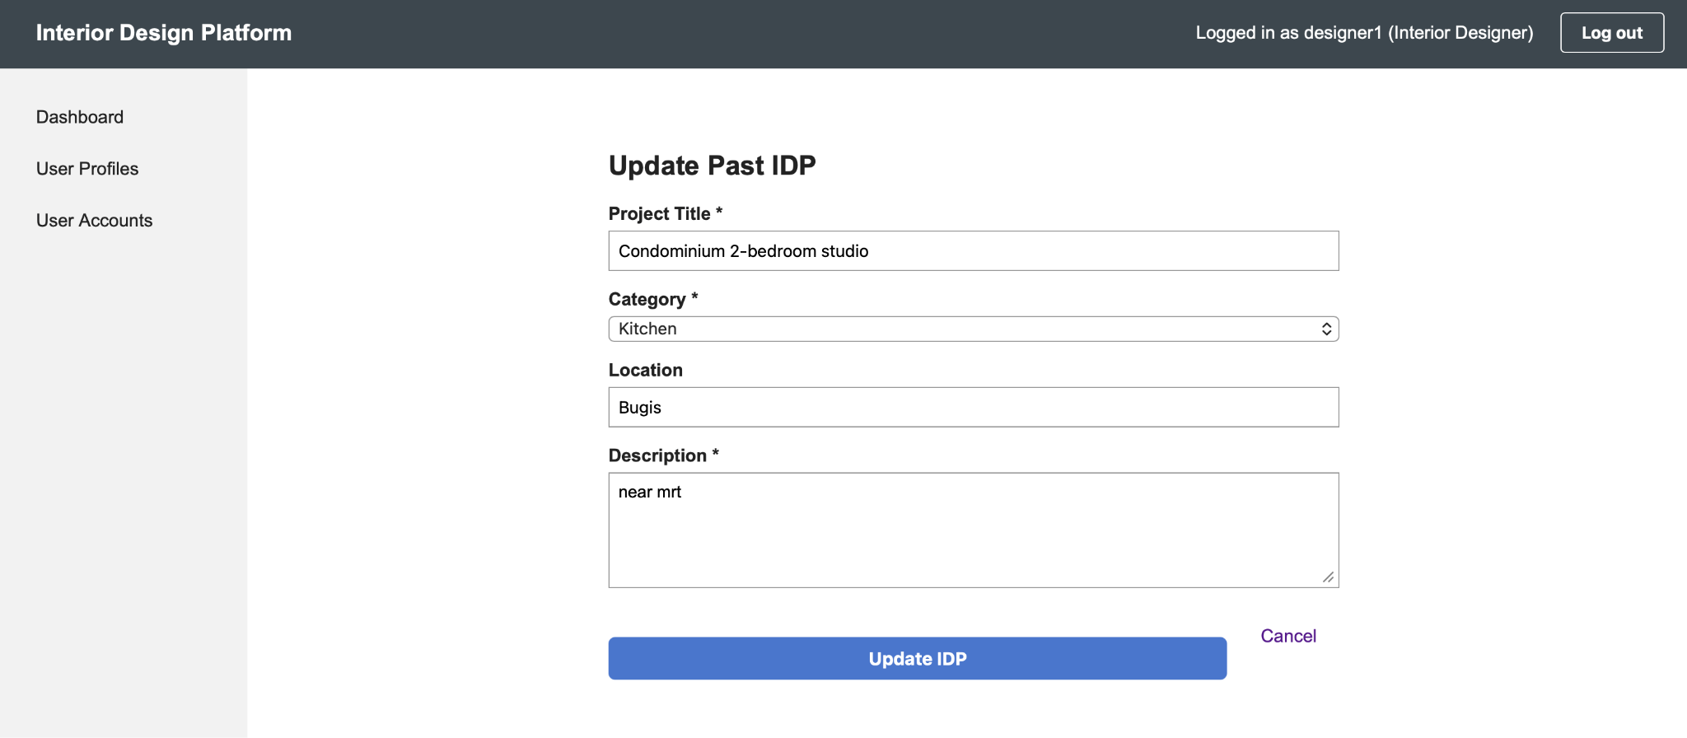
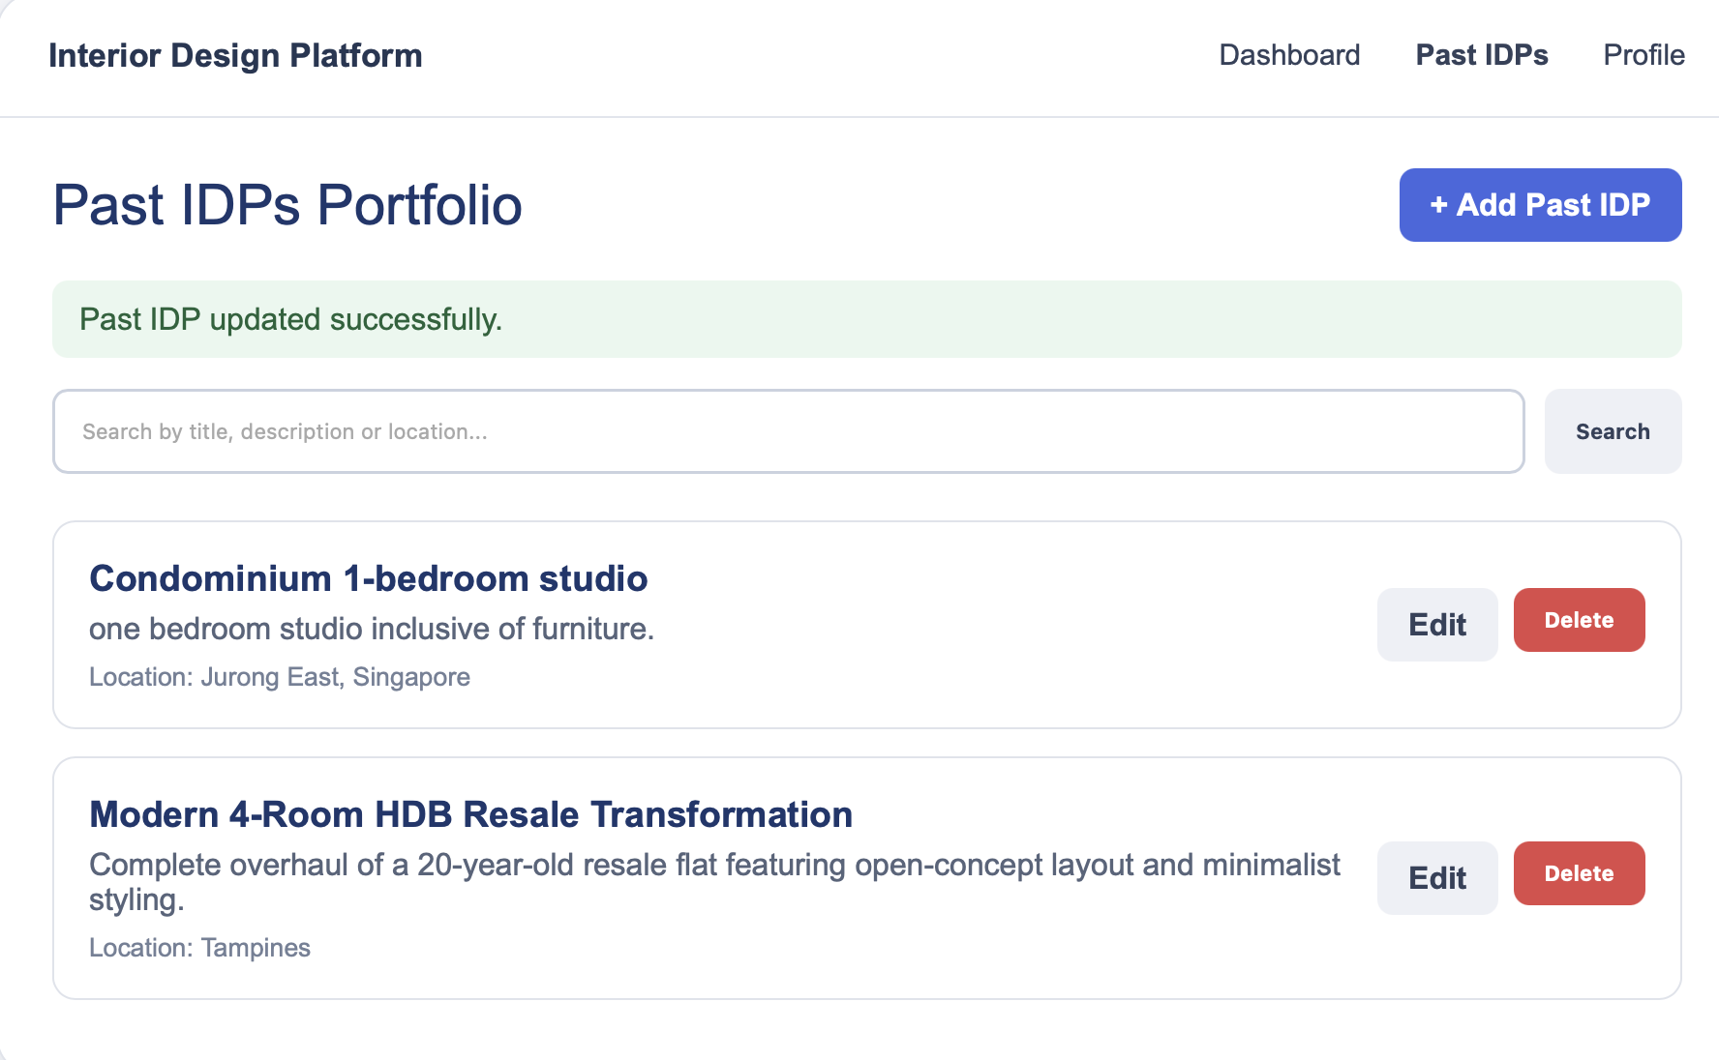

8. Source and Scope Notes
This separate US27 report is based on the supplied SprintReport.pdf (pages 13–16) and the supplied Sprint4.zip US27 diagram assets. The report preserves the original use case description, source terminology, task IDs, test procedures, test data, expected outputs, actual outputs and test date as recorded in the source. No additional test results or implementation details have been assumed.

