CSIT314 Software Development Methodologies – Group Project
Sprint 4 – US28: Delete Past IDP
Interior Design Platform – Interior Designer
User Story # | User Story Description
#28 | As an interior designer, I want to delete a past IDP so that it is no longer shown on the platform.

Use Case Diagram | Taiga Task ID: #190
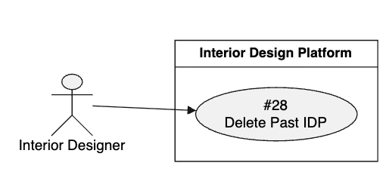

Use Case Description |  | Taiga Task ID: #190
Use Case Name: | Delete Past IDP
Actor: | Interior Designer
Triggering Event: | The Interior Designer selects the Delete option for an existing past IDP.
Brief Description: | The Interior Designer removes a previously added completed project from the platform so that customers can no longer view it.
Pre-condition(s): | 1. The Interior Designer is logged in. 2. The designer has an active account. 3. The selected Past IDP exists and belongs to the designer.
Post-condition(s): | 1. The selected Past IDP is deleted or made unavailable for public viewing. 2. The deleted project is no longer displayed to customers.
Main Flow: | - The Interior Designer opens the Past IDPs section.  - The system displays the designer's past projects.  - The designer selects the project they want to delete.  - The system displays the selected project's details.  - The designer selects the Delete option.  - The system displays a confirmation message.  - The designer confirms the deletion.  - The system processes the deletion request.  - The system removes the project from the publicly displayed Past IDPs.  - The system displays a successful deletion confirmation.  - The system refreshes the Past IDPs list.
Alternative Flow(s): | A1 – Deletion Cancelled: If the designer cancels the deletion, the system returns to the project details without deleting the project.  A2 – Project Not Found: If the selected project cannot be found, the system displays an error message.  A3 – Deletion Failure: If the system cannot complete the deletion, it displays an error message and allows the designer to try again.

BCE Diagram | Taiga Task ID: #198
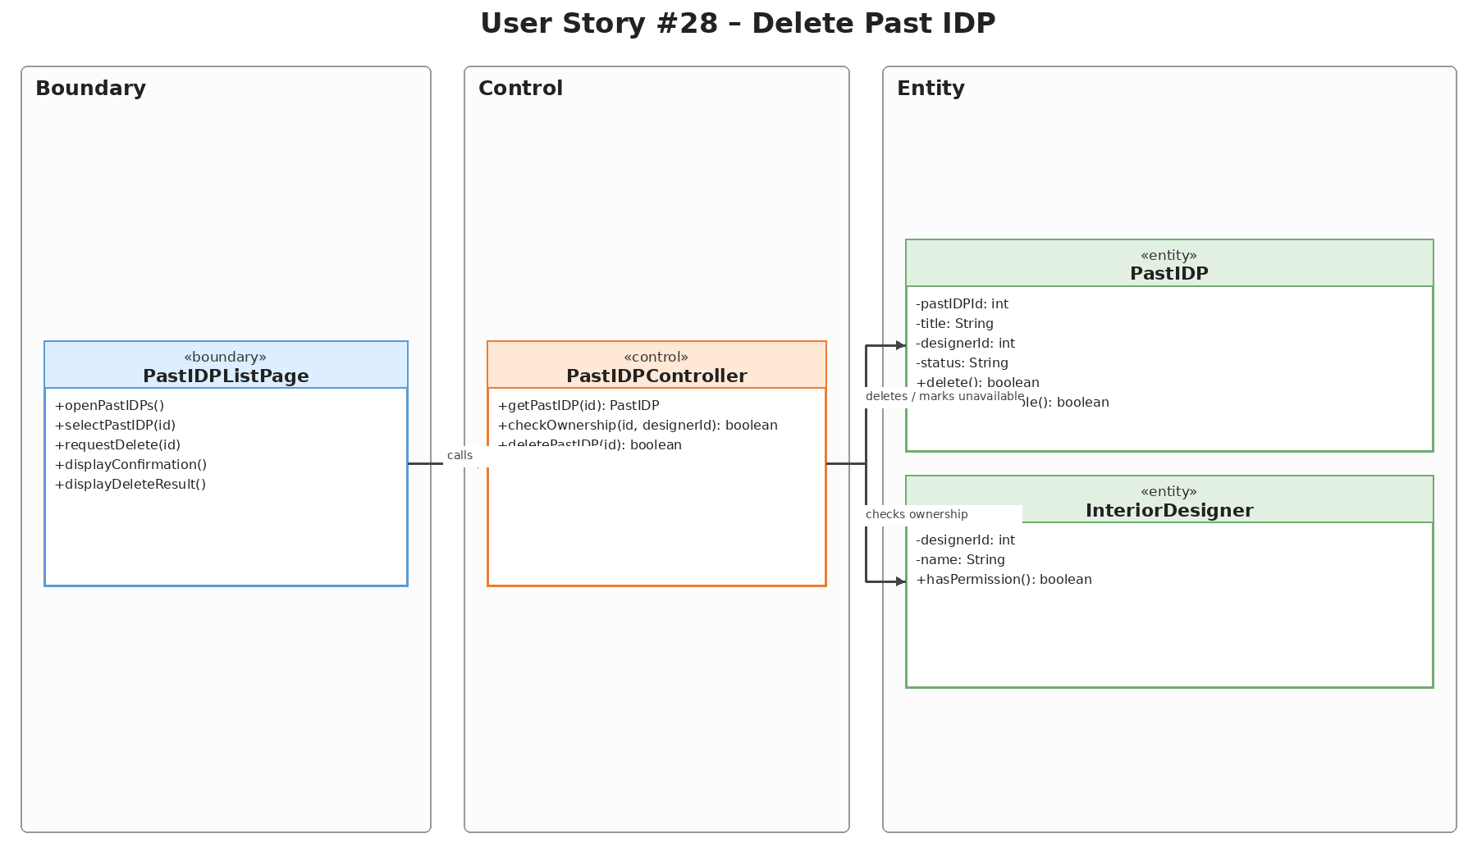

Sequence Diagram | Taiga Task ID: #198
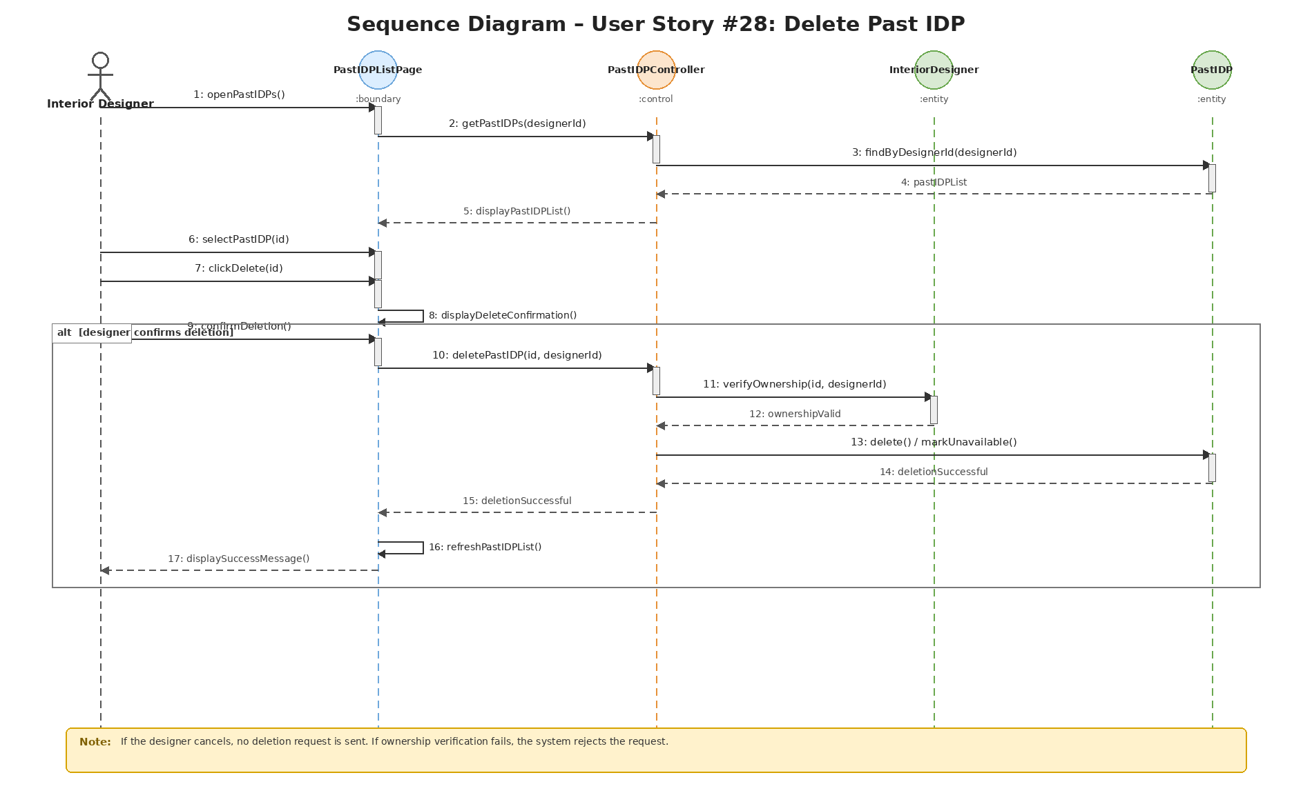

Wireframe | Taiga Task ID: #250
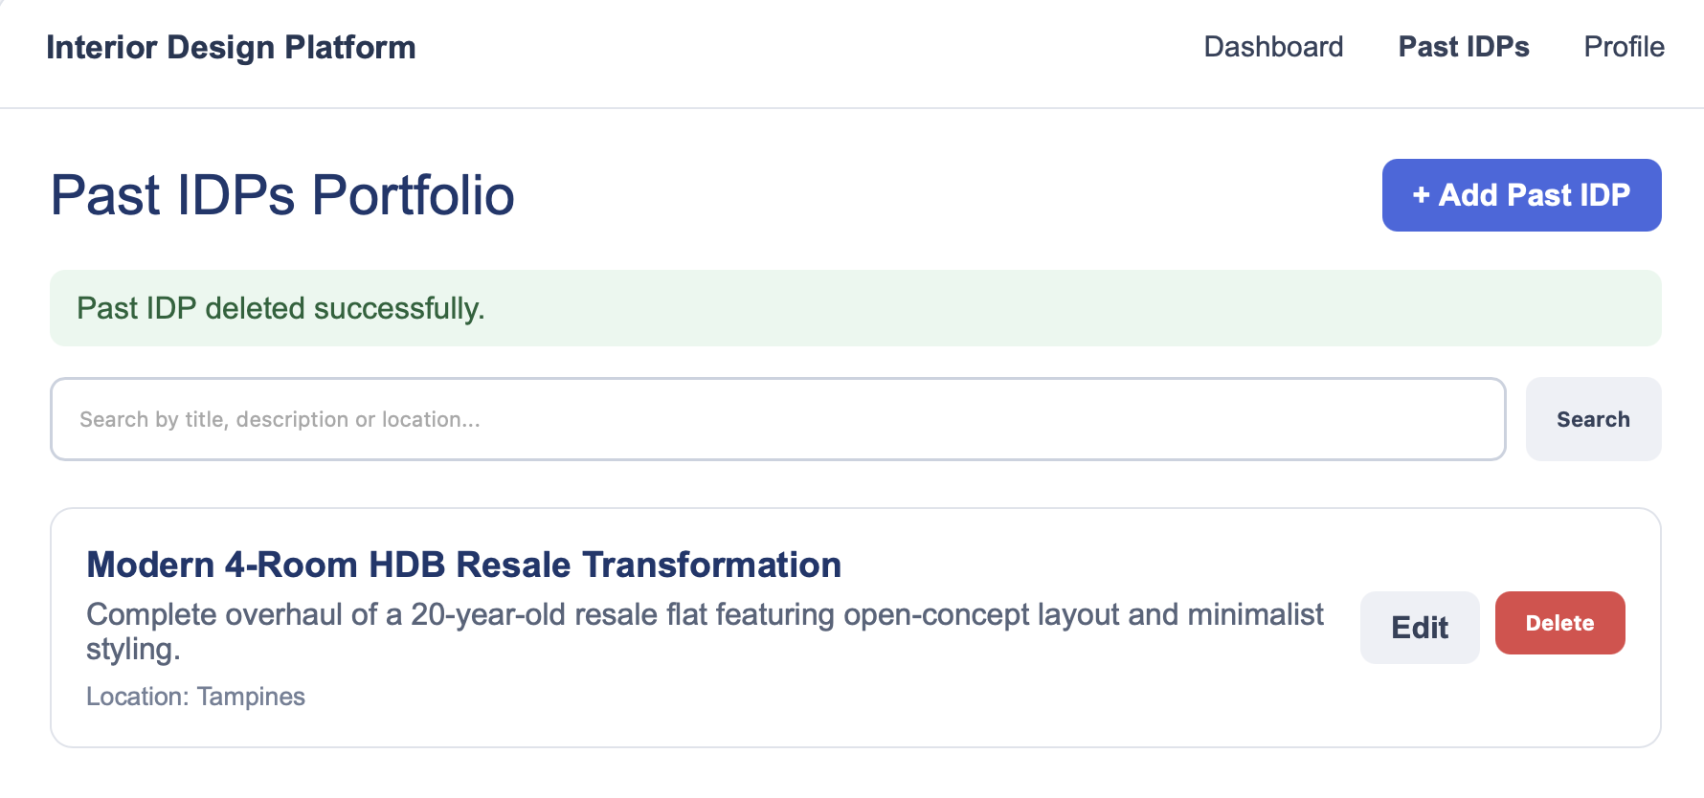

Test Case Documentation |  | Taiga Task ID: #
Test Case: | Delete Past IDP
Test ID: | 28
Test Case Description: | Verify that an interior designer can delete an existing past IDP and that it is no longer displayed in the portfolio.
Test Case Procedure: | 1. Log in using an interior designer account.  2. Open the Past IDPs Portfolio page.  3. Locate the past IDP to remove.  4. Select Delete for that project.  5. Confirm deletion by selecting OK in the confirmation dialog.  6. Check that the deleted project no longer appears in the portfolio.
Test Data: | Project to delete: Modern 4-Room HDB Resale Transformation  Action: Select Delete, then confirm with OK
Expected Output: | The system asks for confirmation. After confirmation, the selected past IDP is deleted, a success message appears and the project is removed from the portfolio.
Actual Output: | Passed
Test Date: | 02 Nov 2026
Result:
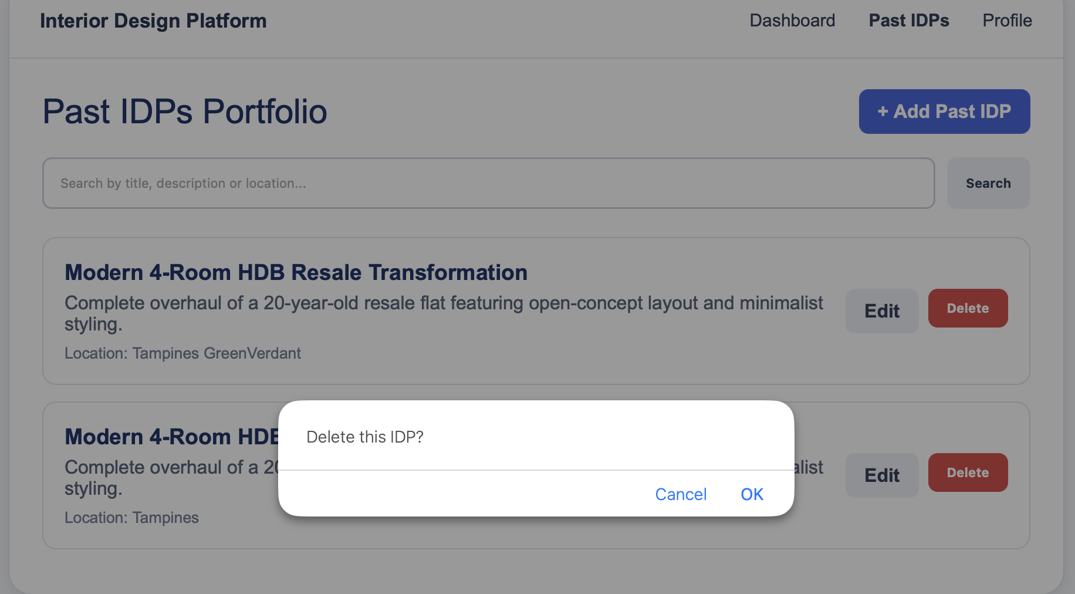

8. Source and Scope Notes
This separate US28 report is based on the supplied SprintReport.pdf (pages 16–20) and the supplied Sprint4.zip US28 diagram assets. The report preserves the original use case description, source terminology, task IDs, test procedures, test data, expected outputs, actual outputs and test date. No additional test results or implementation details have been assumed.

