CSIT314 Software Development Methodologies – Group Project
Sprint 4 – US29: Search Past IDP
Interior Design Platform – Interior Designer
User Story # | User Story Description
#29 | As an interior designer, I want to search my past IDPs so that I can find the IDP I need to manage.

Use Case Diagram | Taiga Task ID: #191
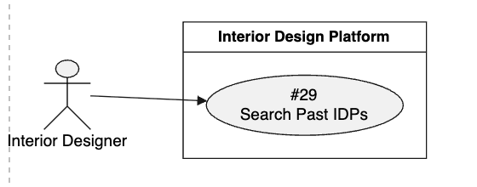

Use Case Description |  | Taiga Task ID: #191
Use Case Name: | Search Past IDPs
Actor: | Interior Designer
Triggering Event: | The Interior Designer enters a keyword into the search bar in the Past IDPs section.
Brief Description: | The Interior Designer searches previously added completed projects using keywords to find a specific IDP they want to manage.
Pre-condition(s): | 1. The Interior Designer is logged in.  2. The designer has access to the Past IDPs section.
Post-condition(s): | 1. The system displays past IDPs matching the search keyword.  2. The designer can select a matching project to view or manage.
Main Flow: | - The Interior Designer opens the Past IDPs section.  - The system displays the designer's past IDPs and a search bar.  - The designer enters a keyword into the search bar.  - The designer submits the search request.  - The system searches the designer's past IDPs using the entered keyword.  - The system retrieves matching projects.  - The system displays the search results.  - The designer selects a project from the results.  - The system displays the selected project's details.
Alternative Flow(s): | A1 – Empty Search: If the designer submits an empty search field, the system displays all past IDPs or asks the designer to enter a keyword.  A2 – No Matching Results: If no projects match the keyword, the system displays a message indicating that no results were found.  A3 – Invalid Search Input: If the search input contains invalid information, the system displays an appropriate validation message.  A4 – Search Failure: If the system cannot process the search request, it displays an error message and allows the designer to try again.

BCE Diagram | Taiga Task ID: #199
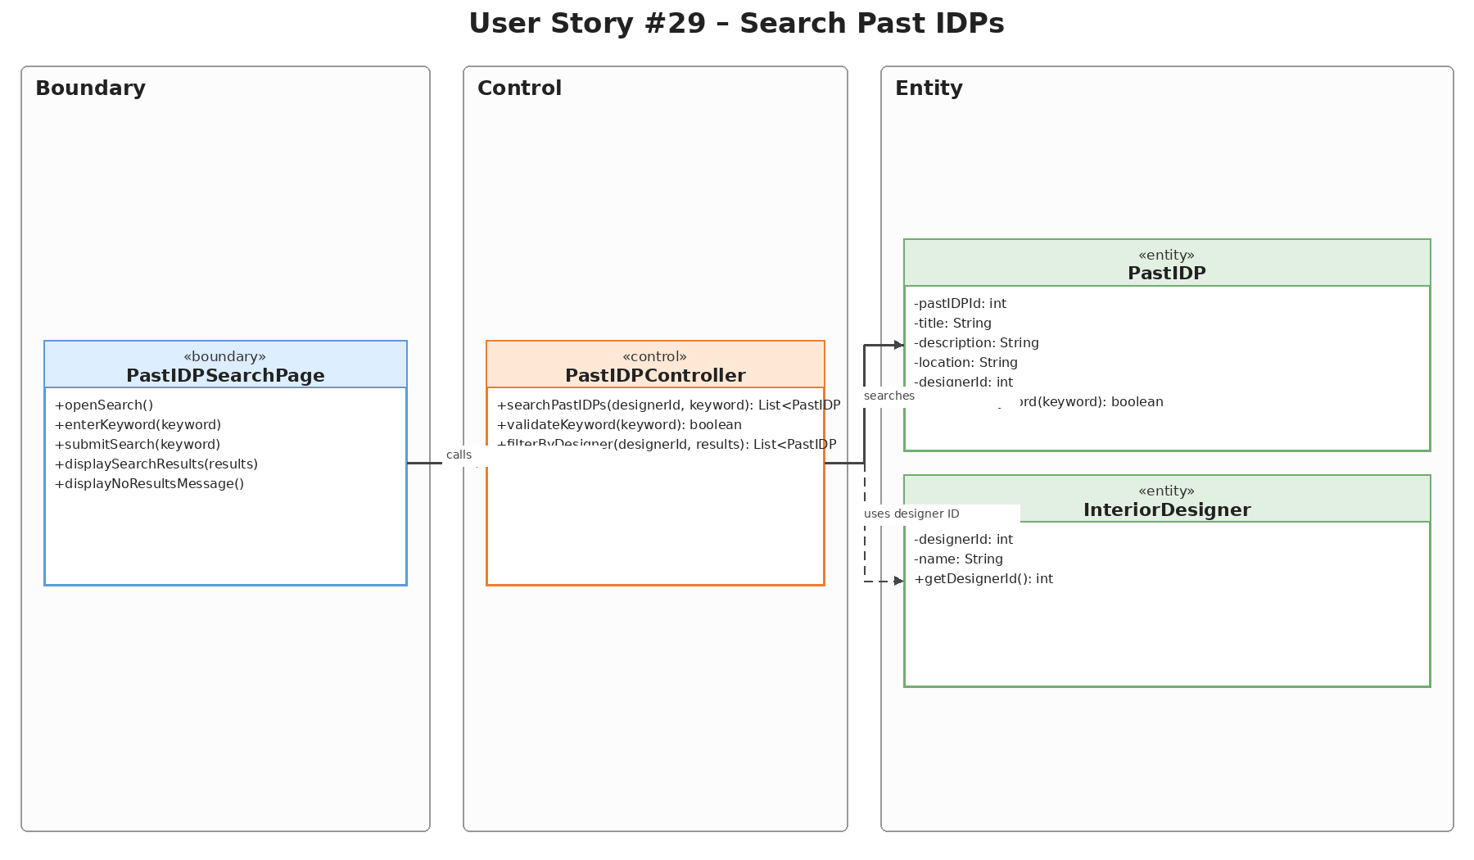

Sequence Diagram | Taiga Task ID: #199
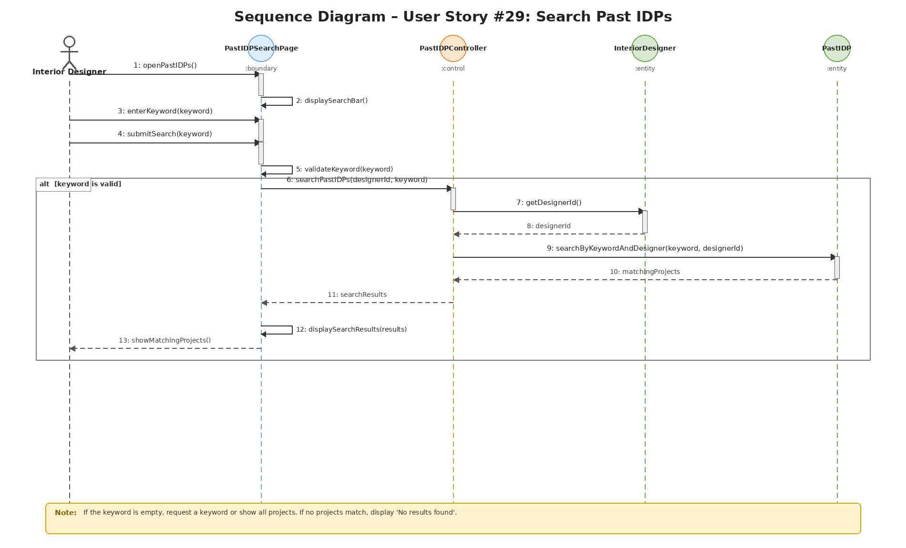

Wireframe | Taiga Task ID: #251


Test Case Documentation |  | Taiga Task ID: #
Test Case: | Search Past IDP
Test ID: | 29
Test Case Description: | Verify that an interior designer can search their past IDPs using a keyword and find matching project records.
Test Case Procedure: | 1. Log in using an interior designer account.  2. Open the Past IDPs Portfolio page.  3. Enter a keyword related to an existing project in the search field.  4. Select Search.  5. Check that the displayed results match the entered keyword.
Test Data: | Search keyword: Modern  Expected matching project: Modern 4-Room HDB Resale Transformation
Expected Output: | The system displays past IDP records matching the keyword. If no record matches, an appropriate no-results message is displayed.
Actual Output: | Passed
Test Date: | 02 Nov 2026
Result:
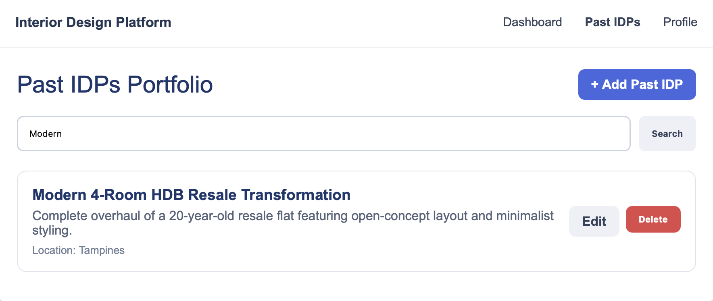

8. Source and Scope Notes
This separate US29 report is based on the supplied SprintReport.pdf (pages 20–24) and the supplied Sprint4.zip US29 diagram assets. The report preserves the original use case description, source terminology, task IDs, search procedures, test data, expected outputs, actual outputs and test date. No additional test results or implementation details have been assumed.

