CSIT314 Software Development Methodologies – Group Project
Sprint 4 – US34: Search save List
Interior Design Platform – Interior Designer

6.8 User Story #34
User Story # | User Story Description
#34 | As a customer, I want to search my saved list so that I can find an IDP I saved earlier.

Use Case Diagram | Taiga Task ID: #193
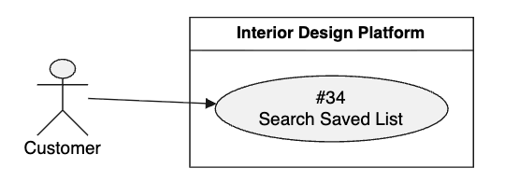

Use Case Description |  | Taiga Task ID: #193
Use Case Name: | Search Saved List
Actor: | Customer
Triggering Event: | The Customer enters a keyword into the search bar in the saved list section.
Brief Description: | The Customer searches their previously saved IDPs using keywords to find a particular project they want to view again.
Pre-condition(s): | 1. The Customer is logged in.  2. The Customer has access to their saved list.
Post-condition(s): | 1. The system displays saved IDPs matching the search keyword.  2. The Customer can select a matching IDP to view its details.
Main Flow: | - The Customer opens the saved list section.  - The system displays the Customer's saved IDPs and a search bar.  - The Customer enters a keyword into the search bar.  - The Customer submits the search request.  - The system searches the Customer's saved list using the entered keyword.  - The system retrieves matching saved IDPs.  - The system displays the search results.  - The Customer selects an IDP from the results.  - The system displays the selected IDP's details.
Alternative Flow(s): | A1 – Empty Search: If the Customer submits an empty search field, the system displays all saved IDPs or asks the Customer to enter a keyword.  A2 – No Matching Results: If no saved IDPs match the keyword, the system displays a message indicating that no results were found.  A3 – Invalid Search Input: If the search input contains invalid information, the system displays a validation message.  A4 – Search Failure: If the system cannot process the search request, it displays an error message and allows the Customer to try again.

BCE Diagram | Taiga Task ID: #201
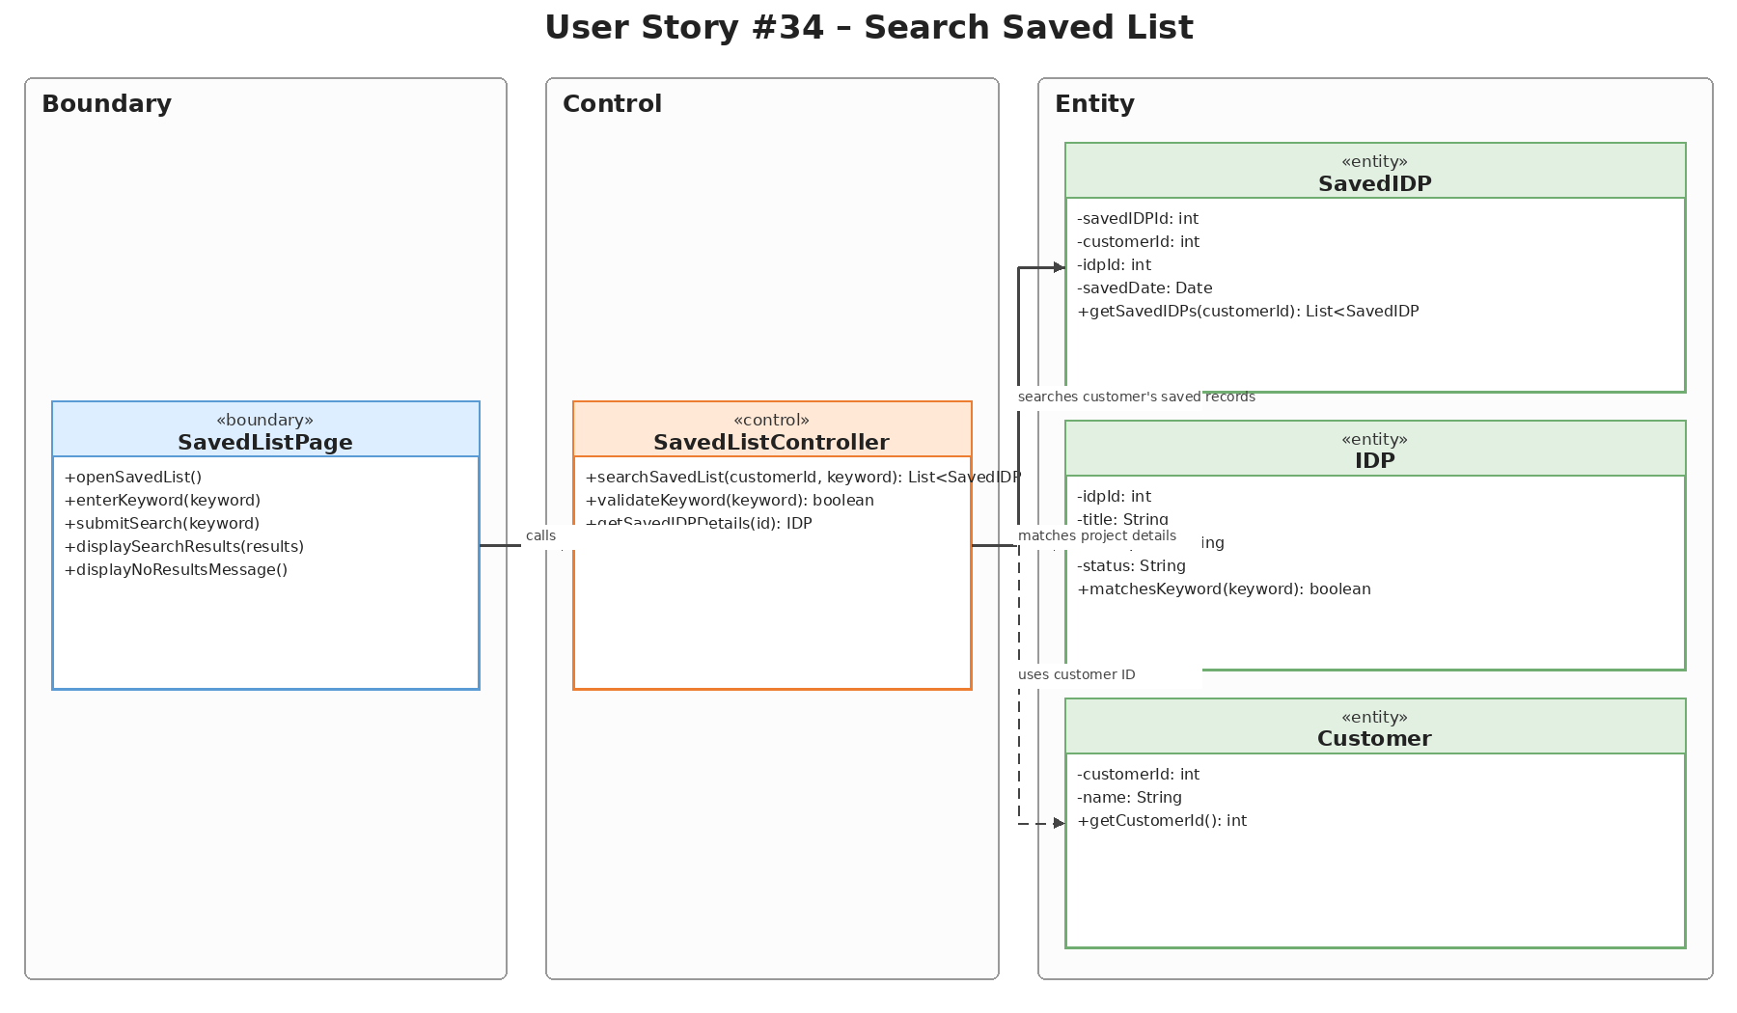

Sequence Diagram | Taiga Task ID: #201
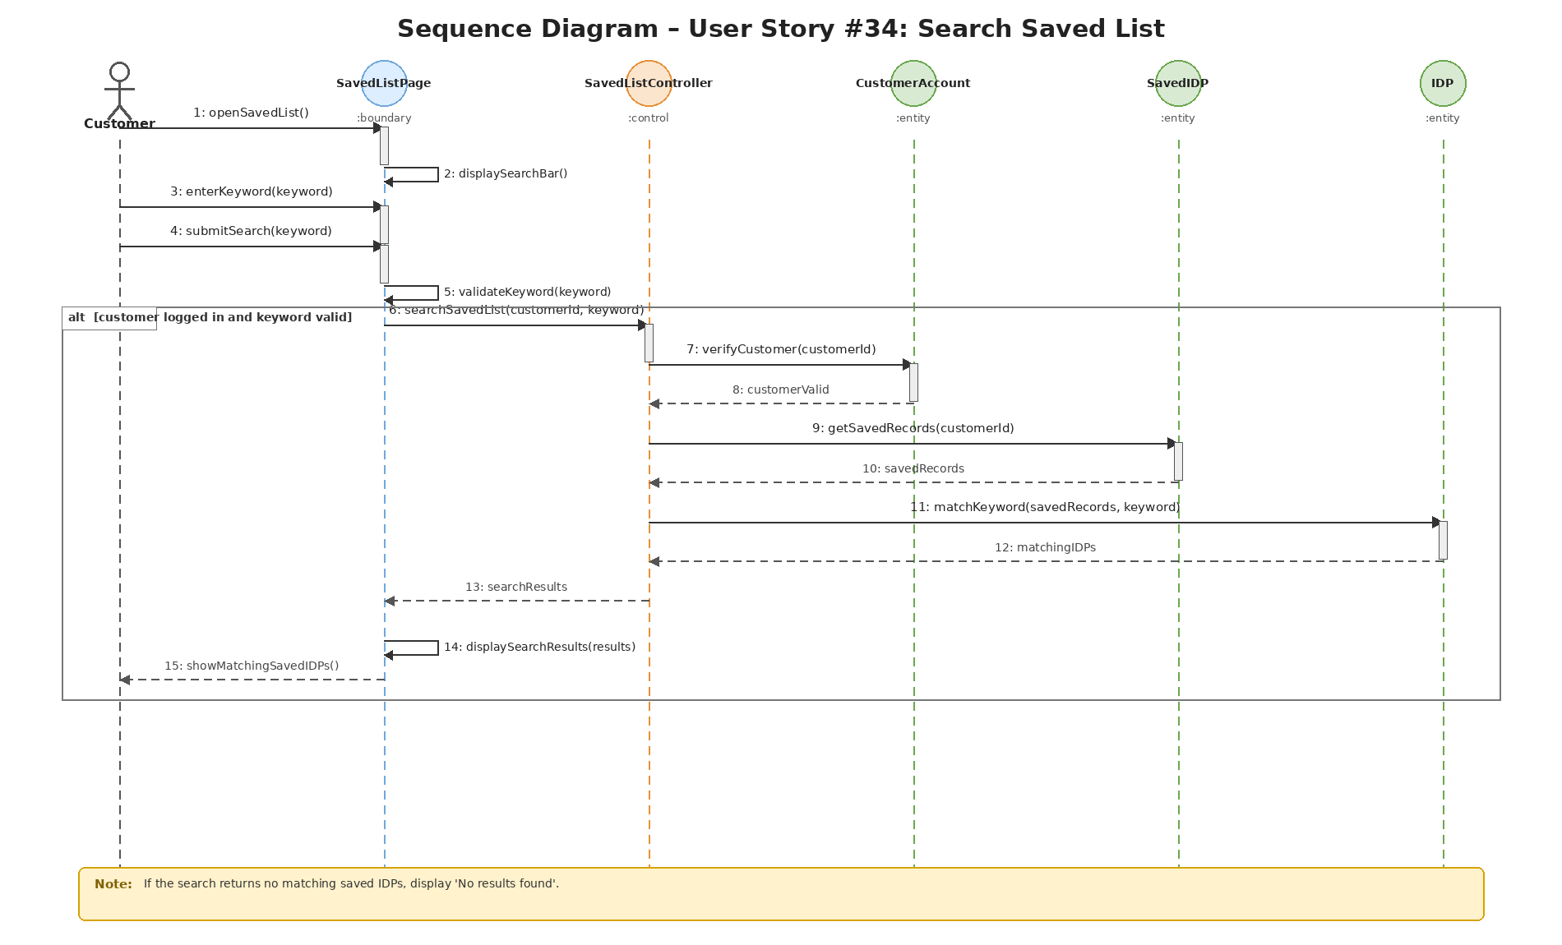

Wireframe | Taiga Task ID: #253
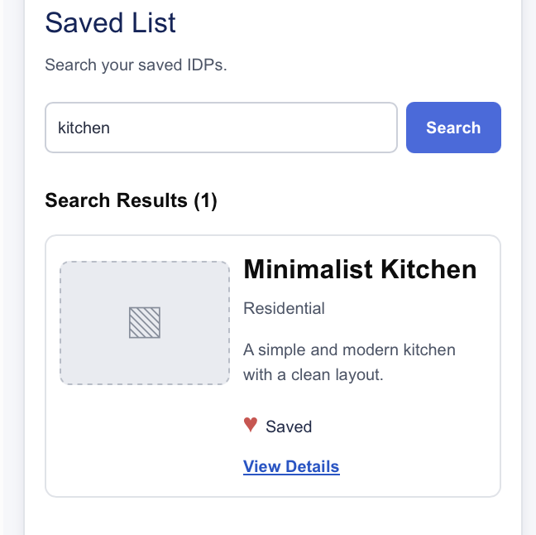

Test Case Documentation |  | Taiga Task ID: #
Test Case:
Test ID:
Test Case Description:
Test Case Procedure:
Test Data:
Expected Output:
Actual Output:
Test Date:
Result:
Insert screenshot…

8. Source and Scope Notes
This separate US34 report is based on the supplied SprintReport.pdf (pages 27–31) and the supplied Sprint4.zip US34 diagram assets. The report preserves the original use case description, source terminology, task IDs, main flow, alternative flows and design documentation. The supplied test case documentation is incomplete; therefore, no test results, test dates or implementation details have been assumed.

