Take-Home Exercise 3: Tracing Influence: A Shiny Dashboard for Music Networks
Hao Liu
2025-06-13

0 Packages check
This section ensures that all required R packages are available for the analysis and interactive modules in this project.
packages <- c(
"shiny", "shinydashboard",
"jsonlite", "igraph", "ggraph",
"dplyr", "lubridate",
"plotly", "visNetwork", "DT",
"leaflet", "ggridges", "ggmosaic"
)
installed <- rownames(installed.packages())
for (pkg in packages) {
if (!pkg %in% installed) install.packages(pkg)
library(pkg, character.only = TRUE)
}

1 Data Preparation & Testing
We load your knowledge‐graph JSON, clean it into tidy node and edge tables, and build an igraph for global metrics.
library(jsonlite)
library(tibble)
library(dplyr)
library(lubridate)
library(igraph)
# Load JSON
raw_json <- fromJSON("MC1_graph.json")
# Helper: Parse "YYYY" or "YYYY-MM-DD"
parse_date <- function(x) {
x <- as.character(x)
x[x == ""] <- NA
year_only <- !is.na(x) & grepl("^\\d{4}$", x)
x[year_only] <- paste0(x[year_only], "-01-01")
ymd(x)
}
# Clean nodes
g_nodes_df <- as_tibble(raw_json$nodes) %>%
rename(
id = id,
label = name,
node_type = `Node Type`
) %>%
mutate(
id = as.character(id),
release_date = parse_date(release_date),
written_date = if ("written_date" %in% names(.)) parse_date(written_date) else as.Date(NA)
)
# Clean edges
g_edges_df <- as_tibble(raw_json$links) %>%
rename(
from_id = source,
to_id = target,
relation = `Edge Type`
) %>%
mutate(
from_id = as.character(from_id),
to_id = as.character(to_id)
)
# Build igraph
g_all <- graph_from_data_frame(
d = g_edges_df %>%
transmute(from = from_id, to = to_id, relation),
vertices = g_nodes_df %>%
transmute(name = id, label, node_type),
directed = TRUE
)
# Sanity checks
stopifnot(
nrow(g_nodes_df) > 0,
nrow(g_edges_df) > 0,
all(c("id", "label", "node_type") %in% names(g_nodes_df)),
all(c("from_id", "to_id", "relation") %in% names(g_edges_df))
)
print(g_all)
IGRAPH 6fcff41 DN-- 17412 37857 --
+ attr: name (v/c), label (v/c), node_type (v/c), relation (e/c)
+ edges from 6fcff41 (vertex names):
[1] 0 ->1841 0 ->4 1 ->0 1 ->16180 2 ->0 2 ->16180 3 ->0
[8] 5 ->5088 5 ->14332 5 ->11677 5 ->2479 5 ->827 5 ->10417 5 ->14768
[15] 5 ->13985 5 ->13297 5 ->3387 5 ->9122 5 ->8680 5 ->5928 5 ->9
[22] 6 ->5 7 ->16881 7 ->5088 7 ->5 7 ->6231 7 ->6231 7 ->7054
[29] 7 ->9808 7 ->9808 7 ->13567 7 ->13567 7 ->14175 7 ->16514 8 ->16881
[36] 8 ->5 8 ->7054 8 ->13567 10->14322 10->14 11->10 11->11459
[43] 11->14322 12->10 12->11459 13->10 13->10 13->11459 13->11459
[50] 15->16367 15->24 15->21 16->15 16->15 16->16367 17->15
+ ... omitted several edges

2 Module 1: Influence Over Time
Tasks & Questions:
- Who has Sailor been most influenced by over time?
- Was influence intermittent or gradual?

2.1 Input & Output Definitions
Input ID | Widget | Choices / Default | Purpose
yearRange | sliderInput | 2010–2040; default c(2010,2040) | Filter by written_date year
artist1 | selectInput | nodes_df$name; default “Sailor Shift” | Choose focal artist

Output ID | Render | Description
tsPlot | renderPlotly() | Line chart: count per year
tsTable | renderDT() | Data table of yearly counts

2.2 Code Preparation & Testing
Before wiring up the Shiny module, we encapsulate our data-manipulation steps into a reusable function and verify its basic behavior:
library(dplyr)
library(tidyr)
library(tibble)
g <- fromJSON("MC1_graph.json")
nodes <- g$nodes
edges <- g$links
get_influence_over_time <- function(
artist_name,
yearRange = c(2010, 2040),
nodes_df = nodes,
edges_df = edges
) {
# 1. Find the artist’s Person‐node ID
artist_id <- nodes_df %>%
filter(`Node Type` == "Person", name == artist_name) %>%
pull(id)
if (length(artist_id) == 0) {
stop("Artist not found: ", artist_name)
}
# 2. Get all the Song IDs they perform
artist_songs <- edges_df %>%
filter(`Edge Type` == "PerformerOf", source == artist_id) %>%
pull(target)
if (length(artist_songs) == 0) {
warning("No songs found for artist: ", artist_name)
}
# 3. Build the influence‐edges table (one row per Sailor song → influencer)
wanted_types <- c(
"InStyleOf", "LyricalReferenceTo",
"InterpolatesFrom", "DirectlySamples", "CoverOf"
)
infl_edges <- edges_df %>%
filter(
`Edge Type` %in% wanted_types,
source %in% artist_songs
) %>%
transmute(
song_id = source, # Sailor’s song
infl_song = target, # the influencing song
rel_type = `Edge Type`
) %>%
# 3a. bring in the Sailor‐song’s release year
left_join(
nodes_df %>%
filter(`Node Type` == "Song") %>%
transmute(song_id = id,
year = as.integer(substr(release_date, 1, 4))),
by = "song_id"
) %>%
# 3b. bring in the Person‐node who performed the influencing song
left_join(
edges_df %>%
filter(`Edge Type` == "PerformerOf") %>%
transmute(infl_song = target,
performer = source),
by = "infl_song"
) %>%
# 3c. bring in the influencer’s name
left_join(
nodes_df %>%
filter(`Node Type` == "Person") %>%
transmute(performer = id,
influencer = name),
by = "performer"
) %>%
# 3d. drop any incomplete rows
filter(!is.na(influencer), !is.na(year))
# 4. Count by year
counts <- infl_edges %>%
count(year, name = "num_influences")
# 5. Fill zero‐counts for the full slider window
full_years <- tibble(year = seq(yearRange[1], yearRange[2]))
full_years %>%
left_join(counts, by = "year") %>%
replace_na(list(num_influences = 0)) %>%
arrange(year)
}
Now we test also Sailor Shift case:
# gives you a 31‐row tibble for 2010–2040
df_sailor <- get_influence_over_time("Sailor Shift", c(2010, 2040))
print(df_sailor)
# A tibble: 31 × 2
year num_influences
<int> <int>
1 2010 0
2 2011 0
3 2012 0
4 2013 0
5 2014 0
6 2015 0
7 2016 0
8 2017 0
9 2018 0
10 2019 0
# ℹ 21 more rows

2.3 UI Storyboard
Below is a wireframe for Module 1: Influence Over Time. It shows how users will interact with the controls and view the results:

Sidebar
Input ID | Widget | Choices / Default | Description
yearRange | sliderInput | 2010–2040; default full | Allows user to select a year range for analysis.
artist1 | selectInput | Artist list; default = Sailor Shift | Dropdown menu to choose the focal artist for the analysis.

Main Panel
Output ID | Render | Description
tsPlot | renderPlotly() | Interactive line chart showing the number of influences per year. Hover for counts; zoom/pan enabled.
tsTable | renderDT() | Data table of [year, num_influences], with sorting, pagination, and search functionality.
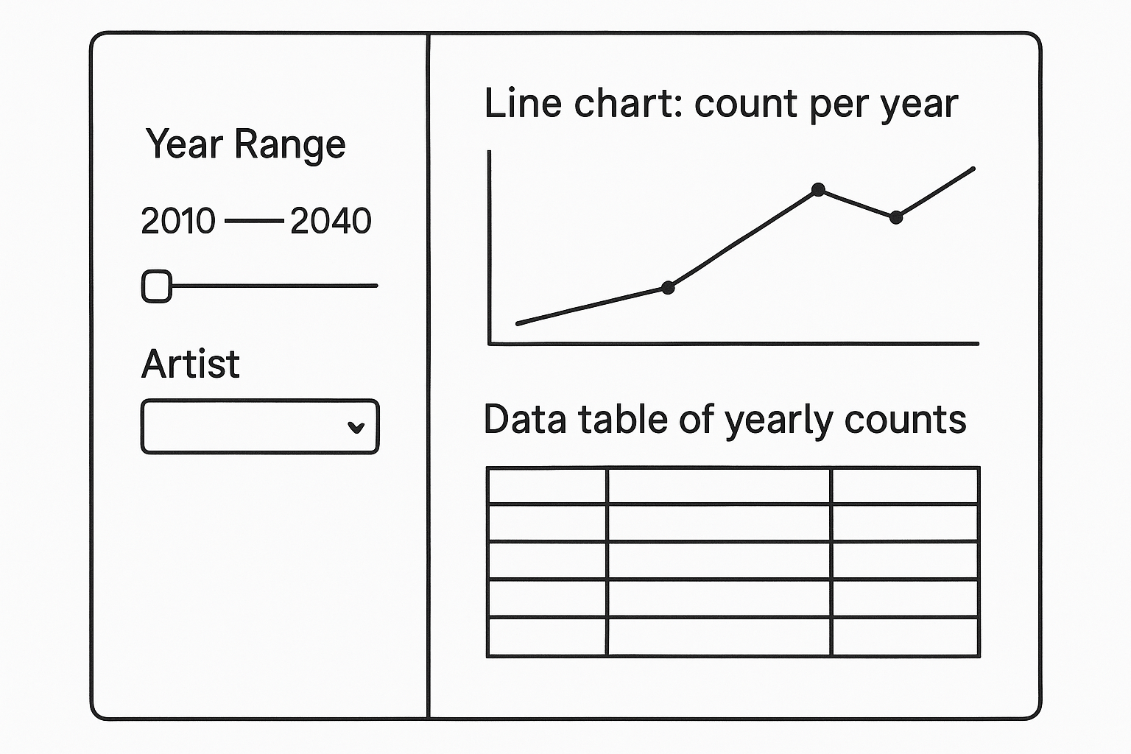
 Note
User flow:
- Pick a subset of years via the slider.
- Select an artist to focus on.
- Instantly see how many influence-edges point to them each year, both in chart and table form.
- Explore whether influence arrives in bursts (intermittent) or builds gradually over time.

Code for UI Dashboard
library(shiny)
library(plotly)
library(DT)
library(dplyr)
library(lubridate)
# Assume these are already in your global environment:
# • nodes – your g_nodes_df or similar with Person nodes
# • edges_labeled – your preprocessed edge table with to_written_date
# • get_influence_over_time() – the helper that returns a tibble (year, num_influences)
ui <- fluidPage(
titlePanel("Influence Over Time"),
sidebarLayout(
sidebarPanel(
sliderInput(
inputId = "yearRange",
label = "Year range:",
min = 2010,
max = 2040,
value = c(2010, 2040),
sep = "",
step = 1
),
selectizeInput(
inputId = "artist1",
label = "Choose artist:",
choices = NULL, # will be populated server-side
options = list(
placeholder = 'Type to search…',
maxOptions = 5000
)
)
),
mainPanel(
plotlyOutput("tsPlot"),
br(),
DTOutput("tsTable")
)
)
)
server <- function(input, output, session) {
# Prepare the list of artists once
artist_choices <- sort(
unique(
nodes %>%
filter(`Node Type` == "Person") %>%
pull(name)
)
)
# Populate the selectize input server-side
updateSelectizeInput(
session,
"artist1",
choices = artist_choices,
server = TRUE
)
# Reactive data frame of influence counts
influence_df <- reactive({
req(input$artist1, input$yearRange)
get_influence_over_time(
artist = input$artist1,
yearRange = input$yearRange
)
})
# Render the time‐series plot
output$tsPlot <- renderPlotly({
df <- influence_df()
plot_ly(
df,
x = ~year,
y = ~num_influences,
type = "scatter",
mode = "lines+markers",
hovertemplate = "%{x}: %{y} influences<extra></extra>"
) %>%
layout(
title = paste("Influence over time for", input$artist1),
xaxis = list(title = "Year"),
yaxis = list(title = "Number of influences")
)
})
# Render the data table
output$tsTable <- renderDT({
df <- influence_df()
datatable(
df,
rownames = FALSE,
options = list(
pageLength = 10,
lengthChange = FALSE,
autoWidth = TRUE
)
)
})
}
shinyApp(ui, server)
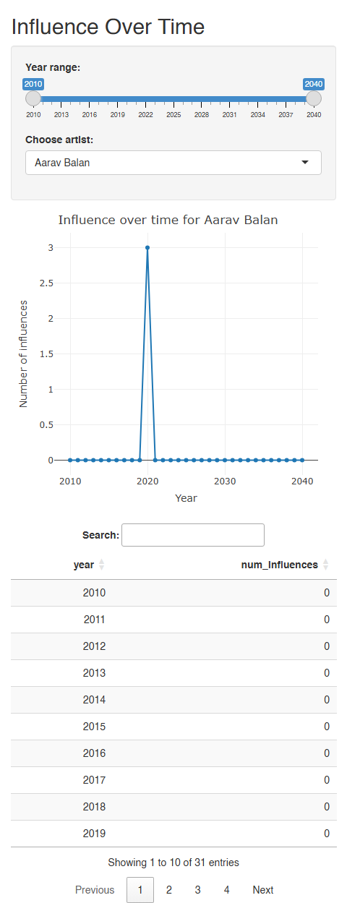

3 Module 2: Collaboration Network & Propagation
Tasks & Questions:
- Who has Sailor collaborated with, and whom has she influenced (directly/indirectly)?
- How has influence propagate through her songs and collaborators?

3.1 Input & Output Definitions
Input ID | Widget | Choices / Default | Purpose
artist2 | selectInput | nodes_df$label; default “Sailor Shift” | Choose the focal artist for the network
relationTypes | checkboxGroupInput | c(“CollaboratorOf”, “InfluencedBy”) | Select which edge types to include (collaborations vs. influences)
networkDepth | sliderInput | 1–3; default 1 | How many hops (degrees of separation) to traverse from the focal artist

Output ID | Render | Description
networkPlot | renderPlotly() | Interactive network graph showing nodes and edges for the selected artist
propTable | renderDT() | Data table listing each connected node, relation type, and shortest path

3.2 Code Preparation & Testing
This section defines how the filtered ego-network is built from the full graph g_all, and how the propagation paths are traced through shortest path calculations:
library(igraph)
# — 1. Build a filtered ego‐network around the chosen artist —————————————
get_collab_influence_graph <- function(artist = "Sailor Shift",
rel_types = NULL,
depth = 3) {
# If no rel_types given, include every edge relation in the graph
if (is.null(rel_types)) {
rel_types <- E(g_all)$relation %>% unique()
}
# 1a) Keep only edges of the selected types
g_filt <- subgraph.edges(
g_all,
E(g_all)[ E(g_all)$relation %in% rel_types ],
delete.vertices = FALSE
)
# 1b) Find the vertex index of the focal artist
vid <- which(V(g_filt)$label == artist)
if (length(vid) == 0) {
stop(sprintf("Artist '%s' not found in the graph.", artist))
}
# 1c) Gather all vertices within `depth` hops
vs <- ego(
graph = g_filt,
order = depth,
nodes = vid,
mode = "all"
)[[1]]
# 1d) Return the induced subgraph
induced_subgraph(g_filt, vids = vs)
}
# — 2. Build propagation paths table ———————————————————————————————
get_propagation_table <- function(sub_g, artist = "Sailor Shift") {
# Locate the starting vertex
vid <- which(V(sub_g)$label == artist)
if (length(vid) == 0) {
stop(sprintf("Artist '%s' not in the subgraph.", artist))
}
# Compute shortest paths from the artist to every node
paths <- shortest_paths(
graph = sub_g,
from = vid,
to = V(sub_g),
mode = "all"
)$vpath
# Build a tibble: target, path length, and the full path string
tibble::tibble(
target = sapply(paths, function(p) V(sub_g)$label[tail(p,1)]),
path_length = sapply(paths, length) - 1,
path = sapply(paths, function(p)
paste(V(sub_g)$label[p], collapse = " → "))
)
}
Let’s test the function:
# 1. Extract the full ego‐network for Sailor Shift using every relation
full_graph_ss <- get_collab_influence_graph(
artist = "Sailor Shift",
rel_types = NULL,
depth = 3
)
print(full_graph_ss)
IGRAPH 7385962 DN-- 730 1388 --
+ attr: name (v/c), label (v/c), node_type (v/c), relation (e/c)
+ edges from 7385962 (vertex names):
[1] 76 ->12237 128 ->12237 304 ->3323 304 ->16312 455 ->15855 455 ->15855
[7] 457 ->15855 550 ->342 550 ->552 876 ->879 876 ->1857 876 ->13484
[13] 877 ->876 877 ->15771 877 ->15771 878 ->876 878 ->876 878 ->1857
[19] 878 ->6337 878 ->6337 878 ->6616 878 ->13484 878 ->15771 901 ->10016
[25] 922 ->14893 934 ->3881 1113->1116 1113->1116 1113->7026 1276->3986
[31] 1276->6177 1294->2333 1294->2333 1294->2493 1294->2927 1294->3349
[37] 1294->3349 1294->4167 1294->4167 1294->7662 1294->7662 1294->9772
[43] 1294->9772 1294->10759 1294->11368 1294->12475 1294->13654 1294->13654
+ ... omitted several edges
# 2. Propagation table for Sailor Shift
prop_table_ss <- get_propagation_table(full_graph_ss, artist = "Sailor Shift")
print(prop_table_ss)
# A tibble: 730 × 3
target path_length path
<chr> <dbl> <chr>
1 Ming Ren 3 Sailor Shift → Fog & Fiddle → Provenc…
2 Sovereign Echoes 3 Sailor Shift → Fog & Fiddle → Provenc…
3 Echo Chamber Records 3 Sailor Shift → Salty Dreams → Susurro…
4 Twilight Passage 3 Sailor Shift → Oceanbound → Altitude …
5 Eastern Flight Records 3 Sailor Shift → Saltwater Hymn → Paral…
6 Belinda Knappe 3 Sailor Shift → Coral Beats → Harvest …
7 Riverflow Records 3 Sailor Shift → Coral Beats → Harvest …
8 Archival Resonance Records 3 Sailor Shift → High Tide Heartbeat → …
9 Yang Peng 3 Sailor Shift → Coral Beats → Sacred F…
10 Min Cao 3 Sailor Shift → Coral Beats → Sacred F…
# ℹ 720 more rows
# 3. And for another artist, say “Maya Jensen”
full_graph_mj <- get_collab_influence_graph(
artist = "Maya Jensen",
rel_types = NULL,
depth = 2
)
prop_table_mj <- get_propagation_table(full_graph_mj, artist = "Maya Jensen")
print(full_graph_mj)
IGRAPH 73f98a9 DN-- 46 92 --
+ attr: name (v/c), label (v/c), node_type (v/c), relation (e/c)
+ edges from 73f98a9 (vertex names):
[1] 16960->17260 16960->17314 16971->17260 16971->17314 16996->17260
[6] 16996->17299 17022->17255 17022->17260 17100->17260 17110->17255
[11] 17110->17260 17118->17120 17118->17121 17119->17120 17119->17121
[16] 17120->17121 17120->17260 17120->17314 17146->17260 17164->17167
[21] 17164->17261 17164->17263 17165->17167 17165->17261 17166->17167
[26] 17166->17261 17235->17260 17235->17314 17243->17260 17243->17299
[31] 17255->17121 17255->17192 17255->17260 17255->17260 17255->17261
[36] 17255->17262 17255->17263 17255->17299 17256->17121 17256->17260
+ ... omitted several edges
print(prop_table_mj)
# A tibble: 46 × 3
target path_length path
<chr> <dbl> <chr>
1 Hallowed Transaction 2 Maya Jensen → The Kelp Forest Canticles → …
2 Sawtooth Serenade 2 Maya Jensen → Tidal Whisper → Sawtooth Ser…
3 Für uns alle zusammen 2 Maya Jensen → The Kelp Forest Canticles → …
4 Violet Engines 2 Maya Jensen → Ivy Echos → Violet Engines
5 Jasper Quinn 2 Maya Jensen → Ivy Echos → Jasper Quinn
6 Crimson Carriage 2 Maya Jensen → Ivy Echos → Crimson Carriage
7 Cassette Future 2 Maya Jensen → Ivy Echos → Cassette Future
8 Rainfall Fiction 2 Maya Jensen → Ivy Echos → Rainfall Fiction
9 The Hollow Monarchs 2 Maya Jensen → Ivy Echos → The Hollow Monar…
10 Zachary Cole 2 Maya Jensen → Ballads for the Low Tide → Z…
# ℹ 36 more rows

3.3 UI Storyboard

Left Sidebar – User Controls
Input ID | Widget | Choices / Default | Description
artist_focus | selectInput | Artist list; default = Sailor Shift | Dropdown to select the focal artist for network exploration (nodes_df$label).
edge_types | checkboxGroupInput | CollaboratorOf, InfluencedBy; default = both checked | Checkboxes to include/exclude collaboration and/or influence edges in the network display.
max_depth | sliderInput | 1–3; default = 1 | Slider to control the maximum degrees (“hops”) from the focal artist to traverse in the network.

Main Panel – Outputs
Output ID | Render | Description
artistGraph | renderPlotly() or visNetworkOutput() | Interactive network graph: nodes represent artists or songs; edges styled by type (dotted = influence, solid = collaboration). Tooltips show name/type.
pathTable | renderDT() | Data table listing each reachable node (Target), the path length from the focal artist, and the full propagation path.
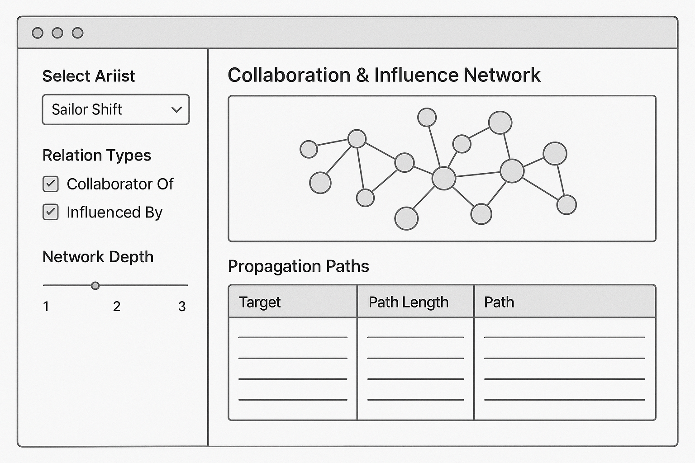
 Note
User flow:
- Select a focal artist from the dropdown list.
- Choose the type(s) of relationships to explore: collaboration, influence, or both.
- Adjust the network depth slider to reveal 1–3 degrees of connections.
- Instantly view an interactive graph of connected artists and songs.
- Examine the data table to trace influence and collaboration paths, including how far and through whom influence propagates.
- Use this information to uncover direct vs. indirect influence patterns and how Sailor Shift’s reach spreads across the network.

Code for UI Dashboard
library(shiny)
library(visNetwork)
library(igraph) # ← make sure this is loaded
library(DT)
library(dplyr)
server <- function(input, output, session) {
# 1) populate artist list
updateSelectizeInput(
session, "artist",
choices = sort(V(g_all)$label),
server = TRUE
)
# 2) filtered ego‐network
subgraph <- reactive({
req(input$artist)
get_collab_influence_graph(
artist = input$artist,
rel_types = input$rel_types,
depth = input$depth
)
})
# 3) *** FIXED *** visNetwork data
vis_data <- reactive({
sg <- subgraph()
# 3a) vertices → data.frame
verts <- igraph::as_data_frame(sg, what = "vertices")
nodes_df <- verts %>%
rename(
id = name, # igraph stores node IDs in ‘name’
title = label # human‐readable label
) %>%
mutate(
group = node_type # use your node_type attr for coloring
)
# 3b) edges → data.frame
eds <- igraph::as_data_frame(sg, what = "edges")
edges_df <- eds %>%
rename(
from = from, # source vertex id
to = to, # target vertex id
title = relation # use the relation as the hover text
)
list(nodes = nodes_df, edges = edges_df)
})
# 4) render the network
output$networkGraph <- renderVisNetwork({
d <- vis_data()
visNetwork(d$nodes, d$edges) %>%
visOptions(
highlightNearest = list(enabled = TRUE, degree = 1),
nodesIdSelection = TRUE
) %>%
visLegend() %>%
visLayout(randomSeed = 42)
})
# 5) propagation table
output$propagationTable <- renderDT({
sg <- subgraph()
df <- get_propagation_table(sg, input$artist)
datatable(
df,
rownames = FALSE,
options = list(pageLength = 10, lengthChange = FALSE, autoWidth = TRUE)
)
})
}
shinyApp(ui, server)
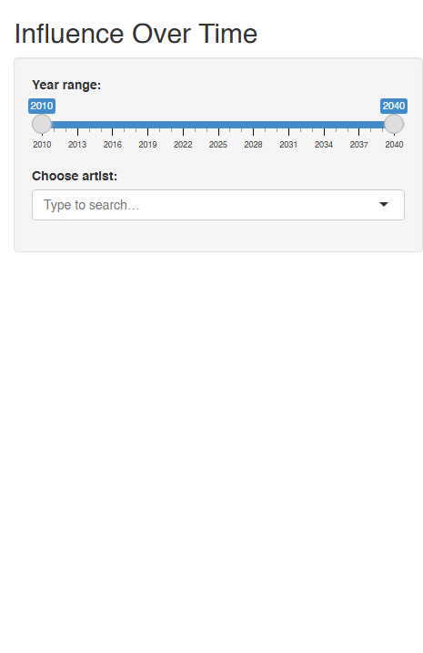

4 Module 3: Genre-Level Influence Patterns
Tasks & Questions:
- Which genres and top artists have been most influenced by Oceanus Folk?
- Which genres or artists has Oceanus Folk drawn inspiration from?

4.1 Input & Output Definitions
Input ID | Widget | Choices / Default | Purpose
genre_focus | selectInput | Genre list; default = Oceanus Folk | Choose the genre to analyze (starting with Oceanus Folk)
influenceDir | radioButtons | c("From", "To") | Direction of influence: from genre to others, or others to this genre
topN | numericInput | default = 10 | Limit number of top genres/artists shown in bar chart & table

Output ID | Render | Description
genreBarPlot | renderPlotly() | Horizontal bar plot of top genres/artists influenced or influencing
genreTable | renderDT() | Data table showing genre interactions: target, count, and example artists

4.2 Code Preparation & Testing
We’ll use edge metadata (like Edge Type = InfluencedBy) and node genres to build an influence matrix between genres. Here’s a proposed structure for this:
library(dplyr)
library(tibble)
edges_labeled <- g_edges_df %>%
# join the song info on to_id → id
left_join(
g_nodes_df %>%
select(id, label, release_date) %>%
rename(
to_label = label,
to_release_date = release_date
) %>%
mutate(
to_release_date = ymd(to_release_date)
),
by = c("to_id" = "id")
)
# 1) Filter only influence‐type edges
influence_edges <- edges_labeled %>%
filter(relation %in% c(
"InStyleOf", "LyricalReferenceTo",
"InterpolatesFrom", "DirectlySamples", "CoverOf"
))
# 2) Attach genres for source and target nodes
infl_ext <- influence_edges %>%
left_join(
g_nodes_df %>% select(id, genre) %>% rename(source_genre = genre),
by = c("from_id" = "id")
) %>%
left_join(
g_nodes_df %>% select(id, genre) %>% rename(target_genre = genre),
by = c("to_id" = "id")
)
# 3) Compute summary by focus_genre and direction
get_genre_influence_data <- function(
focus_genre = "Oceanus Folk",
direction = "From",
topN = 10
) {
# Choose source vs. target based on direction
if (direction == "From") {
df <- infl_ext %>% filter(source_genre == focus_genre)
group_col <- sym("target_genre")
artist_col <- sym("to_id")
} else {
df <- infl_ext %>% filter(target_genre == focus_genre)
group_col <- sym("source_genre")
artist_col <- sym("from_id")
}
df %>%
filter(!is.na(!!group_col)) %>%
group_by(genre = !!group_col) %>%
summarise(
influence_count = n(),
example_artists = paste(
unique(g_nodes_df$label[match(!!artist_col, g_nodes_df$id)])[1:5],
collapse = "; "
),
.groups = "drop"
) %>%
arrange(desc(influence_count)) %>%
slice_head(n = topN)
}
# 4) Sanity check
test_from <- get_genre_influence_data("Oceanus Folk", "From", 5)
stopifnot(
nrow(test_from) <= 5,
all(c("genre", "influence_count", "example_artists") %in% names(test_from))
)
print(test_from)
# A tibble: 5 × 3
genre influence_count example_artists
<chr> <int> <chr>
1 Oceanus Folk 147 Fragments of Consciousness; Clocktower Cadence; …
2 Indie Folk 100 Ripples and Whispers; Sing Song Swing; Sunlight …
3 Synthwave 19 Voices of the Frontier; The Last Horizon; Echoes…
4 Dream Pop 15 The Last Sweet Moment; Harmonious Compromise; Tr…
5 Doom Metal 14 Mercy's Endless Tide; Whispers of Finality; Sunb…

4.3 UI Storyboard

Sidebar – User Controls (Inputs)
UI Element | Type | Description
Genre Selector | selectInput | Dropdown list of all genres (default: Oceanus Folk). Allows the user to pick a genre as the focal point for analysis.
Direction Radio | radioButtons | Two choices: “From” (genres/artists influenced by selected genre), “To” (genres/artists that influence selected genre).
Top N Numeric | numericInput | User sets the number (N) of top genres/artists to show in the outputs (default 10, min 1, max 30).

Main Panel – Outputs
UI Element | Type | Description
Genre Bar Plot | renderPlotly() | Interactive horizontal bar chart: shows the top N genres (and, optionally, key artists) most influenced by or influencing the focal genre.
Genre Table | renderDT() | Data table: shows detailed genre-genre links (genre name, influence count, and example artists), sortable and searchable.
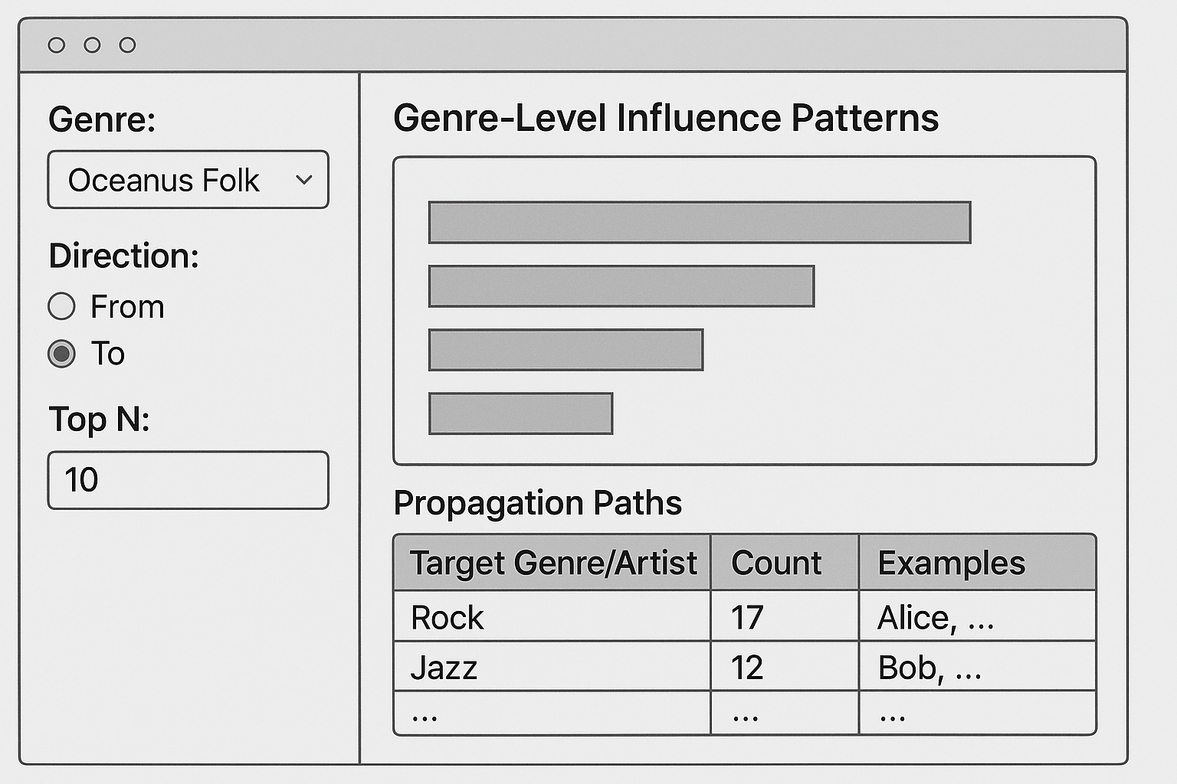
 Note
User flow:
- User opens the module. By default, Oceanus Folk is selected as the focal genre, “From” direction is chosen, and the top 10 results are displayed.
- User changes the genre to “Electro Pop.” The bar plot and table instantly update to show genres influenced by Electro Pop (or that influence Electro Pop, depending on direction).
- User toggles direction from “From” to “To,” revealing genres that have influenced the currently selected genre.
- User adjusts the Top N to 20, revealing more connections in both the bar plot and the data table.
- User explores the bar plot, hovering over bars to view example artists.
- User scans/sorts the table, quickly identifying which genres and artists are most involved in cross-genre influence with the selected focal genre.

Code for UI Dashboard
library(shiny)
library(dplyr)
library(plotly)
library(DT)
# Assumes you have in your global environment:
# • g_nodes_df: a data frame with columns `id`, `genre`, `label`, etc.
# • get_genre_influence_data(): the function you defined above
ui <- fluidPage(
titlePanel("Genre-Level Influence Patterns"),
sidebarLayout(
sidebarPanel(
# 1. Genre selector (server‐side selectize for performance)
selectizeInput(
inputId = "genre_focus",
label = "Focal genre:",
choices = NULL, # populated in server
options = list(
placeholder = "Type to search…",
maxOptions = 5000
)
),
# 2. Direction toggle
radioButtons(
inputId = "influenceDir",
label = "Direction of influence:",
choices = c("From selected genre" = "From",
"To selected genre" = "To"),
selected = "From"
),
# 3. Top N control
numericInput(
inputId = "topN",
label = "Top N genres/artists:",
value = 10,
min = 1,
max = 50,
step = 1
)
),
mainPanel(
# 4. Bar chart output
plotlyOutput("genreBarPlot", height = "400px"),
br(),
# 5. Data table output
DTOutput("genreTable")
)
)
)
server <- function(input, output, session) {
# Populate the genre list server-side
updateSelectizeInput(
session, "genre_focus",
choices = sort(unique(g_nodes_df$genre)),
server = TRUE
)
# Reactive summary table based on inputs
summary_tbl <- reactive({
req(input$genre_focus, input$influenceDir, input$topN)
get_genre_influence_data(
focus_genre = input$genre_focus,
direction = input$influenceDir,
topN = input$topN
)
})
# Render the horizontal bar chart
output$genreBarPlot <- renderPlotly({
df <- summary_tbl()
plot_ly(
df,
x = ~influence_count,
y = ~reorder(genre, influence_count),
type = "bar",
orientation = "h",
hovertemplate = paste(
"<b>%{y}</b><br>",
"Count: %{x}<br>",
"Examples: %{customdata}",
"<extra></extra>"
),
customdata = ~example_artists
) %>%
layout(
title = if (input$influenceDir == "From") {
paste("Top", input$topN, "genres influenced by", input$genre_focus)
} else {
paste("Top", input$topN, "genres influencing", input$genre_focus)
},
xaxis = list(title = "Influence edges"),
yaxis = list(title = "")
)
})
# Render the data table
output$genreTable <- renderDT({
df <- summary_tbl() %>%
rename(
Genre = genre,
`Influence Count`= influence_count,
`Example Artists`= example_artists
)
datatable(
df,
rownames = FALSE,
options = list(
pageLength = input$topN,
lengthChange = FALSE,
autoWidth = TRUE
)
)
})
}
shinyApp(ui, server)
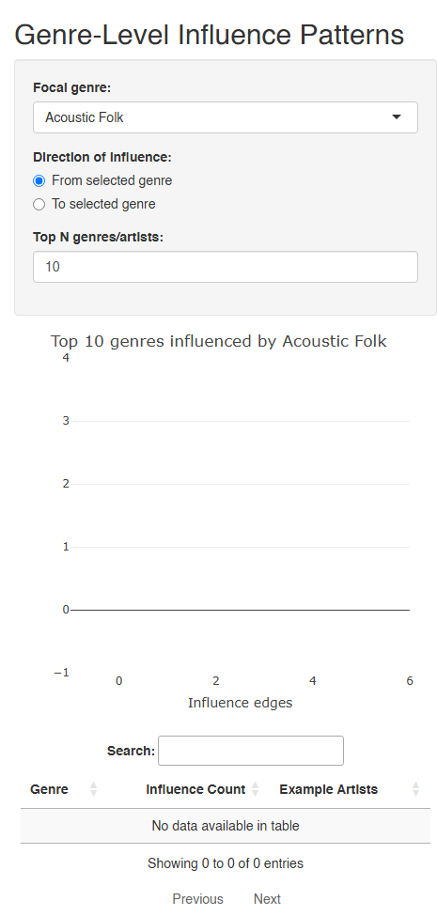

5 References

References
- Chang, W., Cheng, J., Allaire, J., Xie, Y., & McPherson, J. (2023). shiny: Web Application Framework for R. R package version 1.8.0. https://CRAN.R-project.org/package=shiny
- Wickham, H., François, R., Henry, L., & Müller, K. (2023). dplyr: A Grammar of Data Manipulation. R package version 1.1.4. https://CRAN.R-project.org/package=dplyr
- Sievert, C. (2020). plotly: Create Interactive Web Graphics via ‘plotly.js’. R package version 4.10.3. https://CRAN.R-project.org/package=plotly
- Xie, Y., Cheng, J., & Tan, X. (2023). DT: A Wrapper of the JavaScript Library ‘DataTables’. R package version 0.31. https://CRAN.R-project.org/package=DT

Data Source
- Project dataset: MC1_graph.json (provided as part of ISSS608 course materials, 2025).

AI Tools
- OpenAI. (2024–2025). ChatGPT (GPT-4o model) for code explanation, report drafting, and technical writing assistance.

