**Experimental procedures**

**Themis have provided a link for storing our platform's test data in the GitHub official website R package Themis, which includes 30 types of tumors and the published literatures. You can employ your subtyping methods for subtyping analysis of these test datasets.**

**Themis_custom_method(directory, path)**

**Themis_process1(directory)**

**Themis_output(directory)**

***directory*** is the working directory where the above files (“cliFile”, “clusterFile”, “CaculateScore.R”, “Compare_Method.R”, etc.) are stored.

cliFile: Clinical files’ path. The merge results of various analyses (Compare_Method.R) on the sample data, including Stemness Score Caculation (mRNAsi), immune infiltration scores (ESTIMATEScore, ImmuneScore, and StromalScore), immune therapy response prediction (TIDE), as well as clinical information (OS/PFS) and merged clinical risk factors.

clusterFile: When the user has a custom method, apply it to the directory where the resulting subtyping result file is stored after the platform has existing data.

***path*** is the path to the “sum data” folder. The sum data folder stores three files: data_meta_sum.RData, tcga_meta_sum.RData, all_pvalue_sum.RData. data_meta_sum.RData: Summarized the relevant clinical information of the eight literature data mentioned in the article. tcga_meta_sum.RData: Summarized clinical information on 30 different tumor types in TCGA. all_pvalue_sum.RData: The statistical results of the correlation between the subtyping analysis of 38 test data and clinical phenotype using these 8 typing methods. ***These three files can be obtained from the data folder of the downloaded Themis package***.

Example:

1. Set the working directory and create a "**sum data**" folder under it. The sum data folder stores three files: **data_meta_sum.RData, tcga_meta_sum.RData, all_pvalue_sum.RData**. As shown in the following figure:

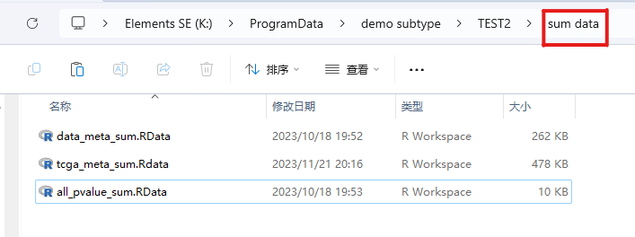

1. clusterFile: When the user has a custom method, apply it to the directory where the resulting subtyping result file is stored after the platform has existing data. The file naming format is **“your method’s name_test data’s name_ cluster.txt”**. As shown in the following figure:

