DS 613 Homework 5

Xuehao Wang

02/26/2021

An investor sued his broker for lack of diversification. Below are the rates of return (in percent) for the investor’s portfolio over 39 months (data from Moore, McCabe, and Craig (2017)). The average of the S&P 500 stock index for the same period was 0.95%. Does the broker perform worse than average? Copy and paste the data below into R

Stockreturns <- c(-8.36, 1.63, -2.27, -2.93, -2.70,   
 -2.93, -9.14, -2.64, 6.82, -2.35,   
 -3.58, 6.13, 7.00, -15.25, -8.66,  
 -1.03, -9.16, -1.25, -1.22, -10.27,  
 -5.11, -0.80, -1.44, 1.28, -0.65,  
 4.34, 12.22, -7.21, -0.09, 7.34,   
 5.04, -7.24, -2.14, -1.01, -1.41,   
 12.03, -2.53, 4.33, 1.35)  
 Stockreturns

## [1] -8.36 1.63 -2.27 -2.93 -2.70 -2.93 -9.14 -2.64 6.82 -2.35  
## [11] -3.58 6.13 7.00 -15.25 -8.66 -1.03 -9.16 -1.25 -1.22 -10.27  
## [21] -5.11 -0.80 -1.44 1.28 -0.65 4.34 12.22 -7.21 -0.09 7.34  
## [31] 5.04 -7.24 -2.14 -1.01 -1.41 12.03 -2.53 4.33 1.35

1. Use and show R code to find the mean of the sample data.

sample_mean <- mean(Stockreturns)  
sample_mean

## [1] -1.124615

1. Use and show R code to find the standard deviation of the sample data

sd(Stockreturns) -> sample_sd  
sample_sd

## [1] 5.977673

1. Assuming a normal distribution, use and show R code to find the proportion of returns that are less than -1.5.

pnorm(q = -1.5, mean = sample_mean, sd = sample_sd)

## [1] 0.4749638

1. Assuming a normal distribution, use and show R code to find return value that is above 70% of the returns

qnorm(p = 0.3, mean = sample_mean, sd = sample_sd)

## [1] -4.25931

1. Use and show R code to find Q1 for the data.

quantile(Stockreturns) #Q1 is -3.255

## 0% 25% 50% 75% 100%   
## -15.250 -3.255 -1.410 1.490 12.220

1. Explore the data by producing and examining a boxplot and checking for normality.

boxplot(Stockreturns) #boxplot

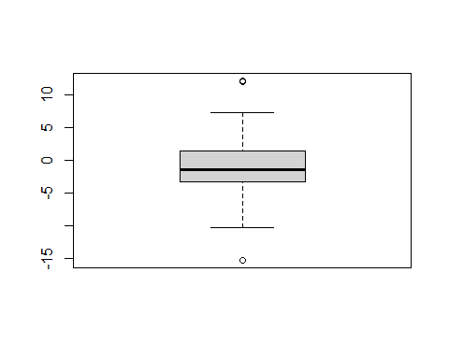

qqnorm(Stockreturns)  
qqline(Stockreturns) #check for normality

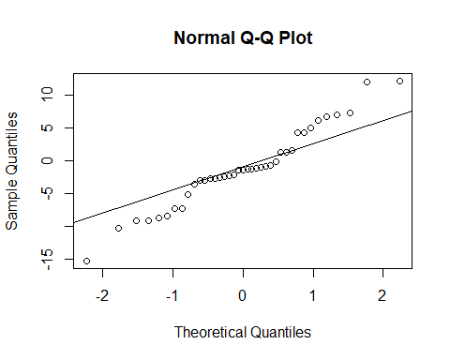

1. State the appropriate null and alternative hypothesis required for the appropriate t test. H(0): the broker perform worse than average H(a): the broker perform better than average
2. Use and show R code that will output the needed p value and confidence interval to determine if the null hypothesis should be rejected.

t.test(Stockreturns, mu = sample_mean, alternative = "greater", conf.level = .95)

##   
## One Sample t-test  
##   
## data: Stockreturns  
## t = 0, df = 38, p-value = 0.5  
## alternative hypothesis: true mean is greater than -1.124615  
## 95 percent confidence interval:  
## -2.738401 Inf  
## sample estimates:  
## mean of x   
## -1.124615

P value is 0.5 which is large than 0.05, it can not reject the Null hypothesis, and also mean of x -1.12 is not in 95% interval, also supports that can not reject the null hypothesis.

1. Now answer the question originally stated. Does the broker perform worse than average? (Explain or justify in two or three sentences)

Since we can not reject the Null hypothesis and the reason show above, so the broker does profrem worse than the average.