REL301m |  | Final Assignment

TetrisRL: An Evolution Strategy Approach to AI Game Agents
by
Nguyen Anh Hao
SE171792

Introduction

Objective
The main objective of this project is to develop and evaluate an AI Agent for playing Tetris using an evolution strategies (ES).

Motivation
First release since 1984, Tetris remains one of the most popular and enduring games in history, celebrated for its simple yet addictive gameplay that has captivated millions around the world. Despite its straightforward mechanics, the game challenges the limits of human reaction time and decision-making, especially as the pace accelerates.
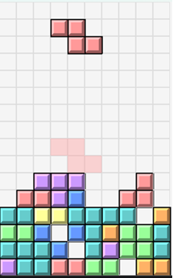
Figure: Tetris gameplay

Literature Review

Tetris AI – The (Near) Perfect Bot – YiYuan Lee (2013)
The blog post introduced a fairly efficient approach to training a tetris AI model: using a heuristic function and genetic algorithms (GA) appoarch. The results published by the author seem very promising: the model has played continuously for 2 weeks without losing. Unfortunately, the source code has been hidden by the author and only the source code of the Java webapp with a fixed set of weights is left. Source: https://codemyroad.wordpress.com/2013/04/14/tetris-ai-the-near-perfect-player/

TetrisRL
Based on the idea presented in the blog, I started the journey of rebuilding the entire environment, agent, algorithm from scratch.

Environment
The Tetris game environment was built in 4 parts:
- Piece:
- The available Tetris shapes (I, O, T, S, Z, J, L) are defined in a dictionary with their rotation matrices. Each shape has one or more rotations.
- Methods rotate() and rotate_counterclockwise() allow the piece to change its orientation, move(dx, dy) method updates the piece’s position on the grid.
- get_cells() computes the absolute positions on the grid occupied by the piece.
- clone() method provides a way to create a duplicate of the piece, which is particularly useful when simulating moves or cloning the environment state.
- Grid:
- A 2D grid with specified dimensions, each cell is assigned to 0 (empty cell) or 1 (has block).
- is_valid_position(piece) checks whether the cells are ready to place a piece in, place_piece(piece) marks the grid cells based on the piece’s position.
- clear_lines() identifies, counts and removes fully occupied rows (no empty cell), then shifts the remaining rows down.

- Random Piece Generator:
- mode= ‘classic’: a generator that uses the Tetris random algorithm called “7-bag generator”. 7 piece shapes are shuffled and put into a bag, whenever the environment calls for a new piece, the generator will pop out a piece shape. Until there are no more pieces to pop out, the generator will fill the bag. This mode will ensure that within 14 moves there will be exactly 2 duplicates of each piece shape.
- Mode= ‘random’: a completely random generator that chooses piece shape using random.choice(). This mode increases the difficulty of the game as it is possible to encounter difficult piece shapes (like ‘S’ or ‘Z’) multiple times in a row.
- A random seed is set to ensure that the evaluation of the performance of different agents is objective.
- Game mechanism:
- reset() and clone() allow reinitializing the game or duplicating the current state. The cloning functionality ensures that both the grid and the pieces are duplicated, which is useful for simulations or move evaluations.
- move_piece(), rotate_piece(), drop_piece(), and hard_drop() handle the piece movement and rotation logic, including collision detection and reverting invalid moves.
- new_piece() and update() are used to continuously update the game state.
- get_possible_moves() and simulate_moves() are created to support AI decision- making.

Agent
- The heuristic function (reward function):
According to Yiyuan Lee, this Tetris game as 4 important characteristics: aggrerate heights, cleared lines, holes and bumpiness.
- Aggrerate heights: define by the sum of the height of each columns.
- Cleared lines: define by the number of completed lines in the grid.
- Holes: define as an empty space such that there is at least one tile in the same column above it.
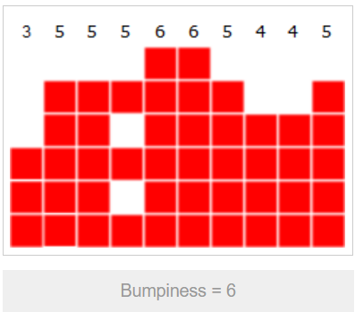
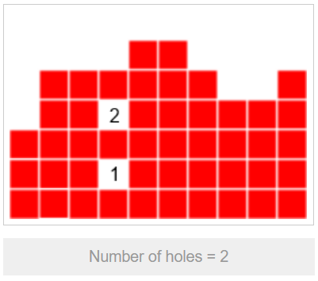
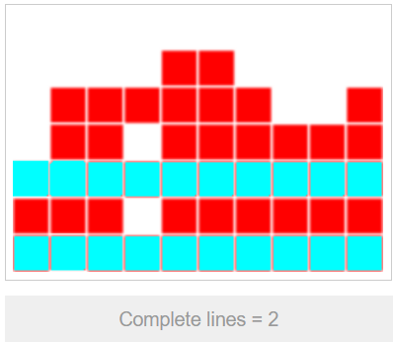
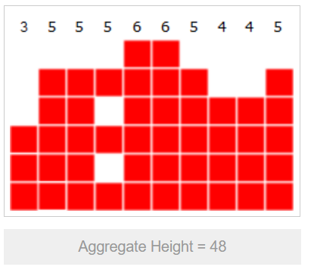
- Bumpiness: define by computing the sum of the absolute differences between all two adjacent columns.

The reward of a state will be calculated by taking a linear combination of four heuristics above:
$$reward=ω_{1}×(aggrerate_heights)+ω_{2}×(cleared_lines)+ω_{3}×(holes)+ω_{4}×(bumpiness)$$
with $ω_{1},ω_{2},ω_{3},ω_{4}$ are constant parameters
- Choose action strategies
There are 2 mode ‘normal’ and ‘promax’ represent 2 strategies for agent when chosing action:
- ‘normal’: agent will get all possible moves from a state, calculate the reward for each possible move and choose the move that gain max reward.
- ‘promax’: this mode allow agent to find the best move by considering both the current piece and the next piece. For each moves in the current piece, simulate all possible moves of the next piece and choose the action that maximize the total reward (current + next piece).
- For the ‘normal’ mode, the computational complexity is $O(n)$,compare to $O(n^{2})$ of the ‘promax’ mode.

Evolution Strategies
I have updated the Genetic Algorithm from the refence to the newer method, the Evolution Strategies, which have quite similar ideas but different implementations.
Evolution Strategies (ES) summary:
- Create a 4D vector $[ω_{1},ω_{2},ω_{3},ω_{4}]$ as baseline.
- Apply Gaussian noises to the baseline to create a population.
- Each candidate in population plays simulate games .
- Evaluate candidates rewards and update the baseline.
- Loop the operation 2,3,4 until n-generations.
- Evaluate training results, hyperparameter fine-tuning.
The training process was seperated into 2 phases: exploration and exploitation
- Exploration: high sigma and learning rate to encourage exploration. The baseline is updated by:
$$ω= ω + (\frac{α}{σ.n})×[ℵ(0,1)⋅Ζ_{reward}]$$

$$ω:weights\left(baseline\right),$$
$$α: learning rate,$$
$$σ:noise rate,$$
$$n: population,$$
$$ℵ\left(0,1\right):Gaussian noises,$$
$$Ζ_{reward}: standardized rewards$$
- Exploitation: very small sigma and learning rate for better exploitation. The baseline now is updated by ‘elite candidate strategy’ – choose the candidate that has best performance to the the new baseline.

Agent Performance

