1-1 One-Variable Optimization

01/10/2019

#1-1-1  
#1 var optimization Symbolic&Numeric calculations and visualization with R  
  
#  
#1 Variable Optimization sample question  
#-------------------------------------------------------------------------  
#AIM: FIND P MAX  
#ASSUMPTIONS  
w<-expression(200+5*t)  
p<-expression(0.65-0.01*t)  
C<-expression(0.45*t)  
R<-expression(p*w)  
P<-expression(R-C)  
#t<-expression(t>0)  
#load symbolic calculation package  
library(Ryacas)  
#library(Deriv)  
#Subtitute and expand P(R,c) and get P(t)  
yacas(P)##DO NOT RUN expression((0.65 - 0.01 * t) * (5 * t + 200) - 0.45 * t)

## expression((0.65 - 0.01 * t) * (5 * t + 200) - 0.45 * t)

y<-yacas(P)  
y<-y[["text"]]  
y<-parse(text=y)  
dydt=D(y,"t")#Find the 1st Derivative  
 #dydt<-parse(text=dydt)  
 #<-parse(text=paste(as.character(dydt)[2],as.character(dydt)[3]))  
d2ydt2<-D(dydt,"t")#2nd deriv  
#-------------------------------------------------------------------------  
#Display Results  
y

## expression((0.65 - 0.01 * t) * (5 * t + 200) - 0.45 * t)

dydt

## (0.65 - 0.01 * t) * 5 - 0.01 * (5 * t + 200) - 0.45

d2ydt2

## -(0.01 * 5 + 0.01 * 5)

#> dydt  
#(0.65 - 0.01 * t) * 5 - 0.01 * (5 * t + 200) - 0.45  
#Copy the result of dydt and y  
yacas("(0.65 - 0.01 * t) * 5 - 0.01 * (5 * t + 200) - 0.45")#dydt==0

## expression(5 * (0.65 - 0.01 * t) - 0.01 * (5 * t + 200) - 0.45)

#yacas("Simplify(%)")  
yacas("Solve((%)==0,t)")

## expression(list(t == 0.8/0.1))

yacas("Solve((0.65 - 0.01 * t) * (5 * t + 200) - 0.45 * t==0,t)")#y==0

## expression(list(t == -((root(26.64, 2) - 0.8)/0.1), t == (root(26.64,   
## 2) + 0.8)/0.1))

##t.opti=0.8/0.1=8  
#-------------------------------------------------------------------------  
plot(0:20,eval({t=0:20;y}),type="l",xlab="Time(D)",ylab="Profit($)")  
title("Profit~Time")  
abline(v=8,untf=FALSE)

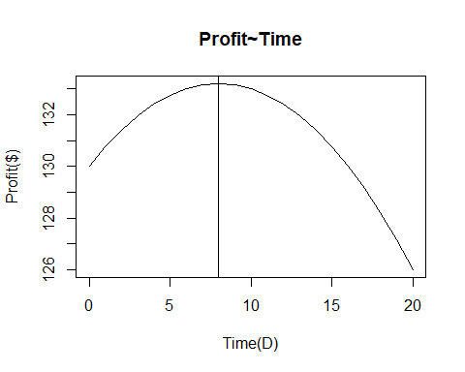

#------------------------------------------------------------------------  
t.opti=8  
P.max=eval({t<-t.opti;y})  
list("t.opti"=t.opti,"P.max"=P.max)

## $t.opti  
## [1] 8  
##   
## $P.max  
## [1] 133.2