2-2Multivariable Optimization

Hao Li

12/01/2019

## R Markdown

This R repository is for demonstration of algorithms involved in the book Mathematical Modeling (4th Edition) written by Prof. Mark. M. Meerschaert

#This R repository is for demonstration of algorithms involved in the book  
#Mathematical Modeling (4th Edition) written by Prof. Mark. M. Meerschaert  
#coded, edited and tested by Hao Li during Dec. 2018 - Jan. 2019.  
  
#1-2-2 Multivariable Optimization  
#Plot contour with restrictions  
#Load results from 1-2-1  
#1. SOLVE THE EQUATIONS  
  
(ym=matrix(c((-174),(-144)),ncol=1))

## [,1]  
## [1,] -174  
## [2,] -144

(B=rbind(c((-0.007),(-0.02)),c((-0.02),-0.007)))

## [,1] [,2]  
## [1,] -0.007 -0.020  
## [2,] -0.020 -0.007

x=solve(B,ym)  
remove(ym)  
remove(B)  
x[1]#s

## [1] 4735.043

x[2]#t

## [1] 7042.735

y<-function(s,t) (339 - 0.01 * s - 0.003 * t) * s + (399-0.004*s-0.01*t) * t - (195 * s + 225 * t + 4e+05)  
y(x[1],x[2])

## [1] 553641

#Visualization  
library(plot3D)  
x1=seq(from = 0, to = 10000, length.out = 100);x2=seq(from = 0, to = 10000, length.out = 100)  
m = mesh(x=x1,y=x2)  
z = y(m$x,m$y)  
#layout(matrix(1:2,1))  
  
contour(x1,x2,z,xlab='x1',ylab='x2')  
abline(v=x[1],untf=FALSE)   
abline(h=x[2],untf=FALSE)  
title("Contours of f(x1,x2)")  
#Add the margins of domain there  
abline(h=8000,col = 'red',untf=FALSE)  
abline(v=5000,col = 'red',untf=FALSE)  
abline(coef=c(10000,-1),col = 'red',untf=FALSE)

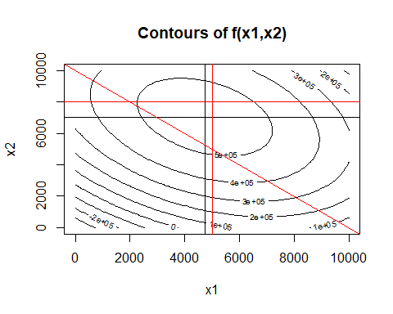

persp3D(x1,x2,z)

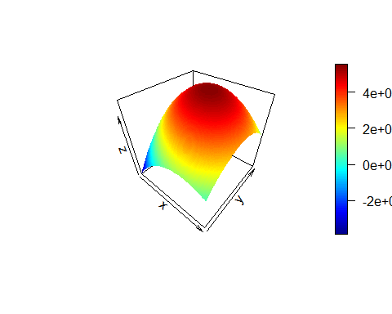

#3d Visualization with rgl and Plot3Drgl  
#library(plot3Drgl)  
#persp3Drgl(x1,x2,z)  
#grid3d(c('x+','y+','z+'))  
#axis3d(c('x+','y+','z+'))  
#points3D(c(x[1],x[2],y(x[1],x[2])),col ='purple')  
#lines3d(cbind(c(x[1],x[2],y(x[1],x[2])),c(x[1],x[2],0)))