3-2Discrete Optimization

Hao Li

12/01/2019

# Note

This R repository is for demonstration of algorithms involved in the book Mathematical Modeling (4th Edition) written by Prof. Mark. M. Meerschaert

#Exp 3.2  
#Discrete Optimization Problem  
  
#R script to solve Exp 3.2 with NO SIMPLIFICATION ON THE ORIGIONAL MAP  
#This uses some R conventions with origin on the top left corner of the matrix  
#  
#Define map matrix  
  
gmap = cbind(c(3,2,5,8,10,0),  
 c(0,1,3,5,6,2),  
 c(1,1,3,2,3,3),  
 c(4,2,0,1,1,1),  
 c(2,3,1,0,3,1),  
 c(1,2,2,0,1,1))  
#gmap = edit(gmap)#Uncomment this to edit the 'map' in an e-spreadsheet  
  
require(plot3D)

## Loading required package: plot3D

x = seq(from = .5,to=5.5,by=1);y = seq(from = .5,to = 5.5,by=1)  
gbase = mesh(x,y)  
#gbase$x  
#gbase$y  
  
#Define radius function r  
r = function(pos,gbase) sqrt((pos[1]-gbase$x)^2 + (pos[2]-gbase$y)^2)  
#This uses vectorizations for many times, returns a radius matrix for   
#position marked at pos on geographical base  
  
ztime= function(pos,gmap,gbase) 3.2 + 1.7* sum(gmap* r(pos,gbase)^.91)/84  
  
library(doParallel)

## Loading required package: foreach

## Loading required package: iterators

## Loading required package: parallel

#registerDoParallel(8)#Uncomment this to activate parallel computing  
  
pix = .05  
xbase = seq(from = 0, to =6, by = pix);ybase = xbase  
  
z = foreach(i = seq_along(ybase),.combine = cbind) %dopar%{  
 v= numeric(length(xbase))  
 for(j in seq_along(xbase)) v[j]<-ztime(pos =c(xbase[j],ybase[i]),gmap,gbase)  
 v  
}

## Warning: executing %dopar% sequentially: no parallel backend registered

persp(z)

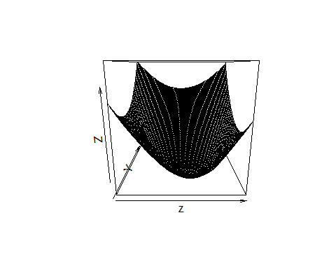

library(plot3D)  
persp3D(xbase,ybase,z)

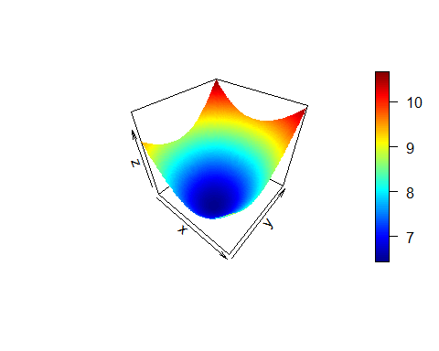

filled.contour(xbase,ybase,z)

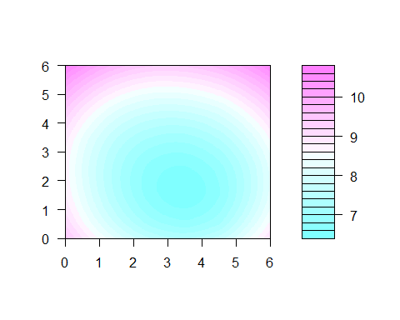

contour(xbase,ybase,z)

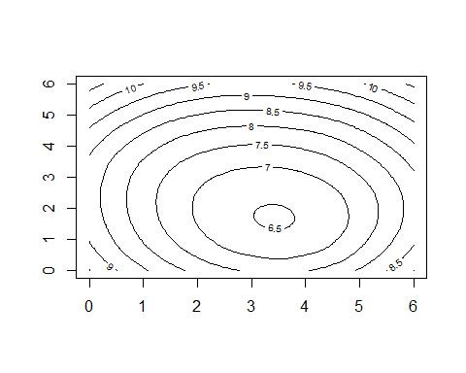

#which.min(z)/length(xbase)  
yi =as.integer(which.min(z)/length(xbase))  
(x_min_trans = ybase[yi])

## [1] 1.45

xi = which.min(z)- yi*length(xbase)  
(y_min_trans = 6-xbase[xi])

## [1] 2.5

(z_min_trans = min(z))

## [1] 6.447936

#Alternatively...  
#Random search test  
re=foreach(i = 1:8,.combine = cbind) %dopar% {  
 R=Inf  
 for(j in 1:125){  
 pos=runif(2,0,6)  
 Rnew =ztime(pos,gmap,gbase)  
 if(Rnew<R){  
 p = pos  
 R = Rnew  
 }  
 }  
 rbind(p[1],p[2],R)  
}  
result=re[,which.min(re[3,])]  
  
  
(x_min_trans1 = result[2])

##   
## 1.960397

(y_min_trans1 = 6-result[1])

##   
## 2.629805

(z_min_trans1 = result[3])

## R   
## 6.475245