AvaSoft Chart

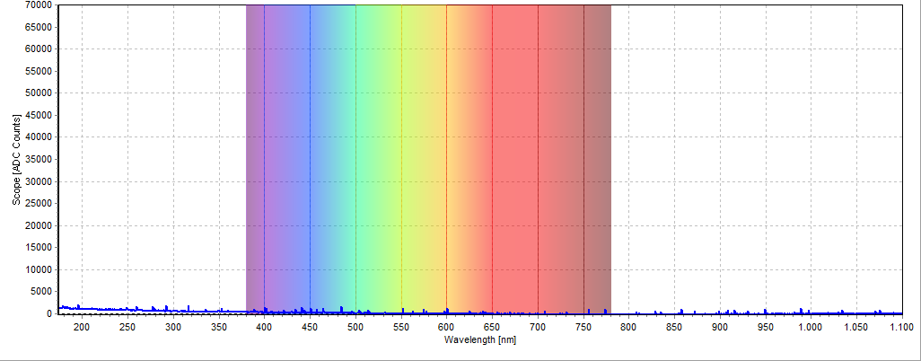

Dark_text_1

(01) Live:2201416U1 wavelength range: 174,06 to 1100,10Integration (ms):3000,00 Averages:1

