1. using three visible vehicle information (velocity and distance among them)
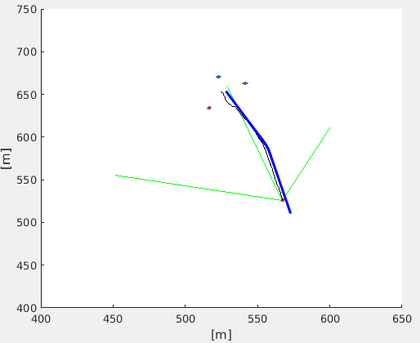
Only one vehicle is tracked. The others have the bad tracking.

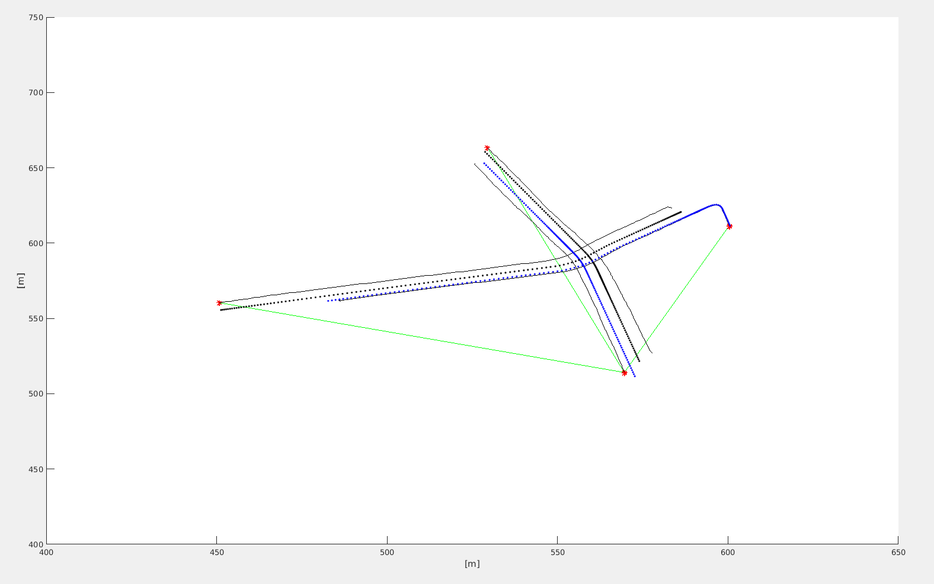
2. Using the global system with velocity and distance among cars (without GPS information)

The result is almost the same as the sckf.

Model with Distance difference for SLAM problem

1. The program is shut by the chol error that the Matrix must be positive definite. The fragment plot is here:
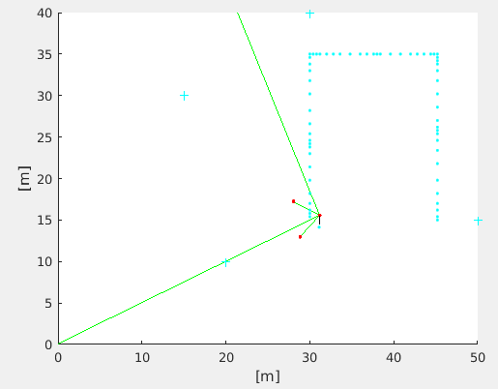

In the figure, + is the transmitter point, the blue dots are the real way of the vehicle trajectory. The red dots is the position that the transmitter predicted by the vehicle at the feature updating step. The start point is a little bit derivate from the real start point. The black line it the predicted way.

Even in the case that the transmitter position and the distance between vehicle and transmitter are exactly known exactly. We can not precess slam well. Especially at the feature updating step, the wrong prediction of the vehicle state both at previous and now time step makes the distance different among every time step but not the distance difference.

One more question is that the error in the distance difference measurement is very small, that will dominate the measurement process when updating the vehicle state. The kalman gain use cross-covariance divided by the innovation covariance. The innovation covariance is calculate by (z-z_m)(z_z_m)’. And the cross-covariance is calculated by (x-x_)(z-z_m)’. Innovation covariance is much small than the cross-covariance when using the distance difference as measurement. It contributes to a large kalman gain and have a huge updating to the feature at the feature-updating step, even we set the feature state is correct initial phase. Therefore this model is not work quite well.

