**Computer Graphics Programming 1**

**Name**: Ban Hao

**Student Id**: 2591928

Operating System: Windows 10

Working hours: 10 hours

1. Get included examples to work.

The results of four example scenes are as follows:

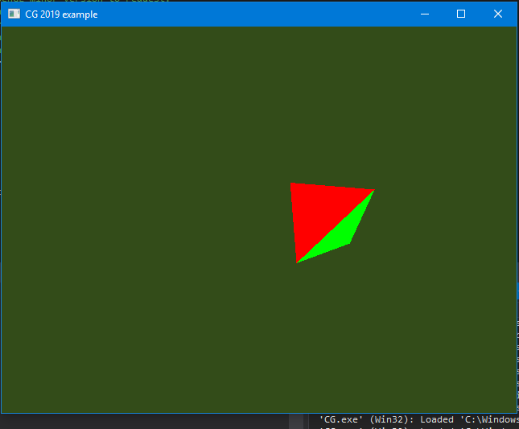 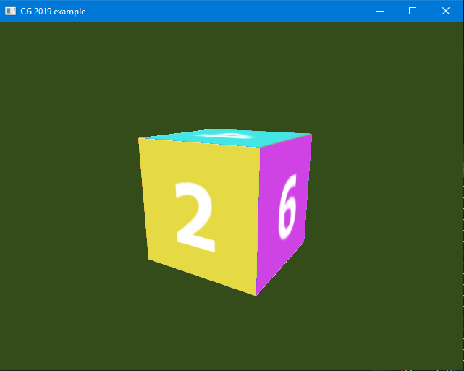

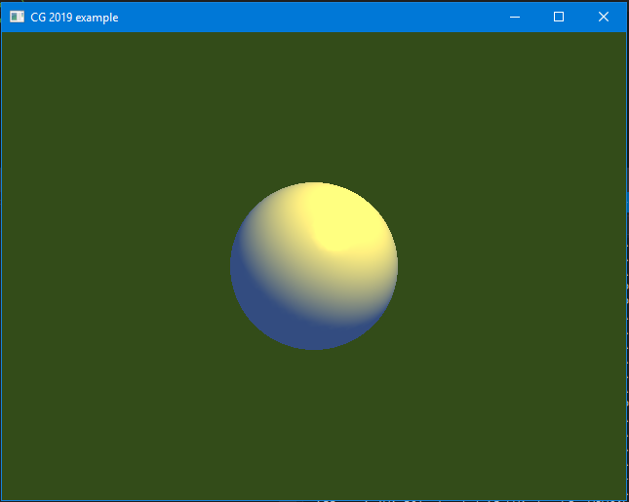 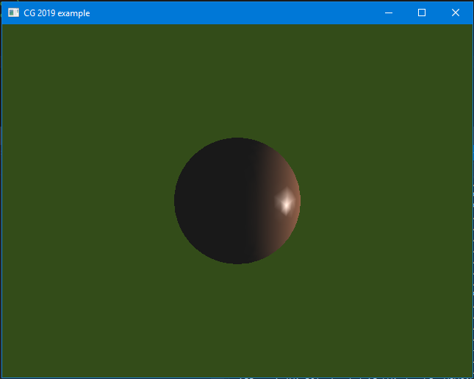

1. Render a simple cube.

I draw 12 triangles in red color. All points in each triangle are in clockwise direction, which means faces always points outside.

1. Change the cube color by mouse clicking.

**Problems**:

In this part, I think the most difficult parts is I can’t see any output in debug. So, I can’t check the value of parameter is correct or not.

Another problem is I need to get the height of rectangle window after each resizing.

**Solutions:**

In order to solve this problem, I find and define a function OutputDebugPrintf() in header file, assignment1.h, which can print output from terminal to debug.

Using glReadPixels() function can help me get the position of mouse clicking point. In order to get the position of mouse clicking when lower left corner as the origin, I need to get the height of rectangle window. So I add window resize event. After that, I can get the height of rectangle window after each resizing.

In 3.c and 3.d question, I add a uniform vec4 variable named cubeColor. And then, I use glUniform4fv() to set the cubeColor as color property, and transfer it into fragment shader.