Functional Specification

Year: _2019_ Semester: _Spring_ Team: __17__ Project : _Face Tracking Drone______

Creation Date: ___Jan 16, 2019________ Last Modified: Jan 17, 2019

Team Members (#1 is Team Leader):

Member 1: Xufei Gao_______________________ Email: [gao288@purdue.edu](mailto:_gao288@purdue.edu)___________

Member 2: Xingchen Wang__________________ Email: wang2930@purdue.edu_________

Member 3: Yi Qiao_________________________ Email: qiao22@purdue.edu____________

Member 4: Haobo Chen_____________________ Email: chen1887@purdue.edu__________

Assignment Evaluation:

|  |  |  |  |  |
| --- | --- | --- | --- | --- |
| **Item** | **Score (0-5)** | **Weight** | **Points** | **Notes** |
| **Assignment-Specific Items** | | | | |
| **Functional Description** | 4.5 | x3 | 13.5 |  |
| **Theory of Operation** | 5 | x3 | 15 |  |
| **Expected Usage Case** | 5 | x3 | 15 |  |
| **Design Constraints** | 4.5 | x3 | 13.5 |  |
| **Writing-Specific Items** | | | | |
| **Spelling and Grammar** | 4 | x2 | 8 |  |
| **Formatting and Citations** | 4.5 | x1 | 4.5 |  |
| **Figures and Graphs** | 4.5 | x2 | 9 |  |
| **Technical Writing Style** | 4 | x3 | 12 |  |
| **Total Score** | 90.5 | | |  |

5: Excellent 4: Good 3: Acceptable 2: Poor 1: Very Poor 0: Not attempted

1.0 Functional Description

The autonomous face tracking drone is designed to record a short performance by individual musician. It will be able to track the movement of the performer’s face and make according action to ensure the performer’s face is always in the video frame. The drone will be able to send the video to a local computer in real time. The video data will be locally saved and undergo face recognition algorithm at the same time. After the video stream is processed on the computer, control signal will be sent back and drone will move as the command directed.

2.0 Theory of Operation

The drone itself will have a flight controller. The flight control will be bought directly from manufacturer and will be able to stabilize the stance of drone by itself. More specific movement will be controlled by signals sent from microcontroller or radio controller.

Since the drone has multiple control source, there has to be a multiplexer select the control signal and send the command to the flight control.

The autonomous control signals sent from the ground will be received via a RF receiver, while the radio controller will use its own paired receiver. The radio controller will be bought directly from manufacturer and will be able to support all the movement including throttle, yawing, pitching and rolling through its 6 channels.

The camera will be either a goPro or a drone dedicated camera. It will be connected directly with a video transmitter in order to send video to the local machine for real time processing.

The camera will sit on a 2-axis or 3-axis gimbal equipped with brushless motors and dedicated gimbal control. The control signal for adjusting the rotation speed/angle will be sent from microcontroller to the gimbal control.

3.0 Expected Usage Case

The face tracking autonomous drone is supposed to be used outdoor. It is designed to be portable and easy to start with. People like youtubers, musicians and journalists are the targeted group who may purchase this product. However, the drone is mainly designed for musicians who are performing/soloing and want to record autonomous videos, as videos recorded by a fixed camera may not output a video that meet with the performers’ artistic desire. A face tracking drone would be able to record the performance from multiple point of view while having minimum interference with the performance. If multiple performers are using the drone at same time, one target face will be selected for tracking. The target face might be changed with the signal from the ground station GUI application.

4.0 Design Constraints

4.1 Computational Constraints

The primary computational functions of the autonomous drone are focused on real-time face tracking accompanied by some minor command and signal composition. Since the face detection and position extraction algorithms are too heavy for microcontrollers, we are going to off-load the heavy image processing tasks onto our base (laptop or even desktop workstation), leaving the microcontrollers to perform relatively simple tasks. After the video stream sent back is processed on our base, a simple command is composed (i.e move rightward/leftward by 5cm) and send back to our microcontroller via RF/WIFI. The microcontroller is responsible for convert such high level commands into PPM/PWM/IBUS signals and send to the flight controller.

Regarding the image processing algorithms running at base, our target is to reach around 30 frames per second on average, thus having a reasonable and responsive motion control for the drone.

4.2 Electronics Constraints

A flight controller is used to control the four ESCs. The flight controller has GPS and Gyro embedded, and they can be used with provided interfaces. A camera is used to record video which will be sent back to local computer through a video transmitter. A receiver is connected with local computer to acquire videos from the drone. This drone will be using RF or WIFI protocol to receive control signals from the local computer. The microcontroller will need to interface with flight controller by SPI for giving moving commands. The microcontroller will also need to interface with camera gimbal by RF or SPI.

4.3 Thermal/Power Constraints

Since the drone will mostly relying on battery, we will use a 3S/4S 30-50c Lipo battery(12v-16v) to power it. The power is distributed to 4 ESCs as well as the brushless motors they control by our power distribution board (PDB). However, our microcontroller and flight controller are working under 5v/3.3v, thus stepping down power regulation is needed to power our control system. Since the drone will not be touched directly by users after taken off, heat should not be a major problem in our use case.

In order to provide reasonable filming time, we are going to choose Lipo battery whose capacity is at least 5000mAh. Our target operation time is around 15 minutes.

4.4 Mechanical Constraints

Due to the limitation of maximum load of the drone, the total weight of batteries, camera, PCB, microcontroller, and drone itself should be limited. The endurance of flight will also be influenced by the total weight. Our face tracking drone is designed for individual musicians so that we plan to restrict the size to ensure the portability of the product. When drone is flying in the air while recording the video, stability is a key factor to consider. Thus, in our design, we will consider the possibility that the drone will be shaken by the wind, also our face tracking drone is vulnerable to snowy or rainy weather. Therefore, usage is restricted to the sunny weathers with no wind.

4.5 Economic Constraints

Since there are lots of original ideas and extra functions, our face tracking drone will definitely be competitive compared to the similar products on the market. For an individual musician, the recording part of the device is the key part of creating attractive musical works, so we have to have high technological parts installed in our product, which will result in a relatively high cost. However, our target user group is very specific, so there would not be a great market. To balance the cost and our willingness to sell, we decide to set the price to 400-500 dollars.

4.6 Other Constraints

Since original music videos are sometimes for personal use only, keeping the copyrights of music videos are essential. Therefore, the photographer has to pay close attention to the data security during the process of transmitting videos to computers. At the same time, it is not a toy for a child. A young user is probable to damage the face tracking drone shortly. Keeping the product away from kid is necessary.

5.0 Sources Cited:

No external source needs to be cited in this report.

Appendix

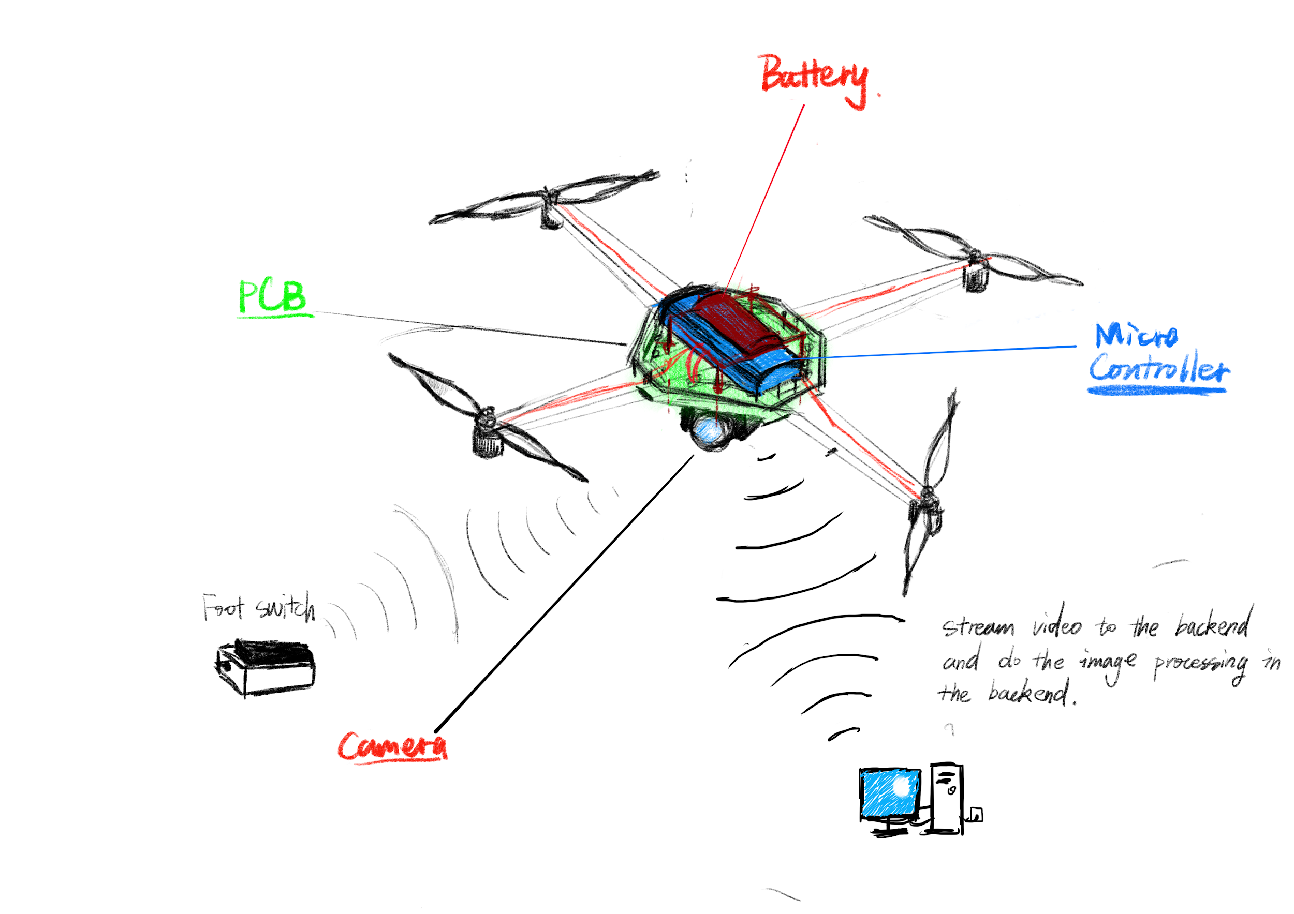

Figure 1. Concept Overview Sketch

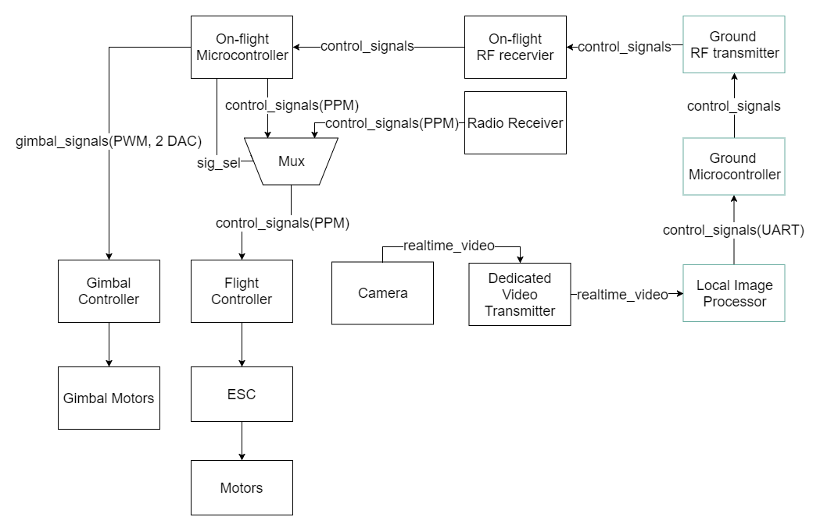

Figure 2. Block Diagram