Electrical Overview

Year: _2019_ Semester: _Spring_ Team: __17__ Project: _Face Tracking Drone______

Creation Date: ____Jan 29, 2019__________ Last Modified: November 24, 2015

Author: ____Haobo Chen_________________ Email: __chen1887@purdue.edu_____

Assignment Evaluation:

|  |  |  |  |  |
| --- | --- | --- | --- | --- |
| **Item** | **Score (0-5)** | **Weight** | **Points** | **Notes** |
| **Assignment-Specific Items** | | | | |
| **Electrical Overview** | 4.5 | x3 | 13.5 |  |
| **Electrical Considerations** | 4.5 | x3 | 13.5 |  |
| **Interface Considerations** | 5 | x3 | 15 |  |
| **System Block Diagram** | 5 | x3 | 15 |  |
| **Writing-Specific Items** | | | | |
| **Spelling and Grammar** | 4 | x2 | 8 |  |
| **Formatting and Citations** | 5 | x1 | 5 |  |
| **Figures and Graphs** | 5 | x2 | 10 |  |
| **Technical Writing Style** | 5 | x3 | 15 |  |
| **Total Score** | 95 | | |  |

5: Excellent 4: Good 3: Acceptable 2: Poor 1: Very Poor 0: Not attempted

General Comments:

1.0 Electrical Overview

The microcontroller for this project will be a 32-bit microcontroller. It will not perform any computation directly. Instead, it will be the interface between other devices including flight controller, RF transceiver and gimbal controller. The inputs will be control signals received from local computer, pedal controllers, and statuses of the gimbal motors. The output will be control signals sent to flight controller and gimbal controller.

There will be another 32-bit microcontroller taking charge of sending control signals from a local computer to the drone. The input is control signals from local computer. The output is control signals sent to a RF transceiver.

2.0 Electrical Considerations

2.1 Operating Voltage

This project consists of two operating parts: flight part and ground part. The flight part is powered by HRB 11.1V 5000mAh 3S 50C-100C LiPo Battery with Traxxas TRX Plug [1], whose output voltage is 11.1V. There are four devices belonging to the flight part: STM32F4 microcontroller [2], 4x SIMONK 30A ESC For DJI Phantom [3], Pixhawk flight control [4] and STorM 32 gimbal [5]. The operating voltage range of the ESC is 8V to 12V and that of gimbal is 11.1V to 16.8 V. 11.1V falls in both of these two ranges. But the operating voltages of microcontroller and flight control are both 5v. Therefore, a voltage regulator is needed, which converts the 11.1V to 5V.

For the ground part, there are two devices need to be powered: STM32F4 microcontroller and Dunlop GCB95 Cry Baby Wah Pedal [6]. For this microcontroller, it is powered by the laptop using USB. And there is a battery to power the pedal which provides 9V output matching the operating voltage of the pedal.

2.2 Operating Frequency

While our project is targeting tracking human face in real time, such task requires heavy computing power. With a reasonable setup (a laptop/ desktop computer), our target operating frequency will be around (30-50 fps). In order to keep track of the target face and not lose track easily, 30-50 Hz would be reasonable.

On the RF side, the NRF24L01+ module can handle data transfer at 2000 kbps [7]. Since we want our latency as low as possible to reach the best face tracking accuracy, we will use the maximum transfer speed. While doing so may increase the power consumption, neither the RF module nor the microcontroller consumes significant power compare to the motors. The large battery and relative trivial power cost will allow us to use a more aggressive RF setting.

2.3 Power Supply

The power for the drone’s ESCs is supplied by a ‘HRB 11.1V 5000mAh 3S 50C-100C Lipo Battery’, and the flight controller will be powered by this battery as well but the voltage has been transformed to 5V. VTX transmitter and micro-controller will be power through this battery as well.

The power for the ground station is supplied by usual laptop power outlet, however, the RF transmitter [8] will be powered by a usb-uart bridge which is connected with laptop.

Our battery is a 5000mAh 3S 50C Lipo battery, which can support discharge rate up to 5000mA * 50 = 250Amp and operate at 11.1V.

The maximum current that the electronic components would draw from the battery at any instant is 51.72A, which is less than the maximum current the battery can provide. The breakdown for this usage is:

* STM32F4 [2] = 215 uA
* 4 * ESCs [3] * 3A = 12A
* Pixhawk [4] = 215 uA
* Storm32 gimbal [5] = 1.5A
* Dunlop GCB95 Cry Baby Wah Pedal [6] = DC 10mA
* 4 * motors * 9.5A = 38 A (Tested with 11.1V power)
* VTX receiver = 200 mA

3.0 Interface Considerations

3.1 Serial Interface

SPI will be used for communication between most microcontroller and all the devices on the drone. SPI is selected against I2C mainly because of it’s high speed data transfer rate. A high data rate is important to make sure the drone reacts fast enough to the control signals. The trade off that the distance of SPI transfer must be short is not a concern because the distance between on-flight devices is short enough. It is also verified that SPI works with other devices on the drone. SPI data transfer rate need to be the same as RF data transfer rate, which is 2000kpbs[6].

3.2 UART Interface

A UART interface will be used between the local computer and the microcontroller on the base. Since RF modules is used instead of wifi modules for control signal transfer between the local computer and the drone, a seperate microcontroller is needed at the local computer. It will also use SPI to perform on-board communication. UART is used for communication with local computer. Since UART data rate cam reach.

4.0 Sources Cited:

[1] “HRB 11.1V 5000mAh 3S 50C-100C LiPo Battery with Traxxas TRX Plug for RC DJI F450 Quadcopter RC Helicopter Airplane Hobby Drone and FPV (6.10 x 1.89 x 0.91 Inch),” Amazon. [Online]. Available: https://www.amazon.com/gp/product/B06XNTHQRZ/ref=ppx_yo_dt_b_asin_title_o02__o00_s00?ie=UTF8&psc=1. [Accessed: 31-Jan-2019].

[2] “UM1472 User manual Discovery kit with STM32F407VG MCU,” 2017. [Online]. Available: https://www.st.com/content/ccc/resource/technical/document/user_manual/70/fe/4a/3f/e7/e1/4f/7d/DM00039084.pdf/files/DM00039084.pdf/jcr:content/translations/en.DM00039084.pdf. [Accessed: 30-Jan-2019].

[3] Banggood.com, “Emax Simonk Series 12A 20A 25A 30A 40A ESC For Quadcopter QAV250,” www.banggood.com. [Online]. Available: https://www.banggood.com/Emax-Simonk-Series-12A-20A-25A-30A-40A-ESC-For-Quadcopter-QAV-250-p-918126.html?gmcCountry=US¤cy&createTmp=1&utm_source=googleshopping&utm_medium=cpc_bgs&utm_content=frank&utm_campaign=pla-multi-us-pc&gclid=Cj0KCQiA4aXiBRCRARIsAMBZGz-O2gRXrM7_tCtIcU7Sx-A3RHQLYna4j4z12bqb-wSPt7emUOng5fIaAoVjEALw_wcB&ID=45173&cur_warehouse=CN. [Accessed: 31-Jan-2019].

[4] “Radiolink Pixhawk PX4 32 Bit ARM Flight Controller NEO-M8N GPS Pixhawk Power Module for RC Multirotor Quad for RC Multirotor Quad with 4G Micro-SD,” Amazon. [Online]. Available: https://www.amazon.com/gp/product/B01N4KJEV4/ref=ppx_yo_dt_b_asin_title_o04__o00_s00?ie=UTF8&psc=1. [Accessed: 31-Jan-2019].

[5] Kspronakenn and paraphernalia_p..., “HAKRC Storm 32 Brushless Gimbal Lightweight For Gopro3 For Gopro4 FPV Fittings 757290957421,” eBay, 27-Jun-2018. [Online]. Available: https://www.ebay.com/itm/HAKRC-Storm-32-Brushless-Gimbal-Lightweight-For-Gopro3-For-Gopro4-FPV-Fittings/152138384908?ssPageName=STRK:MEBIDX:IT&_trksid=p2057872.m2749.l2649. [Accessed: 31-Jan-2019].

[6] James, “Dunlop GCB95 Cry Baby Wah Pedal,” inSync, 15-Dec-2018. [Online]. Available: https://www.sweetwater.com/store/detail/Crybaby--dunlop-gcb95-cry-baby-wah-pedal?mrkgcl=28&mrkgadid=3325657697&rkg_id=0&product_id=Crybaby&campaigntype=shopping&campaign=aaShopping - SKU - Guitars&adgroup=Guitar Pedals & Effects - Dunlop - crybaby&placement=google&adpos=1o2&creative=324206639905&device=m&matchtype=&network=g&gclid=CjwKCAiAs8XiBRAGEiwAFyQ-egxysKxqTJadK10n-TwCgGN2Osoj3nOlY6GVNjMfYtQz8tlb-f7tRBoCAB4QAvD_BwE. [Accessed: 31-Jan-2019].

[7] “nRF24L01Pluss_Preliminary_Product_Specification_v1_0” 2006.[Online]. Available: <https://www.sparkfun.com/datasheets/Components/SMD/nRF24L01Pluss_Preliminary_Product_Specification_v1_0.pdf>

[8] “MakerFocus 2pcs NRF24L01 PA LNA Wireless Transceiver RF Transceiver Module 2.4G 1100m with Antenna in Antistatic Foam Compatible Arduino,” Amazon. [Online]. Available: https://www.amazon.com/MakerFocus-NRF24L01-Transceiver-Antistatic-Compatible/dp/B01IK78PQA/ref=sr_1_2_sspa?ie=UTF8&qid=1548376671&sr=8-2-spons&keywords=nrf24l01&psc=1&smid=A1N6DLY3NQK2VM. [Accessed: 31-Jan-2019].

Appendix 1: System Block Diagram

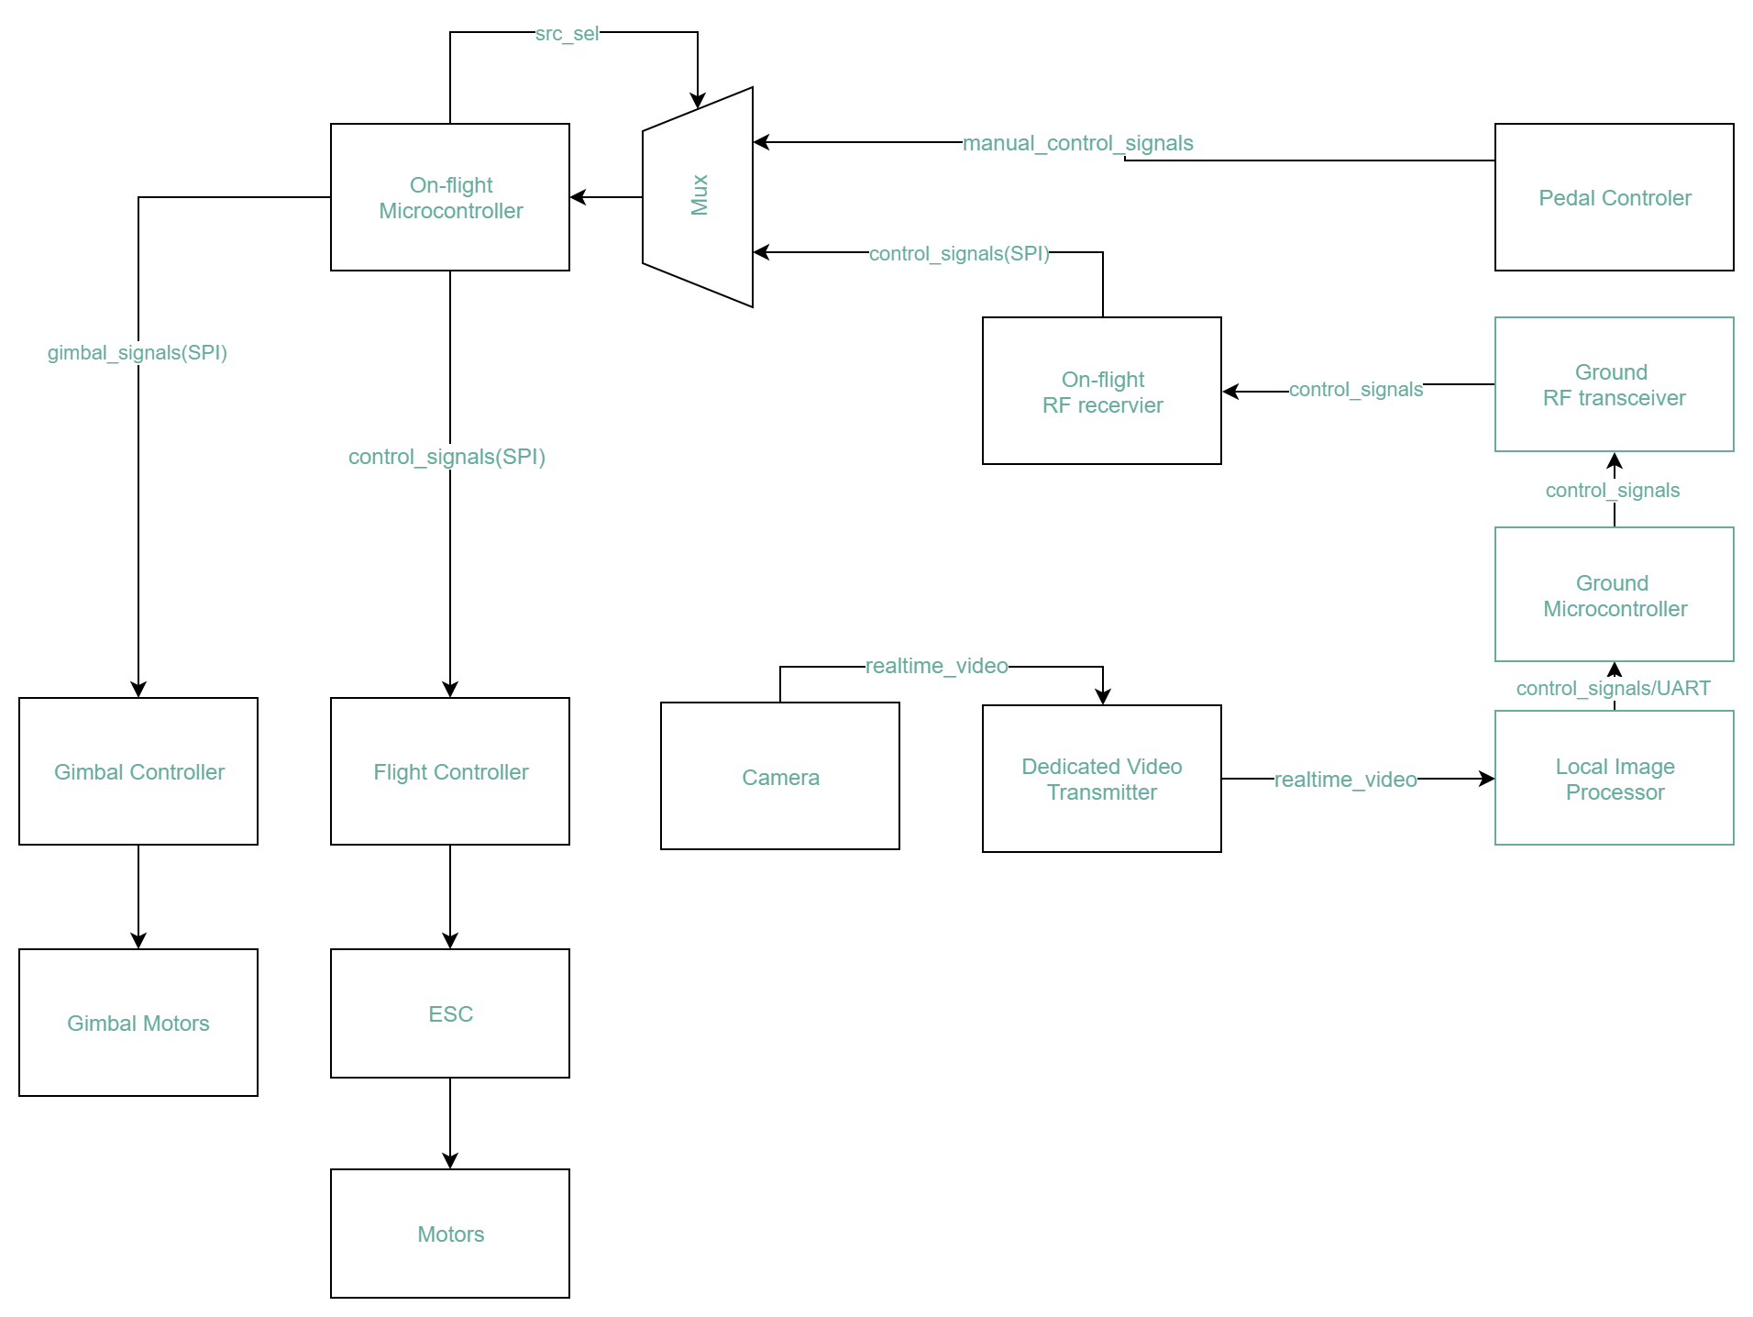

Figure 1. System block diagram