Mechanical Overview

Year: _2019_ Semester: _Spring_ Team: __17__ Project: _Face Tracking Drone______

Creation Date: ____Feb 5, 2019__________ Last Modified: March 3, 2015

Author: Xingchen Wang__________________ Email: wang2930@purdue.edu_________

Assignment Evaluation:

|  |  |  |  |  |
| --- | --- | --- | --- | --- |
| **Item** | **Score (0-5)** | **Weight** | **Points** | **Notes** |
| **Assignment-Specific Items** | | | | |
| **Commercial Packaging Analysis 1** | 4.5 | x2 | 9 |  |
| **Commercial Packaging Analysis 2** | 4.5 | x2 | 9 |  |
| **CAD Model Illustrations** | 4.5 | x4 | 18 |  |
| **Project Packaging Specifications** | 5 | x2 | 10 |  |
| **PCB Footprint Layout** | 5 | x2 | 10 |  |
| **Writing-Specific Items** | | | | |
| **Spelling and Grammar** | 3 | x2 | 6 |  |
| **Formatting and Citations** | 5 | x1 | 5 |  |
| **Figures and Graphs** | 4.5 | x2 | 9 |  |
| **Technical Writing Style** | 4.5 | x3 | 13.5 |  |
| **Total Score** | 90 | | |  |

5: Excellent 4: Good 3: Acceptable 2: Poor 1: Very Poor 0: Not attempted

Comments:

1. Commercial Product Packaging

We analyzed two commercial products from the B&H and amazon, which are similar to our face tracking drone. They are “YUNEEC Mantis Q Drone [1]” and “Holy Stone HS100 Drone [2]”.

* 1. YUNEEC Mantis Q Drone

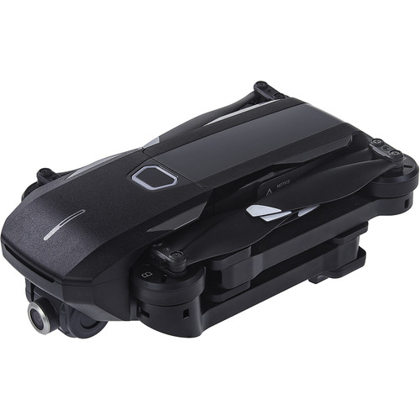

Figure 1: Packaging of YUNEEC Mantis Q Drone

The ‘YUNEEC Mantis Q Drone’ is a commercial product that is similar to our project. It also supports intelligent flight mode which has the face tracking functionality.

The advantage of its packaging is that the ‘YUNEEC Mantis Q Drone’ is engineered to be folded with hinges connected to four arms. The arms can fold and reside at the sides of drone. By implementing this property, it is obvious that the drone will be portable and it reduces the risk of damage to the drone during transportation.

Also, this package protects the battery really well and it is designed to hold the battery in a safe area inside the drone. Since battery can damaged by accident, it is important to include this feature. At the same time, the package is designed in a way such that the battery can be replaced easily.

The disadvantage is obvious as well. Although the foldable design means portability, the arms of the drone needs to be designed to be thin in order to realize this feature. Thin arms increase the probability of damage during flight. Since we cannot assume that every customer is a good pilot, we have decided to discard the “foldable” feature and use more stable arms.

We definitely will design the package to protect the battery and ensure it can be easily installed and disassembled. In addition, we will try to design the package which makes transportation easier. Maybe the arms are hard to be engineered to support folding, but the drone’s mount could be designed to be foldable which reduces the size of the drone in the vertical dimension.

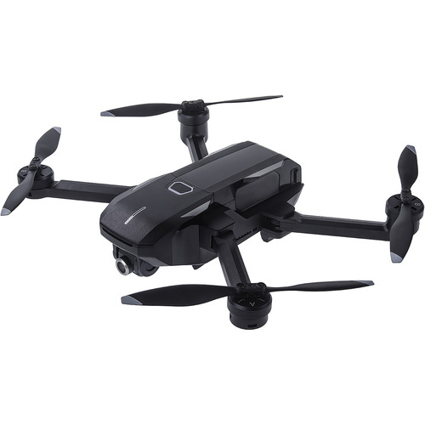

Figure 2: Packaging for product #1

* 1. Holy Stone HS100 Drone

“Holy Stone HS100 Drone” is packaged with x-shaped plastic packaging with curved edges. Under the main body of the drone, there is a gimbal to hang the camera. Four arms are supported by support brackets when the drone is landed on the ground.

The use of plastic as the packaging material is worth being applied to our project. First of all, plastic is cheap which reduces the packaging cost of the product. Light weight is definitely a beneficial feature for a flying project which aims to ensure long flying time. The light weight combined with the compact design of the product lead to easy portability for user to carry it every day. But the product can by damaged easily because of using plastic, as plastic is a relatively weak material.

We also plan to use a gimbal to hang the camera. The gimbal can guarantee the stability and reliability of quality of video recording. We also plan to install a set of landing stand. In addition, we consider using red for our packaging, because it contrasts with the color of the sky drastically. In this way, the pilot can track the position of the drone easily when flying it.

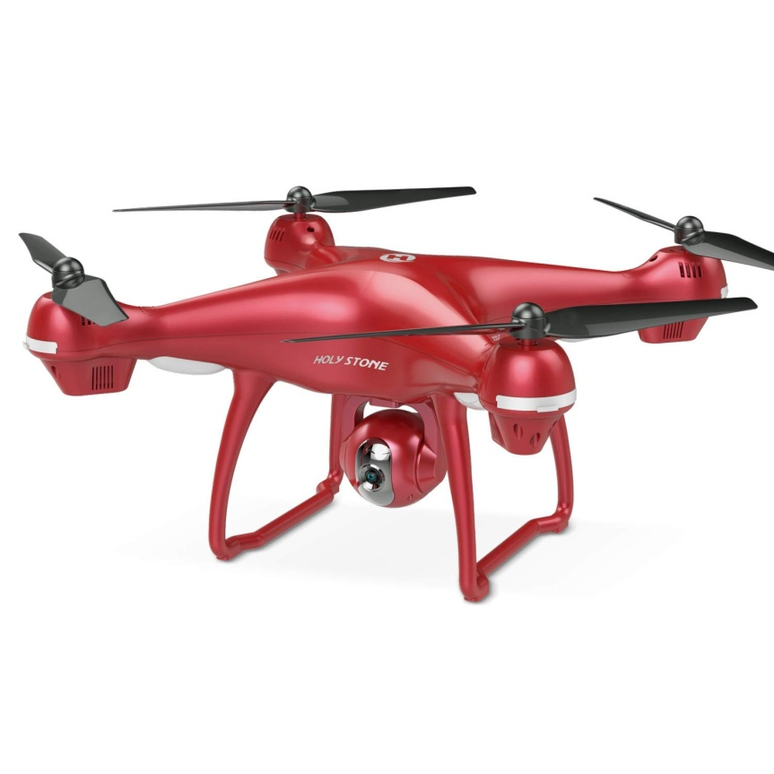

Figure 3: Packaging of Holy Stone HS100 Drone

3.0 Sources Cited

[1] Brian and Joe, “YUNEECMantis Q Drone,” About B&H | B&H Photo Video, 17-Dec-2018. [Online]. Available: https://www.bhphotovideo.com/c/product/1432518-REG/yuneec_yunmqus_mantis_q_drone.html/?ap=y&gclid=CjwKCAiA7vTiBRAqEiwA4NTO6zN36tV8PQY6So0dFMuuxK-LWvlFRxkIx9-FYTV9K6I-dEIjy0266xoCsPEQAvD_BwE&lsft=BI:514&smp=Y. [Accessed: 08-Feb-2019].

[2] “Holy Stone HS100 Drone with 1080p HD Camera FPV Live Video RC Quadcopter with GPS Return Home Function Follow Me and Altitude Hold, Drone for Beginners, Kids and Adults, Color Red,” Amazon. [Online]. Available: https://www.amazon.com/dp/B07GS33PTY/ref=sspa_dk_detail_3?psc=1&pd_rd_i=B07GS33PTY&pd_rd_w=UPs8Y&pf_rd_p=2bd81721-c115-4b8d-93a3-2ecd17466ded&pd_rd_wg=6GX8q&pf_rd_r=2ATJV7GFE52VRJ7D5MN3&pd_rd_r=38f6209f-2974-11e9-b139-8fc39df8cf8c. [Accessed: 08-Feb-2019].

Appendix 1: CAD Model Illustrations

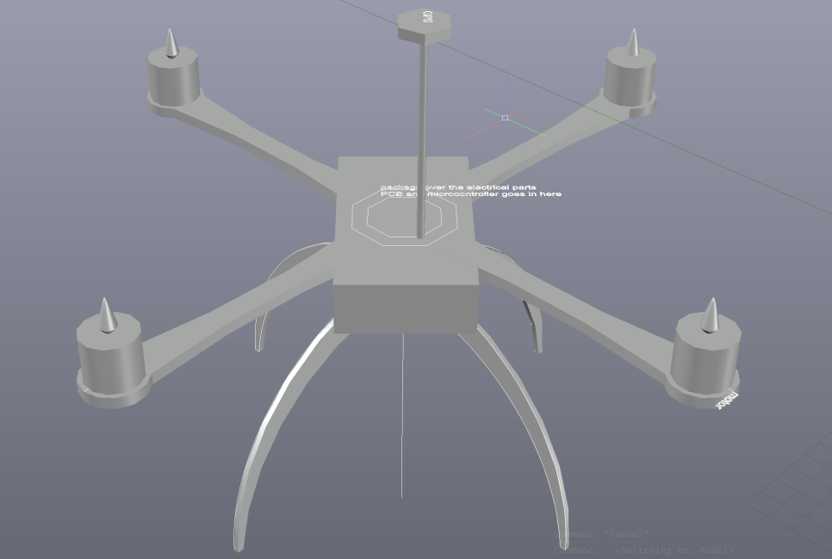

Figure 4: Model of the drone

[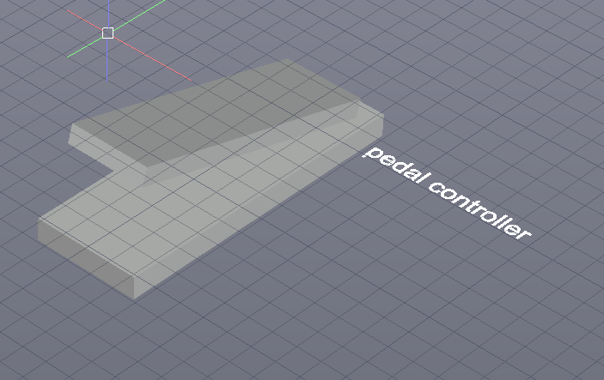](https://engineering.purdue.edu/ece477)

Figure 5: Model of pedal controller

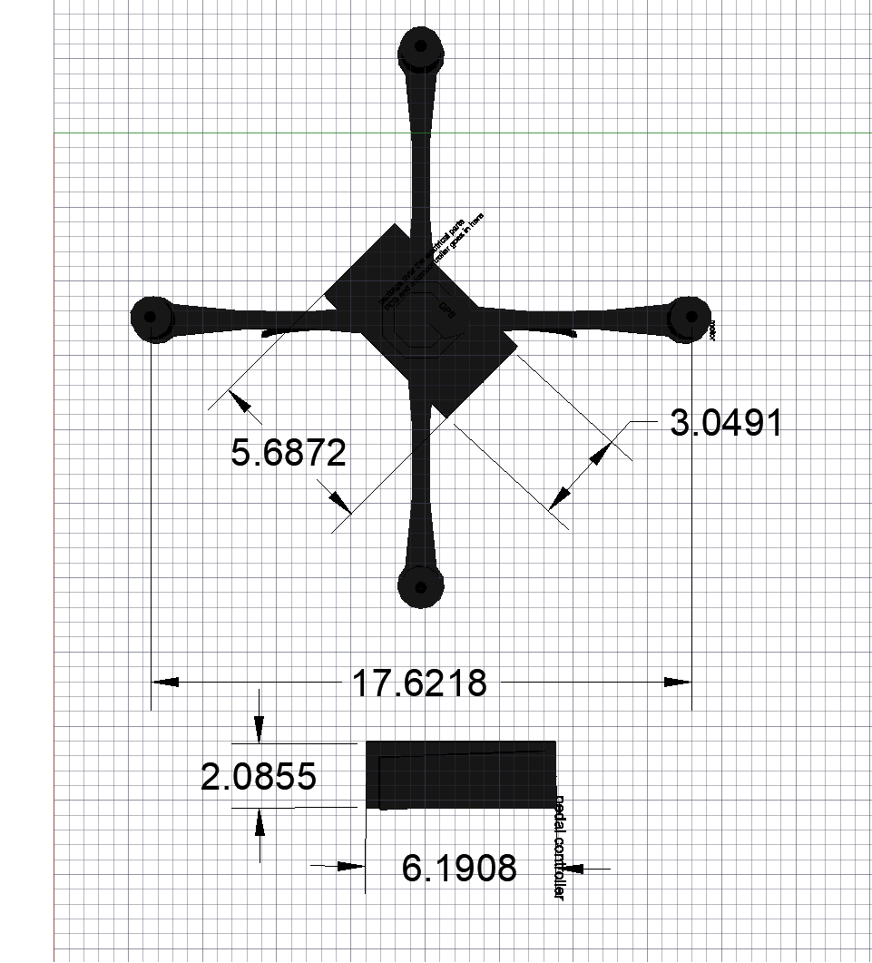

Figure 6: Top view of model dimensions (unit: inch)

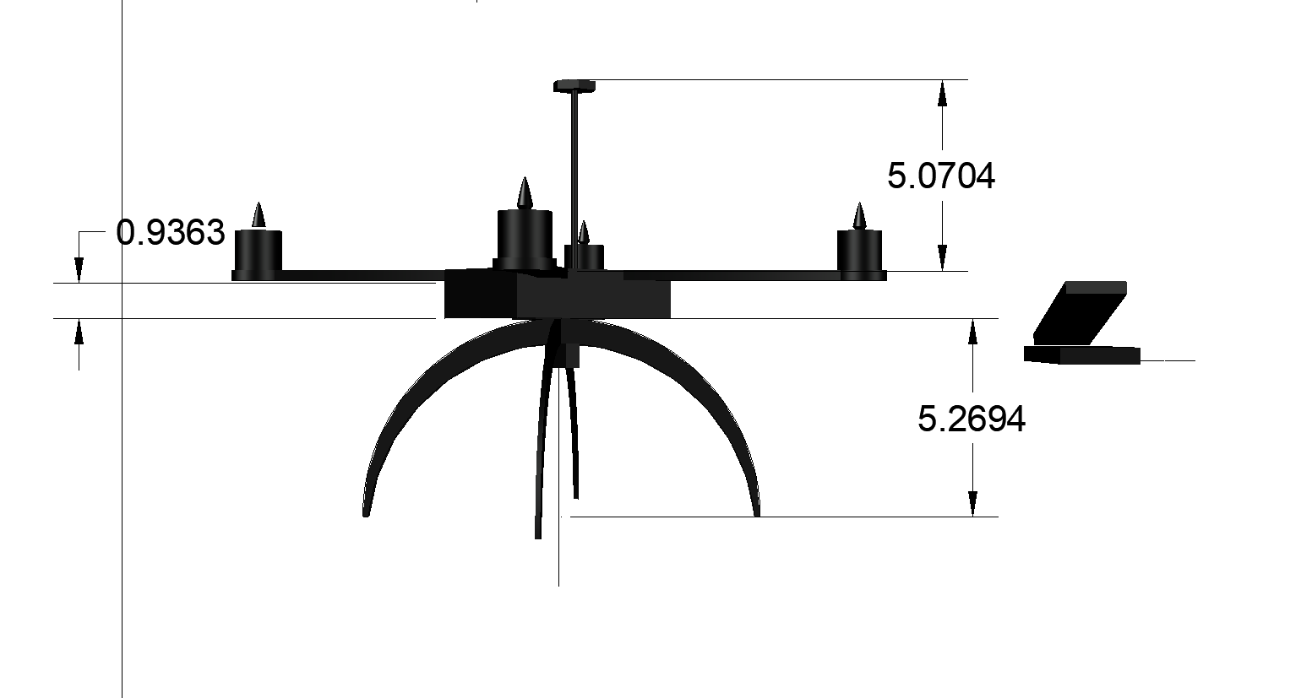

Figure 7: Side view of model dimensions (unit: inch)

Appendix 2: Project Packaging Specifications

|  |  |  |  |
| --- | --- | --- | --- |
| Material | Tool required | Weight (g) | Cost ($) |
| PLA Filament | 3D printer | 500 | 19.99 |
| Lock Nuts | Wrench | 11.04 | 1 |
| Bolt M3*6 | hex key | 19.2 | 2 |
| total |  | 530.24 | 22.99 |

Table 1: Materials, tools, weight and cost

Appendix 3: PCB Footprint Layout

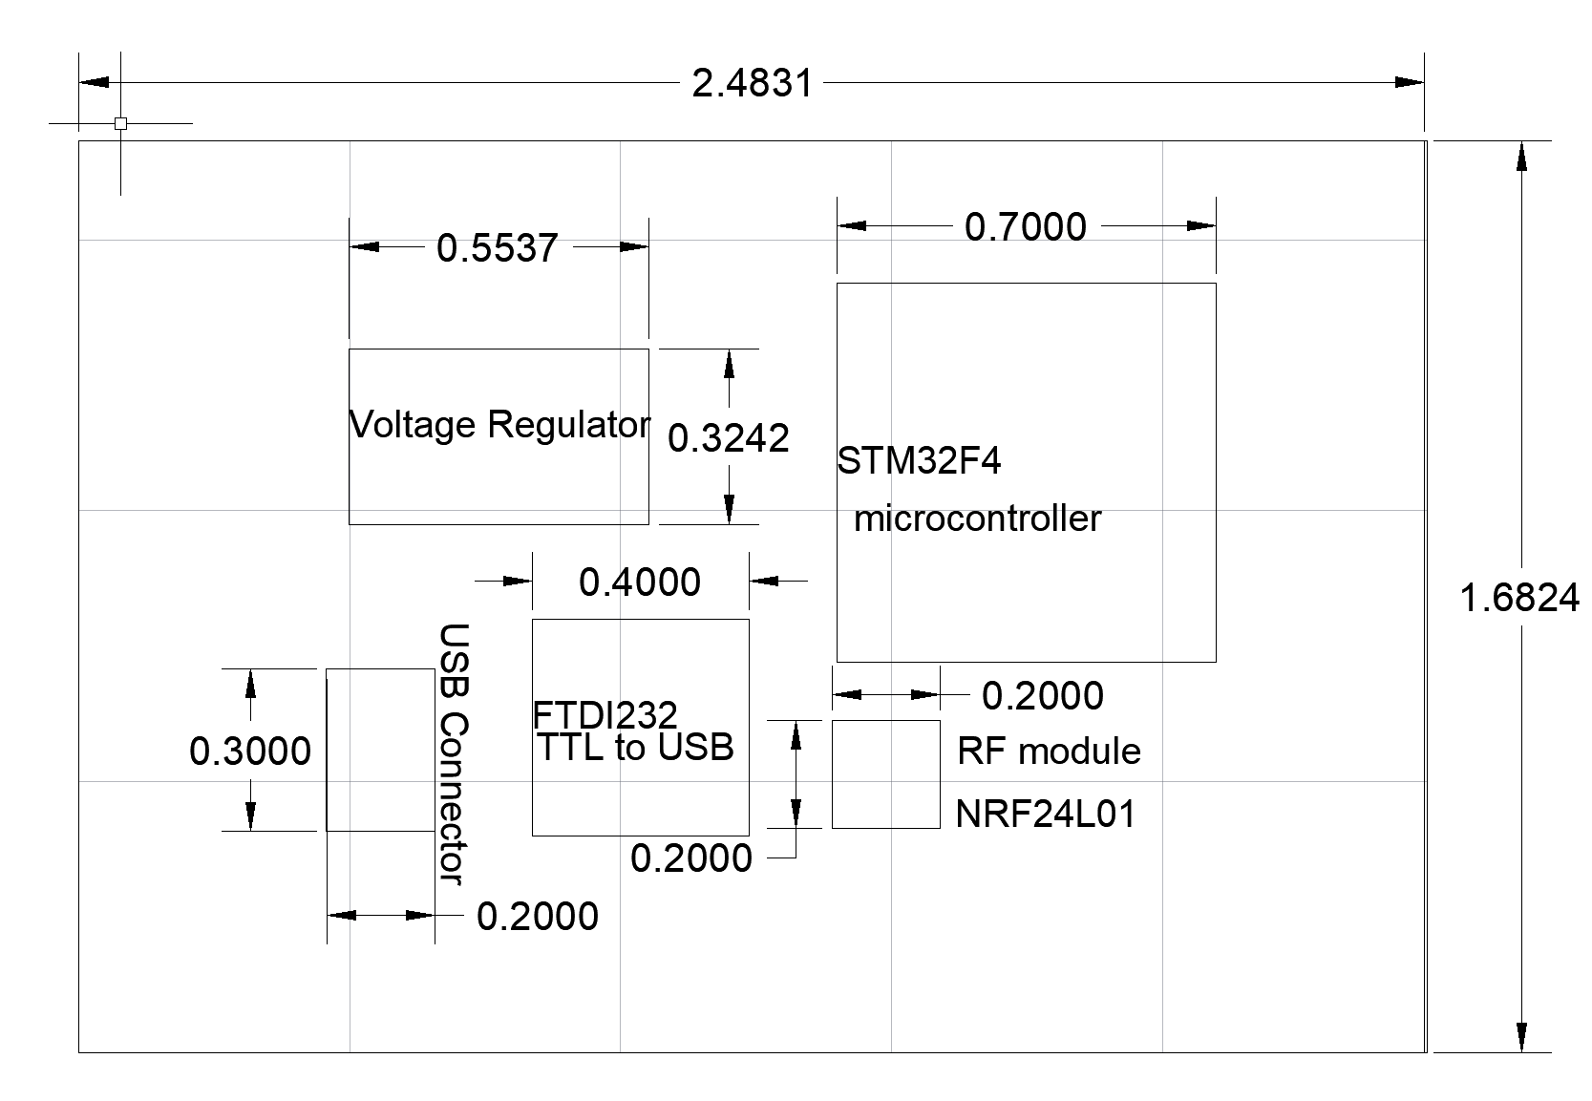

Figure 8: PCB layout for the ground part (unit: inch)

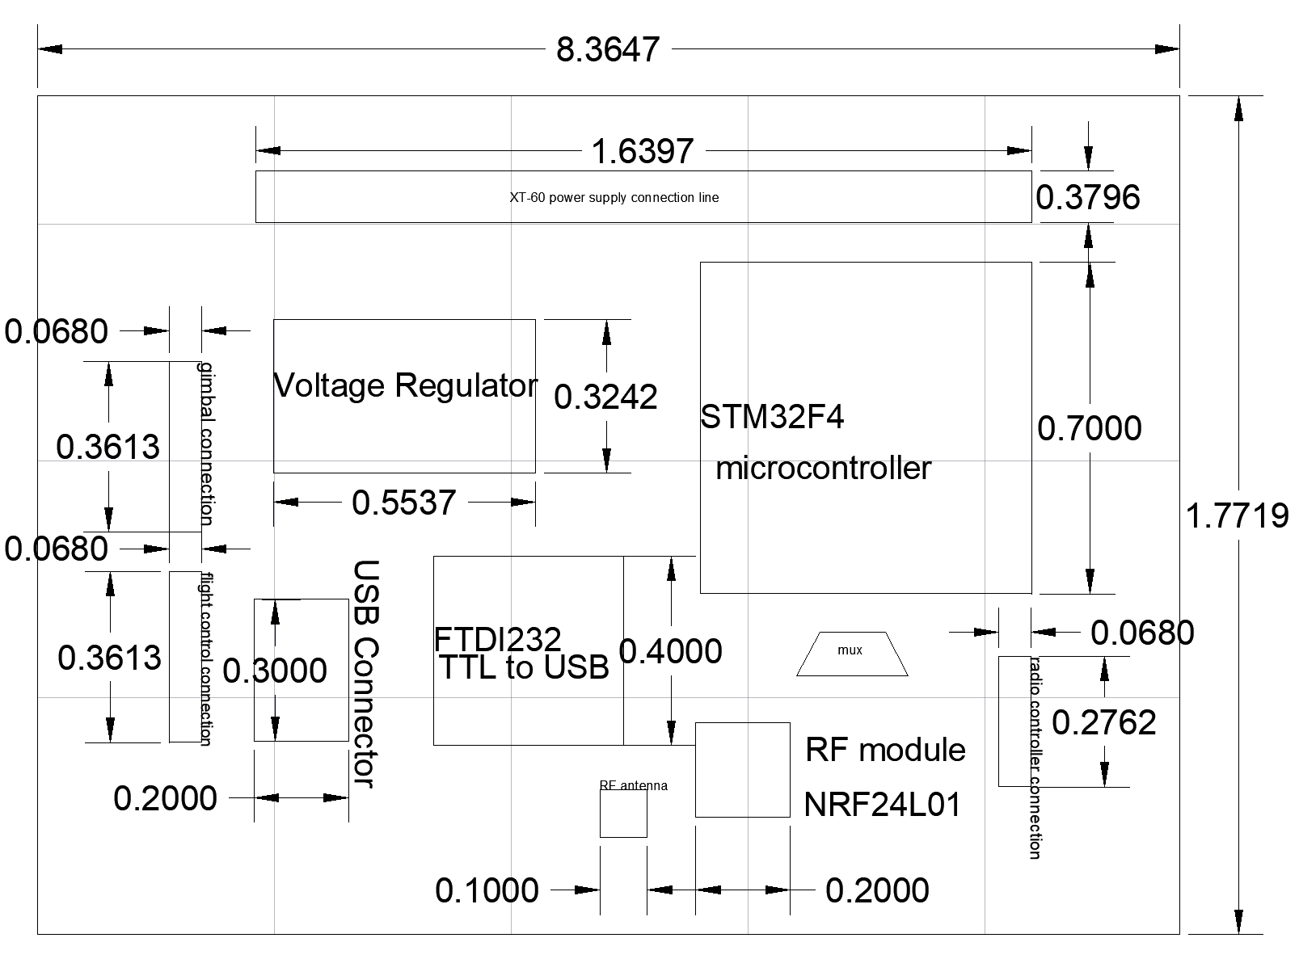

Figure 9: PCB layout for the drone part (unit: inch)