User Manual

Year: _2019_ Semester: _Spring_ Team: __17__ Project: _Face Tracking Drone______

Creation Date: ____Apr 6, 2019__________ Last Modified: March 3, 2015

Author: Xufei Gao_______________________ Email: [gao288@purdue.edu](mailto:_gao288@purdue.edu)___________

Assignment Evaluation:

|  |  |  |  |  |
| --- | --- | --- | --- | --- |
| **Item** | **Score (0-5)** | **Weight** | **Points** | **Notes** |
| **Assignment-Specific Items** | | | | |
| **Product Description** |  | x1 |  |  |
| **Product Illustration** |  | x2 |  |  |
| **Setup Instructions** | 4.5 | x3 | 13.5 |  |
| **Usage Instructions** | 4.5 | x3 | 13.5 |  |
| **Troubleshooting Instructions** |  | x3 |  |  |
| **Writing-Specific Items** | | | | |
| **Spelling and Grammar** |  | x2 |  |  |
| **Formatting and Citations** |  | x1 |  |  |
| **Figures and Graphs** |  | x2 |  |  |
| **Technical Writing Style** |  | x3 |  |  |
| **Total Score** | 97 | | |  |

5: Excellent 4: Good 3: Acceptable 2: Poor 1: Very Poor 0: Not attempted

Comments:

*Good Work.*

1. Product Description

Have you ever encountered a situation such that you couldn’t find someone holding your camera when you are ready to make some films or videos with some great ideas? This face recognizing drone can be your best support. This product is suitable for anyone who wants to make videos such as journalists, YouTubers, and performers. The drone can be toggled between manual mode and auto mode. While in auto mode, the human face is set to the center of the whole frame and the drone will adjust on its own while you are moving. Just have the application installed and monitor the videos coming from your drone, the set-up is pretty easy, but it does require some procedures, so it is recommended for adults. If any emergencies happen which are caused by improper usage and people get hurt, please go to see doctors or ask for help.

1. Product Illustrations

Face tracking drone:

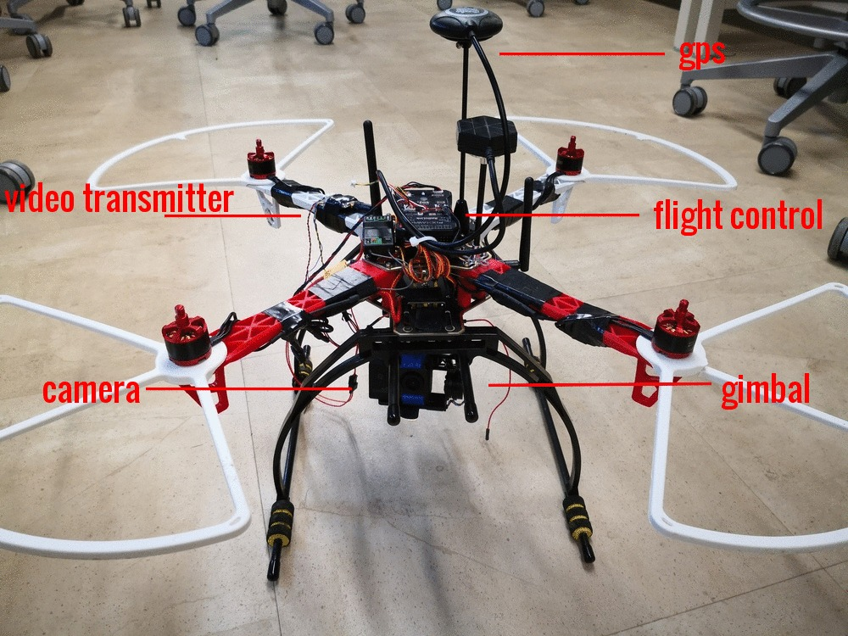

Figure 1. Drone illustrations

Ground station:

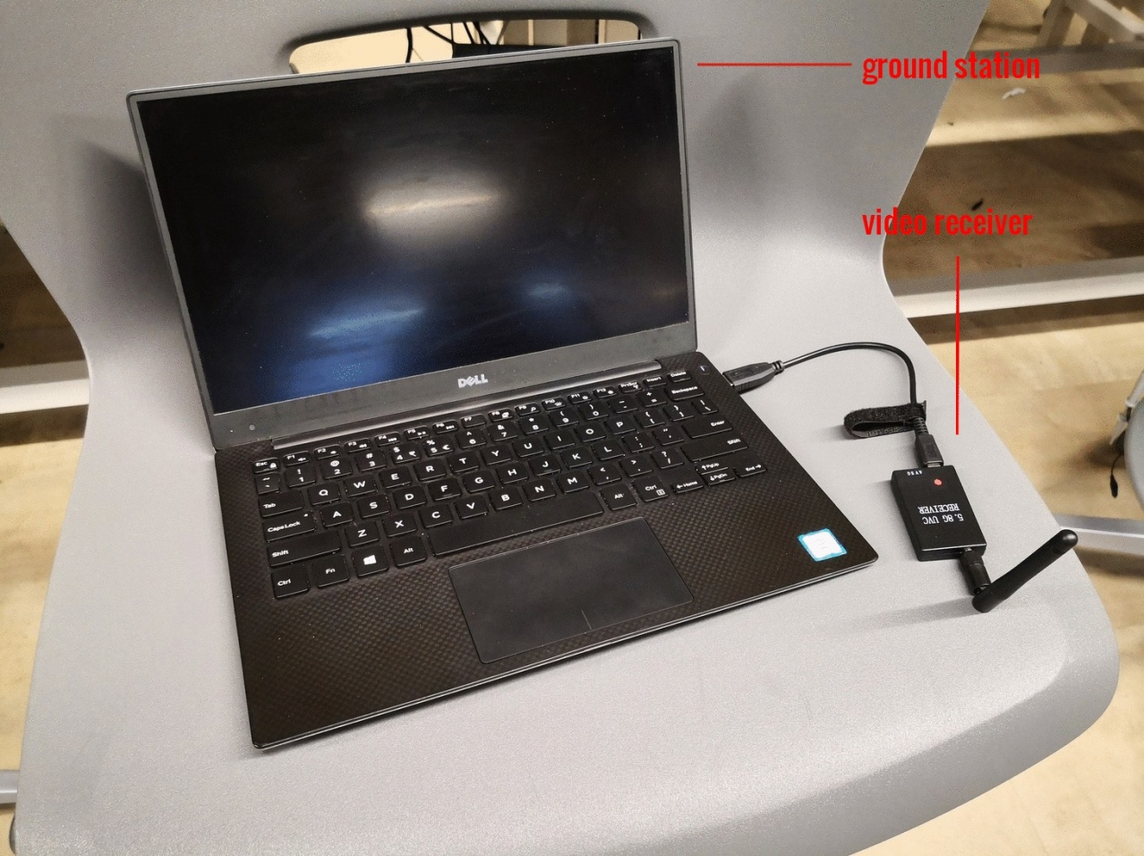

Figure 2. Ground station illustrations

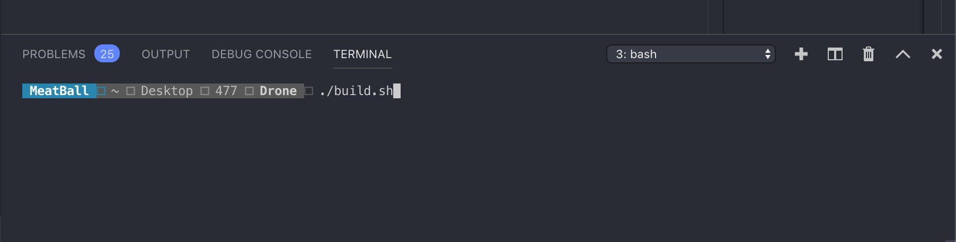

Figure 3. Booting code

Run the build shell script to build the application, the build process will start the application automatically.

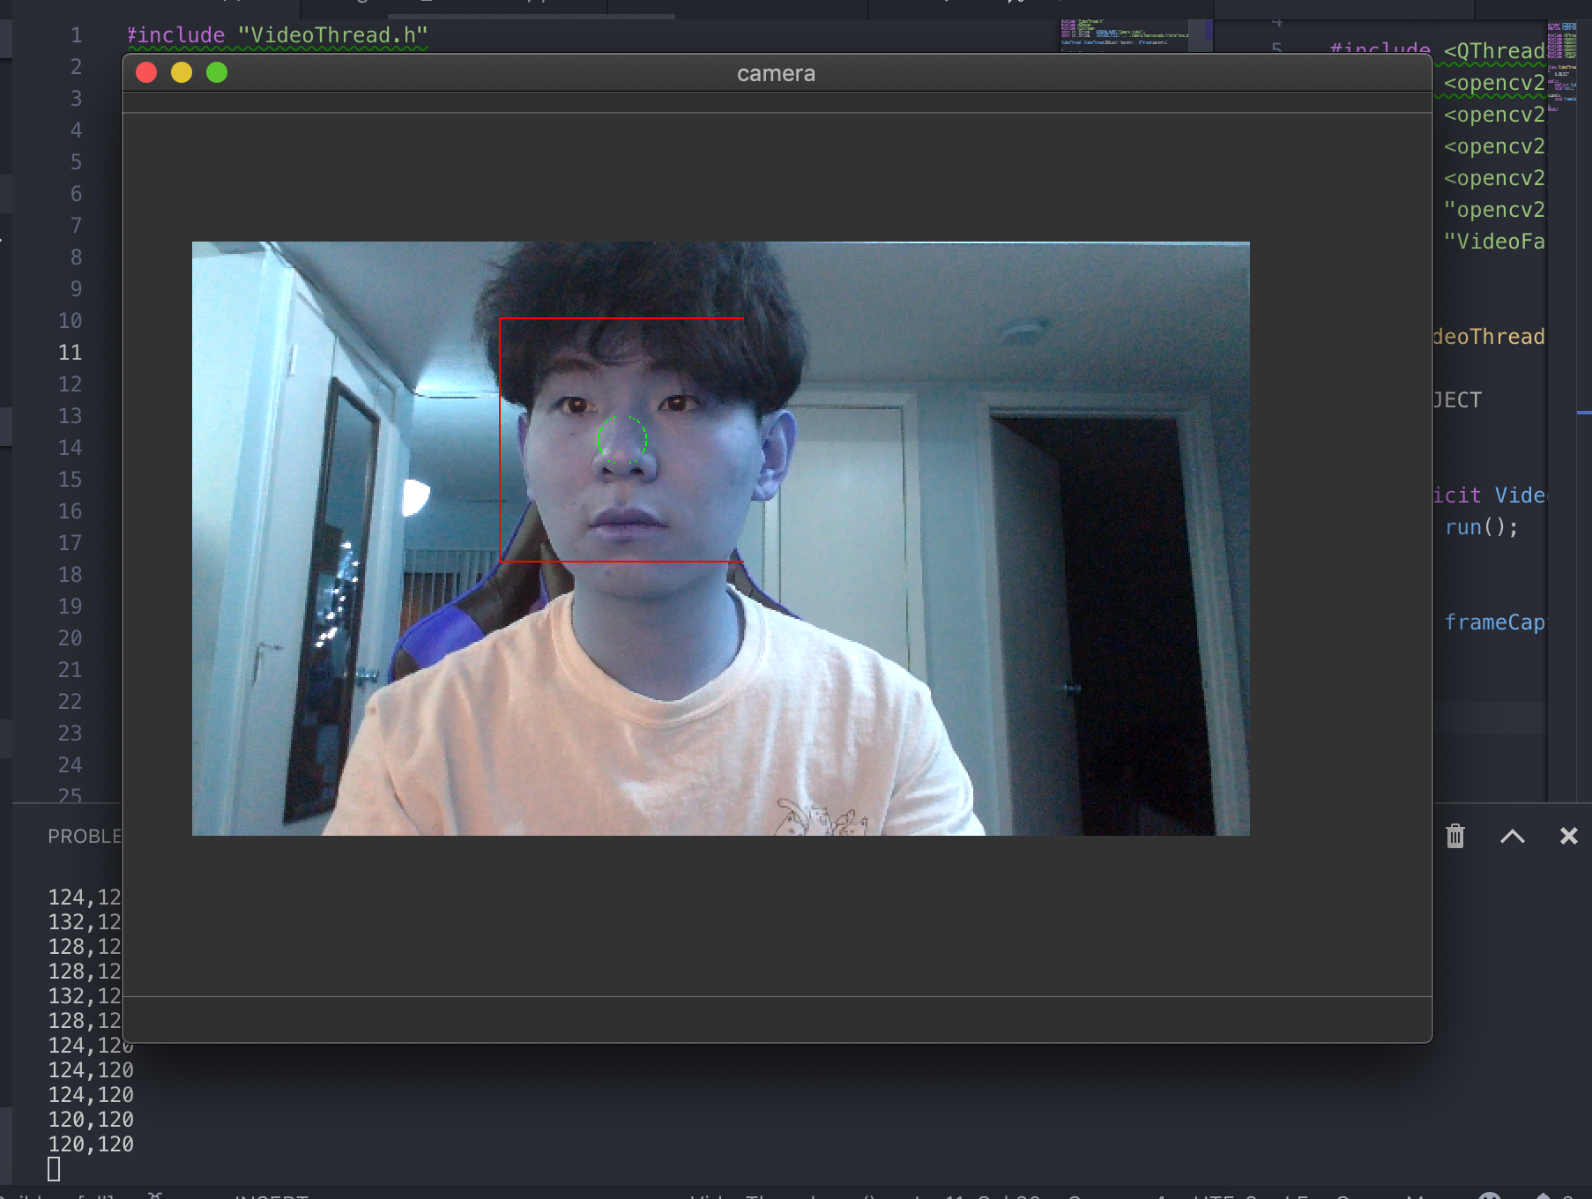

Figure 4. GUI for user

This is the monitor window and the number in the terminal shows how many pixels away from the center point.

1. Setup Instructions
2. Charge the battery with any lipo battery chargers until it is fully charged.
3. Plug the battery into the TRX connector and you should see the flight controller lights up. Place the battery in the battery docker.
4. Configure the flight controller with Mission Planner and map the switches of your controller. Be sure to assign a mode switch for your drone.
5. Press the safe button and unarm the drone.
6. Connect the video connector with the PC ground station.
7. Usage Instructions
8. First, unarm the drone and select the mode to start with. It is not recommended to start with Acro mode if you are not an experienced pilot.
9. Push the throttle and keep the camera in front of you.
10. Wait for the application in the pc prompt for facial detection.
11. After the face is recognized then switch to auto mode the drone will be following you.
12. You can land the drone by using its own auto function or manually land the drone with the controller.
13. Please be aware of the battery level since the drone will crash if it is out of battery.
14. Troubleshooting Instructions

|  |  |
| --- | --- |
| **Problem** | **Potential Solutions** |
| No video output to the Ground station | * Try searching the video signal with the video RF receiver to make sure the VTX is on the same channel with the receiver. * If the above solution doesn’t work, try checking if the camera is broken or out of battery. * Then check if the VTX is functioning properly by pressing the push button and see if the channel switch is working or not. If VTX is broken, then it needs to be replaced. |
| Drone not flying stable | * First, check if the mode is in loiter mode. The drone cannot hold its position in other modes. * Then check if the compass is broken or not, try to locate your position in the Mission Planner Application and see if the compass is working. * Calibrate your accelerometer in Mission Planner. * Check if any of the motors or ESCs fail. |
| Flight controller cannot be unarmed | * If any of your switches and throttle switch is not in the low position, the drone can’t be unarmed. * First, check if the compass is installed correctly and make sure to press the safe button. * See the error code that is shown in the Mission Planner and searches for the error code. |

Table1. Troubleshooting

We are sorry you are experiencing trouble with your face tracking drone!

24/7 Customer Support: 1-765-409-7060.