Math Meteor Defense
Presentation script for the game demo
HW1, Digital Product Development and Peer Improvement · about 3½ minutes · live demo in two browser tabs, no slides
Read the right-hand column aloud. The left-hand column says what to do and shows what the screen should look like at that moment, so you can check you are in the right place. Times are a guide.
Before class
- Open math-meteor-defense-mvp.html in the first Chrome tab and math-meteor-defense.html in the second, on the computer you will present with. Stay online so the game’s rounded font loads.
- In that browser, play waves 1 and 2 of the new version once, so wave 3 is unlocked for step 8. On another computer, skip step 8.
- Leave the speed on Normal and check the sound level in the room.
- Practise step 7. A wrong answer goes to the meteor whose answer is closest, or to the lowest one if none is close.
- The brief asks for evidence of peer improvement. If Pair A tested the game or suggested any of these changes, say so in step 3.
Script
Step · what to do · what you should see | What to say
1 Open  0:00 – 0:15  Start on the first tab, the MVP. | “Our game is called Math Meteor Defense. It’s for kids aged nine to twelve, and it practises the maths they learn in Grade 5 and 6. Meteors with sums on them fall towards a city, and you type the answer to zap them. I’ll show you our first version, and then what it looks like now.”
2 The first version  0:15 – 0:50  Point at the sidebar, then at the box at the bottom.  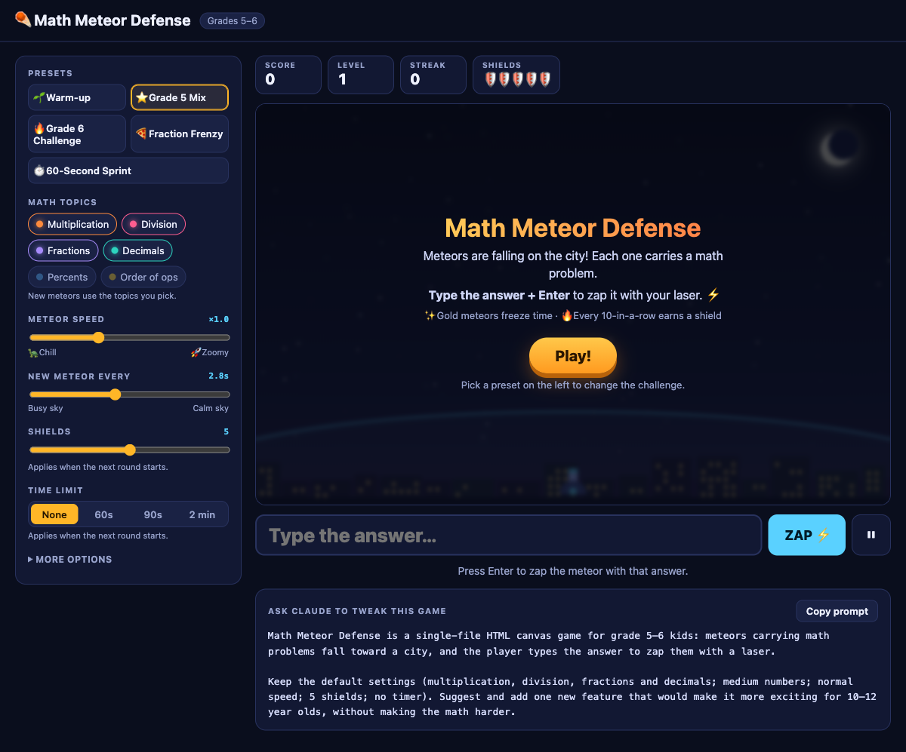  MVP: a settings dashboard, grade presets, and the “Ask Claude” box. | “This is the first version. We built it quickly with an AI coding tool, so we had something we could actually test. It works, but look at it. Half the screen is sliders, the presets are labelled Grade 5 and Grade 6, and down here there’s a box that writes instructions for the AI. That’s a tool for us, not a game for a ten-year-old.”
2 The first version, continued  Click Grade 6 Challenge, then Play. When a few meteors are down, point at the hardest sum, then type any wrong number and press Enter.  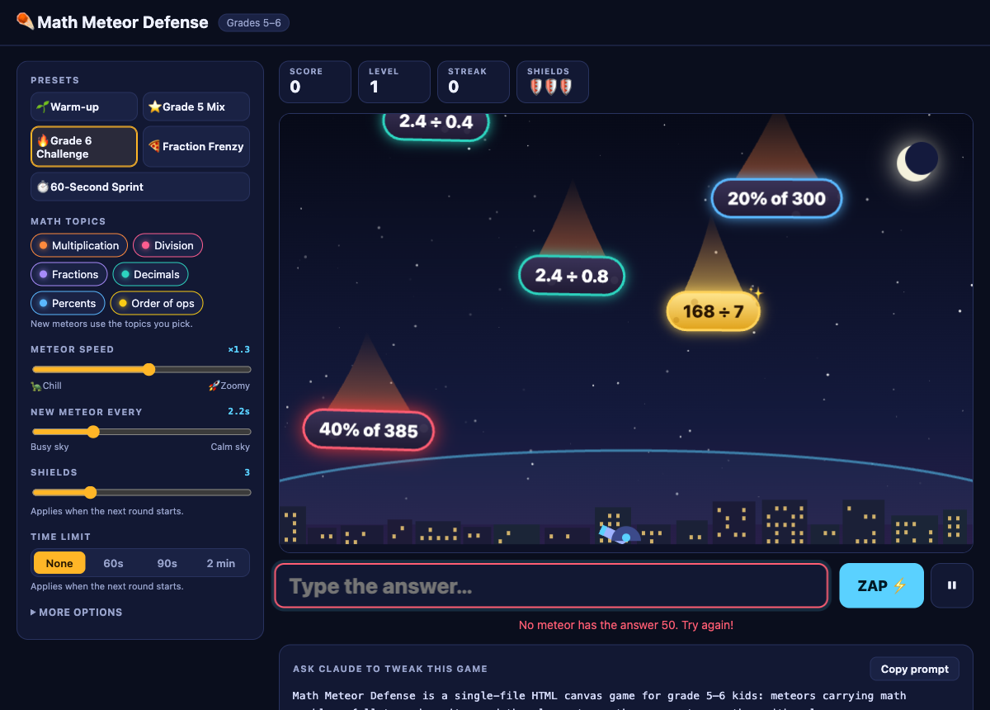  MVP: hard sums, and a wrong answer that only says “Try again!” | “The sums also get hard very quickly. Look at this one. That’s far too much for most ten-year-olds to do in their head while it falls.”  “And when I get one wrong, all it says is ‘Try again’. There’s no help at all.”
3 What we changed, and why  0:50 – 1:10  Switch to the second tab while you talk. | “So we tested it, wrote down what wasn’t working for kids, and fixed it. We took out everything that was really for us. We swapped the grade labels for waves that get harder step by step. We made the numbers friendlier. And we redrew it as a cartoon, so it feels like a game, not a dashboard.”  “Then we checked it against the brief again and found one gap: wrong answers still didn’t get a real hint. Fixing that gave us version 1.1, which is what you’ll see now.”
4 Start screen  1:10 – 1:25  Nothing to click yet.  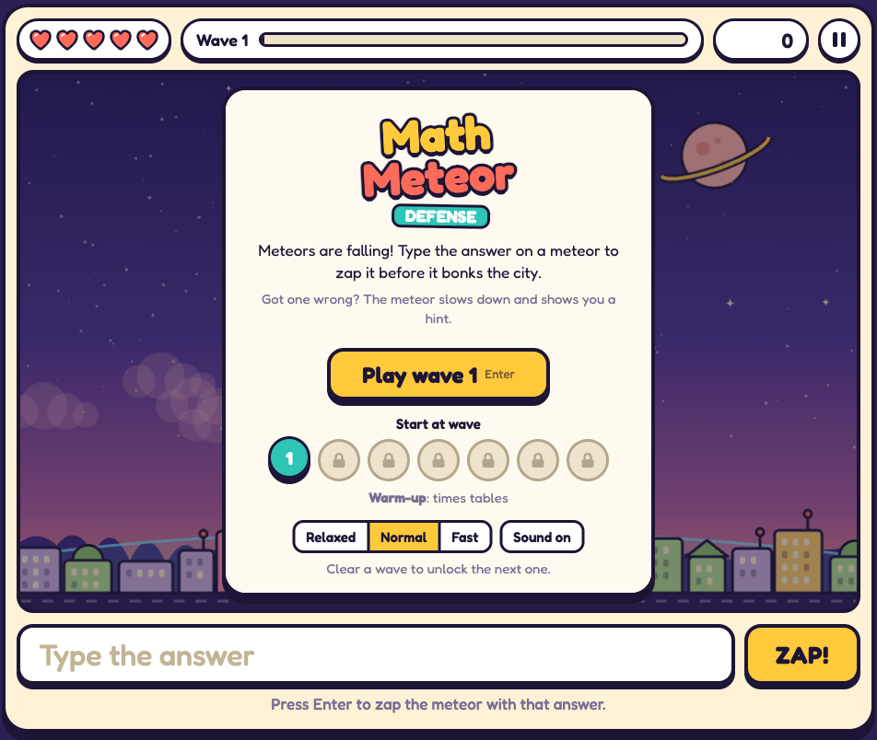  V1.1: one-line instructions, the hint line, wave picker and speed. | “This is the start screen. The instructions fit in one sentence: type the answer on a meteor to zap it. Just below, it tells you that a wrong answer gets a hint. You start at wave 1, and every wave you clear unlocks the next.”
5 One new skill per wave  1:25 – 1:40  Press Enter to play wave 1.  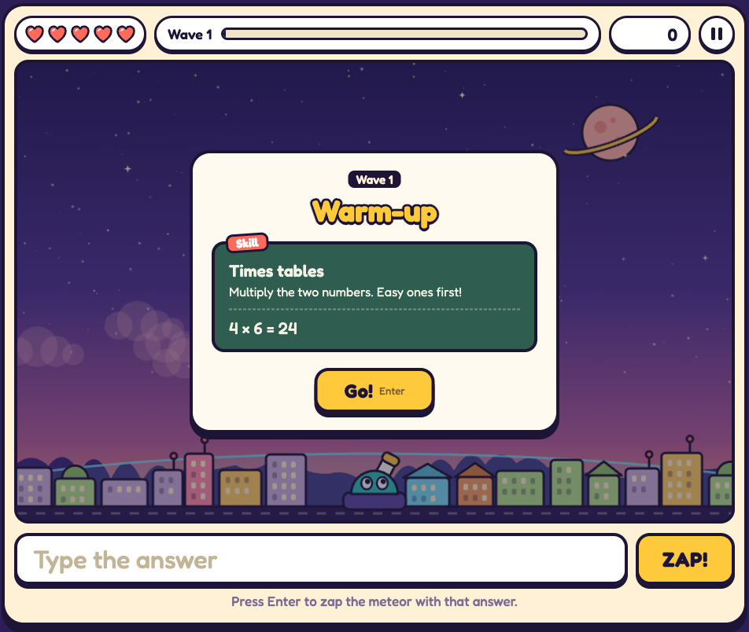  V1.1: the skill card before wave 1. | “Before each wave there’s a short card that teaches one skill, with a worked example. Wave 1 is times tables. Then come division, fractions, decimals, percents and order of operations, and the meteors get a little faster each time.”
6 Playing and scoring  1:40 – 1:55  Press Enter for Go!, then zap two or three meteors.  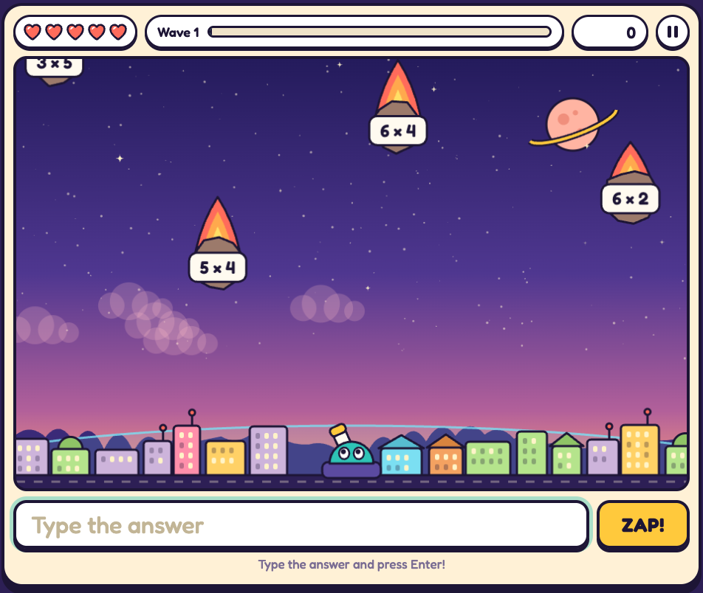  V1.1: hearts, wave progress and score along the top. | “Every meteor you zap is worth 10 points. Get five in a row and your points double, and it keeps climbing, up to four times. If a meteor reaches the city, you lose a heart.”
7 Hints for wrong answers  1:55 – 2:30  Type one more than the answer on the lowest meteor and press Enter. Then do it once more.  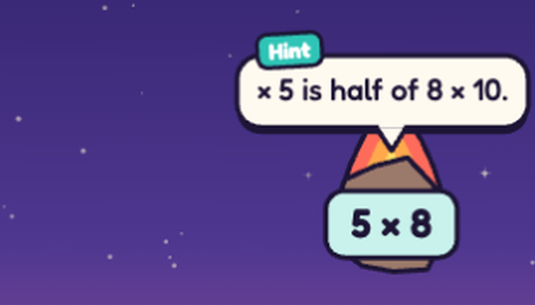  First wrong answer: a nudge.  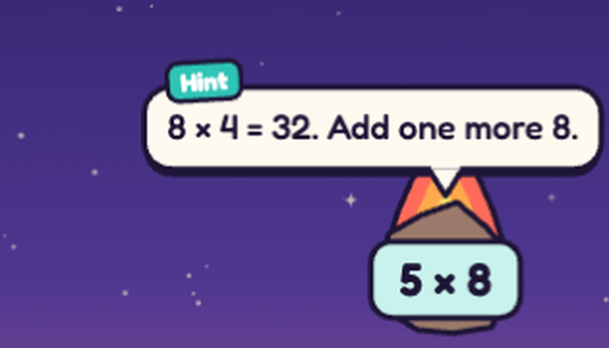  Second wrong answer: the next step. | “Now the part we added in 1.1. Watch what happens when I get one wrong. The game works out which meteor I meant, slows it down, and gives me a hint, not the answer.”  “If I’m still wrong, the hint goes one step further.”
7 Hints for wrong answers, continued  Find a times sum and type its two numbers added together, such as 8 for 6 × 2.  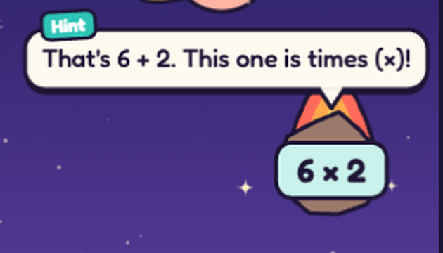  A common mistake gets its own message. | “It also knows the common mistakes. Here I added instead of multiplying, and it tells me exactly that.”
8 Harder waves (optional)  2:30 – 2:40  Only if wave 3 is unlocked: press Esc, Quit to menu, pick wave 3, Play. Otherwise go to step 9.  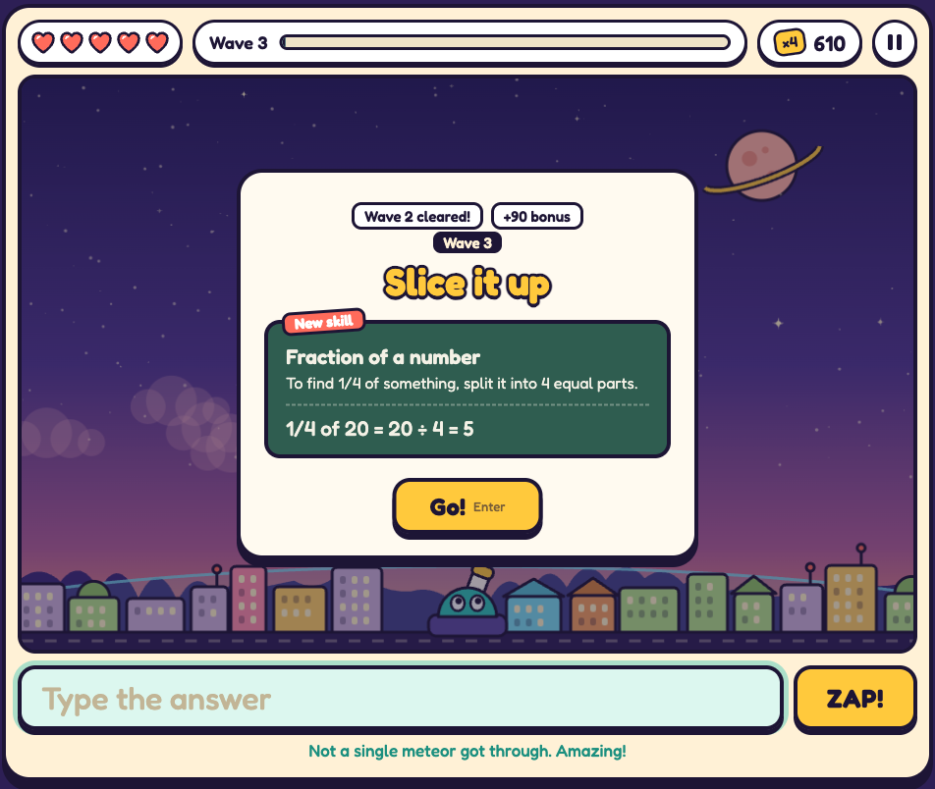  V1.1: the wave 3 card. | “Later waves bring in new topics, like fractions here, always with a worked example first.”
9 Wrap up on the final screen  2:40 – 3:20  Press Go! if you did step 8, then stop answering. The hearts run out in about 30 seconds: say the first two paragraphs while meteors fall, the last one on the results screen.  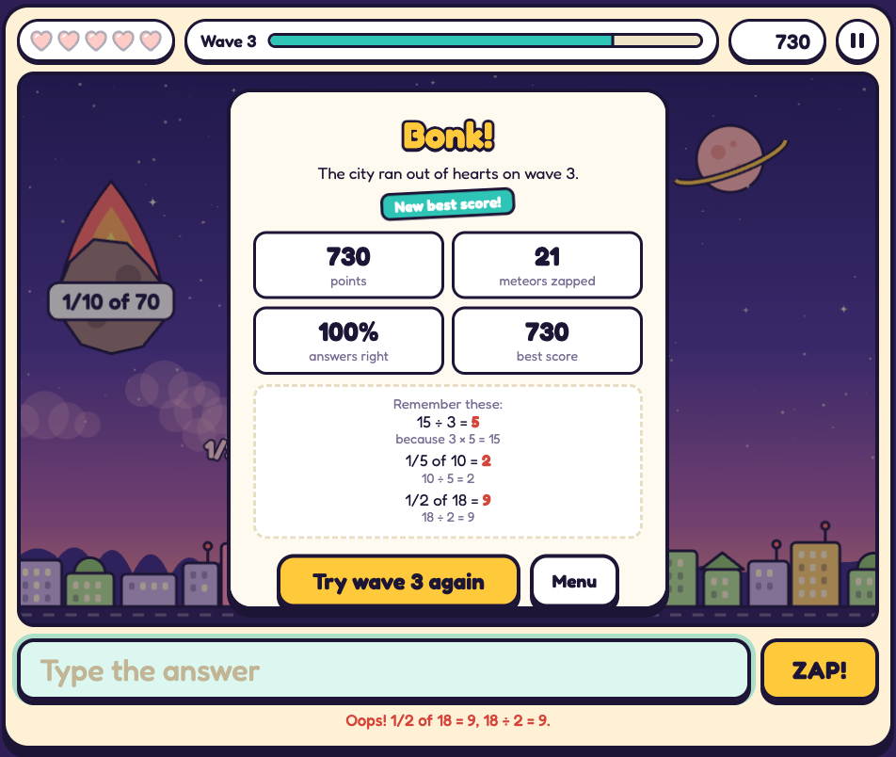  V1.1: the final screen, with the missed sums and how to work them out. | “So that’s how we worked: build something quickly, test it, fix what isn’t right for kids, and check it against the brief again. In a few rounds it went from a settings dashboard to a game a ten-year-old can just pick up and play.”  “And every time a meteor gets through, the game shows the right answer and how to work it out.”  “When the hearts run out, you get your score, how many you got right, and the sums you missed, with the answers. So even losing teaches you something. Thank you!”
What the script covers
Checked against section 3 of the HW1 brief, the Pair B game requirements, the evaluation criteria, and the lecturer’s preference for a live demo.
The brief or the lecturer asks for | Where in the script
Show Version 1.0 and the final version | Step 2 (MVP); steps 4–9 (V1.1)
Explain the development and improvement process | Steps 3 and 9
Demonstrate the product itself, no slides | Every step, in two browser tabs
A clear start screen, and instructions | Steps 4 and 5
Multiple stages, with difficulty rising over at least three levels | Steps 5 and 8
A scoring system, with scoring for correct answers | Step 6
Hints for incorrect answers | Step 7
A final screen with feedback or results | Step 9
Educational and age-appropriate | Steps 1, 3 and 5
Evidence of revision and improvement | Steps 2, 3 and 7

