User Testing Final Report
Kowloon Bus App Interface Redesign
Maze Prototype Testing + Qualitative User Feedback
Maze Version: Kowloon_bus_redesign
Study Title: Kowloon_bus_app_Maze_user_testings
Number of Participants: 9
Number of Blocks / Missions: 21
Report Generated: November 2026
Data Sources:
1. Maze Official Report (quantitative metrics, path analysis, MCQs)
2. Researcher-collected qualitative feedback & task success coding

1. Executive Summary
This report consolidates quantitative usability metrics from the Maze platform with qualitative observations and user feedback collected during moderated testing of a redesigned Kowloon Bus (KMB) mobile application prototype. Nine participants completed a structured set of tasks covering core functions: reading bus information, saving stations, checking saved stations, searching routes, finding nearby bus stations, using the map, locating landmarks, and adjusting text size.
Overall satisfaction was high: 89% rated the new version “Good” and 11% “Very Good”. No participants rated the experience as Moderate, Bad, or Really Bad. Task success rates (Maze definition) were generally strong (most missions ≥88.9%), although several flows exhibited high misclick rates and non-expected-path completions, revealing discoverability and affordance issues.
Key friction points identified across both data sources include: (1) low discoverability of the station-saving interaction (expected-path success only 22.2%), (2) confusion between walking time and total trip time in route search results, (3) hidden or non-salient map and text-size controls, and (4) occasional obstruction of UI elements by instructional overlays.

2. Method

2.1 Participants
Nine participants completed the full test protocol. All testing was conducted in English. Location services were required to be enabled.

2.2 Test Platform & Protocol
Testing was conducted on the Maze platform using an interactive prototype (version: Kowloon_bus_redesign). The study contained 21 blocks comprising onboarding, multiple prototype-test missions, and multiple-choice knowledge / ease-of-use questions. Average durations and misclick rates were automatically logged by Maze.
In parallel, the researcher coded each task outcome using three categories:
- Direct success – participant completed the task via the intended path without assistance.
- Indirect success – participant eventually succeeded but via a non-optimal or exploratory path.
- Failed trial – participant could not complete the task or abandoned it.
Post-task ease ratings and free-form verbal feedback were also recorded by the researcher.

2.3 Missions Overview (Maze)
The primary missions evaluated were:
- Let’s get started! (Onboarding)
- When will the next Bus No.8 arrive?
- Take a ride on Bus No.8 (full-route duration)
- Save Cross Harbour Tunnel Station
- Have a check of your saved stations
- From Hung Hom Station to Argyle Centre (route search)
- Find bus stations nearby
- Use a map and take a look around
- Find landmarks around me
- Adjust the size of texts + verify Bus No.116 arrival

3. Overall Results

3.1 Aggregate Satisfaction
Final overall rating of the new Kowloon Bus interface:
Rating | Percentage | Count (n=9)
Very Good | 11% | 1
Good | 89% | 8
Moderate | 0% | 0
Bad / Really Bad | 0% | 0

Maze overall usability score for the study: 71 (out of 100).

3.2 Task Success Summary (Researcher Coding)
The table below merges researcher-coded outcomes with Maze success rates. Direct + Indirect success ≈ Maze success rate in most cases; discrepancies arise when participants reached the goal via unexpected paths.
Task | Direct | Indirect | Failed | Maze Success
Read bus information | 9 | 0 | 0 | 100%
Save Cross Harbour Tunnel | 2 | 6 | 1 | 88.9%
Check saved stations | 7 | 1 | 1 | 88.9%
Search route | 8 | 1 | 0 | 100%
Find bus stations | 4 | 5 | 0 | 100%
Check out the map | 6 | 3 | 0 | 100%
Find landmarks | 8 | 0 | 1 | 88.9%
Adjust text size | 6 | 3 | 0 | 100%

Note: Maze “Success rate” reflects completion of the mission (reaching the goal screen). The Expected-path rate (shown in later sections) is often lower, indicating that many users succeeded via alternative routes.

4. Detailed Mission-by-Mission Analysis

4.1 Onboarding – “Let’s get started!”
Mission score: 91 | Avg. duration: 33.1 s | Success rate: 100% | Drop-off: 0% | Misclick rate: 73.5%
All nine participants completed onboarding. High misclick rate on the welcome screen (56% on Screen 1) suggests users explored language options or feature descriptions before tapping “Get started”. Location-permission screen performed cleanly (0% misclicks).

4.2 Read Bus Information (Bus No.8 arrival)
Researcher coding: Direct 9 / Indirect 0 / Failed 0. Ease: Really Easy 44%, Easy 44%, Moderate 11%.
Maze MCQ accuracy: 100% (all 9 selected “After 5 min”).
This was the strongest task. Information hierarchy on the home / favourites cards is clear for simple arrival-time queries.

4.3 Take a Ride on Bus No.8 – Full Route Duration
Mission score: 84 | Avg. duration: 16.5 s | Success rate: 100% | Misclick rate: 25%
MCQ: “How long does it take from the first station to terminal?” → 27 min (correct) selected by 78% (7/9); 22% (2 users) selected 5 min (confused arrival time with total trip time).
Qualitative note: Two users mistook the live arrival countdown for the full-route duration. Clearer visual separation of “Next arrival” vs “Full journey time” is recommended.

4.4 Save Cross Harbour Tunnel Station
Mission score: 43 | Avg. duration: 38.3 s | Maze Success: 88.9% | Drop-off: 11.1% | Misclick rate: 54.5%
Expected-path completion: only 22.2% — the lowest in the study.
Researcher coding: Direct 2, Indirect 6, Failed 1.
Ease ratings: Really Easy 33%, Easy 22%, Moderate 22%, A Little Difficult 22%.
Qualitative feedback (verbatim themes):
- “Not intuitive. Don’t know that the station inside the column is interactive and can therefore lead to the saving process of target station.” (Indirect & Failed)
- “Thought the stations can be searched then saved.” (Indirect)
Path analysis shows heavy drop-off after the home screen and expanded route. The “Save this stop” control on the stop-detail card is not sufficiently salient. Users expected a more conventional search-then-save or long-press pattern.

4.5 Check Saved Stations
Mission score: 83 | Avg. duration: 6.3 s | Success: 88.9% | Drop-off: 11.1% | Misclick: 61.7%
Expected-path rate: 77.8%.
Researcher coding: Direct 7, Indirect 1, Failed 1.
Qualitative feedback:
- “The ‘Saved’ button was obstructed by the bottom of the instructions.” (Failed)
- “Thought the saved stations can directly be checked in ‘My Favorite’ column in the home page.” (Indirect)
The instructional overlay temporarily blocked the target control for at least one participant — a classic testing artefact that should be mitigated in future Maze configurations.

4.6 Search Route (Hung Hom → Argyle Centre)
Mission score: 68 | Avg. duration: 31.3 s | Success: 100% | Misclick: 55.8%
Expected-path rate: 88.9%.
Researcher coding: Direct 8, Indirect 1, Failed 0.
Ease: Easy 56%, Really Easy 44%.
MCQ – Recommended bus & walking time: only 33% accuracy. Six users mistook walking time for total trip time; one user explicitly requested “a page with less distracting or redundant information”.
Qualitative feedback:
- “Thought Search function should be bound with Map function.” (Indirect)
The results card presentation of time components (walking vs in-vehicle vs total) requires redesign for clearer scanning.

4.7 Find Bus Stations Nearby
Mission score: 44 | Avg. duration: 31.2 s | Success: 100% | Misclick: 38.7%
Expected-path rate: only 44.4% — second-lowest expected-path performance.
Researcher coding: Direct 4, Indirect 5, Failed 0.
Ease (Nearby function overall): Easy 44%, Really Easy 33%, Moderate 22%.
MCQ – Which bus arrives first: 89% correct (Bus No.101); one user selected Bus No.8.
Qualitative feedback:
- “Thought the details can be checked through the map.” (Indirect)
- “Didn’t pay attention to the buttons at the bottom. Thought the stations can be checked through the map.” (Indirect)
Users expected map-centric discovery; the list-first Nearby view was not the mental model for several participants.

4.8 Use a Map and Take a Look Around
Mission score: 78 | Avg. duration: 17.2 s | Success: 100% | Misclick: 15.4%
Expected-path rate: 66.7%.
Researcher coding: Direct 6, Indirect 3, Failed 0.
Qualitative feedback:
- “Forgot the small Map View button at the home page. Thought the map can be opened through an obvious button hidden inside the buttons underneath.” (Indirect)
Map entry point is under-emphasized.

4.9 Find Landmarks Around Me
Mission score: 76 | Avg. duration: 10.6 s | Success: 88.9% | Drop-off: 11.1% | Misclick: 60.6%
Expected-path rate: 88.9%.
Researcher coding: Direct 8, Indirect 0, Failed 1.
MCQ – Which bus to Queen Elizabeth Hospital: 100% (both No.11K and No.116 correctly identified by all).
Qualitative feedback:
- “Thought the landmarks should be found on Map, but failed to click anything because of no responses from the app (This is normal because it is just a prototype with certain testing routes).” (Failed)
Prototype limitations affected one participant; overall landmark discovery was acceptable once the correct entry point was found.

4.10 Adjust Text Size
Mission score: 71 | Avg. duration: 31.6 s | Success: 100% | Misclick: 37.3%
Expected-path rate: 66.7%.
Researcher coding: Direct 6, Indirect 3, Failed 0.
Ease: Really Easy 56%, Easy 22%, Moderate 22%.
Post-adjustment MCQ (Bus No.116 arrival): 100% correct (“After 9 min”).

Qualitative feedback:
- “Don’t know they need to enter ‘More’ page to adjust text size.” (Indirect)
- “Thought the text size can be pinched open, but tapped Map View by accident and thus entered Map page.” (Indirect)
Accessibility settings buried under “More” reduce discoverability. Pinch-to-zoom expectation is strong among mobile users.

5. Multiple-Choice Knowledge Accuracy
The following table summarises objective comprehension of information presented by the interface.
Question | Accuracy | Notes
When will next Bus No.8 arrive? | 100% | All correct
Full route duration of Bus No.8 | 78% | 2 confused with arrival
Recommended bus + walking time | 33% | 6 confused walk vs total
Which bus arrives first (Nearby) | 89% | 1 misjudged No.8
Bus(es) to Queen Elizabeth Hospital | 100% | Both 11K & 116
When will next Bus No.116 arrive? | 100% | After text-size change

6. Key Findings & Design Implications
Synthesising Maze quantitative data with qualitative feedback yields the following prioritised issues:
High-priority issues
- Station saving affordance is weak. Only 22.2% followed the expected path. Users do not realise list items are tappable for save actions. Recommendation: add explicit “Save” icon or long-press menu, and surface saved status more prominently.
- Time-component confusion in search results (walking time vs total trip time) produced the lowest MCQ accuracy (33%). Recommendation: restructure result cards with clearer labels, visual hierarchy, and optional “Details” expansion.
- Map entry point lacks salience. Users looked for a more obvious map button. Recommendation: elevate Map View to a primary navigation or floating action.
Medium-priority issues
- Text-size control is buried under “More”. Users expected system-level pinch or an accessibility shortcut. Recommendation: expose text-size control on the home screen or settings quick panel.
- Nearby list vs map mental model mismatch. Several users ignored bottom navigation and expected map-first discovery.
- Instructional overlays occasionally obstructed interactive elements during testing.
Positive findings
- Core information lookup (arrival times, hospital routes) achieved near-perfect accuracy once users reached the correct screens.
- Overall affective response is strongly positive (100% Good or Very Good).
- No catastrophic failures; even low-expected-path missions eventually reached high overall success rates.

7. Appendix – Selected Maze Screenshots
Representative screens from the Maze report are included below for reference. Full 50-page official report is available separately.
Figure 1. Onboarding – Welcome screen (Screen 1)
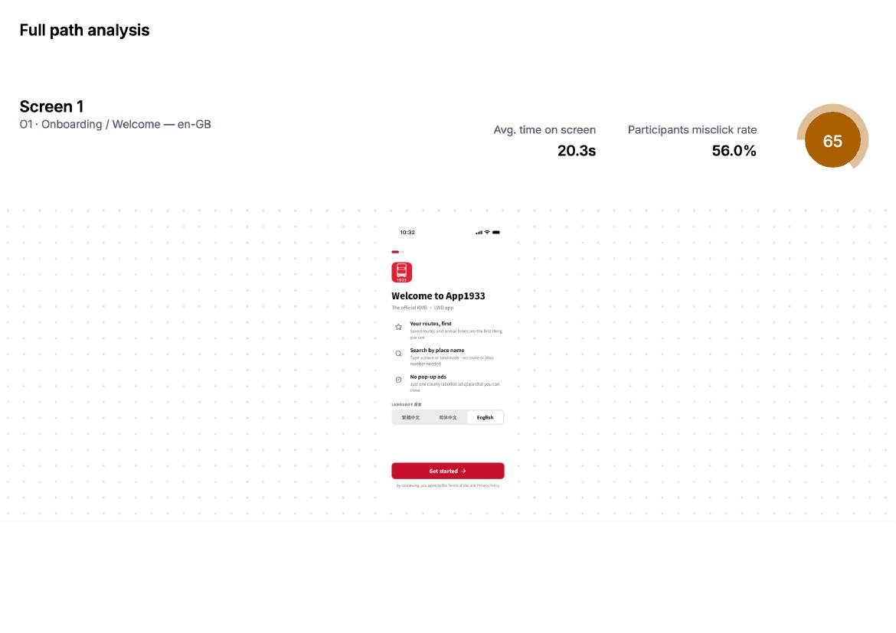
Figure 2. Location permission screen
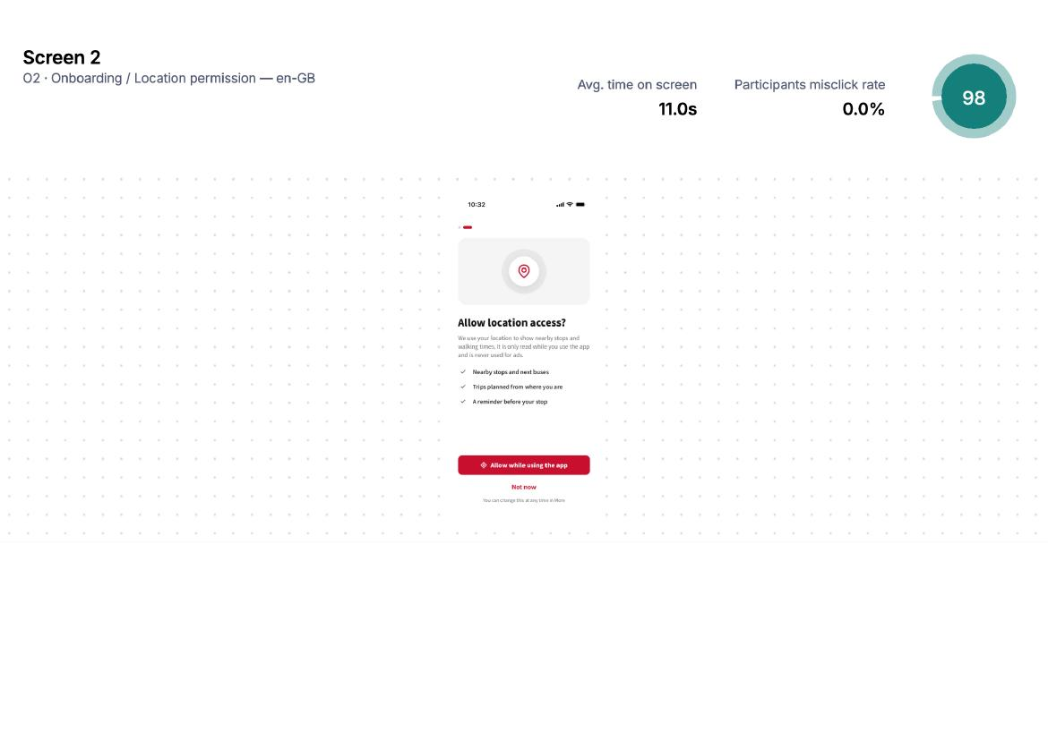

Figure 3. Home screen with Favourites and Nearby (example from path analysis)
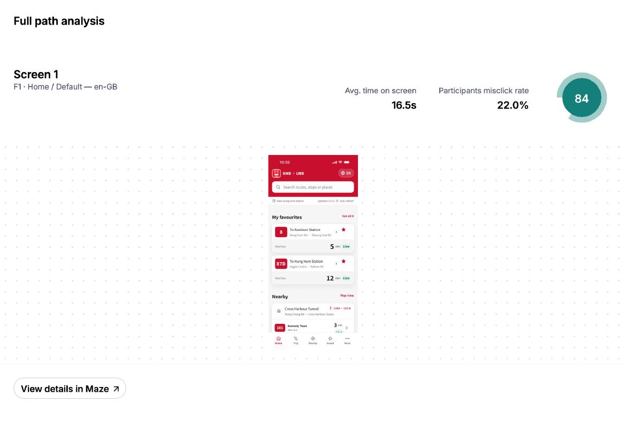
Figure 4. Save Cross Harbour Tunnel – Mission overview (score 43, high misclick)
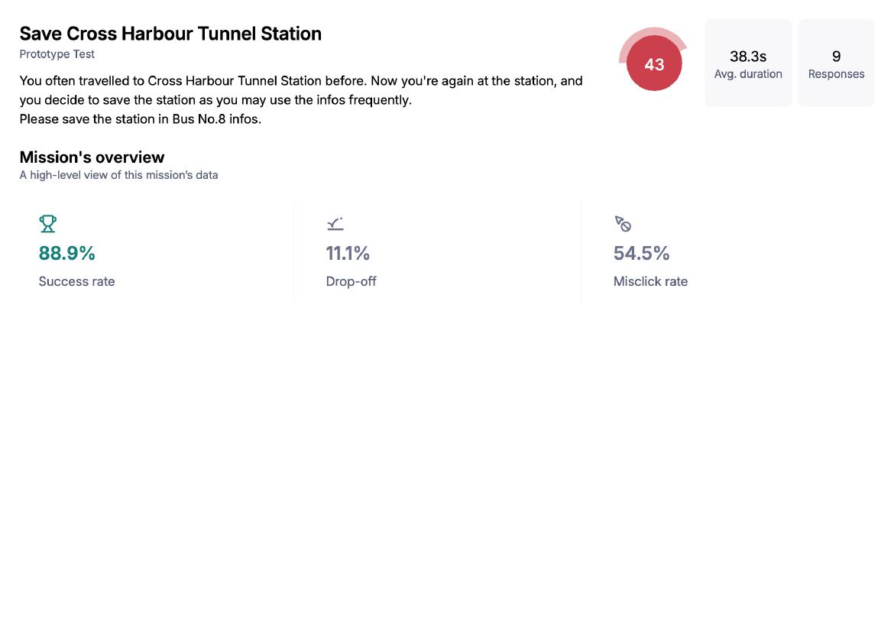
Figure 5. Save Station – Expected-path success only 22.2%
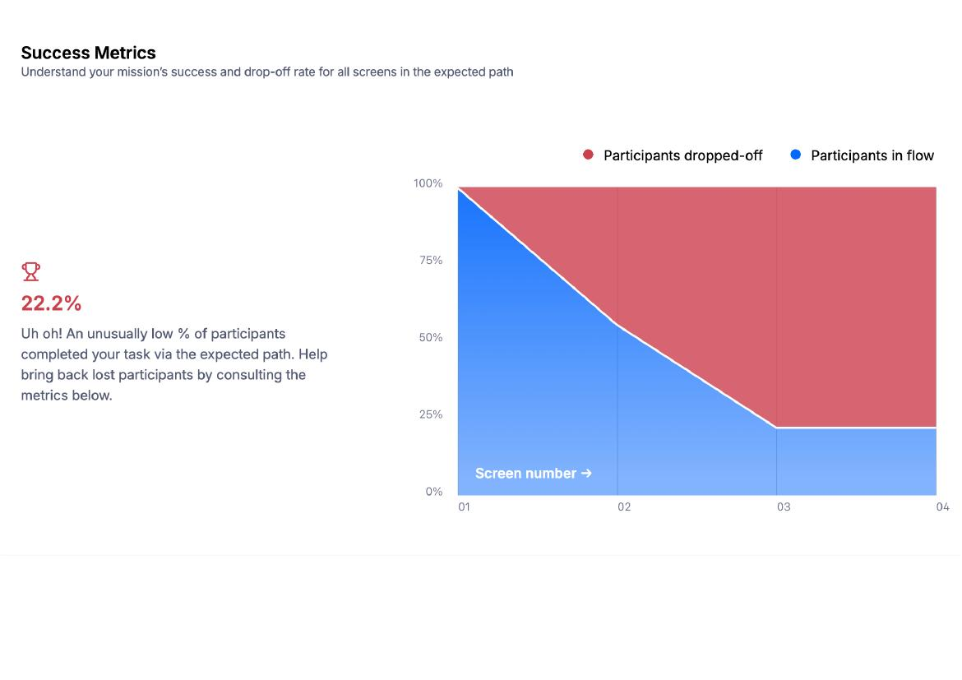
Figure 6. Route / Stop detail screen showing “Save this stop” control
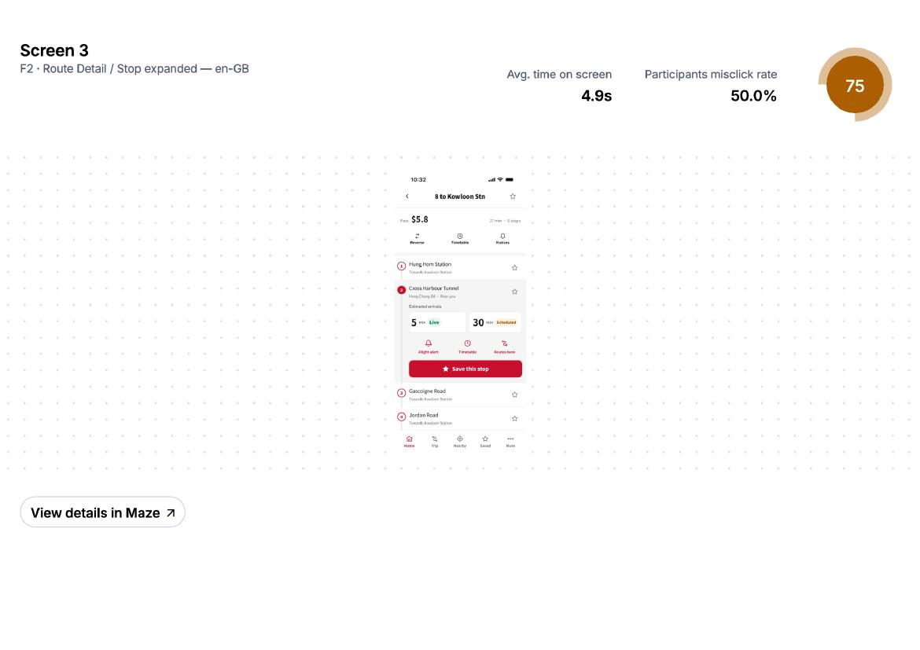

Figure 7. Route search MCQ – walking time vs total time confusion (33% accuracy)
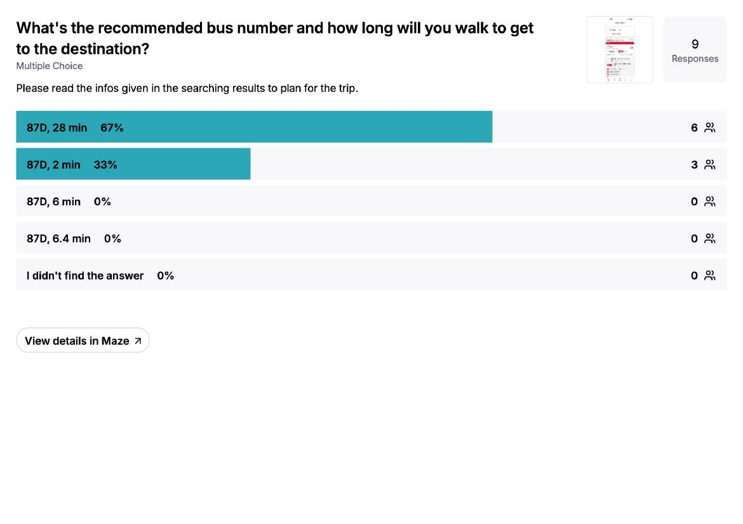
Figure 8. Find bus stations nearby – Expected-path rate 44.4%
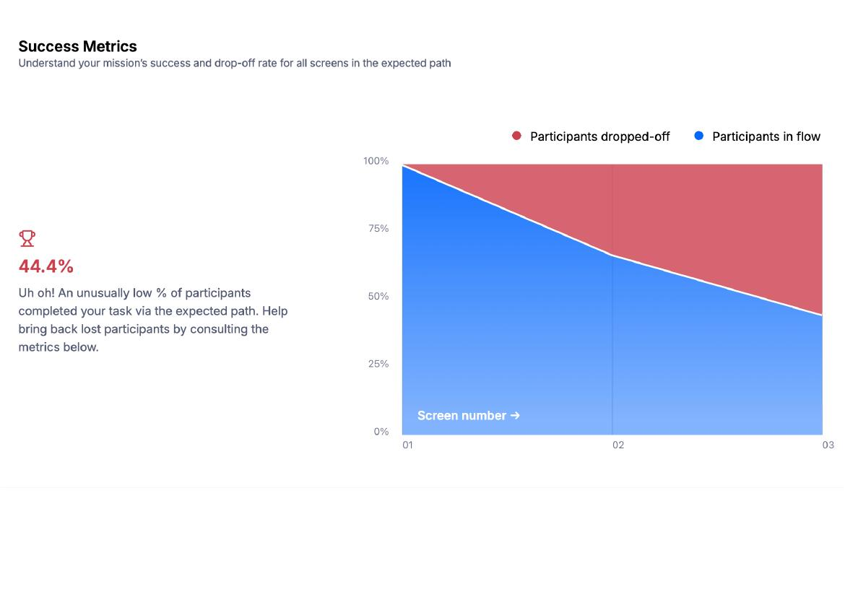
Figure 9. Overall satisfaction – 89% Good, 11% Very Good
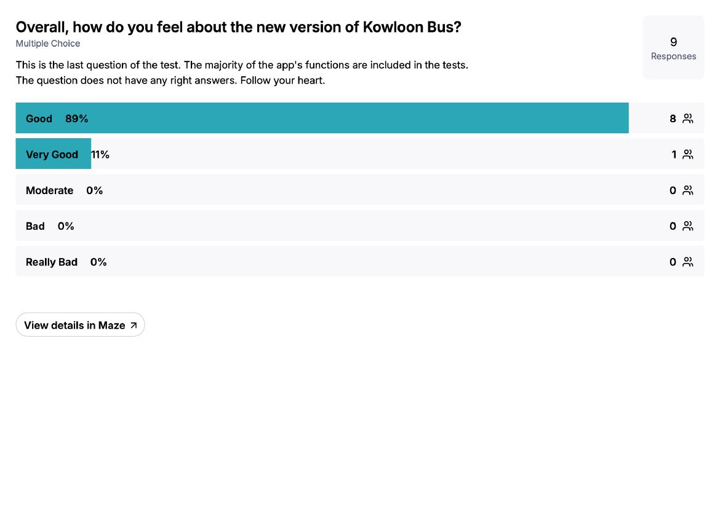
End of Report. All quantitative figures are taken directly from the Maze official report. Qualitative statements are transcribed from researcher notes of participant comments. No data have been fabricated or altered.

