COMP3423 Human Computer Interaction · Group Project Report
Re-designing App1933
A new mobile interface for KMB and LWB bus passengers, built around one question: when is my bus coming?
Group A21
The Hong Kong Polytechnic University · Semester 1, 2026/27 · Submitted 15 November 2026
Workload declaration
Name | SID | Role | Key tasks
Haochen Fa* | 24113347D | Project Lead & UX Strategist | Timeline and coordination; expanded the first design into the full bilingual screen set (Table 5.4); HCI-principle mapping (Table 3.1); Introduction and Conclusion (Sections 1, 6); final QA
Chenyang Zhang | 25091317D | User Researcher | Target users and dual-track journey map (Section 3.2, Figure 3.1); Maze test design, recruitment and running; Testing section (Section 5); Appendices A and B
Xulu Zhang | SID | Interaction Designer | Information architecture and site map (Section 3.3, Figure 3.2); prototype structure, states and variables (Table 5.4, 2 Nov); walkthrough (Section 3.4, Figure 3.3)
Li-En Lo | 24109751D | Visual & UI Designer | Wireframe sketch and first high-fidelity screens (Figure 5.2, v1); visual language and style guide (Section 3.6, Figure 3.4); PPT design
Moling Kong | 24103622D | Accessibility & Evaluation Lead | Heuristic evaluation of the existing app (Section 4); accessibility audit (Appendix D); accessibility accommodations and 200% checks (Section 3.7; Table 5.4, 3–5 Nov)
* Group leader
Links (publicly viewable)
Figma design file | https://www.figma.com/design/2JkOkm1pztoaZask0fDJeq/APP1933-KMB.LWB-Redesign?node-id=0-1
Clickable prototype | https://www.figma.com/proto/2JkOkm1pztoaZask0fDJeq/APP1933-KMB.LWB-Redesign?node-id=26-1387&starting-point-node-id=26%3A1387
Maze report | https://app.maze.co/report/Kowloon_bus_redesign/oBtJvOVQD-qXRtWj33TtgofbHD7gVvM9/intro

1. Introduction

1.1 The application and its context
App1933 is the official mobile app of Kowloon Motor Bus (KMB) and Long Win Bus (LWB). KMB runs bus routes across Kowloon and the New Territories, and LWB runs routes to North Lantau and the airport. The app's job is easy to state. Most of the time, people open it to find out when their bus will arrive; less often, they look up a route, plan a trip to a place or look for a stop nearby. We studied version 2.3.38 for iOS and checked our findings on an iPhone running version 2.3.39 in November 2026.

1.2 Target users
We design for two groups identified in our checkpoint research (Figure 3.1):
- Older passengers. Many do not know route numbers or stop codes, find small text hard to read, and can mistake a sudden full-screen advert for a scam. Among older Hong Kong adults, ability, confidence and anxiety predict technology use more strongly than perceived usefulness (Chen & Chan, 2014), so an app that feels unpredictable or hard to read loses this group even when it holds the information they need.
- Students and daily commuters. They are confident smartphone users, short of time and often using the phone with one hand while walking. They want their usual route and its next arrival without extra steps.

1.3 Problem statement
The existing interface makes both groups work too hard for the one thing they open it for. On opening, a full-screen advert appears whose skip button is about 6% of the screen width. Home leads with a rotating promotion banner, and a floating button covers part of the arrival list. Search accepts only route numbers, so a passenger who knows the destination but not the bus cannot start. Saving a stop takes seven taps through an unlabelled ≡ icon. Arrival times on Home do not say whether they are live estimates or timetable entries. There is also no way to enlarge text: the app has no text-size setting and ignores the iPhone's own text size (Appendix D). Section 4 shows each problem in annotated screenshots of the real app.

1.4 Why App1933
App1933 is an everyday app in Hong Kong whose users range from secondary-school students to retirees, which makes it a fair test of designing for very different people at once. Its problems are also typical of transit apps: advertising competes with time-critical information, search follows the operator's data rather than the passenger's way of thinking, and accessibility is left to the phone.

1.5 Scope
We redesigned the five features in Table 1.1, one per team member. Each covers a stage of the passenger journey and is tested by at least one Maze task. The scope is realistic for five students in eight weeks because we redesign the interface, not the service. The prototype uses simulated arrival times, timetables and fares, keeps the app's existing functions, and removes only what competes with the main task: pop-up adverts and the Games tab.
Table 1.1. The five redesigned features.
Code | Feature | Main change | Maze blocks
F1 | Home | Saved routes first; every arrival labelled Live or Scheduled; no pop-up adverts | 2–5
F2 | One-tap save and route detail | 44 pt ☆ on every stop; a labelled save button; Undo instead of a pop-up | 6–8
F3 | Trip planning | Search by place name; origin preset to the current location; corrections that are shown and can be undone | 9–11
F4 | Nearby stops and landmarks | Stops by street, walking time and next bus; landmarks with category and buses | 12–17
F5 | More menu and accessibility | Grouped settings; text size in three steps labelled 100%, 150% and 200%; high contrast; calm mode | 18–20

2. Related Work
We drew on 18 sources: six on HCI theory, five on real-time transit information and intrusive interfaces, and seven on touch input, older adults and accessibility standards. Rather than summarise them one at a time, we group them by the design question they helped us answer, note where they disagree or fall short, and end each theme with the decision it led to. Table 2.1 maps every source to the features it informs.

2.1 Real-time information and trust (F1, F4)
Real-time arrival information helps passengers in measurable ways. In a survey of 488 users of OneBusAway in Seattle, 91% said they spent less time waiting and 92% were more satisfied with public transit (Ferris et al., 2010). At bus stops, riders without real-time information overestimated how long they had waited, while riders using it did not, and they actually waited almost two minutes less (Watkins et al., 2011). A later review finds the same pattern across many cities: shorter waits, better route choices and more use of transit (Brakewood & Watkins, 2019).
The evidence is narrower than these figures suggest. Two of the three sources come from one project with mostly young, self-selected users. Ferris et al. also found smaller satisfaction gains among older respondents, and inaccurate data was the most common complaint. The benefit therefore depends on riders trusting the numbers, and it does not reach older riders by default. We found no peer-reviewed usability study of a Hong Kong bus app, so we treat these results as principles to transfer rather than local proof.
Design consequence. F1 puts saved routes and their next arrival first and labels every time Live or Scheduled, so riders know which numbers to trust. F4 shows walking time and the next buses on each nearby stop, so riders can judge whether another stop is worth the walk.

2.2 Interruptions, adverts and dark patterns (F1, F5)
Edwards et al. (2002) found that forced pop-up adverts feel most intrusive when people are absorbed in a task, and that intrusiveness leads to irritation and avoidance. Opening a bus app to catch a bus is exactly that kind of moment. Gray et al. (2018) go further and classify persistent interruptions of this kind ("nagging") as a dark pattern, which makes them an ethical problem as well as a usability one. Guidelines for older users independently rule out pop-up and animated adverts (Zaphiris et al., 2005).
The sources differ on what to do instead. Edwards et al. found that adverts related to the user's task felt less intrusive, so the evidence argues against forced interruption rather than against advertising as such. That matters here, because the operator earns advertising income and a design that removed every advert would not be realistic.
Design consequence. F1 removes the launch advert and all pop-ups but keeps one labelled, closable "Ad · Sponsored" card at the end of Home. Calm mode in F5 ("Fewer animations, ads and extras") goes further for those who want it.

2.3 Choice, density and redundancy (F3, F5, tab bar)
Hick (1952) showed that choice reaction time grows with the logarithm of the number of alternatives. Nielsen's (1994) heuristic of aesthetic and minimalist design (H8) and the ageing guidelines of Zaphiris et al. (2005), which ask for fewer choices and no irrelevant information, reach similar advice from practice and from a literature review. Hick's participants, however, chose between equally likely options they had not practised. In a familiar menu, grouping and clear labels matter as much as the raw number of items, so we grouped settings under headings rather than only cutting them.
Chandler and Sweller (1991) add a caution: in their experiments, material that seemed useful but was not essential made understanding worse, even when it was well integrated. Their tasks were learning tasks rather than glances at a phone, but the warning applies to any screen that repeats information. We kept it in mind on the trip results card (F3A), which leads with the number people decide on, the total journey time, and states the walk once in the summary and once in the step list. Section 5.3 discusses whether this repetition explains the low score on the walking-time question; the evidence points more to the question's wording.
Design consequence. F5 replaces 26 unsorted icons with three headed groups, and the tab bar keeps five tabs; we decline the idea of a sixth tab for the map (Section 5.3). F3A leads with the total time and lists the legs beneath it.

2.4 Signifiers, feedback and reversible actions (F2, F3)
Norman (2013) separates what an interface allows (affordances) from what it shows (signifiers): an action can exist and still go unused if nothing signals it. On safeguards for everyday actions, three sources agree. Shneiderman et al. (2016) include easy reversal of actions among their eight golden rules because it relieves anxiety; Nielsen's user control and freedom (H3) makes the same point; and WCAG 2.2 lists reversibility as one of three acceptable safeguards against errors (criterion 3.3.4; World Wide Web Consortium [W3C], 2024). For a low-stakes action such as saving a stop, undo is faster than a confirmation dialog and just as safe.
Undo only helps once the user has found the action, though, and our test shows the gap. Once participants reached the route screen they saved the stop without trouble, but only two of nine got there by the expected path, because the tappable route card on Home gave no sign that it led there (Section 5.3).
Design consequence. F2 gives saving two visible signifiers, a labelled "Save this stop" button and a ☆ on every stop, with immediate feedback and Undo instead of a dialog. F3's spelling correction says what it changed and can be reversed. We report the missing signifier on the Home card as the main weakness of our design.

2.5 Touch targets and motor control (F2, F4, all screens)
Fitts (1954) showed that the time to hit a target grows with its distance and falls with its size. Parhi et al. (2006) studied one-handed thumb use on small touchscreens and recommend targets of about 9.2 mm for single taps. Platform and web standards set lower bars. Apple (n.d.) gives 44 × 44 pt as the default size of an iOS control, which by our calculation is about 7.3 mm on a current iPhone Pro, and WCAG 2.2 asks for at least 24 × 24 CSS px, with 44 × 44 as the enhanced level (criteria 2.5.8 and 2.5.5; W3C, 2024). Meeting a guideline is therefore not the same as meeting the empirical recommendation. Findlater et al. (2013) found that touchscreens narrowed the speed gap between older and younger adults compared with a mouse but did not close it, and that dragging was relatively slow on touch. Their tablet lay flat on a table, an easier set-up than a phone held in one hand at a bus stop.
Design consequence. F2 puts a 44 pt ☆ on every stop and a full-width save button as the larger primary target. Saving and Undo are single taps with no drag or swipe, and navigation sits in the bottom tab bar. Of the 98 linked elements on the core screens, none is smaller than 24 pt and 84 (86%) are at least 44 pt in both directions (Section 3.7).

2.6 Older adults, legibility and accessibility settings (F5)
The ageing literature and the standards point the same way. Zaphiris et al. (2005) recommend larger sans-serif text, strong contrast and little motion. WCAG 2.2 asks for a contrast of 4.5:1 and text that can be resized to 200% (criteria 1.4.3 and 1.4.4). Apple (n.d.) asks apps to let people enlarge text, ideally to at least 200%, through the app's own control or the system setting, and to reduce animation when Reduce Motion is on. Chen and Chan's (2014) survey of 1,012 Hong Kong residents aged 55 and over shows why this matters beyond comfort: ability, self-efficacy and anxiety predicted technology use better than perceived usefulness, so legibility and a calm interface affect whether older passengers use the app at all.
Two cautions apply. Zaphiris et al. wrote their guidelines for desktop websites in 2005, and Czaja et al. (2019) give a whole chapter to involving older adults in design research, which our test, run in English with participants aged 18 to 48, did not do (Section 6).
Design consequence. F5 puts a text-size control (100%, 150%, 200%) at the top of More, with high contrast and calm mode beside it, and every status in the app is written out rather than shown by colour alone.
Table 2.1. Sources and the features they inform. Group: T = HCI theory, D = transit and interface domain, M = modality, older adults and accessibility.
Source | Group | F1 | F2 | F3 | F4 | F5 | Also used in
Apple (n.d.) | M |  | ● |  |  | ● | §3.7 targets; §5.3 text size
Brakewood & Watkins (2019) | D | ● |  |  | ●
Chandler & Sweller (1991) | T |  |  | ● |  |  | §5.3 walking time
Chen & Chan (2014) | M |  |  |  |  | ● | §1.2 users; §6 limitations
Czaja et al. (2019) | M |  |  |  |  | ● | §6 limitations
Edwards et al. (2002) | D | ● |  |  |  | ●
Ferris et al. (2010) | D | ● | ● |  | ● |  | §5.3 arrivals
Findlater et al. (2013) | M |  | ●
Fitts (1954) | T |  | ● |  | ● |  | §3.5 rationale
Gray et al. (2018) | D | ● |  |  |  |  | §3.5 rationale
Hick (1952) | T |  |  |  |  | ● | §5.3 map tab
Nielsen (1994) | T | ● | ● | ● | ● | ● | §3.5 rationale
Norman (2013) | T |  | ● |  |  |  | §5.3 saving; §6
Parhi et al. (2006) | M |  | ● |  | ●
Shneiderman et al. (2016) | T |  | ● | ● |  |  | §3.5 rationale
Watkins et al. (2011) | D | ● |  |  |  |  | §5.3 arrivals
W3C (2024) | M | ● | ● |  | ● | ● | §3.7 audit; Appendix D
Zaphiris et al. (2005) | M | ● | ● | ● |  | ● | §3.7 memory load

3. Overall Design

3.1 Application overview and purpose
The redesign keeps App1933's purpose and scope but reorganises the app around four goals:
- Answer the main question on the first screen. Saved routes and their next arrivals come first, with no advert in the way.
- Let people search the way they think, by place and landmark names rather than route numbers and stop codes.
- Remove what competes with the task: no pop-up adverts, games or mascot graphics, and a single labelled advert that can be closed.
- Work for older passengers as well as hurried commuters, with larger targets, a text-size setting, high contrast, a calm mode and three interface languages.
The prototype targets an iPhone (402 × 874 pt frames, shown in Figma's iPhone 18 Pro device frame). This report presents the English (en-GB) page of the Figma file, the version we tested in Maze: 31 core screens plus Home at the largest text size, joined by 98 linked elements and a tab bar on every screen. A Traditional Chinese page holds the same screens, with Figma variables that carry state across screens (a saved stop stays saved; language, text size and contrast switch everywhere) and 111 further frames for full route details, search, alerts and dialogs: 142 frames and 18,461 prototype interactions. Arrival times, timetables and fares are simulated.

3.2 Target users and their journey
Figure 3.1 shows the dual-track journey map our User Researcher built for the checkpoint: one track for an older passenger, based on observation, and one for a commuter, based on app-store reviews. Both tracks reach their lowest point at two stages. At launch, a full-screen advert stands between the user and the arrival time. At search, the app accepts only route numbers, asks for stop codes, and its smart suggestion can change the stop the user entered. Reading arrival times is a third, smaller dip: small text, banner adverts over the list, and no way to tell a live estimate from a scheduled time. The lower rows of the map give the principle behind each fix and the feature that delivers it.
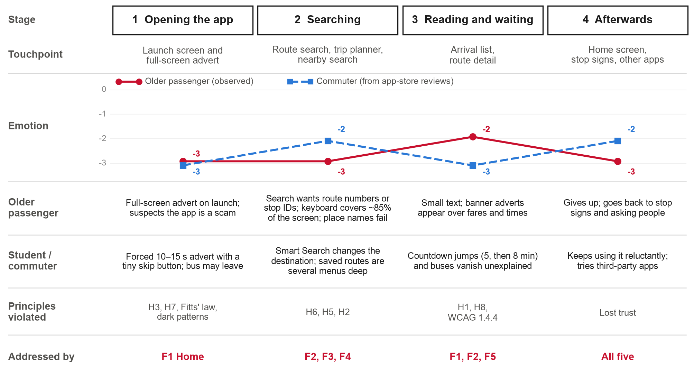
Figure 3.1. Dual-track user journey map: stages, touchpoints, emotion curves, pain points for each group, the principles applied and the features that address them.

3.3 Information architecture
The existing app spreads its functions over six bottom-bar items: Home, Favourites, Search, Nearby, Games, and a grid button that opens 26 unsorted icons. We reduced this to five labelled tabs, each answering one question (Figure 3.2): Home (when is my usual bus coming?), Trip (how do I get to a place?), Nearby (what can I catch from here?), Saved (my routes and stops) and More (settings and accessibility). Route detail, with its stop list, timetable, notices and alight alert, is a shared destination: it opens from Home, Saved, Nearby and Landmarks, so a route looks and behaves the same wherever it is tapped. Every core screen keeps the tab bar, so users can always get back to a known place in one tap. Screen codes structure both the Figma file and this report: O for onboarding, F for feature screens, S for states and edge cases, and M for modals and sheets.
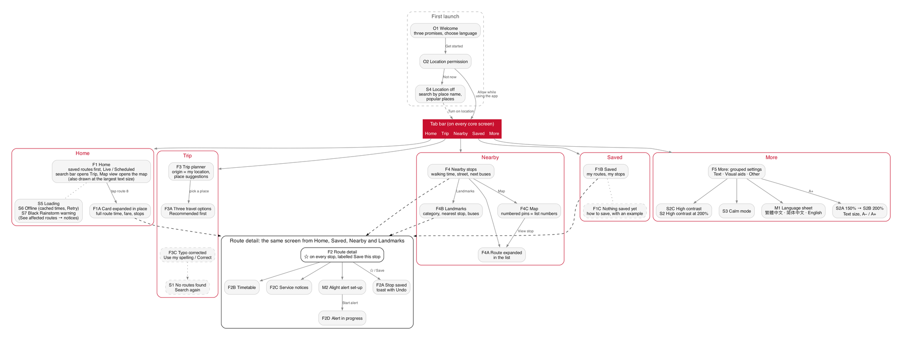
Figure 3.2. Site map of the English prototype, built from its prototype links. Route detail (F2) is shared by four tabs. Screens with dashed outlines are drawn but not linked from another screen. The EN button on Home also opens the language sheet (M1).

3.4 Walkthrough
Figure 3.3 follows two scenarios through the prototype. The numbers below match the badges in the figure, and the screen codes let readers follow along in the public prototype, whose flow "First launch (en-GB)" starts at O1.
Scenario A: a commuter checks the bus and saves a stop. (1) The welcome screen makes three promises ("Your routes, first", "Search by place name", "No pop-up ads") and offers 繁體中文, 简体中文 and English before anything else; a location request then explains what location is used for (O2). (2) Home opens on route 8 to Kowloon Station, next bus in 5 min, Live, under a status line with the area, the last update (10:32) and Auto-refresh. (3) Tapping the card expands it in place to show the journey time, fare, stops and a link, "See full route and save stops". (4) Route detail lists every stop with a ☆, and the stop nearest the user is open with its arrivals and three labelled tools. (5) "Save this stop" fills the star, relabels the button "Stop saved" and shows a toast with Undo; no dialog interrupts. (6) "Remind me before my stop" sets an alight alert, and (7) the alert screen counts down: "2 stops to go".
Scenario B: an older passenger plans a trip by place name and enlarges the text. (1) If location is off, Nearby explains why it is empty and offers two equal ways on: turn location on, or search by place name. (2) In the planner the origin defaults to the user's location, so only a destination is needed, and suggestions give each place's type and street so that similar names can be told apart. (3) The results list three options, the first marked Recommended, with total time, arrival time, fare, the legs of the journey and the next bus. (4) A typo such as "Langham Plce" is corrected in the open, with "Use my spelling" to undo it. (5) In More, (6) the text-size control steps from 100% to 200%, and (7) Home is shown at the larger size.
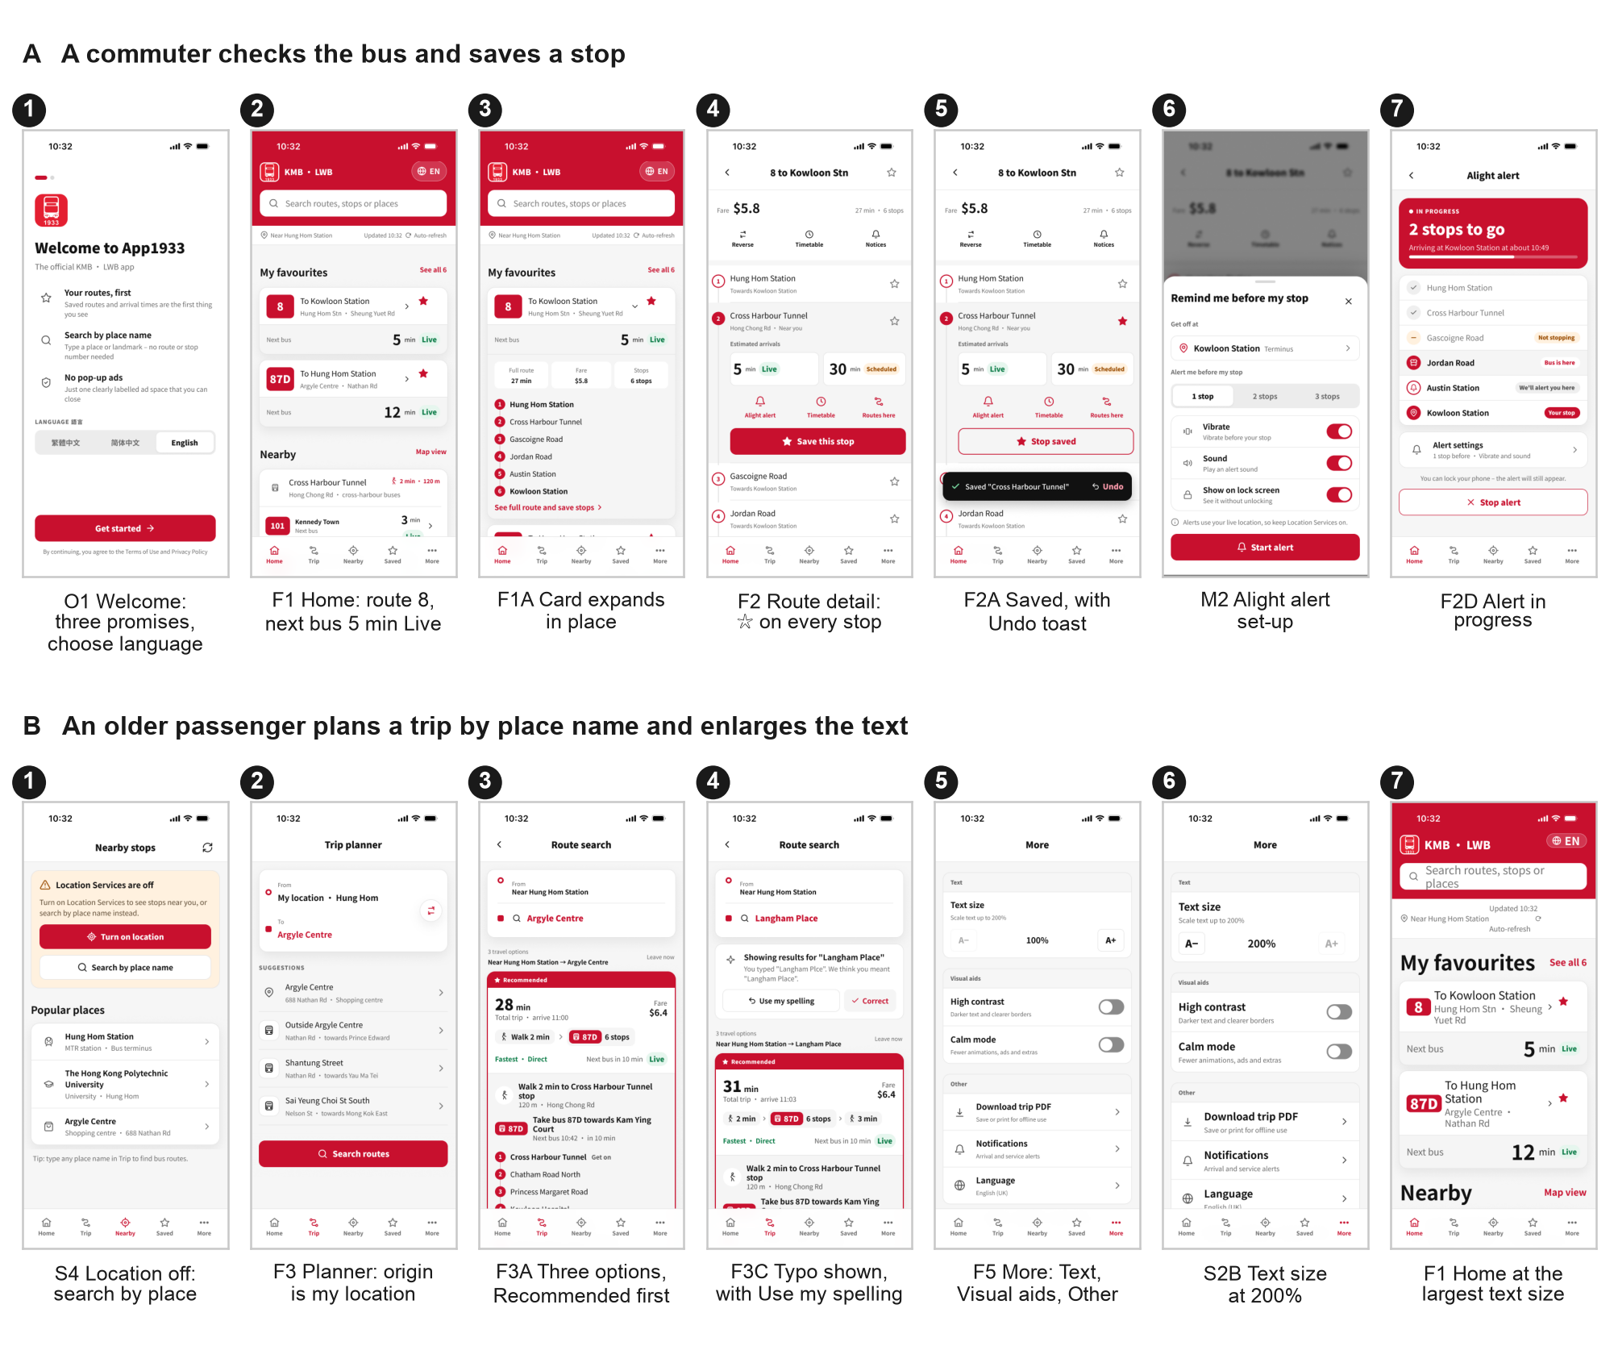
Figure 3.3. Walkthrough of the English prototype. Row A: O1, F1, F1A, F2, F2A, M2, F2D. Row B: S4, F3, F3A, F3C, F5, S2B and Home at the largest text size.

3.5 Design rationale
Table 3.1 lists the decisions that apply across the whole app and the principle behind each; decisions specific to one feature follow in Section 4. H1 to H10 refer to Nielsen's (1994) heuristics.
Table 3.1. App-wide design decisions and the principles behind them.
Decision | Where | Principle
Saved routes and next arrivals are the first content on Home; no launch advert | F1 | Flexibility and efficiency of use (H7); forced adverts cause irritation and avoidance (Edwards et al., 2002)
Every arrival carries a written label, Live or Scheduled, as well as a colour | F1, F2, F3A, F4 | Visibility of system status (H1); colour is never the only cue (WCAG 1.4.1; W3C, 2024)
A status line shows the last update; offline and disruption states say what is wrong and what to do | F1, S5–S7 | H1; real-time information helps only when riders can trust it (Ferris et al., 2010; Watkins et al., 2011)
Five labelled tabs instead of six items and a grid of 26 icons; settings in three headed groups | Tab bar, F5 | Hick's law (Hick, 1952); recognition rather than recall (H6)
Primary actions are large full-width buttons; ☆ and row targets are at least 44 pt; navigation sits in the bottom tab bar | All | Fitts' law (Fitts, 1954); one-handed thumb use (Parhi et al., 2006); Apple's 44 × 44 pt control size (Apple, n.d.)
Search by place name, with the origin preset to the current location | F3, S4 | Match between system and the real world (H2); H6; error prevention (H5)
Undo instead of a confirmation dialog when saving | F2A | User control and freedom (H3); easy reversal of actions (Shneiderman et al., 2016)
Errors appear at the field that caused them, with a way to recover | S1, F3C | Help users recognise, diagnose and recover from errors (H9)
One labelled, closable advert; no pop-ups, games or mascots | F1, F5 | Aesthetic and minimalist design (H8); avoiding nagging (Gray et al., 2018)
Route badge, arrival block and tab bar look and behave the same on every screen; related information is grouped in one card | All | Consistency and standards (H4)

3.6 Visual language and consistency
The visual language keeps KMB's brand red but uses it sparingly, so that red marks where to act (Figure 3.4). Red (#C8102E) is reserved for the header, route badges, primary buttons and the active tab. Content sits on white with neutral grey (#F5F5F5) containers, and arrival minutes are set in near-black ink rather than red, so they read as information, not warnings. Status uses a small set of colours, always with a written label: green for Live, amber for Scheduled and Diverted, grey for Offline and Suspended. Noto Sans HK is used throughout because it covers Traditional Chinese, Simplified Chinese and Latin text in one family. Screen titles use the Black weight, section titles Bold 20 pt, and the arrival time is the largest text on every card. Shared components (a tab bar in ten variants, the status bar and the official App1933 logo) give every core screen the same anatomy: status bar, header, content, tab bar. We also removed decoration that competed with the task, such as the mascots on the route map, tinted icon badges and "tap to view" filler text.
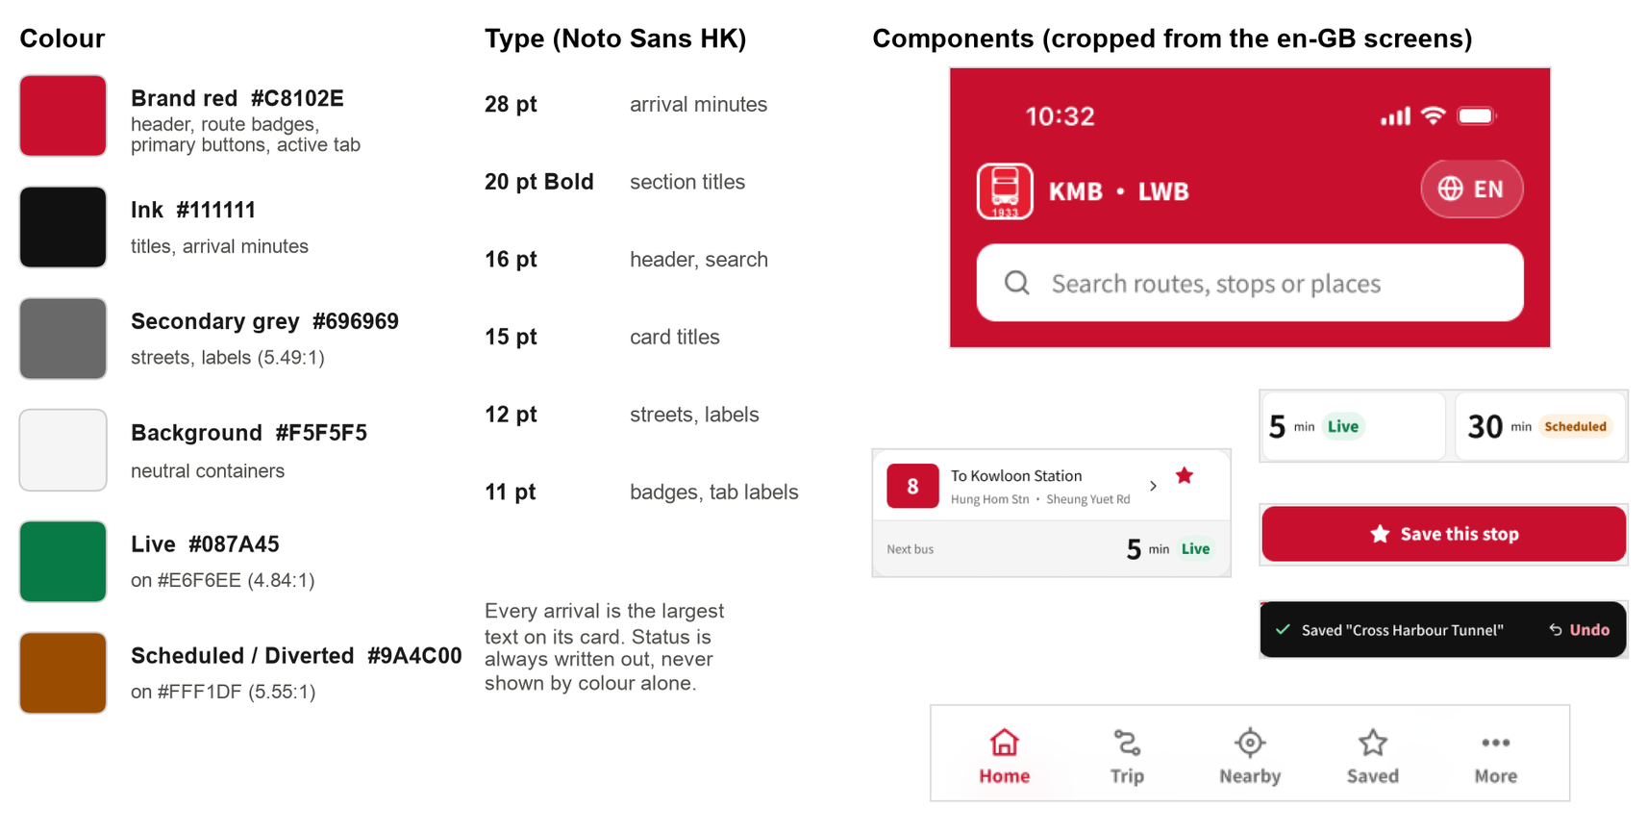
Figure 3.4. Style guide: colours with their uses and contrast ratios, the type scale, and components cropped from the English screens.

3.7 Accessibility considerations
Accessibility was part of the design from the start, mainly for older passengers but also for anyone reading a phone on a moving bus (Figure 3.5).
- Text size. More has a text-size control with three steps labelled 100%, 150% and 200%. The steps do not scale every style by the same factor: at the largest step, Home's headings double (20 to 40 pt), route names grow from 15 to 22 pt and small labels from 12 to 18 pt, while text on More grows from 16 to 18 and 20 pt. In the prototype the larger sizes are drawn on More and on one Home screen, not on every screen. A built app would also follow the phone's own text size, which the current app ignores (Appendix D).
- High contrast and calm mode are labelled switches on More, each with a one-line explanation ("Darker text and clearer borders"; "Fewer animations, ads and extras"). The prototype shows them switched on but does not redraw every screen.
- Contrast. We computed the WCAG contrast ratio of every text layer on the 31 core screens: 1,155 of 1,169 meet AA (4.5:1). White on brand red reaches 5.88:1, the secondary grey 5.49:1, and the Live and Scheduled badges 4.84:1 and 5.55:1. The exceptions are past-hour times in the timetable (4.17:1), street names on the illustrative map (3.99:1) and the small "Current location" label on the three Nearby screens (1.92:1).
- Target size. None of the 98 linked elements is smaller than 24 pt, so all meet WCAG 2.5.8, and 84 (86%) reach Apple's 44 pt in both directions. The smaller ones are the language button on Home (69 × 40 pt), the switches on More (50 × 30 pt) and one route badge on Landmarks (40 × 28 pt).
- Not by colour alone. Live, Scheduled, Offline, Diverted and Suspended are always written out (WCAG 1.4.1).
- Less to remember. Place-name search, the preset origin, suggestions with categories and saved routes on Home favour recognition over recall (H6; Zaphiris et al., 2005).
- Choice of language and of location. Three interface languages are offered, each named in its own script, and every screen that depends on location has an alternative without it (S4).
Figma cannot test screen-reader behaviour, so labels and reading order are specified only at design level (Section 6). The contrast and target figures were computed by script from the Figma file and do not detect backgrounds built from overlapping layers, so they are close estimates rather than a formal audit.
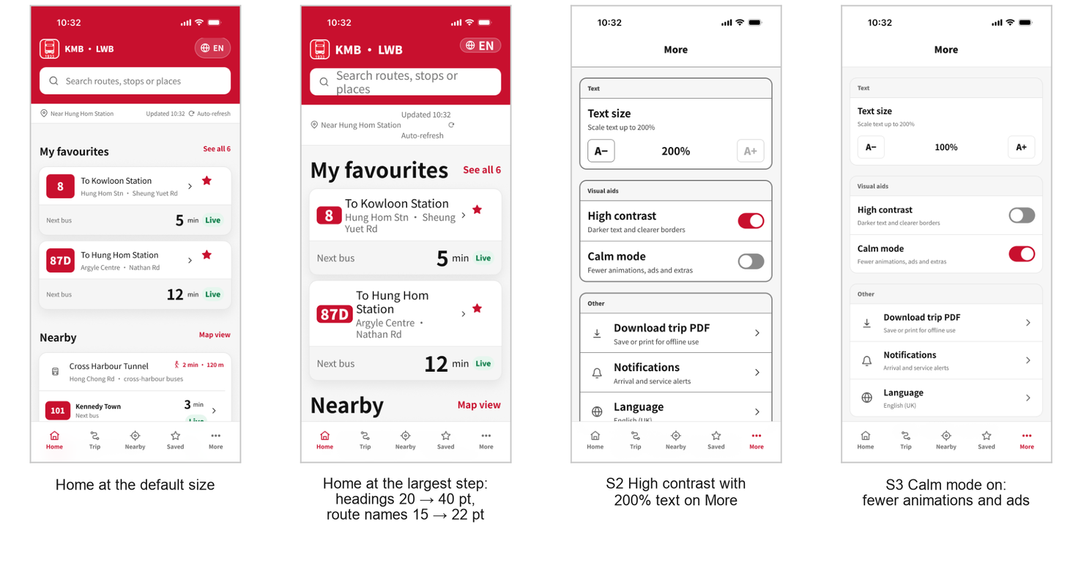
Figure 3.5. Accessibility settings in the English prototype: Home at the default size and at the largest step, high contrast with 200% text on More (S2), and calm mode (S3).

4. Feature Details
Each feature follows the same structure: (a) the problem in the existing app, in an annotated screenshot of the real app (v2.3.38, or v2.3.39 where marked iPhone); (b) the HCI principles involved; (c) the redesign, with captures of the new screens; and (d) the rationale. The original app is in Chinese, so we translate its labels in the text. The new screens come from the English prototype, and their codes match the site map (Figure 3.2). All five features can be clicked through in the public prototype (Appendix C).

4.1 F1 Home: saved routes first, honest arrival times, no pop-up adverts
(a) Problem in the existing app. Opening the app shows a full-screen advert whose only exit is a small skip button, about 6% of the screen width; the full-width 開啟 (Open) bar at the bottom belongs to the advert (Figure 4.1a). Home itself leads with a rotating banner of quizzes and promotions, a floating trip-planner button covers part of the list, and our iPhone captures show a banner advert above the tab bar on every main tab. Arrival minutes on Home and in Favourites are bare numbers, so a live estimate looks exactly like a timetable entry. A whole tab is given to mini-games.
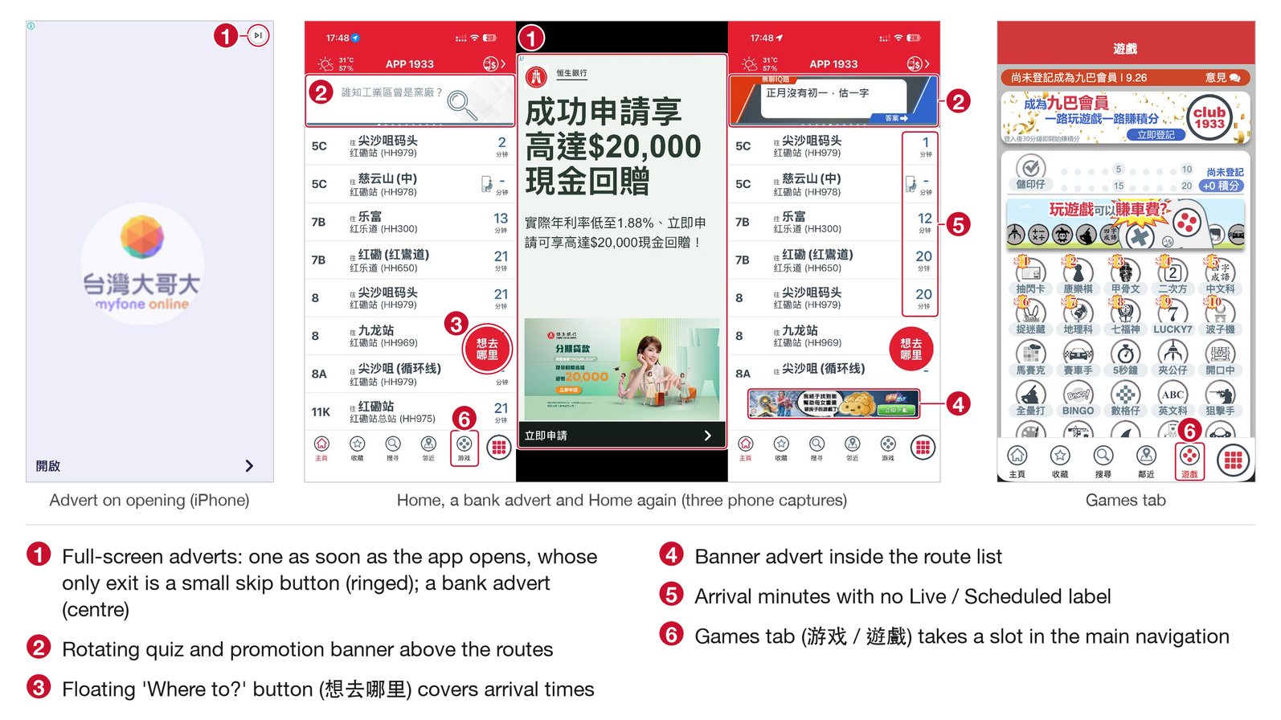
Figure 4.1a. Launch advert and Home in the existing app (real screenshots, annotated; the legend explains each callout).
(b) HCI principles. Violated: flexibility and efficiency of use (H7) and user control and freedom (H3), because the user must wait for or dismiss an advert before reaching the one thing they came for; visibility of system status (H1), because live and scheduled times cannot be told apart; and aesthetic and minimalist design (H8). A forced advert with a small exit beside a large "Open" bar is the kind of interruption that causes irritation and avoidance (Edwards et al., 2002) and matches what Gray et al. (2018) call nagging. Applied: H7, H1, H3, H8.
(c) Redesign. The first section under the header is My favourites: one card per saved route, with the destination, the boarding stop and the next bus in the largest type on the card (Figure 4.1b). Each arrival carries a green Live or amber Scheduled badge, and a status line ("Near Hung Hom Station · Updated 10:32 · Auto-refresh") sits under the header. Tapping a route expands the card in place to show its journey time, fare, stops and a link to the full route (F1A). Below, the nearest stop shows its next buses with a Map view link, and Home ends with a single closable card marked "Ad · Sponsored". The states are designed too: a skeleton while loading (S5), an offline view that marks each time Offline and offers Retry (S6), and a Black Rainstorm view that marks route 8 Suspended and 87D Diverted (S7).
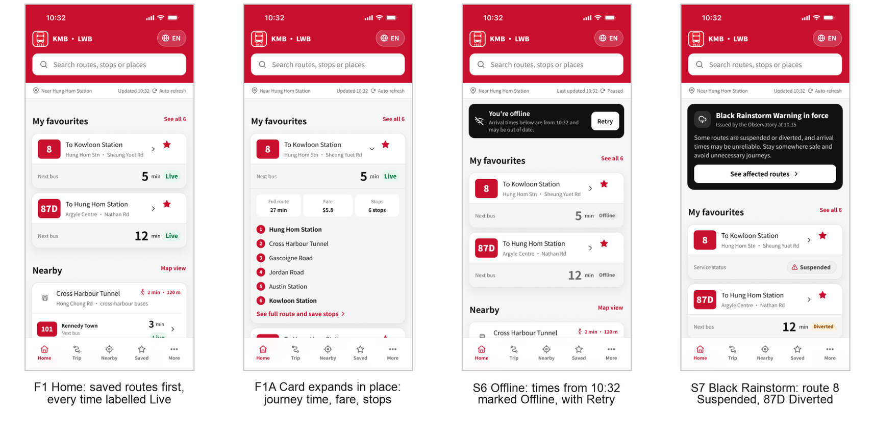
Figure 4.1b. Redesigned Home (F1), the expanded card (F1A), and the offline (S6) and disruption (S7) states.
(d) Rationale. Both groups open the app to check one bus, often in a hurry, so the first screen should answer that question without a further step (H7). Real-time information reduces the strain of waiting only when riders can trust it (Ferris et al., 2010; Watkins et al., 2011). That is why every time states its source, and why the offline and disruption states say plainly when the data is old or the service is not running. We kept one advert because the operator relies on advertising income, but made it predictable, labelled and closable. Tested in blocks 2–5: all nine participants read the next Bus 8 correctly.

4.2 F2 One-tap save and route detail
(a) Problem in the existing app. In route detail, the selected stop shows four unlabelled round icons next to decorative district trivia (Figure 4.2a). To save the stop, the user has to know that the ≡ icon hides a menu, open it, and pick 收藏此車站 (Save this stop) from a dark pop-up that covers the screen: seven taps from Home in our count. The saved stop then appears in Favourites as a bare number with no Live or Scheduled label, and when nothing is saved, the tab says only that there are no saved stops, with no hint of how to save one. Above the list, mascot graphics cover parts of the route map.
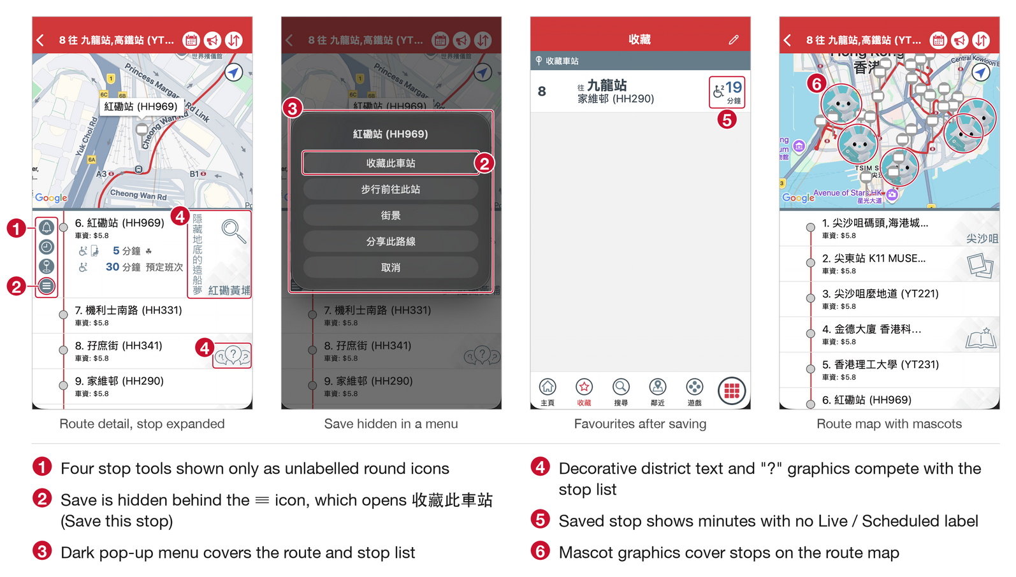
Figure 4.2a. Saving a stop in the existing app (real screenshots, annotated; the legend explains each callout).
(b) HCI principles. Violated: recognition rather than recall (H6), since users must remember what each unlabelled icon does; Fitts' law (Fitts, 1954), since saving sits behind small targets and several steps; aesthetic and minimalist design (H8); and visibility of system status (H1) after saving. Applied: H6, Fitts' law, user control and freedom (H3) through Undo, feedback (H1), and Norman's (2013) point that an action needs a visible signifier.
(c) Redesign. Every stop row in route detail has a 44 pt ☆, and a ☆ in the title bar saves the whole route (Figure 4.2b). The stop nearest the user opens with its arrivals (5 min Live, 30 min Scheduled), three labelled tools (Alight alert, Timetable, Routes here) and a full-width "Save this stop" button. Saving fills the star, relabels the button "Stop saved" and shows a toast with Undo, and nothing blocks the screen (F2A). Saved lists routes and stops separately, each route with its live arrival; when empty, it explains how to save ("Tap ☆ on any route or stop to save it", F1C). The timetable is split by direction and day type and highlights the next departure (F2B). Notices explain diversions and severe-weather arrangements (F2C). The alight alert lets the user choose the stop and how early to be told, then counts down and still alerts when the phone is locked (M2, F2D).
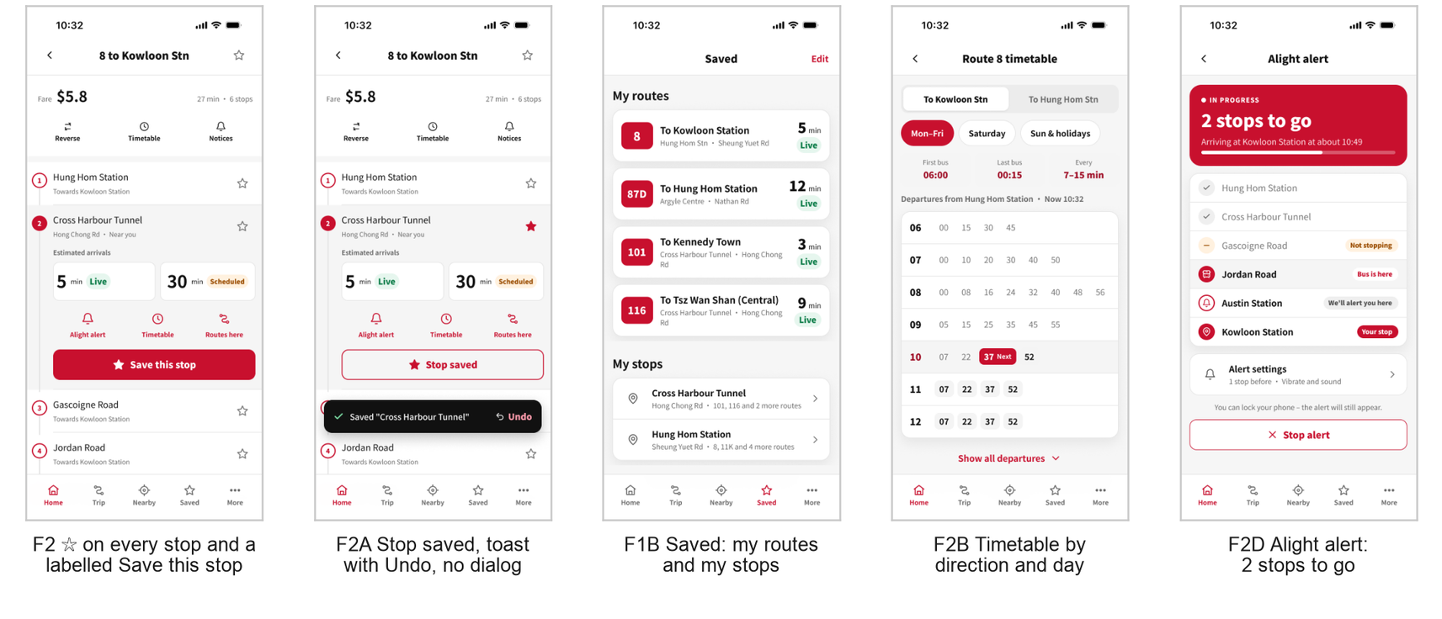
Figure 4.2b. Route detail with a ☆ on every stop (F2), the saved state with Undo (F2A), Saved (F1B), the timetable (F2B) and the alight alert in progress (F2D).
(d) Rationale. Saving is what makes Home useful, so it has to be obvious and quick. A visible star on every stop and a labelled button replace recall with recognition (H6), and large targets suit one-handed use (Parhi et al., 2006). Undo is faster than a confirmation dialog and lets people act without fear of mistakes (H3; Shneiderman et al., 2016). Tested in blocks 6–8. Once on the route screen, participants saved without difficulty; the way in from the Home card was harder to find, which Section 5.3 discusses.

4.3 F3 Trip planning by place name
(a) Problem in the existing app. The main search box accepts only route numbers and opens a keypad that covers most of the screen (Figure 4.3a). In the point-to-point planner the origin field shows a raw "null", and it still does in v2.3.39. Starting from a place rather than a stop takes four steps: region, district, area, then a map and a confirm button (Appendix E, Figure E.1). Typing a stop name returns nine near-identical entries for Hung Hom Station, told apart only by codes in brackets. Overnight routes are ranked among the fastest options, with only a small clock icon to hint that one may not be running. The Smart Suggestion feature replaces the boarding stop the user entered with another one, and when nothing is found, the planner tells the user to phone the hotline.
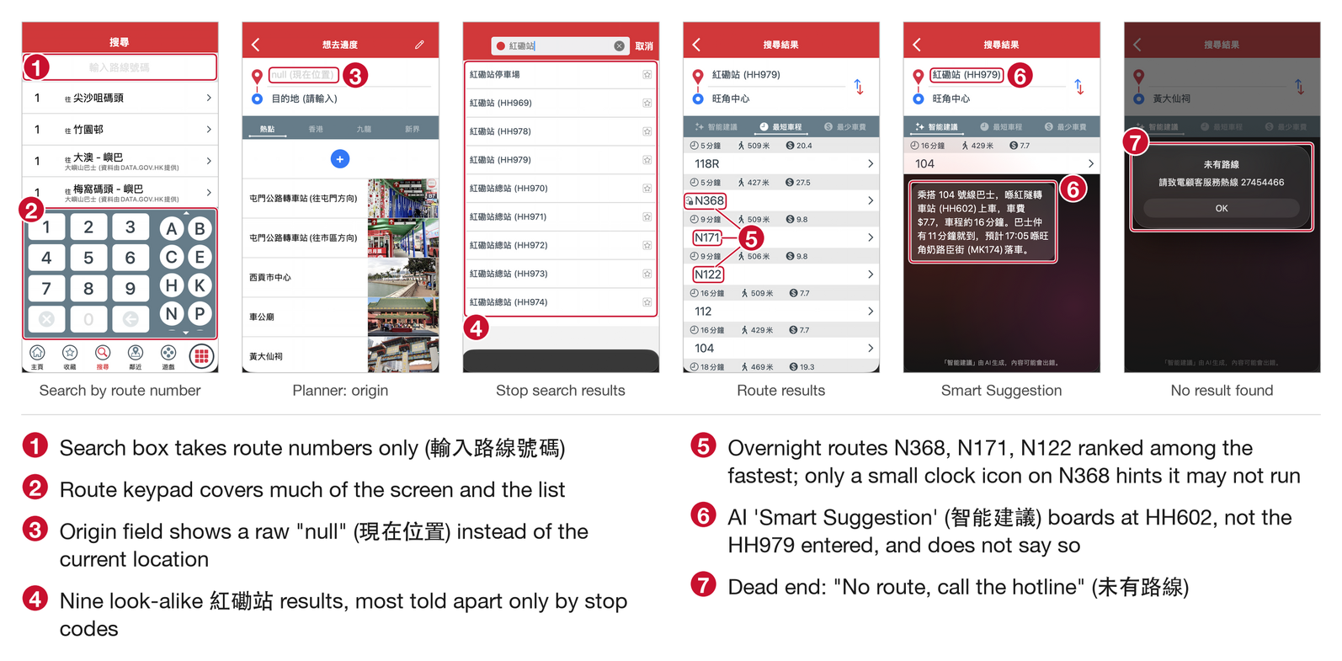
Figure 4.3a. Search and the trip planner in the existing app (real screenshots, annotated; the legend explains each callout).
(b) HCI principles. Violated: match between system and the real world (H2), since people think in places rather than route numbers, stop codes or district lists; recognition rather than recall (H6); flexibility and efficiency of use (H7); error prevention (H5), since a null origin is accepted; help users recognise, diagnose and recover from errors (H9); and user control and freedom (H3), since the suggestion changes the query without asking. Applied: the same six.
(c) Redesign. The origin starts as "My location • Hung Hom", so a search cannot run without one (Figure 4.3b). Typing "Argyle Centre" suggests the shopping centre and the stops around it, each with its type and street. The results show three options. The first is marked Recommended and "Fastest · Direct", with total time and arrival (28 min, arrive 11:00), fare, the legs as chips (walk 2 min, then 87D for 6 stops), the next bus (in 10 min, Live) and step-by-step directions. A misspelling such as "Langham Plce" is corrected in the open: the screen says what it searched for instead and offers "Use my spelling" (F3C). An invalid destination is flagged under the field, with a way forward (S1), and the same place-name search is offered when location is off (S4).
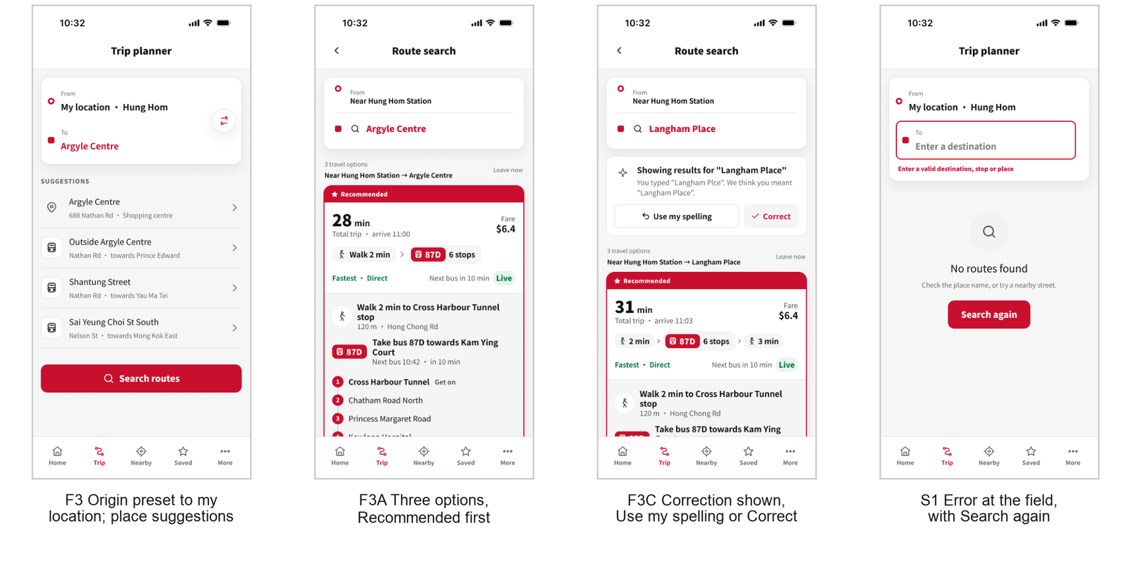
Figure 4.3b. The planner with the origin preset (F3), results with the recommended option first (F3A), a visible spelling correction (F3C) and an error shown at the field (S1).
(d) Rationale. Older passengers in our research know where they want to go but not which bus goes there, so search starts from places (H2, H6). Presetting the origin removes the most common error before it can happen (H5). We kept a smart correction, because typing errors are common on small keyboards and guidelines for older users ask search to cope with them (Zaphiris et al., 2005), but made it visible and reversible: the system suggests and the user decides (H3; Shneiderman et al., 2016). The results card leads with the total time because that is the number people choose between, the same layout mainstream journey planners such as Google Maps use. Tested in blocks 9–11: all nine succeeded, eight by the expected path.

4.4 F4 Nearby stops and landmarks
(a) Problem in the existing app. Nearby search asks for a stop code on a letter keypad, and few passengers know their stop's code (Figure 4.4a). With location off, the screen shows one line of text and no way forward. On a real phone, the stop list is headed by a row of stop codes, and the landmarks list shows only a walking distance beside each icon, with no name or category, as our Accessibility Lead noted on the capture.
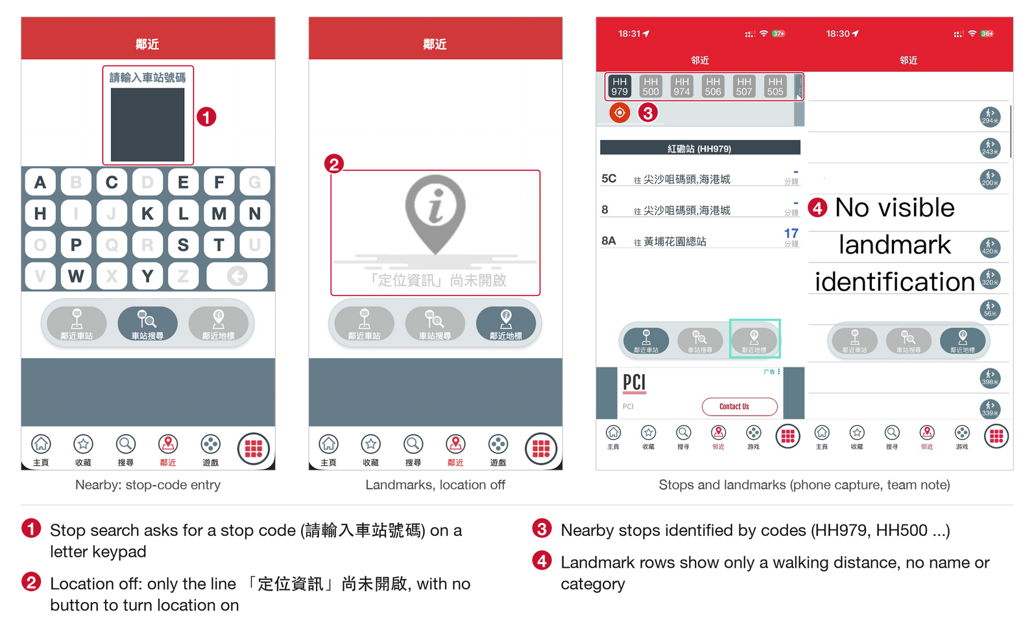
Figure 4.4a. Nearby in the existing app (real screenshots, annotated; the right-hand capture carries our Accessibility Lead's note).
(b) HCI principles. Violated: match between system and the real world (H2), recognition rather than recall (H6), and help users recover from errors (H9) when location is off. Rows without names also give screen-reader users nothing to announce (WCAG 1.1.1 and 1.3.1; W3C, 2024). Applied: H2, H6, H9, and consistency between the list and the map (H4).
(c) Redesign. Each stop card is headed by walking time and distance, then the stop name and street, then the next buses, each with its destination, minutes and a Live or Scheduled badge (Figure 4.4b). Tapping a route shows its journey time, fare and stops without leaving the list (F4A). A Landmarks filter lists places by name with category, walking time, nearest stop and the buses that serve them, for example "The Hong Kong Polytechnic University · University · 5 min walk" (F4B). The map uses numbered pins that match the list and opens from Nearby or from Home's Map view link (F4C). With location off, the screen explains why and offers two equal options: turn location on, or search by place name (S4).
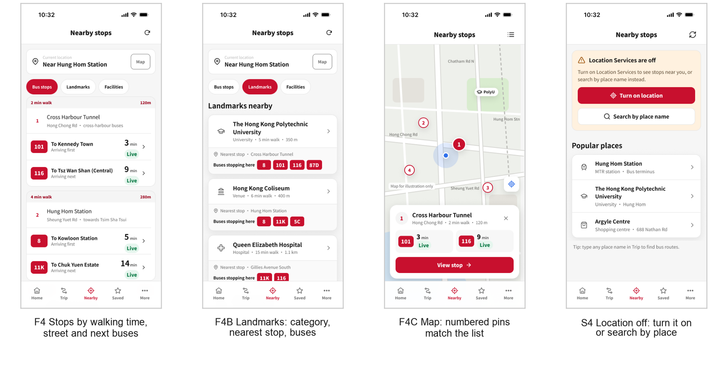
Figure 4.4b. Nearby stops by walking time and street (F4), landmarks with their buses (F4B), the map with numbered pins (F4C) and the location-off state (S4).
(d) Rationale. People find a stop by where it is and how far away it is, not by its code (H2). Showing the next buses on the stop card saves commuters a step, and listing the buses that serve a landmark answers an older passenger's typical question, "which bus goes to the hospital?", directly. The list and the map show the same numbered stops, so users can choose a view without learning two systems (H4, H7). Tested in blocks 12–17: all nine found a nearby stop, and all nine named both buses to Queen Elizabeth Hospital.

4.5 F5 More menu and accessibility
(a) Problem in the existing app. The grid button opens 26 icons in no particular order, mixing membership, pet buses, online shopping and social media with service information (Figure 4.5a). The language menu is a dark pop-up with no cancel button. None of the 26 items changes text size, and the app ignores the iPhone's own text size: with Larger Text at its maximum, every word on Home stays exactly the same size (Appendix D, Figure D.2). Our audit also found low-contrast labels (1.4:1 to 4.4:1) and icon buttons that were not exposed to assistive technology.
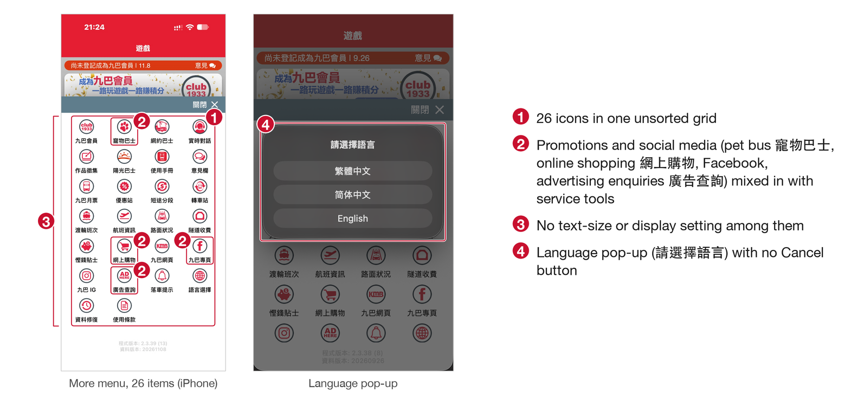
Figure 4.5a. The More menu and language pop-up in the existing app (real screenshots, annotated; the legend explains each callout).
(b) HCI principles. Violated: Hick's law (Hick, 1952), since decision time grows with the number of undifferentiated choices; aesthetic and minimalist design (H8); user control and freedom (H3) in the language pop-up; and WCAG 1.4.4 Resize Text. Applied: Hick's law, H8, H3, H6, and WCAG 1.4.1, 1.4.3 and 1.4.4.
(c) Redesign. Three headed sections replace the grid: Text, Visual aids and Other (Figure 4.5b). The text-size control ("Scale text up to 200%") steps through 100%, 150% and 200%, shows the current value and dims its button at either limit (S2A, S2B). Back on Home after the largest step, headings are twice their size and arrival text about one and a half times. High contrast and calm mode are labelled switches with one-line explanations. The language sheet (M1) lists 繁體中文, 简体中文 and English, each in its own script, applies the choice straight away and closes with ×; the EN button on Home opens the same sheet.
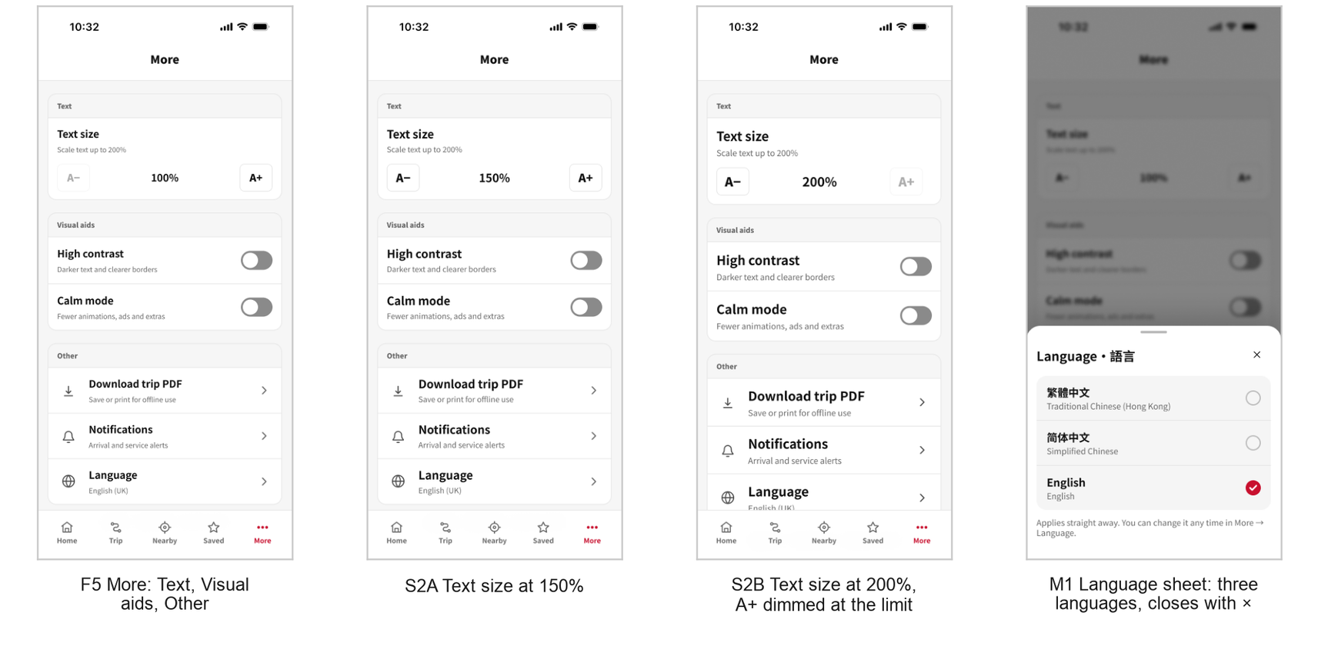
Figure 4.5b. More with grouped settings (F5), text size at 150% and 200% (S2A, S2B) and the language sheet (M1).
(d) Rationale. Grouping a few real settings under clear headings makes each one quick to find (Hick's law, H8). Larger, high-contrast text is a standing recommendation for older users (Zaphiris et al., 2005), and both Apple (n.d.) and WCAG 1.4.4 ask for text that can be enlarged to 200%. Our largest step doubles headings and enlarges arrival text by about half, and a built app would also follow the system text size. We put these settings at the top of More because that is where iOS and Android apps keep display settings, so people who look for settings find them. Calm mode answers the worry about adverts that came up in our journey research. Tested in blocks 18–20, our accessibility-focused task: all nine enlarged the text and then read the next Bus 116 correctly at the largest size.

5. Testing Method, Results and Discussion

5.1 Method
Participants and recruitment. Nine people took part between 5 and 7 November 2026 (Appendix A, Table A.1). They were classmates, friends and relatives of the team, contacted by direct message. Ages ranged from 18 to 48 (median 19): seven were aged 18 to 20, and two were 45 and 48. Five used a laptop, three a phone and one a tablet. Nine is above the brief's minimum of five and suits a formative test, whose aim is to find problems rather than to estimate rates for a population. No participant was aged 60 or over, although older passengers are one of our two target groups; Section 6 returns to this.
Set-up and tasks. We imported the English prototype into Maze as a study of 21 blocks: nine prototype missions, each with one expected path; six comprehension questions with fixed correct answers; five ease ratings; and one overall rating (Table 5.1; full wording in Appendix B). The test ran in English. The tested page uses plain navigation links, so only designed routes respond, and a tap on anything else (a map pin, a language button on the welcome screen, a filter that is already selected) counts as a misclick. Block 18 tests an accessibility accommodation directly: participants enlarge the text to the largest step and then read an arrival time at that size.
Procedure. Participants opened the Maze link on their own device and did the test alone, remotely and without a moderator. Study time ranged from 6.7 to 22.4 minutes (median 9.2). Every session started after the design's last save, on 5 November at 17:56. Maze recorded no open-text answers. Afterwards, some participants talked to our User Researcher about the design, and the researcher's notes of those conversations are the source of the comments quoted below. They are notes rather than recordings, and not every participant took part.
Metrics. For each mission Maze reports the success rate, the share who succeeded by the expected path (direct success; any other successful route counts as indirect), the misclick rate, the mean time and a usability score from 0 to 100. Maze's mean time leaves out anyone who gave up. We add comprehension accuracy, the ease ratings, and each participant's path and taps from Maze's export, which also gives medians.
Table 5.1. Maze missions, the features they test and the questions that followed them.
Block | Mission (Maze title) | Feature | Follow-up questions (block)
1 | Let's get started! | O1–O2 | —
3 | Take a ride on Bus No.8 | F1 | Next Bus 8 (2, asked before the mission); route 8 journey time (4); ease (5)
6 | Save Cross Harbour Tunnel Station | F2 | Ease of saving (8)
7 | Have a check of your saved stations | F2, F1 | —
9 | From Hung Hom Station to Argyle Centre | F3 | Recommended bus and walking time (10); ease (11)
12 | Find bus stations nearby | F4 | Which bus arrives first (13)
14 | Use a map and take a look around | F4 | —
15 | Find landmarks around me | F4 | Buses to Queen Elizabeth Hospital (16); ease of Nearby (17)
18 | Adjust the size of texts | F5 | Next Bus 116 at 200% (19); ease (20); overall rating (21)

5.2 Results
All nine participants finished the study. Across the nine missions there were 59 direct successes, 19 indirect successes and 3 give-ups, each by a different participant. Maze's overall usability score was 71 out of 100, and all nine rated the redesign Good (8) or Very Good (1). Table 5.2 gives the mission metrics, and Figure 5.1 shows the outcomes, comprehension and ease ratings. Comprehension was 45 of 54 answers correct (83%).
Table 5.2. Mission metrics (n = 9). Mean time leaves out participants who gave up; medians are our calculation over all nine from the export.
Block · mission | Success | Expected path | Misclick | Mean (s) | Median (s) | Score
1 · Onboarding | 100% | 100% | 73.5% | 33.1 | 28.7 | 91
3 · Read Bus 8 information | 100% | 100% | 25.0% | 16.5 | 11.9 | 84
6 · Save a stop | 88.9% | 22.2% | 54.5% | 38.3 | 22.8 | 43
7 · Check saved stops | 88.9% | 77.8% | 61.7% | 6.3 | 5.8 | 83
9 · Plan a trip | 100% | 88.9% | 55.8% | 31.3 | 23.9 | 68
12 · Find nearby stops | 100% | 44.4% | 38.7% | 31.2 | 18.7 | 44
14 · Use the map | 100% | 66.7% | 15.4% | 17.2 | 10.6 | 78
15 · Find landmarks | 88.9% | 88.9% | 60.6% | 10.6 | 9.2 | 76
18 · Adjust text size | 100% | 66.7% | 37.3% | 31.6 | 25.8 | 71
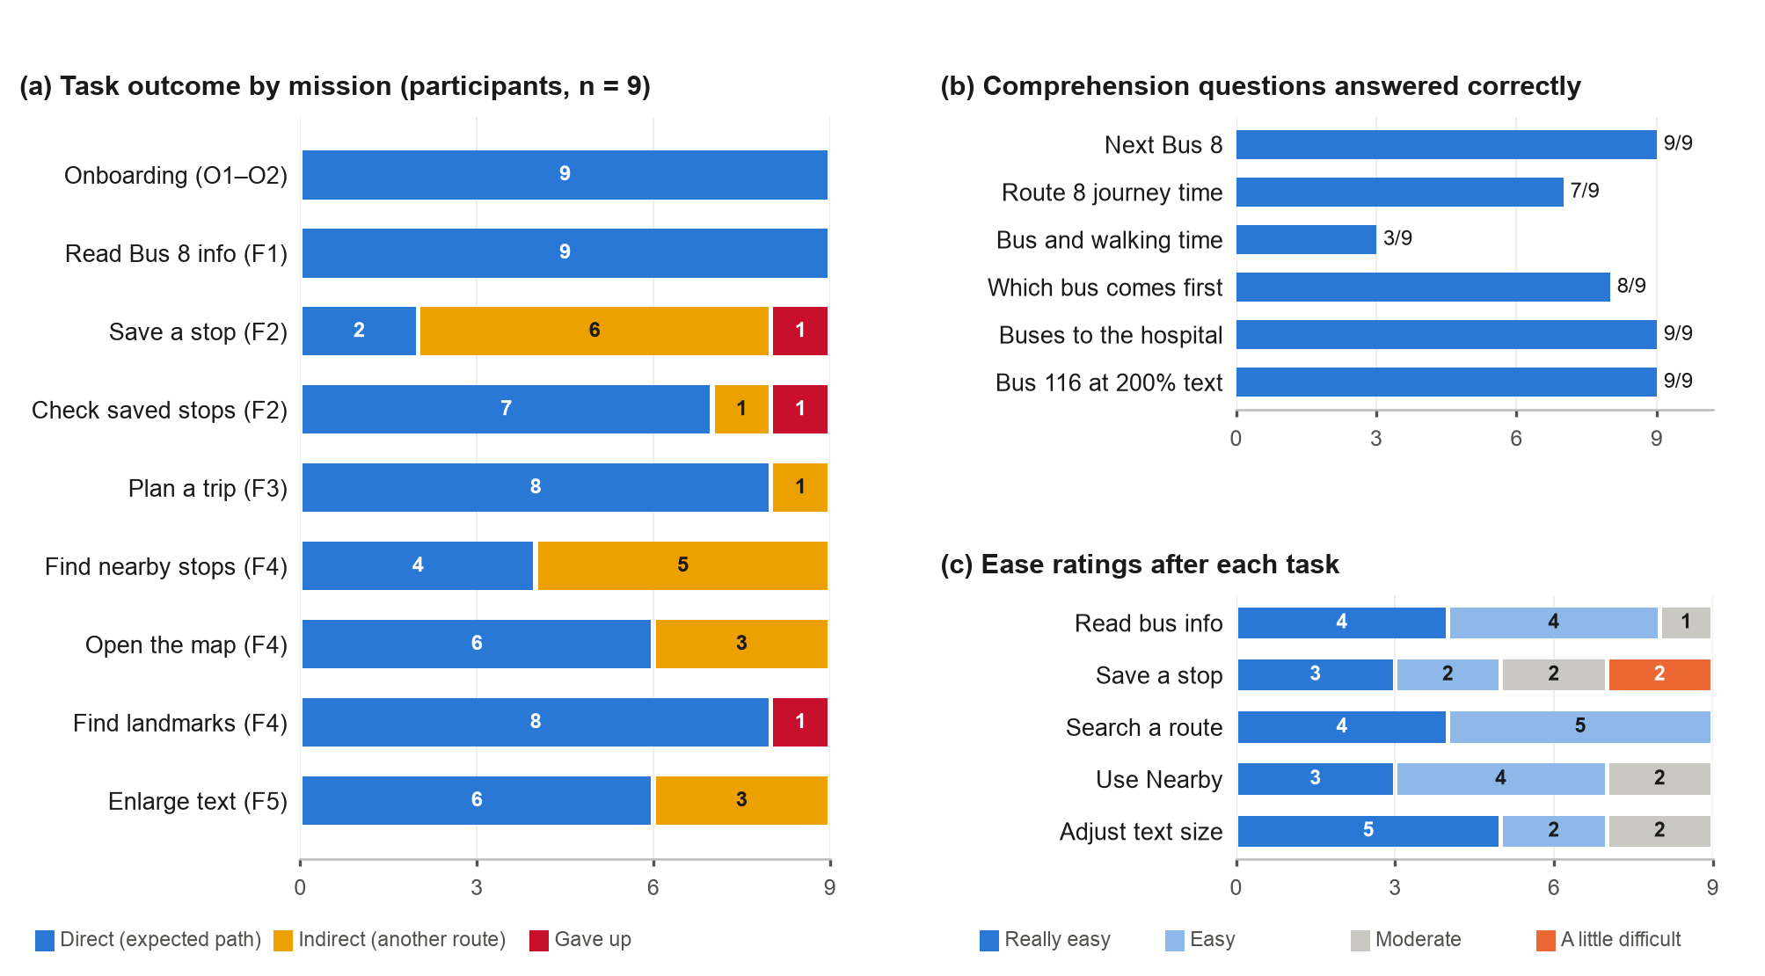
Figure 5.1. (a) Outcome of each mission; (b) comprehension questions answered correctly; (c) ease ratings. Source: Maze report and export.
Phone users found the expected path less often. In blocks 3 to 18, the three phone users went direct in 10 of 24 tasks and the five laptop users in 35 of 40, and two of the three give-ups were on phones. Most misclicks were taps on elements that were not linked on the test page: 34 of the 50 on the welcome screen were on the language buttons, three of the five on the Nearby list were on the filter already in use, and nine of the eleven on the 200% screen were on the dimmed A+ button and the calm-mode switch. The clearest exception was the save mission, where three participants tapped the stop card on Home 13 times.
Table 5.3. Participants' comments, as written down by the User Researcher after the sessions (verbatim from the notes).
Mission | Outcome | Comment
Save a stop | Gave up / indirect | "Not intuitive. Don't know that the station inside the column is interactive and can therefore lead to the saving process of target station."
Save a stop | Indirect | "Thought the stations can be searched then saved."
Check saved | Gave up | "The 'Saved' button was obstructed by the bottom of the instructions."
Check saved | Indirect | "Thought the saved stations can directly be checked in 'My Favorite' column in the home page."
Plan a trip | Indirect | "Thought Search function should be bound with Map function."
Nearby stops | Indirect | "Didn't pay attention to the buttons at the bottom. Thought the stations can be checked through the map."
Use the map | Indirect | "Forgot the small Map View button at the home page. Thought the map can be opened through an obvious button hidden inside the buttons underneath."
Landmarks | Gave up | "Thought the landmarks should be found on Map, but failed to click anything because of no responses from the app (This is normal because it is just a prototype with certain testing routes)."
Text size | Indirect | "Don't know they need to enter 'More' page to adjust text size."
Text size | Indirect | "Thought the text size can be pinched open, but tapped Map View by accident and thus entered Map page."

5.3 Discussion
Reading bus times works. Once on the right screen, participants read what they needed: the next Bus 8 (9 of 9), the first bus at the nearest stop (8 of 9), both buses to Queen Elizabeth Hospital (9 of 9) and the next Bus 116 at the largest text size (9 of 9). Reading Bus 8's information was also the only mission besides onboarding with no misses at all, and eight of nine rated reading bus information Easy or Really easy. This supports the central decision of F1, putting saved routes and their next arrival first with a Live label, and agrees with the literature on real-time information (Section 2.1).
The way into saving is our main weakness. Saving a stop had the lowest expected-path rate (2 of 9), the lowest score (43) and the only "A little difficult" ratings in the study. Maze's navigation paths show where people went. Five expanded the route 8 card on Home, but only two went straight on from it to the route screen: two collapsed it and expanded it again before going on, and one left for Saved. Of the eight who eventually reached that screen, four came from the Home card and four by opening route 8 in Saved. The ratings follow the paths: everyone who needed six screens or fewer rated saving Easy or Really easy, and the four who needed nine or more, or gave up, rated it Moderate or A little difficult (Appendix A, Table A.4). The first comment in Table 5.3 names the cause. The expanded card was tappable, but apart from a small text link nothing on it signalled that it led to saving: a missing signifier, in Norman's (2013) terms. Several participants also looked for the stop where stops appear (the stop card on Home, Nearby, the map, search), and none of these leads to saving. Once on the route screen, saving worked. We accept this finding, and it shapes our future direction (Section 6).
The two duration questions mostly measured their wording. Seven of nine gave the 27-minute journey time for route 8; the other two answered "5 min", the next-bus countdown. Only three of nine gave the 2-minute walk in the trip question; the other six chose 28 minutes, the total. We report both results in full, but we do not think they show that the screens are confusing. Block 4 asked participants to "select the number you just read from the No.8 bus info", and the number they had just read, in block 2, was the five-minute wait. Block 10 asked "how long will you walk to get to the destination", which can fairly be read as asking for the whole trip, and 28 minutes is exactly the value labelled "Total trip". On both screens the duration in question is labelled: "Full route 27 min" on the card, and "Walk 2 min" as a chip and again in the first step. All nine chose the right bus, 87D, and all nine rated route search Easy or Really easy. One participant asked for "a page with less distracting or redundant information", and Chandler and Sweller's (1991) work on redundancy is a reason to take that seriously: if a later test showed that the repeated walking time costs accuracy, the step list could start collapsed. For now we keep the layout, which follows mainstream journey planners, and propose two small changes: relabel "Full route" as "Journey time", closer to the Chinese 全程需時, and ask "How many minutes do you walk before boarding?" in the next test.
Most indirect results used designed routes, and two failures came from the test set-up. Maze counts any route other than the single expected path as indirect, even a shorter one. In the Nearby mission, all five indirect participants used routes we designed: four went through the map, and one tapped route 101 in Home's own nearby section, which is shorter than the expected path. The 67% misclick rate on the Nearby list is mostly not navigation error, since three of its five misclicks were taps on the filter already in use. The landmarks failure came from a participant who spent 18 taps on map pins and labels, which were not linked on the test page. In the check-saved mission, the participant who gave up was on an iPhone and said Maze's instruction panel hid the Saved tab. The path fits, although the same participant used the tab bar later, so we call this a probable artefact. The onboarding misclick rate (73.5%) is also an artefact: all 50 misclicks were on the welcome screen, mostly on the unlinked language buttons, and one participant made 32 of them.
Where feedback asks us to break conventions, we keep the design. Two participants did not expect text size under More, and one tried to pinch the screen. Yet seven of nine tapped More as their very first move, and all nine finished. Text size sits in an app's settings on iOS and Android and in almost every app; pinch-to-zoom is a convention for maps, photos and web pages, not app interfaces; and a built app would also follow the phone's own text size. Likewise, one participant wanted the map built into search, and others reached nearby stops through the map. A list shows time, fare and transfers that a map hides, and the map is already one tap from Home and from Nearby: eight of nine reached it in one or two taps. We accept that the Map view link on Home has little visual weight, but a sixth tab for a secondary task would add a choice to every screen (Hick, 1952).
Reading the numbers with care. Satisfaction was uniformly positive, but participants were peers and relatives who may rate a friend's design kindly, and the Maze score penalises alternative routes and taps on unlinked areas, so it partly measures prototype fidelity. We therefore give more weight to what participants did than to how they rated it. The phone-laptop gap rests on three phone users and this data cannot explain it, but the app is meant for phones, so the expected-path rates may be optimistic.

5.4 Iteration evidence
The design was frozen on 5 November at 17:56, before the first Maze session that evening, so no screen changed in response to the Maze results. The design did change several times before the test, and Figma's version history records each step (Table 5.4). Figure 5.2 shows one frame, the English route results screen, at three dates. The final step, an accessibility pass on the arrival rows, followed our own 200% acceptance check on 3 November: it is iteration after an expert review rather than after user testing. The changes we would make in response to the Maze results are proposed in Table 5.5.
Table 5.4. Design timeline, from the project files and Figma's version history (times HKT).
Date (2026) | Owner | What changed
1 Oct | Chenyang Zhang | Dual-track user journey map
11–12 Oct | Li-En Lo; all | Hand-drawn wireframe sketch redrawn as a digital wireframe; mid-project checkpoint
28 Oct, 14:39 | Li-En Lo | v1: first high-fidelity design, 13 screens at 390 × 844
28 Oct, 15:18–15:53 | Haochen Fa | Expanded to the full flow: 28 screens, each in Chinese and English; first prototype links; visual clean-up (no tinted badges, red reserved for actions)
29–30 Oct | Haochen Fa | v2: separate Chinese and English pages; 150%, 200% and high-contrast states (31 screens per language); resized to 402 × 874; official logo; floating language button removed
2 Nov | Xulu Zhang | Variables for text size, contrast, language and state; 111 frames of dialogs, full routes, search and alerts (142 frames on the Chinese page)
3 Nov | Moling Kong | 200% acceptance-check frames on both pages
5 Nov, 16:14–17:56 | Moling Kong | Final: arrival rows reworked on 15 Chinese and 14 English screens (Live/Scheduled badge beside the minutes, taller route rows and arrival blocks). Last save before testing
5–7 Nov | Chenyang Zhang | Maze test with nine participants
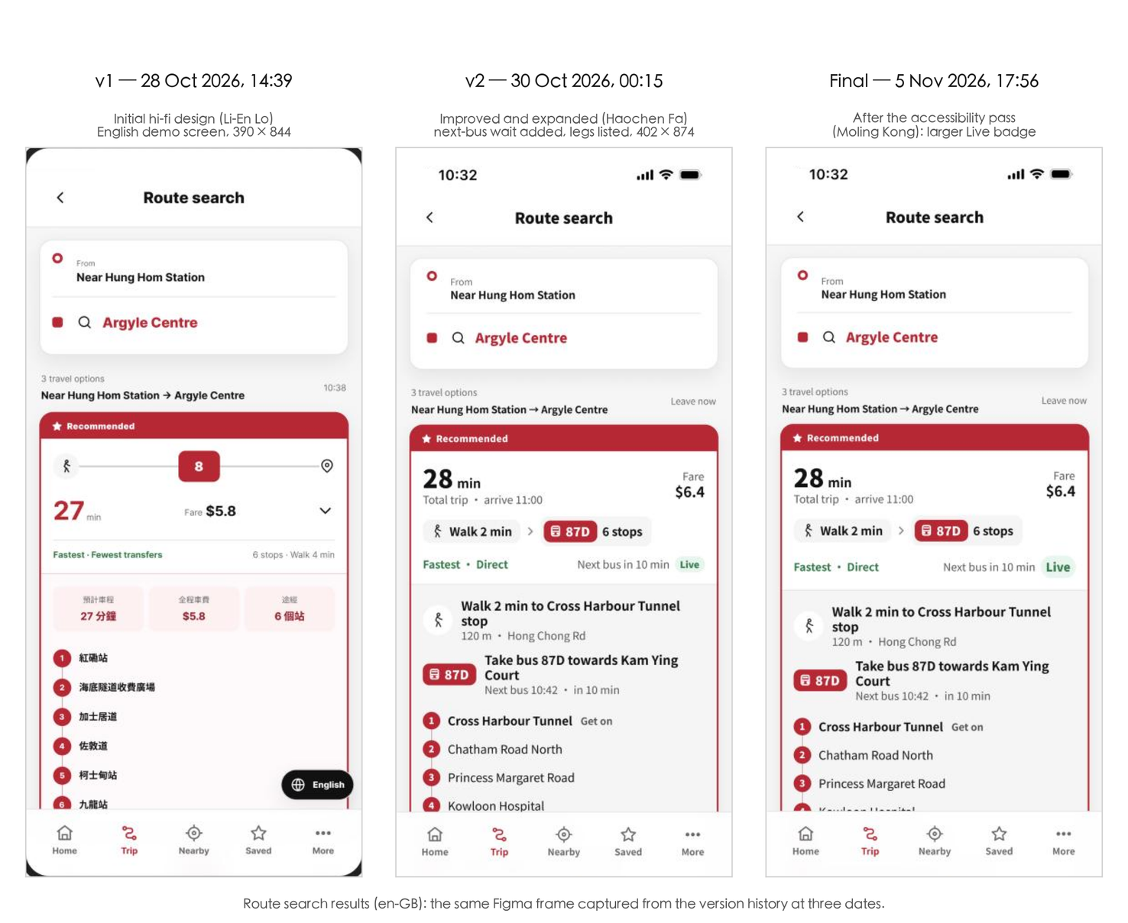
Figure 5.2. One Figma frame, the English route results screen, captured from the version history. v1 (28 Oct) shows an unlabelled red "27 min" and no wait for the next bus. v2 (30 Oct) labels the trip time, states the next bus twice with its Live source and lists the journey as legs. The final version (5 Nov) has a larger Live badge.
Table 5.5. Changes proposed for the next version, in response to the Maze results.
Finding | Proposed change | Evidence
Home card not recognised as the way to save | A visible "Save stops" button on the expanded card, and a stop page opened from the Home stop card (Section 6) | Block 6: 2/9 expected path; 13 taps on the Home stop card; comments
"Full route" read as the wait by two participants | Relabel it "Journey time", matching the Chinese 全程需時 | Block 4
Map view link easy to miss | More visual weight for the Map buttons on Home and Nearby | Block 14: one participant took eight steps; comment
Saved stops expected on Home | Show saved stops as well as saved routes in My favourites | Block 7 comment
Test did not include older passengers | Re-test in Cantonese with participants aged 60+, on phones, with reworded questions | Profile; blocks 4 and 10

6. Conclusion and Future Work

6.1 Summary
We redesigned five features of App1933 for older passengers and daily commuters, and tied each decision to HCI theory and to studies of real-time transit information and ageing. The prototype answers "when is my bus coming?" on the first screen, labels every arrival Live or Scheduled, lets people search by place, puts a star on every stop, and offers text size, high contrast and calm mode in a grouped menu. Nine participants tested the English prototype in Maze. All finished the study, 78 of 81 mission attempts succeeded, and the information design worked: participants read arrival times, the buses serving a landmark and enlarged text correctly. The clearest weakness is the way into saving a stop from Home, which lacked a signifier. The two duration questions scored lower, but their wording, more than the screens, explains most of the wrong answers.

6.2 Future direction: a stop page
Our next step would be a stop page, reachable from the stop card on Home, from Nearby, from the map and from search, showing every route at that stop with its next arrivals and a labelled save button. The save results justify it. Only two of nine took the expected path; three participants tapped the Home stop card 13 times, looking for exactly this; and others looked for the stop in Nearby, on the map and in search, where stops appear but cannot be saved. A stop page would give all of those places the same destination and make saving possible wherever a stop is shown, while the route screen stays for people who start from a route. We would test it against the current design with the same task, comparing the expected-path rate and the taps on the stop card.

6.3 Limitations
- Sample. Nine participants aged 18 to 48, none aged 60 or over, tested in English, although one target group is older Cantonese speakers. Participants were peers and relatives, who may rate kindly.
- Devices. Five used a laptop, so most taps were mouse clicks and touch-target size and thumb reach were barely tested. Phone users took the expected path far less often.
- Unmoderated sessions. No one watched participants work, so hesitation shows only in the click data. The comments are the researcher's notes of informal conversations, not recordings.
- Prototype fidelity. The English page has plain links only, so taps on unlinked elements count as misclicks and caused one failure. Screens do not scroll, so content below the frame on 12 of the 31 screens cannot be reached. Text size, high contrast and calm mode are drawn on More and one Home screen, not applied everywhere, and two drawn screens (F3C, F1C) are not linked. The Chinese page's extra frames are wireframe-level, and its final save has layout faults (a squashed Home search bar, an invisible language label on S5–S7), which is why we present the English page.
- Text size and wording. The text-size steps are labelled 100%, 150% and 200%, but not every style scales by those factors (Section 3.7). Two comprehension questions pointed participants towards another value on the screen (blocks 4 and 10).
- Screen readers. We did not test the prototype with a screen reader, and our check of the original app inspected what it exposes to assistive technology rather than using VoiceOver.
- No re-test. The design was frozen before testing, so the changes in Table 5.5 are untested.

References
Apple Inc. (n.d.). Accessibility. Human Interface Guidelines. Retrieved November 8, 2026, from https://developer.apple.com/design/human-interface-guidelines/accessibility
Brakewood, C., & Watkins, K. (2019). A literature review of the passenger benefits of real-time transit information. Transport Reviews, 39(3), 327–356. https://doi.org/10.1080/01441647.2018.1472147
Chandler, P., & Sweller, J. (1991). Cognitive load theory and the format of instruction. Cognition and Instruction, 8(4), 293–332. https://doi.org/10.1207/s1532690xci0804_2
Chen, K., & Chan, A. H. S. (2014). Gerontechnology acceptance by elderly Hong Kong Chinese: A senior technology acceptance model (STAM). Ergonomics, 57(5), 635–652. https://doi.org/10.1080/00140139.2014.895855
Czaja, S. J., Boot, W. R., Charness, N., & Rogers, W. A. (2019). Designing for older adults: Principles and creative human factors approaches (3rd ed.). CRC Press. https://doi.org/10.1201/b22189
Edwards, S. M., Li, H., & Lee, J.-H. (2002). Forced exposure and psychological reactance: Antecedents and consequences of the perceived intrusiveness of pop-up ads. Journal of Advertising, 31(3), 83–95. https://doi.org/10.1080/00913367.2002.10673678
Ferris, B., Watkins, K., & Borning, A. (2010). OneBusAway: Results from providing real-time arrival information for public transit. In Proceedings of the SIGCHI Conference on Human Factors in Computing Systems (pp. 1807–1816). ACM. https://doi.org/10.1145/1753326.1753597
Findlater, L., Froehlich, J. E., Fattal, K., Wobbrock, J. O., & Dastyar, T. (2013). Age-related differences in performance with touchscreens compared to traditional mouse input. In Proceedings of the SIGCHI Conference on Human Factors in Computing Systems (pp. 343–346). ACM. https://doi.org/10.1145/2470654.2470703
Fitts, P. M. (1954). The information capacity of the human motor system in controlling the amplitude of movement. Journal of Experimental Psychology, 47(6), 381–391. https://doi.org/10.1037/h0055392
Gray, C. M., Kou, Y., Battles, B., Hoggatt, J., & Toombs, A. L. (2018). The dark (patterns) side of UX design. In Proceedings of the 2018 CHI Conference on Human Factors in Computing Systems (Paper 534, pp. 1–14). ACM. https://doi.org/10.1145/3173574.3174108
Hick, W. E. (1952). On the rate of gain of information. Quarterly Journal of Experimental Psychology, 4(1), 11–26. https://doi.org/10.1080/17470215208416600
Nielsen, J. (1994). Enhancing the explanatory power of usability heuristics. In Proceedings of the SIGCHI Conference on Human Factors in Computing Systems (pp. 152–158). ACM. https://doi.org/10.1145/191666.191729
Norman, D. A. (2013). The design of everyday things (Rev. and expanded ed.). Basic Books.
Parhi, P., Karlson, A. K., & Bederson, B. B. (2006). Target size study for one-handed thumb use on small touchscreen devices. In Proceedings of the 8th Conference on Human-Computer Interaction with Mobile Devices and Services (pp. 203–210). ACM. https://doi.org/10.1145/1152215.1152260
Shneiderman, B., Plaisant, C., Cohen, M., Jacobs, S., Elmqvist, N., & Diakopoulos, N. (2016). Designing the user interface: Strategies for effective human-computer interaction (6th ed.). Pearson.
Watkins, K. E., Ferris, B., Borning, A., Rutherford, G. S., & Layton, D. (2011). Where is my bus? Impact of mobile real-time information on the perceived and actual wait time of transit riders. Transportation Research Part A: Policy and Practice, 45(8), 839–848. https://doi.org/10.1016/j.tra.2011.06.010
World Wide Web Consortium. (2024). Web Content Accessibility Guidelines (WCAG) 2.2 (A. Campbell, C. Adams, R. B. Montgomery, M. Cooper, & A. Kirkpatrick, Eds.). W3C Recommendation. https://www.w3.org/TR/WCAG22/
Zaphiris, P., Ghiawadwala, M., & Mughal, S. (2005). Age-centered research-based web design guidelines. In CHI '05 Extended Abstracts on Human Factors in Computing Systems (pp. 1897–1900). ACM. https://doi.org/10.1145/1056808.1057050

Appendix A. Raw Maze data
The Maze study "Kowloon_bus_app_Maze_user_testings" had 9 responses and 21 blocks. Its full report is online (Appendix C) and as a 50-page PDF export. Maze's per-participant export, 21 CSV files with one per block, is included in the submission folder raw_data/. Each task file has one row per tap, with the participant's start and end time, device, operating system, browser, path, time on each screen, and the target and position of every tap; each question file has one row per participant. Every total in the export matches the Maze report. P1 to P9 are numbered by start time; times are Hong Kong time.
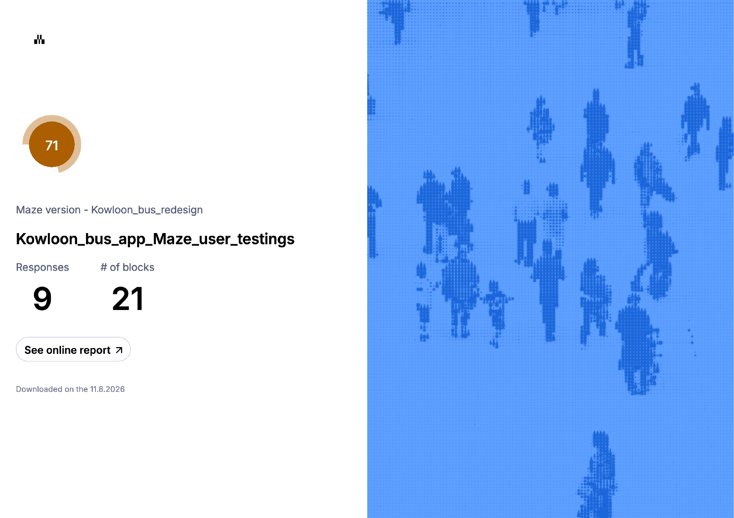
Figure A.1. Maze report, page 1: study overview (9 responses, 21 blocks, usability score 71).
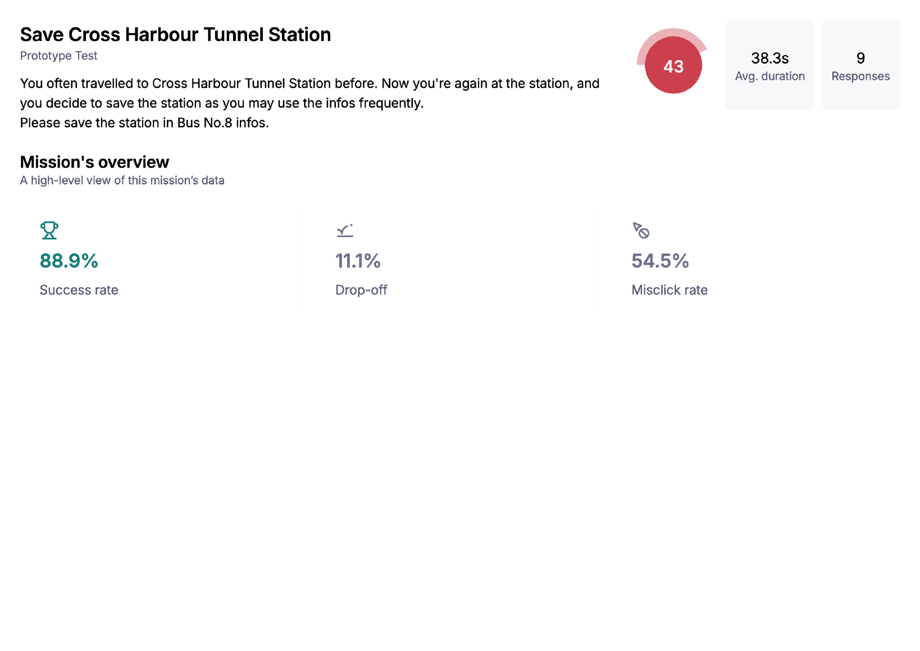
Figure A.2. Maze report, page 13: overview of the save mission (block 6).
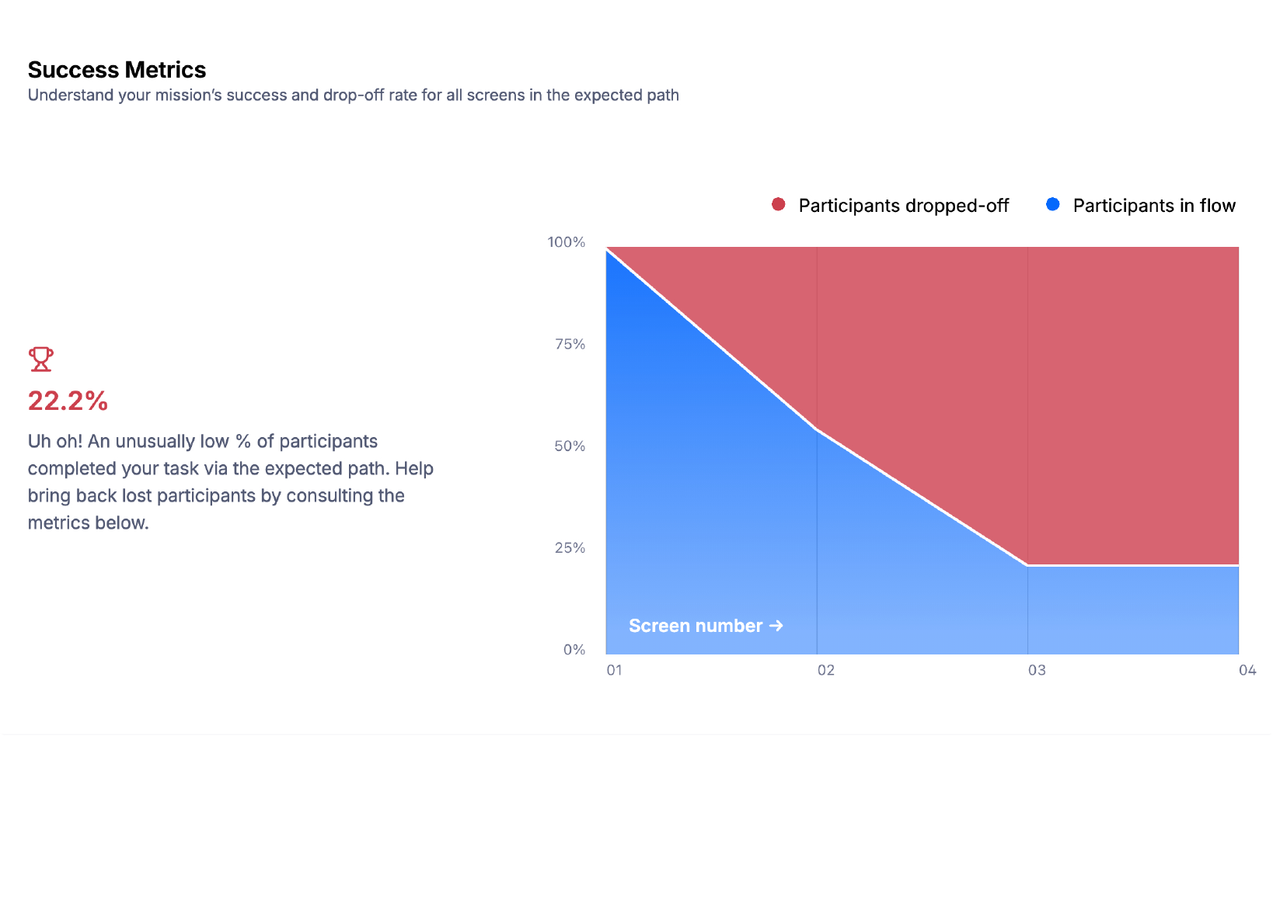
Figure A.3. Maze report, page 14: success metrics for the save mission, with 22.2% on the expected path.
Table A.1. Participant profile (from the User Researcher's participant sheet and the Maze export).
P | Maze tester ID | Age | Device | OS · browser (export) | Date | Start–end | Study time
P1 | 607053489 | 19 | Phone | Android · WeChat | 5 Nov | 20:20–20:31 | 10.5 min
P2 | 607067413 | 48 | Laptop | Mac OS · WeChat | 5 Nov | 20:34–20:53 | 18.2 min
P3 | 607074633 | 20 | Phone | Android · WeChat | 5 Nov | 20:42–20:53 | 10.9 min
P4 | 607092204 | 45 | Laptop | Mac OS · Chrome | 5 Nov | 21:19–21:28 | 9.2 min
P5 | 607462892 | 19 | Laptop | Windows · Chrome | 6 Nov | 11:21–11:28 | 6.9 min
P6 | 607587743 | 19 | Laptop | Windows · Chrome | 6 Nov | 19:43–19:51 | 7.6 min
P7 | 608091492 | 19 | Laptop | Windows · WeChat | 7 Nov | 13:19–13:41 | 22.4 min
P8 | 608092742 | 19 | Tablet | iPad · Safari | 7 Nov | 13:24–13:31 | 6.7 min
P9 | 607192590 | 18 | Phone | iOS · Instagram | 7 Nov | 19:29–19:36 | 7.2 min
Table A.2. Result of each mission for each participant (D = direct, I = indirect, ✗ = gave up). Clicks and misclicks are totals over the nine missions.
P | Device | 1 | 3 | 6 | 7 | 9 | 12 | 14 | 15 | 18 | D / I / ✗ | Clicks | Misclicks
P1 | Phone | D | D | I | D | D | I | I | D | I | 5 / 4 / 0 | 67 | 46
P2 | Laptop | D | D | I | D | D | D | D | D | D | 8 / 1 / 0 | 48 | 24
P3 | Phone | D | D | ✗ | I | I | I | I | D | D | 4 / 4 / 1 | 91 | 59
P4 | Laptop | D | D | D | D | D | D | D | D | D | 9 / 0 / 0 | 19 | 1
P5 | Laptop | D | D | I | D | D | D | D | D | D | 8 / 1 / 0 | 34 | 15
P6 | Laptop | D | D | D | D | D | I | D | D | D | 8 / 1 / 0 | 27 | 8
P7 | Laptop | D | D | I | D | D | D | D | ✗ | D | 7 / 1 / 1 | 42 | 20
P8 | Tablet | D | D | I | D | D | I | D | D | I | 6 / 3 / 0 | 69 | 33
P9 | Phone | D | D | I | ✗ | D | I | I | D | I | 4 / 4 / 1 | 64 | 34
All |  | 9 D | 9 D | 2 D | 7 D | 8 D | 4 D | 6 D | 8 D | 6 D | 59 / 19 / 3 | 461 | 240
Table A.3. Comprehension answers (✓ = correct; otherwise the answer given) and ratings for each participant. RE = Really easy, E = Easy, M = Moderate, LD = A little difficult; G = Good, VG = Very good.
P | 2 Bus 8 | 4 Route 8 | 10 Walk | 13 First | 16 QEH | 19 Bus 116 | Correct | 5 Read | 8 Save | 11 Search | 17 Nearby | 20 Text | 21 All
P1 | ✓ | ✓ | 28 min | ✓ | ✓ | ✓ | 5/6 | E | E | E | E | E | G
P2 | ✓ | ✓ | 28 min | ✓ | ✓ | ✓ | 5/6 | RE | M | E | E | RE | G
P3 | ✓ | ✓ | ✓ | ✓ | ✓ | ✓ | 6/6 | E | LD | RE | RE | RE | G
P4 | ✓ | ✓ | ✓ | ✓ | ✓ | ✓ | 6/6 | E | RE | RE | E | E | G
P5 | ✓ | ✓ | 28 min | ✓ | ✓ | ✓ | 5/6 | RE | E | RE | M | M | G
P6 | ✓ | 5 min | 28 min | ✓ | ✓ | ✓ | 4/6 | RE | RE | RE | RE | RE | VG
P7 | ✓ | ✓ | 28 min | ✓ | ✓ | ✓ | 5/6 | RE | RE | E | M | RE | G
P8 | ✓ | ✓ | ✓ | ✓ | ✓ | ✓ | 6/6 | M | LD | E | RE | RE | G
P9 | ✓ | 5 min | 28 min | No.8 | ✓ | ✓ | 3/6 | E | M | E | E | M | G
All | 9/9 | 7/9 | 3/9 | 8/9 | 9/9 | 9/9 | 45/54
Table A.4. Save mission (block 6): each participant's path, misclicks and rating of how easy saving was (block 8).
P | Path (screen codes) | Screens | Misclicks | Result | Rating
P4 | F1 → F1A → F2 → F2A | 4 | 1 | Direct | Really easy
P6 | F1 → F1A → F2 → F2A | 4 | 0 | Direct | Really easy
P7 | F1 → F1B → F2 → F2A | 4 | 1 | Indirect, via Saved | Really easy
P5 | F1 → F1A → F1B → F2 → F2A | 5 | 0 | Indirect, via Saved | Easy
P1 | F1 → F1A → F1 → F1A → F2 → F2A | 6 | 1 | Indirect | Easy
P2 | F1 → F3 → F3A → F3 → F1 → F1B → F1 → F1B → F2 → F2A | 10 | 15 | Indirect, via Trip and Saved | Moderate
P9 | F1 → F1A → F1 → F1A → F1 → F1A → F1 → F1A → F2 → F2A | 10 | 0 | Indirect | Moderate
P8 | F1 → F4C → F4A → F4B → F4 → F4C → F4 → F4C → F4 → F1B → F4 → F3 → F1 → F4 → F4A → F1B → F2 → F2A | 18 | 23 | Indirect, via Nearby, map and Saved | A little difficult
P3 | F1 → F4A → F4 → F4A → F4C → F4A → F4 → F4C → F4A | 9 | 32 | Gave up | A little difficult

Appendix B. Task script
The wording below is copied from the Maze study, including its spelling. Multiple-choice options are listed as they appear in the Maze report.
Block | Type | Title | Text shown to participants
1 | Mission | Let's get started! | "Please tap the start button to have a try on the app." "Remember to turn on the location info while using the app!" "(You can only use English for the app testing.)"
2 | Question | When will the next Bus No.8 arrive? | "You want to take Bus No.8. Please find out when the next Bus No.8 will arrive." Options: After 5 min; After 12 min; After 3 min; After 9 min; I didn't find the answer.
3 | Mission | Take a ride on Bus No.8 | "Now you're already on Bus No.8, and you wonder how long it will take from the first station to terminal. Please find out the right answer."
4 | Question | How long does it take from the first station to terminal? | "Select the number you just read from the No.8 bus info." Options: 27 min; 5 min; 12 min; 19 min; I didn't find the answer.
5 | Rating | Is it easy for you to read infos of buses? | "The question does not have any right answers. Follow your heart." Scale: Really Easy, Easy, Moderate, A Little Difficult, Really Difficult.
6 | Mission | Save Cross Harbour Tunnel Station | "You often travelled to Cross Harbour Tunnel Station before. Now you're again at the station, and you decide to save the station as you may use the infos frequently. Please save the station in Bus No.8 infos."
7 | Mission | Have a check of your saved stations | "Please check the station you just saved (there are already some default saved buses and stations just for app testings.)"
8 | Rating | Is it easy for you to save a station? | "The question does not have any right answers. Follow your heart." Scale: Really Easy, Easy, Moderate, A Little Difficult, Really Difficult.
9 | Mission | From Hung Hom Station to Argyle Centre | "You are right now at Hung Hom Station, and you have no idea how to get to Argyle Centre." "Please search the recommended route from Hung Hom Station to Argyle Centre."
10 | Question | What's the recommended bus number and how long will you walk to get to the destination? | "Please read the infos given in the searching results to plan for the trip." Options: 87D, 28 min; 87D, 2 min; 87D, 6 min; 87D, 6.4 min; I didn't find the answer.
11 | Rating | Is it easy for you to search a route? | "The question does not have any right answers. Follow your heart." Scale: Really Easy, Easy, Moderate, A Little Difficult, Really Difficult.
12 | Mission | Find bus stations nearby | "You are right now close to Hung Hom Station, and you want to catch the bus at a station close to you." "Please find out the nearest bus and see the details of the bus using "Nearby" function."
13 | Question | Which bus arrives first? | "According to the detailed infos you read, find out which bus comes first at the station neareast [sic] to you." Options: Bus No.101; Bus No.8; Bus No.11K; Bus No.116; I didn't find the answer.
14 | Mission | Use a map and take a look around | "In "Nearby", please turn on the map and see your location."
15 | Mission | Find landmarks around me | "Find out the landmarks around you using "Nearby" function."
16 | Question (multiple answers) | Which bus can take you to Queen Elizabeth Hospital? | "Find out the bus number(s) that can take you to Queen Elizabeth Hospital. This question may have one or more right answers." Options: No. 11K; No. 116; No. 8; No. 5C; No. 87D; I didn't find the answer.
17 | Rating | Is it easy for you to use "Nearby" function? | "The question does not have any right answers. Follow your heart." Scale: Really Easy, Easy, Moderate, A Little Difficult, Really Difficult.
18 | Mission | Adjust the size of texts | "The text on the home screen is too small for you to read comfortably. Make it the largest (200%), then return to the home screen and check when the next Bus No.116 arrives."
19 | Question | When will the next Bus No.116 arrive? | "Read the infos in the Homepage with larger text size." Options: After 9 min; After 12 min; After 5 min; After 3 min; I didn't find the answer.
20 | Rating | Is it easy for you to adjust size of texts? | "The question does not have any right answers. Follow your heart." Scale: Really Easy, Easy, Moderate, A Little Difficult, Really Difficult.
21 | Rating | Overall, how do you feel about the new version of Kowloon Bus? | "This is the last question of the test. The majority of the app's functions are included in the tests. The question does not have any right answers. Follow your heart." Options: Very Good; Good; Moderate; Bad; Really Bad.

Appendix C. Figma and Maze links
Item | Link and notes
Figma design file | https://www.figma.com/design/2JkOkm1pztoaZask0fDJeq/APP1933-KMB.LWB-Redesign?node-id=0-1  Opens on the page "App Screens · English en-GB", the version tested and shown in this report. The file also holds the Traditional Chinese page, the components and the boards comparing the original app with the redesign.
Clickable prototype | https://www.figma.com/proto/2JkOkm1pztoaZask0fDJeq/APP1933-KMB.LWB-Redesign?node-id=26-1387&starting-point-node-id=26%3A1387  Starts the flow "First launch (en-GB)" at the welcome screen (O1). Shown in the iPhone 18 Pro device frame; arrival times are simulated.
Maze report | https://app.maze.co/report/Kowloon_bus_redesign/oBtJvOVQD-qXRtWj33TtgofbHD7gVvM9/intro  Full online report, including each mission's navigation overview.

Appendix D. Accessibility audit of the existing app
Our Accessibility & Evaluation Lead audited App1933 v2.3.38 for iOS, run on a Mac at the size of a 375 × 667 pt iPhone screen with the interface in Traditional Chinese, against four WCAG basics: contrast, target size, text scaling and screen-reader support (W3C, 2024). The contrast checks were repeated on iPhone screenshots of v2.3.39 taken on 8 November 2026, and every failure found on the Mac appeared on the phone with the same ratio to within 0.05. Contrast was measured on the screenshots with the WCAG relative-luminance formula. Target sizes were read from the app's accessibility tree where exposed, otherwise measured on the screenshots, and converted to iOS points. Text scaling was tested on the iPhone with the system text size at its maximum. Screen-reader support was judged by listing what each main screen exposes to assistive technology; we did not run a VoiceOver session.
Table D.1. Audit results.
# | Check | WCAG | Result
1 | Body text, stop names, fares, arrival times, tab labels | 1.4.3 | Pass. Near-black on white, 14.7:1 to 21:1; blue arrival minutes 9.4:1 and 10.6:1; selected red tab label 6.0:1.
2 | White text on the red header | 1.4.3 | Pass, narrowly. 4.84:1 on the Mac build; 4.60:1 on the iPhone.
3 | Search placeholder, the only hint of what to type | 1.4.3 | Fail. #DBDBDB on white, 1.38:1 (iPhone 1.36:1).
4 | Nearby mode buttons and empty-state message | 1.4.3 | Fail. Unselected buttons white on #BABBBB, 1.92:1 (working buttons, so not exempt); empty-state message 1.66:1.
5 | White text on the slate section bars | 1.4.3 | Fail, narrowly. 4.37:1.
6 | Unused letters on the stop-code keypad | 1.4.3 | Exempt. 1.35:1, but the keys are disabled.
7 | Icons against their background | 1.4.11 | Pass. 4.37:1 to 13.0:1.
8 | Touch-target size | 2.5.8; Apple 44 pt | Mixed. Tabs, menu cells and keypad keys are 44 pt or more. Route header icons (29 pt) and the four stop action icons (26 pt) meet 24 pt but not 44 pt. The planner's star (about 17 pt, inside a tappable row) fails 2.5.8. The skip button on the launch advert is roughly 22–25 pt and is the only way past it.
9 | Text scaling | 1.4.4 | Fail. No text-size setting among the 26 menu items, and the app ignores the iPhone's text size: at the maximum setting, Home text is the same size to the pixel (Figure D.2). Text is already cut off in four places at the default size.
10 | Screen-reader names and roles | 1.1.1, 4.1.2 | Fail (by inspection). Tabs, the 26 menu items and the language options are exposed with names. Route rows, stop lists, keypads and every icon-only button are not exposed in our inspection. "Close" in the menu is exposed as text, not as a button, and the search box as static text, not a text field.
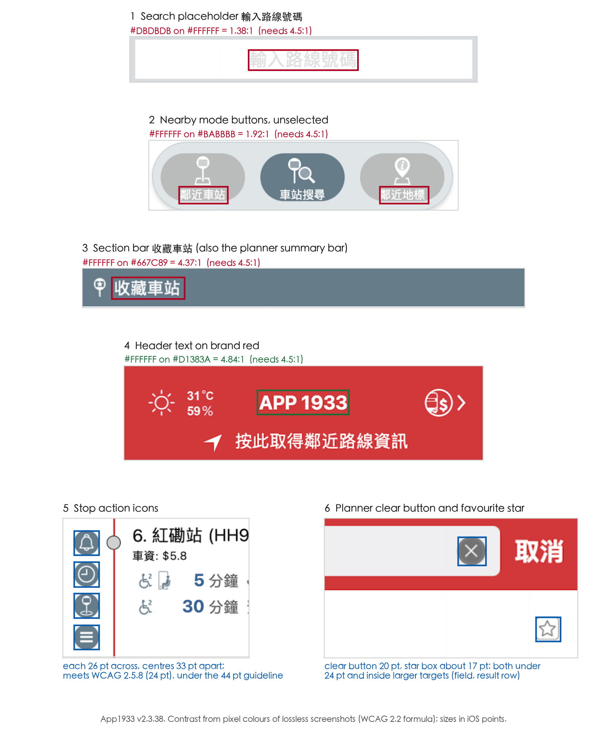
Figure D.1. Contrast failures and small targets in App1933 v2.3.38. Red boxes are contrast failures, green is a pass, and blue marks measured targets.
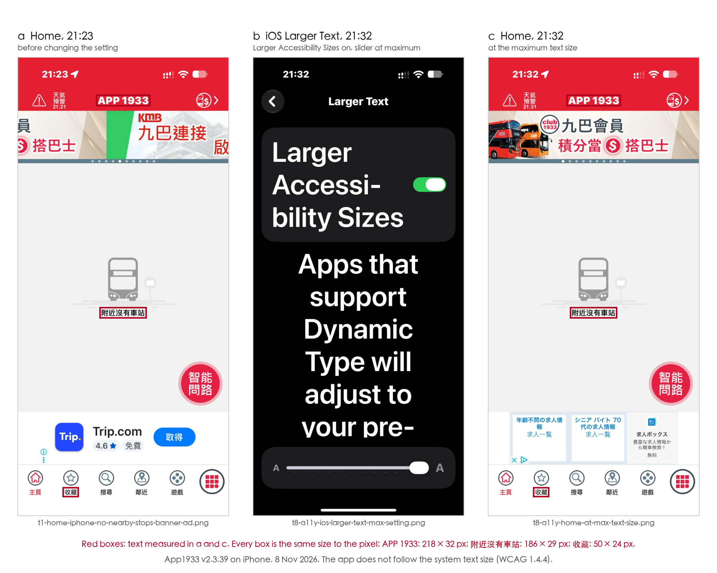
Figure D.2. App1933 ignores the iPhone's text size: (a) Home before the change; (b) Larger Text with Larger Accessibility Sizes on and the slider at its maximum; (c) Home at that setting, with every measured text box the same size as in (a).
Table D.2. What each main screen exposes to assistive technology (accessibility-tree inspection).
Screen | Exposed (name · role) | Not exposed
Home | APP 1933 · text; six tab buttons | Route rows, banner, location prompt, weather, fare button, trip-planner button
Route detail | "Go back" · button (in English, in a Chinese interface); stop markers on the map | Header icons, stop list, arrival times, stop action icons
More menu | 26 items · button; Close · text, with no button role | —
Language dialog | 繁體中文, 简体中文, English · button | No cancel option exists
Search | Search · text; placeholder · text (should be a text field) | Keypad, results
Nearby | Nearby · text | Instruction, stop-code keypad, mode buttons
Saved | Saved · text | Saved stop row, arrival time, edit button
The app is built with React Native, which passes accessibility information to iOS; we read that information on a Mac rather than listening to VoiceOver on an iPhone. VoiceOver may read more than the Mac shows, for example the text inside a route row, so the "not exposed" list is an upper bound. The icon-only controls have no text inside them to fall back on, so their missing labels are the most secure part of this finding.
How the redesign responds. Secondary text is #696969 or darker (5.49:1), containers are neutral grey with ink text, and red is kept for the header, route badges, primary buttons and the active tab (Section 3.6). No linked element is under 24 pt and 86% reach 44 pt, with a 44 pt ☆ on every stop (Section 3.7). Text size has its own control under More (F5). The four bare icons in route detail become three labelled tools and a labelled save button (F2). Screen-reader labels cannot be built in a Figma prototype and remain future work.

Appendix E. Extra screen captures
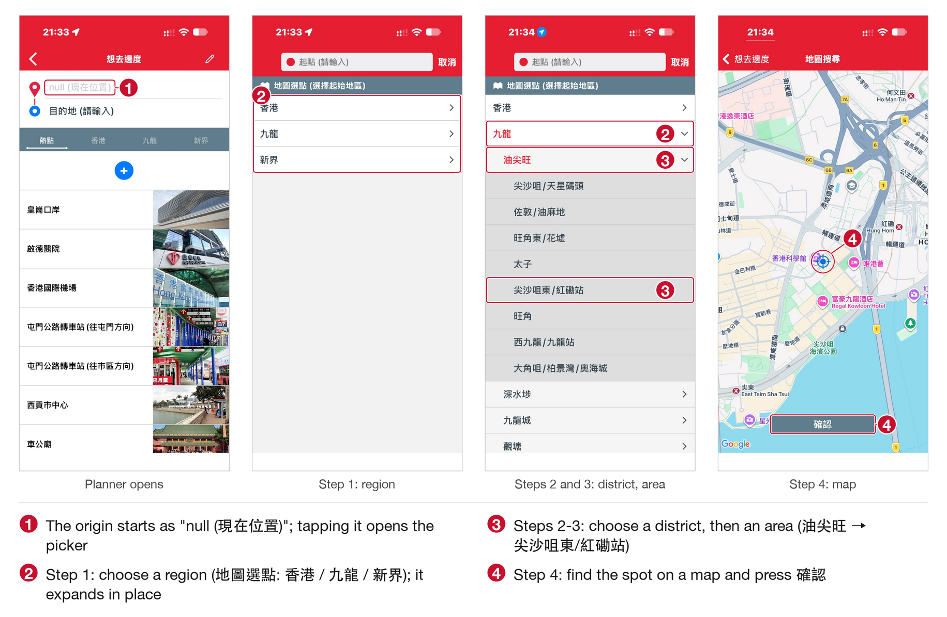
Figure E.1. Picking a starting place in the existing planner (iPhone, v2.3.39): the origin starts as "null", then region, district and area, then the map and a confirm button.
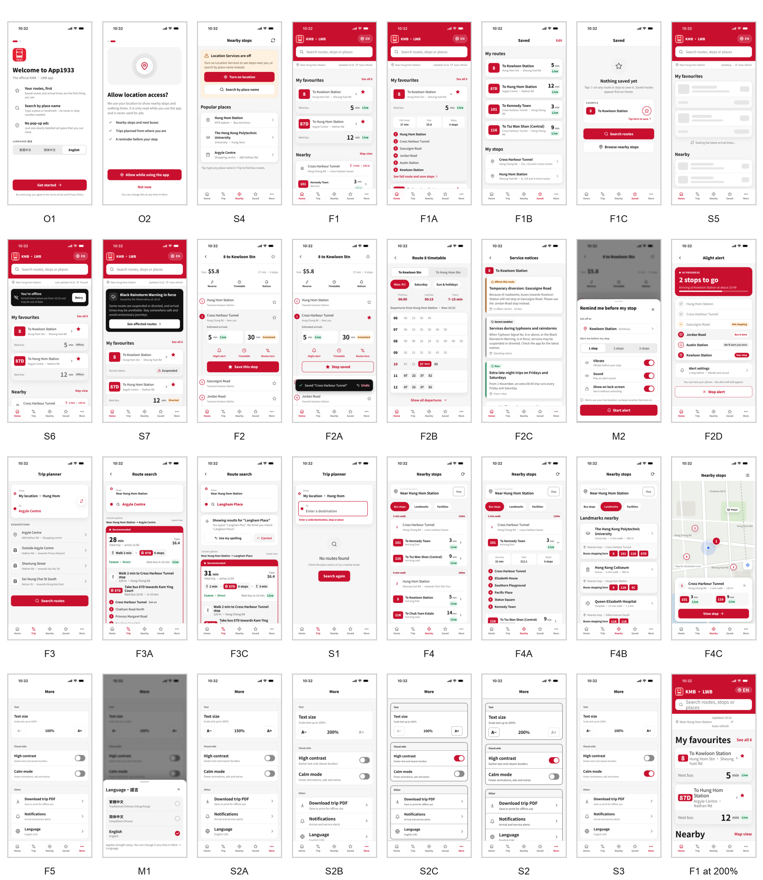
Figure E.2. All 32 screens of the English prototype (31 core screens and Home at the largest text size).

