COMP3423 Human-Computer Interaction, Group Project
Mid-Project Checkpoint: Redesigning App1933 (KMB · LWB)
FA Haochen (24113347D); ZHANG Chenyang (25091317D); ZHANG Xulu (); LO Li-En (24109751D); KONG Moling (24103622D)
1. App Choice and Target Users
We are redesigning App1933, the official app of Kowloon Motor Bus and Long Win Bus. Most people use it to check when the next bus will arrive, look up routes and fares, and plan trips. At our kickoff meeting we considered seven everyday apps and chose App1933 for two reasons. First, people often open it in a hurry, for example while walking to a bus stop, so any delay or extra step is costly. Second, its usability problems are obvious and are mentioned repeatedly in app-store reviews: ads that are hard to close, an outdated interface, mini-games inside a bus app, and a search function that requires a route number or stop ID.
Target users. We focus on two groups who use the app in different ways. Elderly passengers often do not know route numbers or stop IDs, find small text hard to read, and may mistake pop-up ads for scams, so they need a simple interface and search by place name. Students and daily commuters are comfortable with smartphones but usually short of time. They often use the app one-handed while walking, so their regular routes and arrival times should appear as soon as the app opens.
2. Team Roles
Member | Role | Main responsibilities
Haochen Fa (leader) | Project Lead & UX Strategist | Schedule, Introduction and Conclusion, HCI-principle mapping, final review
Chenyang Zhang | User Researcher | Personas, user journey, Maze test design, Testing section
Xulu Zhang | Interaction Designer | Information architecture, screen states, Figma prototype flow
Li-En Lo | Visual & UI Designer | Home wireframe, colour scheme, style guide, high-fidelity screens, slides
Moling Kong | Accessibility & Evaluation Lead | Heuristic evaluation, accessibility audit, accessible design features
3. User Journey (Draft)
This table summarises our journey map. The elderly track is based on observing an older user; the commuter track is based on app-store reviews (quotes paraphrased). Emotions range from 0 (neutral) to −3 (very negative).
Stage | Elderly passenger | Student / commuter | Principles violated
1. Opening the app | Does: opens the app at home to check a route.  Problem: a full-screen ad appears straight away; they suspect the app is a scam and want to close it.  Feels: suspicious, alarmed (−3) | Does: opens the app while hurrying to the stop.  Problem: a forced 10–15 second ad with a tiny skip button; the bus may leave before it ends.  “Ads every single time I open it, when I’m in a hurry.”  Feels: anxious, annoyed (−3) | User control and freedom; efficiency of use; Fitts’ law (tiny skip target); dark patterns  Addressed by: F1
2. Searching | Does: tries to find a bus to a familiar place.  Problem: search only takes route numbers; the keyboard covers about 85% of the screen; nearby search wants a numeric stop ID; the AI assistant finds nothing; “Kai Tak – MTR Exit A, Muk On Street” gives 0 results.  Feels: lost, confused (−3) | Does: looks up a trip or opens a saved route.  Problem: Smart Search changes the destination on its own; saved routes sit several menus deep.  “Smart Search has become dumb search: ‘no routes found’ everywhere.”  Feels: frustrated, impatient (−2) | Recognition rather than recall; error prevention; match with the real world (place names, not IDs)  Addressed by: F2, F3, F4
3. Reading and waiting | Does: tries to read the fare and arrival time.  Problem: small text, and banner ads keep appearing over the information.  Feels: eye strain, stress (−2) | Does: watches the countdown at the stop.  Problem: the arrival time jumps around, and some buses disappear from the list with no explanation.  “5 minutes, then 8, then the bus vanished.”  Feels: distrustful, angry (−3) | Visibility of system status; minimalist design; accessibility (text size, contrast)  Addressed by: F1, F2, F5
4. Afterwards | Does: stops using the app.  Result: goes back to reading stop signs or asking other people.  Feels: has lost confidence in the app (−3) | Does: keeps using it, reluctantly.  Result: feels each update makes it worse and tries third-party bus apps.  Feels: dissatisfied, cynical (−2) | Loss of trust in the app’s reliability
In both tracks, the most negative moments (−3) occur at launch and during search, so removing launch ads and improving search are the top priorities in our feature list.
4. From Wireframe to High-Fidelity Design
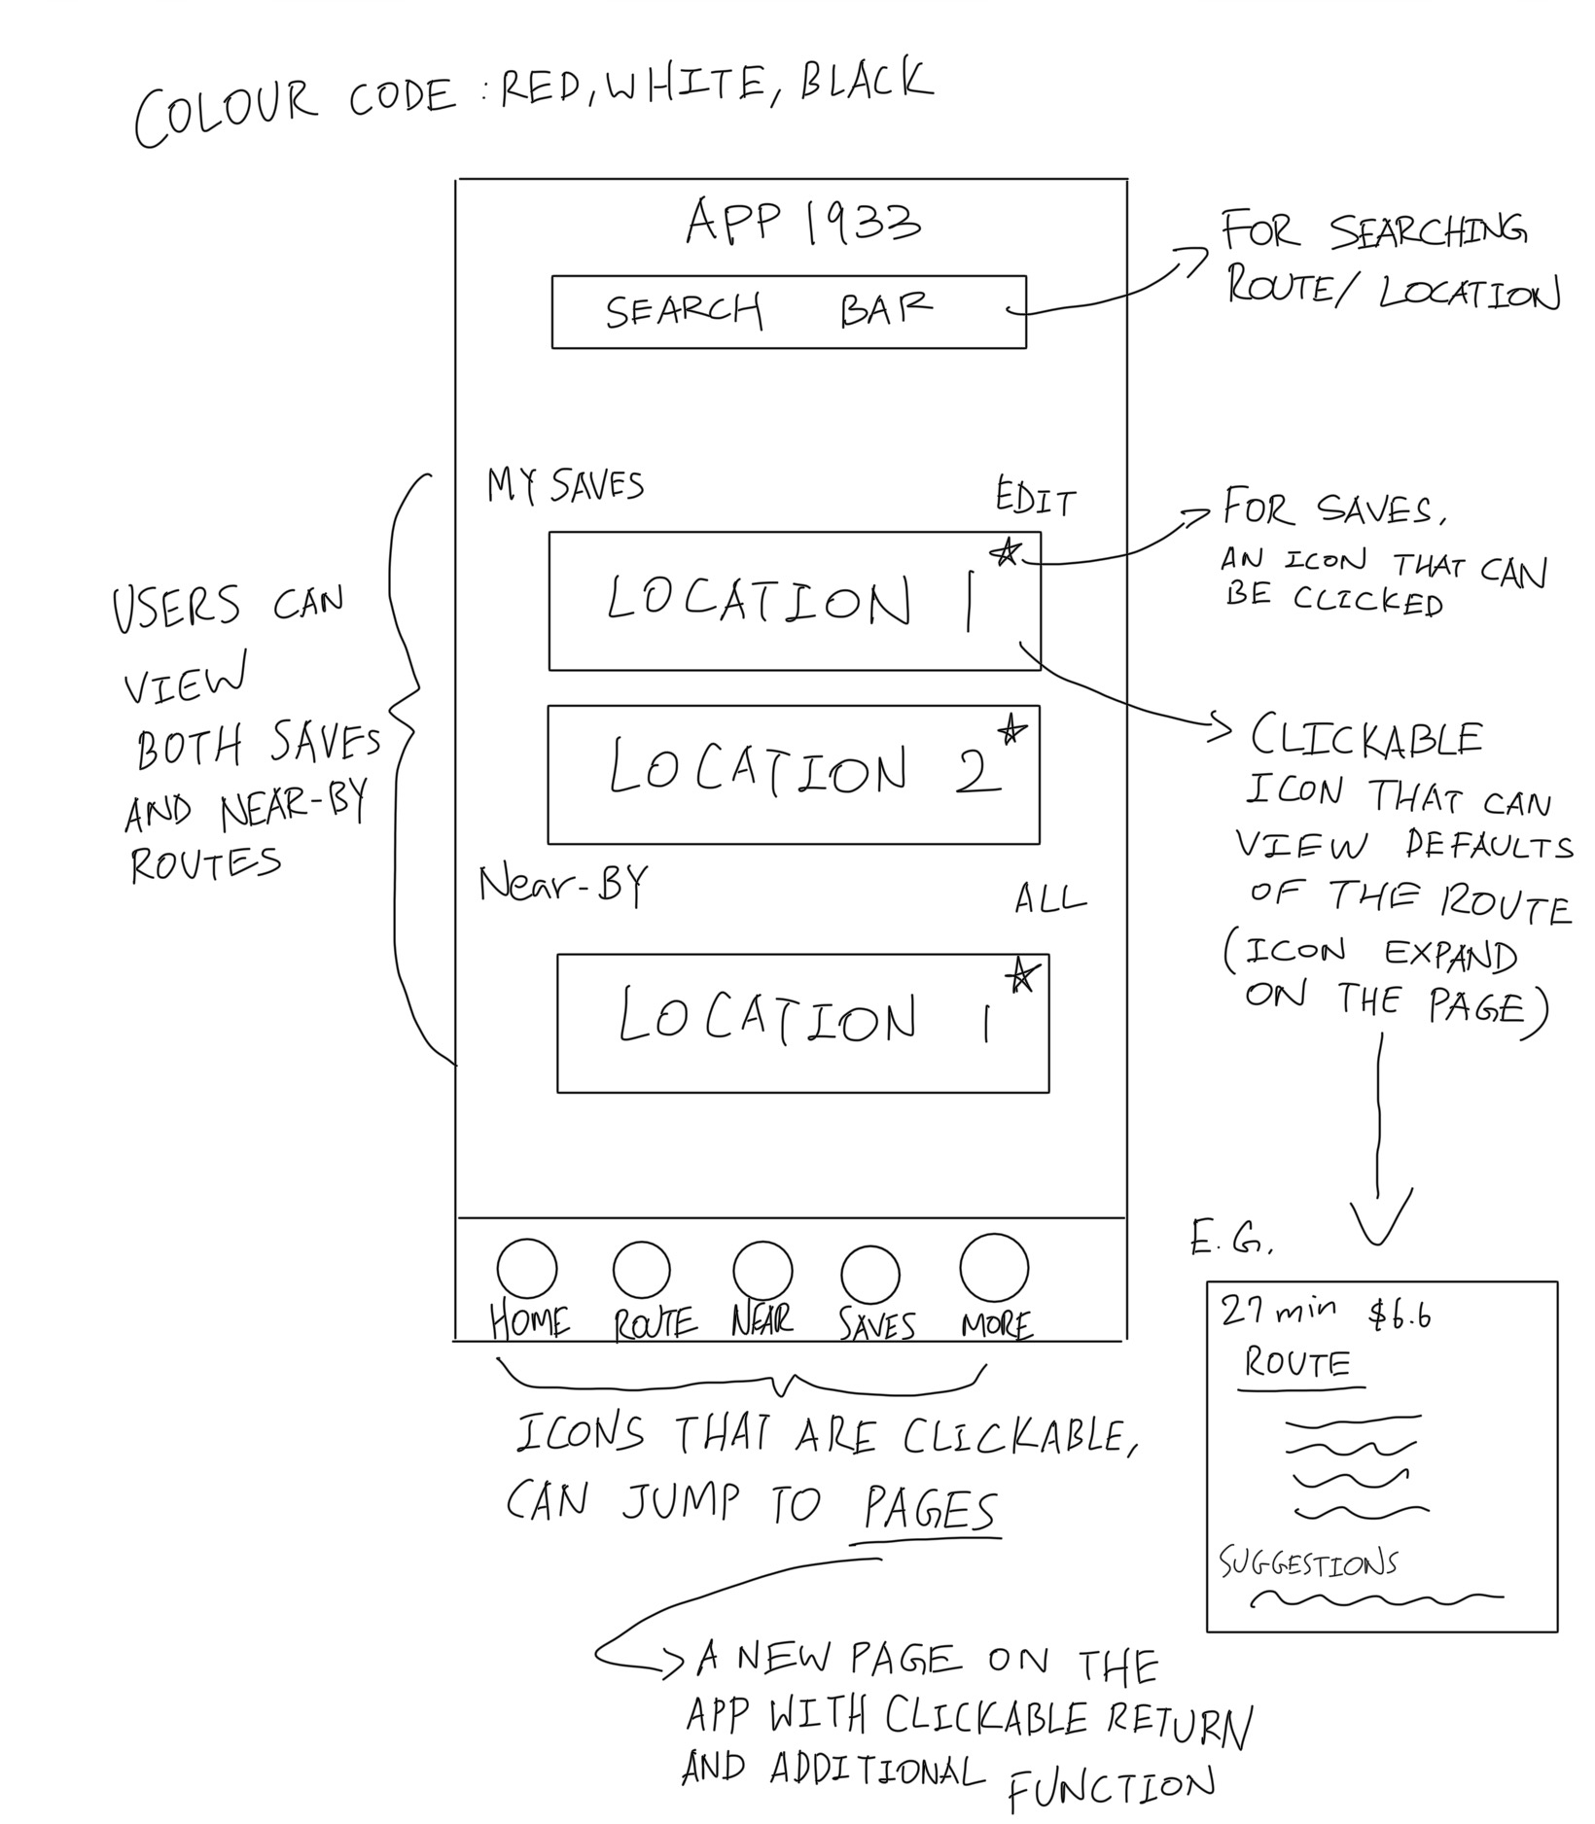  (a) Hand-drawn sketch | 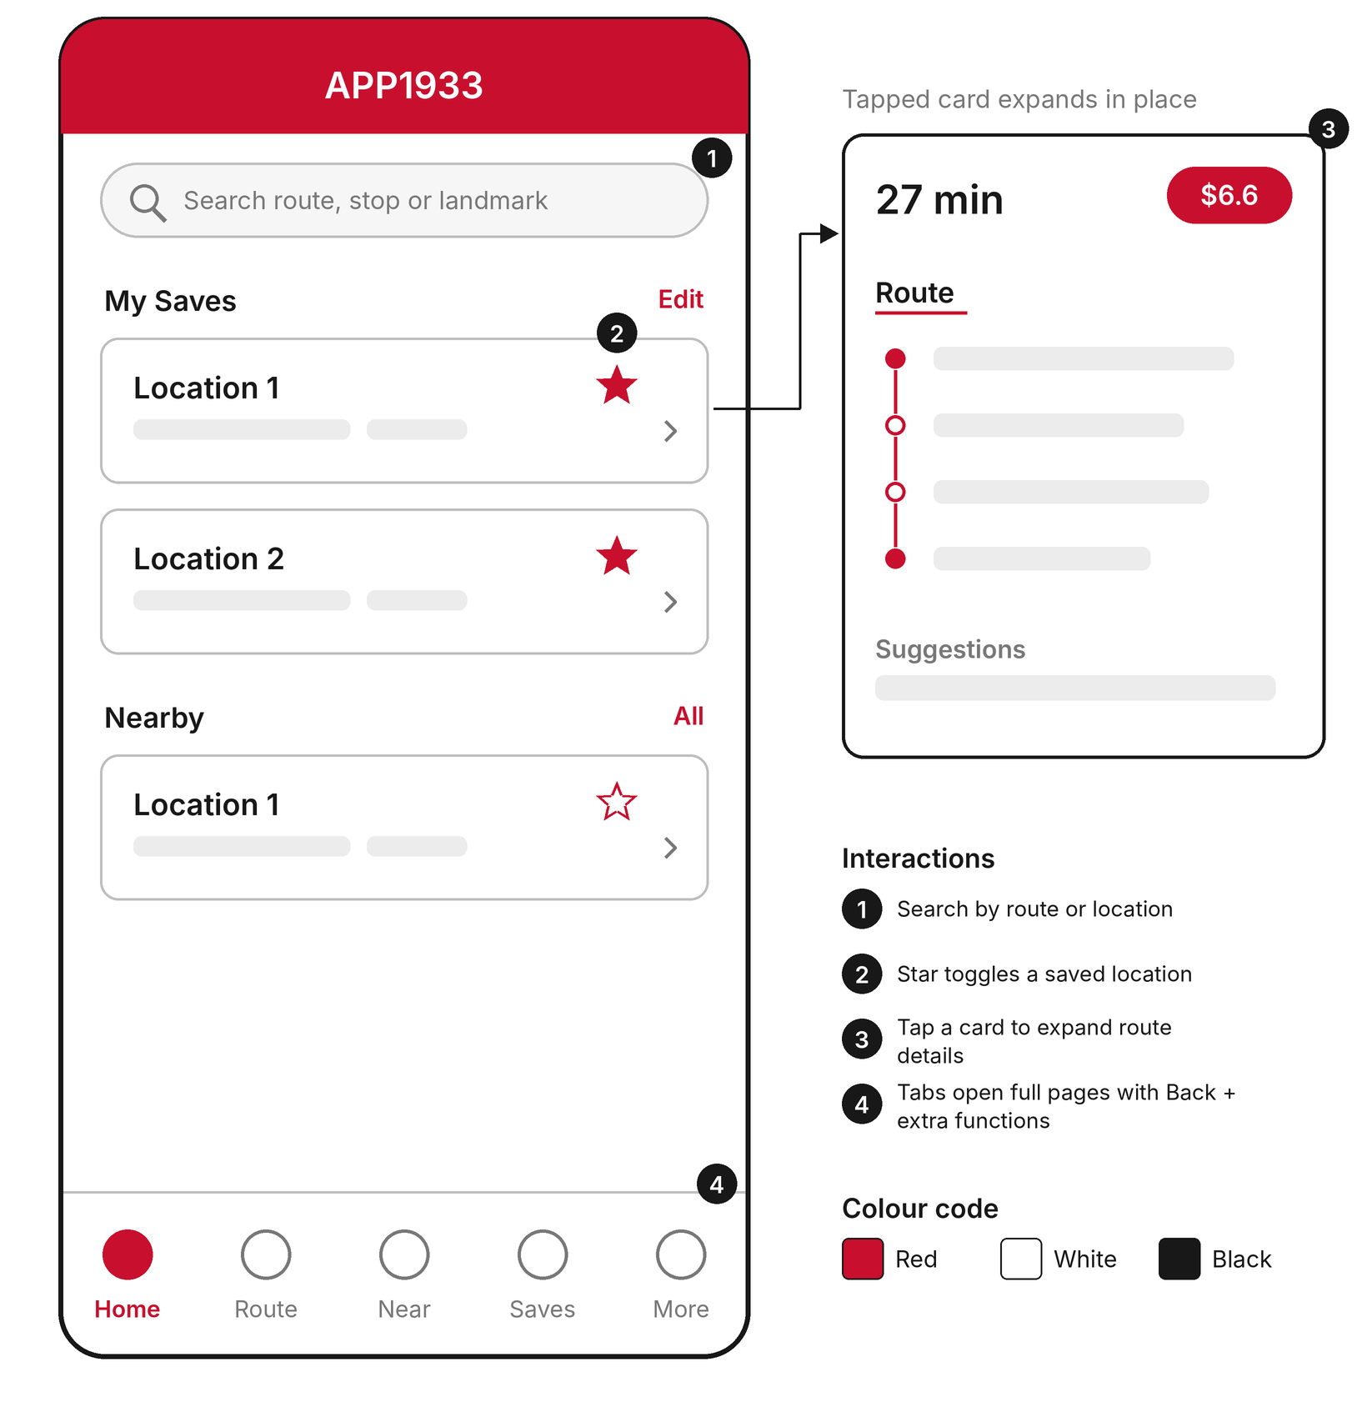  (b) Digital wireframe | From sketch to wireframe. The hand-drawn sketch (a) set the basic structure: a search bar at the top, saved and nearby locations on Home, and five tabs at the bottom.  We redrew it (b) to tidy the layout and turn the handwritten notes into numbered interactions, then used it as the starting point for the Figma design.

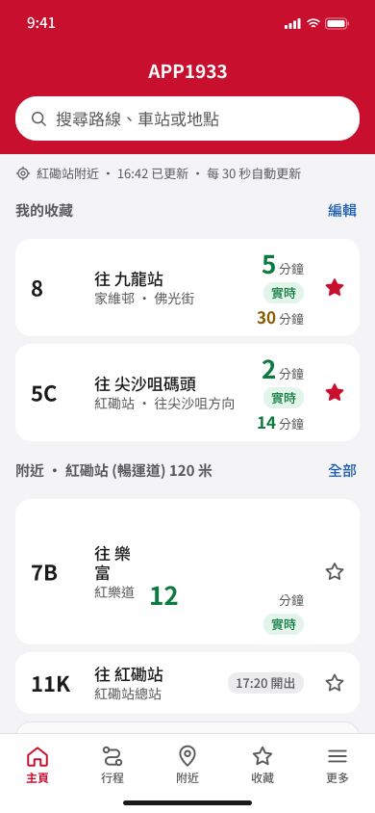  (c) F1 Home | 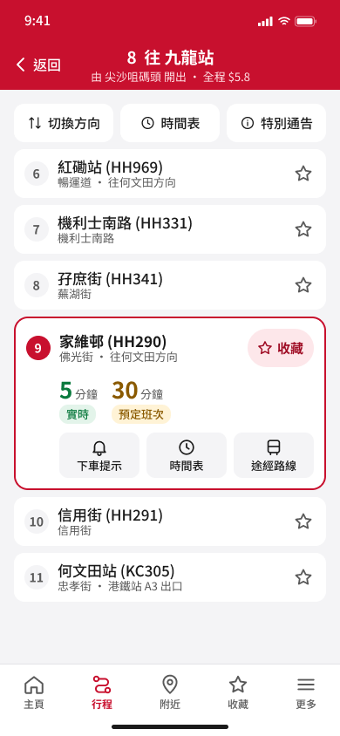  (d) F2 One-tap save | 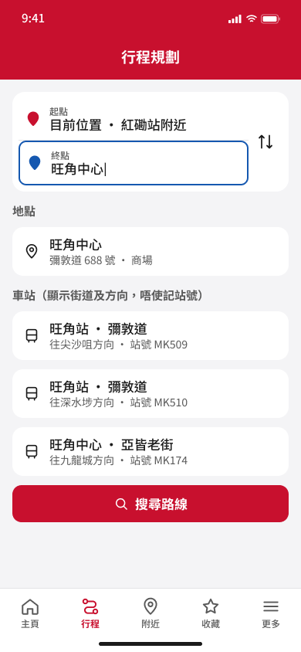  (e) F3 Trip planning | High-fidelity screens (Figma). (c) Home lists saved routes first, and each arrival carries a 實時 (live) or 預定班次 (scheduled) label.  (d) Every stop on a route has a 44 pt ☆, and the open stop has a labelled 收藏 (save) button.  (e) Trip planning starts from the current location and accepts place names, not just route numbers.  The interface is in Traditional Chinese for Hong Kong users. The other 11 screens, covering F4, F5 and edge cases, are in our Figma file.
5. Five Features to Redesign
Feature | Problem in the current app | HCI principle(s) | What we are prototyping
F1. Home | Launch ads; saved routes buried; no way to tell live from scheduled times | Efficiency of use; user control; visibility of system status | Saved routes first; live / scheduled labels; one labelled ad slot, no pop-ups
F2. One-tap save | 7 taps to save, behind an unlabelled ≡ icon; a blocking pop-up | Recognition rather than recall; Fitts’ law | 44 pt ☆ on every stop; labelled 收藏 button; undo instead of a pop-up
F3. Trip planning | Route-number search; “null” origin allowed; Smart Search changes the destination | Error prevention; helping users recover from errors | Search by place name; origin set to current location; AI changes can be undone
F4. Nearby stops and landmarks | Needs a stop code; rows show only a distance | Match with the real world; screen-reader accessibility | Stops with street, walking time and next bus; landmarks with category and bus
F5. More menu and accessibility | 30 unsorted icons; system text size ignored | Minimalist design; Hick’s law; WCAG 1.4.4 | Grouped menu; text size, contrast and calm mode; works at 200% text
6. Progress and Next Steps
- Completed (Weeks 1–4): all of the above, plus first high-fidelity screens for all five features (14 screens in Figma).
- Week 5: clickable prototype, annotated real-app screenshots, accessibility audit and Maze plan.
- Week 6: Maze test with at least five participants, including at least one aged 60 or above. Draft tasks: check the next bus on a saved route (F1); save a stop on route 8 (F2); plan a trip to 旺角中心 by place name (F3); find which bus goes to PolyU from Nearby (F4); switch to larger text (F5). Measures: success rate, time on task, misclicks and a 1–5 ease rating.
- Weeks 7–8: analyse the results, revise the prototype (v1 to v2), write the report and record the video.
Scope. Live arrival accuracy depends on KMB’s back end, which we cannot change; we focus on presenting it clearly.

