**C:\Users\Emagno\Desktop\main-logo.png**

**Basic math learning in grade school**

A Project Proposal Presented to

College of Information Technology and Engineering

PHINMA Araullo University

In Partial Fulfillment

of the Requirements for the Degree of

Bachelor of Science in Information Technology

by:

Ison, Hanter Jhon O.

Pangilinan, Nhorie Lyn C.

Sangbaan, Rianne Shiane T.

Romano, Renz Joshua R.

Serrano, Ejay M.

**Jhon liabres**

Class adviser

Oct 2022

**ITE301(basic math learning in grade school)**

**Description**

Since pandemic a lot of kids has been left behind in education especially in math that why in this Apps the basic math is a useful and resourceful way of introducing elementary school students to basic mathematical concepts.

**Statement of the problem**

**General Problem**

We encountered a problem especially after pandemic that involve a child education, that most student are left behind especially in Math

**Specific Problems**

* How the application lessens the problems that child encounter such as lack of focus, interest?
* How the app will help the children to learn the basic math?
* How the app will help the teacher to have more learning materials to teach kids?

**Objective**

To create an app that will help the child and to be knowledgeable student in the subject of math.

**Specific objective**

* to develop an application to be more creative, colorful, and fun.
* To build an app for the children who will learn a basic math through
* To develop an app for teachers to have a plenty of learning resources and to provide the core information that students will experience, learn, and apply during a course. They hold the power to engage the students to learn.

**Significance**

**To the student**- This application will help the student especially the children to learn basic math in more modern, creative and enjoyable way.

**To the teacher** – This application will benefit the teachers because it can be a learning material for students in more creative ways.

**To the parent**- This apps are a wonderful way to save time and money as they are very inexpensive and easy to use. As parents are timely updated about school activities, educational apps save a lot of their time.

**Scope and limitation**

**Scope  
-** Only use Addition, Subtraction, Multiplication and Division solving math problem.

**Limitation  
-** scientific solving calculator that no rigorize of our system.

**Site Structure**

Multiplication

Division

Addition

Subtraction

Basic Math

Activity

Activity

Activity

Activity

**User flow Diagram**

**Addition**

**Computing**

**Answer**

Basic Math

Answer

Answer

Answer

Answer

**Division**

**Multiplication**

**Subtraction**

**Activity**

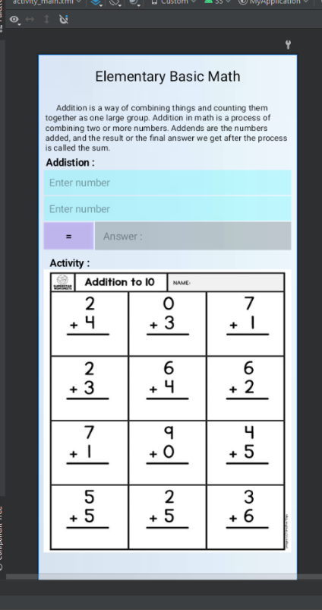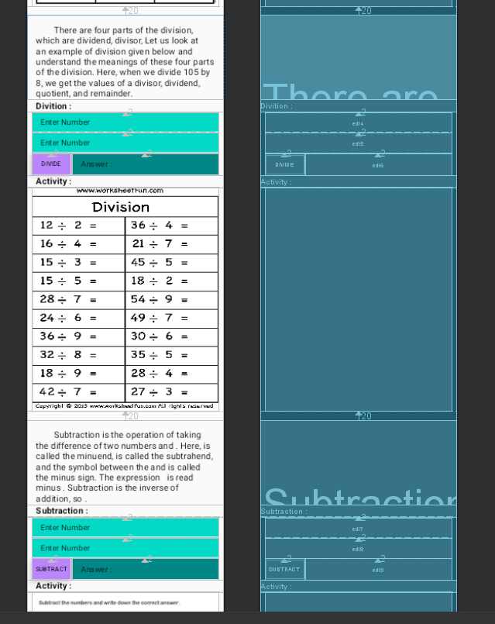**App screen templates design**

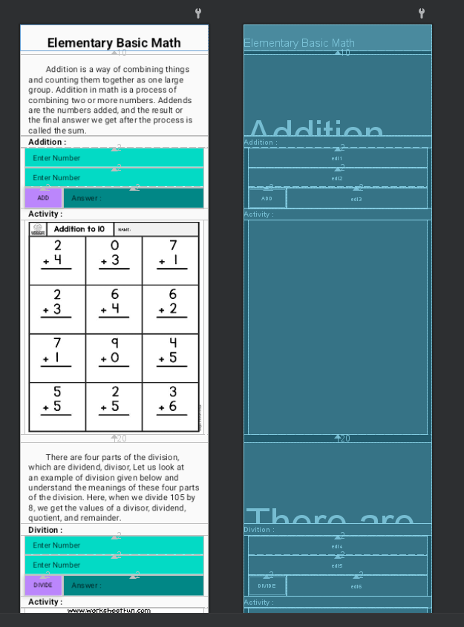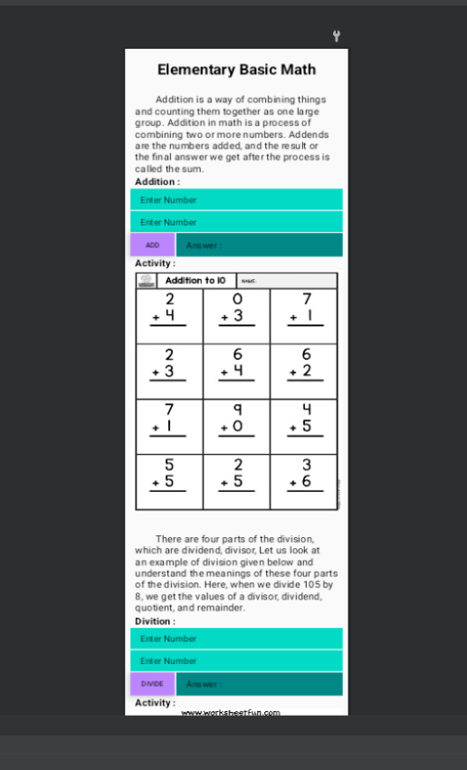

**Developers curriculum vitae**

# Hanter John O. Ison

**Purok Damayan, Brgy. Marawa Jaen Nueva Ecija**

**Contact Number**: *09277531488*

**E-mail Address**: hanterjohnison@gmail.com

|  |
| --- |
| Career Objectives |

A challenging position where I can contribute my knowledge and skills. A job where action takes place and thinking is always present. I wish to join a group of warm people that could help enhance and gain knowledge with great opportunity for professional growth.

|  |
| --- |
| Education |

* **BACHELOR OF SCIENCE- INFORMATION TECHNOLOGY**

*Araullo University*

S.Y.June 2020 – June 2024

* **Marawa National Highschool**

**Marawa Jaen**   
S.Y. 2013-2017

* **Marawa Elementary School**

**Marawa Jaen**S.Y. 2006-2012

|  |
| --- |
| Personal Information |

**Age : 20**  
**Civil status**: Single

**Date of birth**: December 18, 2001

**Height**: 5,8

**Weight**: 65 kgs

**Religion**: Iglesia Ni Cristo

**Father’s Name:** Edelino Ison

**Occupation:** Company worker

**Mother’s Name:** Analyza Odiza  
**Occupation:** Housewife  
  
  
  
  
***I hereby certify that all above information’s are true and correct to the best of my knowledge, understanding and belief.***

**Hanter John O. Ison**

Student