SUPPLEMENTARY MATERIALS
NCCT-Based Radiomics and Deep Learning for mRS Prognostication After Spontaneous Intracerebral Hemorrhage: A Network Meta-Analysis
This supplementary material includes Supplementary Tables S3-S19 and Supplementary Figures S1-S18, providing search strategies, the list of excluded studies, risk-of-bias and certainty assessments, detailed data extraction tables, network meta-analysis diagnostics and consistency assessments, meta-regression analyses, and clinical decision analyses. The TRIPOD-SRMA and PRISMA-NMA checklists (Supplementary Tables S1 and S2) accompany the main article. The analysis code is provided in the accompanying GitHub repository.
17 Supplementary Tables · 18 Supplementary Figures · 98 pages
Contents
Supplementary Tables
Table S3. Search strategy in PubMed, Embase, Web of Science, and Cochrane Library. 6
Table S4. Excluded Studies with Reasons for Exclusion 9
Table S5. Risk of bias assessment (PROBAST+AI) model development based on seven domains. 11
Table S6. Risk of bias assessment (PROBAST+AI) model evaluation based on seven domains. 14
Table S7. GRADE certainty assessment for prognostic classification performance across model categories. 17
Table S8. Methodological Details of the Bayesian Hierarchical Network Meta-Analysis of Diagnostic Test Accuracy (NMA-DTA). 19
Table S9. Supplementary baseline clinical and imaging characteristics of patients and cohorts. 22
Table S10. Diagnostic performance of included models for poor functional outcome at 90 days. 30
Table S11. Diagnostic performance of included models for poor functional outcome at 6 months. 37
Table S12. Diagnostic performance of included models for poor functional outcome at discharge. 39
Table S13. CT acquisition and image-preprocessing characteristics. 42
Table S14. Segmentation and model-development characteristics. 46
Table S15. Meta-regression analyses of all study-level covariates. 50
Table S16. Between-study variance (τ²) explained by each covariate in the meta-regression analyses. 51
Table S17. MCMC Convergence Diagnostics. 52
Table S18. Clinical decision table across assumed prevalence scenarios. 53
Table S19. Sensitivity analyses of diagnostic-node rankings by outcome 56
Supplementary Figures
Figure S1. Trace plots of the Markov chain Monte Carlo simulations for the 90-day analysis. 57
Figure S2. Posterior density plots of sensitivity and specificity for the evaluated model categories (90-day analysis). 58
Figure S3A. Transitivity checks across direct comparisons for continuous study-level covariates (publication year, age, male proportion, and ICH volume). 59
Figure S3B. Transitivity checks across direct comparisons for categorical study-level covariates (center, region, validation type, and mRS threshold). 60
Figure S4. Design-by-treatment interaction assessment of global inconsistency (ΔDIC) for sensitivity and specificity. 61
Figure S5. Node-splitting consistency tests for sensitivity and specificity (90-day analysis). 62
Figure S6A. Forest plots of individual studies for the conventional clinical-CT models (90-day analysis). 63
Figure S6B. Forest plots of individual studies for the CT-based radiomics-only ML models (90-day analysis). 64
Figure S6C. Forest plots of individual studies for the clinical-CT-radiomics ML models (90-day analysis). 65
Figure S6D. Forest plots of individual studies for the CT-based DL-only models (90-day analysis). 66
Figure S6E. Forest plots of individual studies for the clinical-CT-DL fusion models (90-day analysis). 67
Figure S7. Direct evidence contribution of the network meta-analysis (90-day analysis). 68
Figure S8. Pairwise meta-analysis of direct comparisons for sensitivity and specificity (90-day analysis). 69
Figure S9. Outlier diagnostics assessment for the included studies (90-day analysis). 70
Figure S10A. Forest plots of pooled diagnostic performance for poor functional outcome at 6 months. 71
Figure S10B. SUCRA heatmap for poor functional outcome at 6 months. 72
Figure S11A. Forest plots of pooled diagnostic performance for poor functional outcome at discharge. 73
Figure S11B. SUCRA heatmap for poor functional outcome at discharge. 74
Figure S12A. Sensitivity analysis of pooled diagnostic performance: external validation studies only. 75
Figure S12B. Sensitivity analysis of pooled diagnostic performance: excluding outlier studies. 76
Figure S12C. Sensitivity analysis of pooled diagnostic performance: studies using a mRS >3 threshold. 77
Figure S12D. Sensitivity analysis of pooled diagnostic performance: excluding high-risk studies. 78
Figure S13A. SUCRA heatmap for the sensitivity analysis scenario in Figure S12A (external validation studies only). 79
Figure S13B. SUCRA heatmap for the sensitivity analysis scenario in Figure S12B (excluding outlier studies). 80
Figure S13C. SUCRA heatmap for the sensitivity analysis scenario in Figure S12C (mRS >3 threshold). 81
Figure S13D. SUCRA heatmap for the sensitivity analysis scenario in Figure S12D (excluding high-risk studies). 82
Figure S14A. Univariable meta-regression bubble plot for age. 83
Figure S14B. Univariable meta-regression bubble plot for male proportion. 84
Figure S14C. Univariable meta-regression bubble plot for ICH volume. 85
Figure S14D. Univariable meta-regression bubble plot for publication year. 86
Figure S15A. Subgroup analysis by center. 87
Figure S15B. Subgroup analysis by region. 88
Figure S16A. Subgroup analysis by validation type. 89
Figure S16B. Subgroup analysis by mRS threshold. 90
Figure S16C. Subgroup analysis by input modality. 91
Figure S17A. Deeks' funnel plot asymmetry test for the overall network. 92
Figure S17B. Deeks' funnel plot asymmetry test for the conventional clinical-CT models. 93
Figure S17C. Deeks' funnel plot asymmetry test for the CT-based radiomics-only ML models. 94
Figure S17D. Deeks' funnel plot asymmetry test for the clinical-CT-radiomics ML models. 95
Figure S17E. Deeks' funnel plot asymmetry test for the CT-based DL-only models. 96
Figure S17F. Deeks' funnel plot asymmetry test for the clinical-CT-DL fusion models. 97
Figure S18. Clinical decision curves of positive and negative predictive values across assumed prevalence scenarios. 98
PART I. SUPPLEMENTARY TABLES
Table S3. Search strategy in PubMed, Embase, Web of Science, and Cochrane Library.
Database | Search strategy | Filters and limits | Records retrieved
PubMed | ("Cerebral Hemorrhage"[Mesh] OR "Intracranial Hemorrhage, Hypertensive"[Mesh] OR "Basal Ganglia Hemorrhage"[Mesh] OR intracerebral hemorrhag*[Title/Abstract] OR intracerebral haemorrhag*[Title/Abstract] OR cerebral hemorrhag*[Title/Abstract] OR cerebral haemorrhag*[Title/Abstract] OR brain hemorrhag*[Title/Abstract] OR brain haemorrhag*[Title/Abstract] OR intraparenchymal hemorrhag*[Title/Abstract] OR intraparenchymal haemorrhag*[Title/Abstract] OR parenchymal hemorrhag*[Title/Abstract] OR parenchymal haemorrhag*[Title/Abstract] OR hemorrhagic stroke*[Title/Abstract] OR haemorrhagic stroke*[Title/Abstract] OR spontaneous intracerebral hemorrhag*[Title/Abstract] OR spontaneous intracerebral haemorrhag*[Title/Abstract] OR spontaneous cerebral hemorrhag*[Title/Abstract] OR spontaneous cerebral haemorrhag*[Title/Abstract] OR primary intracerebral hemorrhag*[Title/Abstract] OR primary intracerebral haemorrhag*[Title/Abstract] OR hypertensive intracerebral hemorrhag*[Title/Abstract] OR hypertensive intracerebral haemorrhag*[Title/Abstract] OR basal ganglia hemorrhag*[Title/Abstract] OR basal ganglia haemorrhag*[Title/Abstract] OR putaminal hemorrhag*[Title/Abstract] OR putaminal haemorrhag*[Title/Abstract] OR thalamic hemorrhag*[Title/Abstract] OR thalamic haemorrhag*[Title/Abstract] OR ICH[Title/Abstract] OR SICH[Title/Abstract] OR HICH[Title/Abstract]) AND ("Artificial Intelligence"[Mesh] OR "Machine Learning"[Mesh] OR "Deep Learning"[Mesh] OR "Neural Networks, Computer"[Mesh] OR "Image Processing, Computer-Assisted"[Mesh] OR artificial intelligence[Title/Abstract] OR machine learn*[Title/Abstract] OR deep learn*[Title/Abstract] OR radiomic*[Title/Abstract] OR radiomics-based[Title/Abstract] OR radiomic signature*[Title/Abstract] OR radiomics signature*[Title/Abstract] OR radiomic score*[Title/Abstract] OR radiomics score*[Title/Abstract] OR Rad-score[Title/Abstract] OR Radscore[Title/Abstract] OR texture analys*[Title/Abstract] OR texture feature*[Title/Abstract] OR quantitative imag*[Title/Abstract] OR quantitative image feature*[Title/Abstract] OR image feature*[Title/Abstract] OR imaging feature*[Title/Abstract] OR neural network*[Title/Abstract] OR convolutional neural network*[Title/Abstract] OR CNN[Title/Abstract] OR transformer[Title/Abstract] OR vision transformer[Title/Abstract] OR ResNet[Title/Abstract] OR DenseNet[Title/Abstract] OR random forest*[Title/Abstract] OR support vector machine*[Title/Abstract] OR SVM[Title/Abstract] OR gradient boost*[Title/Abstract] OR XGBoost[Title/Abstract] OR LightGBM[Title/Abstract] OR CatBoost[Title/Abstract] OR supervised learn*[Title/Abstract] OR ensemble learn*[Title/Abstract] OR ensemble model*[Title/Abstract]) AND ("Prognosis"[Mesh] OR "Treatment Outcome"[Mesh] OR "Recovery of Function"[Mesh] OR "Functional Status"[Mesh] OR "Disability Evaluation"[Mesh] OR "Outcome Assessment, Health Care"[Mesh] OR modified Rankin[Title/Abstract] OR Rankin Scale[Title/Abstract] OR mRS[Title/Abstract] OR functional outcome*[Title/Abstract] OR functional status[Title/Abstract] OR functional prognos*[Title/Abstract] OR functional recovery[Title/Abstract] OR functional independen*[Title/Abstract] OR functional dependen*[Title/Abstract] OR poor functional outcome*[Title/Abstract] OR unfavorable functional outcome*[Title/Abstract] OR unfavourable functional outcome*[Title/Abstract] OR neurological outcome*[Title/Abstract] OR neurologic outcome*[Title/Abstract] OR clinical outcome*[Title/Abstract] OR patient outcome*[Title/Abstract] OR poor outcome*[Title/Abstract] OR unfavorable outcome*[Title/Abstract] OR unfavourable outcome*[Title/Abstract] OR disability[Title/Abstract] OR dependence[Title/Abstract] OR independence[Title/Abstract] OR prognos*[Title/Abstract] OR outcome prediction[Title/Abstract] OR outcome predict*[Title/Abstract] OR prognostic prediction[Title/Abstract]) | No restrictions on date, language, or publication type were applied. | 734
Embase | ('intracerebral hemorrhage'/exp OR 'cerebral hemorrhage'/exp OR 'hemorrhagic stroke'/exp OR 'intracerebral hemorrhag*':ab,ti OR 'intracerebral haemorrhag*':ab,ti OR 'cerebral hemorrhag*':ab,ti OR 'cerebral haemorrhag*':ab,ti OR 'brain hemorrhag*':ab,ti OR 'brain haemorrhag*':ab,ti OR 'intraparenchymal hemorrhag*':ab,ti OR 'intraparenchymal haemorrhag*':ab,ti OR 'parenchymal hemorrhag*':ab,ti OR 'parenchymal haemorrhag*':ab,ti OR 'hemorrhagic stroke*':ab,ti OR 'haemorrhagic stroke*':ab,ti OR 'spontaneous intracerebral hemorrhag*':ab,ti OR 'spontaneous intracerebral haemorrhag*':ab,ti OR 'spontaneous cerebral hemorrhag*':ab,ti OR 'spontaneous cerebral haemorrhag*':ab,ti OR 'primary intracerebral hemorrhag*':ab,ti OR 'primary intracerebral haemorrhag*':ab,ti OR 'hypertensive intracerebral hemorrhag*':ab,ti OR 'hypertensive intracerebral haemorrhag*':ab,ti OR 'basal ganglia hemorrhag*':ab,ti OR 'basal ganglia haemorrhag*':ab,ti OR 'putaminal hemorrhag*':ab,ti OR 'putaminal haemorrhag*':ab,ti OR 'thalamic hemorrhag*':ab,ti OR 'thalamic haemorrhag*':ab,ti OR ICH:ab,ti OR SICH:ab,ti OR HICH:ab,ti) AND ('artificial intelligence'/exp OR 'machine learning'/exp OR 'deep learning'/exp OR 'artificial neural network'/exp OR 'image analysis'/exp OR 'artificial intelligence':ab,ti OR 'machine learn*':ab,ti OR 'deep learn*':ab,ti OR radiomic*:ab,ti OR 'radiomics-based':ab,ti OR 'radiomic signature*':ab,ti OR 'radiomics signature*':ab,ti OR 'radiomic score*':ab,ti OR 'radiomics score*':ab,ti OR 'rad-score':ab,ti OR radscore:ab,ti OR 'texture analys*':ab,ti OR 'texture feature*':ab,ti OR 'quantitative imag*':ab,ti OR 'quantitative image feature*':ab,ti OR 'image feature*':ab,ti OR 'imaging feature*':ab,ti OR 'neural network*':ab,ti OR 'convolutional neural network*':ab,ti OR CNN:ab,ti OR transformer:ab,ti OR 'vision transformer':ab,ti OR ResNet:ab,ti OR DenseNet:ab,ti OR 'random forest*':ab,ti OR 'support vector machine*':ab,ti OR SVM:ab,ti OR 'gradient boost*':ab,ti OR XGBoost:ab,ti OR LightGBM:ab,ti OR CatBoost:ab,ti OR 'supervised learn*':ab,ti OR 'ensemble learn*':ab,ti OR 'ensemble model*':ab,ti) AND ('prognosis'/exp OR 'treatment outcome'/exp OR 'functional status'/exp OR 'disability'/exp OR 'modified Rankin':ab,ti OR 'Rankin Scale':ab,ti OR mRS:ab,ti OR 'functional outcome*':ab,ti OR 'functional status':ab,ti OR 'functional prognos*':ab,ti OR 'functional recovery':ab,ti OR 'functional independen*':ab,ti OR 'functional dependen*':ab,ti OR 'poor functional outcome*':ab,ti OR 'unfavorable functional outcome*':ab,ti OR 'unfavourable functional outcome*':ab,ti OR 'neurological outcome*':ab,ti OR 'neurologic outcome*':ab,ti OR 'clinical outcome*':ab,ti OR 'patient outcome*':ab,ti OR 'poor outcome*':ab,ti OR 'unfavorable outcome*':ab,ti OR 'unfavourable outcome*':ab,ti OR disability:ab,ti OR dependence:ab,ti OR independence:ab,ti OR prognos*:ab,ti OR 'outcome prediction':ab,ti OR 'outcome predict*':ab,ti OR 'prognostic prediction':ab,ti) | No restrictions on date, language, or publication type were applied. | 3032
Web of Science | TS=("Intracerebral Hemorrhag*" OR "Intracerebral Haemorrhag*" OR "Cerebral Hemorrhag*" OR "Cerebral Haemorrhag*" OR "Brain Hemorrhag*" OR "Brain Haemorrhag*" OR "Intraparenchymal Hemorrhag*" OR "Intraparenchymal Haemorrhag*" OR "Parenchymal Hemorrhag*" OR "Parenchymal Haemorrhag*" OR "Hemorrhagic Stroke*" OR "Haemorrhagic Stroke*" OR "Spontaneous Intracerebral Hemorrhag*" OR "Spontaneous Intracerebral Haemorrhag*" OR "Spontaneous Cerebral Hemorrhag*" OR "Spontaneous Cerebral Haemorrhag*" OR "Primary Intracerebral Hemorrhag*" OR "Primary Intracerebral Haemorrhag*" OR "Hypertensive Intracerebral Hemorrhag*" OR "Hypertensive Intracerebral Haemorrhag*" OR "Basal Ganglia Hemorrhag*" OR "Basal Ganglia Haemorrhag*" OR "Putaminal Hemorrhag*" OR "Putaminal Haemorrhag*" OR "Thalamic Hemorrhag*" OR "Thalamic Haemorrhag*" OR ICH OR SICH OR HICH) AND TS=("Artificial Intelligence" OR "Machine Learn*" OR "Deep Learn*" OR Radiomic* OR "Radiomics-based" OR "Radiomic Signature*" OR "Radiomics Signature*" OR "Radiomic Score*" OR "Radiomics Score*" OR "Rad-score" OR Radscore OR "Texture Analys*" OR "Texture Feature*" OR "Quantitative Imag*" OR "Quantitative Image Feature*" OR "Image Feature*" OR "Imaging Feature*" OR "Neural Network*" OR "Convolutional Neural Network*" OR CNN OR Transformer OR "Vision Transformer" OR ResNet OR DenseNet OR "Random Forest*" OR "Support Vector Machine*" OR SVM OR "Gradient Boost*" OR XGBoost OR LightGBM OR CatBoost OR "Supervised Learn*" OR "Ensemble Learn*" OR "Ensemble Model*") AND TS=("Modified Rankin" OR "Rankin Scale" OR mRS OR "Functional Outcome*" OR "Functional Status" OR "Functional Prognos*" OR "Functional Recovery" OR "Functional Independen*" OR "Functional Dependen*" OR "Poor Functional Outcome*" OR "Unfavorable Functional Outcome*" OR "Unfavourable Functional Outcome*" OR "Neurological Outcome*" OR "Neurologic Outcome*" OR "Clinical Outcome*" OR "Patient Outcome*" OR "Poor Outcome*" OR "Unfavorable Outcome*" OR "Unfavourable Outcome*" OR Disability OR Dependence OR Independence OR Prognos* OR "Outcome Prediction" OR "Outcome Predict*" OR "Prognostic Prediction") | No restrictions on date, language, or publication type were applied. | 593
Cochrane Library | ([mh "Cerebral Hemorrhage"] OR [mh "Intracranial Hemorrhage, Hypertensive"] OR [mh "Basal Ganglia Hemorrhage"] OR "intracerebral hemorrhag*":ti,ab,kw OR "intracerebral haemorrhag*":ti,ab,kw OR "cerebral hemorrhag*":ti,ab,kw OR "cerebral haemorrhag*":ti,ab,kw OR "brain hemorrhag*":ti,ab,kw OR "brain haemorrhag*":ti,ab,kw OR "intraparenchymal hemorrhag*":ti,ab,kw OR "intraparenchymal haemorrhag*":ti,ab,kw OR "parenchymal hemorrhag*":ti,ab,kw OR "parenchymal haemorrhag*":ti,ab,kw OR "hemorrhagic stroke*":ti,ab,kw OR "haemorrhagic stroke*":ti,ab,kw OR "spontaneous intracerebral hemorrhag*":ti,ab,kw OR "spontaneous intracerebral haemorrhag*":ti,ab,kw OR "spontaneous cerebral hemorrhag*":ti,ab,kw OR "spontaneous cerebral haemorrhag*":ti,ab,kw OR "primary intracerebral hemorrhag*":ti,ab,kw OR "primary intracerebral haemorrhag*":ti,ab,kw OR "hypertensive intracerebral hemorrhag*":ti,ab,kw OR "hypertensive intracerebral haemorrhag*":ti,ab,kw OR "basal ganglia hemorrhag*":ti,ab,kw OR "basal ganglia haemorrhag*":ti,ab,kw OR "putaminal hemorrhag*":ti,ab,kw OR "putaminal haemorrhag*":ti,ab,kw OR "thalamic hemorrhag*":ti,ab,kw OR "thalamic haemorrhag*":ti,ab,kw OR ICH:ti,ab,kw OR SICH:ti,ab,kw OR HICH:ti,ab,kw) AND ([mh "Artificial Intelligence"] OR [mh "Machine Learning"] OR [mh "Deep Learning"] OR [mh "Neural Networks, Computer"] OR [mh "Image Processing, Computer-Assisted"] OR "artificial intelligence":ti,ab,kw OR "machine learn*":ti,ab,kw OR "deep learn*":ti,ab,kw OR radiomic*:ti,ab,kw OR "radiomics-based":ti,ab,kw OR "radiomic signature*":ti,ab,kw OR "radiomics signature*":ti,ab,kw OR "radiomic score*":ti,ab,kw OR "radiomics score*":ti,ab,kw OR "Rad-score":ti,ab,kw OR Radscore:ti,ab,kw OR "texture analys*":ti,ab,kw OR "texture feature*":ti,ab,kw OR "quantitative imag*":ti,ab,kw OR "quantitative image feature*":ti,ab,kw OR "image feature*":ti,ab,kw OR "imaging feature*":ti,ab,kw OR "neural network*":ti,ab,kw OR "convolutional neural network*":ti,ab,kw OR CNN:ti,ab,kw OR Transformer:ti,ab,kw OR "Vision Transformer":ti,ab,kw OR ResNet:ti,ab,kw OR DenseNet:ti,ab,kw OR "random forest*":ti,ab,kw OR "support vector machine*":ti,ab,kw OR SVM:ti,ab,kw OR "gradient boost*":ti,ab,kw OR XGBoost:ti,ab,kw OR LightGBM:ti,ab,kw OR CatBoost:ti,ab,kw OR "supervised learn*":ti,ab,kw OR "ensemble learn*":ti,ab,kw OR "ensemble model*":ti,ab,kw) AND ([mh "Prognosis"] OR [mh "Treatment Outcome"] OR [mh "Recovery of Function"] OR [mh "Functional Status"] OR [mh "Disability Evaluation"] OR [mh "Outcome Assessment, Health Care"] OR "modified Rankin":ti,ab,kw OR "Rankin Scale":ti,ab,kw OR mRS:ti,ab,kw OR "functional outcome*":ti,ab,kw OR "functional status":ti,ab,kw OR "functional prognos*":ti,ab,kw OR "functional recovery":ti,ab,kw OR "functional independen*":ti,ab,kw OR "functional dependen*":ti,ab,kw OR "poor functional outcome*":ti,ab,kw OR "unfavorable functional outcome*":ti,ab,kw OR "unfavourable functional outcome*":ti,ab,kw OR "neurological outcome*":ti,ab,kw OR "neurologic outcome*":ti,ab,kw OR "clinical outcome*":ti,ab,kw OR "patient outcome*":ti,ab,kw OR "poor outcome*":ti,ab,kw OR "unfavorable outcome*":ti,ab,kw OR "unfavourable outcome*":ti,ab,kw OR disability:ti,ab,kw OR dependence:ti,ab,kw OR independence:ti,ab,kw OR prognos*:ti,ab,kw OR "outcome prediction":ti,ab,kw OR "outcome predict*":ti,ab,kw OR "prognostic prediction":ti,ab,kw) | No restrictions on date, language, or publication type were applied. | 32
Table S4. Excluded Studies with Reasons for Exclusion
Excluded Reference | Detailed Explanation
There were neither discharge data, nor 90-day data, nor (6-month) data. (n = 8)
01. Machine Learning-Based Prediction of Transition to Functional Upper Limb Recovery After Intensive Inpatient Rehabilitation in Early Subacute Stroke. | The reported functional outcome was assessed at a time point outside the prespecified discharge, 90-day and 6-month windows.
02. Multimodal machine learning for predicting postoperative functional outcomes in surgically treated supratentorial deep intracerebral hemorrhage: a prospective multicenter study. | The study did not report functional outcome at discharge, 90-days, or 6 months as required.
03. Integrating multimodal data and deep learning for functional assessment and rehabilitation prediction after cerebral hemorrhage. | No eligible discharge, 90-day, or 6-month functional outcome time point was reported.
04. Prediction of Neurological Recovery in Patients with Primary Basal Ganglia Hemorrhage Based on Non-Contrast Computed Tomography Radiomics Combined with Clinical Features. | The outcome timing did not meet the prespecified discharge, 90-day, or 6-month follow-up requirement.
05. Automated Computer Vision Methods for Image Segmentation, Stereotactic Localization, and Functional Outcome Prediction of Basal Ganglia Hemorrhages. | Functional outcome was assessed within one year after surgery rather than at discharge, 90 days, or 6 months.
06. ICH-PRNet: a cross-modal intracerebral haemorrhage prognostic prediction method using joint-attention interaction mechanism. | The report did not provide an eligible discharge, 90-day, or 6-month functional outcome time point.
07. The use of cloud based machine learning to predict outcome in intracerebral haemorrhage without explicit programming expertise. | The functional outcome time point was not clearly reported as discharge, 90 days, or 6 months.
08. Machine learning-based predictive model for post-stroke dementia. | The study did not provide the prespecified discharge, 90-day, or 6-month functional outcome assessment.
Fewer than two model categories evaluated. (n = 7)
09. Identifying treatment-responsive patient subgroups in a neutral clinical trial of Intensive blood pressure reduction in acute intracerebral hemorrhage: A post hoc explainable machine learning analysis. | The study did not provide a direct comparison of at least two prespecified model categories within the same eligible cohort.
10. Multimodal GPT-5 for Predicting Poor Functional Outcomes After Intracerebral Hemorrhage in the Emergency Department: Validation Study. | Only one eligible model category was available; no second prespecified model category was reported for direct comparison.
11. Machine learning-based prediction of 6-month functional recovery in hypertensive cerebral hemorrhage: insights from XGBoost and SHAP analysis. | Different machine-learning procedures did not constitute separate prespecified model categories; fewer than two eligible categories were available.
12. Clinical, radiological, and radiomics feature-based explainable machine learning models for prediction of neurological deterioration and 90-day outcomes in mild intracerebral hemorrhage. | Multiple algorithms used the same clinical, radiological and radiomics input set, so they represented a single prespecified model category.
13. Predicting functional outcomes of patients with spontaneous intracerebral hemorrhage based on explainable machine learning models: a multicenter retrospective study. | CNB, SVM, GNB, MLP and XGBoost were algorithmic alternatives using the same input framework, not separate prespecified model categories.
14. A machine learning model based on results of a comprehensive radiological evaluation can predict the prognosis of basal ganglia cerebral hemorrhage treated with neuroendoscopy. | The reported model/ROI alternatives did not provide at least two distinct prespecified model categories for an eligible direct comparison.
15. Prediction Model for Unfavorable Outcome in Spontaneous Intracerebral Hemorrhage Based on Machine Learning. | SVM, decision tree, ANN and logistic regression were different algorithms applied within one model category, leaving fewer than two eligible model categories.
TP, FP, FN, TN could not be extracted. (n = 4)
16. Radiomic hemorrhage roundness predicts outcome beyond the ICH score in deep intracerebral hemorrhage with IVH. | Eligible functional outcome models were reported, but TP, FP, FN and TN could not be extracted or reliably reconstructed from the reported results.
17. Development and validation of a clinical-radiomics nomogram for predicting 180-day functional outcomes in patients with spontaneous thalamic hemorrhage. | The study reported an eligible mRS-based 6-month outcome, but the 2×2 classification counts could not be extracted or reconstructed.
18. An interpretable artificial intelligence model based on CT for prognosis of intracerebral hemorrhage: a multicenter study. | Multiple eligible model types were compared for an mRS-based 6-month outcome, but TP, FP, FN and TN were not recoverable from the reported performance data.
19. Predicting Outcome of Patients With Cerebral Hemorrhage Using a Computed Tomography-Based Interpretable Radiomics Model: A Multicenter Study. | Eligible radiomics and combined models were reported, but the available results did not permit reconstruction of TP, FP, FN and TN.
Functional outcome not assessed with the mRS. (n = 4)
20. Prediction of 180-day post-admission's GOS in patients with spontaneous intracerebral hemorrhage based on explainable machine learning technology. | The outcome was assessed with the Glasgow Outcome Scale (GOS), not the modified Rankin Scale (mRS).
21. Factors Associated with Early Functional Prognosis in Upper Limb Rehabilitation of Stroke Patients. | Functional prognosis was assessed with upper-limb functional scales rather than mRS.
22. Development of predictive model for post-stroke depression at discharge based on decision tree algorithm: A multi-center hospital-based cohort study. | The target outcome was post-stroke depression rather than an mRS-defined functional outcome.
23. An artificial intelligence-based prognostic prediction model for hemorrhagic stroke. | The discharge prognosis was defined using the Glasgow Outcome Scale (GOS), not mRS.
Only full-text excluded studies are listed below.
Table S5. Risk of bias assessment (PROBAST+AI) model development based on seven domains.
Author, year | Quality |  |  |  | Applicability concerns |  |  | Overall judgement
Author, year | Participants and data sources ª | Predictors ^{b} | Outcome ^{c} | Analysis ^{d} | Participants and data sources ^{e} | Predictors ^{f} | Outcome ^{g} | Quality ^{h} | Applicability concerns ^{i}
Pszczolkowski et al., 2021 | H | H | U | L | L | L | L | H | L
Wang et al., 2022 | L | L | L | L | L | L | L | L | L
Xia et al., 2025 | L | L | L | L | L | L | L | L | L
Wang et al., 2024 | H | L | U | L | L | L | L | H | L
Dierksen et al., 2024 | L | L | L | L | L | L | L | L | L
Ji et al., 2026 | L | L | L | L | L | L | L | L | L
Huang et al., 2023 | L | L | H | L | L | L | L | H | L
Li et al., 2024 | L | L | L | L | L | L | L | L | L
Huang et al., 2022 | H | L | H | L | L | L | H | H | H
Zhang et al., 2026 | L | L | L | L | L | L | L | L | L
Zhou et al., 2021 | L | L | L | L | L | L | L | L | L
Zhao et al., 2023 | L | L | U | L | L | L | L | U | L
Wu et al., 2025 | L | L | U | L | L | L | L | U | L
Tran et al., 2025 | H | L | H | L | L | L | H | H | H
Chen et al., 2024 | L | L | L | L | L | L | L | L | L
Liu et al., 2026 | U | U | U | U | U | L | L | U | U
Song et al., 2021 | L | L | U | L | L | L | L | U | L
Song et al., 2024 | L | L | U | L | L | L | L | U | L
Jiang et al., 2025 | L | L | U | L | L | L | L | U | L
Pei et al., 2024 | L | L | U | L | L | L | L | U | L
Abbreviation: PROBAST+AI, Prediction model Risk of Bias Assessment Tool + AI, L low; H high; U unclear.
Footnote: Signaling questions are rated as "yes" (Y), "probably yes" (PY), "probably no" (PN), "no" (N), "no information" (NI), and in some cases "not applicable" (NA). All signaling questions are phrased in such a way that "yes" or "probably yes" indicates a low risk of bias. Any signaling questions rated as "no" or "probably no" indicate a potential high risk of bias in that domain. If there are no "no" or "probably no" ratings, but "no information" (NI) is present, the risk of bias in that domain is classified as unclear.
a. Participants and data sources
1.1 Were appropriate data sources used?
1.2 Was an appropriate study design used?
1.3 Did the in- and exclusions of study participants result in a representative dataset?
b. Predictors
2.1 Were predictors defined and assessed in a similar way for all participants?
2.2 Was any pre-processing of predictors similar for all participants?
2.3 Were predictor assessments made without knowledge of outcome data?
2.4 Were the predictors included in the model available at the time the model was intended to be used?
c. Outcome
3.1 Were outcomes defined and assessed appropriately?
3.2 Were outcomes defined and assessed in a similar way for all participants?
3.3 Were outcome assessments made without use or knowledge of predictor data?
3.4 Was the time interval between predictor assessment and outcome assessment appropriate?
d. Analysis
4.1 Was there evidence that the sample size was reasonable?
4.2 Were continuous and categorical predictors handled appropriately?
4.3 Were participants with missing or censored data handled appropriately in the analysis?
4.4 If methods to address class imbalance were used, was the model or the model predictions recalibrated?
4.5 Were methods used to address potential model overfitting?
e. Participants and data sources
Concern that the (data of the) included participants do not match the review question or the assessor’s intended use of the prediction model.
f. Predictors
Concern that the definition, pre-processing, assessment, or timing of assessment of the predictors in the model do not match the review question or the assessor’s intended use.
g. Outcome
Concern that the outcome, its definition, assessment, or timing of assessment do not match the review question or the assessor’s intended use.
h. Quality
Low risk: If all four domains were rated low concern regarding quality.
High risk: If at least one domain was rated high concern regarding quality .
Unclear: If at least one domain was rated unclear concern regarding quality and no domains were rated high concern.
i. Applicability concerns
Low risk: If all three domains were rated low concern for applicability.
High risk: If at least one domain was rated high concern for applicability.
Unclear: If at least one domain was rated unclear concern for applicability and no domains were rated high concern.
Table S6. Risk of bias assessment (PROBAST+AI) model evaluation based on seven domains.
Author, year | Risk of bias |  |  |  | Applicability concerns |  |  | Overall judgement
Author, year | Participants and data sources ª | Predictors ^{b} | Outcome ^{c} | Analysis ^{d} | Participants and data sources ^{e} | Predictors ^{f} | Outcome ^{g} | Risk of bias ^{h} | Applicability concerns ^{i}
Pszczolkowski et al., 2021 | H | H | U | L | L | L | L | H | L
Wang et al., 2022 | L | L | L | H | L | L | L | H | L
Xia et al., 2025 | L | L | L | L | L | L | L | L | L
Wang et al., 2024 | H | L | U | L | L | L | L | H | L
Dierksen et al., 2024 | L | L | L | L | L | L | L | L | L
Ji et al., 2026 | L | L | L | L | L | L | L | L | L
Huang et al., 2023 | H | L | H | H | L | L | H | H | H
Li et al., 2024 | L | L | L | L | L | L | L | L | L
Huang et al., 2022 | L | L | L | L | L | L | L | L | L
Zhang et al., 2026 | L | L | L | L | L | L | L | L | L
Zhou et al., 2021 | L | L | L | L | L | L | L | L | L
Zhao et al., 2023 | L | L | U | L | L | L | L | U | L
Wu et al., 2025 | L | U | U | L | L | L | L | U | L
Tran et al., 2025 | H | L | H | L | L | L | H | H | H
Chen et al., 2024 | L | L | L | L | L | L | L | L | L
Liu et al., 2026 | U | U | U | U | U | L | L | U | U
Song et al., 2021 | L | L | U | L | L | L | L | U | L
Song et al., 2024 | L | L | U | H | L | L | L | H | L
Jiang et al., 2025 | L | L | U | L | L | L | L | U | L
Pei et al., 2024 | L | L | U | H | L | L | L | H | L
Abbreviation: PROBAST+AI, Prediction model Risk of Bias Assessment Tool + AI, L low; H high; U unclear.
Footnote: Signaling questions are rated as "yes" (Y), "probably yes" (PY), "probably no" (PN), "no" (N), "no information" (NI), and in some cases "not applicable" (NA). All signaling questions are phrased in such a way that "yes" or "probably yes" indicates a low risk of bias. Any signaling questions rated as "no" or "probably no" indicate a potential high risk of bias in that domain. If there are no "no" or "probably no" ratings, but "no information" (NI) is present, the risk of bias in that domain is classified as unclear.
a. Participants and data sources
1.1 Were appropriate data sources used?
1.2 Was an appropriate study design used?
1.3 Did the in- and exclusions of study participants result in a representative dataset?
b. Predictors
2.1 Were predictors defined and assessed in a similar way for all participants?
2.2 Was any pre-processing of predictors similar for all participants?
2.3 Were predictor assessments made without knowledge of outcome data?
2.4 Were the predictors included in the model available at the time the model was intended to be used?
c. Outcome
3.1 Were outcomes defined and assessed appropriately?
3.2 Were outcomes defined and assessed in a similar way for all participants?
3.3 Were outcome assessments made without use or knowledge of predictor data?
3.4 Was the time interval between predictor assessment and outcome assessment appropriate?
d. Analysis
4.1 Was model evaluation based on only apparent performance avoided?
4.2 Was there evidence that the sample size was reasonable?
4.3 Were participants with missing or censored data handled appropriately in the analysis?
4.4 If methods to address class imbalance were used, was the evaluation done in a dataset without imbalance correction?
4.5 If data splitting was done to create training and test datasets, was there evidence that data leakage was avoided?
4.6 If resampling methods were used to evaluate model performance, were all model development steps replicated in the resampling process?
4.7 Was the predictive performance of the model evaluated appropriately, e.g., calibration, discrimination, and net benefit?
e. Participants and data sources
Concern that the (data of the) included participants do not match the review question or the assessor’s intended use of the prediction model.
f. Predictors
Concern that the definition, pre-processing, assessment, or timing of assessment of the predictors in the model do not match the review question or the assessor’s intended use.
g. Outcome
Concern that the outcome, its definition, assessment, or timing of assessment do not match the review question or the assessor’s intended use.
h. Risk of bias
Low risk: If all four domains were rated low risk of bias.
High risk: If at least one domain was rated high risk of bias.
Unclear: If at least one domain was rated unclear risk of bias and no domains were rated high risk of bias.
i. Applicability concerns
Low risk: If all three domains were rated low concern for applicability.
High risk: If at least one domain was rated high concern for applicability.
Unclear: If at least one domain was rated unclear concern for applicability and no domains were rated high concern.
Table S7. GRADE certainty assessment for prognostic classification performance across model categories.
Index test | Summary accuracy (95% CrI) | Participants (studies) | Risk of bias | Inconsistency | Indirectness | Imprecision | Publication bias | Certainty of evidence
Conventional clinical-CT models | Sensitivity: 0.75 (0.69 to 0.80) | 1,819 (14 studies) | No downgrade | Downgrade 1 | No downgrade | No downgrade | No downgrade | ⨁⨁⨁◯ Moderate
Conventional clinical-CT models | Specificity: 0.78 (0.72 to 0.83) | 1,819 (14 studies) | No downgrade | Downgrade 1 | No downgrade | No downgrade | No downgrade | ⨁⨁⨁◯ Moderate
CT-based radiomics-only ML models | Sensitivity: 0.73 (0.67 to 0.78) | 2,012 (12 studies) | No downgrade | Downgrade 1 | No downgrade | No downgrade | Downgrade 1 | ⨁⨁◯◯ Low
CT-based radiomics-only ML models | Specificity: 0.69 (0.61 to 0.76) | 2,012 (12 studies) | No downgrade | Downgrade 1 | No downgrade | No downgrade | Downgrade 1 | ⨁⨁◯◯ Low
Clinical-CT-radiomics ML models | Sensitivity: 0.76 (0.71 to 0.81) | 1,454 (12 studies) | No downgrade | Downgrade 1 | No downgrade | No downgrade | No downgrade | ⨁⨁⨁◯ Moderate
Clinical-CT-radiomics ML models | Specificity: 0.81 (0.75 to 0.86) | 1,454 (12 studies) | No downgrade | Downgrade 1 | No downgrade | No downgrade | No downgrade | ⨁⨁⨁◯ Moderate
CT-based DL-only models | Sensitivity: 0.78 (0.72 to 0.83) | 1,127 (4 studies) | No downgrade | Downgrade 1 | No downgrade | No downgrade | No downgrade | ⨁⨁⨁◯ Moderate
CT-based DL-only models | Specificity: 0.66 (0.57 to 0.74) | 1,127 (4 studies) | No downgrade | Downgrade 1 | No downgrade | No downgrade | No downgrade | ⨁⨁⨁◯ Moderate
Clinical-CT-DL fusion models | Sensitivity: 0.82 (0.75 to 0.88) | 482 (3 studies) | No downgrade | Downgrade 1 | No downgrade | No downgrade | No downgrade | ⨁⨁⨁◯ Moderate
Clinical-CT-DL fusion models | Specificity: 0.83 (0.75 to 0.89) | 482 (3 studies) | No downgrade | Downgrade 1 | No downgrade | No downgrade | No downgrade | ⨁⨁⨁◯ Moderate
Node definitions:model-category labels correspond directly to the network nodes.
Certainty of evidence levels:High = no downgrade; Moderate = downgraded one level (e.g., Downgrade 1 on one domain); Low = downgraded two levels (e.g., Downgrade 1 on two domains or Downgrade 2 on one domain); Very low = downgraded three or more levels.
Detailed GRADE assessment criteria (each domain is rated 'No downgrade', 'Downgrade 1' [one level], or 'Downgrade 2' [two levels]):
a. Risk of bias:rated on the basis of PROBAST/QUADAS-2 style signalling questions covering participant selection, the prediction model, the outcome definition, and flow/timing.
b. Inconsistency:derived from the width of the posterior prediction interval (PI) relative to the 95% credible interval and the magnitude of between-study variance (tau); downgrade when the PI is materially wider than the CrI, indicating substantial unexplained heterogeneity across studies.
c. Indirectness:assigned when the evidence differs from the review question in population, model definition/version, or outcome definition.
d. Imprecision:downgraded when the 95% CrI is wide (width > 0.20) or crosses the prespecified minimum acceptable sensitivity/specificity threshold.
e. Publication bias:based on the Deeks funnel-plot asymmetry signal when estimable (p < 0.10), combined with visual inspection and study-distribution judgement when evidence is sparse.
GRADE certainty rating and specific reasons for downgrading (listed per model category and outcome):
Conventional clinical-CT models — Sensitivity (certainty: Moderate): Inconsistency: Downgrade 1 (prediction interval materially wider than the credible interval).
Conventional clinical-CT models — Specificity (certainty: Moderate): Inconsistency: Downgrade 1 (prediction interval materially wider than the credible interval).
CT-based radiomics-only ML models — Sensitivity (certainty: Low): Inconsistency: Downgrade 1 (prediction interval materially wider than the credible interval). Publication bias: Downgrade 1 (Deeks' test p = 0.01; threshold p < 0.10).
CT-based radiomics-only ML models — Specificity (certainty: Low): Inconsistency: Downgrade 1 (prediction interval materially wider than the credible interval). Publication bias: Downgrade 1 (Deeks' test p = 0.01; threshold p < 0.10).
Clinical-CT-radiomics ML models — Sensitivity (certainty: Moderate): Inconsistency: Downgrade 1 (prediction interval materially wider than the credible interval).
Clinical-CT-radiomics ML models — Specificity (certainty: Moderate): Inconsistency: Downgrade 1 (prediction interval materially wider than the credible interval).
CT-based DL-only models — Sensitivity (certainty: Moderate): Inconsistency: Downgrade 1 (prediction interval materially wider than the credible interval).
CT-based DL-only models — Specificity (certainty: Moderate): Inconsistency: Downgrade 1 (prediction interval materially wider than the credible interval).
Clinical-CT-DL fusion models — Sensitivity (certainty: Moderate): Inconsistency: Downgrade 1 (prediction interval materially wider than the credible interval).
Clinical-CT-DL fusion models — Specificity (certainty: Moderate): Inconsistency: Downgrade 1 (prediction interval materially wider than the credible interval).
Table S8. Methodological Details of the Bayesian Hierarchical Network Meta-Analysis of Diagnostic Test Accuracy (NMA-DTA).
Statistical software | Main platform | R 4.3.2 (https://www.r-project.org)
Statistical software | MCMC engine | JAGS 4.3.1, interfaced via the R2jags package
Statistical software | Visualisation packages | ggplot2, bayesplot, igraph, ggridges, ellipse, and related extensions
Statistical software | Random seed | set.seed(2024) to ensure full reproducibility
Layer 1 — Data Layer (Likelihood)
Likelihood | True positives (TP) | Modelled as a binomial count, parameterised by the algorithm-specific sensitivity and the number of disease-positive subjects in each study
Likelihood | True negatives (TN) | Modelled as a binomial count, parameterised by the algorithm-specific specificity and the number of disease-negative subjects in each study
Link function | Logit transformation | Maps sensitivity and specificity from the probability scale to an unconstrained real-valued space, facilitating linear decomposition of effects
Effect decomposition | Global summary effect | Algorithm-level fixed effect representing the pooled logit-sensitivity and logit-specificity across all studies
Effect decomposition | Study baseline effect | Study-level random effect capturing the overall diagnostic performance shift attributable to each study's population and setting
Effect decomposition | Multi-arm data structure | Each study may evaluate several algorithm categories and contributes one observation row per algorithm; the study-level random effects are shared across all algorithms evaluated within the same study, linking the multi-arm evidence in the network [6]
Derived indices | Full diagnostic accuracy set | Posterior distributions of sensitivity (Se), specificity (Sp), positive likelihood ratio (LR+), negative likelihood ratio (LR−), and diagnostic odds ratio (DOR) are derived from the fixed-effect posterior samples
Layer 2 — Study-Level Random Effects (Scale Mixture of Normals)
Motivation | Limitation of standard models | The conventional bivariate normal random-effects model assumes all studies arise from a single normal distribution; in the presence of outlying studies, this can cause summary estimates to be unduly influenced by a small number of extreme observations
Methodological source | Reference | Scale Mixture of Normals proposed by Verde (2010) [4]
Core mechanism | Per-study mixture weight | A continuous weight parameter is introduced for each study; marginally, this is equivalent to replacing the bivariate normal distribution with a bivariate t-distribution, granting the model the ability to down-weight outlying studies automatically
Core mechanism | Weight prior | Mixture weight follows a Gamma distribution whose shape and rate parameters are both equal to ν/2, where ν is the degrees-of-freedom parameter
Core mechanism | Degrees-of-freedom parameter ν | Controls the heaviness of the tail of the between-study distribution. Smaller ν indicates stronger departure from normality and greater support for the robust model over the standard normal alternative. Prior: Exponential distribution with mean = 1
Outlier criterion | Decision threshold | A study whose posterior mean mixture weight falls below 0.75 is classified as a high-heterogeneity outlying study
Layer 3 — Hyperprior Layer
Covariance structure | Prior for the precision matrix | Wishart distribution with scale matrix equal to the 2×2 identity matrix and degrees of freedom df = 5, providing a weakly informative hyperprior on the between-study precision matrix that avoids imposing directional constraints on the Se–Sp relationship [4,5]
Covariance structure | Covariance matrix | Obtained by inverting the precision matrix; used to extract the between-study standard deviations τ(Se) and τ(Sp), and their correlation coefficient ρ
Covariance structure | log-DOR heterogeneity τ(logDOR) | Derived from the between-study covariance matrix of the logit-transformed sensitivity and specificity as τ(logDOR) = sqrt[τ²(Se) + τ²(Sp) + 2·Cov(Se, Sp)]; monitored within the model and recomputed post-MCMC in R from posterior samples of the covariance matrix, with small negative values arising from numerical rounding truncated to zero [5]
Fixed-effect priors | Algorithm fixed effects | Weakly informative normal prior: mean = 0, standard deviation = 2 [4]; on the probability scale this spans approximately 99% of the (0, 1) interval, imposing no directional constraint
Fixed-effect priors | Meta-regression coefficients | Same weakly informative normal prior as the fixed effects: mean = 0, standard deviation = 2
Design-specific effects (DBT model) | Variance hyperprior | In the design-by-treatment (inconsistency) model, the standard deviations of the design-specific deviations for logit-sensitivity and logit-specificity are assigned Uniform(0, 2) weakly informative hyperpriors [8]
III. MCMC Configuration
Chains and iterations | Number of parallel chains | 4 chains, each initialised with independently drawn random starting values
Chains and iterations | Burn-in (warm-up) | 40,000 iterations per chain, discarded to eliminate the influence of initial values
Chains and iterations | Sampling iterations | 60,000 iterations per chain after burn-in (100,000 total per chain including burn-in)
Chains and iterations | Thinning factor | 5 (every 5th post-burn-in sample retained) to reduce within-chain autocorrelation
Effective samples | Per chain | 12,000 retained posterior samples per chain, i.e. (100,000 − 40,000) / 5
Effective samples | Total across all chains | 48,000 posterior samples pooled across the four chains used for inference
Initialisation | Initial value strategy | Initial values generated automatically by JAGS by sampling from the prior distributions; each chain was assigned a distinct random-number generator with a chain-specific reproducible seed derived from the master analysis seed
IV. Convergence Diagnostics
Visual diagnostics | MCMC trace plots | Inspect whether all chains are well-mixed, trajectories are stationary, and no systematic drift or inter-chain separation is present
Visual diagnostics | Posterior density overlay plots | Inspect whether density curves from all chains overlap closely and are unimodal
Quantitative diagnostics | Brooks–Gelman–Rubin statistic (R̂) | Convergence criterion: R̂ < 1.05, indicating that between-chain variance has contracted sufficiently relative to within-chain variance
Quantitative diagnostics | Effective sample size (ESS) | Criterion: ESS > 1,000 for each key parameter, ensuring adequate precision of posterior estimates
Model fit | Deviance Information Criterion (DIC) | Evaluates overall model fit quality; lower DIC indicates a better balance between goodness-of-fit and model complexity
V. Post-Processing & Derived Statistics
Ranking analysis | SUCRA computation | Based on the posterior rank distribution of each algorithm across all MCMC iterations, the cumulative ranking probability curve is computed and integrated; SUCRA = 100% indicates the algorithm always ranks first, 0% always last [5]
Pairwise comparisons | League table construction | Upper triangle: posterior difference in sensitivity (column algorithm − row algorithm); lower triangle: corresponding difference in specificity; diagonal: posterior mean DOR with 95% CrI for each algorithm; all estimates reported as posterior mean (95% CrI)
Pairwise comparisons | Relative diagnostic odds ratio (RDOR) | Ratio of two algorithms' DOR values, computed iteration-wise from posterior samples; RDOR > 1 with 95% CrI lower bound > 1 indicates the column algorithm significantly outperforms the row algorithm overall
Heterogeneity reporting | Format for τ and τ² | Reported as posterior mean (95% CrI) separately for the sensitivity scale τ(Se), specificity scale τ(Sp), and log-DOR scale τ(logDOR)
Small-study effects | Deeks' funnel plot asymmetry test | Horizontal axis: log-DOR; vertical axis: 1/√ESS, where the effective sample size ESS = 4·(TP+FN)·(FP+TN)/(TP+FP+FN+TN) with a 0.5 continuity correction applied to zero cells; a linear regression of log-DOR on 1/√ESS weighted by ESS tests whether the slope departs significantly from zero, performed for the whole network and separately for each algorithm with at least 3 studies. P < .10 indicates significant asymmetry, suggesting potential small-study effects [7]
VI. Inconsistency Assessment and Additional Analyses
Inconsistency | Global: design-by-treatment interaction model | The consistency model was compared with a design-by-treatment (unconstrained) model that adds design-specific effects to both logit-sensitivity and logit-specificity. ΔDIC = DIC(inconsistency model) − DIC(consistency model): |ΔDIC| ≤ 2 indicates equivalent fit compatible with consistency, ΔDIC > 2 favours the consistency model, and ΔDIC < −2 suggests potential global inconsistency [9]
Inconsistency | Local: node splitting | For each comparison informed by both direct and indirect evidence, direct and indirect estimates were contrasted on the logit scale for sensitivity and specificity (inconsistency factor = direct − indirect); a two-sided posterior probability, 2 × min[P(IF > 0), P(IF < 0)], below .05 was considered evidence of local inconsistency [8]
Transitivity | Covariate distribution comparison | The distribution of prespecified study-level characteristics (centre composition, input-data modality, geographical region, validation setting, and mRS threshold) was compared across the direct comparisons of the network; disproportionate composition across comparisons would signal potential violation of the transitivity assumption
Meta-regression | Covariate specification | Each prespecified covariate was added separately to the network model on the logit scale, with distinct regression coefficients for sensitivity and specificity; continuous covariates were mean-centred and categorical covariates entered as indicator variables with the reference level fixed at 0; coefficients were summarised as posterior mean (95% CrI)
Uncertainty | 95% prediction intervals | 95% prediction intervals for sensitivity, specificity, and DOR, representing the expected performance of a future study, were derived from the posterior between-study covariance matrix; in the summary ROC plane, the 95% prediction region is displayed as an ellipse around the summary operating point [4]
Prior sensitivity | Robustness assessment | Not formally assessed in this report; priors were prespecified as weakly informative (see priors above), and the scale-mixture formulation limits sensitivity to the between-study distribution.
Abbreviations: CrI, credible interval; DIC, deviance information criterion; DOR, diagnostic odds ratio; ESS, effective sample size; MCMC, Markov chain Monte Carlo; RDOR, relative diagnostic odds ratio; SUCRA, surface under the cumulative ranking curve; DBT, design-by-treatment; PI, prediction interval; IF, inconsistency factor. Reference numbers correspond to those in the main text.
[1] Hutton B, et al. The PRISMA extension statement for reporting of systematic reviews incorporating network meta-analyses. Ann Intern Med. 2015;162(11):777-784.
[2] Moons KGM, et al. PROBAST+AI: an updated quality, risk of bias, and applicability assessment tool. BMJ. 2025;388:e082505.
[3] Gopalakrishna G, et al. Applying GRADE to diagnostic tests. J Clin Epidemiol. 2014;67(7):760-768.
[4] Verde PE. Meta-analysis of diagnostic test data: A bivariate Bayesian modeling approach. Stat Med. 2010;29:3088-3102.
[5] Ma X, Lian Q, Chu H, et al. A Bayesian hierarchical model for network meta-analysis of multiple diagnostic tests. Biostatistics. 2018;19(1):87-102.
[6] Owen RK, Cooper NJ, Quinn TJ, et al. Network meta-analysis of diagnostic test accuracy studies. J Clin Epidemiol. 2018;99:64-74.
[7] Deeks JJ, Macaskill P, Irwig L. The performance of tests of publication bias in systematic reviews of DTA. J Clin Epidemiol. 2005;58(9):882-893.
[8] Dias S, Welton NJ, Caldwell DM, Ades AE. Checking consistency in mixed treatment comparison meta-analysis. Stat Med. 2010;29(7-8):932-944.
[9] Spiegelhalter DJ, Best NG, Carlin BP, van der Linde A. Bayesian measures of model complexity and fit. J R Stat Soc Series B Stat Methodol. 2002;64(4):583-639.
ANN, artificial neural networks; DL, deep learning; ML, machine learning.
Table S9. Supplementary baseline clinical and imaging characteristics of patients and cohorts.
Author, year | Node(s) | Recruit. period | Treatment | Age | Male | GCS/NIHSS | Onset-to-CT | ICH vol. | ICH site | IVH | PHE | Follow-up
Pszczolkowski et al., 2021 | A, B, C | NR | TXA/placebo | Tr: P 73.10 ± 12.80; G 64.08 ± 13.52 y; Te: P 72.55 ± 12.30; G 65.29 ± 12.75 y | Tr: P 319/643 (49.6%); G 353/559 (63.1%); Te: P 128/258 (49.6%); G 164/259 (63.3%) | NR | Tr: P 1.92 (1.33–2.75), G 1.95 (1.37–2.83) h; Te: P 1.89 (1.33–2.93), G 2.00 (1.38–3.05) h | Tr: P 18.78 (7.71–42.14), G 7.50 (3.36–14.83) mL; Te: P 20.20 (9.79–40.49), G 7.27 (3.51–14.51) mL | NR | NR | NR | 1,719/1,732 (99.2%)
Wang et al., 2022 | A, D, E | Tr: 2016–2020; Ext.; Te: 2017–2020 | Mixed | Tr: 53.39 ± 12.29 y; Ext.; Te: 48.5 ± 10.8 y | Tr: 169/219 (77.17%); Ext.; Te: 33/35 (94.29%) | GCS—Tr: 8.7 (6.2–8.9); Ext.; Te: 8.6 (6.3–8.88) | NR | NR | Pons | NR | NR | Tr: 219/219 (100%); Ext.; Te: 35/35 (100%)
Xia et al., 2025 | A, B, C | 2014–2021 | NR | Tr:60.50 [52.00–73.00] y; IV:59.00 [50.00–69.00] y; EV:NR | Tr:169 (57.9%); IV:199 (68.2%); EV:65 (60.7%) | GCS Tr:12.00 [8.00–14.00]; IV:12.00 [9.00–14.00]; EV:NR | Baseline CT ≤24 h post-onset | Tr:20.65 [6.35–49.95] mL; IV:22.91 [8.19–53.98] mL; EV:NR | Deep or lobar Tr:Deep 220 (75.3%); IV:Deep 203 (69.5%); EV:NR | Tr:97 (33.2%); IV:96 (32.9%); EV:NR | Tr:90 (30.8%); IV:104 (35.6%); EV:NR | NR
Wang et al., 2024 | A, D, E | 2016–2020 | NR | Ctr 1:60 [51–70] y; Ctr 2:59 [55–71] y; Ctr 3:59 [53–70] y | Ctr 1:599 (60%); Ctr 2:17 (59%); Ctr 3:35 (61%) | Ctr 1:GCS 10 ± 4; Ctr 2:GCS 10 ± 3; Ctr 3:GCS 10 ± 4 | Ctr 1:3.0 [1.5–4.0] h; Ctr 2:4.0 [3.0–4.5] h; Ctr 3:2.0 [1.0–3.0] h | Ctr 1:30.3 [13.7–70.9] mm³; Ctr 2:47.3 [16.1–68.9] mm³; Ctr 3:39.1 [14.5–66.9] mm³ | Ctr 1: Deep 906 (90%); Lobar 106 (10%); Ctr 2: Deep 27 (93%); Lobar 2 (7%); Ctr 3: Deep 45 (79%); Lobar 12 (21%) | Ctr 1:508 (50%); Ctr 2:12 (41%); Ctr 3:28 (49%) | Ctr 1:10.9 [4.7–22.5] mm³; Ctr 2:11.9 [4.6–27.2] mm³; Ctr 3:16.3 [8.0–34.0] mm³ | NR
Dierksen et al., 2024 | A, B, C | NR | Intensive BP reduction vs standard care | Tr: 62.4 ± 13.1 y; Ext.; Te: 62.2 ± 13.2 y | Tr: 299 (60%); Ext.; Te: 222 (63%) | Tr: GCS 14 (12–15); NIHSS 12 (5–19); Ext.; Te: GCS 14 (12–15); NIHSS 12 (5–19) | Admission CT; time NR | Tr: 13.8 ± 12.8 mL; Ext.; Te: 13.3 ± 11.6 mL | Tr: BG 281 (56%), Thal 155 (31%), lobar 63 (13%); Ext.; Te: BG 200 (57%), Thal 116 (33%), lobar 36 (10%) | Tr: 366 (73%); Ext.; Te: 254 (72%) | Tr: 2.2 ± 3.1 mL; Ext.; Te: 1.9 ± 2.0 mL | NR
Ji et al., 2026 | D, E | Ctr A: 2019– 2022; Ctr B: 2021– 2023 | NR | Ctr A: 57.0 (49.0–67.0) y; Ctr B: 58.0 (51.0–67.0) y | Ctr A: 250/391 (63.9%); Ctr B: 77/117 (65.8%) | GCS: A G 13.0 (12.0–15.0), P 6.0 (5.0–8.2); B G 14.0 (10.0–15.0), P 7.0 (6.8–9.0). NIHSS: A G 10.0 (6.0–15.5), P 27.0 (21.8–30.0); B G 10.0 (2.0–15.0), P 25.0 (20.0–25.0) | NR | NR | NR | NR | NR | Tr/IV:193/391; EV:60/117
Huang et al., 2023 | A, B, C | 2016–2021 | NR | Tr: 60 (52, 70) y; IV: 58 (51, 70) y; EV:59 (53, 70) y | Tr: 465 (57%); IV:135 (68%); EV:52 (61%) | GCS <9: 399 (36.3%); GCS ≥9: 699 (63.7%) | ≤6 h; Tr: 3.0 (2.0–4.0) h; IV: 2.8 (1.0–4.0) h; EV: 2.5 (1.0–4.0) h | Tr: 29.8 (13.3–69.8) mL; IV: 32.9 (15.9–76.2) mL; EV: 43.8 (14.7–67.2) mL | Deep 977 (89.0%); Lobar 121 (11.0%) | 546 (49.7%) | Tr: 9.2 (4.1–20.3) mL; IV: 16.7 (7.6–31.3) mL; EV: 16.9 (7.3–31.7) mL | NR
Li et al., 2024 | A, B, C | 2017–2020 | CT-guided stereotactic hematoma evacuation | Tr: 56.72 ± 11.64 y; IV: 58.94 ± 13.44 y | Tr: 104/138 (75.4%); IV: 19/36 (52.8%) | Tr: GCS 10.45 ± 2.81; IV: GCS 10.08 ± 2.97 | NR | Tr: 32.18 ± 12.56 mL; IV: 36.54 ± 12.74 mL | Tr: Basal ganglia 112/138 (81.2%), non-basal ganglia 26/138 (18.8%); IV: Basal ganglia 26/36 (72.2%), non-basal ganglia 10/36 (27.8%) | Tr: 73/138 (52.9%); IV: 23/36 (63.9%) | NR | 268/268 (100%)
Huang et al., 2022 | A, B, C | 2016–2021 | NR | Tr: 60 (52, 70) y; IV: 58 (51, 70) y; EV: 59 (53, 70) y | Tr: 465 (57%); IV: 135 (68%); EV: 52 (61%) | Tr: GCS <9, 301 (37%); ≥9, 513 (63%); IV: GCS <9, 68 (34%); ≥9, 130 (66%); EV: GCS <9, 30 (35%); ≥9, 56 (65%) | Tr: 3.0 (2.0, 4.0) h; IV: 2.8 (1.0, 4.0) h; EV: 2.5 (1.0, 4.0) h | Tr: 29.8 (13.3, 69.8); IV: 32.9 (15.9, 76.2); EV: 43.8 (14.7, 67.2) | Tr: Deep 727 (89%), Lobar 87 (11%); IV: Deep 178 (90%), Lobar 20 (10%); EV: Deep 72 (84%), Lobar 14 (16%) | Tr: 409 (50%); IV: 97 (49%); EV: 40 (47%) | Tr: 9.2 (4.1, 20.3) mL; IV: 16.7 (7.6, 31.3) mL; EV: 16.9 (7.3, 31.7) mL | 1085/1098 (98.8%)
Zhang et al., 2026 | A, B, C | 2021–2023 | Conservative/surgical | Tr: 18–65: 156 (54.4%); 66–79: 114 (39.7%); ≥80: 17 (5.9%); IV: 18–65: 79 (64.2%); 66–79: 37 (30.1%); ≥80: 7 (5.7%) | Tr: 179 (62.4%); IV: 89 (72.4%) | GCS Tr: 14.00 (9.00–15.00); IV: 13.00 (10.00–15.00) | ≤24 h | Tr: 7 (4–11) mL; IV: 7 (4–10) mL | Thal | Tr: 212 (73.9%); IV: 84 (68.3%) | NR | NR
Zhou et al., 2021 | A, B, C | 2014–2021 | Std SICH care; craniotomy/MIS as indicated | Deriv: 61.41 ± 13.18 y; Val: 60.89 ± 10.12 y | Deriv: 219 (62.2%); Val: 86 (60.6%) | GCS Deriv: 13 [10–14]; Val: 13 [11–14] | Deriv: 3.28 ± 2.46 h; Val: 3.07 ± 1.62 h | Deriv: 17.48 ± 13.51 mL; Val: 18.86 ± 11.29 mL | Deriv: Deep 280 (79.5%), Lobar 72 (20.5%); Val: Deep 112 (78.9%), Lobar 30 (21.1%) | Deriv: 98 (27.8%); Val: 40 (28.2%) | NR | NR
Zhao et al., 2023 | A, D, E | H: 2016–2019; Y: 2018–2021 | AHA/ASA-guided care | Tr: 61.1 ± 14.5 y; IV: 58.2 ± 15.3 y; EV: 68.5 ± 13.2 y | Tr: 341 (75.8%); IV: 40 (80.0%); EV: 69 (65.0%) | Tr: GCS 15.0 (10.0–15.0); IV: 15.0 (9.8–15.0); EV: 14.0 (10.3–15.0) | Tr: 8.0 (4.0–20.0) h; IV: 11.3 (4.8–18.5) h; EV: 4.0 (2.0–6.0) h | Tr: 18.9 (8.8–44.4) mL; IV: 21.5 (10.8–47.1) mL; EV: 13.8 (6.4–38.0) mL | Tr: Deep 268 (59.6%); Lobar 128 (28.4%); BS 23 (5.1%); CB 31 (6.9%); IV: Deep 38 (76.0%); Lobar 8 (16.0%); BS 3 (6.0%); CB 1 (2.0%); EV: Deep 62 (59.6%); Lobar 29 (27.9%); BS 11 (10.6%); CB 2 (1.9%) | Tr: 202/450 (44.9%); IV: 24/50 (48.0%); EV: 32/104 (30.8%) | Tr: 12.5 (5.6–23.0) mL; IV: 11.9 (5.9–19.6) mL; EV: 7.4 (3.5–19.6) mL | Tr: 450/450 (100%); IV: 50/50 (100%); EV: 104/104 (100%)
Wu et al., 2025 | A, D, E | 2008–2021 | NR | 61.5 ± 14.2 y | 1221/1853 (65.9%) | GCS 11.1 ± 4.2; NIHSS NR | NR | NR | NR | NR | NR | 1853/1853 (100%)
Tran et al., 2025 | B, D | NR | ATACH-2: intensive vs standard BP lowering; Yale: NR | Tr/CV: 62.1 ± 12.9 y; EV: 69.6 ± 14.4 y | Tr/CV: 528 (60.9%); EV: 354 (54.9%) | GCS — Tr/CV: 3–11: 127 (14.7%); 12–14: 242 (27.9%); 15: 497 (57.4%).; EV: 3–11: 179 (27.8%); 12–14: 168 (26.1%); 15: 270 (41.9%); unknown 28 (4.3%). NIHSS — Tr/CV: 0–4: 137 (15.8%); 5–9: 226 (26.1%); 10–14: 235 (27.1%); 15–19: 159 (18.4%); 20–25: 77 (8.9%); >25: 27 (3.1%); unknown 5 (0.6%).; EV: 0–4: 181 (28.1%); 5–9: 110 (17.1%); 10–14: 76 (11.8%); 15–19: 86 (13.3%); 20–25: 67 (10.4%); >25: 38 (5.9%); unknown 87 (13.5%) | NR | Tr/CV: 13.1 ± 12.6 mL; EV: 18.7 ± 20.7 mL | NR | NR | NR | 645/645 (100%)
Chen et al., 2024 | A, D | MGH:1994–2019; Yale: NR | NR; small proportion received comfort care only | Tr: 72.0 [62.0–80.0] y; Val.: 72.0 [63.0–81.0] y; Te: 69.7 [61.0–79.0] y; EV: 68.0 [59.0–77.0] y | Tr: 229 (46.1%); Val.: 73 (44.2%); Te: 95 (43.2%); EV: 81 (55.5%) | GCS — Tr: 15 [12–15]; Val.: 15 [14–15]; Te: 15 [13–15]; EV: 15 [11.5–15] | Admission NCCT; time NR | Tr: 11.6 [3.2–27.5] mL; Val.: 10.4 [2.9–26.9] mL; Te: 11.6 [3.3–27.8] mL; EV: NR | Tr: Inf. 51 (10.3%), lobar 234 (47.1%), deep 211 (42.5%); Val.: 17 (10.3%), 69 (41.8%), 79 (47.9%); Te: 25 (11.4%), 96 (43.6%), 99 (45.0%); EV: NR | Tr: 160 (32.2%); Val.: 47 (28.5%); Te: 72 (32.7%); EV: NR | NR | Exact 6-/12-month completion rate NR; all included patients had ≥1 follow-up
Liu et al., 2026 | A, B, C | Ctr 1: 2016–2020; Ctr 2/3: 2021–2021 | NR | 59 (51–69) y | 1235/2136 (58%) | GCS: low <9: 647/2136 (30%); high ≥9: 1489/2136 (70%) | 5.0 (3.0–13.0) h | 29.8 (13.2–60.9) mL | Deep: 1803/2136 (85%); Lobar: 333/2136 (15%) | 1000/2136 (47%) | 12.2 (5.3–23.9) mL | NR
Song et al., 2021 | A, B, C | 2014–2020 | N/A | Tr: 61.0 ± 13.7; IV: 60.7 ± 13.2; EV: 66.4 ± 12.2 y | Tr: 153/244 (62.7%); IV: 66/104 (63.5%); EV: 57/87 (65.5%) | Tr: 13.0 [10.0–14.0]; IV: 13.0 [10.3–14.0]; EV: 13.0 [10.0–14.0] | Tr: 2.5 [2.0–4.0] h; IV: 3.0 [2.0–4.0] h; EV: 3.0 [2.0–7.0] h | Tr: 11.0 [5.9–19.8] mL; IV: 14.8 [7.4–24.8] mL; EV: 12.1 [5.4–22.7] mL | Deep: 186/244 (76.2%); 82/104 (78.8%); 58/87 (66.7%); Lobar: 39/244 (16.0%); 14/104 (13.5%); 22/87 (25.3%); BS/CB NR | Tr: 80/244 (32.8%); IV: 26/104 (25.0%); EV: 26/87 (29.9%) | NR | 435/435 (100%)
Song et al., 2024 | A, B, C | 2019–2022 | Conservative | P 61.92 ± 13.29; G 59.96 ± 13.52 y | P 56 (63.6%); G 62 (79.5%) | NR | P 6.00 (4.00, 8.00); G 7.00 (5.00, 12.25) h | P 11.50 (7.80, 22.82); G 9.35 (3.90, 15.22) mL | P Basal ganglia 60 (68.2%), Thalamic 18 (20.5%), Lobar 10 (11.4%); G Basal ganglia 41 (52.6%), Thalamic 18 (23.1%), Lobar 19 (24.4%) | P 17 (19.3%); G 5 (6.4%) | NR | 166/166 (100%)
Jiang et al., 2025 | A, B, C | 2022–2025 | Surgical | Tr: 58.85 ± 14.28 y; EV: 59.23 ± 13.34 y | Tr: 115/154 (74.7%); EV: 49/66 (74.2%) | Tr: GCS 9.00 (6.25–13.00); EV: GCS 8.00 (6.00–12.00) | NR | Tr: 50.90 (39.08–76.92) mL; EV: 46.45 (28.47–70.50) mL | Tr: lobar 37 (24.0%), deep 117 (76.0%); EV: lobar 17 (25.8%), deep 49 (74.2%) | Tr: 92 (59.7%); EV: 35 (53.0%) | NR | NR
Pei et al., 2024 | A, B, C | 2020–2023 | NR | Tr: 63.12 ± 14.74 y; Val: 65.21 ± 15.57 y | Tr: 81/115 (70.4%); Val: 29/46 (63.0%) | Tr: GCS 12.0 (9.0–13.0); Val: GCS 12.0 (9.5–13.0) | Tr: 9.0 (5.0–23.0) h; Val: 8.0 (6.0–21.0) h | Tr: 9.9 (5.1–21.25) mL; Val: 12.1 (6.3–32.1) mL | Deep/middle/right; location rec. | Tr: 39/115 (33.9%); Val: 19/46 (41.3%) | NR | NR
Notes: Data are mean ± SD, median (IQR), or n (%) as reported.
Tr = training; IV = internal validation; EV = external validation; Te = test; Val = validation; Deriv = derivation; Ctr = center; P/G = poor/good outcome; CV = cross-validation; y = years; h = hours; mL = millilitres; mm³ = cubic millimetres; BP = blood pressure; TXA = tranexamic acid; SICH = spontaneous ICH; MIS = minimally invasive surgery; AHA/ASA = American Heart Association/American Stroke Association; BG = basal ganglia; BS = brainstem; CB = cerebellum; Thal = thalamus; Inf. = infratentorial; GCS = Glasgow Coma Scale; NIHSS = National Institutes of Health Stroke Scale; ICH = intracerebral hemorrhage; IVH = intraventricular hemorrhage; PHE = perihematomal edema; NR = not reported; N/A = not applicable. Follow-up = assessed/expected participants (%).
Model nodes: A. Conventional clinical-CT models; B. CT-based radiomics-only ML models; C. Clinical-CT-radiomics ML models; D. CT-based DL-only models; E. Clinical-CT-DL fusion models.
Table S10. Diagnostic performance of included models for poor functional outcome at 90 days.
Author, year | Node(s)(A–E) | Model/Alg. | Input modality | Input features | Data split method | Validation level | mRS cut-off | N | Poor outcome | TP | FP | FN | TN | AUC(95% CI)
Pszczolkowski et al., 2021 | A | Clinical-CT model/Elastic-net GLM | Multi-modality | Age, gender, onset-to-CT time, baseline ICH volume, antiplatelet use, ultra-early haematoma growth | 70% training + 30% testing; 10-fold CV within training set | Int. val. | mRS 4–6 | 517 | 258 | 160 | 48 | 98 | 211 | 0.789 (0.750–0.828)
Pszczolkowski et al., 2021 | B | NCCT radiomics/Elastic-net GLM | Single-modality | Baseline NCCT radiomics features, including ICH radiomics, PHE volume and IVH volume | 70% training + 30% testing; 10-fold CV within training set | Int. val. | mRS 4–6 | 517 | 258 | 180 | 67 | 78 | 192 | 0.783 (0.744–0.823)
Pszczolkowski et al., 2021 | C | NCCT radiomics + Clinical-CT model/Elastic-net GLM | Multi-modality | NCCT radiomics + age, gender, onset-to-CT time, baseline ICH volume, antiplatelet use, ultra-early haematoma growth | 70% training + 30% testing; 10-fold CV within training set | Int. val. | mRS 4–6 | 517 | 258 | 179 | 45 | 79 | 214 | 0.818 (0.781–0.854)
Wang et al., 2022 | A | Clinical-CT model / Logistic regression | Multi-modality | GCS score; hemorrhage volume; platelet; need for mechanical ventilation | Train. cohort n=219; independent testing cohort n=35 | Ext. val. | mRS 4–6 | 35 | 8 | 7 | 8 | 1 | 19 | 0.875 (0.761–0.966)
Wang et al., 2022 | D | DL model / ResNet18 | Single-modality | CT images; combined ROI (resized-ROI + crop-ROI) of hemorrhage/perihematomal region; 512-dimensional DL features | Train. cohort n=219; independent testing cohort n=35 | Ext. val. | mRS 4–6 | 35 | 8 | 8 | 13 | 0 | 14 | 0.759 (0.609–0.885)
Wang et al., 2022 | E | Combined model / LASSO + Logistic regression | Multi-modality | DL score, GCS score, need for mechanical ventilation , platelet | Train. cohort n=219; independent testing cohort n=35 | Ext. val. | mRS 4–6 | 35 | 8 | 7 | 6 | 1 | 21 | 0.894 (0.791–0.972)
Xia et al., 2025 | A | Clinical-semantic model (CSM) / Logistic regression | Multi-modality | Age; GCS; IVH; PHE; MLS | Train. 292; internal testing 292; external validation 107 | Ext. val. | mRS 4–6 | 107 | 69 | 47 | 13 | 22 | 25 | 0.781 (0.678–0.884)
Xia et al., 2025 | B | Radiomics model (RM, VOI40%) / Logistic regression | Single-modality | 15 intra-/peri-hematoma CT radiomics features (VOI40%) | Train. 292; internal testing 292; external validation 107 | Ext. val. | mRS 4–6 | 107 | 69 | 41 | 9 | 28 | 29 | 0.793 (0.709–0.876)
Xia et al., 2025 | C | Clinical semantic-radiomics model (CSRM, VOI40%) / Logistic regression | Multi-modality | Age; GCS; IVH; PHE; MLS + VOI40% Rad-score | Train. 292; internal testing 292; external validation 107 | Ext. val. | mRS 4–6 | 107 | 69 | 48 | 11 | 21 | 27 | 0.901 (0.840–0.962)
Wang et al., 2024 | A | Clinical-CT model / Logistic regression | Multi-modality | Age; IVH; ICH volume; PHE volume; admission GCS | Random 7:3 split; training n=768, test n=330; 5-fold CV in training set | Int. val. | mRS 4–6 | 330 | 212 | 161 | 29 | 51 | 89 | 0.830 (NR)
Wang et al., 2024 | D | DL model / ResNet50 + Logistic regression | Single-modality | 15 selected deep-learning features extracted from hematoma and PHE ROIs on NCCT |  | Int. val. | mRS 4–6 | 330 | 212 | 159 | 25 | 53 | 93 | 0.850 (NR)
Wang et al., 2024 | E | Combined model / Logistic regression | Multi-modality | Age; IVH; ICH volume; PHE volume; admission GCS + Deep Score |  | Int. val. | mRS 4–6 | 330 | 212 | 174 | 18 | 38 | 100 | 0.890 (NR)
Dierksen et al., 2024 | A | Clinical-CT model; SVM_rad + noFS | Multi-modality | Age, sex, race, GCS, NIHSS, BP, treatment, laboratory variables, medical history, ICH location/side, hydrocephalus, pineal/septum shift, hematoma volume, PHE volume, IVH | 500 training/cross-validation + 352 independent test | Int. val. | mRS 4–6 | 352 | 134 | 100 | 39 | 34 | 179 | 0.830 (0.780–0.870)
Dierksen et al., 2024 | B | ICH + PHE Radiomics model; ElNet + RIDGE | Single-modality | ICH and PHE radiomic features, including shape, first-order intensity, texture-matrix features, wavelet-derived features, and Laplacian-of-Gaussian (LoG)-derived features from hematoma and perihematomal edema regions. | 500 training/cross-validation + 352 independent test | Int. val. | mRS 4–6 | 352 | 134 | 107 | 97 | 27 | 121 | 0.740 (0.700–0.790)
Dierksen et al., 2024 | C | ICH/PHE + Clinical model; SVM_rad + PCA | Multi-modality | ICH + PHE radiomics (shape, first-order, texture, wavelet, LoG) + age, sex, race, GCS, NIHSS, BP, treatment, laboratory variables, medical history, ICH location/side, hydrocephalus, pineal/septum shift, hematoma volume, PHE volume, IVH | 500 training/cross-validation + 352 independent test | Int. val. | mRS 4–6 | 352 | 134 | 93 | 37 | 41 | 181 | 0.850 (0.810–0.890)
Ji et al., 2026 | D | Baseline-Image (3D CNN) | Single-modality | 3D NCCT images | Five-fold cross-validation + independent external test | Ext. val. | mRS 3–6 | 117 | 60 | 46 | 24 | 14 | 33 | 0.737 (0.637–0.821)
Ji et al., 2026 | E | Image + Text multimodal model (3D CNN + BioClinicalBERT + dual-stream attention) | Multi-modality | 3D NCCT, age, sex, hypertension, diabetes, smoking, alcohol, onset time, GCS, NIHSS | Five-fold cross-validation + independent external test | Ext. val. | mRS 3–6 | 117 | 60 | 48 | 9 | 12 | 48 | 0.846 (0.769–0.919)
Huang et al., 2023 | A | Clinical logistic regression | Multi-modality | Age, GCS, glycemia, ICH volume, hematoma location | Temporal split + external-center validation | Ext. val. | mRS 4–6 | 86 | 49 | 43 | 10 | 6 | 27 | 0.881 (0.808–0.955)
Huang et al., 2023 | B | Rad-score logistic regression | Single-modality | 7 PHE radiomics features | Temporal split + external-center validation | Ext. val. | mRS 4–6 | 86 | 49 | 34 | 7 | 15 | 30 | 0.805 (0.714–0.896)
Huang et al., 2023 | C | COMB clinical-radiomics logistic regression | Multi-modality | Age, GCS, glycemia, ICH volume, hematoma location, PHE Rad-score | Temporal split + external-center validation | Ext. val. | mRS 4–6 | 86 | 49 | 44 | 8 | 5 | 29 | 0.905 (0.839–0.970)
Li et al., 2024 | A | Clinical-CT model / LightGBM | Multi-modality | Admission GCS score; maximum transverse diameter of hematoma; hematoma volume; hematoma location | Random hold-out (8:2); 5-fold CV for tuning | Int. val. | mRS 4–6 | 54 | 36 | 31 | 0 | 5 | 18 | 0.922 (0.845–0.999)
Li et al., 2024 | B | Radiomics model / LightGBM | Single-modality | 23 radiomics features: shape features, first-order histogram features, and texture features including GLCM, GLRLM, GLSZM, NGTDM | Random hold-out (8:2); 5-fold CV for tuning | Int. val. | mRS 4–6 | 54 | 36 | 29 | 6 | 7 | 12 | 0.770 (0.633–0.906)
Li et al., 2024 | C | Clinical-radiomics nomogram / Nomogram | Multi-modality | Admission GCS score; maximum transverse diameter of hematoma; hematoma volume; hematoma location, 23 radiomics features / Rad-score | Random hold-out (8:2); 5-fold CV for tuning | Int. val. | mRS 4–6 | 54 | 36 | 32 | 1 | 4 | 17 | 0.932 (0.864–0.999)
Huang et al., 2022 | A | Clinical-CT model / multivariable logistic regression | Multi-modality | Age, GCS, ICH volume, hemorrhage location | Temporal split + independent external validation | Ext. val. | mRS 4–6 | 86 | 49 | 43 | 11 | 6 | 26 | 0.881 (0.808–0.955)
Huang et al., 2022 | B | Edema radiomics model / multivariable logistic regression | Single-modality | PHE radiomics features (Rad-score) | Temporal split + independent external validation | Ext. val. | mRS 4–6 | 86 | 49 | 34 | 7 | 15 | 30 | 0.805 (0.714–0.896)
Huang et al., 2022 | C | Combined model / multivariable logistic regression | Multi-modality | Age, GCS; ICH volume; hemorrhage location; hematoma-edema Rad-score | Temporal split + independent external validation | Ext. val. | mRS 4–6 | 86 | 49 | 43 | 8 | 6 | 29 | 0.893 (0.825–0.961)
Tran et al., 2025 | B | Extra Trees Classifier (ExtraTrees) | Single-modality | 1693 hematoma radiomics → NMF 128 | ATACH-2 n=866, stratified 5-fold CV → Yale n=645 independent test | Ext. val. | mRS 4–6 | 645 | 301 | 224 | 146 | 77 | 198 | 0.724 (0.685–0.762)
Tran et al., 2025 | D | Extra Trees Classifier (ExtraTrees) | Single-modality | nnU-Net + VAE-GAN latent features → NMF 128 each |  | Ext. val. | mRS 4–6 | 645 | 301 | 246 | 169 | 55 | 175 | 0.750 (0.710–0.785)
Liu et al., 2026 | A | Clinical-CT model(G2)/ Logistic regression | Multi-modality | Clinical features (age, sex, SBP, GCS, laboratory data, CT radiological features) | Train.: Center 1; Int. val.: Center 1; Ext. val.: Center 2+3 | Ext. val. | mRS 4–6 | 35 | 17 | 15 | 4 | 2 | 14 | 0.879 (0.749–1.000)
Liu et al., 2026 | B | Radiomics model (Rad.G2) / Logistic regression | Single-modality | G2 ICH, PHE handcrafted radiomics (8 features) | Train.: Center 1; Int. val.: Center 1; Ext. val.: Center 2+3 | Ext. val. | mRS 4–6 | 35 | 17 | 7 | 0 | 10 | 18 | 0.807 (0.661–0.954)
Liu et al., 2026 | C | Combined model (COMB.G2) / Logistic regression | Multi-modality | Clinical features + NCCT radiomics features | Train.: Center 1; Int. val.: Center 1; Ext. val.: Center 2+3 | Ext. val. | mRS 4–6 | 35 | 17 | 14 | 2 | 3 | 16 | 0.915 (0.805–1.000)
Liu et al., 2026 | A | Clinical-CT model(G3)/ Logistic regression | Multi-modality | Clinical features (age, sex, SBP, GCS, laboratory data, CT radiological features)z | Train.: Center 1; Int. val.: Center 1; Ext. val.: Center 2+3 | Ext. val. | mRS 4–6 | 15 | 3 | 3 | 1 | 0 | 11 | 0.944 (0.823–1.000)
Liu et al., 2026 | B | Radiomics model (Rad.G3) / Logistic regression | Single-modality | G3 ICH + PHE handcrafted radiomics (8 features) | Train.: Center 1; Int. val.: Center 1; Ext. val.: Center 2+3 | Ext. val. | mRS 4–6 | 15 | 3 | 2 | 0 | 1 | 12 | 0.972 (0.895–1.000)
Liu et al., 2026 | C | Combined model (COMB.G3) / Logistic regression | Multi-modality | Clinical features + NCCT radiomics features | Train.: Center 1; Int. val.: Center 1; Ext. val.: Center 2+3 | Ext. val. | mRS 4–6 | 15 | 3 | 2 | 1 | 1 | 11 | 0.944 (0.823–1.000)
Liu et al., 2026 | A | Clinical-CT model(G4)/ Logistic regression | Multi-modality | Clinical features (age, sex, SBP, GCS, laboratory data, CT radiological features)z | Train.: Center 1; Int. val.: Center 1; Ext. val.: Center 2+3 | Ext. val. | mRS 4–6 | 15 | 10 | 10 | 3 | 0 | 2 | 0.820 (0.587–1.000)
Liu et al., 2026 | B | Radiomics model (Rad.G4) / Logistic regression | Single-modality | G4 ICH + PHE handcrafted radiomics (8 features) | Train.: Center 1; Int. val.: Center 1; Ext. val.: Center 2+3 | Ext. val. | mRS 4–6 | 15 | 10 | 10 | 4 | 0 | 1 | 0.700 (0.324–1.000)
Liu et al., 2026 | C | Combined model (COMB.G4) / Logistic regression | Multi-modality | Clinical features + NCCT radiomics features | Train.: Center 1; Int. val.: Center 1; Ext. val.: Center 2+3 | Ext. val. | mRS 4–6 | 15 | 10 | 7 | 3 | 3 | 2 | 0.800 (0.560–1.000)
Song et al., 2021 | A | Clinical-CT model / Multivariate logistic regression | Multi-modality | Midline shift; CT onset-to-scan time; GCS; serum glucose; uric acid | Train 244; Int. val. 104; Ext. val. 87 | Ext. val. | mRS 4–6 | 87 | 53 | 36 | 12 | 17 | 22 | 0.700 (0.590–0.820)
Song et al., 2021 | C | Clinical-radiomics nomogram / Multivariate logistic regression | Multi-modality | Clinical predictors + hematoma Rad-score | Train 244; Int. val. 104; Ext. val. 87 | Ext. val. | mRS 4–6 | 87 | 53 | 45 | 14 | 8 | 20 | 0.730 (0.620–0.840)
Song et al., 2024 | A | Clinical-CT model (logistic regression) | Multi-modality | Gender, baseline ICH volume, CT onset-to-scan time, IVH, AST/ALT | Train 132; Int. val. 34 | Int. val. | mRS 3–6 | 34 | 16 | 12 | 4 | 4 | 14 | 0.760 (NR)
Song et al., 2024 | B | Perihematomal radiomics model (Random Forest) | Single-modality | NCCT perihematomal tissue radiomics features | Train 132; Int. val. 34 | Int. val. | mRS 3–6 | 34 | 16 | 10 | 2 | 6 | 16 | 0.830 (0.809–0.854)
Song et al., 2024 | C | Clinical-radiomics nomogram (Random Forest) | Multi-modality | Clinical predictors + hematoma Rad-score | Train 132; Int. val. 34 | Int. val. | mRS 3–6 | 34 | 16 | 10 | 1 | 6 | 17 | 0.840 (NR)
Jiang et al., 2025 | A | Clinical-CT model / Multivariate logistic regression | Multi-modality | Age; hydrocephalus; brain herniation; location; ICH volume; surgery duration | Center-based external validation | Ext. val. | mRS 4–6 | 66 | 43 | 28 | 2 | 15 | 21 | 0.830 (0.718–0.911)
Jiang et al., 2025 | B | Radscore model / Elastic net regression with 10-fold cross-validation | Single-modality | Flatness; Least axis length; VolumeCC | Center-based external validation | Ext. val. | mRS 4–6 | 66 | 43 | 30 | 5 | 13 | 18 | 0.743 (0.621–0.843)
Jiang et al., 2025 | C | Combined model / Multivariate logistic regression | Multi-modality | Age; hydrocephalus; brain herniation; hematoma location; hematoma volume; surgical duration; Radscore (Flatness, Least axis length, VolumeCC) | Center-based external validation | Ext. val. | mRS 4–6 | 66 | 43 | 30 | 3 | 13 | 20 | 0.865 (0.758–0.936)
Notes: Input modality: Single-modality = CT image information only; Multi-modality = CT information combined with clinical variables. Algorithm/Model corresponds to the reported model producing the listed TP, FP, FN, and TN. When multiple algorithms were reported for a single node, the authors' designated primary model is presented.
External validation results were used when available; internal testing sets from three-way splits and training-plus-validation samples from k-fold or leave-one-out cross-validation were classified as internal validation. The mRS cut-off is reported as published (mRS 3-6 preferred); only 90-d/3-mo results are included. Pred. cut-off, if reported, is the classification threshold. AUC is reported as published; NR = not reported.
TP = true positive; FP = false positive; FN = false negative; TN = true negative; AUC = area under the receiver operating characteristic curve; CI = confidence interval; CV = cross-validation; ML = machine learning; DL = deep learning; NCCT = non-contrast CT; ICH = intracerebral hemorrhage; IVH = intraventricular hemorrhage; PHE = perihematomal edema; GCS = Glasgow Coma Scale; NIHSS = National Institutes of Health Stroke Scale.
Model nodes: A. Conventional clinical-CT models; B. CT-based radiomics-only ML models; C. Clinical-CT-radiomics ML models; D. CT-based DL-only models; E. Clinical-CT-DL fusion models.
Table S11. Diagnostic performance of included models for poor functional outcome at 6 months.
Author, year | Node(s)(A–E) | Model/Alg. | Input modality | Input features | Data split method | Validation level | mRS cut-off | N | Poor outcome | TP | FP | FN | TN | AUC(95% CI)
Zhang et al., 2026 | A | Clinical-CT model / Logistic regression | Multi-modality | Age; GCS; rehabilitation therapy; mGS | Random 7:3 hold-out | Int. val. | mRS 4–6 | 123 | 45 | 34 | 14 | 11 | 64 | 0.839 (0.766–0.912)
Zhang et al., 2026 | B | Radiomics model / Logistic regression | Single-modality | CT radiomics Rad-score | Random 7:3 hold-out | Int. val. | mRS 4–6 | 123 | 45 | 36 | 24 | 9 | 54 | 0.796 (0.716–0.873)
Zhang et al., 2026 | C | Clinical-radiomics nomogram / Multivariable logistic regression | Multi-modality | Age; GCS; rehabilitation therapy; mGS; Rad-score | Random 7:3 hold-out | Int. val. | mRS 4–6 | 123 | 45 | 35 | 12 | 10 | 66 | 0.889 (0.831–0.946)
Zhou et al., 2021 | A | Clinical-CT model / Multivariable logistic regression | Multi-modality | GCS; HE; hematoma volume | Center-based derivation/external validation | Int. val. | mRS 3–6 | 30 | 18 | 12 | 3 | 6 | 9 | 0.782 (NR)
Zhou et al., 2021 | B | Rad-score / LASSO regression | Single-modality | NCCT radiomics features | Center-based derivation/external validation | Int. val. | mRS 3–6 | 30 | 18 | 11 | 2 | 7 | 10 | 0.806 (NR)
Zhou et al., 2021 | C | Combined model / Multivariable logistic regression | Multi-modality | GCS; HE; hematoma volume; Rad-score | Center-based derivation/external validation | Int. val. | mRS 3–6 | 30 | 18 | 14 | 3 | 4 | 9 | 0.843 (NR)
Chen et al., 2024 | A | ICH score; FUNC score | Multi-modality | Age; GCS; ICH volume; ICH location; IVH; pre-ICH cognitive status | Train/Val/Test = 497/165/220; Ext. Val.=146 | Int. val. | mRS 3–6 | 190 | 67 | 24 | 17 | 43 | 106 | 0.698 (0.637–0.758)
Chen et al., 2024 | D | fICHnet (ResNet34 + RNN; DenseNet121 + RNN) | Single-modality | Admission NCCT images | Train/Val/Test = 497/165/220; Ext. Val.=146 | Int. val. | mRS 3–6 | 146 | 84 | 65 | 26 | 19 | 36 | 0.753 (0.694–0.810)
Notes: Only studies meeting the full-text eligibility criteria are included. Each Model ID occupies one row. Models directly compared within a study share the same Study ID and cohort; studies with a single model node or without obtainable/reconstructable TP, FP, FN, and TN are excluded.
Input modality: Single-modality = CT image information only; Multi-modality = CT information combined with clinical variables. Algorithm/Model corresponds to the reported model producing the listed TP, FP, FN, and TN. When multiple algorithms were reported for a single node, the authors' designated primary model is presented.
External validation results were used when available; internal testing sets from three-way splits and training-plus-validation samples from k-fold or leave-one-out cross-validation were classified as internal validation. The mRS cut-off is reported as published (mRS 3-6 preferred); only 120-d/6-mo results are included. Pred. cut-off, if reported, is the classification threshold. AUC is reported as published; NR = not reported.
TP = true positive; FP = false positive; FN = false negative; TN = true negative; AUC = area under the receiver operating characteristic curve; CI = confidence interval; CV = cross-validation; ML = machine learning; DL = deep learning; NCCT = non-contrast CT; ICH = intracerebral hemorrhage; IVH = intraventricular hemorrhage; PHE = perihematomal edema; GCS = Glasgow Coma Scale; NIHSS = National Institutes of Health Stroke Scale.
Model nodes: A. Conventional clinical-CT models; B. CT-based radiomics-only ML models; C. Clinical-CT-radiomics ML models; D. CT-based DL-only models; E. Clinical-CT-DL fusion models.
Table S12. Diagnostic performance of included models for poor functional outcome at discharge.
Author, year | Node(s)(A–E) | Model/Alg. | Input modality | Input features | Data split method | Validation level | mRS cut-off | N | Poor outcome | TP | FP | FN | TN | AUC(95% CI)
Zhao et al., 2023 | A | XGBoost model / XGBoost | Multi-modality | Gender; age; GCS; onset-to-CT time; ICH location; 9 NCCT markers; ICH/IVH/PHE size | H: 450 train + 50 internal test; Y: 104 external test | Ext. val. | mRS 4–6 | 104 | 38 | 33 | 8 | 5 | 58 | 0.871 (0.869–0.873)
Zhao et al., 2023 | D | Convolution model / 3D CNN | Single-modality | 3D NCCT images | H: 450 train + 50 internal test; Y: 104 external test | Ext. val. | mRS 4–6 | 104 | 38 | 31 | 10 | 7 | 56 | 0.829 (0.827–0.831)
Zhao et al., 2023 | E | Fusion model / 3D CNN + XGBoost fusion | Multi-modality | 3D NCCT images + gender; age; GCS score; interval from symptom onset to admission CT; ICH location; 9 NCCT markers; ICH size; IVH size; PHE size | H: 450 train + 50 internal test; Y: 104 external test | Ext. val. | mRS 4–6 | 104 | 38 | 34 | 6 | 4 | 60 | 0.905 (0.903–0.907)
Wu et al., 2025 | A | Clinical-CT model / Random Forest | Single-modality | 19 clinical variables: age, sex, smoking, alcohol consumption, hypertension, diabetes mellitus, ESRD, GCS, SBP, DBP, heart rate, hemoglobin, lymphocyte percentage, platelet count, BUN, creatinine, glucose, PT, APTT | Train 670 (5-fold CV); Test 288 | Int. val. | mRS 3–6 | 288 | 229 | 161 | 17 | 68 | 42 | 0.794 (NR)
Wu et al., 2025 | D | Imaging model / 3D ResNet-50 + SE + SA | Single-modality | Initial NCCT images | Train 895 (80/20 train-validation); Test 288 | Int. val. | mRS 3–6 | 288 | 229 | 190 | 18 | 39 | 41 | 0.876 (NR)
Wu et al., 2025 | E | Hybrid model / Random Forest | Multi-modality | 19 clinical variables + Model-I predicted outcome probability (r) from NCCT | Train 670 (5-fold CV); Test 288 | Int. val. | mRS 3–6 | 288 | 229 | 185 | 12 | 44 | 47 | 0.873 (NR)
Pei et al., 2024 | A | Clinical-CT model/Logistic regression | Multi-modality | Sex; IVH; GCS score; ICH volume | Train/validation split (7:3) | Int. val. | mRS 3–6 | 46 | 21 | 13 | 4 | 8 | 21 | 0.711 (0.551–0.871)
Pei et al., 2024 | B | Radiomics model/Logistic regression | Single-modality | NCCT hematoma radiomics features (8 selected features) | Train/validation split (7:3) | Int. val. | mRS 3–6 | 46 | 21 | 17 | 4 | 4 | 21 | 0.869 (0.764–0.975)
Pei et al., 2024 | C | Combined model/Logistic regression | Multi-modality | Sex; IVH; GCS score; ICH volume; Radiomics score | Train/validation split (7:3) | Int. val. | mRS 3–6 | 46 | 21 | 16 | 1 | 5 | 24 | 0.915 (0.836–0.994)
Notes: Only studies meeting the full-text eligibility criteria are included. Each Model ID occupies one row. Models directly compared within a study share the same Study ID and cohort; studies with a single model node or without obtainable/reconstructable TP, FP, FN, and TN are excluded.
Input modality: Single-modality = CT image information only; Multi-modality = CT information combined with clinical variables. Algorithm/Model corresponds to the reported model producing the listed TP, FP, FN, and TN. When multiple algorithms were reported for a single node, the authors' designated primary model is presented.
External validation results were used when available; internal testing sets from three-way splits and training-plus-validation samples from k-fold or leave-one-out cross-validation were classified as internal validation. The mRS cut-off is reported as published (mRS 3-6 preferred); discharge outcomes refer only to in-hospital assessment at discharge (not 90-day or 120-day/6-month timepoints). Pred. cut-off, if reported, is the classification threshold. AUC is reported as published; NR = not reported.
TP = true positive; FP = false positive; FN = false negative; TN = true negative; AUC = area under the receiver operating characteristic curve; CI = confidence interval; CV = cross-validation; ML = machine learning; DL = deep learning; NCCT = non-contrast CT; ICH = intracerebral hemorrhage; IVH = intraventricular hemorrhage; PHE = perihematomal edema; GCS = Glasgow Coma Scale; NIHSS = National Institutes of Health Stroke Scale.
Model nodes: A. Conventional clinical-CT models; B. CT-based radiomics-only ML models; C. Clinical-CT-radiomics ML models; D. CT-based DL-only models; E. Clinical-CT-DL fusion models.
Table S13. CT acquisition and image-preprocessing characteristics.
Author, year | CT timing | CT type | Scanner/model | Inter-center protocol | Contrast | Tube voltage | Tube current | Slice thickness | Slice interval | Matrix | Recon. kernel | Preprocessing
Pszczolkowski et al., 2021 | Baseline NCCT before randomisation; ≤8 h from onset | NCCT | NR | 124 centers; local protocols | No contrast | NR | NR | <2 mm; ≥2 to <4 mm; ≥4 mm | NR | NR | NR | 1-mm isotropic resampling; NN/cubic interpolation; LoG + sym8 Wavelet; 50/100 gray levels
Wang et al., 2022 | Baseline CT; exact onset-to-CT NR | NCCT | Siemens SOMATOM Definition; Siemens SOMATOM PLUS 4; Philips iCT 256 | Heterogeneous scanner/acquisition protocols | No contrast | 120 kV | 240 or 630 mA; 333 mA | 1.2–7.2 mm; 1.0–5.0 mm | NR | 512 × 512 | NR | Resampling to 0.5 × 0.5 × 5 mm; third-order spline interpolation; ROI resize/crop; z-score normalization
Xia et al., 2025 | ≤24 h | NCCT | NR | Standardized CT protocol across two centers; detailed acquisition parameters NR | No contrast | NR | NR | 5 or 6 mm | NR | NR | NR | WW100 HU; WL50 HU
Wang et al., 2024 | Center 1: 3.0 (1.5–4.0) h; Center 2: 4.0 (3.0–4.5) h; Center 3: 2.0 (1.0–3.0) h; all OIT <6 h | NCCT | NR | NR | No contrast | NR | NR | NR | NR | NR | NR | WW 75–85 HU; WL 35–45 HU; input 224 × 224 × 3
Dierksen et al., 2024 | Admission | NCCT | NR | Multi-center; heterogeneous CT acquisition; exact protocols NR | No contrast | NR | NR | Variable; exact acquisition thickness NR | NR | Variable; exact matrix NR | NR | sitkLinear resampling to 1×1×1 mm; HU range PHE 0–40, ICH 0–100; bin width 2; pad distance 10; Original + Wavelet + LoG (σ 2/4/6 mm)
Ji et al., 2026 | Admission | NCCT | Siemens/SOMATOM Definition; GE/BrightSpeed, Optima CT520 series; Philips/Ingenuity CT, Incisive CT, iCT 256 | Multi-center; standardized preprocessing | No contrast | 120 kV | 400–460 mA | 5 mm | 5 mm | NR | GE: Standard; Philips: UB; Siemens: H30 | Resize to 128×512×512; WW 100 HU, WL 50 HU; nnU-Netv2 skull stripping
Huang et al., 2023 | Baseline NCCT within 6 h after symptom onset | NCCT | NR | No restrictions on scanner manufacturer, settings, or slice thickness | No contrast | 120 kV | 148–440 mA | 1–5 mm | NR | NR | NR | Resample 1×1×1 mm³, bin width 25, median imputation, Z-score
Li et al., 2024 | Preoperative | NCCT | GE Revolution Apex 128-row CT | NR | No contrast | 120 kV | 400 mA | 5 mm | NR | 512 × 512 | NR | NR
Huang et al., 2022 | Baseline | NCCT | NR | No restrictions on scanner manufacturer/settings; multicenter heterogeneous acquisition | No contrast | 120 kV | 148–440 mA | 1–5 mm | NR | NR | NR | Resample 1×1×1 mm³; bin width 25; array shift 1000; Z-score
Zhang et al., 2026 | Baseline CT within 24 h of symptom onset | NCCT | Siemens SOMATOM Definition Edge, 64-slice | NR | No contrast | 120 kV | 240 mA | 5.0 mm | NR | NR | NR | WL 40/WW 80 HU; no resampling/preprocessing
Zhou et al., 2021 | Baseline/admission NCCT ≤24 h after onset; Derivation: 3.28 ± 2.46 h; Validation: 3.07 ± 1.62 h | NCCT | Philips Ingenuity; Siemens Somatom Force; Canon Aquilion ONE | Standard departmental protocols; 3 scanners; image normalization applied | No contrast | 120 kV | 250–300 mA | 1 mm or 5 mm | NR | 512 × 512 | NR | Resample 1×1×1 mm³; 256 bins; WL/WW 50/110 HU
Zhao et al., 2023 | Admission/day of admission; initial CT | NCCT | H: GE Discovery CT750; Y: SIEMENS SOMATOM Definition Flash | Different scanners; acquisition parameters differed in tube current/FOV; no harmonization protocol reported | No contrast | H: 120 kV; Y: 120 kV | H: 250 mAs; Y: 400 mAs | H: 5 mm; Y: 5 mm | NR | H: 512 × 512; Y: 512 × 512 | NR | 3D input 256×256×128; TTA rotation/scaling/cropping; prediction averaging
Wu et al., 2025 | NR | NCCT | NR | NR | No contrast | NR | NR | NR | NR | NR | NR | NR
Tran et al., 2025 | Admission | NCCT | NR | ATACH-2: Multi-center, protocol NR; Yale: Single-center, protocol NR | No contrast | NR | NR | ATACH-2: 5.3 ± 1.8 mm; Yale: 4.8 ± 0.7 mm | NR | ATACH-2: 418×418–512×734; Yale: 472×472–1024×1024 | NR | Intensity normalization; isotropic resampling; ROI cropping; 128³/64³
Chen et al., 2024 | Admission | NCCT | MGH: GE (82.2%), Siemens (6.6%), Philips (3.4%), Toshiba (1.7%), Mediso (0.1%), Canon (0.1%), unknown (5.9%); 36 scanners. Yale: GE Discovery CT750 HD | Multi-center; scanner protocols differed by center | No contrast | NR | NR | MGH: ≤5 mm included; thinner slices downsampled to 5 mm. Yale: NR | NR | MGH: 512×512 for 99.7%; Yale: 512×512 | NR | Skull stripping; HU 0–100 normalization; crop; resize 128×128×18
Liu et al., 2026 | Baseline NCCT within 72 h of onset | NCCT | Center 1: SIEMENS Sensation 64; SIEMENS SOMATOM Definition Flash; Center 2/3: Philips ICT 256; NMS NeuViz Glory | Multi-center; slice thickness grouped as <2 mm, 2–<4 mm, ≥4 mm for harmonization | No | 120 kV | 148–440 mA | 1–8 mm | NR | NR | NR | Resampling 1×1×1 mm³; bin width 25; array shift 1000; ComBat harmonization
Song et al., 2021 | Baseline NCCT within 24 h of ictus | NCCT | Center 1/2: Lightspeed VCT (GE); Ingenuity (Philips); Aquilion ONE (Canon) | Two centers | NR | 120 kV | 250–300 mA | 1 mm or 5 mm | NR | 512 × 512 | NR | Resampling 1×1×1 mm³; 256 gray-level bins; WL 50 HU/WW 110 HU
Song et al., 2024 | Baseline NCCT within 24 h after onset | NCCT | NR | Single center | NR | NR | NR | NR | NR | NR | NR | NR
Jiang et al., 2025 | Baseline | NCCT | Philips Medical Systems; Canon Medical Systems | Two centers; standardized acquisition | NR | 120 kV | 250–300 mA | 1 mm | NR | 512 × 512 | NR | Resampling to 1×1×1 mm³; 256-bin discretization; WW 90 HU/WL 40 HU
Pei et al., 2024 | Baseline | NCCT | Canon Aquilion ONE; GE Optima CT540; Siemens SOMATOM Definition | Single center; three scanners | NR | 120 kV | Automated modulation | 6 mm | 6 mm | 512 × 512 | NR | Brain window; 1 × 1 × 1 mm resampling; wavelet + LoG
Notes: Only studies meeting the full-text eligibility criteria are included. Acquisition, segmentation, and development details are reported separately by cohort or center. When scanners, slice thicknesses, or centers differ, items are separated by semicolons. NR = not reported; N/A = not applicable.
CT = computed tomography; NCCT = non-contrast CT; kV = kilovolts; mA = milliamperes; mAs = milliampere-seconds; mm = millimetres; HU = Hounsfield units; WL = window level; WW = window width; LoG = Laplacian of Gaussian; NR = not reported; N/A = not applicable.
Model nodes: A. Conventional clinical-CT models; B. CT-based radiomics-only ML models; C. Clinical-CT-radiomics ML models; D. CT-based DL-only models; E. Clinical-CT-DL fusion models.
Table S14. Segmentation and model-development characteristics.
Author, year | ROI definition | Seg. method | Seg. software | Rater/blinding/ICC | Radiomics SW/version | Initial/final features | Feature selection | DL input | Network/fusion | Harmonization
Pszczolkowski et al., 2021 | Baseline ICH ROI; PHE + IVH volumes added | Semi-automated + manual editing | ITK-SNAP 3.6.0 | 3 raters; blinded to clinical data; ICC NR | MATLAB R2019b; radiomics package + in-house code | 754 / 218 | Correlation filtering (|r|>0.9) + elastic-net; 10-fold CV | N/A | N/A | ComBat; slice-thickness batches; age/sex covariates
Wang et al., 2022 | Hematoma ROI for radiomics; resized-ROI + crop-ROI for DL | Manual | NR | NR | PyRadiomics; version NR | 1051/8 | LASSO | Two-channel 3D CT ROI, 90 × 90 × 36 × 2 | ResNet18; DL score + clinical variables, LASSO + logistic regression | Resampling + z-score normalization
Xia et al., 2025 | 3D hematoma VOI; VOI40% = hematoma + 40% peri-hematoma expansion | Semi-automatic; CNN segmentation + manual correction; morphological dilation | Dr. Wise Hemorrhagic Stroke Analyzer; Deepwise platform | 2 blinded neuroradiologists; resegmentation if VOI change >20%; ICC ≥0.75 | PyRadiomics-based Deepwise platform; version NR | 1,743 / 15 | LASSO | N/A | N/A | N/A
Wang et al., 2024 | Hematoma + PHE ROIs; axial slice-by-slice; ROI <125 mm³ excluded | Manual, slice-by-slice; expert review | ITK-SNAP v3.8.0 | 3 radiologists; reviewed by 7-year-experience radiologist; Blind NR; ICC NR | NR | 2048 / 15 | ANOVA + LASSO | Hematoma + PHE ROI slices, 224 × 224 × 3 | ImageNet-pretrained ResNet50 → Deep Score; Merge = Deep Score + clinical/CT features → LR | N/A
Dierksen et al., 2024 | Separate 3D ICH and PHE ROIs on admission NCCT | Manual slice-by-slice segmentation; separate ICH/PHE masks | MRIcron + 3D Slicer | Trained research associates; neuroradiologist review; blind NR; ICC: ICH 0.94/0.92, PHE 0.94/0.93 | PyRadiomics v2.2.0 | 2260 (1130 ICH + 1130 PHE) / 30 | ICC filtering (>0.8 lower 95% CI); B: RIDGE; C: PCA; repeated 5-fold CV + Bayesian optimization | N/A | N/A | 1-mm isotropic resampling; statistical harmonization NR
Ji et al., 2026 | Whole-brain 3D CT after skull stripping | Automated nnU-Netv2 + manual review | nnU-Netv2; 3D Slicer | Experienced clinicians; blind NR; ICC N/A | NR | NR | N/A | Raw 3D NCCT, 1×128×512×512 | 3D CNN; 3D CNN + BioClinicalBERT + dual-stream cross-modal attention | N/A
Huang et al., 2023 | 3D whole PHE VOI; VOI <0.125 mL excluded | Manual 3D segmentation; >20% modification resegmented | ITK-SNAP v3.8.0 | 3 neuroradiologists; final review by 1; blinded; ICC NR | AI Kit v3.2.2 | 107/7 | Wilcoxon test, multivariable logistic regression | N/A | N/A | Median imputation, Z-score
Li et al., 2024 | 3D whole hematoma ROI on preoperative NCCT | Manual, slice-by-slice | ITK-SNAP 3.8 | 2 radiologists reviewed; 1 senior radiologist resolved disagreement; 1 radiologist (10 y) delineated; Blind NR; ICC NR | PyRadiomics v3.0 | 1,834/23 | Mann–Whitney U → Spearman >0.9 → LASSO (10-fold CV) | N/A | N/A | N/A
Huang et al., 2022 | 3D hematoma + PHE VOIs; exclude <125 mm³ | Manual | ITK-SNAP v3.8.0 | 3 neuroradiologists, blinded; >20% disagreement redefined; ICC NR | A.K. v3.2.2 (PyRadiomics-based) | 214 initial; Edema 7; Hematoma 9; Hematoma-Edema 12 | Wilcoxon → multivariable LR | N/A | N/A | Z-score; IBSI
Zhang et al., 2025 | 3D whole hematoma ROI | Semi-automatic; threshold 40–100 HU + manual delineation | 3D Slicer v5.6.2 | NR | 3D Slicer Radiomics plugin | 107/6 | LASSO (10-fold CV) → VIF → Rad-score | N/A | N/A | N/A
Zhou et al., 2021 | 3D whole-hematoma ROI on axial NCCT | Manual | ITK-SNAP v3.8.0 | 50 cases resegmented; inter-/intra-observer ICC>0.8: 91.6%/93.5%; outcome-blinded | PyRadiomics v3.0.1 | 107/10 | Univariable P<0.05 → LASSO, 10-fold CV | N/A | N/A | Zero-variance removal; median imputation; zero-mean normalization
Zhao et al., 2023 | ICH/IVH/PHE manually delineated; DL used 3D NCCT | Manual | ITK-SNAP 3.8 | 2 neuroradiologists (6/15 y); blinded to clinical/lab data; 20 cases; Dice: ICH 0.89, IVH 0.87, PHE 0.83 | NR | NR | N/A | 3D NCCT, 256×256×128 | Multi-scale 3D Convolution; residual/skip + separable convolution; Fusion = Convolution + XGBoost via MLP | N/A
Wu et al., 2025 | NR | NR | NR | NR | NR | NR | N/A | 3D initial NCCT images | 3D ResNet-50 + SE + SA; hybrid: DL probability (r) + 19 clinical variables → RF | N/A
Tran et al., 2025 | 3D hematoma ROI; dilated hematoma + perilesional tissue | Automatic | nnU-Net | Manual ground-truth masks; rater/blinding NR; Dice 0.88 ± 0.05 (CV), 0.77 ± 0.19 (external test) | PyRadiomics, NR | B: 1693/128; D: 256 (128 nnU-Net + 128 VAE-GAN) | NMF | nnU-Net: 128³/64³ NCCT; VAE-GAN: 64³ dilated ROI | nnU-Net + VAE-GAN → NMF → ExtraTrees | Intensity normalization + isotropic resampling; harmonization NR
Chen et al., 2024 | NR | NR | NR | NR | N/A | NR | N/A | Admission NCCT images | fICHnet (CNN-GRU survival model; ResNet34+RNN/DenseNet121+RNN) | N/A
Liu et al., 2026 | Whole hematoma + PHE VOI | Manual segmentation + radiologist correction | ITK-SNAP v3.8.0 | 7 radiologists; reviewed by 1 radiologist; blinded to outcome; ICC NR | Artificial Intelligence Kit (A.K.) v3.2.2 | G1:12; G2:8; G3:3; G4:8 / NR | Mann–Whitney U → logistic regression → stepwise regression | N/A | N/A | ComBat harmonization
Song et al., 2021 | 3D whole hematoma VOI on baseline NCCT | Manual hematoma delineation; semi-automatic VOI generation | Artificial Intelligence Kit (AK) v3.2.2 | 2 radiologists; 50 cases reproducibility; inter-/intra-observer ICC >0.8 for most features | Artificial Intelligence Kit (AK) v3.2.2, GE Healthcare | 396/12 | mRMR → LASSO (10-fold CV) | N/A | N/A | Feature-domain harmonization; median imputation; standardization
Song et al., 2024 | Hematoma; PHE rings at 5, 10, 15 mm | Semi-automatic; manual removal of ventricle/skull | 3D Slicer v4.11.0 | 2 radiologists blinded to outcome; 1 radiologist review; ICC >0.75 | 3D Slicer radiomics | 944/19 | Correlation test → Mann–Whitney U test → LASSO | N/A | N/A | NR
Jiang et al., 2025 | 3D whole-hematoma ROI | Semi-automatic | ITK-SNAP 3.8.0 | 2 radiologists (≥5 y/2 y); outcome-blinded; 30 cases; intra/inter ICC≥0.75: 104/107, 100/107 | Python 3.2 | 107/3 | ICC≥0.75 → elastic net, 10-fold CV | N/A | N/A | Standardized acquisition + preprocessing; ComBat NR
Pei et al., 2024 | Whole hematoma VOI | Manual | 3D Slicer 5.0.3 | Two radiologists; ICC ≥0.75 | PyRadiomics via 3D Slicer | 1,130/8 | mRMR + LASSO | N/A | N/A | NR
Notes: Table S14 reports ROI definition, segmentation, radiomics, and deep-learning development for the same cohorts. Feature counts are initial/final values where reported.
ROI = region of interest; VOI = volume of interest; Seg. = segmentation; SW = software; ICC = intraclass correlation coefficient; DL = deep learning; CNN = convolutional neural network; CV = cross-validation; LASSO = least absolute shrinkage and selection operator; NMF = non-negative matrix factorization; mRMR = minimum redundancy maximum relevance; VIF = variance inflation factor; LR = logistic regression; TTA = test-time augmentation; VAE-GAN = variational autoencoder-generative adversarial network; IBSI = Image Biomarker Standardisation Initiative; ICH = intracerebral hemorrhage; IVH = intraventricular hemorrhage; PHE = perihematomal edema; NR = not reported; N/A = not applicable.
Model nodes: A. Conventional clinical-CT models; B. CT-based radiomics-only ML models; C. Clinical-CT-radiomics ML models; D. CT-based DL-only models; E. Clinical-CT-DL fusion models.
Table S15. Meta-regression analyses of all study-level covariates.
Covariates | Categories | Rows  (n) | Logit (Sensitivity) β  (95% CrI)  vs. reference | Bayesian P | Logit (Specificity) β  (95% CrI)  vs. reference | Bayesian P | Log (DOR) β  (95% CrI)  vs. reference | Bayesian P
Input data modality | Multimodal | 29 | Reference |  | Reference |  | Reference
 | Unimodal | 16 | 0.77 (-1.50, 3.03) | 0.51 | 0.49 (-1.80, 2.76) | 0.67 | 1.25 (-1.99, 4.48) | 0.44
Centers | Multicenter | 39 | Reference |  | Reference |  | Reference
 | Single center | 6 | 0.19 (-0.74, 1.08) | 0.66 | 0.83 (-0.21, 1.89) | 0.11 | 1.02 (-0.28, 2.28) | 0.11
Region | Asia | 37 | Reference |  | Reference |  | Reference
 | Non-Asia | 8 | -0.12 (-0.71, 0.45) | 0.66 | -0.24 (-0.97, 0.51) | 0.49 | -0.37 (-1.16, 0.45) | 0.34
Validation type | External validation | 30 | Reference |  | Reference |  | Reference
 | Internal validation | 15 | -0.14 (-0.65, 0.38) | 0.57 | 0.43 (-0.19, 1.08) | 0.16 | 0.29 (-0.44, 1.09) | 0.43
mRS threshold | mRS 3 | 3 | Reference |  | Reference |  | Reference
 | mRS 4 | 42 | 0.60 (-0.38, 1.71) | 0.21 | -0.05 (-1.15, 1.42) | 0.94 | 0.54 (-0.86, 2.52) | 0.47
Publication year | Continuous (per 1-year) | 45 | -0.05 (-0.23, 0.11) | 0.51 | 0.09 (-0.12, 0.32) | 0.38 | 0.04 (-0.21, 0.29) | 0.74
Age | Continuous (per 1-unit) | 45 | -0.03 (-0.09, 0.03) | 0.29 | -0.02 (-0.10, 0.05) | 0.57 | -0.05 (-0.13, 0.02) | 0.17
Male proportion | Continuous (per 1-unit) | 45 | 0.01 (-0.03, 0.05) | 0.61 | -0.01 (-0.05, 0.04) | 0.65 | 0.00 (-0.05, 0.05) | 0.92
ICH volume | Continuous (per 1-unit) | 40 | 0.01 (-0.01, 0.03) | 0.33 | 0.02 (-0.01, 0.05) | 0.28 | 0.03 (-0.00, 0.06) | 0.09
Note: β = difference in logit-transformed sensitivity (or specificity) relative to the reference category (β = 0 for the reference; shown as “Reference”). β relative to the reference category; continuous covariates: β per 1-unit increase. Positive β indicates higher, negative β indicates lower performance vs. the reference. For the DOR scale, β = β logit(Se) + β logit(Sp), derived per posterior draw (no separate DOR model); ROR = exp(β logDOR). CrI, 95% credible interval; n, number of arm-level rows (one per data row). Bayesian P = 2×min(Pr(β≤0), Pr(β≥0)), a two-sided posterior tail probability (not a frequentist P value). Model: Bayesian bivariate random-effects meta-regression (arm-level GLMM, fitted in JAGS). Maximum R-hat = 1.00. For the continuous covariates (publication year, age, male proportion, and ICH volume), β is the change per 1-unit increase in the covariate and no reference category applies (the “vs. reference” header concerns categorical covariates only)
Table S16. Between-study variance (τ²) explained by each covariate in the meta-regression analyses.
Covariate | Metric | τ² without covariate  (95% CrI) | τ² with covariate  (95% CrI) | R²  (95% CrI)
Input data modality | τ² logit(Sensitivity) | 0.14 (0.07, 0.34) | 0.14 (0.07, 0.34) | 0.00 (-2.22, 0.69)
Input data modality | τ² logit(Specificity) | 0.24 (0.10, 0.64) | 0.24 (0.10, 0.64) | 0.01 (-2.64, 0.73)
Input data modality | τ² log(DOR) | 0.30 (0.14, 0.77) | 0.30 (0.14, 0.76) | 0.00 (-2.31, 0.70)
Centers | τ² logit(Sensitivity) | 0.14 (0.07, 0.34) | 0.15 (0.07, 0.37) | -0.04 (-2.37, 0.68)
Centers | τ² logit(Specificity) | 0.24 (0.10, 0.64) | 0.22 (0.09, 0.59) | 0.09 (-2.35, 0.75)
Centers | τ² log(DOR) | 0.30 (0.14, 0.77) | 0.28 (0.13, 0.68) | 0.09 (-1.98, 0.72)
Region | τ² logit(Sensitivity) | 0.14 (0.07, 0.34) | 0.15 (0.07, 0.37) | -0.05 (-2.44, 0.67)
Region | τ² logit(Specificity) | 0.24 (0.10, 0.64) | 0.25 (0.10, 0.67) | -0.02 (-2.79, 0.72)
Region | τ² log(DOR) | 0.30 (0.14, 0.77) | 0.30 (0.14, 0.77) | 0.01 (-2.38, 0.70)
Validation type | τ² logit(Sensitivity) | 0.14 (0.07, 0.34) | 0.14 (0.07, 0.36) | -0.02 (-2.33, 0.69)
Validation type | τ² logit(Specificity) | 0.24 (0.10, 0.64) | 0.23 (0.10, 0.62) | 0.05 (-2.54, 0.74)
Validation type | τ² log(DOR) | 0.30 (0.14, 0.77) | 0.32 (0.14, 0.81) | -0.05 (-2.57, 0.69)
mRS threshold | τ² logit(Sensitivity) | 0.14 (0.07, 0.34) | 0.14 (0.07, 0.35) | -0.00 (-2.23, 0.69)
mRS threshold | τ² logit(Specificity) | 0.24 (0.10, 0.64) | 0.24 (0.10, 0.66) | -0.01 (-2.75, 0.73)
mRS threshold | τ² log(DOR) | 0.30 (0.14, 0.77) | 0.33 (0.15, 0.86) | -0.08 (-2.73, 0.68)
Publication year | τ² logit(Sensitivity) | 0.14 (0.07, 0.34) | 0.14 (0.07, 0.35) | -0.00 (-2.29, 0.69)
Publication year | τ² logit(Specificity) | 0.24 (0.10, 0.64) | 0.24 (0.10, 0.65) | -0.00 (-2.69, 0.73)
Publication year | τ² log(DOR) | 0.30 (0.14, 0.77) | 0.32 (0.14, 0.80) | -0.04 (-2.53, 0.69)
Age | τ² logit(Sensitivity) | 0.14 (0.07, 0.34) | 0.15 (0.07, 0.37) | -0.04 (-2.39, 0.68)
Age | τ² logit(Specificity) | 0.24 (0.10, 0.64) | 0.25 (0.11, 0.68) | -0.04 (-2.84, 0.71)
Age | τ² log(DOR) | 0.30 (0.14, 0.77) | 0.29 (0.13, 0.73) | 0.05 (-2.21, 0.72)
Male proportion | τ² logit(Sensitivity) | 0.14 (0.07, 0.34) | 0.15 (0.07, 0.36) | -0.03 (-2.40, 0.68)
Male proportion | τ² logit(Specificity) | 0.24 (0.10, 0.64) | 0.25 (0.10, 0.67) | -0.02 (-2.75, 0.72)
Male proportion | τ² log(DOR) | 0.30 (0.14, 0.77) | 0.32 (0.14, 0.82) | -0.04 (-2.54, 0.69)
ICH volume | τ² logit(Sensitivity) | 0.15 (0.07, 0.36) | 0.15 (0.07, 0.38) | -0.02 (-2.42, 0.70)
ICH volume | τ² logit(Specificity) | 0.27 (0.11, 0.74) | 0.27 (0.11, 0.76) | 0.00 (-2.94, 0.75)
ICH volume | τ² log(DOR) | 0.34 (0.15, 0.89) | 0.30 (0.13, 0.81) | 0.12 (-2.17, 0.75)
Note: τ² = between-study random-effects variance on the logit scale, computed per posterior iteration as Σ = solve(Ω) (Ω = Wishart precision matrix), the same scale as the primary analysis. R² = 1 − τ²(with covariate)/τ²(without covariate), the proportion of between-study variance explained by the covariate; posterior median with 95% CrI (negative values indicate the covariate did not reduce the estimated variance in that iteration). Each meta-regression included a single covariate: for the 45-arm analyses the covariate-free (null) model is shared across covariates, so the “without covariate” τ² values are identical across those covariates and are shown per row for readability; the ICH-volume analysis was restricted to the 40 arms with available ICH volume data, for which the null model was refitted on the same subset (hence its baseline values differ slightly).
How to read this table: τ² (between-study variance, logit scale) reflects how much results differ across studies — the larger τ², the stronger the between-study heterogeneity. "Without covariate" is the total between-study variance when the covariate is ignored; "with covariate" is what remains after accounting for it. If the latter is clearly smaller, the covariate explains part of the heterogeneity. R² is the proportion of between-study variance explained by the covariate (e.g., 0.26 = about 26%); values near 0 or negative mean the covariate did not explain the variance (negative values are posterior noise, not a reverse effect). The three rows refer to sensitivity, specificity, and the diagnostic odds ratio (DOR) scale, respectively.
Table S17. MCMC Convergence Diagnostics.
Parameter | Mean | SD | 2.5% | 97.5% | R-hat | ESS
Se — Conventional clinical-CT models | 0.746 | 0.026 | 0.692 | 0.796 | 1.0011 | 14,000
Se — CT-based radiomics-only ML models | 0.729 | 0.028 | 0.672 | 0.782 | 1.0011 | 14,000
Se — Clinical-CT-radiomics ML models | 0.765 | 0.027 | 0.710 | 0.815 | 1.0012 | 13,000
Se — CT-based DL-only models | 0.779 | 0.029 | 0.719 | 0.832 | 1.0010 | 35,000
Se — Clinical-CT-DL fusion models | 0.820 | 0.031 | 0.753 | 0.876 | 1.0010 | 30,000
Sp — Conventional clinical-CT models | 0.780 | 0.030 | 0.716 | 0.834 | 1.0010 | 30,000
Sp — CT-based radiomics-only ML models | 0.690 | 0.037 | 0.614 | 0.758 | 1.0011 | 26,000
Sp — Clinical-CT-radiomics ML models | 0.809 | 0.029 | 0.747 | 0.860 | 1.0010 | 48,000
Sp — CT-based DL-only models | 0.655 | 0.043 | 0.567 | 0.737 | 1.0012 | 11,000
Sp — Clinical-CT-DL fusion models | 0.831 | 0.037 | 0.751 | 0.895 | 1.0011 | 15,000
DOR — Conventional clinical-CT models | 10.773 | 2.264 | 7.038 | 15.901 | 1.0011 | 14,000
DOR — CT-based radiomics-only ML models | 6.176 | 1.286 | 4.047 | 9.056 | 1.0011 | 17,000
DOR — Clinical-CT-radiomics ML models | 14.293 | 3.208 | 9.030 | 21.638 | 1.0011 | 17,000
DOR — CT-based DL-only models | 6.988 | 1.720 | 4.255 | 10.946 | 1.0011 | 16,000
DOR — Clinical-CT-DL fusion models | 24.477 | 8.263 | 12.375 | 44.334 | 1.0011 | 21,000
τ_Se | 0.387 | 0.085 | 0.258 | 0.586 | 1.0010 | 36,000
τ_Sp | 0.509 | 0.124 | 0.319 | 0.803 | 1.0010 | 37,000
ρ (Se-Sp) | -0.204 | 0.269 | -0.674 | 0.356 | 1.0011 | 20,000
ν | 2.844 | 1.298 | 1.060 | 6.070 | 1.0013 | 6,700
τ_log DOR | 0.570 | 0.129 | 0.372 | 0.870 | 1.0001 | 26,239
Note: CrI, credible interval; SD, standard deviation; ESS, effective sample size. R-hat < 1.05 indicates good convergence; ESS > 1000 is considered adequate. Maximum R-hat = 1.001; minimum ESS = 6700. MCMC settings: 100000 iterations, 40000 burn-in, 4 chains, thin = 5.
Table S18. Clinical decision table across assumed prevalence scenarios.
Index test | Prevalence (%) | Sensitivity, % (95% CrI) | Specificity, % (95% CrI) | PPV, % (95% CrI) | NPV, % (95% CrI) | Positive post-test probability (%) | Negative post-test probability (%) | TP per 1000 | FN per 1000 | TN per 1000 | FP per 1000
Conventional clinical-CT models | 5.0 | 74.6 (69.2 to 79.6) | 78.0 (71.6 to 83.4) | 15.3 (12.2 to 19.1) | 98.3 (98.0 to 98.6) | 15.3 (12.2 to 19.1) | 1.7 (1.4 to 2.0) | 37 | 13 | 741 | 209
Conventional clinical-CT models | 10.0 | 74.6 (69.2 to 79.6) | 78.0 (71.6 to 83.4) | 27.6 (22.6 to 33.3) | 96.5 (95.8 to 97.2) | 27.6 (22.6 to 33.3) | 3.5 (2.8 to 4.2) | 75 | 25 | 702 | 198
Conventional clinical-CT models | 15.0 | 74.6 (69.2 to 79.6) | 78.0 (71.6 to 83.4) | 37.7 (31.7 to 44.3) | 94.6 (93.5 to 95.6) | 37.7 (31.7 to 44.3) | 5.4 (4.4 to 6.5) | 112 | 38 | 663 | 187
Conventional clinical-CT models | 20.0 | 74.6 (69.2 to 79.6) | 78.0 (71.6 to 83.4) | 46.1 (39.7 to 52.9) | 92.5 (91.0 to 93.9) | 46.1 (39.7 to 52.9) | 7.5 (6.1 to 9.0) | 149 | 51 | 624 | 176
Conventional clinical-CT models | 25.0 | 74.6 (69.2 to 79.6) | 78.0 (71.6 to 83.4) | 53.2 (46.7 to 60.0) | 90.2 (88.3 to 92.0) | 53.2 (46.7 to 60.0) | 9.8 (8.0 to 11.7) | 187 | 63 | 585 | 165
Conventional clinical-CT models | 30.0 | 74.6 (69.2 to 79.6) | 78.0 (71.6 to 83.4) | 59.4 (53.0 to 65.8) | 87.8 (85.5 to 89.9) | 59.4 (53.0 to 65.8) | 12.2 (10.1 to 14.5) | 224 | 76 | 546 | 154
Conventional clinical-CT models | 35.0 | 74.6 (69.2 to 79.6) | 78.0 (71.6 to 83.4) | 64.7 (58.6 to 70.8) | 85.1 (82.4 to 87.6) | 64.7 (58.6 to 70.8) | 14.9 (12.4 to 17.6) | 261 | 89 | 507 | 143
Conventional clinical-CT models | 40.0 | 74.6 (69.2 to 79.6) | 78.0 (71.6 to 83.4) | 69.4 (63.7 to 75.0) | 82.2 (79.1 to 85.1) | 69.4 (63.7 to 75.0) | 17.8 (14.9 to 20.9) | 298 | 102 | 468 | 132
Conventional clinical-CT models | 45.0 | 74.6 (69.2 to 79.6) | 78.0 (71.6 to 83.4) | 73.6 (68.3 to 78.6) | 79.0 (75.5 to 82.4) | 73.6 (68.3 to 78.6) | 21.0 (17.6 to 24.5) | 336 | 114 | 429 | 121
Conventional clinical-CT models | 50.0 | 74.6 (69.2 to 79.6) | 78.0 (71.6 to 83.4) | 77.3 (72.5 to 81.8) | 75.5 (71.6 to 79.3) | 77.3 (72.5 to 81.8) | 24.5 (20.7 to 28.4) | 373 | 127 | 390 | 110
CT-based radiomics-only ML models | 5.0 | 72.9 (67.2 to 78.2) | 69.0 (61.4 to 75.8) | 11.1 (9.0 to 13.7) | 98.0 (97.5 to 98.4) | 11.1 (9.0 to 13.7) | 2.0 (1.6 to 2.5) | 36 | 14 | 655 | 295
CT-based radiomics-only ML models | 10.0 | 72.9 (67.2 to 78.2) | 69.0 (61.4 to 75.8) | 20.9 (17.3 to 25.1) | 95.8 (94.9 to 96.6) | 20.9 (17.3 to 25.1) | 4.2 (3.4 to 5.1) | 73 | 27 | 621 | 279
CT-based radiomics-only ML models | 15.0 | 72.9 (67.2 to 78.2) | 69.0 (61.4 to 75.8) | 29.5 (25.0 to 34.7) | 93.5 (92.2 to 94.7) | 29.5 (25.0 to 34.7) | 6.5 (5.3 to 7.8) | 109 | 41 | 586 | 264
CT-based radiomics-only ML models | 20.0 | 72.9 (67.2 to 78.2) | 69.0 (61.4 to 75.8) | 37.2 (32.0 to 43.0) | 91.1 (89.3 to 92.7) | 37.2 (32.0 to 43.0) | 8.9 (7.3 to 10.7) | 146 | 54 | 552 | 248
CT-based radiomics-only ML models | 25.0 | 72.9 (67.2 to 78.2) | 69.0 (61.4 to 75.8) | 44.1 (38.6 to 50.1) | 88.4 (86.2 to 90.5) | 44.1 (38.6 to 50.1) | 11.6 (9.5 to 13.8) | 182 | 68 | 517 | 233
CT-based radiomics-only ML models | 30.0 | 72.9 (67.2 to 78.2) | 69.0 (61.4 to 75.8) | 50.3 (44.7 to 56.4) | 85.6 (82.9 to 88.1) | 50.3 (44.7 to 56.4) | 14.4 (11.9 to 17.1) | 219 | 81 | 483 | 217
CT-based radiomics-only ML models | 35.0 | 72.9 (67.2 to 78.2) | 69.0 (61.4 to 75.8) | 56.0 (50.4 to 61.9) | 82.6 (79.4 to 85.5) | 56.0 (50.4 to 61.9) | 17.4 (14.5 to 20.6) | 255 | 95 | 448 | 202
CT-based radiomics-only ML models | 40.0 | 72.9 (67.2 to 78.2) | 69.0 (61.4 to 75.8) | 61.1 (55.7 to 66.8) | 79.3 (75.7 to 82.7) | 61.1 (55.7 to 66.8) | 20.7 (17.3 to 24.3) | 292 | 108 | 414 | 186
CT-based radiomics-only ML models | 45.0 | 72.9 (67.2 to 78.2) | 69.0 (61.4 to 75.8) | 65.9 (60.7 to 71.1) | 75.7 (71.7 to 79.6) | 65.9 (60.7 to 71.1) | 24.3 (20.4 to 28.3) | 328 | 122 | 379 | 171
CT-based radiomics-only ML models | 50.0 | 72.9 (67.2 to 78.2) | 69.0 (61.4 to 75.8) | 70.2 (65.3 to 75.1) | 71.8 (67.5 to 76.1) | 70.2 (65.3 to 75.1) | 28.2 (23.9 to 32.5) | 365 | 135 | 345 | 155
Clinical-CT-radiomics ML models | 5.0 | 76.5 (71.0 to 81.5) | 80.9 (74.7 to 86.0) | 17.6 (13.8 to 22.3) | 98.5 (98.1 to 98.8) | 17.6 (13.8 to 22.3) | 1.5 (1.2 to 1.9) | 38 | 12 | 768 | 182
Clinical-CT-radiomics ML models | 10.0 | 76.5 (71.0 to 81.5) | 80.9 (74.7 to 86.0) | 31.1 (25.2 to 37.7) | 96.9 (96.2 to 97.5) | 31.1 (25.2 to 37.7) | 3.1 (2.5 to 3.8) | 76 | 24 | 728 | 172
Clinical-CT-radiomics ML models | 15.0 | 76.5 (71.0 to 81.5) | 80.9 (74.7 to 86.0) | 41.6 (34.8 to 49.0) | 95.1 (94.0 to 96.1) | 41.6 (34.8 to 49.0) | 4.9 (3.9 to 6.0) | 115 | 35 | 687 | 163
Clinical-CT-radiomics ML models | 20.0 | 76.5 (71.0 to 81.5) | 80.9 (74.7 to 86.0) | 50.2 (43.1 to 57.7) | 93.2 (91.7 to 94.6) | 50.2 (43.1 to 57.7) | 6.8 (5.4 to 8.3) | 153 | 47 | 647 | 153
Clinical-CT-radiomics ML models | 25.0 | 76.5 (71.0 to 81.5) | 80.9 (74.7 to 86.0) | 57.3 (50.2 to 64.5) | 91.2 (89.3 to 92.9) | 57.3 (50.2 to 64.5) | 8.8 (7.1 to 10.7) | 191 | 59 | 606 | 144
Clinical-CT-radiomics ML models | 30.0 | 76.5 (71.0 to 81.5) | 80.9 (74.7 to 86.0) | 63.3 (56.5 to 70.0) | 88.9 (86.6 to 91.1) | 63.3 (56.5 to 70.0) | 11.1 (8.9 to 13.4) | 229 | 71 | 566 | 134
Clinical-CT-radiomics ML models | 35.0 | 76.5 (71.0 to 81.5) | 80.9 (74.7 to 86.0) | 68.4 (62.0 to 74.6) | 86.5 (83.8 to 89.0) | 68.4 (62.0 to 74.6) | 13.5 (11.0 to 16.2) | 268 | 82 | 526 | 124
Clinical-CT-radiomics ML models | 40.0 | 76.5 (71.0 to 81.5) | 80.9 (74.7 to 86.0) | 72.8 (66.9 to 78.4) | 83.8 (80.6 to 86.8) | 72.8 (66.9 to 78.4) | 16.2 (13.2 to 19.4) | 306 | 94 | 485 | 115
Clinical-CT-radiomics ML models | 45.0 | 76.5 (71.0 to 81.5) | 80.9 (74.7 to 86.0) | 76.7 (71.3 to 81.7) | 80.8 (77.2 to 84.2) | 76.7 (71.3 to 81.7) | 19.2 (15.8 to 22.8) | 344 | 106 | 445 | 105
Clinical-CT-radiomics ML models | 50.0 | 76.5 (71.0 to 81.5) | 80.9 (74.7 to 86.0) | 80.0 (75.2 to 84.5) | 77.5 (73.5 to 81.4) | 80.0 (75.2 to 84.5) | 22.5 (18.6 to 26.5) | 382 | 118 | 404 | 96
CT-based DL-only models | 5.0 | 77.9 (71.9 to 83.2) | 65.5 (56.7 to 73.7) | 10.8 (8.6 to 13.5) | 98.3 (97.7 to 98.7) | 10.8 (8.6 to 13.5) | 1.7 (1.3 to 2.3) | 39 | 11 | 622 | 328
CT-based DL-only models | 10.0 | 77.9 (71.9 to 83.2) | 65.5 (56.7 to 73.7) | 20.3 (16.6 to 24.8) | 96.4 (95.3 to 97.3) | 20.3 (16.6 to 24.8) | 3.6 (2.7 to 4.7) | 78 | 22 | 589 | 311
CT-based DL-only models | 15.0 | 77.9 (71.9 to 83.2) | 65.5 (56.7 to 73.7) | 28.7 (24.1 to 34.4) | 94.4 (92.8 to 95.7) | 28.7 (24.1 to 34.4) | 5.6 (4.3 to 7.2) | 117 | 33 | 557 | 293
CT-based DL-only models | 20.0 | 77.9 (71.9 to 83.2) | 65.5 (56.7 to 73.7) | 36.3 (31.0 to 42.6) | 92.2 (90.1 to 94.0) | 36.3 (31.0 to 42.6) | 7.8 (6.0 to 9.9) | 156 | 44 | 524 | 276
CT-based DL-only models | 25.0 | 77.9 (71.9 to 83.2) | 65.5 (56.7 to 73.7) | 43.1 (37.4 to 49.7) | 89.9 (87.2 to 92.2) | 43.1 (37.4 to 49.7) | 10.1 (7.8 to 12.8) | 195 | 55 | 491 | 259
CT-based DL-only models | 30.0 | 77.9 (71.9 to 83.2) | 65.5 (56.7 to 73.7) | 49.4 (43.5 to 56.0) | 87.4 (84.2 to 90.2) | 49.4 (43.5 to 56.0) | 12.6 (9.8 to 15.8) | 234 | 66 | 458 | 242
CT-based DL-only models | 35.0 | 77.9 (71.9 to 83.2) | 65.5 (56.7 to 73.7) | 55.0 (49.2 to 61.5) | 84.6 (80.9 to 88.0) | 55.0 (49.2 to 61.5) | 15.4 (12.0 to 19.1) | 273 | 77 | 426 | 224
CT-based DL-only models | 40.0 | 77.9 (71.9 to 83.2) | 65.5 (56.7 to 73.7) | 60.2 (54.5 to 66.4) | 81.6 (77.4 to 85.6) | 60.2 (54.5 to 66.4) | 18.4 (14.4 to 22.6) | 312 | 88 | 393 | 207
CT-based DL-only models | 45.0 | 77.9 (71.9 to 83.2) | 65.5 (56.7 to 73.7) | 65.0 (59.5 to 70.8) | 78.4 (73.6 to 82.8) | 65.0 (59.5 to 70.8) | 21.6 (17.2 to 26.4) | 351 | 99 | 360 | 190
CT-based DL-only models | 50.0 | 77.9 (71.9 to 83.2) | 65.5 (56.7 to 73.7) | 69.4 (64.2 to 74.8) | 74.8 (69.5 to 79.8) | 69.4 (64.2 to 74.8) | 25.2 (20.2 to 30.5) | 390 | 110 | 327 | 173
Clinical-CT-DL fusion models | 5.0 | 82.0 (75.3 to 87.6) | 83.1 (75.1 to 89.5) | 20.9 (14.8 to 29.1) | 98.9 (98.5 to 99.2) | 20.9 (14.8 to 29.1) | 1.1 (0.8 to 1.5) | 41 | 9 | 789 | 161
Clinical-CT-DL fusion models | 10.0 | 82.0 (75.3 to 87.6) | 83.1 (75.1 to 89.5) | 35.7 (26.8 to 46.4) | 97.6 (96.8 to 98.4) | 35.7 (26.8 to 46.4) | 2.4 (1.6 to 3.2) | 82 | 18 | 748 | 152
Clinical-CT-DL fusion models | 15.0 | 82.0 (75.3 to 87.6) | 83.1 (75.1 to 89.5) | 46.7 (36.7 to 57.9) | 96.3 (95.0 to 97.4) | 46.7 (36.7 to 57.9) | 3.7 (2.6 to 5.0) | 123 | 27 | 706 | 144
Clinical-CT-DL fusion models | 20.0 | 82.0 (75.3 to 87.6) | 83.1 (75.1 to 89.5) | 55.3 (45.1 to 66.1) | 94.9 (93.0 to 96.4) | 55.3 (45.1 to 66.1) | 5.1 (3.6 to 7.0) | 164 | 36 | 665 | 135
Clinical-CT-DL fusion models | 25.0 | 82.0 (75.3 to 87.6) | 83.1 (75.1 to 89.5) | 62.2 (52.3 to 72.2) | 93.3 (90.9 to 95.3) | 62.2 (52.3 to 72.2) | 6.7 (4.7 to 9.1) | 205 | 45 | 623 | 127
Clinical-CT-DL fusion models | 30.0 | 82.0 (75.3 to 87.6) | 83.1 (75.1 to 89.5) | 67.8 (58.5 to 77.0) | 91.5 (88.6 to 94.0) | 67.8 (58.5 to 77.0) | 8.5 (6.0 to 11.4) | 246 | 54 | 581 | 119
Clinical-CT-DL fusion models | 35.0 | 82.0 (75.3 to 87.6) | 83.1 (75.1 to 89.5) | 72.5 (63.9 to 80.8) | 89.6 (86.1 to 92.6) | 72.5 (63.9 to 80.8) | 10.4 (7.4 to 13.9) | 287 | 63 | 540 | 110
Clinical-CT-DL fusion models | 40.0 | 82.0 (75.3 to 87.6) | 83.1 (75.1 to 89.5) | 76.5 (68.7 to 83.9) | 87.4 (83.4 to 91.0) | 76.5 (68.7 to 83.9) | 12.6 (9.0 to 16.6) | 328 | 72 | 498 | 102
Clinical-CT-DL fusion models | 45.0 | 82.0 (75.3 to 87.6) | 83.1 (75.1 to 89.5) | 80.0 (72.9 to 86.4) | 85.0 (80.3 to 89.1) | 80.0 (72.9 to 86.4) | 15.0 (10.9 to 19.7) | 369 | 81 | 457 | 93
Clinical-CT-DL fusion models | 50.0 | 82.0 (75.3 to 87.6) | 83.1 (75.1 to 89.5) | 83.0 (76.7 to 88.6) | 82.3 (77.0 to 87.0) | 83.0 (76.7 to 88.6) | 17.7 (13.0 to 23.0) | 410 | 90 | 415 | 85
CrI, credible interval; PPV, positive predictive value; NPV, negative predictive value. Positive post-test probability equals PPV. Negative post-test probability is the probability of disease after a negative test, calculated as 1 minus NPV. Absolute results are standardized to 1,000 tested persons at each assumed prevalence.
Table S19. Sensitivity analyses of diagnostic-node rankings by outcome
Diagnostic node | 90 days | 6 months | Discharge | External validation studies only | Excluding outlier studies | mRS >3 studies only | Excluding high-risk studies | Excluding overlapping cohorts
Sensitivity
Conventional clinical-CT models | #4 (28.0%) | #4 (13.0%) | #5 (10.0%) | #3 (57.0%) | #4 (25.0%) | #4 (26.0%) | #3 (59.0%) | #4 (20.4%)
CT-based radiomics-only ML models | #5 (8.0%) | #3 (36.0%) | #2 (65.0%) | #5 (2.0%) | #5 (7.0%) | #5 (8.0%) | #5 (26.0%) | #5 (13.5%)
Clinical-CT-radiomics ML models | #3 (53.0%) | #2 (51.0%) | #4 (47.0%) | #1 (79.0%) | #3 (56.0%) | #3 (55.0%) | #1 (61.0%) | #3 (51.7%)
CT-based DL-only models | #2 (66.0%) | #1 (100.0%) | #1 (67.0%) | #4 (48.0%) | #2 (66.0%) | #2 (66.0%) | #4 (43.0%) | #2 (68.5%)
Clinical-CT-DL fusion models | #1 (96.0%) | — | #3 (61.0%) | #2 (64.0%) | #1 (96.0%) | #1 (95.0%) | #1 (61.0%) | #1 (96.0%)
Specificity
Conventional clinical-CT models | #3 (54.0%) | #2 (79.0%) | #4 (34.0%) | #4 (36.0%) | #3 (54.0%) | #3 (57.0%) | #2 (70.0%) | #3 (55.0%)
CT-based radiomics-only ML models | #4 (22.0%) | #3 (34.0%) | #3 (39.0%) | #2 (57.0%) | #4 (22.0%) | #4 (21.0%) | #4 (23.0%) | #4 (21.6%)
Clinical-CT-radiomics ML models | #2 (80.0%) | #1 (86.0%) | #1 (91.0%) | #3 (53.0%) | #2 (80.0%) | #2 (82.0%) | #1 (80.0%) | #2 (80.1%)
CT-based DL-only models | #5 (3.0%) | #4 (1.0%) | #5 (19.0%) | #5 (6.0%) | #5 (3.0%) | #5 (4.0%) | #5 (7.0%) | #5 (3.4%)
Clinical-CT-DL fusion models | #1 (91.0%) | — | #2 (67.0%) | #1 (98.0%) | #1 (91.0%) | #1 (85.0%) | #2 (70.0%) | #1 (89.9%)
Diagnostic odds ratio (DOR)
Conventional clinical-CT models | #3 (51.0%) | #3 (42.0%) | #5 (10.0%) | #3 (49.0%) | #3 (50.0%) | #3 (51.0%) | #3 (69.0%) | #3 (50.8%)
CT-based radiomics-only ML models | #5 (7.0%) | #4 (17.0%) | #3 (50.0%) | #5 (11.0%) | #5 (7.0%) | #5 (6.0%) | #4 (21.0%) | #5 (6.7%)
Clinical-CT-radiomics ML models | #2 (75.0%) | #1 (82.0%) | #1 (84.0%) | #2 (72.0%) | #2 (76.0%) | #2 (76.0%) | #1 (78.0%) | #2 (75.5%)
CT-based DL-only models | #4 (19.0%) | #2 (59.0%) | #4 (38.0%) | #4 (22.0%) | #4 (19.0%) | #4 (20.0%) | #5 (10.0%) | #4 (18.9%)
Clinical-CT-DL fusion models | #1 (98.0%) | — | #2 (68.0%) | #1 (95.0%) | #1 (98.0%) | #1 (97.0%) | #2 (72.0%) | #1 (98.1%)
Abbreviations: DOR, diagnostic odds ratio; PROBAST+AI, Prediction model Risk of Bias Assessment Tool for artificial intelligence; SUCRA, surface under the cumulative ranking curve.
Note: Rank #1 indicates the highest SUCRA value, and values in parentheses represent SUCRA values (%). An em dash (—) indicates that no SUCRA rank was estimable for the corresponding diagnostic node in the respective sensitivity analysis. For sensitivity analyses, “outlier studies” were defined as studies identified as potential outliers using the scale-mixture weight criterion (w < 0.75). “High-risk studies” were defined as studies rated as high risk in at least one of the final two columns of the PROBAST+AI model evaluation (validation-set) assessment table. For the overlapping-cohort sensitivity analysis, one of two companion reports of the same cohort was excluded (Huang et al., 2022), and only one of the three external validation cohorts of Liu et al. (2026) was retained (Group 2).
PART II. SUPPLEMENTARY FIGURES
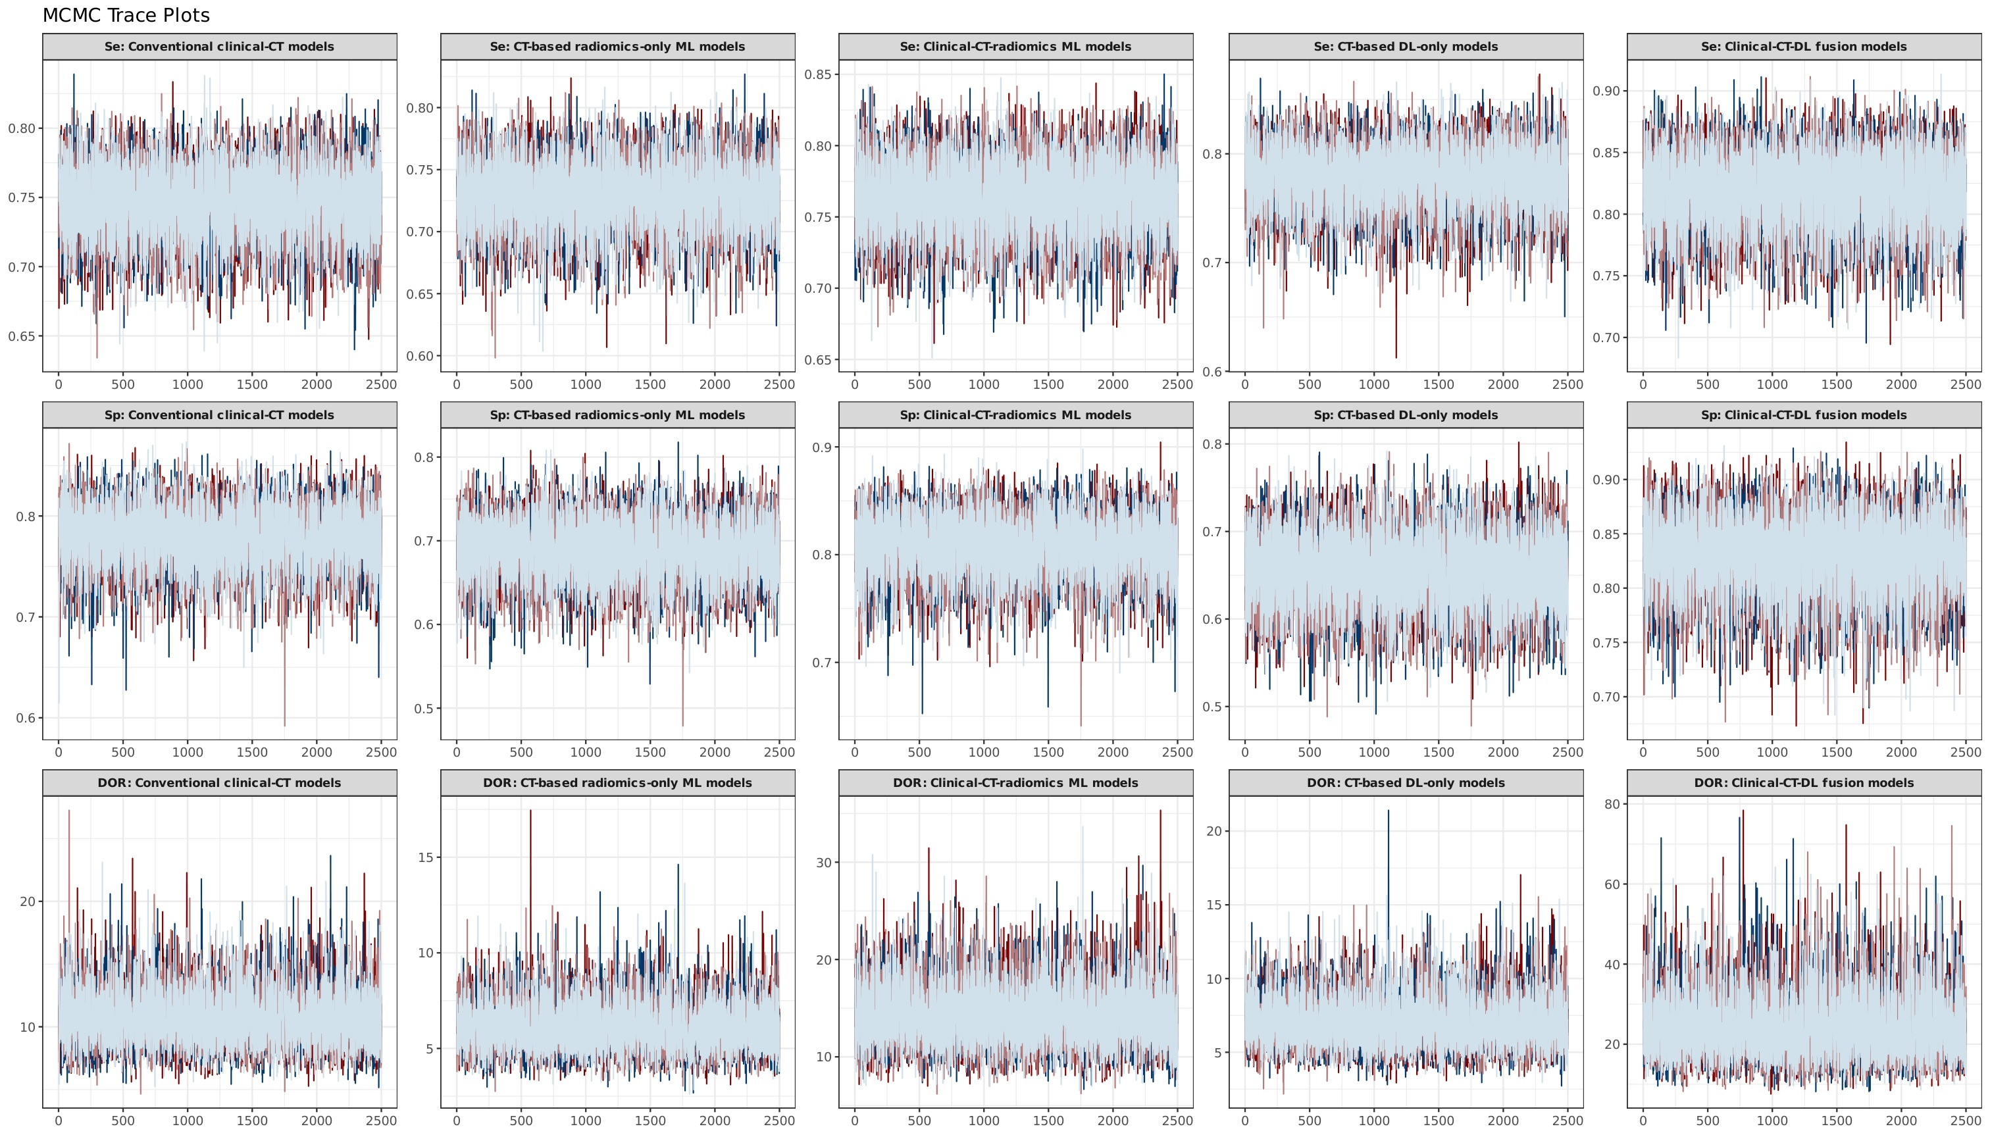
Figure S1. Trace plots of the Markov chain Monte Carlo simulations for the 90-day analysis.
Note: Trace plots of the Markov chain Monte Carlo simulations for sensitivity, specificity, and diagnostic odds ratio (DOR) across the five model categories (90-day analysis). Red and blue lines represent two parallel chains per parameter.
Abbreviations: CT, computed tomography; DL, deep learning; DOR, diagnostic odds ratio; MCMC, Markov chain Monte Carlo; ML, machine learning.
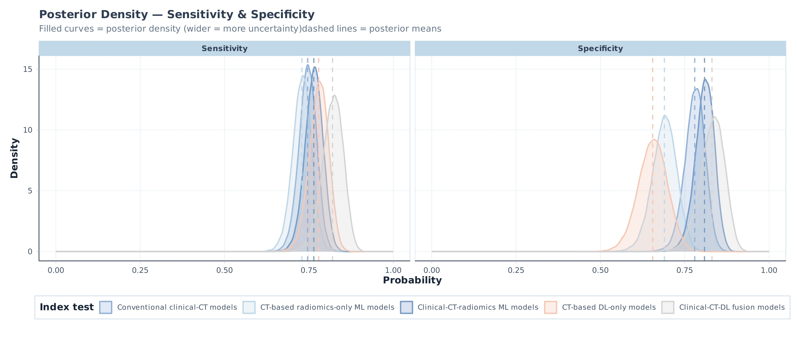
Figure S2. Posterior density plots of sensitivity and specificity for the evaluated model categories (90-day analysis).
Note: Posterior density plots of sensitivity and specificity for the five model categories (90-day analysis). Dashed vertical lines indicate posterior means.
Abbreviations: CT, computed tomography; DL, deep learning; ML, machine learning.
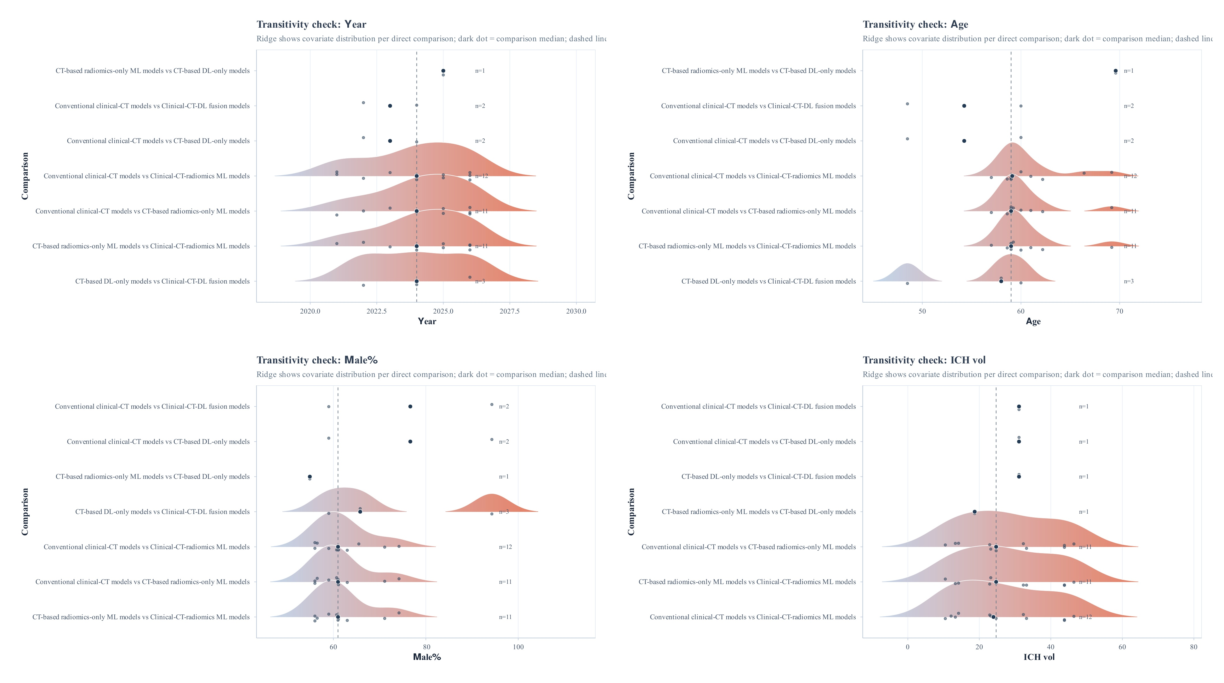
Figure S3A. Transitivity checks across direct comparisons for continuous study-level covariates (publication year, age, male proportion, and ICH volume).
Note: Ridge plots show the distribution of continuous study-level covariates within each direct comparison. Blue and red ridges represent the two compared model categories; dots represent individual studies; dark vertical lines indicate overall medians.
Abbreviations: CT, computed tomography; DL, deep learning; ICH, intracerebral hemorrhage; ML, machine learning.
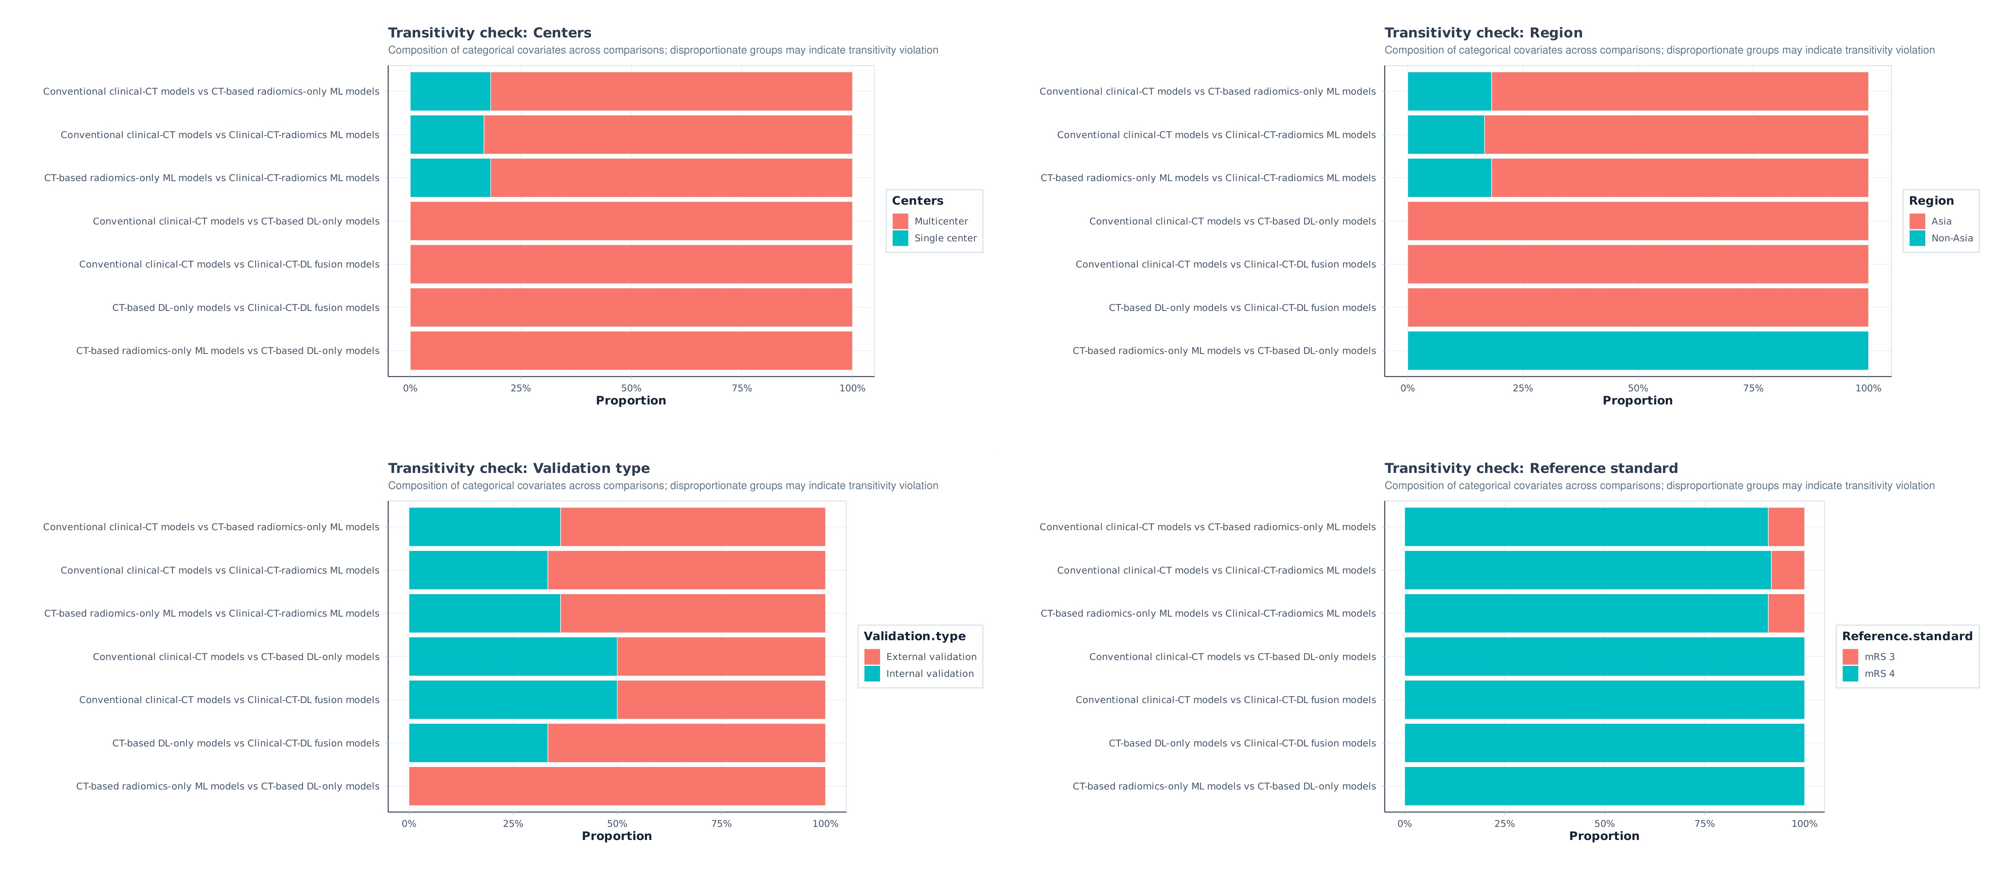
Figure S3B. Transitivity checks across direct comparisons for categorical study-level covariates (center, region, validation type, and mRS threshold).
Note: Stacked bar charts show the composition of categorical study-level covariates within each direct comparison. Disproportionate category distributions may indicate potential transitivity violations.
Abbreviations: CT, computed tomography; DL, deep learning; ML, machine learning.
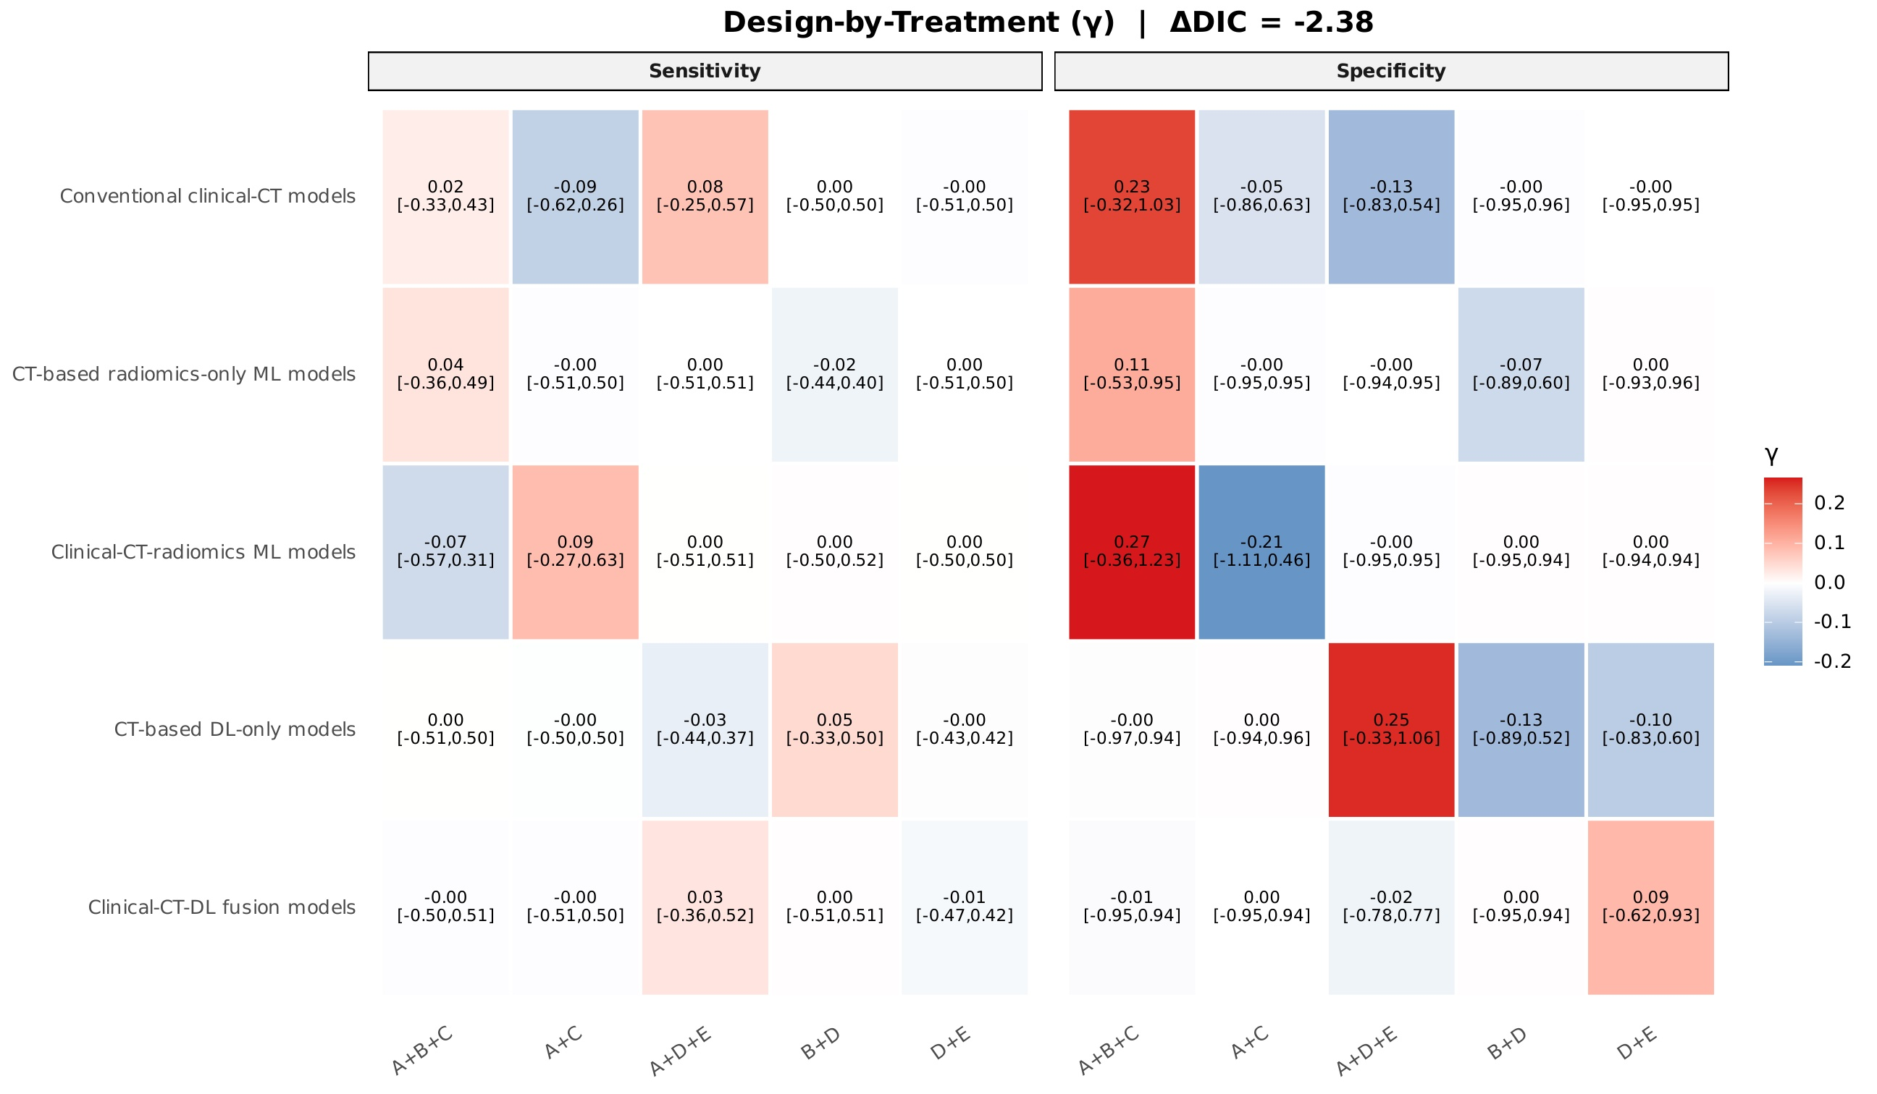
Figure S4. Design-by-treatment interaction assessment of global inconsistency (ΔDIC) for sensitivity and specificity.
Note: Heatmap of the design-by-treatment interaction model assessing global inconsistency for sensitivity and specificity. Cells show the interaction parameter (γ) with 95% credible intervals for each comparison loop; ΔDIC is shown in the figure.
Abbreviations: CrI, credible interval; CT, computed tomography; DIC, deviance information criterion; DL, deep learning; ML, machine learning.
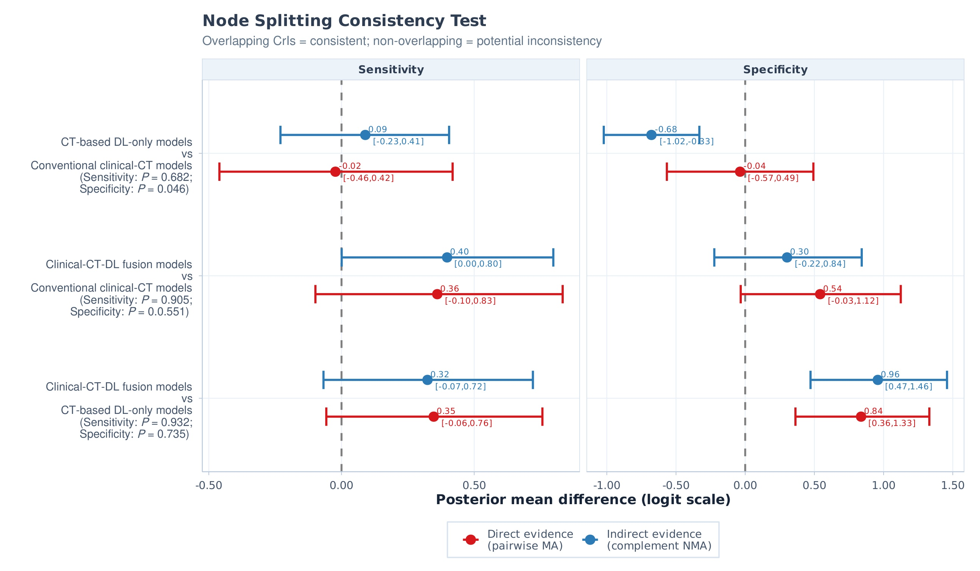
Figure S5. Node-splitting consistency tests for sensitivity and specificity (90-day analysis).
Note: Node-splitting consistency tests comparing direct and indirect evidence for sensitivity and specificity. Overlapping credible intervals indicate consistency; P values are annotated for each comparison.
Abbreviations: CrI, credible interval; CT, computed tomography; DL, deep learning; ML, machine learning.
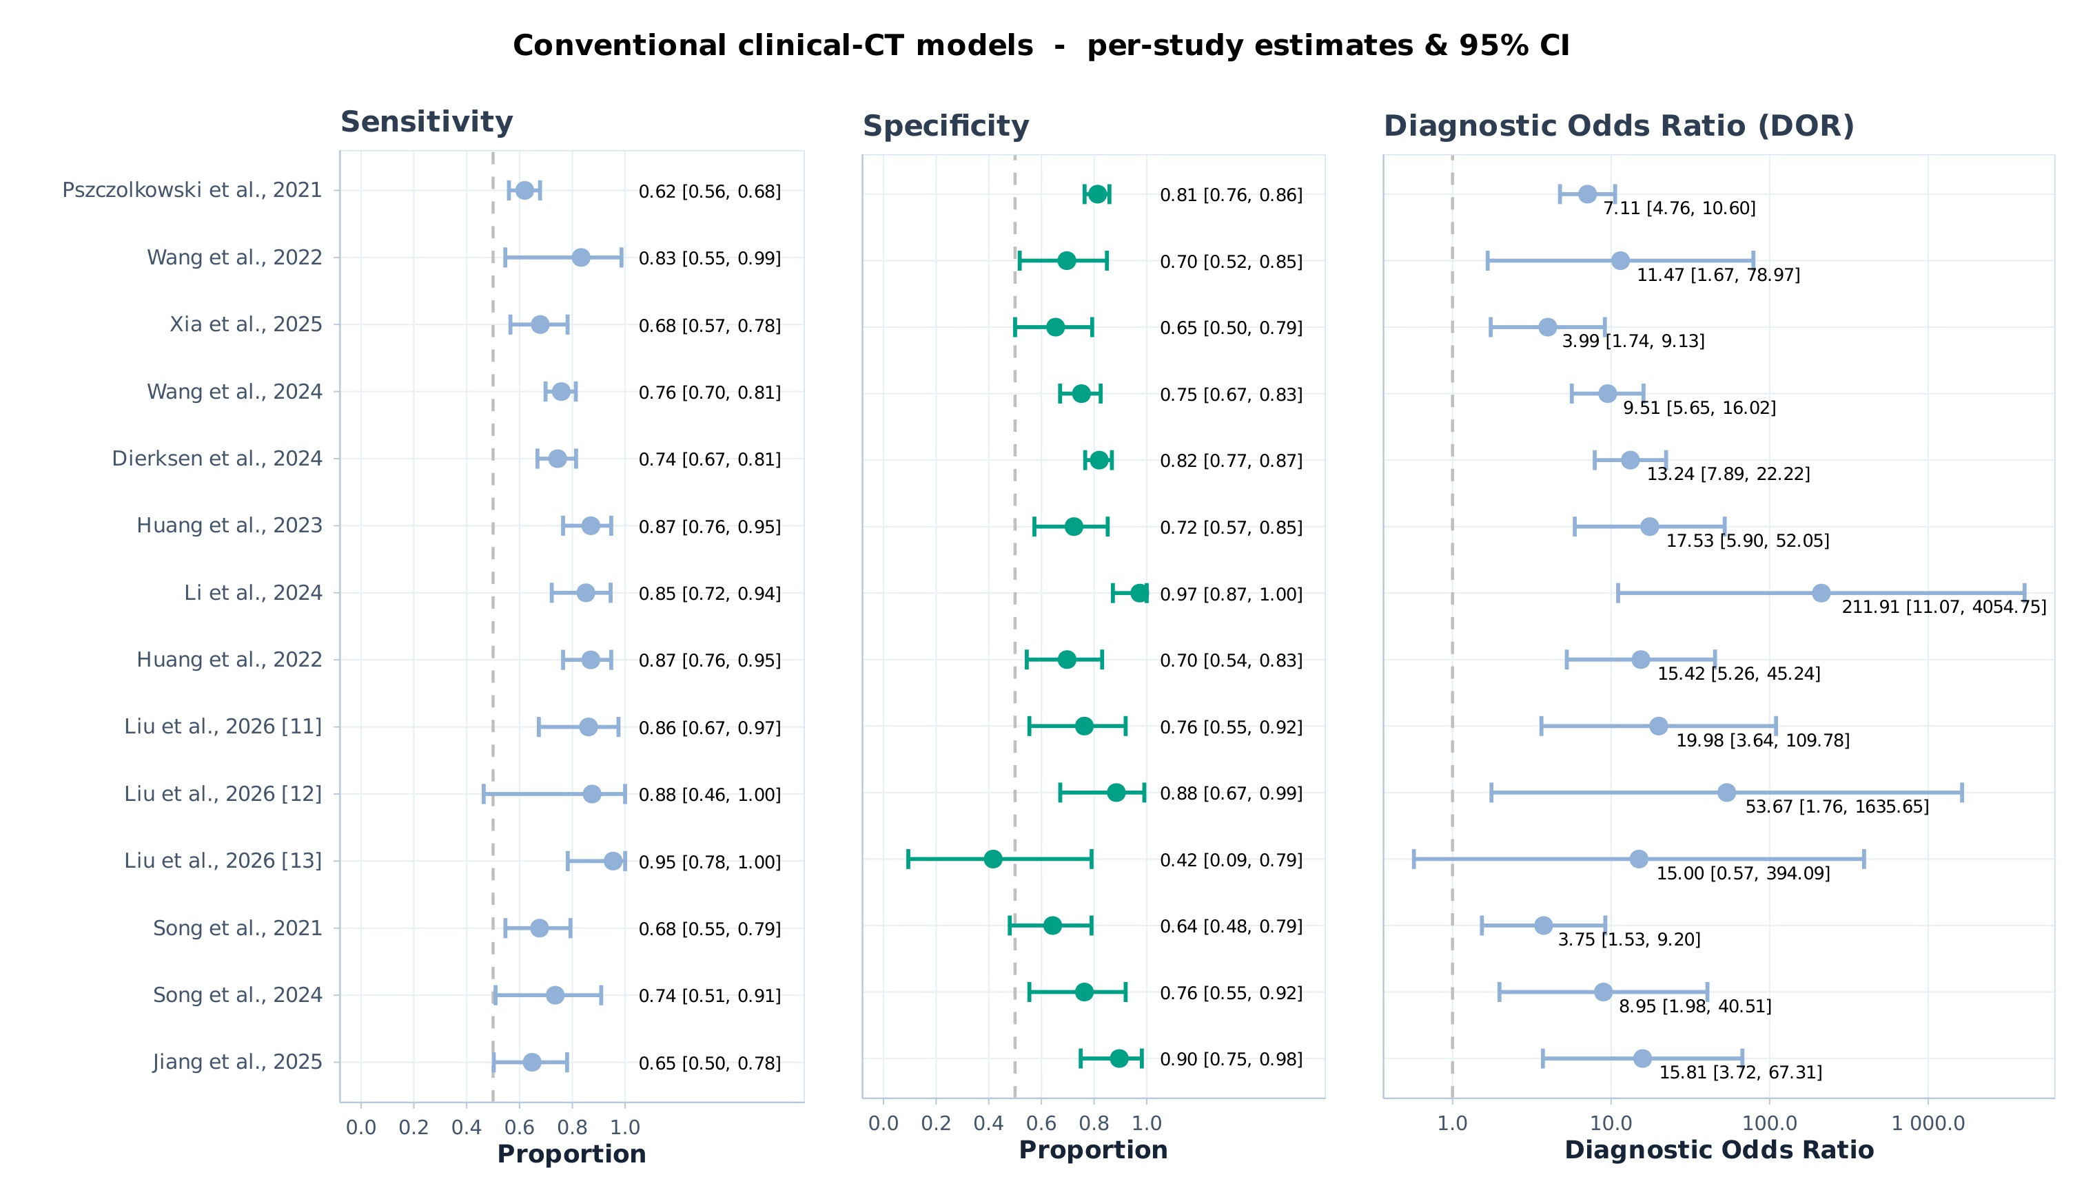
Figure S6A. Forest plots of individual studies for the conventional clinical-CT models (90-day analysis).
Note: Forest plots of per-study sensitivity, specificity, and diagnostic odds ratio (DOR) for the conventional clinical-CT models, with 95% confidence intervals (90-day analysis).
Abbreviations: CI, confidence interval; CT, computed tomography; DL, deep learning; DOR, diagnostic odds ratio; ML, machine learning.
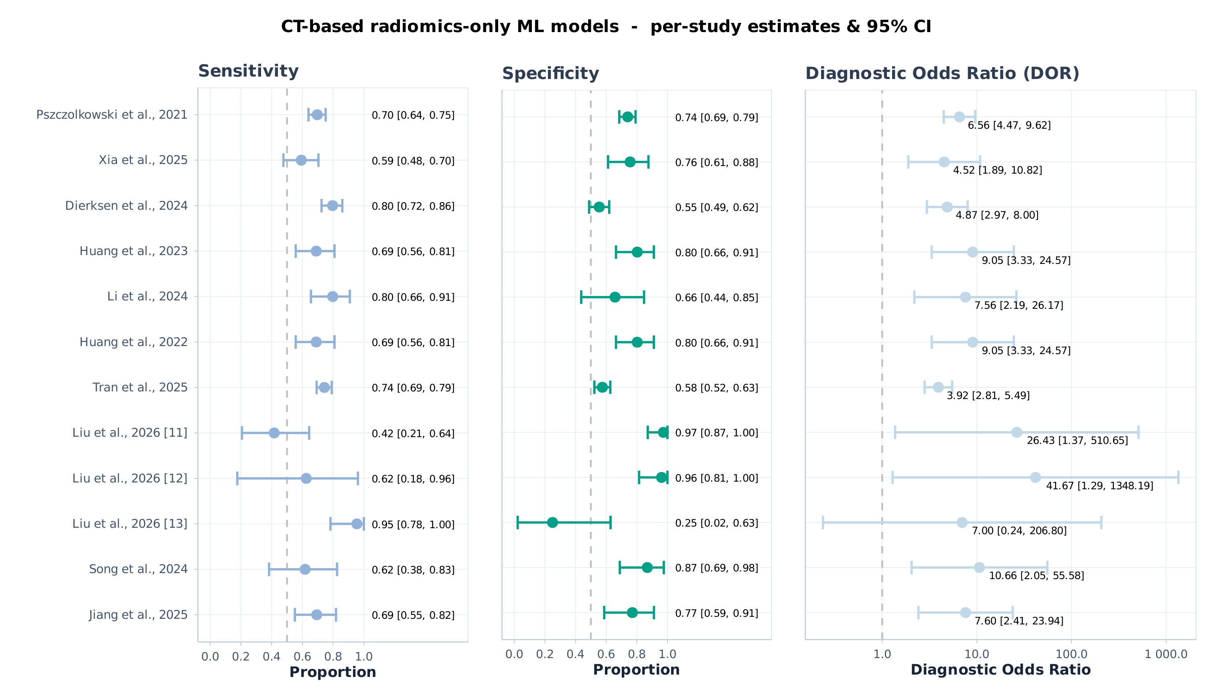
Figure S6B. Forest plots of individual studies for the CT-based radiomics-only ML models (90-day analysis).
Note: Forest plots of per-study sensitivity, specificity, and diagnostic odds ratio (DOR) for the CT-based radiomics-only ML models, with 95% confidence intervals (90-day analysis).
Abbreviations: CI, confidence interval; CT, computed tomography; DL, deep learning; DOR, diagnostic odds ratio; ML, machine learning.
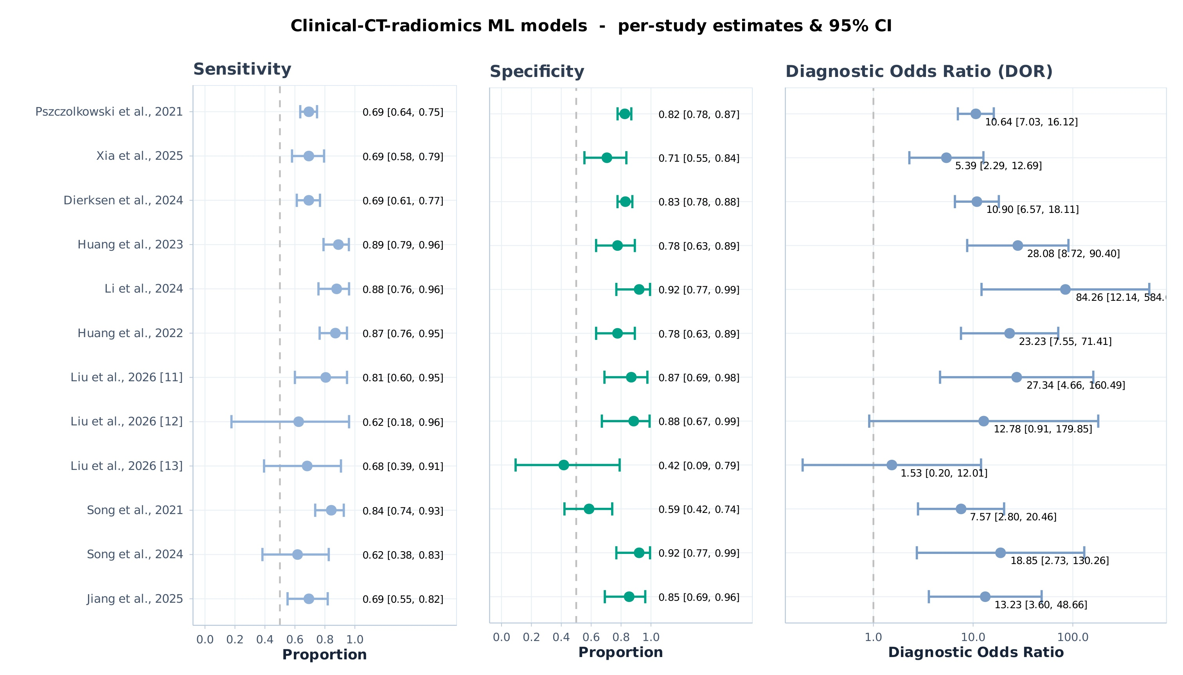
Figure S6C. Forest plots of individual studies for the clinical-CT-radiomics ML models (90-day analysis).
Note: Forest plots of per-study sensitivity, specificity, and diagnostic odds ratio (DOR) for the clinical-CT-radiomics ML models, with 95% confidence intervals (90-day analysis).
Abbreviations: CI, confidence interval; CT, computed tomography; DL, deep learning; DOR, diagnostic odds ratio; ML, machine learning.
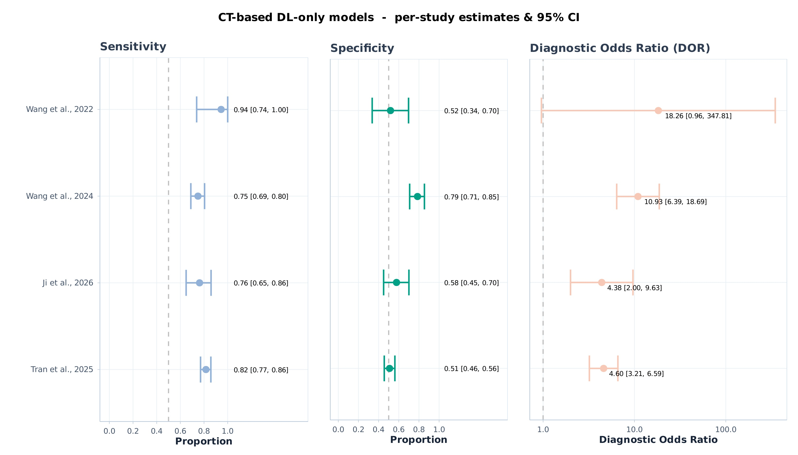
Figure S6D. Forest plots of individual studies for the CT-based DL-only models (90-day analysis).
Note: Forest plots of per-study sensitivity, specificity, and diagnostic odds ratio (DOR) for the CT-based DL-only models, with 95% confidence intervals (90-day analysis).
Abbreviations: CI, confidence interval; CT, computed tomography; DL, deep learning; DOR, diagnostic odds ratio; ML, machine learning.
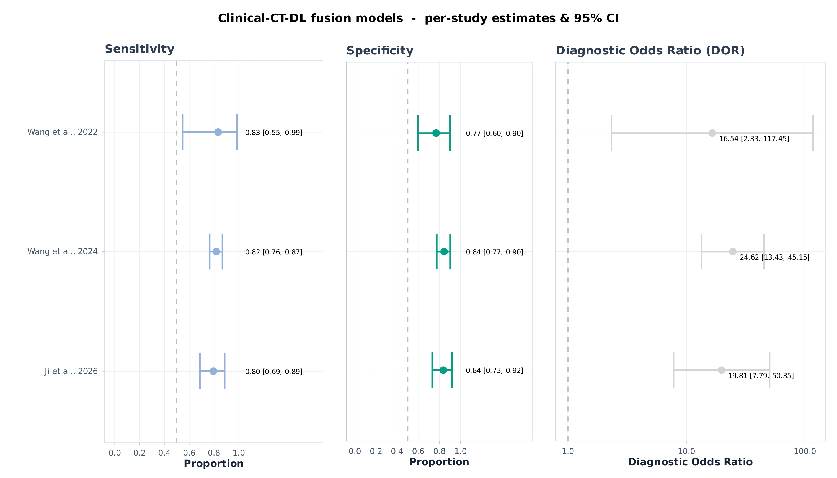
Figure S6E. Forest plots of individual studies for the clinical-CT-DL fusion models (90-day analysis).
Note: Forest plots of per-study sensitivity, specificity, and diagnostic odds ratio (DOR) for the clinical-CT-DL fusion models, with 95% confidence intervals (90-day analysis).
Abbreviations: CI, confidence interval; CT, computed tomography; DL, deep learning; DOR, diagnostic odds ratio; ML, machine learning.
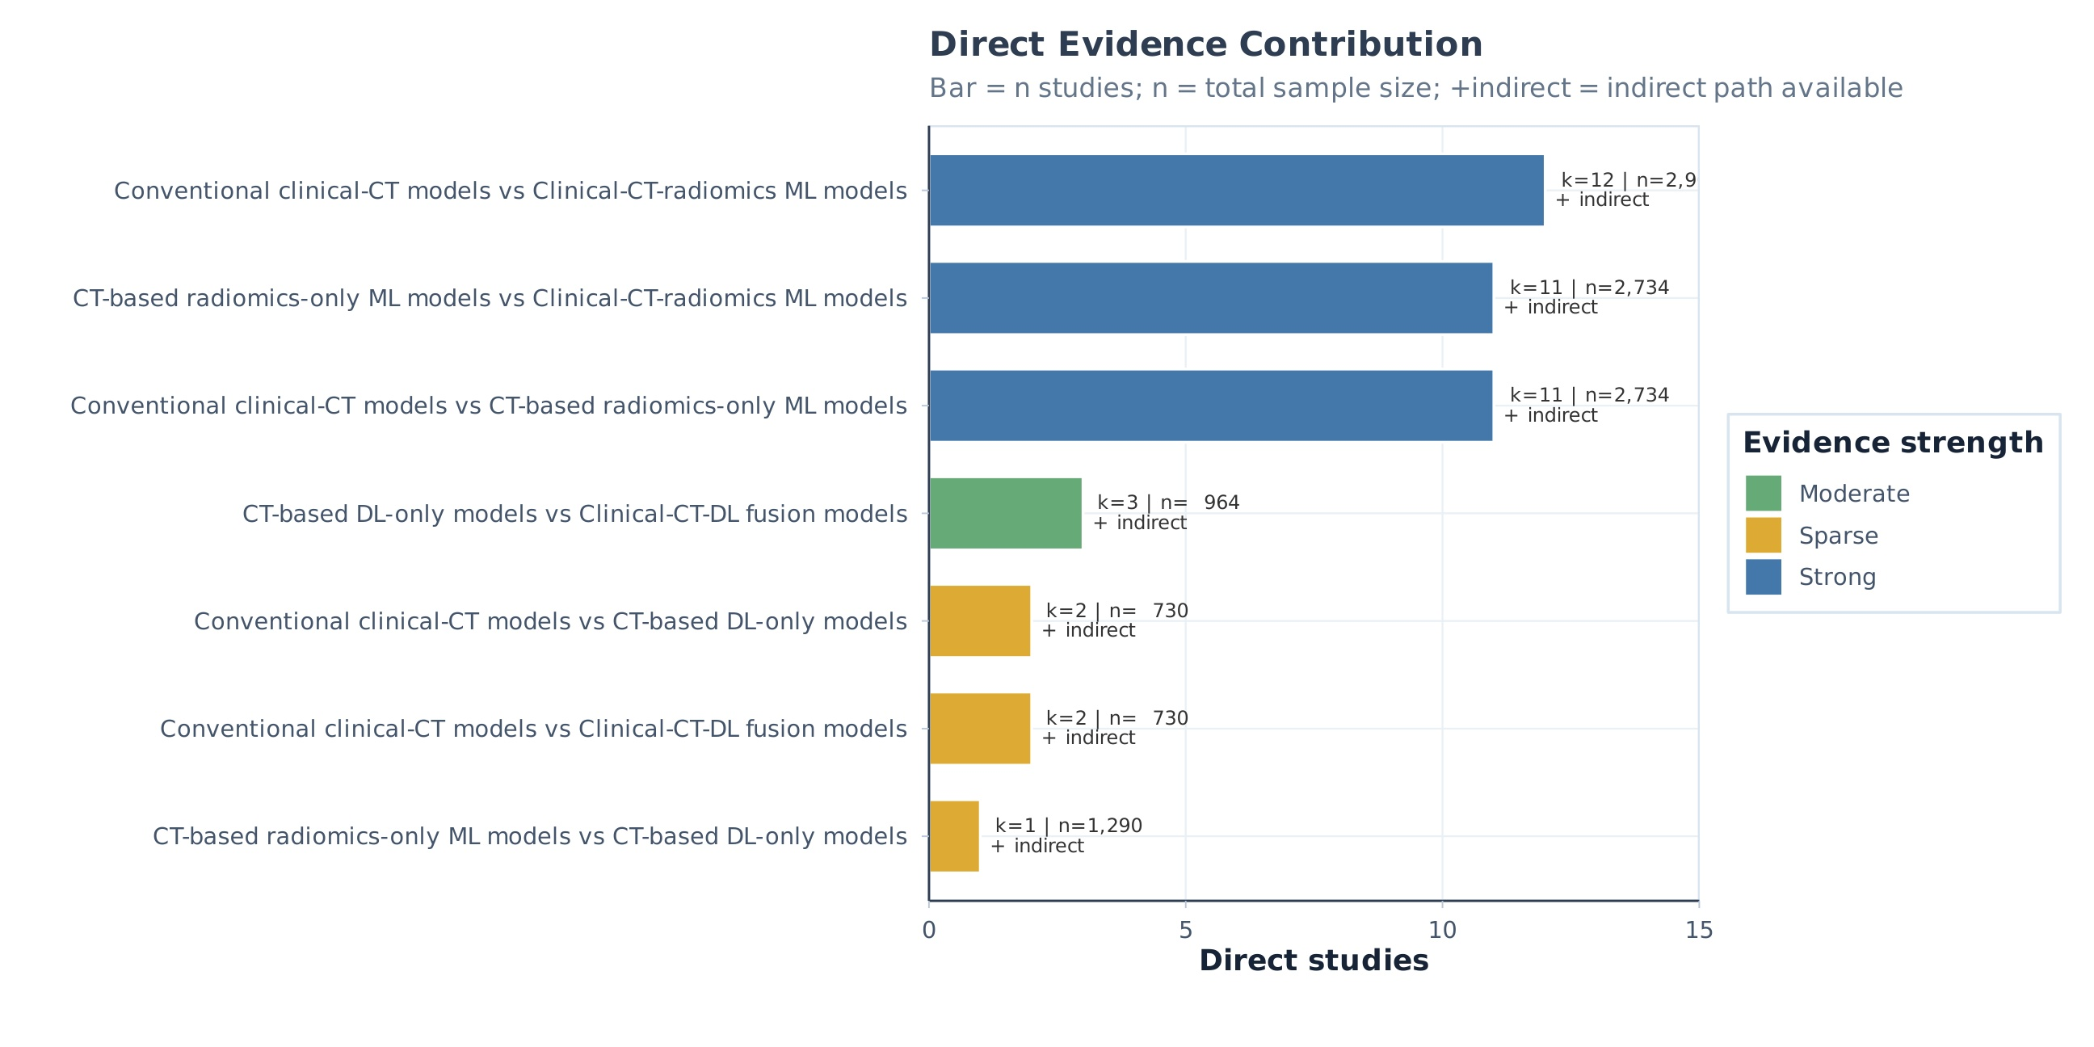
Figure S7. Direct evidence contribution of the network meta-analysis (90-day analysis).
Note: Direct evidence contribution of the network meta-analysis. Bars show the number of direct studies (k) per pairwise comparison; colors indicate evidence strength (strong, moderate, or sparse); '+' indicates an available indirect path.
Abbreviations: CT, computed tomography; DL, deep learning; ML, machine learning.
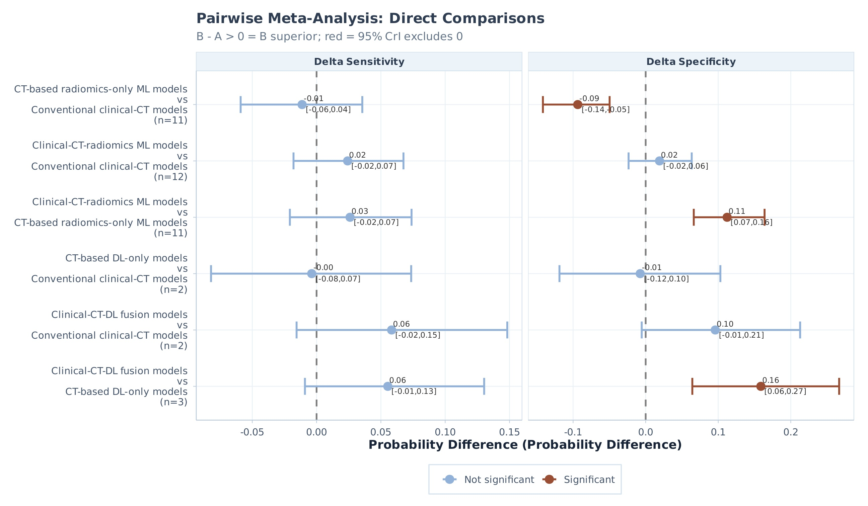
Figure S8. Pairwise meta-analysis of direct comparisons for sensitivity and specificity (90-day analysis).
Note: Pairwise meta-analysis of direct comparisons. Panels show probability differences (Δ) in sensitivity and specificity between paired model categories; red intervals indicate 95% credible intervals excluding zero (B - A > 0 indicates that B is superior to A).
Abbreviations: CrI, credible interval; CT, computed tomography; DL, deep learning; ML, machine learning.
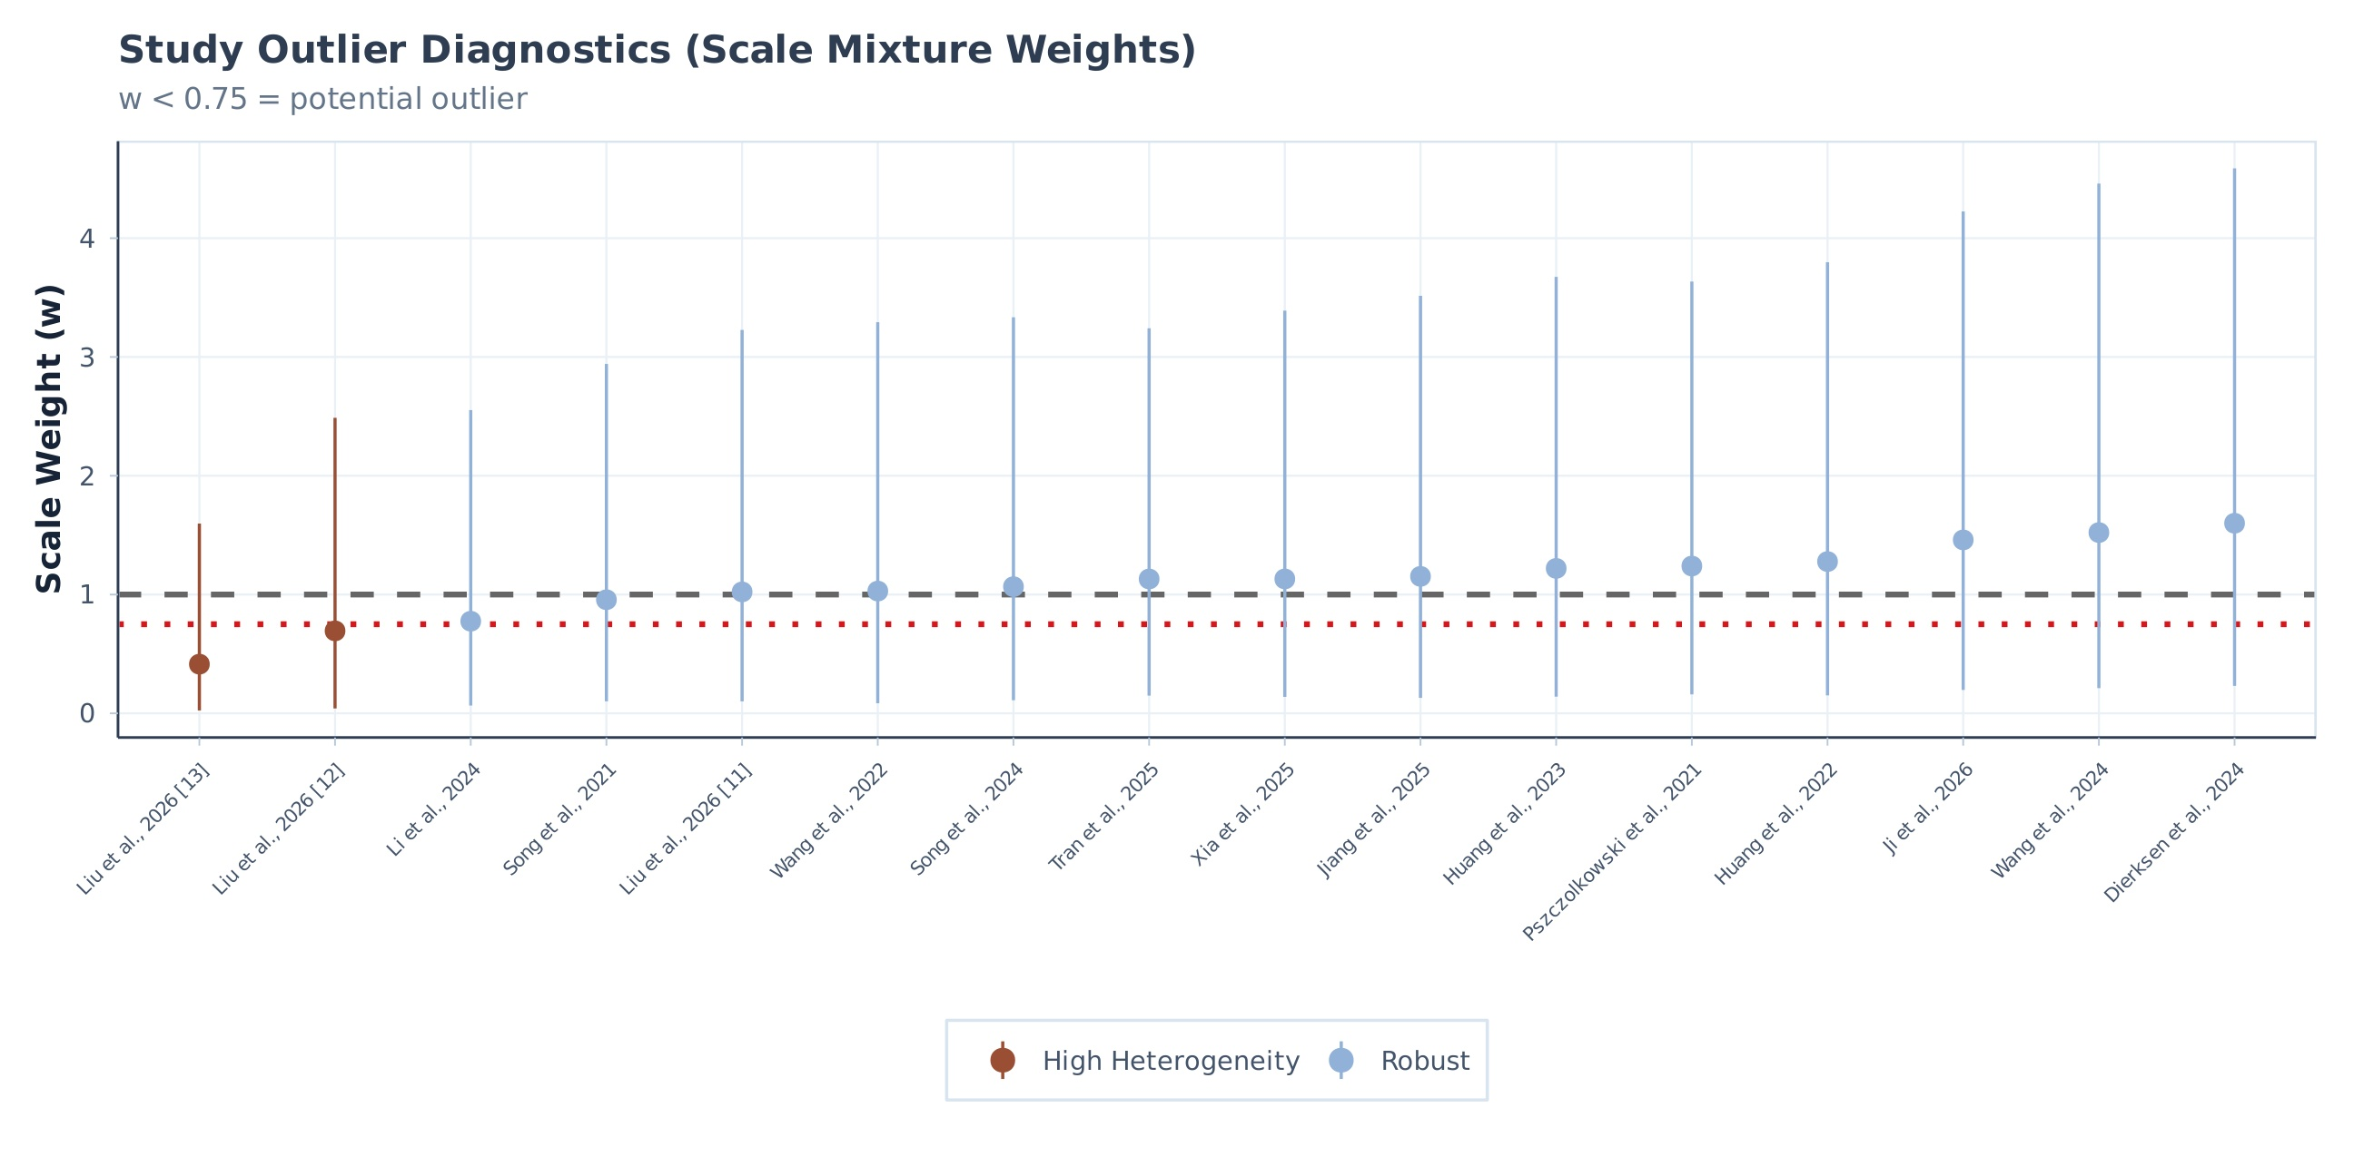
Figure S9. Outlier diagnostics assessment for the included studies (90-day analysis).
Note: Study outlier diagnostics based on scale-mixture weights. Studies with a scale weight w < 0.75 were considered potential outliers (orange = high heterogeneity; blue = robust).
Abbreviations: CT, computed tomography; DL, deep learning; ML, machine learning.
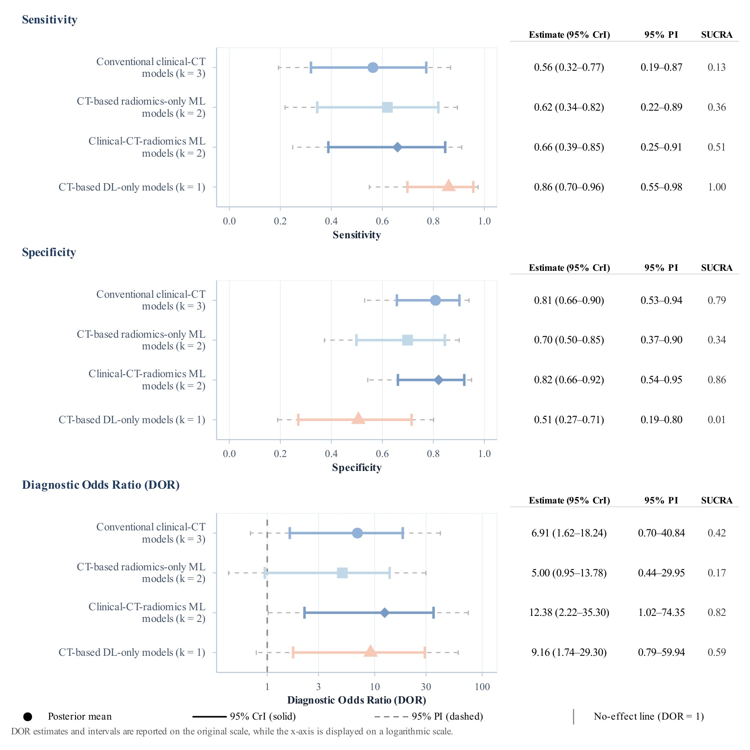
Figure S10A. Forest plots of pooled diagnostic performance for poor functional outcome at 6 months.
Note: Forest plots of pooled sensitivity, specificity, and diagnostic odds ratio (DOR) for poor functional outcome at 6 months. Points show posterior means with 95% credible intervals and prediction intervals.
Abbreviations: CrI, credible interval; CT, computed tomography; DL, deep learning; DOR, diagnostic odds ratio; ML, machine learning; PI, prediction interval; SUCRA, surface under the cumulative ranking curve.
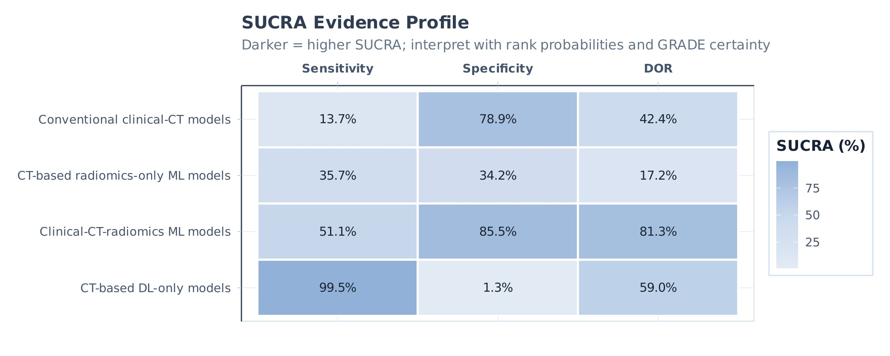
Figure S10B. SUCRA heatmap for poor functional outcome at 6 months.
Note: SUCRA heatmap for poor functional outcome at 6 months. Darker cells indicate higher SUCRA values; interpret alongside rank probabilities and GRADE certainty.
Abbreviations: CT, computed tomography; DL, deep learning; DOR, diagnostic odds ratio; ML, machine learning; SUCRA, surface under the cumulative ranking curve.
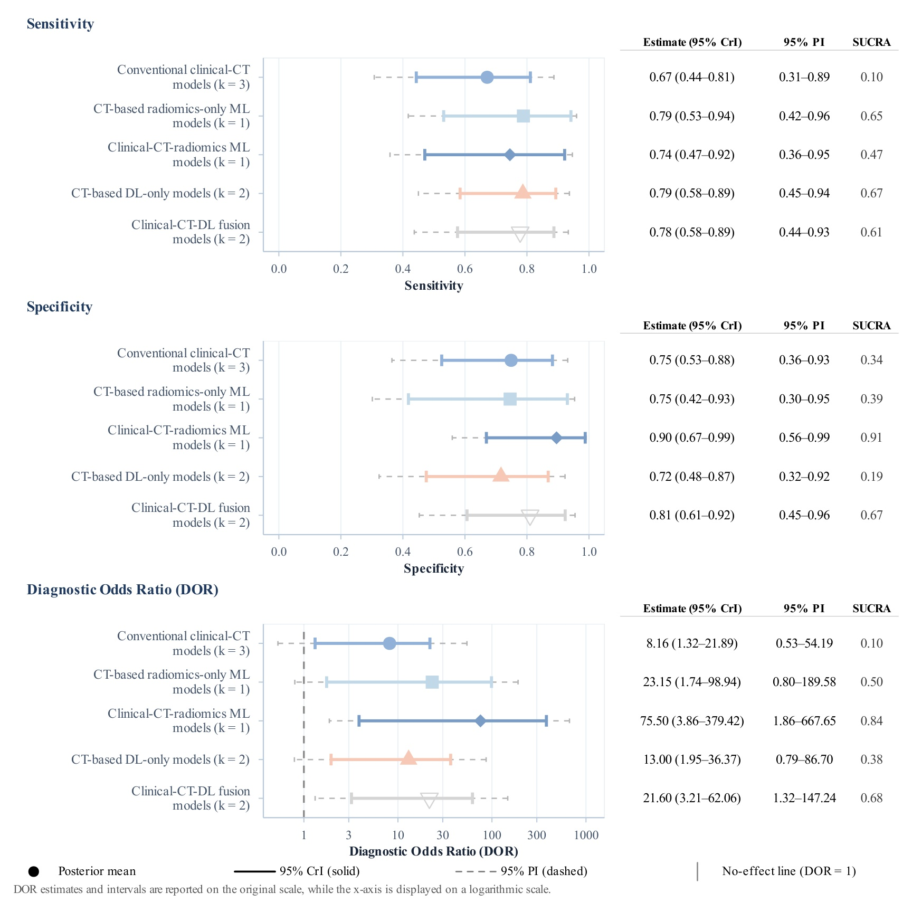
Figure S11A. Forest plots of pooled diagnostic performance for poor functional outcome at discharge.
Note: Forest plots of pooled sensitivity, specificity, and diagnostic odds ratio (DOR) for poor functional outcome at discharge. Points show posterior means with 95% credible intervals and prediction intervals.
Abbreviations: CrI, credible interval; CT, computed tomography; DL, deep learning; DOR, diagnostic odds ratio; ML, machine learning; PI, prediction interval; SUCRA, surface under the cumulative ranking curve.
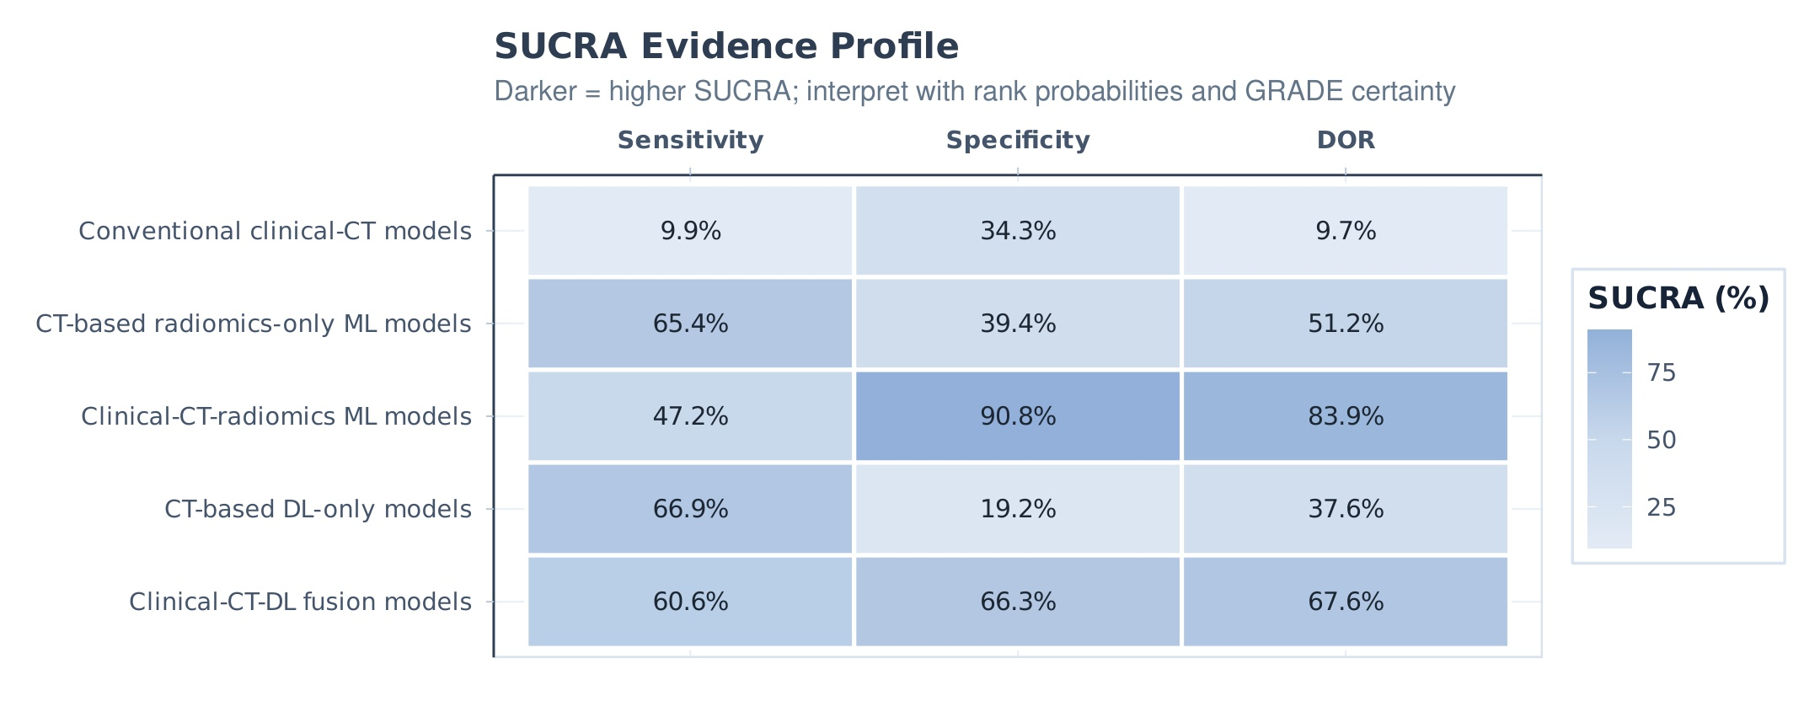
Figure S11B. SUCRA heatmap for poor functional outcome at discharge.
Note: SUCRA heatmap for poor functional outcome at discharge. Darker cells indicate higher SUCRA values; interpret alongside rank probabilities and GRADE certainty.
Abbreviations: CT, computed tomography; DL, deep learning; DOR, diagnostic odds ratio; ML, machine learning; SUCRA, surface under the cumulative ranking curve.
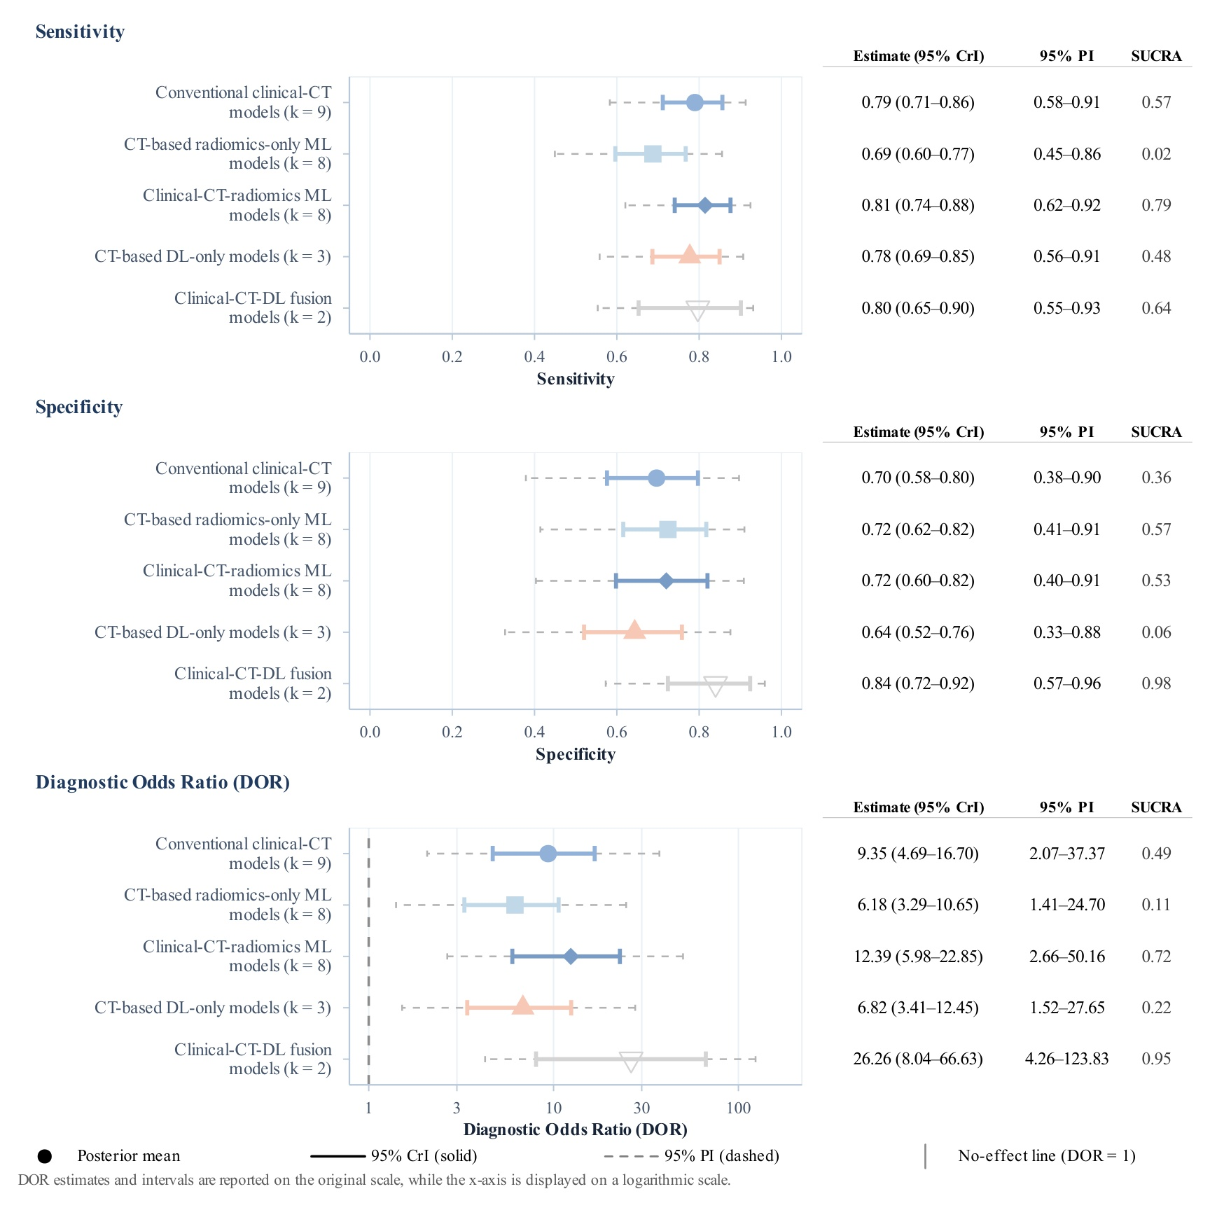
Figure S12A. Sensitivity analysis of pooled diagnostic performance: external validation studies only.
Note: Forest plots of pooled diagnostic performance in the sensitivity analysis restricted to external validation studies. Points show posterior means with 95% credible intervals and prediction intervals.
Abbreviations: CrI, credible interval; CT, computed tomography; DL, deep learning; DOR, diagnostic odds ratio; ML, machine learning; PI, prediction interval.
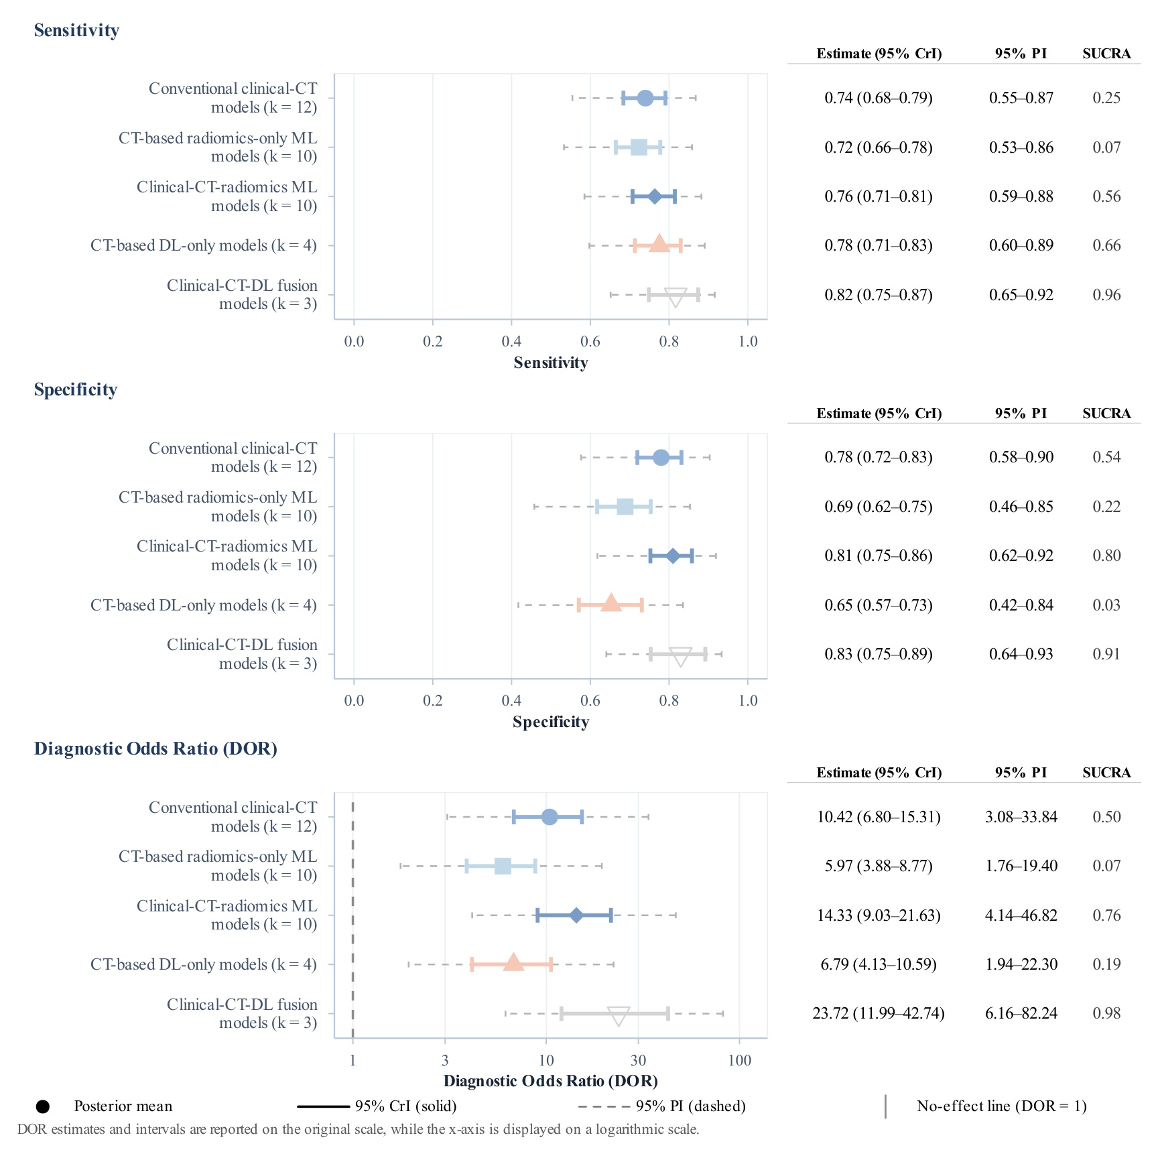
Figure S12B. Sensitivity analysis of pooled diagnostic performance: excluding outlier studies.
Note: Forest plots of pooled diagnostic performance in the sensitivity analysis excluding outlier studies. Points show posterior means with 95% credible intervals and prediction intervals.
Abbreviations: CrI, credible interval; CT, computed tomography; DL, deep learning; DOR, diagnostic odds ratio; ML, machine learning; PI, prediction interval.
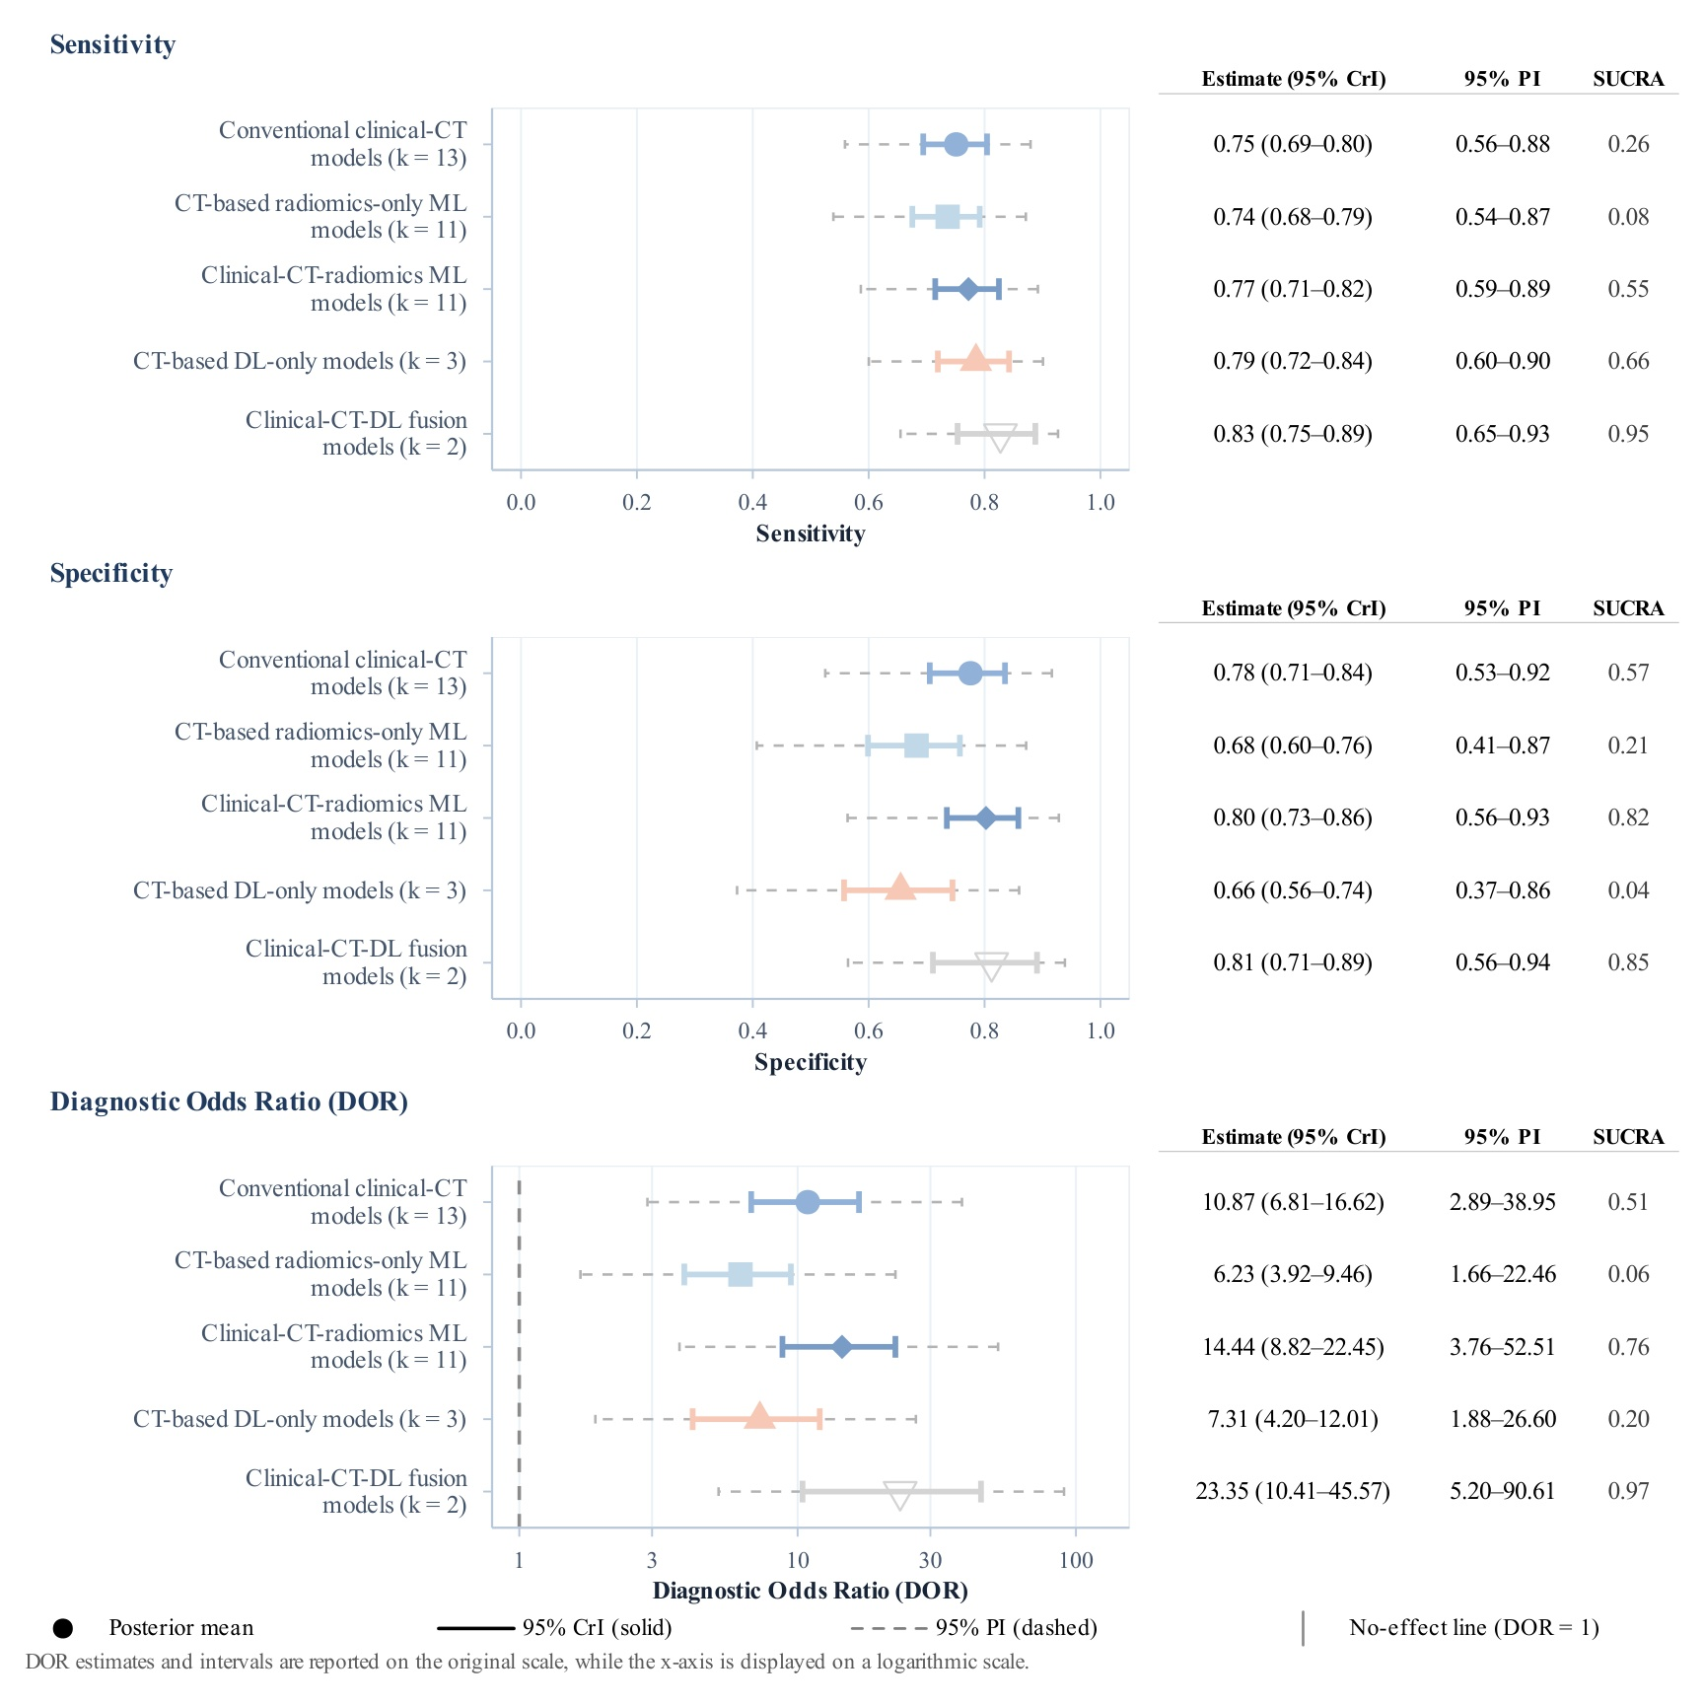
Figure S12C. Sensitivity analysis of pooled diagnostic performance: studies using a mRS >3 threshold.
Note: Forest plots of pooled diagnostic performance in the sensitivity analysis restricted to studies using an mRS >3 threshold. Points show posterior means with 95% credible intervals and prediction intervals.
Abbreviations: CrI, credible interval; CT, computed tomography; DL, deep learning; DOR, diagnostic odds ratio; ML, machine learning; mRS, modified Rankin Scale; PI, prediction interval.
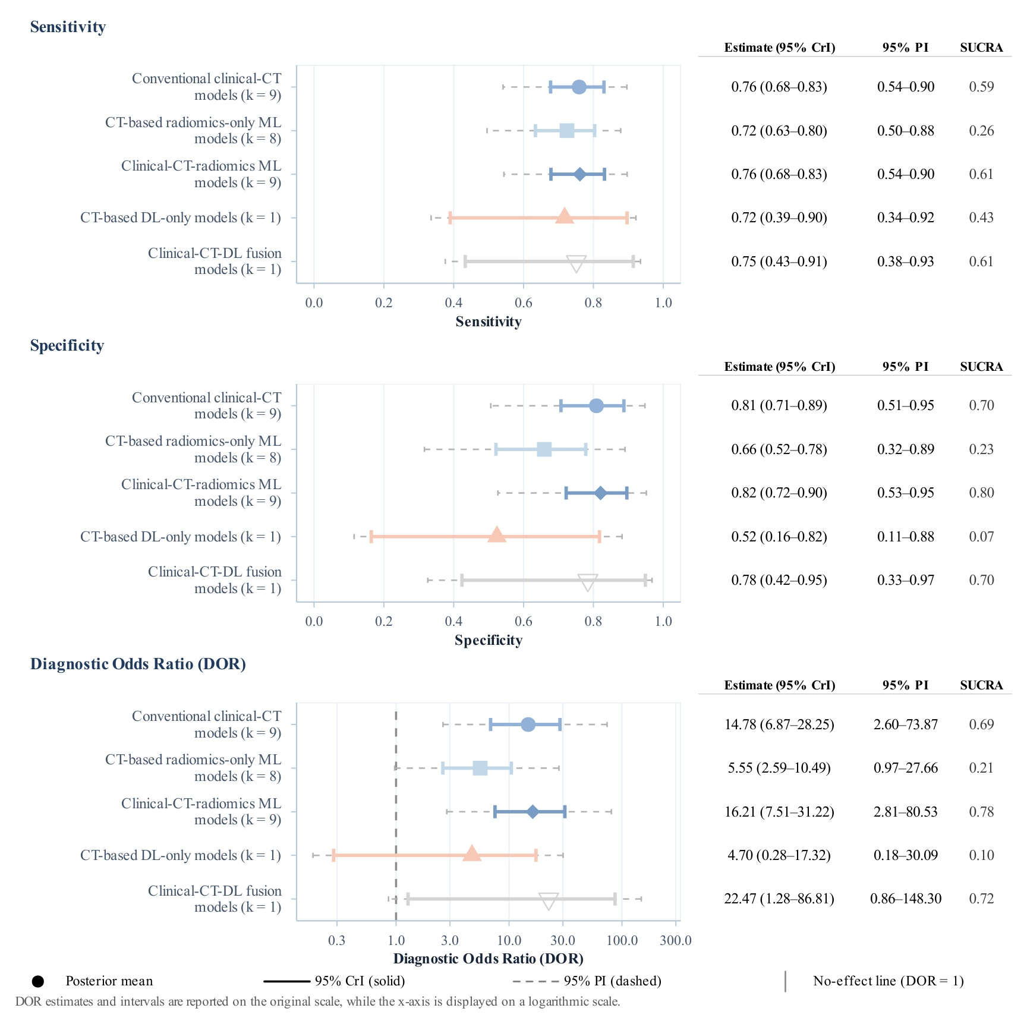
Figure S12D. Sensitivity analysis of pooled diagnostic performance: excluding high-risk studies.
Note: Forest plots of pooled diagnostic performance in the sensitivity analysis excluding studies at overall high risk of bias (PROBAST+AI). Points show posterior means with 95% credible intervals and prediction intervals.
Abbreviations: CrI, credible interval; CT, computed tomography; DL, deep learning; DOR, diagnostic odds ratio; ML, machine learning; PI, prediction interval; PROBAST+AI, Prediction model Risk of Bias Assessment Tool for artificial intelligence.
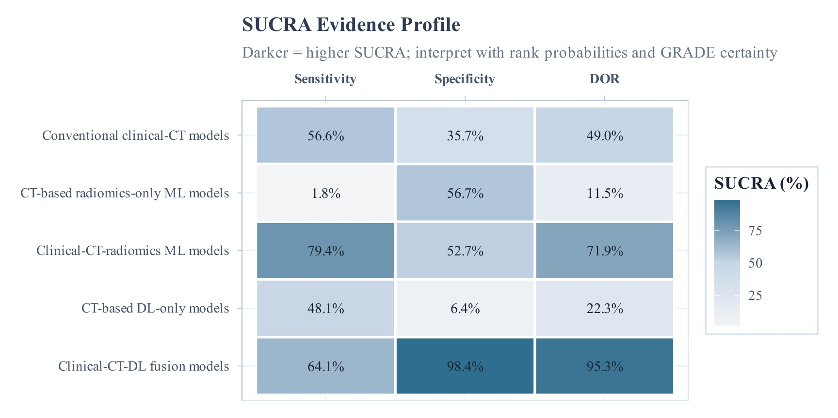
Figure S13A. SUCRA heatmap for the sensitivity analysis scenario in Figure S12A (external validation studies only).
Note: SUCRA heatmap for the sensitivity analysis restricted to external validation studies.
Abbreviations: CT, computed tomography; DL, deep learning; DOR, diagnostic odds ratio; ML, machine learning; SUCRA, surface under the cumulative ranking curve.
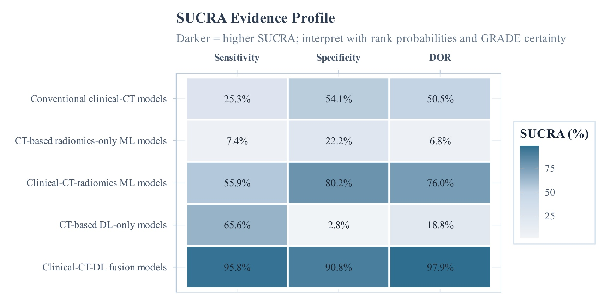
Figure S13B. SUCRA heatmap for the sensitivity analysis scenario in Figure S12B (excluding outlier studies).
Note: SUCRA heatmap for the sensitivity analysis excluding outlier studies.
Abbreviations: CT, computed tomography; DL, deep learning; DOR, diagnostic odds ratio; ML, machine learning; SUCRA, surface under the cumulative ranking curve.
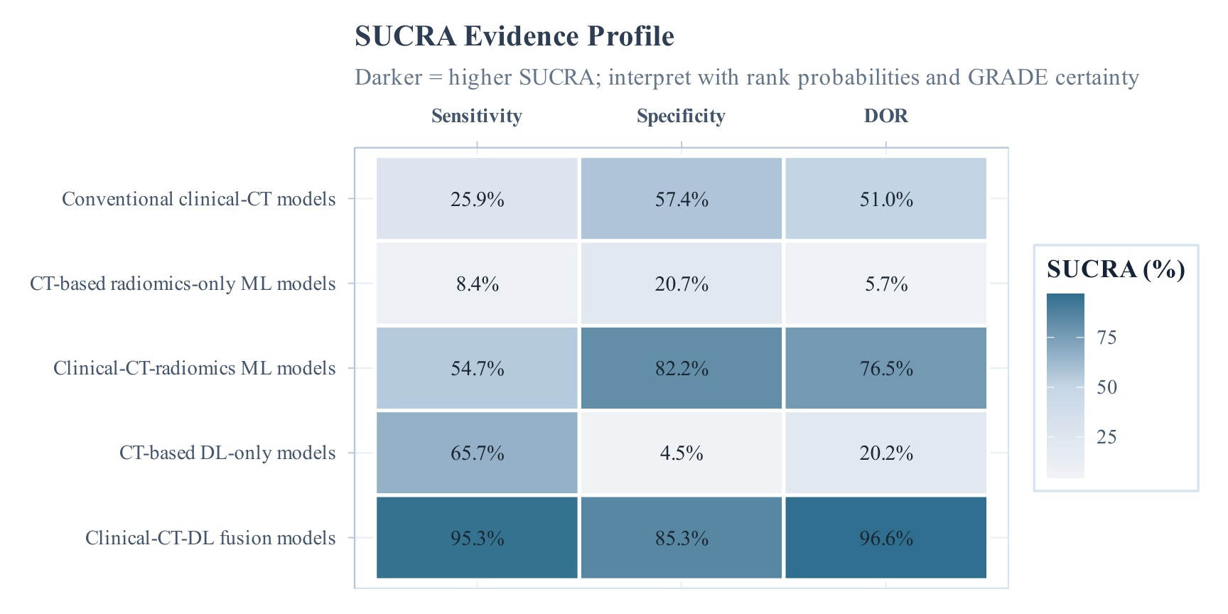
Figure S13C. SUCRA heatmap for the sensitivity analysis scenario in Figure S12C (mRS >3 threshold).
Note: SUCRA heatmap for the sensitivity analysis restricted to studies using an mRS >3 threshold.
Abbreviations: CT, computed tomography; DL, deep learning; DOR, diagnostic odds ratio; ML, machine learning; mRS, modified Rankin Scale; SUCRA, surface under the cumulative ranking curve.
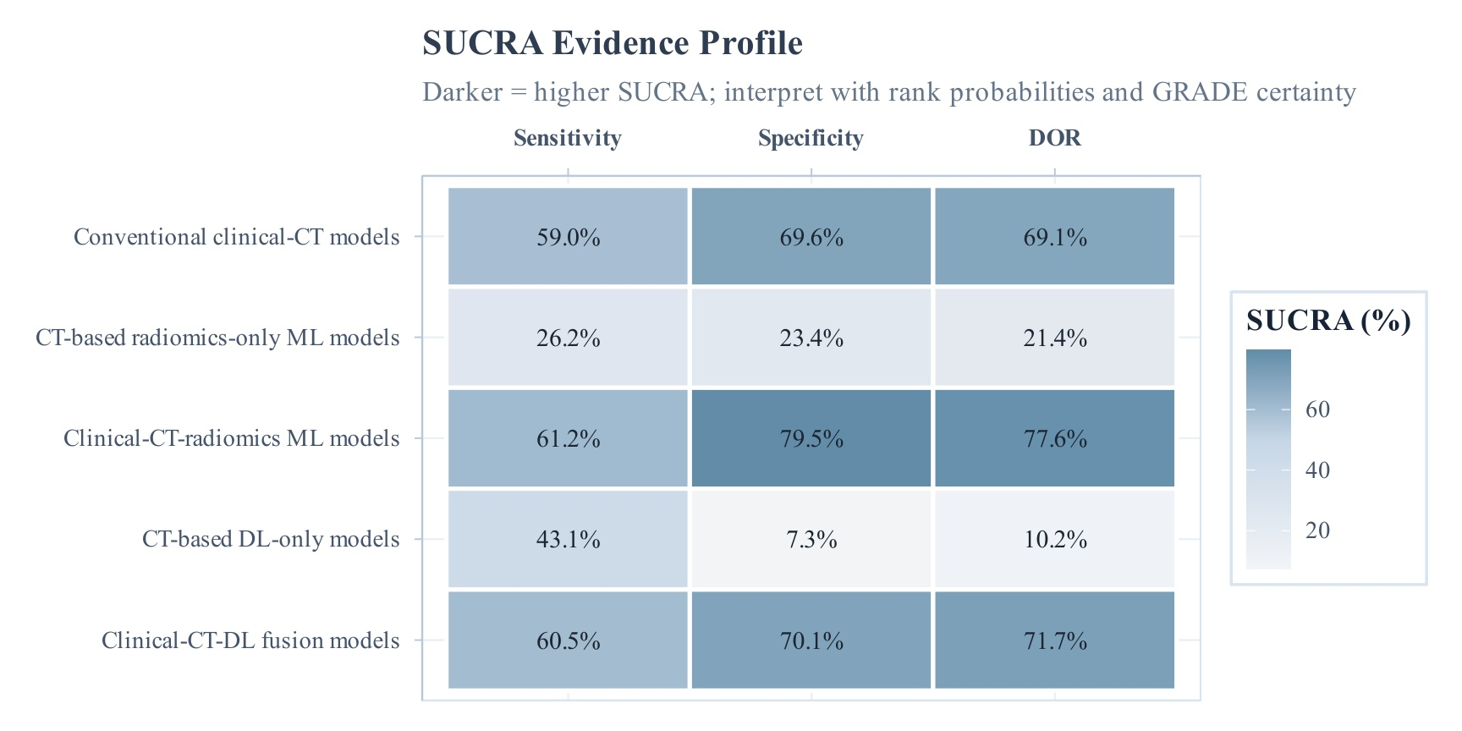
Figure S13D. SUCRA heatmap for the sensitivity analysis scenario in Figure S12D (excluding high-risk studies).
Note: SUCRA heatmap for the sensitivity analysis excluding studies at overall high risk of bias (PROBAST+AI).
Abbreviations: CT, computed tomography; DL, deep learning; DOR, diagnostic odds ratio; ML, machine learning; PROBAST+AI, Prediction model Risk of Bias Assessment Tool for artificial intelligence; SUCRA, surface under the cumulative ranking curve.
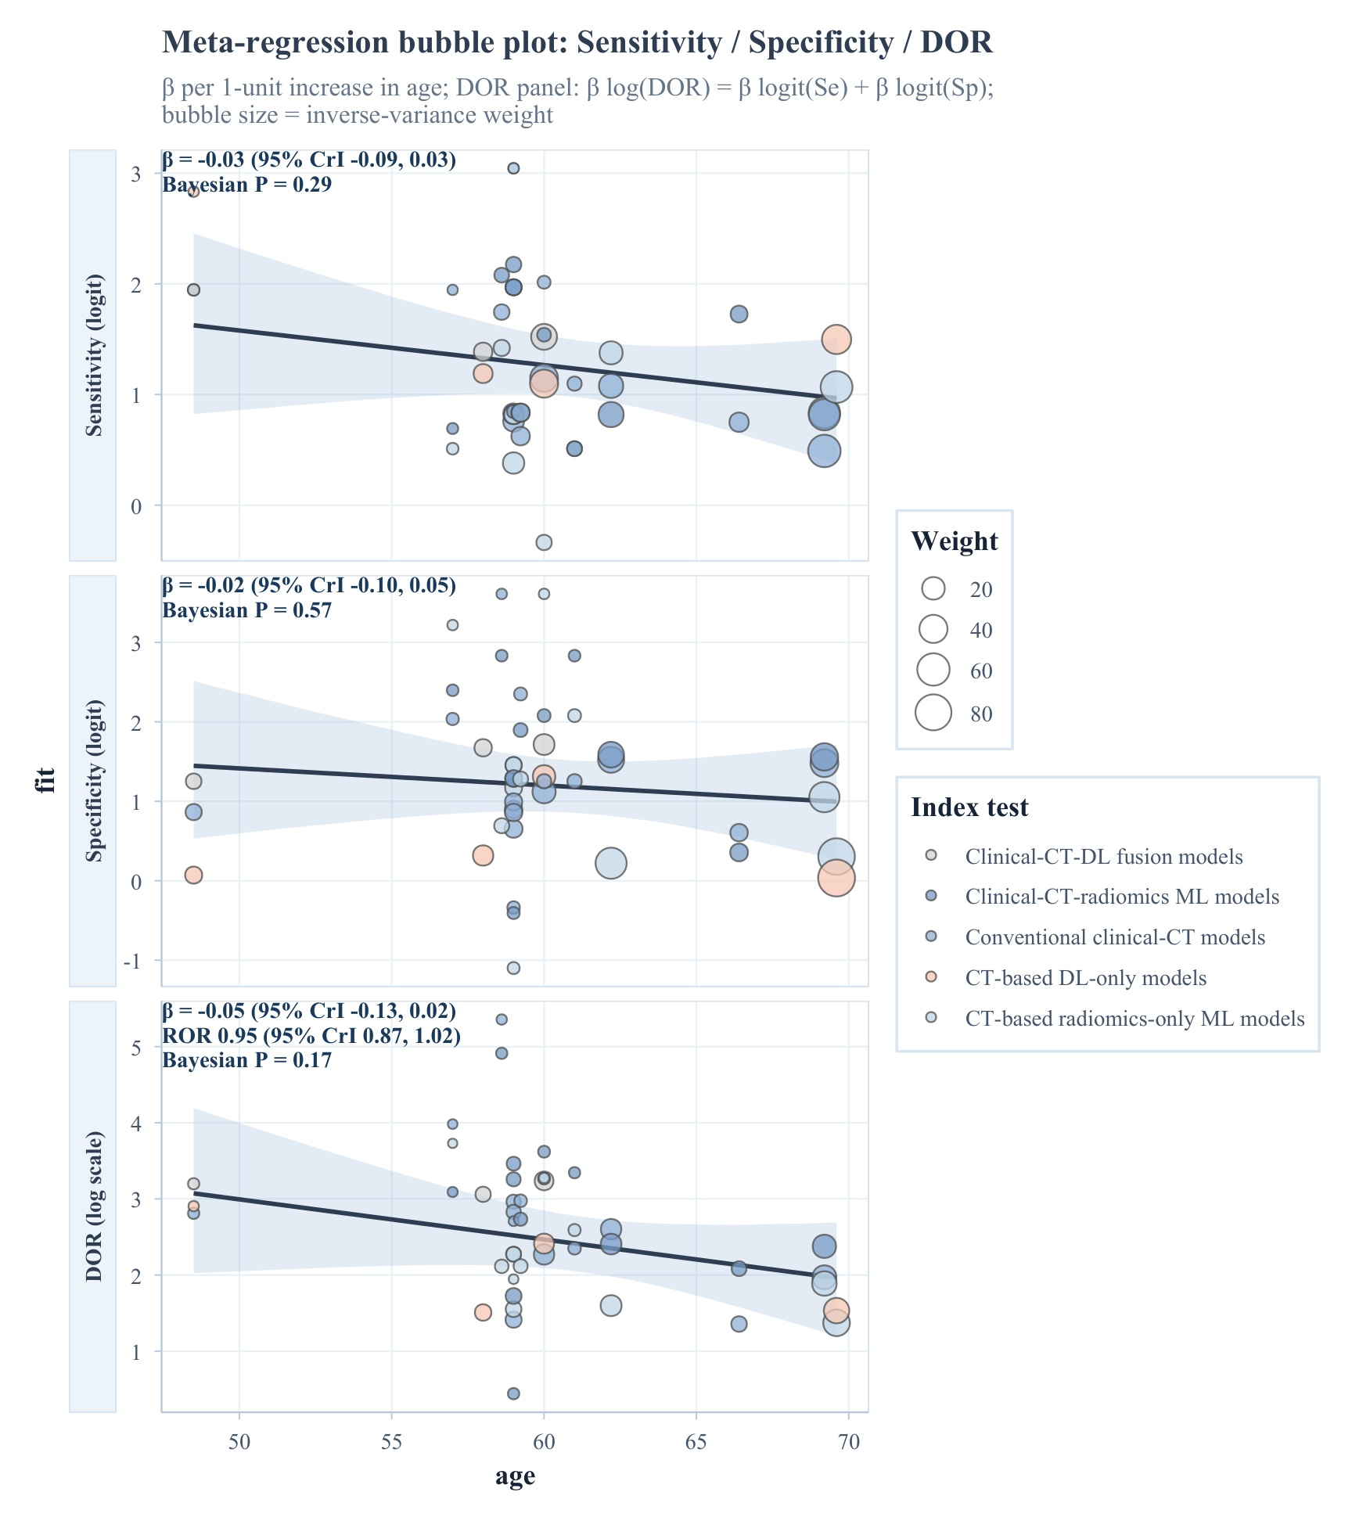
Figure S14A. Univariable meta-regression bubble plot for age.
Note: Univariable meta-regression bubble plot for age. Panels show the fitted association for sensitivity (logit), specificity (logit), and diagnostic odds ratio (log scale); bubble size reflects inverse-variance weight and shaded bands represent 95% credible intervals.
Abbreviations: CrI, credible interval; CT, computed tomography; DL, deep learning; DOR, diagnostic odds ratio; ML, machine learning.
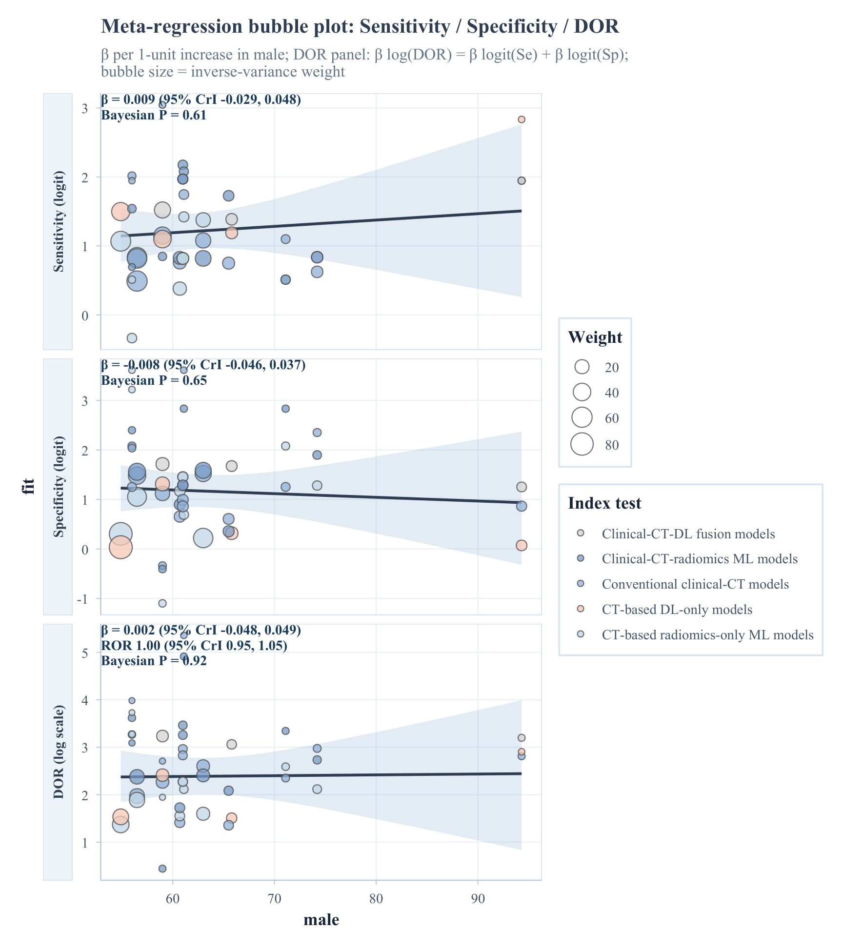
Figure S14B. Univariable meta-regression bubble plot for male proportion.
Note: Univariable meta-regression bubble plot for male proportion. Panels show the fitted association for sensitivity (logit), specificity (logit), and diagnostic odds ratio (log scale); bubble size reflects inverse-variance weight and shaded bands represent 95% credible intervals.
Abbreviations: CrI, credible interval; CT, computed tomography; DL, deep learning; DOR, diagnostic odds ratio; ML, machine learning.
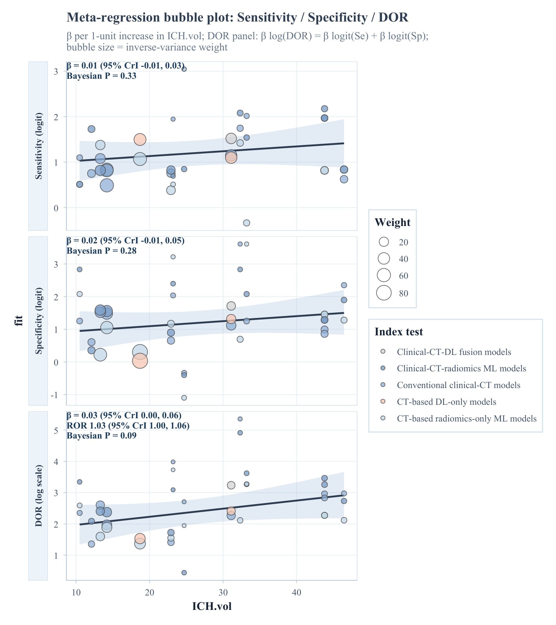
Figure S14C. Univariable meta-regression bubble plot for ICH volume.
Note: Univariable meta-regression bubble plot for ICH volume. Panels show the fitted association for sensitivity (logit), specificity (logit), and diagnostic odds ratio (log scale); bubble size reflects inverse-variance weight and shaded bands represent 95% credible intervals.
Abbreviations: CrI, credible interval; CT, computed tomography; DL, deep learning; DOR, diagnostic odds ratio; ICH, intracerebral hemorrhage; ML, machine learning.
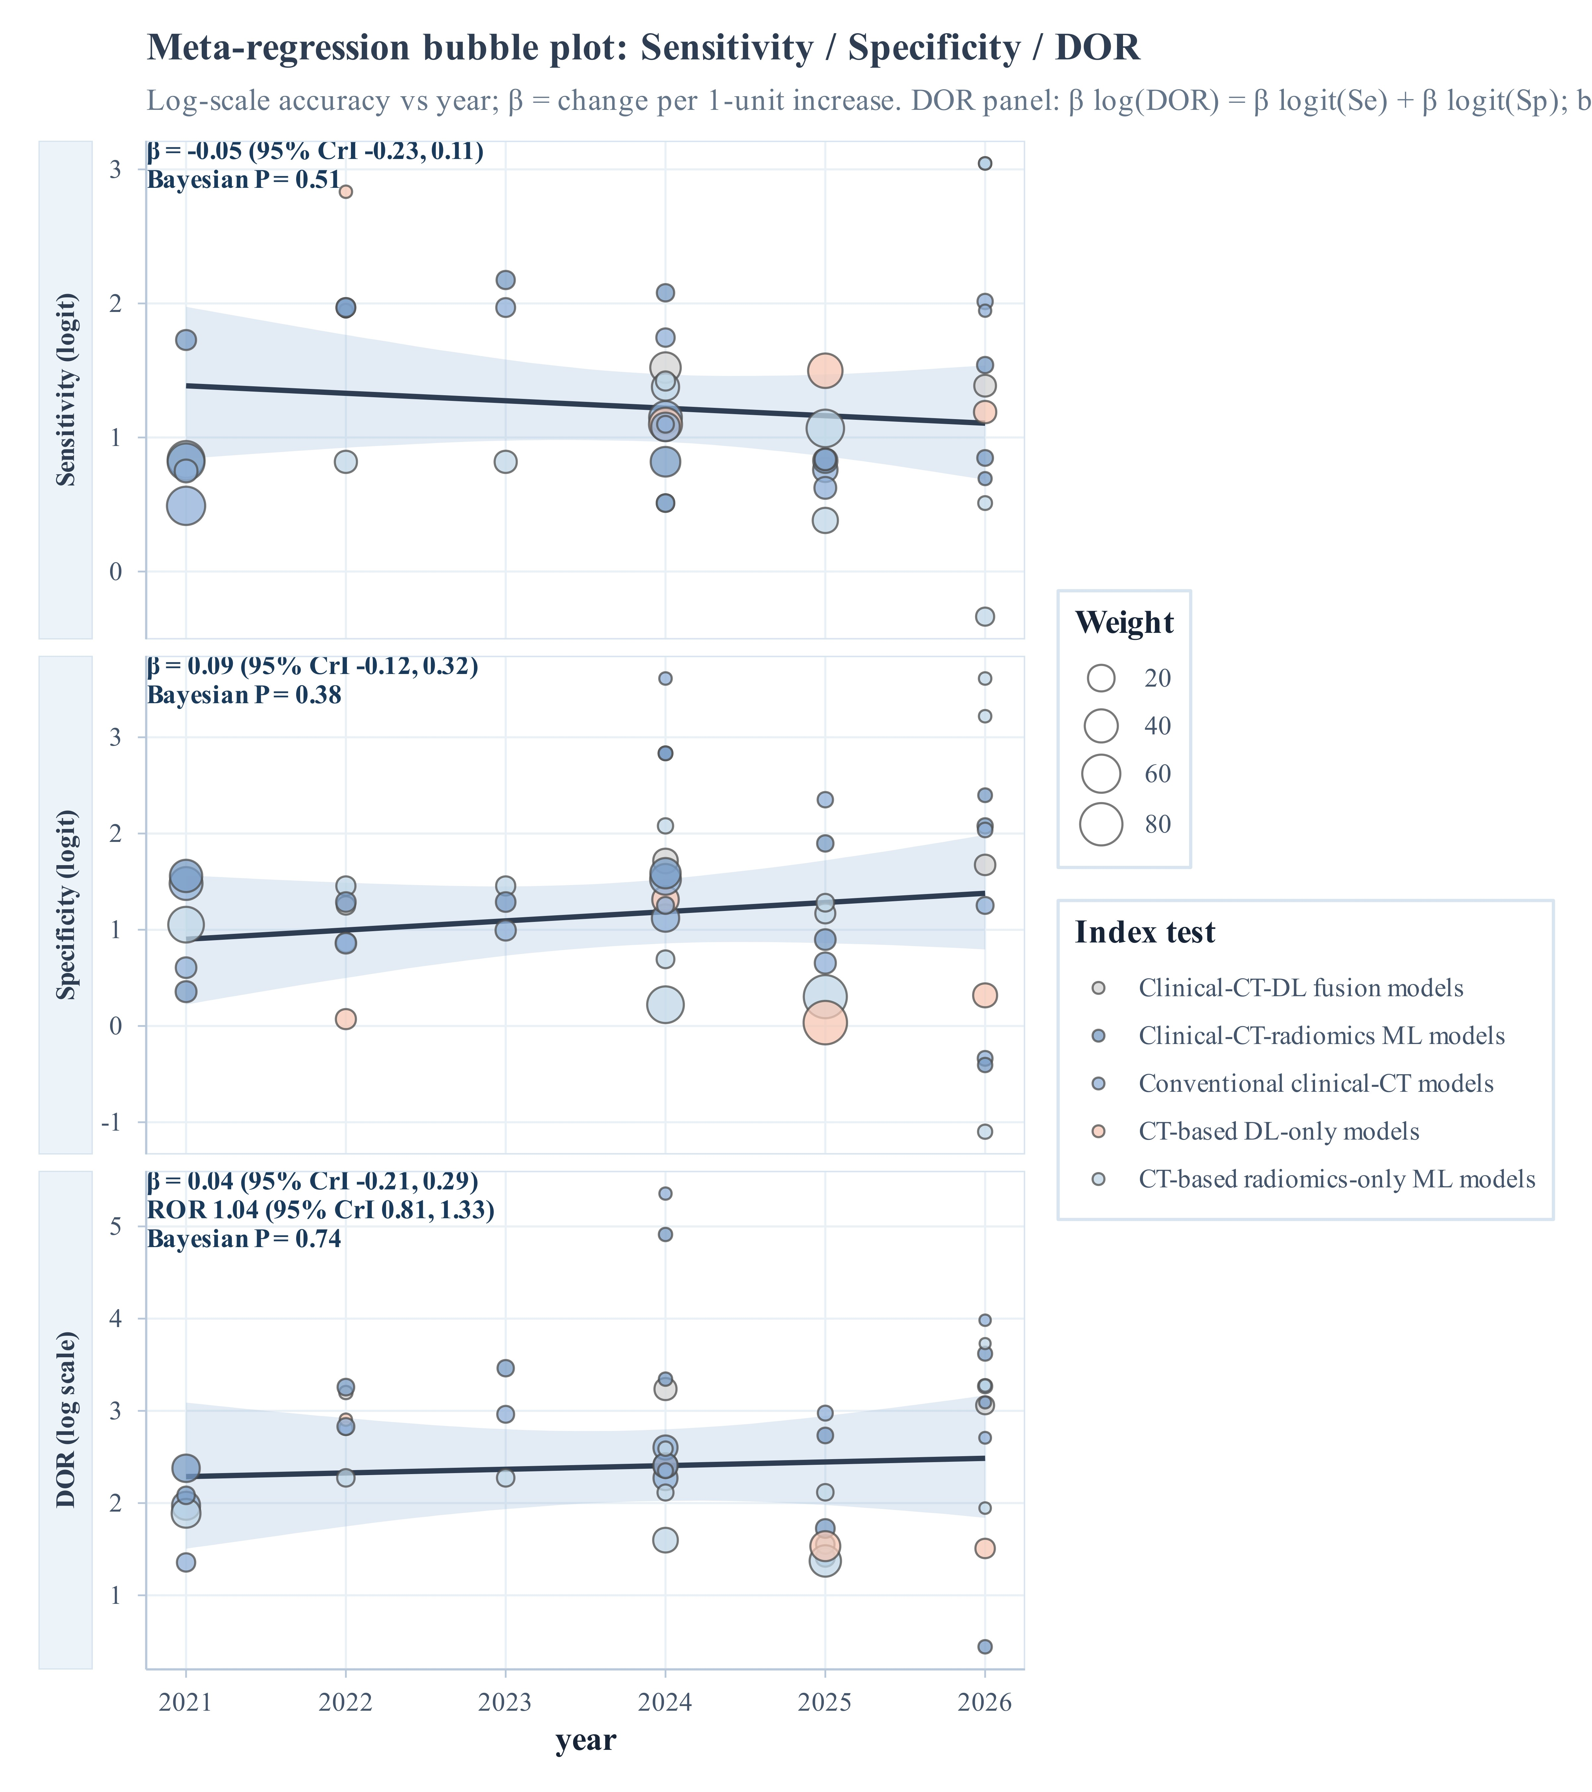
Figure S14D. Univariable meta-regression bubble plot for publication year.
Note: Univariable meta-regression bubble plot for publication year. Panels show the fitted association for sensitivity (logit), specificity (logit), and diagnostic odds ratio (log scale) against publication year; bubble size reflects inverse-variance weight and shaded bands represent 95% credible intervals.
Abbreviations: CrI, credible interval; CT, computed tomography; DL, deep learning; DOR, diagnostic odds ratio; ML, machine learning; ROR, relative diagnostic odds ratio.
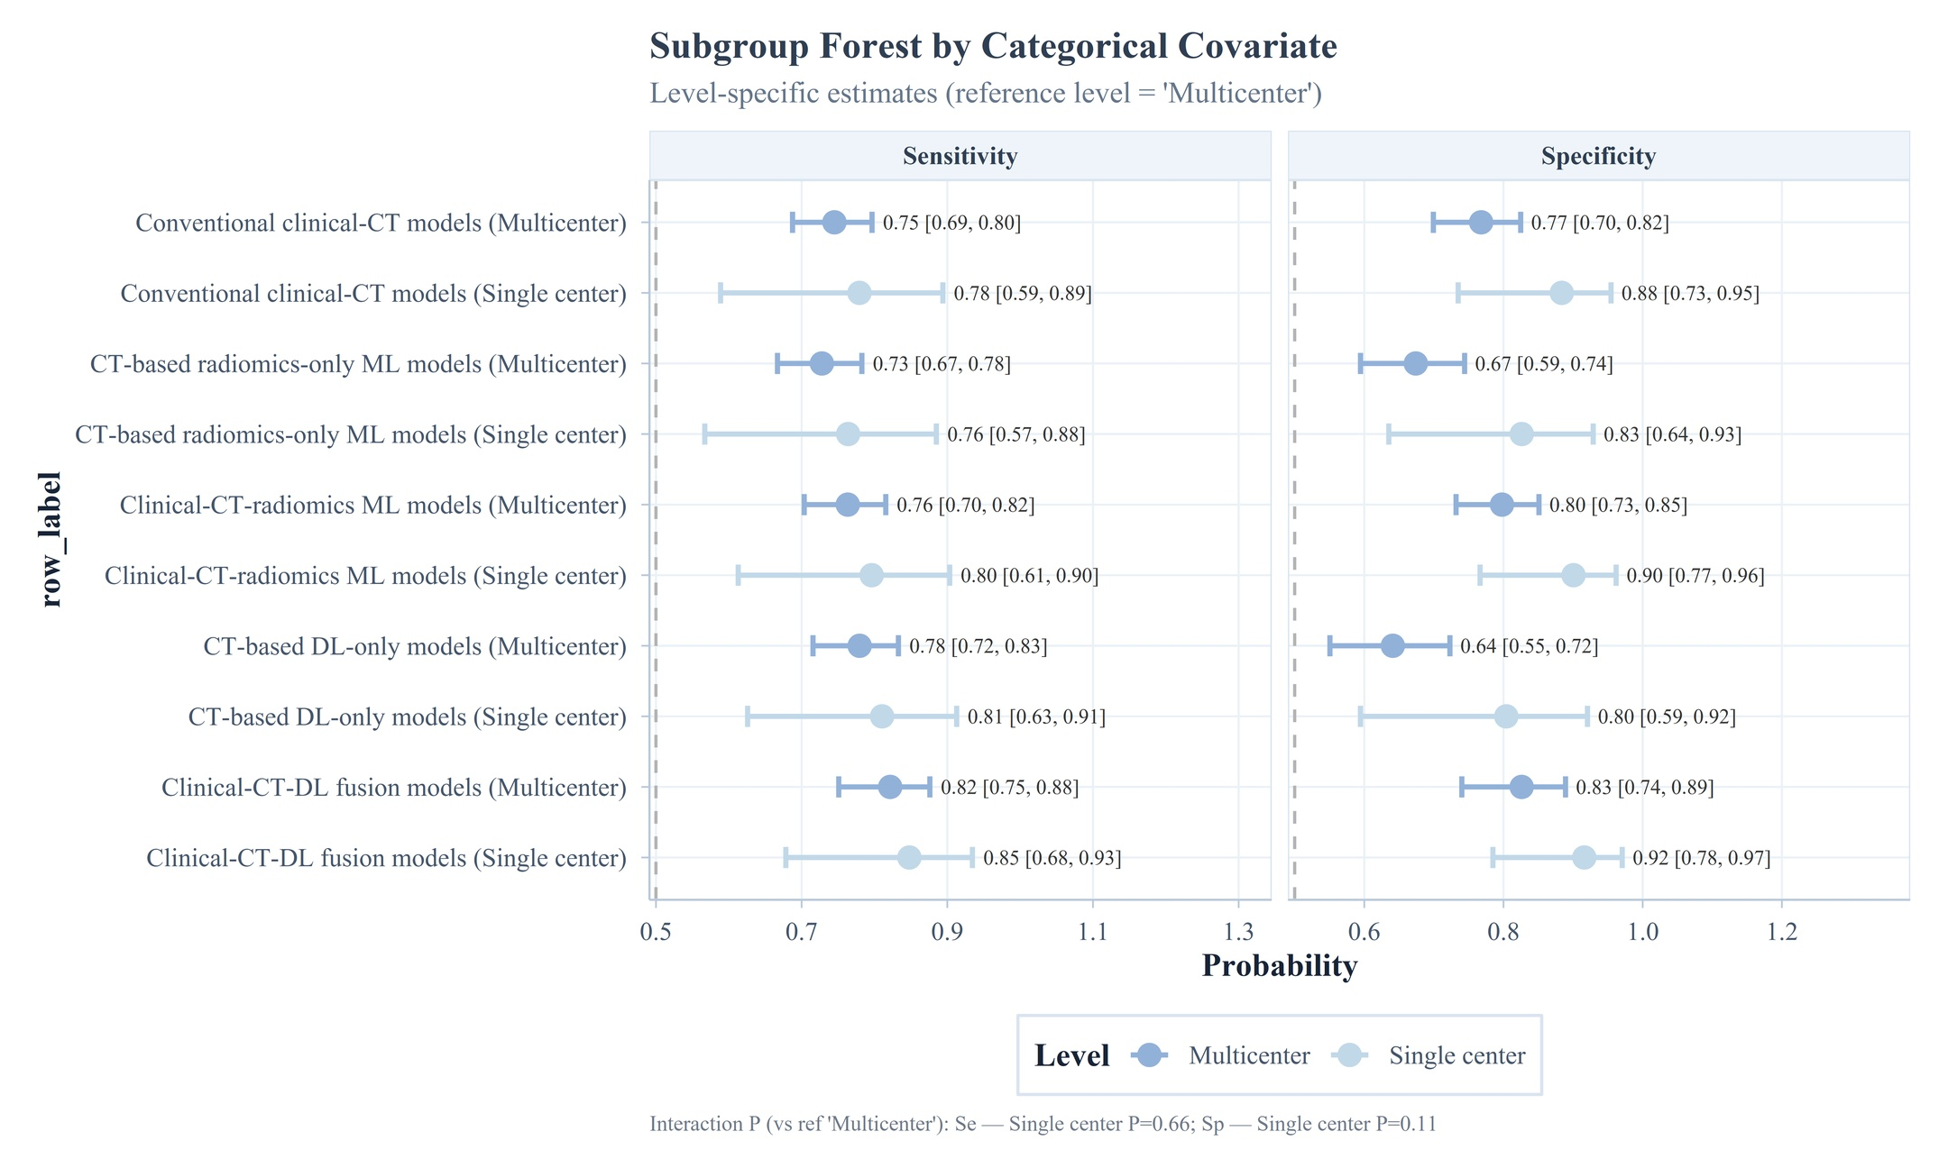
Figure S15A. Subgroup analysis by center.
Note: Subgroup analysis by center (multicenter vs single center). Panels show subgroup-specific sensitivity and specificity with 95% credible intervals; P values indicate differences versus the reference subgroup.
Abbreviations: CrI, credible interval; CT, computed tomography; DL, deep learning; ML, machine learning.
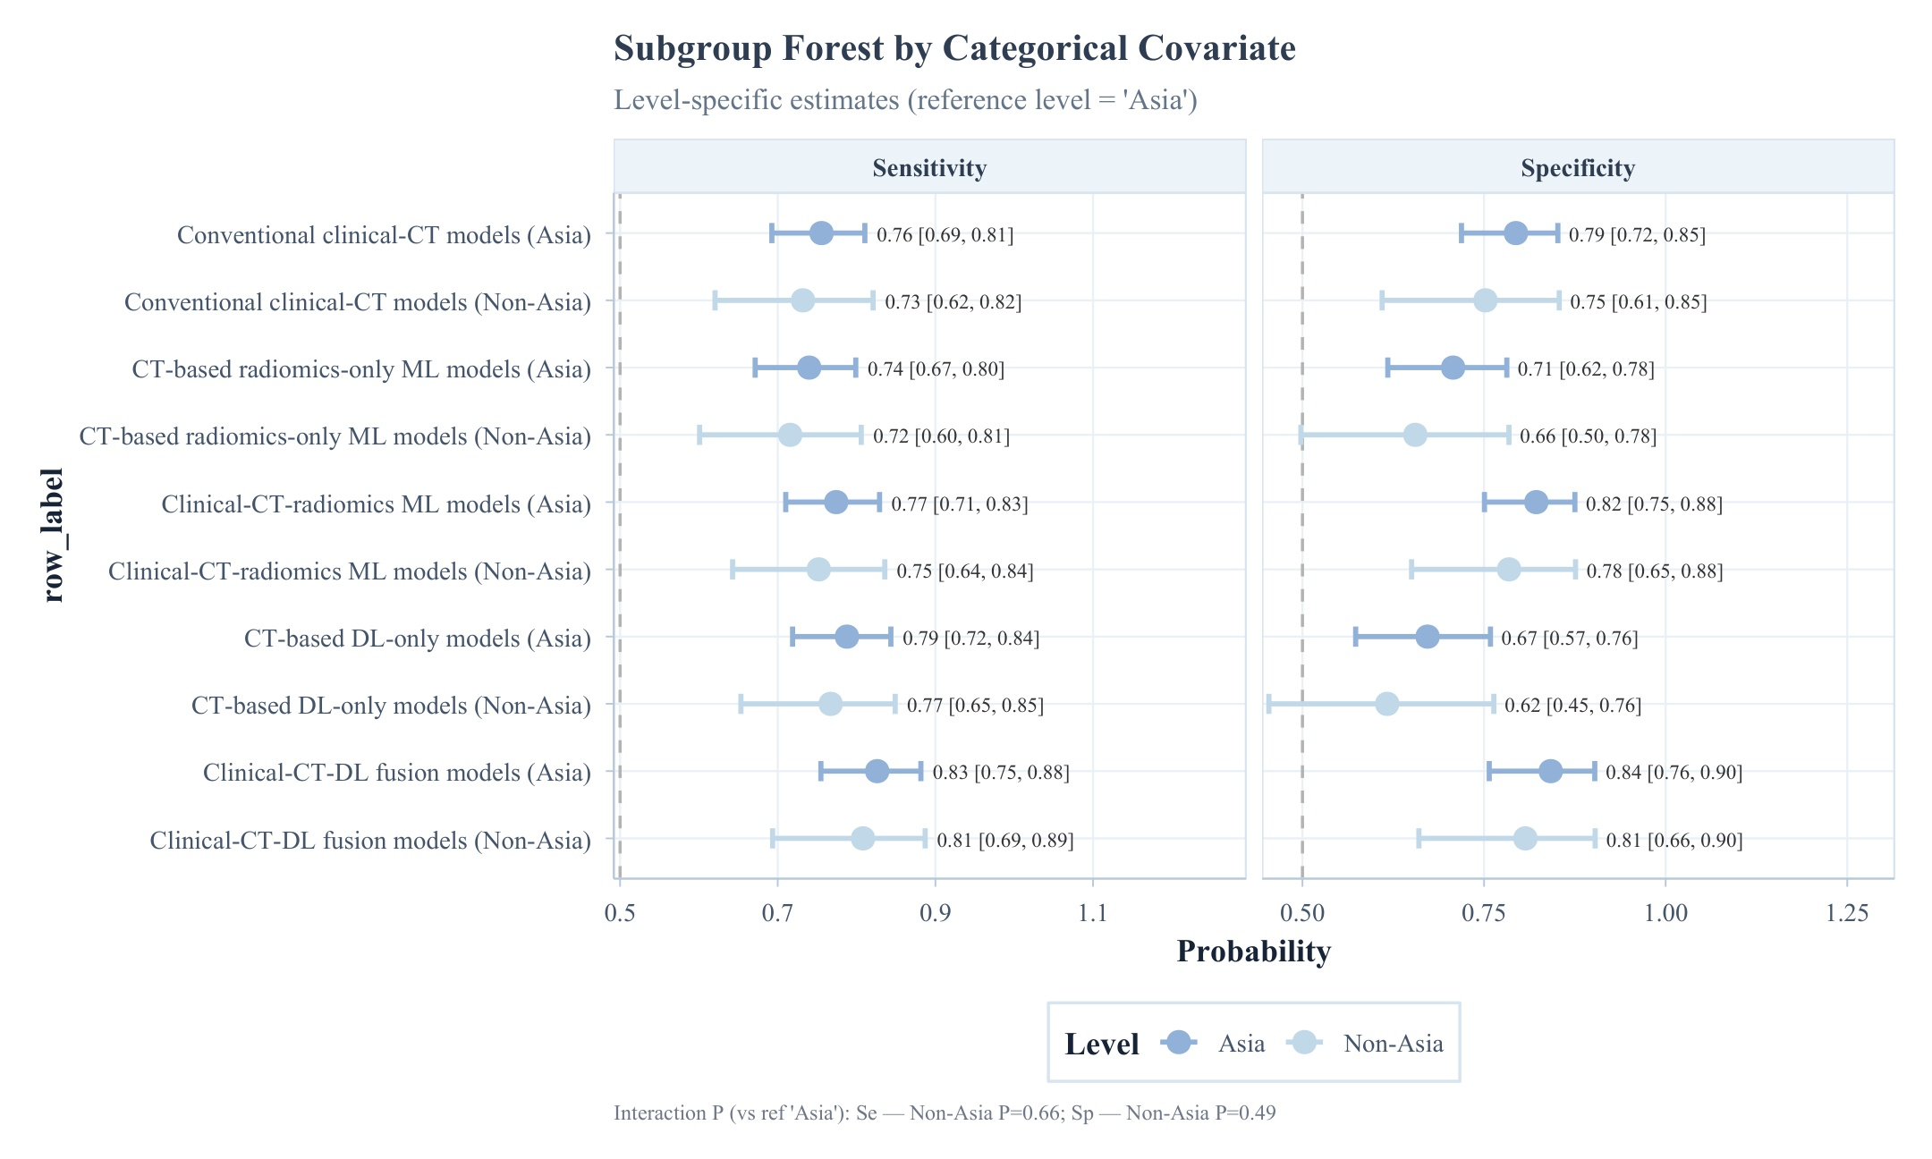
Figure S15B. Subgroup analysis by region.
Note: Subgroup analysis by region. Panels show subgroup-specific sensitivity and specificity with 95% credible intervals; P values indicate differences versus the reference subgroup.
Abbreviations: CrI, credible interval; CT, computed tomography; DL, deep learning; ML, machine learning.
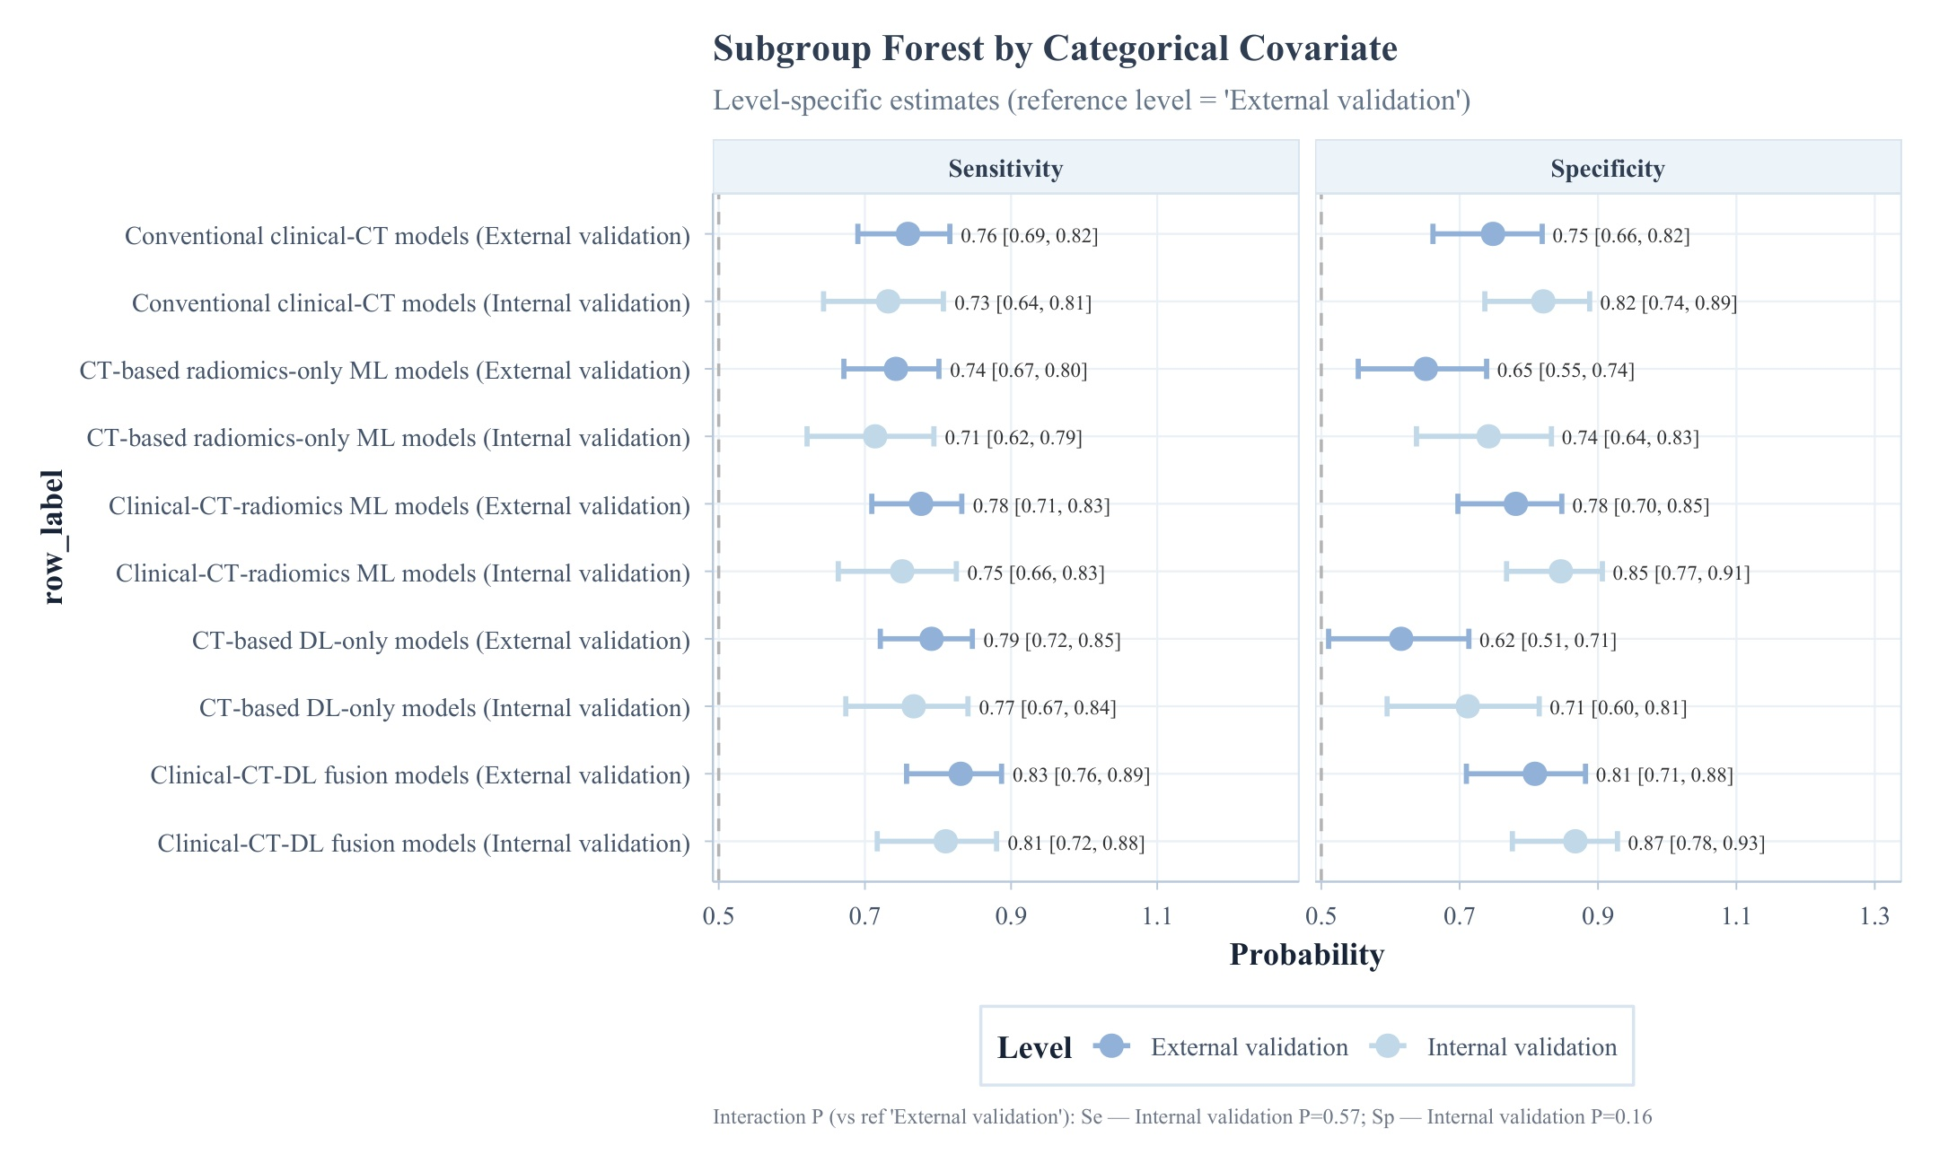
Figure S16A. Subgroup analysis by validation type.
Note: Subgroup analysis by validation type (internal vs external validation). Panels show subgroup-specific sensitivity and specificity with 95% credible intervals; P values indicate differences versus the reference subgroup.
Abbreviations: CrI, credible interval; CT, computed tomography; DL, deep learning; ML, machine learning.
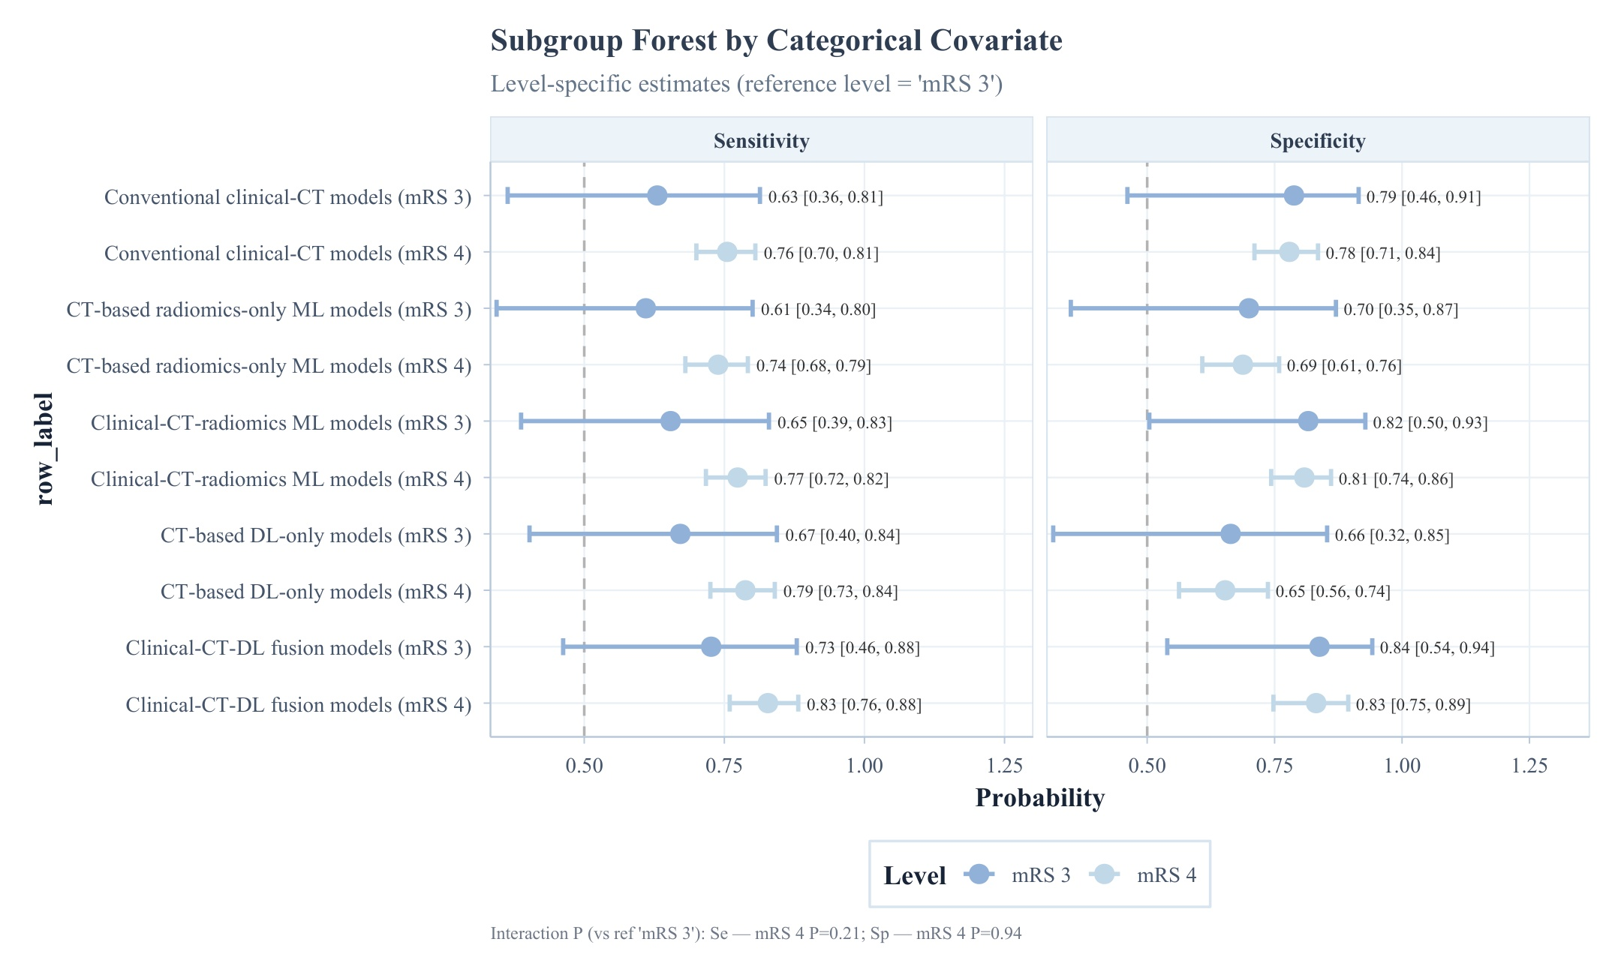
Figure S16B. Subgroup analysis by mRS threshold.
Note: Subgroup analysis by mRS threshold. Panels show subgroup-specific sensitivity and specificity with 95% credible intervals; P values indicate differences versus the reference subgroup.
Abbreviations: CrI, credible interval; CT, computed tomography; DL, deep learning; ML, machine learning.
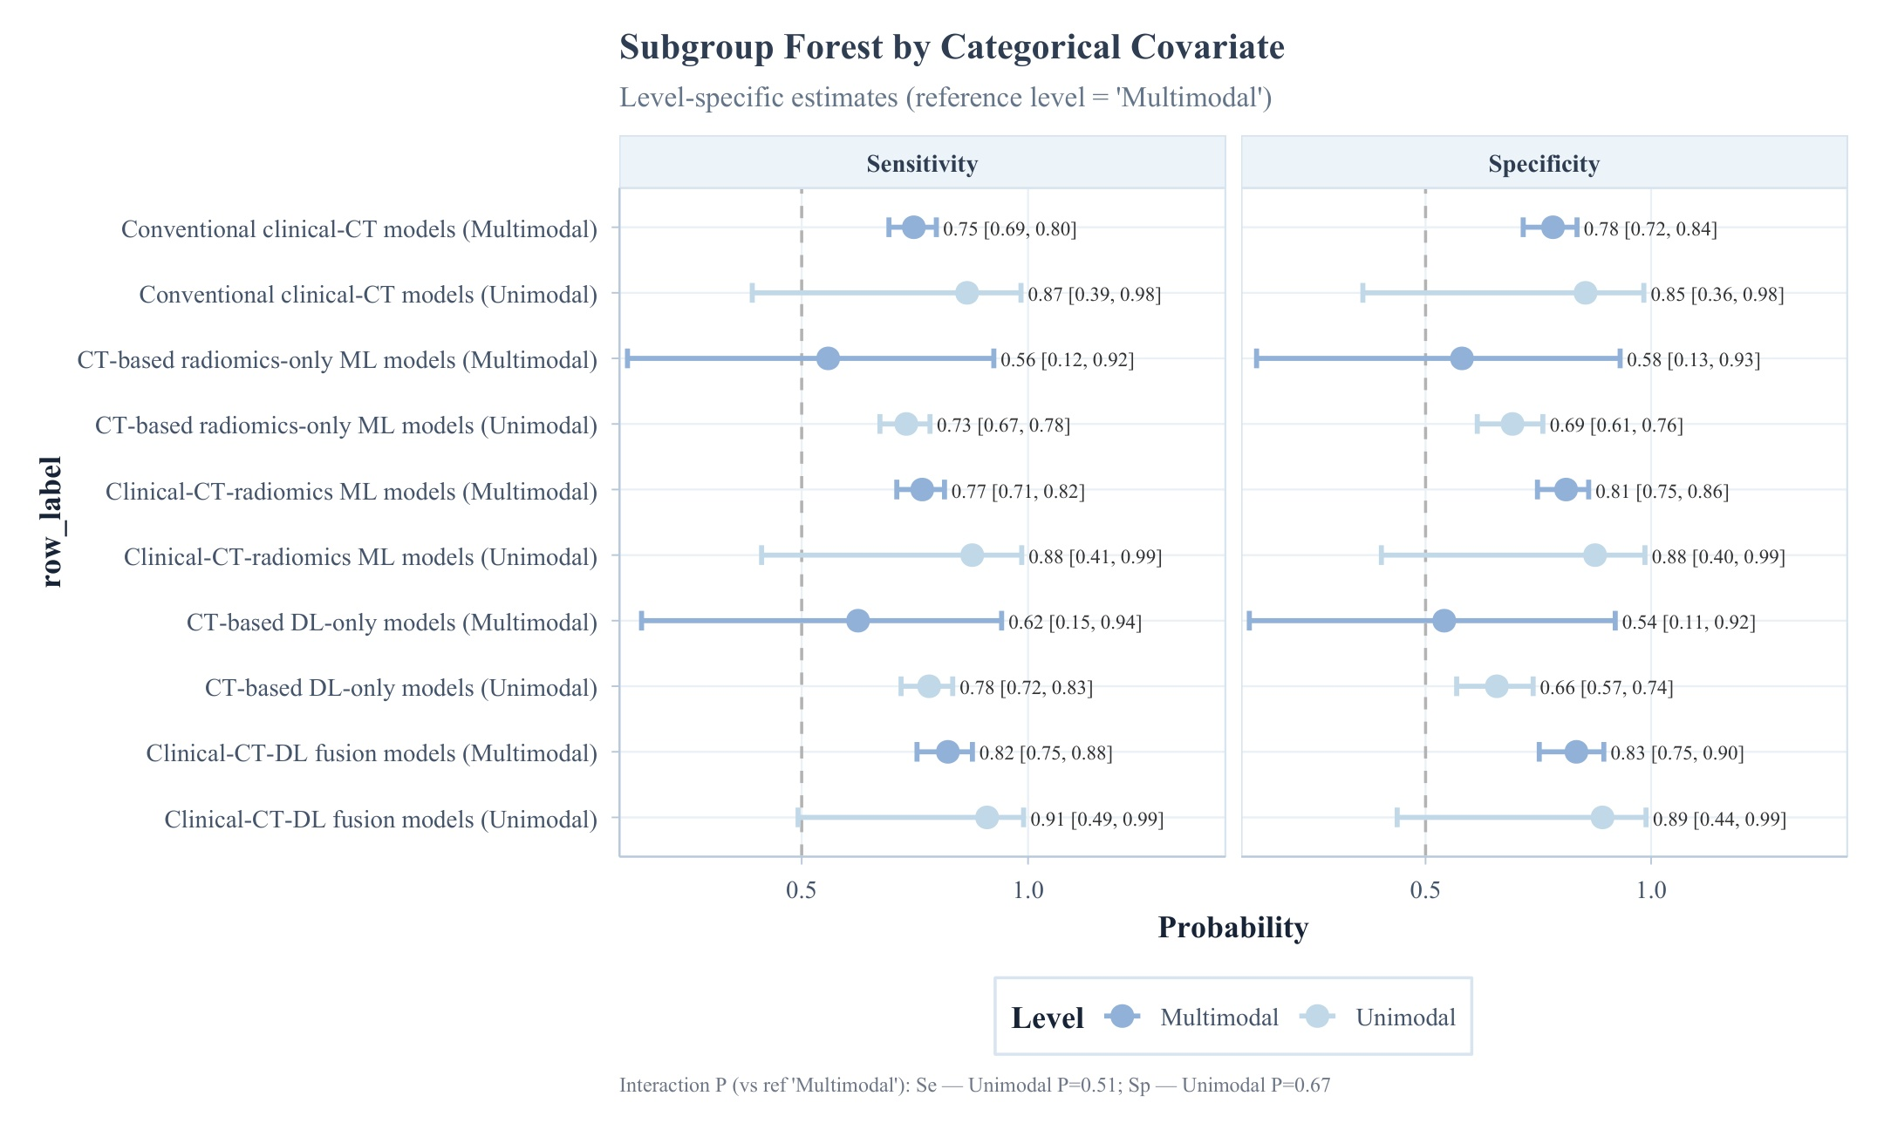
Figure S16C. Subgroup analysis by input modality.
Note: Subgroup analysis by input modality. Panels show subgroup-specific sensitivity and specificity with 95% credible intervals; P values indicate differences versus the reference subgroup.
Abbreviations: CrI, credible interval; CT, computed tomography; DL, deep learning; ML, machine learning.
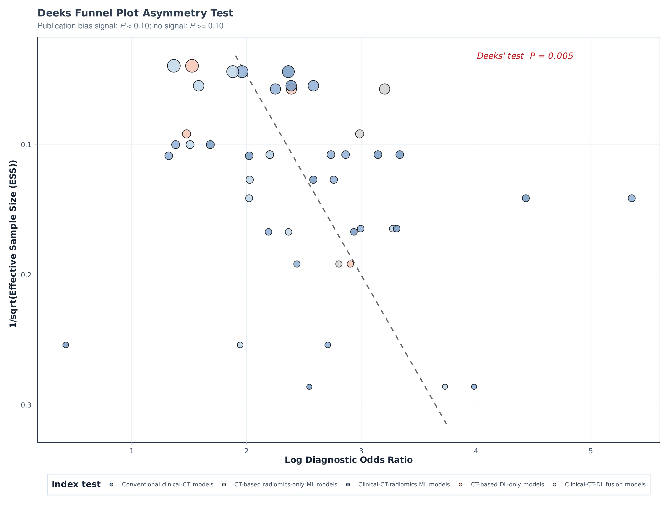
Figure S17A. Deeks' funnel plot asymmetry test for the overall network.
Note: Deeks' funnel plot asymmetry test for the overall network. The dashed line shows the weighted regression; P < 0.10 was considered suggestive of small-study effects.
Abbreviations: CT, computed tomography; DL, deep learning; DOR, diagnostic odds ratio; ML, machine learning.
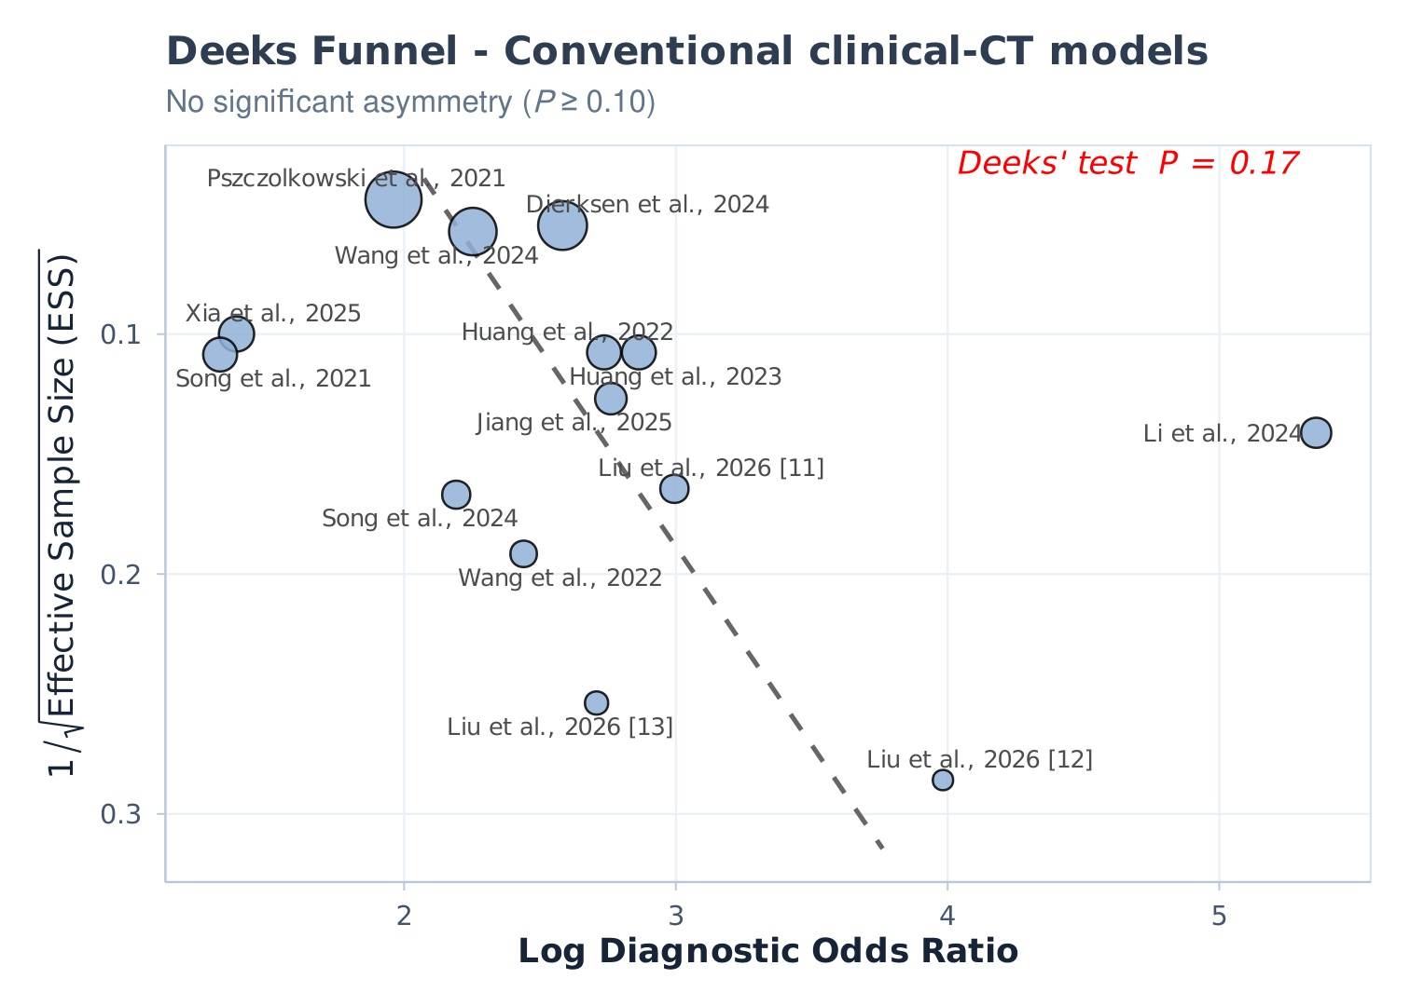
Figure S17B. Deeks' funnel plot asymmetry test for the conventional clinical-CT models.
Note: Deeks' funnel plot asymmetry test for the conventional clinical-CT models. The dashed line shows the weighted regression; P < 0.10 was considered suggestive of small-study effects.
Abbreviations: CT, computed tomography; DL, deep learning; DOR, diagnostic odds ratio; ML, machine learning.
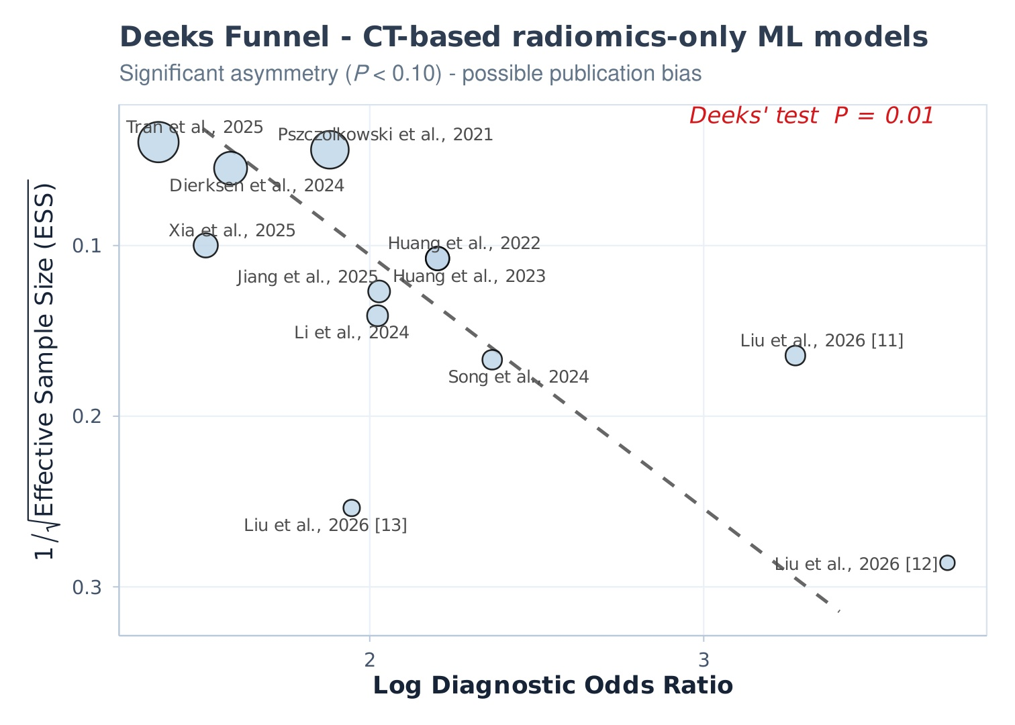
Figure S17C. Deeks' funnel plot asymmetry test for the CT-based radiomics-only ML models.
Note: Deeks' funnel plot asymmetry test for the CT-based radiomics-only ML models. The dashed line shows the weighted regression; P < 0.10 was considered suggestive of small-study effects.
Abbreviations: CT, computed tomography; DL, deep learning; DOR, diagnostic odds ratio; ML, machine learning.
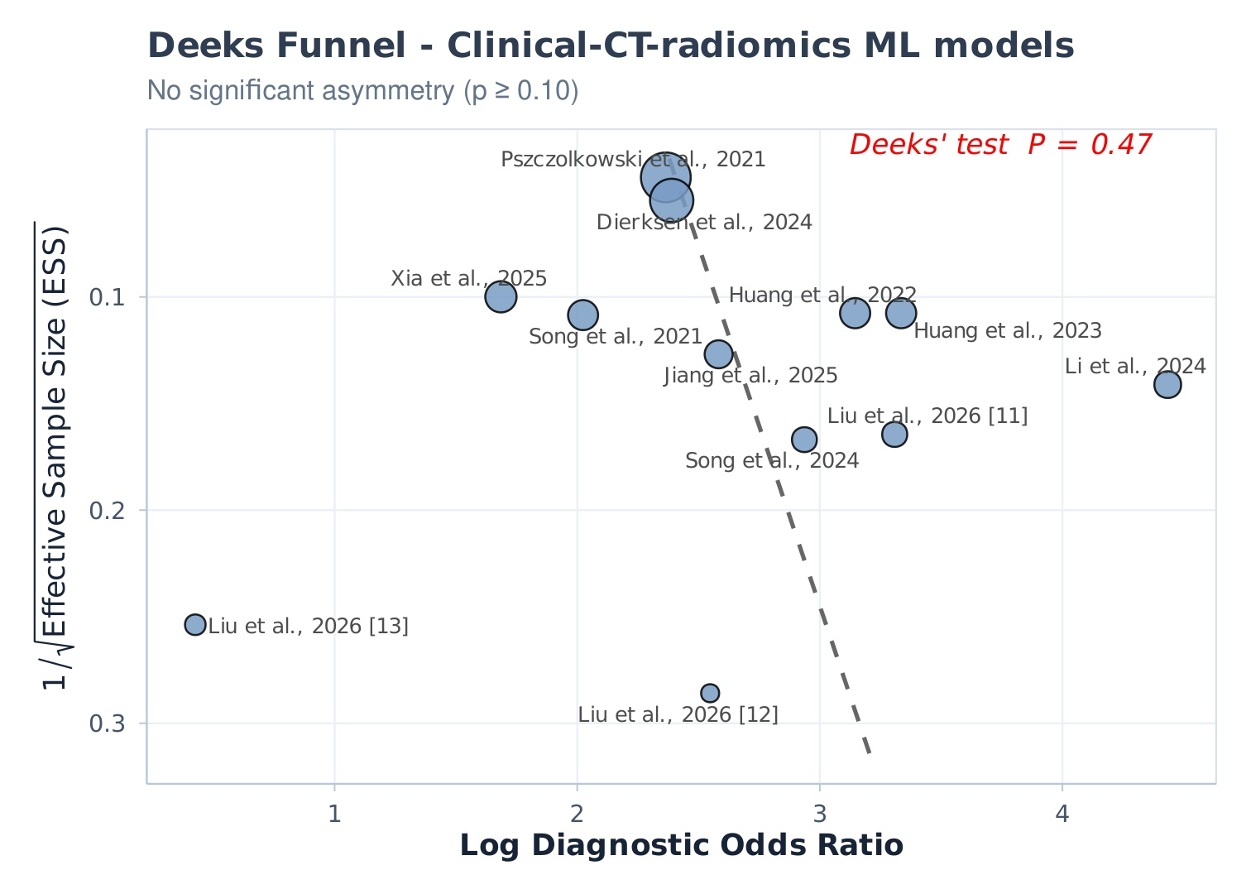
Figure S17D. Deeks' funnel plot asymmetry test for the clinical-CT-radiomics ML models.
Note: Deeks' funnel plot asymmetry test for the clinical-CT-radiomics ML models. The dashed line shows the weighted regression; P < 0.10 was considered suggestive of small-study effects.
Abbreviations: CT, computed tomography; DL, deep learning; DOR, diagnostic odds ratio; ML, machine learning.
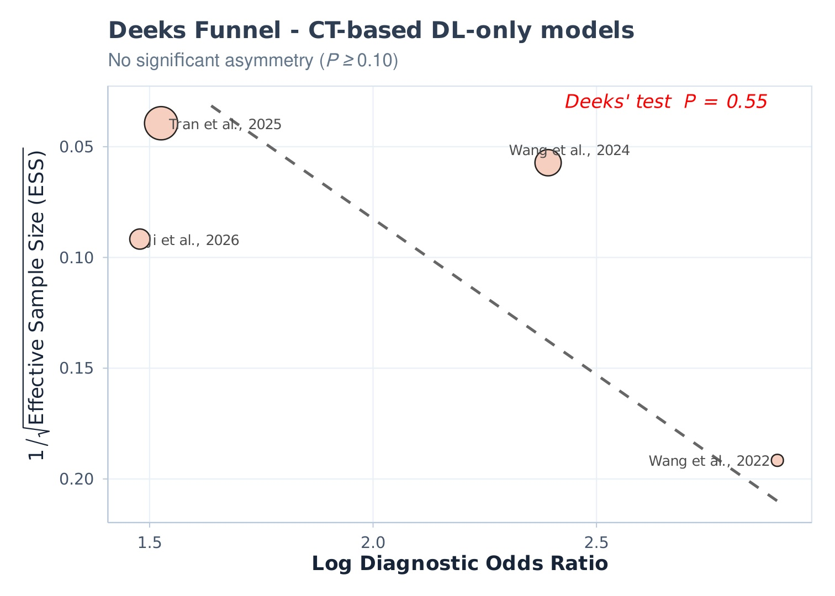
Figure S17E. Deeks' funnel plot asymmetry test for the CT-based DL-only models.
Note: Deeks' funnel plot asymmetry test for the CT-based DL-only models. The dashed line shows the weighted regression; P < 0.10 was considered suggestive of small-study effects.
Abbreviations: CT, computed tomography; DL, deep learning; DOR, diagnostic odds ratio; ML, machine learning.
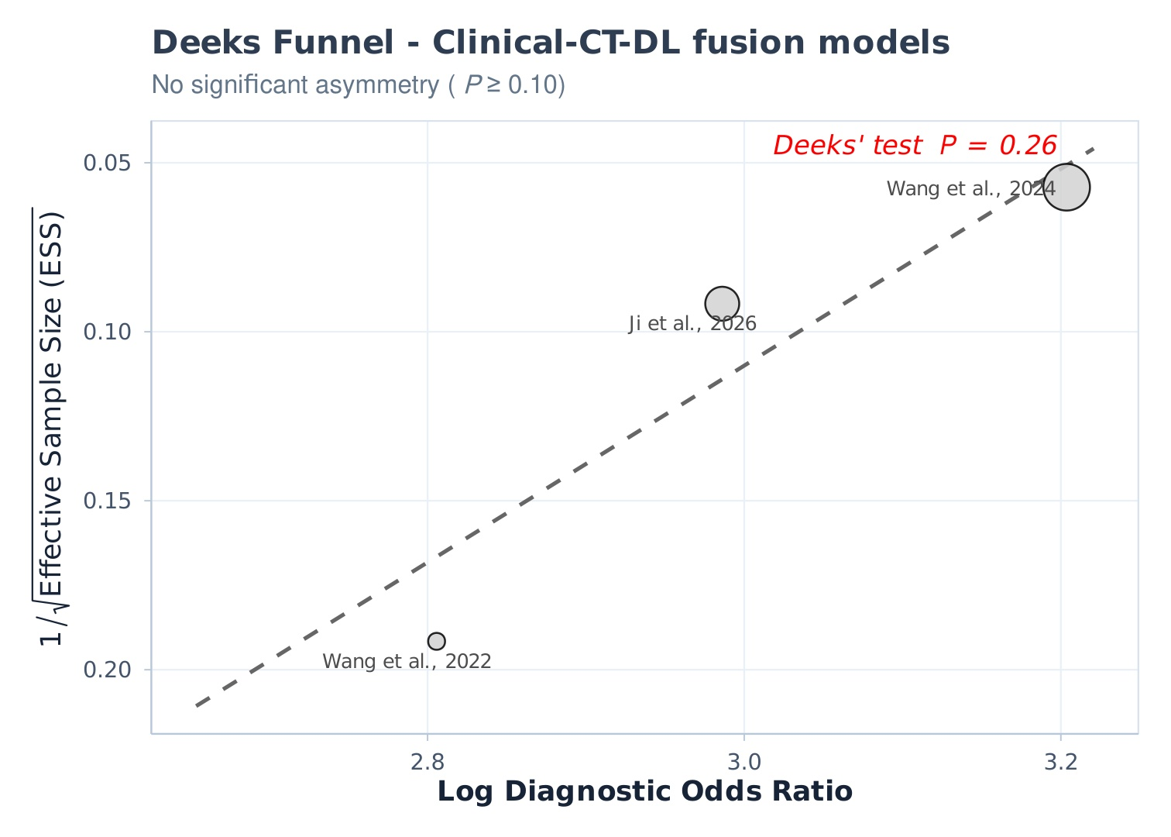
Figure S17F. Deeks' funnel plot asymmetry test for the clinical-CT-DL fusion models.
Note: Deeks' funnel plot asymmetry test for the clinical-CT-DL fusion models. The dashed line shows the weighted regression; P < 0.10 was considered suggestive of small-study effects.
Abbreviations: CT, computed tomography; DL, deep learning; DOR, diagnostic odds ratio; ML, machine learning.
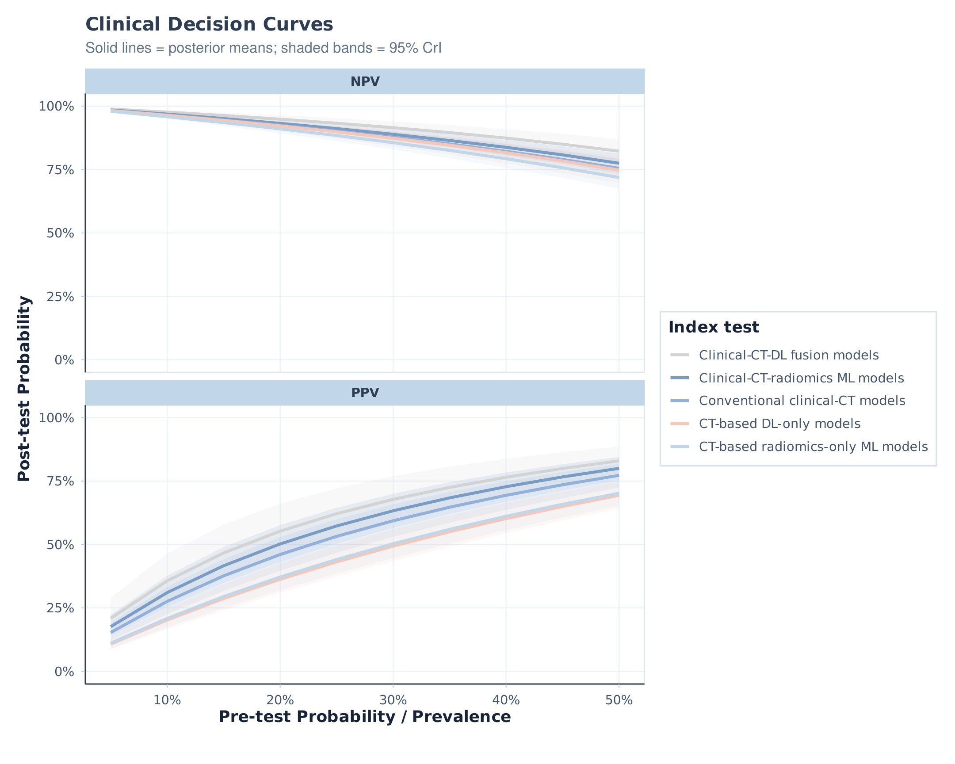
Figure S18. Clinical decision curves of positive and negative predictive values across assumed prevalence scenarios.
Note: Decision curves of pooled positive and negative predictive values across assumed prevalence scenarios. Solid lines represent posterior means; shaded bands represent 95% credible intervals.
Abbreviations: CrI, credible interval; CT, computed tomography; DL, deep learning; ML, machine learning; NPV, negative predictive value; PPV, positive predictive value.

