The Moderating Role of Workplace Policy Support in the Relationship Between Work Pressure and Father Participation in Family Education

Abstract
Objective: To examine the moderating effect of workplace policy support on the relationship between work pressure and father participation frequency in family education.
Methods: Hierarchical multiple regression was used to test the moderation effect using survey data from 575 fathers of lower-grade primary school students. Simple slope analysis, Johnson-Neyman technique, and multiple robustness checks were conducted to further explore the nature of the interaction.
Results: The interaction between work pressure and workplace policy support significantly predicted father participation frequency, B = 0.230, p = .003, ΔR² = .015. Simple slope analysis revealed that at low levels of policy support (-1 SD), work pressure was significantly negatively associated with participation, B = -0.277, p = .005; at moderate and high levels of policy support, the relationship was not significant. The effect size was small, f² = .016.
Conclusion: Workplace policy support functions as a buffer in the relationship between work pressure and father participation. Hypothesis 4 was supported.
Keywords: workplace policy support; work pressure; father participation; moderation effect; family education

1. Introduction
Father participation in family education plays a crucial role in child development. However, in modern society, work pressure often poses a significant barrier to fathers' involvement in family education. Workplace policy support, as an important external resource, may play a moderating role in the relationship between work pressure and father participation. According to Conservation of Resources Theory (Hobfoll, 1989), resources possessed by individuals can buffer the resource depletion caused by stress. Therefore, the present study hypothesized that workplace policy support moderates the relationship between work pressure and father participation frequency in family education (H4). Specifically, when policy support is high, the negative impact of work pressure on father participation would be attenuated.

2. Methods

2.1 Participants
Data were drawn from a survey of parents of lower-grade primary school students in a district in eastern China. Using a three-stage PPS sampling method, a total of 1,788 valid questionnaires were collected, including 577 fathers. After excluding 2 participants who selected "other" for the work pressure item, the final analytical sample consisted of 575 fathers, yielding a valid response rate of 99.7%.

2.2 Measures
Father participation frequency. Measured with a single item on a 5-point Likert scale, ranging from 1 (never) to 5 (always).
Work pressure. Measured with a single item asking participants about the impact of work pressure on their participation in family education, ranging from 1 (little impact) to 3 (strong impact).
Workplace policy support. Measured with a multiple-choice question including four supportive policies: parental leave, flexible work arrangements, education subsidies, and psychological counseling. Participants received 1 point for each policy selected, with scores ranging from 0 (no support) to 4 (all four policies).
Control variables. Included age, education level, household income, and number of children.

2.3 Analytical Strategy
Following standard moderation analysis procedures (Aiken & West, 1991; Hayes, 2018): (1) the independent variable (work pressure) and moderator (policy support) were mean-centered; (2) the interaction term was created; (3) hierarchical regression was conducted, entering control variables, main effects, and the interaction term sequentially; (4) simple slope analysis was performed; (5) the Johnson-Neyman technique was used to identify regions of significance; (6) effect sizes were calculated; (7) robustness checks were conducted using bootstrap and alternative specifications.

3. Results

3.1 Descriptive Statistics and Correlations
Means, standard deviations, and correlations among study variables are presented in Table 1.
Variable | M | SD | 1 | 2 | 3 | 4
1. Participation | 3.643 | 1.155 | 1
2. Work Pressure | 1.870 | 0.675 | -.064 | 1
3. Policy Support | 0.903 | 0.909 | .141*** | -.123** | 1
4. Age | 2.332 | 0.642 | -.033 | -.053 | -.081 | 1
5. Education | 2.993 | 1.177 | .113** | -.123** | .169*** | -.124**
6. Income | 1.990 | 0.970 | .047 | -.168*** | .117** | -.143***
Note. * p < .05, ** p < .01, *** p < .001.
Work pressure was not significantly correlated with participation frequency at the zero-order level, r = -.064, p > .05. Policy support was significantly positively correlated with participation frequency, r = .141, p < .001. Work pressure was significantly negatively correlated with policy support, r = -.123, p < .01.

3.2 Hierarchical Regression Analysis
Results of the hierarchical regression analysis are presented in Table 2.
Variable | Model 1 | Model 2 | Model 3
Intercept | 3.220***  (.328) | 3.283***  (.327) | 3.292***  (.325)
Age | -.050  (.089) | -.045  (.089) | -.042  (.088)
Education | .124**  (.048) | .103*  (.048) | .109*  (.048)
Income | .002  (.052) | -.014  (.053) | -.008  (.052)
No. of Children | .092  (.096) | .102  (.096) | .087  (.096)
Work Pressure (X) |  | -.078  (.073) | -.067  (.073)
Policy Support (W) |  | .153**  (.054) | .168***  (.054)
X × W Interaction |  |  | .230**  (.077)
R² | .015 | .032 | .047
Adjusted R² | .008 | .022 | .035
F | 2.125 | 3.098** | 3.976***
ΔR² |  | .017** | .015**
Note. * p < .05, ** p < .01, *** p < .001. Standard errors in parentheses.
The overall model was statistically significant, R² = .047, F(7, 567) = 3.976, p < .001. As predicted, the interaction between work pressure and workplace policy support was significantly associated with participation frequency, B = 0.230, SE = 0.077, β = .124, t(567) = 2.997, p = .003, 95% CI [0.080, 0.381], ΔR² = .015, F(1, 567) = 8.983, p = .003. Variance inflation factors (VIFs) were all below 1.25, indicating no concerns with multicollinearity. Hypothesis 4 was supported.

3.3 Simple Slope Analysis
To interpret the nature of the interaction, we conducted simple slope analyses at one standard deviation below the mean (low support), at the mean (moderate support), and at one standard deviation above the mean (high support) of workplace policy support.

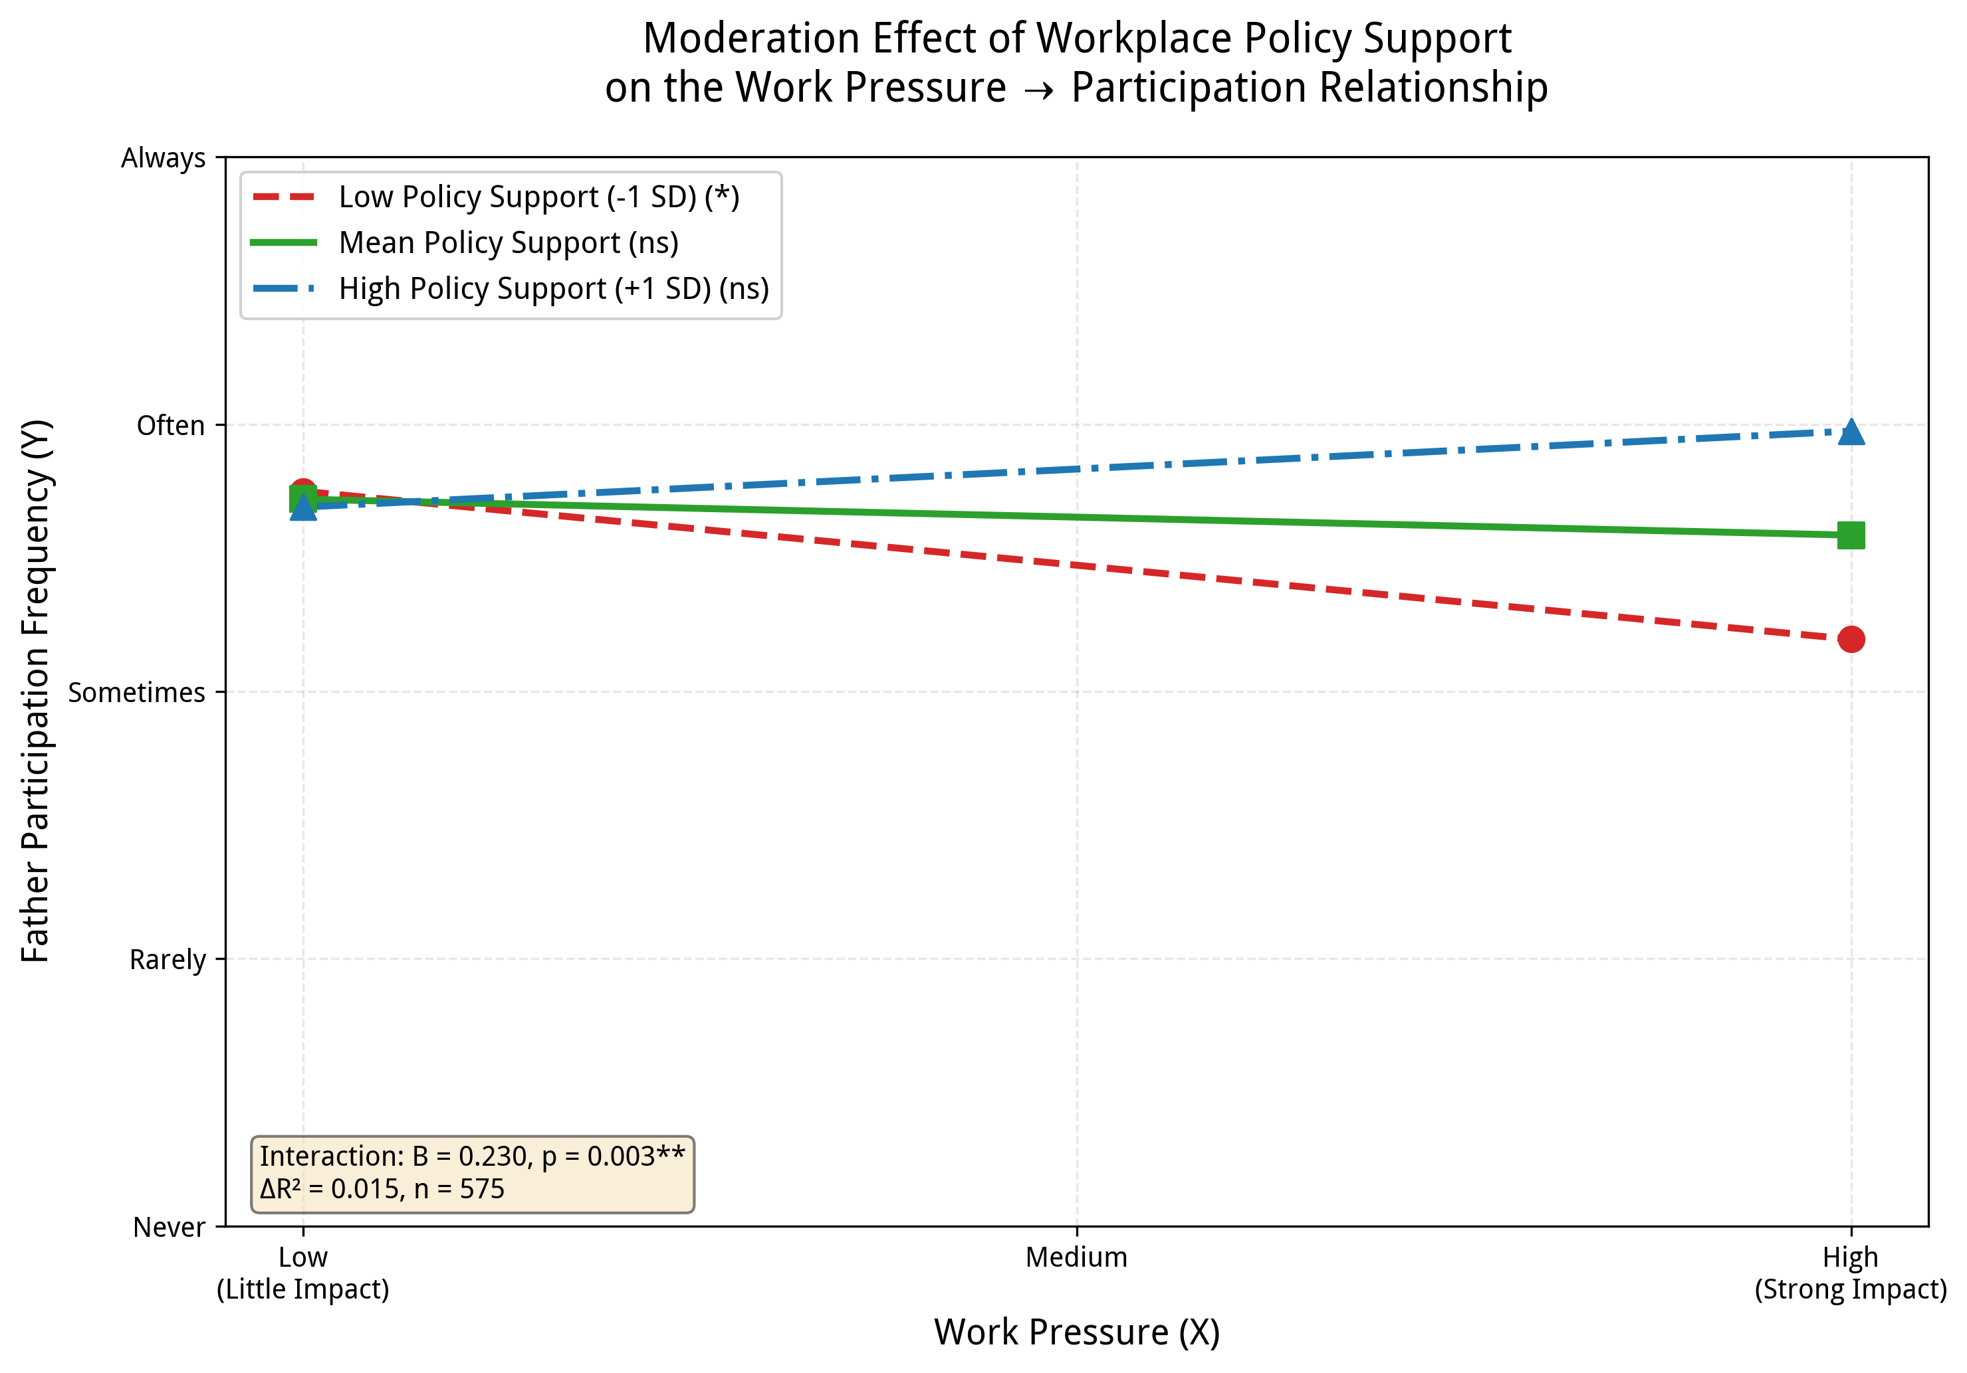
Figure 1. Interaction plot of work pressure and workplace policy support predicting father participation frequency.
As depicted in Figure 1, the pattern of results was consistent with a buffering interaction. At low levels of policy support (-1 SD), work pressure was significantly and negatively associated with participation frequency, B = -0.277, SE = 0.098, t(567) = -2.820, p = .005, 95% CI [-0.469, -0.084]. At mean levels of policy support, the relationship was not statistically significant, B = -0.067, SE = 0.073, t(567) = -0.928, p = .354, 95% CI [-0.210, 0.075]. At high levels of policy support (+1 SD), the slope was positive but not significant, B = 0.142, SE = 0.103, t(567) = 1.377, p = .169, 95% CI [-0.060, 0.345].

3.4 Johnson-Neyman Regions of Significance
The Johnson-Neyman technique was used to identify the regions of significance. The interaction was statistically significant when workplace policy support was below 0.545 (approximately 36.0% of the sample), where work pressure was negatively associated with participation. For the majority of participants (58.3%) with moderate policy support (between 0.545 and 2.357), work pressure was not significantly related to participation frequency. When policy support exceeded 2.357 (approximately 5.7% of the sample), the slope became positive and significant; however, this finding should be interpreted cautiously given the small proportion of participants in this range.

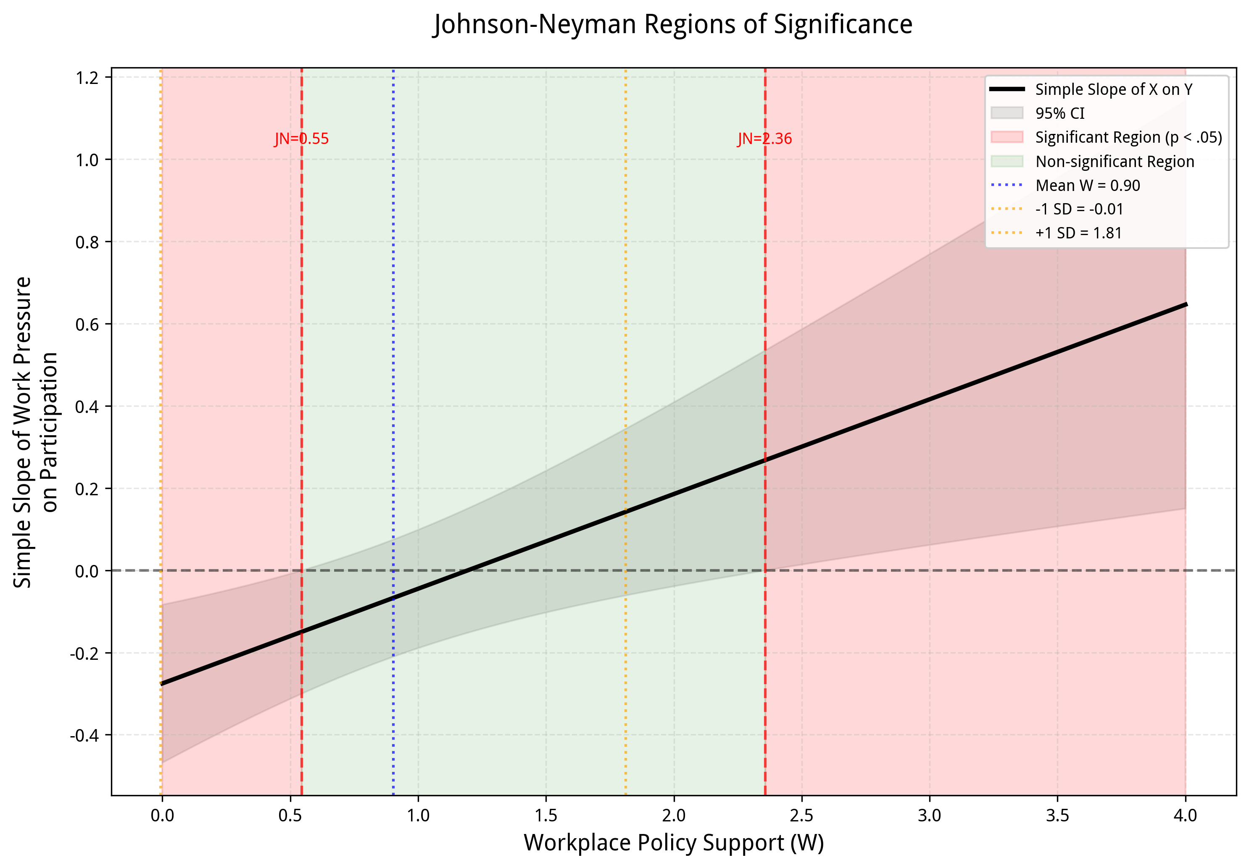
Figure 2. Johnson-Neyman regions of significance for the moderating effect of workplace policy support.

3.5 Effect Size
The effect size for the interaction was small, f² = .016 (Cohen, 1988), indicating that although the moderation effect was statistically significant, its practical magnitude was limited.

3.6 Robustness Checks
Several robustness checks confirmed the reliability of the results:
- Bootstrap analysis with 5,000 resamples yielded a 95% confidence interval for the interaction term that did not contain zero [0.080, 0.381];
- When policy support was dichotomized (any support vs. no support), the interaction remained significant, B = 0.528, p < .001;
- The interaction effect was consistent across different sets of control variables;
- Excluding high-influence cases (Cook's D > 4/n) did not substantively alter the results.
Collectively, these analyses indicate that the moderation effect is robust.

4. Discussion

4.1 Principal Findings
The present study examined the moderating role of workplace policy support in the relationship between work pressure and father participation in family education. The results indicated that the moderation effect was statistically significant, supporting Hypothesis 4. Specifically, workplace policy support functioned as a buffer: when policy support was lacking, work pressure significantly inhibited father involvement; when policy support was present, the negative impact of pressure was attenuated to non-significance.

4.2 Theoretical Implications
The findings of this study support the Conservation of Resources Theory, positing that workplace policies, as a form of resource, can buffer the resource depletion caused by work pressure, thereby protecting fathers' participation in family education. Additionally, this study enriches the empirical evidence for Bronfenbrenner's ecological systems theory, demonstrating that exosystem factors (workplace policies) can moderate the impact of mesosystem factors (work pressure) on the microsystem (family participation).

4.3 Practical Implications
The results of this study have important implications for policy-making and corporate management. First, workplace supportive policies are particularly important for fathers experiencing high work pressure. When policy support is lacking, pressure significantly inhibits fathers' participation in family education. Second, attention should be focused on fathers with low policy support and high work pressure. Providing them with flexible work arrangements, parental leave, and other forms of support may effectively enhance their participation in family education.

4.4 Limitations
Several limitations of this study should be acknowledged. First, the work pressure variable measured the "perceived impact of pressure on participation" rather than "work pressure per se," which may have introduced conceptual overlap with the outcome variable and potentially biased effect estimates. Second, the cross-sectional design precludes causal inference. Third, core variables were measured with single items, which may have limited reliability and validity. Fourth, policy support was operationalized as a simple count, assuming equal weight for each policy type, whereas different policies may have differential effects. Fifth, the sample was drawn from a single district in eastern China, which may limit generalizability. Sixth, although statistically significant, the effect size was small, suggesting limited practical impact.

4.5 Future Research Directions
Future research could improve upon the present study in several ways: using more rigorous measures of work pressure; employing longitudinal designs to establish causality; examining the differential effects of specific types of policy support; exploring other potential moderators (e.g., gender role attitudes, spousal support); and validating the findings across different cultural contexts.

5. Conclusion
Workplace policy support significantly moderates the relationship between work pressure and father participation frequency in family education, functioning as a buffer. When policy support is lacking, work pressure significantly inhibits father participation; when policy support is present, the negative impact of pressure is attenuated to non-significance. Hypothesis 4 was supported. However, the effect size was small, and the practical magnitude should be interpreted with caution.

References
Aiken, L. S., & West, S. G. (1991). Multiple regression: Testing and interpreting interactions. Sage.
Bronfenbrenner, U. (1979). The ecology of human development: Experiments by nature and design. Harvard University Press.
Cohen, J. (1988). Statistical power analysis for the behavioral sciences (2nd ed.). Lawrence Erlbaum.
Hayes, A. F. (2018). Introduction to mediation, moderation, and conditional process analysis: A regression-based approach (2nd ed.). Guilford Press.
Hobfoll, S. E. (1989). Conservation of resources: A new attempt at conceptualizing stress. American Psychologist, 44(3), 513-524.

