NORTHWESTERN UNIVERSITY
{Place the Dissertation Title Here in Mixed Case with No Special Characters}
A DISSERTATION
SUBMITTED TO THE GRADUATE SCHOOL
IN PARTIAL FULFILLMENT OF THE REQUIREMENTS

for the degree
DOCTOR OF PHILOSOPHY
{Program Name}
By
{Your Name}
EVANSTON, ILLINOIS
{Month and Year degree will be conferred, e.g., June 2022}

{Copyright page is optional but should be included if you choose to register copyright in the manuscript}

© Copyright by {name, year}
All Rights Reserved

Abstract
{Insert your abstract here. Inclusion of an abstract is required. It must be double spaced. There is no word limit on your abstract. The abstract of a foreign language dissertation must be in English. Mathematical formulas, photographs, diagrams, and other illustrative materials should not be included in the abstract.}

Acknowledgment
{This section is optional. If included, it should be double spaced.}

Preface
{This section is optional. If included, it should be double spaced.}
List of Abbreviations
{This section is optional. If included, it may be single spaced.}

Glossary
{This section is optional. If included, it may be single spaced.}

{Dedication page is optional. If included, it should be double-spaced}.
Table of Contents
{The dissertation must include a table of contents. The format of the table of contents should conform to the guidelines in an approved style manual. It is important that the table of contents accurately reflect the outline and organization of the manuscript. The table of contents should be double spaced.}

List of Tables, Illustrations, Figures, and Graphs
{These lists should reproduce the specific titles and page locations of all illustrative materials. Lists may be single spaced.}

Introduction
{This section is optional}
{Body of the Text: Chapters should follow a logical outline, with a clear distinction between chapters, main heads within chapters, and subordinate heads within the main heads. The outline and organization of the main body of the text should be accurately reflected in the table of contents. All non-textual elements (e.g., tables, graphs, and images) must be described in the text. Body of the text must be double spaced, with the exception of quotations as paragraphs, captions, items in tables, lists, graphs, charts, footnotes/endnotes, bibliographic entries, lists in appendices.}

Guides and How-To’s
This section will provide tutorials on some of the most common dissertation formatting problems. The vast majority of these tutorials have to do with page numbers, which are the single most common error that comes up in dissertation reviews. After reading these tutorials, you will be able to format your page numbers to start and stop in the right places, respect the margin requirements, and appear in the proper place on landscape pages.
How to Number Your Pages Correctly
As you may recall from Chapter 1, every page in the dissertation should have a page number, with the exception of the title page. The numbering should begin on the second page with “2”. The easiest way to make sure the title page is not numbered, while ensuring that every other page is numbered, is by changing the header settings. In order to do this, click into the header so that the “Header & Footer Tools” menu appears. Then, make sure the “Different First Page” option is selected. Now you can delete the page number from the title page while still leaving page numbers on the rest of the page.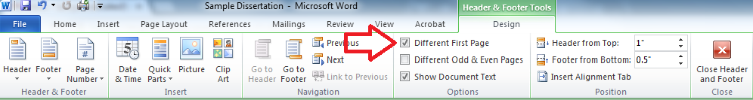
Figure 1 - Header and Footer Tools menu with "Different First Page" option selected.
The single most common formatting error that appears in NU dissertations is the placement of page numbers. Page numbers need to be placed in the upper right-hand corner of the page, and they need to conform to margin requirements. These margin requirements are important because of ProQuest’s archiving process; when dissertations are archived, the pages are cropped, and if text, figures, or page numbers are placed too close to the edge of the page, they run the risk of being cut off. Assuming your margin settings are correct, Microsoft Word should automatically place page numbers one inch from the right side of the page; it’s the requirement that they be placed at least ¾” from the top of the page that causes problems, as the default header setting puts only a half-inch margin between the page number and the top of the page.
The solution to this problem can be found in the “Header and Footer Tools” menu. Once the menu is open, set the “Header from Top” distance to ¾” (or more). This setting adjustment will ensure that any text in the header, including page numbers, is placed ¾” from the top of the page.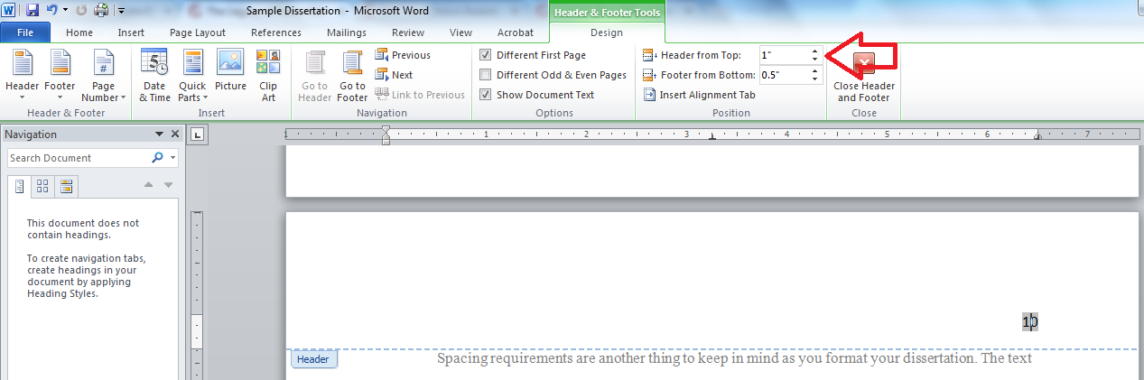
Figure 2 - Header and Footer Tools menu, with "Header from Top" set to one inch.
In some cases, you might want to insert a landscape page into your thesis in order to accommodate a table or figure. The following tutorial will show you how to include a landscape page and change the position of the page number, if desired.
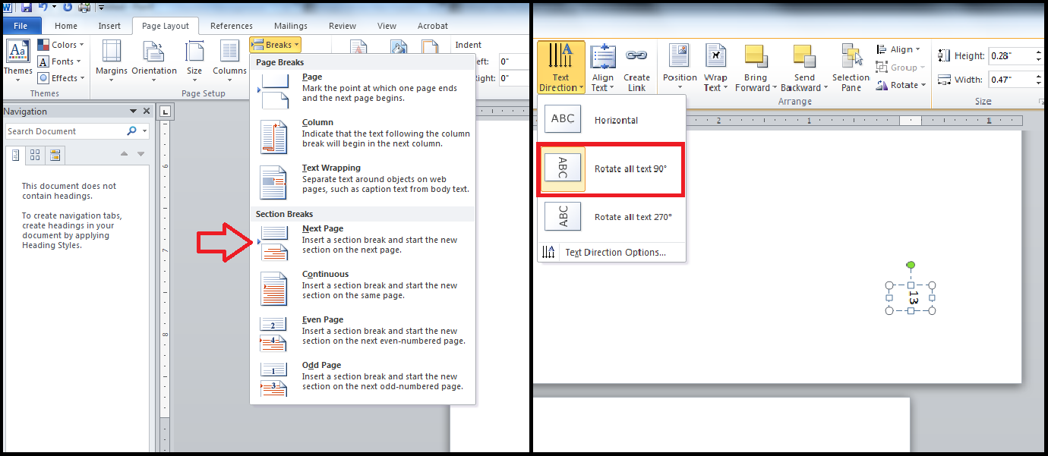
In order to insert a landscape page into a document with portrait orientation, you will need to start a new section. In order to do this, use the “Page Breaks” tool within the Page Layout menu, and select the type of section break labelled “Next Page,” as seen in Figure 3. Once you have created the new section, select the new page and change the orientation (also in the Page Layout menu) to landscape.

Figure 3 – Section break menu option

To add a page number to your landscape page for best on-paper readability (for printed/bound copies), insert a text box by going to the Insert menu and selecting “Text Box.” Now, reposition your text box so that it appears in the lower right-hand corner of the page. Make sure that your text box is positioned at least ¾” from the edges of the page. You can then type in the appropriate page number. In order to get the number to face the correct direction, click into the text box and select the Drawing Tools menu. From there, select the “Text Direction” sub-menu and choose the “Rotate all text 90°” option, as seen in Figure 3. Your page number should now be facing the appropriate direction. In order to put the remaining pages back into landscape format, add another section break and change the page orientation back to “Portrait.” You may have to add the page numbers back into the header in this section, in which case you should double-check that your page numbers are still positioned properly.

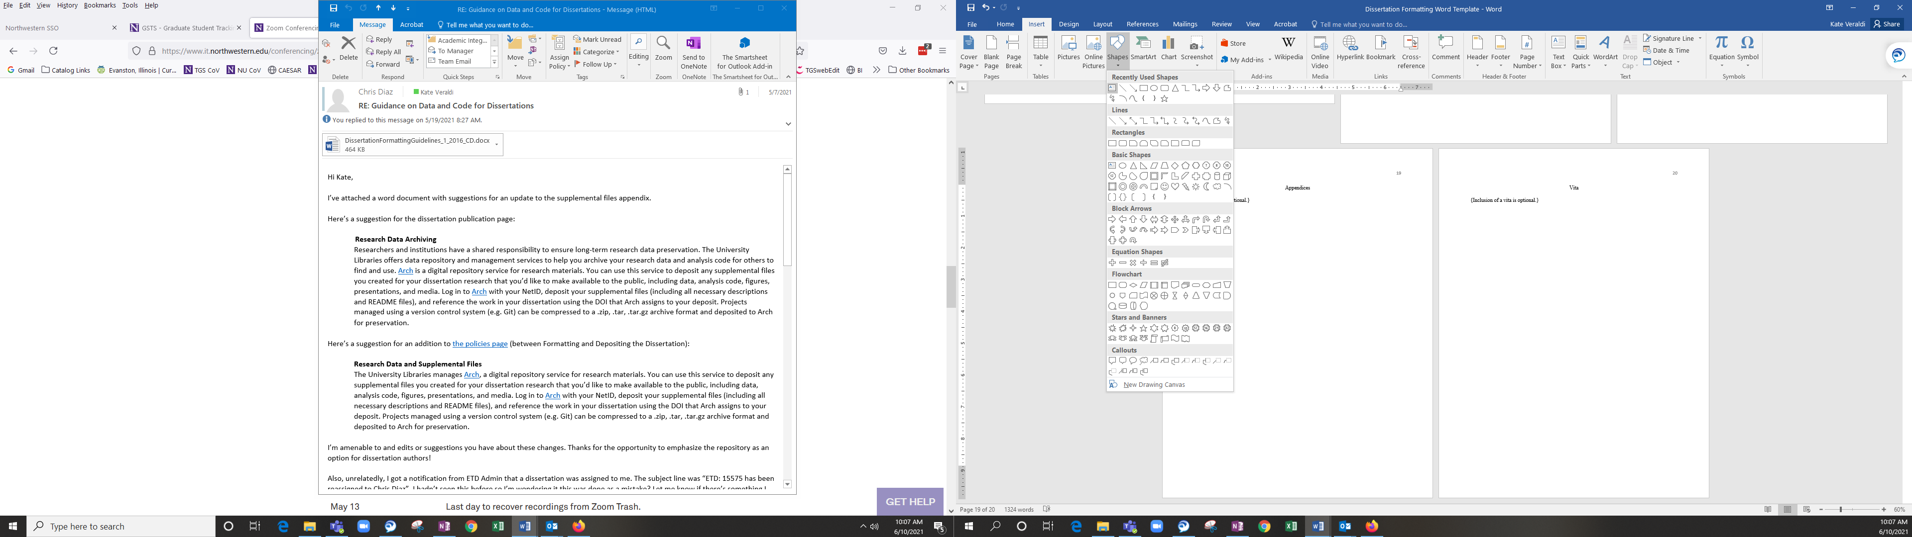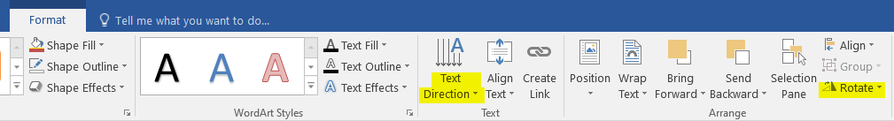
Figure 4 – Drawing Tools menu with “Rotate all text 90°” selected under the “Text Direction” heading.
16

Tables, Illustrations, Figures or Graphs
{If not incorporated into the main body of the text, these items should immediately follow the text. They should not be placed at the end of chapters.}

References
{Each dissertation must include references to document the text. These references may be included at the bottom of the page or at the end of the text, but cannot be placed at the end of each chapter. The format for references should conform to the guidelines in an approved style manual. Reference may be single-spaced.}

Appendices
{This section is optional.}

Vita
{Inclusion of a vita is optional but strongly recommended.}

Unfortunately, these tutorials are designed to help with dissertations written in Microsoft Word. If you are using LaTeX, these guides will be of no use. Of course, if you are using LaTeX, you probably aren’t having these problems to begin with.
If you change your header settings after setting up your Table of Contents, you will probably want to double-check that the Table of Contents and any other numbered lists (List of Figures or List of Tables) are still accurate, as changing the distance of the header from the top of the page can throw off the numbering.

