**EECS 660 Homework 2 Instructions**

The goal of this homework is to implement the Kruskal’s algorithm in the *Algorithm Design* book. The pseudo code is as follows:

***Kruskal’s Algorithm***

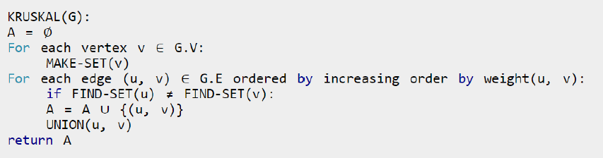

Please read the following instructions carefully.

1. Input format:

Your program should read in an input text file that contains a matrix $M$ of the edge weights, where $M[i,j]$ represents the weight of the edge between nodes $i$ and $j$:

0 4 4 0 0

4 0 5 0 0

4 5 0 0 1

0 0 0 0 4

0 0 1 4 0

For example, the above graph contains 5 nods. The weight of the edge between node 0 and node 1 is 4. The edge weight between node 1 and node 2 is 5.

*Note:*

*Weights of 0 indicate the corresponding edges do not exist. Also, we have undirected graphs and therefore symmetric edge weights, i.e., cost(i, j) = cost(j, i).*

*When there are some edges with the same weigh, you should always try the edge with smaller first node, for the above weight matrix, edge (0,1), (0,2), (3,4) has the same weight 4, the order of picking them should be (0,1), (0,2), (3,4).*

2. Output format:

**The program should output the edges in the order that they are include in the graph**. For the edge cost matrix above, the program would output the following:

2 4

0 1

0 2

3 4

*Note: Two nodes of each edge should be represented in ascending order, which means edge (2, 4) is not able to be shown as (4, 2).*

3. Execution of submission:

Your program should be able to run from the console using the command:

“python3 [Your_Program] input.txt”

Your program should simply print to **stdout**, not an output file. **Python 3** will be used as the interpreter.

*Note: Do not use “Numpy” package in your program. The original Python is sufficient to complete this assignment.*

4. Submission:

You only need to submit the python file. Name the file as “mst_username#”, with **username#** corresponding to your **KU inline username with your initials**. For example, if my online username is c123z456, my program should be named “mst_c123z456.py”. Please submit your python file via Blackboard. **The submission deadline is 11:59 March 26th, 2020**.

5. Questions and/or feedbacks:

Contact the instructor Cuncong Zhong at [cczhong@ku.edu](mailto:cczhong@ku.edu) for logistic issues, or the grader Chiehen Hung at [seanhung0621@ku.edu](mailto:seanhung0621@ku.edu) for technical issues.