Small Language Model Challenge:
Improving Bits-per-Byte on WikiText-2 through
Architecture, Training, and Inference Optimizations

DASE7506 Mini-Project 1 Report

MA Haoning
U3036708438

Abstract

We improve a small Transformer language model on the WikiText-2 dataset from a baseline BPB of 2.101 to 1.568 (a 25.4% reduction) through three categories of optimizations: (1) architecture changes—RMSNorm, Rotary Position Embeddings (RoPE), and SwiGLU gated MLP; (2) training improvements—Exponential Moving Average (EMA) weight averaging, best-checkpoint selection, and label smoothing ablation; and (3) inference-time enhancements—a training-set bigram mixture and a fully-vectorized causal local cache that exploits within-window token repetition. Ablation studies show that RoPE is the largest single architectural contributor (↓0.149 BPB), and the three architectural components exhibit positive synergy. The causal local cache provides the largest single-step improvement (↓0.058 BPB) without any retraining. The final model has 6.85M parameters and evaluates in 50.6 seconds on CPU, satisfying all hard constraints including the 5× baseline evaluation time limit.

1. Introduction
Language modeling is a fundamental task in natural language processing, where the goal is to learn a probability distribution over token sequences. This project addresses the Small Language Model Challenge, which requires training an autoregressive language model from scratch on the WikiText-2 dataset under tightly constrained conditions. The evaluation metric is bits per byte (BPB), defined as the negative log-likelihood per UTF-8 byte, where lower values indicate better prediction quality.
The challenge imposes several hard constraints: a fixed BPE tokenizer with vocabulary size 2048, a fixed context length of 256 tokens, CPU-only FP32 evaluation, evaluation time within 5× the baseline, peak memory ≤ 4 GiB, and checkpoint size ≤ 64 MiB. Training steps, model architecture (within the fixed forward() and predict_log_probs() interface), optimizer, and regularization strategies are unrestricted.
Our contributions span three dimensions. First, we optimize the model architecture by replacing three baseline components. Second, we improve the training strategy with EMA, best-checkpoint selection, and systematic label smoothing ablation. Third, we introduce two inference-time enhancements—a training-set bigram mixture and a novel causal local cache—that require no retraining and provide substantial additional gains.

2. Method

2.1 Architecture Improvements
We replace three components of the baseline GPT-2-style Transformer:
RMSNorm replaces LayerNorm. RMSNorm normalizes activations by their root mean square without mean centering, which is computationally more efficient and stabilizes training in deep networks. While our ablation shows RMSNorm alone has negligible effect, it contributes positively when combined with other changes.
Rotary Position Embeddings (RoPE) replace learned absolute position embeddings. RoPE encodes relative position information by applying rotation matrices to query and key vectors. Unlike absolute embeddings, RoPE naturally captures relative distances between tokens and generalizes better to unseen positions. This is particularly beneficial for the short 256-token context, where local dependencies dominate.
SwiGLU replaces the standard GELU MLP. SwiGLU uses a gating mechanism: , where the gating allows the network to selectively propagate information. This improves expressiveness per parameter compared to the standard two-layer GELU MLP.

2.2 Training Improvements
Exponential Moving Average (EMA) maintains a smoothed copy of model parameters during training: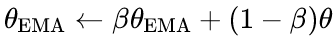, with decay \(\beta = 0.995\). Evaluation uses the EMA weights, which act as implicit ensembling over recent training states and reduce optimization noise. We find that \(\beta = 0.995\) outperforms the more common 0.999 for our 4000-step schedule, as the lower decay tracks the rapidly improving early-training weights more closely.
Best-checkpoint selection saves the checkpoint with the lowest validation BPB rather than the final step. This is critical because our 256×8 model overfits after approximately 2500 steps—validation BPB reaches its minimum at step 2500 and rises thereafter. Best-checkpoint selection recovers approximately 0.02 BPB compared to using the final step.
Label smoothing ablation tests values of 0.1, 0.02, and 0.0. While label smoothing can improve classification accuracy, it softens the target distribution and degrades the pure NLL evaluation metric. We find that label smoothing = 0.0 performs best, as EMA already provides sufficient regularization and the model's natural confidence is well-calibrated.

2.3 Inference-Time Enhancements
Training-set bigram mixture interpolates the neural model's output with a bigram language model estimated from the training set, using log-space interpolation with mixing weight \(\lambda = 0.08\). The bigram probabilities use additive smoothing (\(\beta = 50\)) and capture low-frequency token transitions that the neural network may not fully learn. This adds ~16 MB to the checkpoint (within the 64 MiB limit), requires no retraining, and reduces BPB by ~0.02.
Causal local cache exploits within-window token repetition: at position t, if the current token appeared earlier in the window, previously observed transitions are used to boost likely next tokens via adaptive interpolation 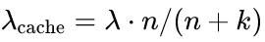 with \(\lambda = 0.30\), \(k = 2.0\). The implementation is fully vectorized (mask + scatter_add, no Python loops) and strictly causal (only uses tokens up to position t). This is the largest single-step improvement, reducing BPB by 0.058, with zero retraining cost and ~6s evaluation overhead.

2.4 Model Scaling
We scale the model from the baseline 128×4 (1.09M params) to 192×6 (3.05M params) and finally to 256×8 (6.85M params). The 256×8 configuration is the largest model that remains within the evaluation time constraint. Scaling provides the largest overall BPB reduction but exhibits diminishing returns and increased overfitting risk.

3. Experiments

3.1 Experimental Setup
All experiments use the WikiText-2 raw dataset with the provided BPE-2048 tokenizer. Training uses AdamW with peak learning rate 0.001, cosine decay to 5% of peak, 200-step linear warmup, batch size 32, weight decay 0.1, and gradient clipping at 1.0. All models use seed 17 for reproducibility. Evaluation is on the test set using the provided evaluator with FP32 precision on CPU (Intel i5-11300H, 8 threads). The baseline evaluation time is 11.08s, giving a 5× limit of 55.4s. Ablation experiments use the small configuration (128×4, 1200 steps) with the original training script to ensure fair comparison.
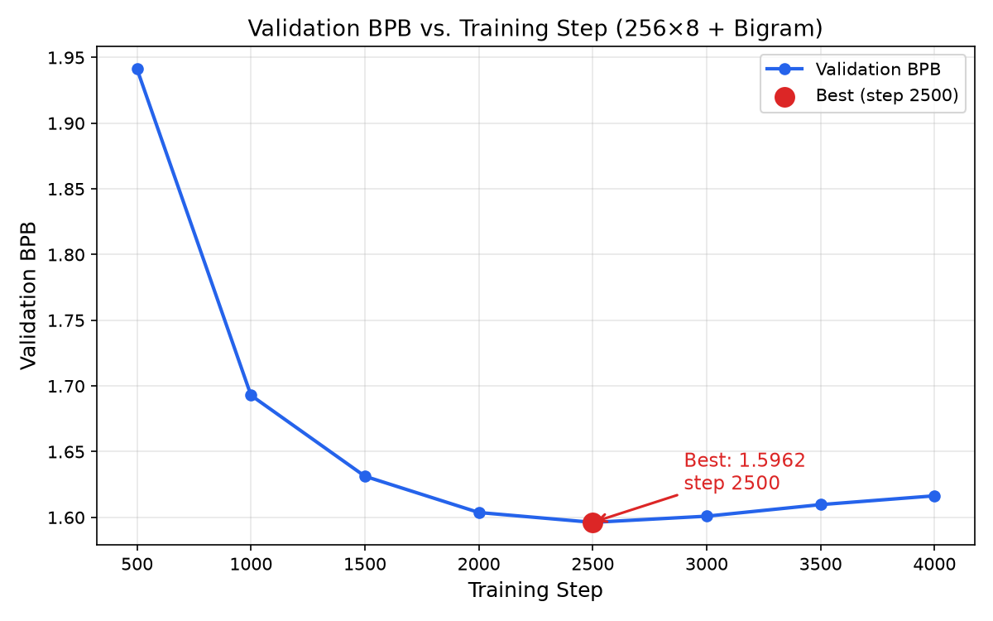
3.2 Main Results
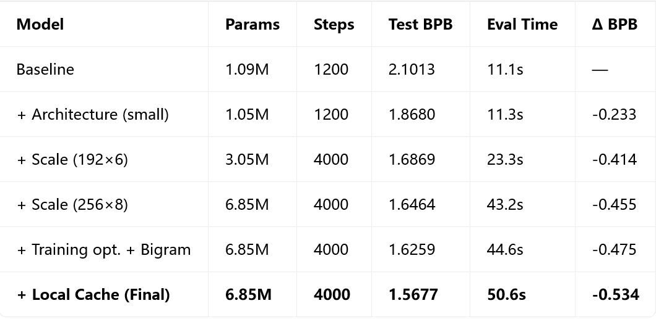
The final model achieves a test BPB of 1.5677, a 25.4% reduction from the baseline. Architecture improvements account for the largest share at small scale (↓0.233), while model scaling provides substantial additional gains (↓0.222 from small to xlarge). The two inference-time enhancements together reduce BPB by 0.079, with the local cache alone contributing 0.058.
3.3 Ablation Study
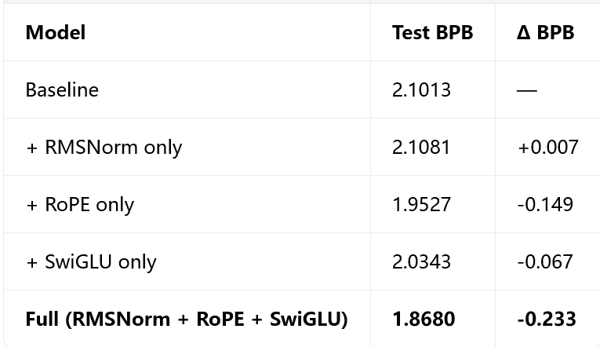
RoPE is the dominant contributor, reducing BPB by 0.149 alone. This is because relative position encoding is particularly effective for the short 256-token context, where local dependencies are most important and absolute embeddings must learn each position independently from limited data. SwiGLU provides a moderate improvement of 0.067 through its gating mechanism. RMSNorm alone has negligible effect (slightly worse).
Synergy analysis: The sum of individual contributions is \(0.149 + 0.067 - 0.007 = 0.209\), while the full combination achieves 0.233. The additional 0.024 improvement indicates positive synergy—RMSNorm, though ineffective alone, stabilizes training for the RoPE+SwiGLU combination, allowing both to operate more effectively than their individual contributions would suggest.
3.4 Inference Hyperparameter Tuning
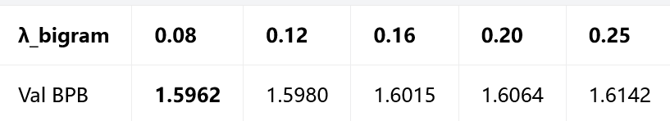
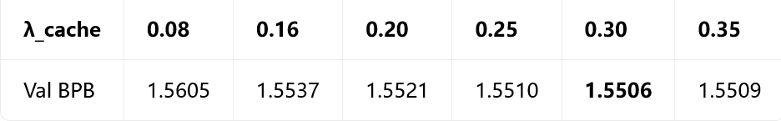
For the bigram mixture, \(\lambda = 0.08\) is optimal—larger values increasingly degrade performance as the bigram model begins to override the neural network's predictions. For the local cache, performance improves monotonically up to \(\lambda = 0.30\) and then slightly degrades at 0.35, indicating that the cache provides useful signal but should not dominate the neural prediction. The cache's adaptive parameter \(k = 2.0\) was also found optimal.
3.5 Constraint Compliance
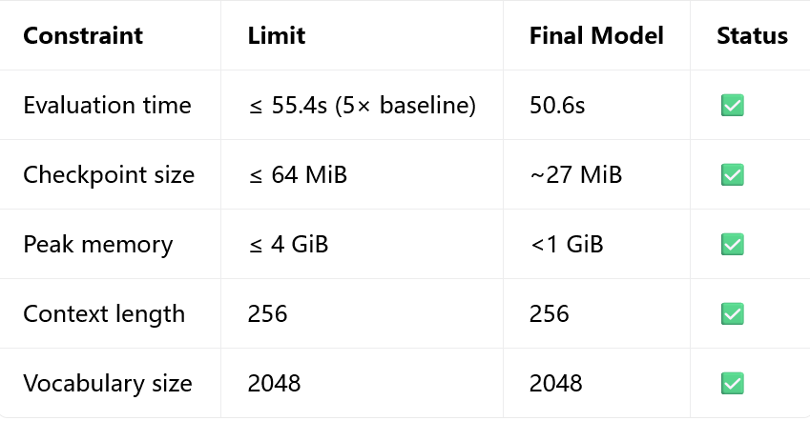
All hard constraints are satisfied. The evaluation time of 50.6s leaves a margin of 4.8s under the 5× baseline limit.

4. Analysis and Discussion

4.1 Why the Local Cache Is the Most Impactful Single Technique
The causal local cache provides the largest single-step improvement (↓0.058 BPB) because it exploits a fundamentally different signal than the neural network. WikiText-2 contains substantial within-document repetition—names, places, titles, recurring entities, and fixed phrases such as "New York" or "United States." A neural network trained on limited data cannot efficiently memorize and retrieve all such context-specific patterns. The local cache directly leverages the current window's transition statistics at inference time, complementing the neural network's learned global patterns. This complementarity is why the cache provides such strong gains despite its simplicity. Moreover, it requires zero training cost and adds only ~6s to evaluation time thanks to the fully vectorized implementation.

4.2 Overfitting and the Importance of Best-Checkpoint Selection
The 256×8 model (6.85M params) trained for 4000 steps (32M tokens) exhibits clear overfitting: validation BPB reaches its minimum at step 2500 and degrades by approximately 0.02 by step 4000. This is consistent with the parameter-to-data ratio of approximately 1:4.7, which is relatively high for language modeling. Several factors mitigate this: EMA weight averaging smooths the training trajectory, best-checkpoint selection recovers the optimal stopping point, and the inference-time enhancements do not overfit since they operate on the evaluation window itself. Notably, label smoothing was counterproductive for this task—while it reduced training loss, it degraded the NLL evaluation metric by making the model less confident, confirming that the choice of regularization must align with the evaluation objective.

4.3 Architectural Synergy
The ablation study reveals positive synergy among the three architectural components. RMSNorm alone is slightly worse than baseline, suggesting that normalization choice has limited impact at this scale. However, in the full combination, RMSNorm contributes an additional 0.024 BPB beyond the sum of individual effects. We attribute this to RMSNorm's stability benefits becoming important when RoPE and SwiGLU increase the network's effective capacity and training dynamics. This finding underscores that architectural components should not be evaluated in isolation—their interactions matter.

4.4 Limitations and Future Work
Several limitations remain. First, the evaluation time margin (4.8s) is narrow, preventing further model scaling or additional inference enhancements. Second, we did not explore Grouped Query Attention (GQA), which could reduce evaluation time and allow larger models within the same time budget. Third, trigram mixtures or more sophisticated copy mechanisms could potentially provide additional gains beyond the bigram and local cache. Fourth, GPU training would enable larger models and longer training schedules, likely yielding further BPB reductions. Finally, the local cache's effectiveness is dataset-dependent—it exploits repetition that may be less prevalent in other corpora.

5. Conclusion
We present a comprehensive optimization pipeline for the Small Language Model Challenge, reducing test BPB from 2.1013 to 1.5677 (a 25.4% improvement) through architecture, training, and inference-time optimizations. Our ablation studies identify RoPE as the largest architectural contributor (↓0.149) and reveal positive synergy among RMSNorm, RoPE, and SwiGLU (combined ↓0.233 vs. sum of individuals 0.209). The causal local cache, a fully-vectorized inference-time technique that exploits within-window repetition, provides the largest single-step improvement (↓0.058) with zero retraining cost. The final model satisfies all hard constraints including evaluation time, memory, and checkpoint size. This work demonstrates that significant gains can be achieved not only through larger models but also through clever inference-time techniques that leverage complementary signals to neural predictions.

