Variables:

Separation: the distance between two stages (25mm).

Range: transition length (25mm)

Rotation angle $α∈(-90°,90°)$

Depthmin: Needle insert minimum depth (65mm).

Depthmax: needle insert depth (165mm).

Depth: needle insert depth (range 100mm).

P1: the needle point on the top stage. (x1, y1, z1)

P2: the needle point in the bottom stage. (x2, y2, z2)

Pt: the target point.

Pe: the entrance point

**The coordinate origin** is at the center of bottom stage.

Draw the 1 stage MK3 robot cross section. This should be revolved about the Z axis.

Top arch:

$$X=depth_{min}*Sin\left(ArcTan\left(\frac{range*t}{separation}\right)\right)$$

$$Z=-depth_{min}*Cos\left(ArcTan\left(\frac{range*t}{separation}\right)\right)$$

$$t∈(0,1)$$

Side slant:

$$X=(depth_{min}+t*depth_{max})*Sin\left(ArcTan\left(\frac{range*t}{separation}\right)\right)$$

$$Z=-depth_{min}*Cos\left(ArcTan\left(\frac{range*t}{separation}\right)\right)-t*depth_{max}*Cos\left(ArcTan\left(\frac{range*t}{separation}\right)\right)$$

$$t∈(0,1)$$

Bottom arc: $$X=(depth_{min}+depth_{max})*Sin\left(ArcTan\left(\frac{range*t}{separation}\right)\right)$$

$$Z=-(depth_{min}+depth_{max})*Cos\left(ArcTan\left(\frac{range*t}{separation}\right)\right)$$

$$t∈(0,1)$$

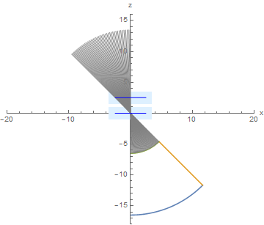

Draw the 2 stage MK3 robot cross section. This should be revolved about the Z axis.

Top arch:

$$X=2*range*\left(t-\frac{1}{2}\right)+depth_{min}*Sin\left(ArcTan\left(\frac{2range*t}{separation}\right)\right)$$

$$Z=-depth_{min}*Cos\left(ArcTan\left(\frac{2range*t}{separation}\right)\right)$$

$$t∈(0,1)$$

Side slant:

$$X=range+(depth_{min}+t*depth_{max})*Sin\left(ArcTan\left(\frac{2range*t}{separation}\right)\right)$$

$$Z=-depth_{min}*Cos\left(ArcTan\left(\frac{2range*t}{separation}\right)\right)-t*depth_{max}*Cos\left(ArcTan\left(\frac{2range*t}{separation}\right)\right)$$

$$t∈(0,1)$$

Bottom arc: $$X=2*range*\left(t-\frac{1}{2}\right)+(depth_{min}+depth_{max})*Sin\left(ArcTan\left(\frac{2range*t}{separation}\right)\right)$$

$$Z=-(depth_{min}+depth_{max})*Cos\left(ArcTan\left(\frac{2range*t}{separation}\right)\right)$$

$$t∈(0,1)$$

Bottom flat side

$$X=range*t$$

$$Y= -depth{}_{min}-depth_{max}$$

$$t∈(0,1)$$

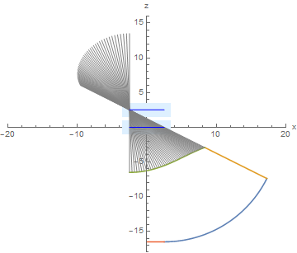

Forward Kinematic (vector calculation):

Given: $P1(d_{1}Cos\left(α_{1}\right),{ d}_{1}Sin\left(α_{1}\right), separation)$, $P2(d_{2}Cos\left(α_{2}\right),d_{2}Sin\left(α_{2}\right),0)$, depth

For one stage MK3 P2(0, 0, 0)

$$\overset{⃑}{Pe}=\overset{⃑}{P1}+depth_{min}*\frac{\overset{⃑}{P1}-\overset{⃑}{P2}}{{\left\|\overset{⃑}{P1}-\overset{⃑}{P2}\right\|}_{2}}$$

$$\overset{⃑}{Pt}=\overset{⃑}{P1}+\left(depth_{min}+depth\right)*\frac{\overset{⃑}{P1}-\overset{⃑}{P2}}{{\left\|\overset{⃑}{P1}-\overset{⃑}{P2}\right\|}_{2}}$$

Inverse Kinematic (vector calculation, P1 Z axis should always be zero, P2 Z axis should be the magnitude of separation (25)):

Given: Pt, Pe, depth

$$\overset{⃑}{P1}=\overset{⃑}{Pe}+depth_{min}*\frac{\overset{⃑}{Pe}-\overset{⃑}{Pt}}{{\left\|\overset{⃑}{Pe}-\overset{⃑}{Pt}\right\|}_{2}}$$

$$X_{2}-X_{1}=t*(X_{e}-X_{t})/depth$$

$$Y_{2}-Y_{1}=t*(Y_{e}-Y_{t})/depth$$

$$Z_{2}-Z_{1}=t*(Z_{e}-Z_{t})/depth$$

$$Z_{2}-Z_{1}=Separation$$

$$t=Separation*\frac{depth}{Z_{e}-Z_{t}}$$

After get the coordinate of each stage, separately substitute into following equations:

$$X=dCos\left(α\right)$$

$$Y=dSin(α)$$

$$α=ArcTan(\frac{Y}{X})$$

$$\left\{\begin{aligned}d=d if X>0, Y>0 \\ d=-d i f X<0, Y>0 \\ d=-d if X<0,Y<0 \\ d=d if X>0,Y<0\end{aligned}\right.$$