Variables:

$s$: The separation distance between two stages (45mm).

$r$: Transition length for the slider actuators (25mm).

$α$: Rotation angle for each stage $[-90°,90°]$.

$d_{min}$: Needle insert minimum depth (65mm).

$d_{max}$: Needle insert depth (100mm).

$d$: Needle insert depth (range 100mm).

$P_{1}$: The needle point on the top stage. $(x_{1}, y_{1}, z_{1})$

$P_{2}$: The needle point in the bottom stage. $(x_{2}, y_{2}, z_{2})$

$P_{t}$: The target point.

$P_{e}$: The entrance point

**The coordinate origin** is at the center of the bottom stage.

The workspace for a 1 stage MK3 is defined by a cross section in the xz plane. The workspace is defined by revolving three arcs about the *z-*axis.

Arc 1: circle segment defined by minimum needle depth:

$$x=d_{min}Sin\left(ArcTan\left(\frac{r t}{s}\right)\right)$$

$z=-d_{min}Cos\left(ArcTan\left(\frac{r t}{s}\right)\right)$

$$t∈[0,1]$$

Arc 2: (line):

$$x=(d_{min}+t d_{max})Sin\left(ArcTan\left(\frac{r t}{s}\right)\right)$$

$z=-(d_{min}+td_{max})Cos\left(ArcTan\left(\frac{r t}{s}\right)\right)$

$$t∈[0,1]$$

Arc 3: $$x=(d_{min}+d_{max})Sin\left(ArcTan\left(\frac{r t}{s}\right)\right)$$

$z=-(d_{min}+d_{max})Cos\left(ArcTan\left(\frac{r t}{s}\right)\right)$

$$t∈[0,1]$$

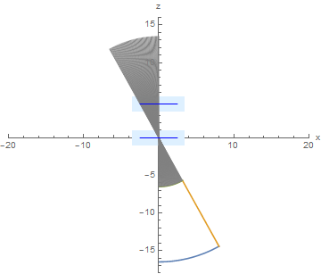

Draw the 2 stage MK3 robot cross section. This should be revolved about the zaxis.

Top arch:

$$x=2r\left(t-\frac{1}{2}\right)+d_{min} Sin\left(ArcTan\left(\frac{2r t}{s}\right)\right)$$

$z=-d_{min} Cos\left(ArcTan\left(\frac{2r t}{s}\right)\right)$

$$t∈[0,1]$$

Side slant:

$$x=r+\left(d_{min}+td_{max}\right)Sin\left(ArcTan\left(\frac{2r t}{s}\right)\right)$$

$z=-\left(d_{min}+t d_{max}\right)Cos\left(ArcTan\left(\frac{2r t}{s}\right)\right)$

$$t∈[0,1]$$

Bottom arc: $$x=2r \left(t-\frac{1}{2}\right)+\left(d_{min}+d_{max}\right)Sin\left(ArcTan\left(\frac{2r t}{s}\right)\right)$$

$z=-\left(d_{min}+d_{max}\right)Cos\left(ArcTan\left(\frac{2r t}{s}\right)\right)$

$$t∈[0,1]$$

Bottom flat side

$$x=r t$$

$y= -d_{min}-d_{max}$

$$t∈[0,1]$$

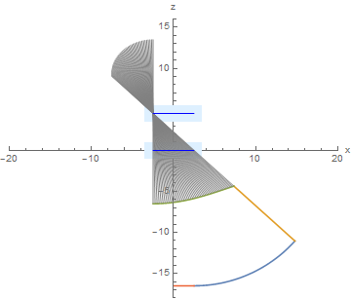

Forward Kinematics (vector calculation):

Given: $P_{1}=(d_{1}\cos{α_{1}},{ d}_{1}\sin{α_{1}}, s)$, $P_{2}= (d_{2}\cos{α_{2}},d_{2}\sin{α_{2}},0)$, depth

For one stage MK3 $P_{2}(0, 0, 0)$

$$\overset{⃑}{P_{e}}=\overset{⃑}{P_{1}}+d_{min}\frac{\overset{⃑}{P_{1}}-\overset{⃑}{P_{2}}}{{\left\|\overset{⃑}{P_{1}}-\overset{⃑}{P_{2}}\right\|}_{2}}$$

$\overset{⃑}{P_{t}}=\overset{⃑}{P_{1}}+\left(d_{min}+d\right)\frac{\overset{⃑}{P_{1}}-\overset{⃑}{P_{2}}}{{\left\|\overset{⃑}{P_{1}}-\overset{⃑}{P_{2}}\right\|}_{2}}$

Inverse Kinematics (vector calculation, $P_{1}$*z* value is zero, $P_{2}$ z-value is *s* (45)):

Given: $P_{t}, P_{e}$, depth

$\overset{⃑}{P_{1}}=\overset{⃑}{P_{e}}+d_{min}\frac{\overset{⃑}{P_{e}}-\overset{⃑}{P_{t}}}{{\left\|\overset{⃑}{P_{e}}-\overset{⃑}{P_{t}}\right\|}_{2}}$

$$x_{2}-x_{1}=t(x_{e}-x_{t})/d$$

$$y_{2}-y_{1}=t(y_{e}-y_{t})/d$$

$$z_{2}-z_{1}=t(z_{e}-z_{t})/d$$

$z_{2}-z_{1}=s$

$t=s\frac{d}{z_{e}-z_{t}}$

After get the coordinate of each stage, separately substitute into following equations:

$$x=rCos\left(α\right)$$

$y=rSin(α)$

$α=ArcTan(\frac{Y}{X})$

$$\left\{\begin{aligned}r=\left|r\right| if X>0, Y>0 \\ r=-\left|r\right| i f X<0, Y>0 \\ r=-\left|r\right| if X<0,Y<0 \\ r=\left|r\right| if X>0,Y<0\end{aligned}\right.$$