**Chemistry Study on Hot Corino Serpen South CARMA-7**

Haotian Liu (under supervision of Dr. Adele Plunkett)1

1 University of Virginia

E-mail: hl7gr@virginia.edu

11/29/2019

Abstract

Sample text inserted for illustration. Replace with abstract text. Your abstract should give readers a brief summary of your article. It should concisely describe the contents of your article, and include key terms. It should be informative, accessible and not only indicate the general scope of the article but also state the main results obtained and conclusions drawn. The abstract should be complete in itself; it should not contain undefined abbreviations and no table numbers, figure numbers, references or equations should be referred to. It should be suitable for direct inclusion in abstracting services and should not normally be more than 300 words.

Keywords: hot corino, astrochemistry, ALMA

**1. Introduction**

This thesis studies the chemistry property of a recently discovered hot corino-like protostar, CARMA-7 in the Serpen South region. CARMA-7 is one of the 15 [C] hot corinoes discovered so far and has a high degree of chemical richness and traces of possible bipolar molecular outflow. This thesis will list molecular line identification results from 6 spectral windows from ALMA observations in 2016 (?) and will attempt to discuss possible structure of the source.

**2. Observation**

The ALMA observation on CARMA-7 is divided into 6 spectral windows, each with a rest frequency (GHz) but same VLSR of 8.0 km/s.

<spectral widow information table>

**3. Methods**

To accurately identify all emission lines from all 6 spectral windows, a variety of continuum substraction and molecular line identification tools were used. These tools include STATCONT, ADMIT (ALMA Data Mining Toolkit, integrated with CASA) and XCLASS. Raw .fits data cubes were first cropped (to eliminate impacts of the cube’s original circular shape on calculation of background rms and improve focus on center area) and continummed substrated (with noise level set to 1) with STATCONT to produce line cubes that were ready as input file for ADMIT’s ContinuumSub and LineIdentification tasks. The following is a sample ADMIT script used to process data cube:

<line_identification_ADMIT.py>

**4. Discussion: detected molecules and their distribution**

Figure x to figure x shows some “promising” molecular lines (with an identifiable line profile) from spectral window 0 to 6. In these observations, CARMA-7 was found to be rich in molecular lines, with some spectral windows dominated by one species (spectral window x, x and x) with high intensity peak / rms ratio and broad lines with sometimes complex shapes. The most noteworthy detections are (the most common lines???). In addition, (some less common lines) are also deteced with multiple occurrence in one or more spectral windows.

<molecule occurrence table>

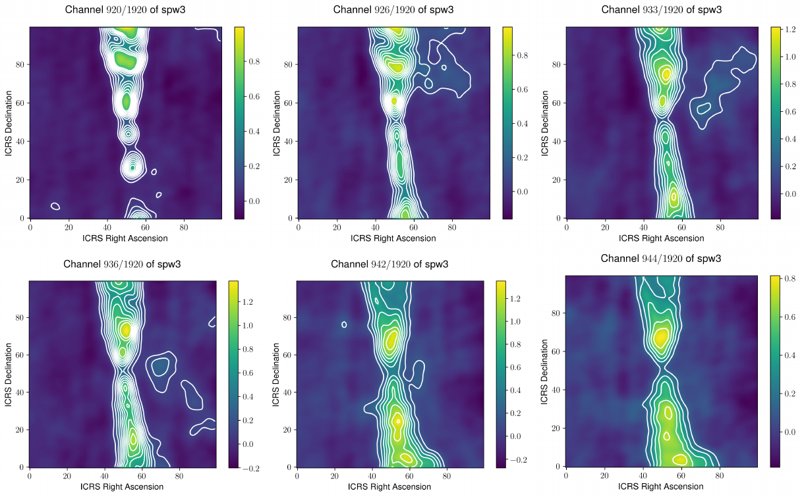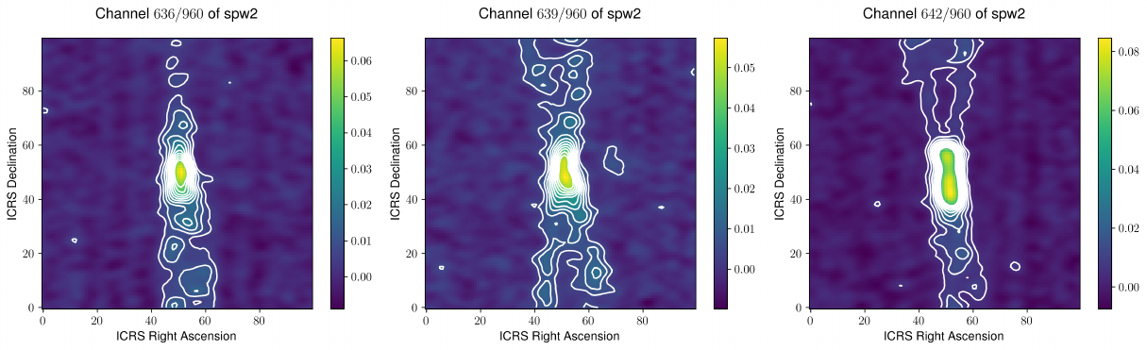

**5. Discussion: motion of the source**

In certain spectral windows such as spectral window 3 and spectral window 2, a bipolar outflow is clearly visible and in progress with each channel but is condensed only to a small channel range (figure x). In other spectral windows, the source sometimes appears to be in some type of less well-defined motion that revolves around its (visual) center. This conclusion is drawn from the observation that in these spectral windows, the contour line-dense region seems to be revolving around center of the plot. Such pattern is clearly visible in contour plots of spectral window 0 and spectral window 5, as shown in figure x and figure x.

It is notable that in all 3 spectral windows (2, 3 and 4) where bipolar outflow jets are observed, these jets are only visible for a rather small frequency range (all less than 20% of the spectral window’s frequency range).

Difficulties arise when trying to match the molecular line profile to channel ranges where signs of motions can be traced. Interestingly, the molecular line plot (peak vs. background rms) does not seem to correspond the slice plot well. This makes analysing source motion difficult since the molecular line shape, which typically reveals information about rotation cannot be used to aid understanding of the exact motion. However, some prominent / dominant lines may still suggest relevant information on source motion, as they appear to be in particularly irregular shapes (example lines)

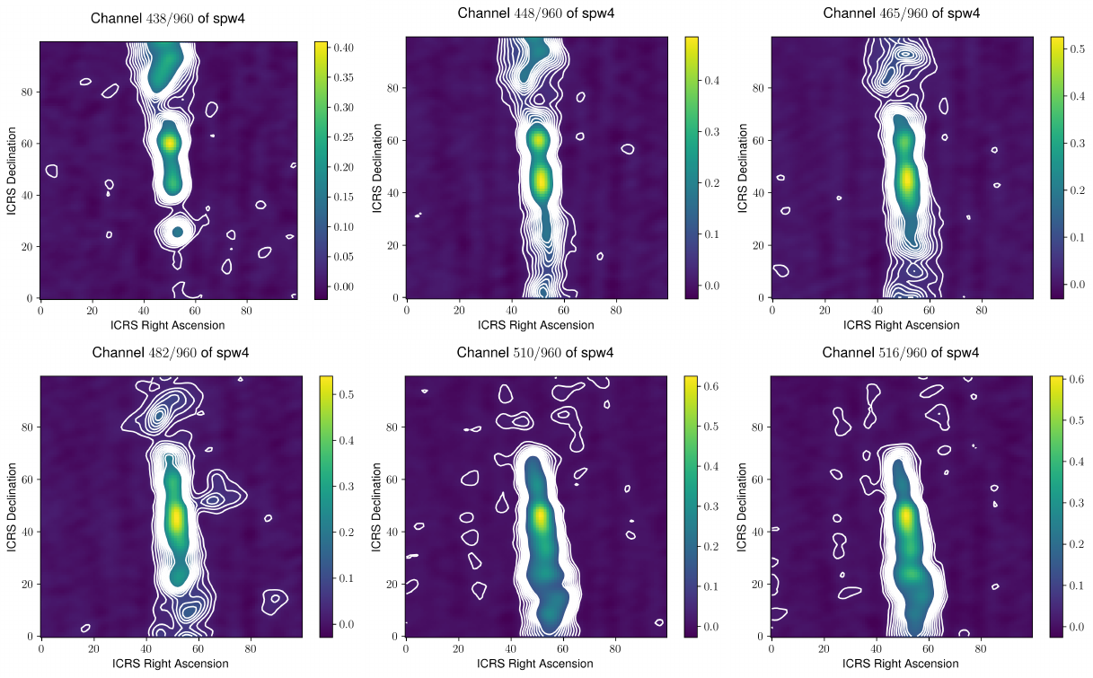

References

1. Surname A, Surname B and Surname C 2015 *Journal Name* **37** 074203
2. Surname A and Surname B 2009 *Journal Name* **23** 544