**Aims**

The objective of this project is to provide a website that acts as a ‘guide’ for the first-year students of UON. So, they can make the transition to the university life as smooth as possible.

1. **Wonderful and ease of use**

Considering that the new students visit our website for the first time, so this website conforms to the public's thinking and aesthetics, It is easy to use and looks wonderful.

1. **Usability**

The information on our website comes from official data, so students can obtain useful information from the website and have a preliminary understanding of the basic information of the university.

1. **Interactivity**

Our website pays attention to giving students a good interactivity. Students will follow the order of the side navigation bar to guide and constantly understand the basic information of the university.

1. **A good guide**

Students can learn what they need to know through the website before the first week, such as semester arrangements, department settings, etc. The content of the website should not be easily confused and should be clearly marked.

1. **Flexibility**

University information and important announcements are constantly updated, so our website will connect to the database, and administrators can update the content of the website.

1. **User experience**

Considering that students are not familiar with campus life and our website, the interface language should be easy to understand, friendly and close to young people. The website should enable new students to fully understand their daily lives and give them a good user experience.

**Methods**

**1.Provide a simple and easy-to-use user interface prototype**

After discussion in the group meeting, we used a hand-drawn form to draw a draft of the user interface on paper. These user interfaces will refer to some well-known website design styles, so that the page layout, components, and styles conform to the public's aesthetics.

**2.Collect information from the university's official website and student feedback**

We will conduct a survey to find out what the freshmen most want to know and what information they need most. Secondly, we will browse the official website of the university, summarize the most important information on the official website. To meet the needs of users, it is vital to know what information they need.

**3.** **Design a Website with** **Flexibility, Usability, ease of use, and Interactivity**

We will use Html5, CSS, JavaScript and other website development technologies to create the basic structure, style and behavior of our website on the lightweight editor Visual Studio Code. we will follow the principles of Progressive enhancement and Graceful degradation. We will not only provide users with important information, but also make the website consistent with the UI prototype, and allow the website to have good interaction with users and give them a good user experience.

**4. Side navigation bar**

we are still developing on the visual studio code. We will use the html list, css box model and float to make the side navigation bar.

**5. Design and develop a well-structured database to store information and link our database and website**

We will use SQL server management studio to manage the database creation. Our interactive code using JavaScript will communicate with SQL to retrieve and upload data from the database in response to user requests. We will design according to the four steps of database design, and then connect database.

**6. Debug and test the website**

Considering that the website is for first-year students, we will discuss whether the style and behavior of the website can enhance user experience and meet user needs. We also obtain user tests from testers to collect available feedback and debug any problems found in the website.

**Results**

We used Microsoft Offices Visio to make use case diagrams, which can well simulate the relationship between participants and the system, and clearly provide our team with a summary view of website usage and behavior. which is conducive to UI design. There are two actors in this use case diagram, students and IT Staff. 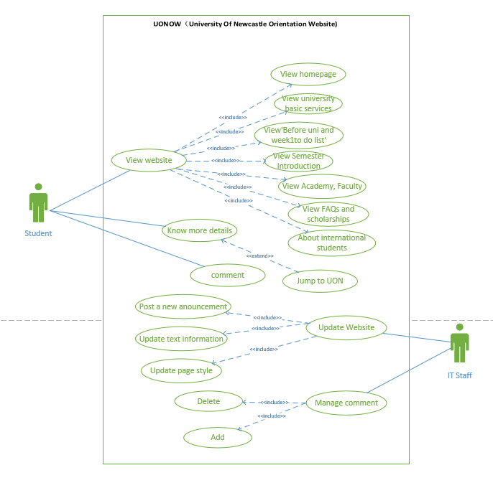

However, the use case diagram is not object-oriented, and the relationship it describes is not precise, and it can only give our team a general direction. we also determine the functional requirements and non-functional requirements of the project.

**Functional requirements:**

* The user should be able to search the university’s infrastructure service information. such as faculty information and university maps, FAQS etc.
* The system should provide external links, link to UON official website to help users learn more.
* The system should be for international students and local students.
* Users should be able to comment.
* Administrators can delete and update information and comments.

**Non-functional requirements**

* The user must be able to browse the website without logging in advance, that is, the user does not need any account.
* Hardware: laptop (mainly used for documentation and programming purposes)
* Software: Gmail, Google Docs, MS Word, MS Visio, Sql server, MS Visual Studio Code, various browsers (especially Google Chrome).
* Compatibility: The website must support access and compatibility with mainstream browsers, such as Google, Firefox, IE, and Safari.
* Security Issues: As we hold the confidentiality of our customer Information, we promised not to disclose it under any circumstances.
* Resources Issues: In order to not lose the data permanently in unexpected moment we will back up the data in the database.

Through the interaction with the lecturer, we have determined the UI, and then let us show the user interface prototype.

We selected some testers for UI testing, we provided them with the user interface prototype, and recorded the problems and suggestions they encountered. Although this experiment is helpful to us, it still has certain limitations. First of all, the testers are not professional, and they cannot express the shortcomings of the system well. Secondly, due to COVID-19 restrictions, we cannot guarantee that all testers are freshmen in the first year, so we can only guarantee that the UI meets the user experience but cannot guarantee that it meets all needs.