**Aims**

The objective of this project is to provide a website that acts as a ‘guide’ for the first-year students of UON. So, they can make the transition to the university life as smooth as possible.

1. **Wonderful and ease of use**

Considering that the new students visit our website for the first time, so this website conforms to the public's thinking and aesthetics, it is easy to use and looks wonderful.

1. **Usability**

The information on our website comes from official data, so students can obtain useful information from the website and have a preliminary understanding of the basic information of the university.

1. **Interactivity**

Our website pays attention to giving students a good interactivity. Students will follow the order of the side navigation bar to guide and constantly understand the basic information of the university.

1. **A good guide**

Students can learn what they need to know through the website before the first week, such as semester arrangements, department settings, etc. The content of the website should not be easily confused and should be clearly marked.

1. **Flexibility**

University information and important announcements are constantly updated, so our website will connect to the database, and administrators can update the content of the website.

1. **User experience**

Considering that students are not familiar with campus life and our website, the interface language should be easy to understand, friendly and close to young people. The website should enable new students to fully understand their daily lives and give them a good user experience.

**Methods**

**1.Provide a simple and easy-to-use user interface prototype**

After discussion in the group meeting, we used a hand-drawn form to draw a draft of the user interface on paper. These user interfaces will refer to some well-known website design styles, so that the page layout, components, and styles conform to the public's aesthetics.

**2.Collect information from the university's official website and student feedback**

We will conduct a survey to find out what the freshmen most want to know and what information they need most. Secondly, we will browse the official website of the university, summarize the most important information on the official website. To meet the needs of users, it is vital to know what information they need.

**3.** **Design a Website with** **Flexibility, Usability, ease of use, and Interactivity**

We will use Html5, CSS, JavaScript and other website development technologies to create the basic structure, style and behavior of our website on the lightweight editor Visual Studio Code. we will follow the principles of Progressive enhancement and Graceful degradation. We will not only provide users with important information, but also make the website consistent with the UI prototype and allow the website to have good interaction with users and give them a good user experience.

**4. Side navigation bar**

we are still developing on the visual studio code. We will use the html list, css box model and float to make the side navigation bar.

**5. Design and develop a well-structured database to store information and link our database and website**

We will use SQL server management studio to manage the database creation. Our interactive code using JavaScript will communicate with SQL to retrieve and upload data from the database in response to user requests. We will design according to the four steps of database design, and then connect database.

**6. Debug and test the website**

Considering that the website is for first-year students, we will discuss whether the style and behavior of the website can enhance user experience and meet user needs. We also obtain user tests from testers to collect available feedback and debug any problems found on the website.

**Results**

We used Microsoft Offices Visio to make use case diagrams, which can well simulate the relationship between participants and the system, and clearly provide our team with a summary view of website usage and behavior. which is conducive to UI design. There are two actors in this use case diagram, students and IT Staff.

Below shows the use case diagram:

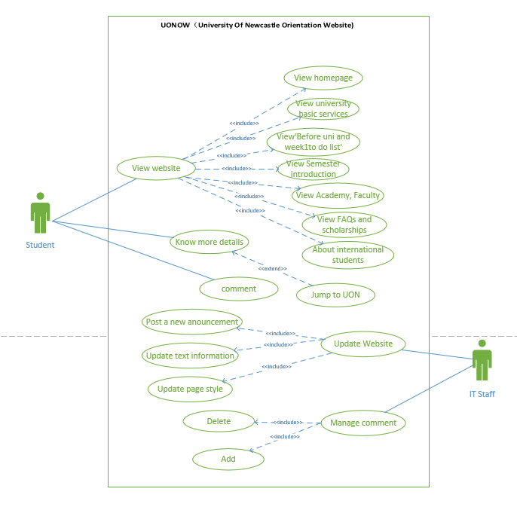

However, the use case diagram is not object-oriented, and the relationship it describes is not precise, and it can only give our team a general direction. we also determine the functional requirements and non-functional requirements of the project.

**Functional requirements:**

* The website should provide relative information that new students need to know, like faculties, courses, semester structures, services, university maps and FAQS etc.
* students to acknowledge what they expected to know before they come to university and by week 1.
* The website should provide external links, link to UON official website to help users learn more.
* The website should provide additional page for international students.
* Administrators could delete and update information to manage the website.

**Non-functional requirements**

* The user must be able to browse the website without logging in advance, that is, the user does not need any account.
* Hardware: laptop (mainly used for documentation and programming purposes)
* Software: Gmail, Google Docs, MS Word, MS Visio, Sql server, MS Visual Studio Code, various browsers (especially Google Chrome).
* Compatibility: The website must support access and compatibility with mainstream browsers, such as Google, Firefox, IE, and Safari.
* Security: Information on website should not be easily changed by anyone except administers. Websites can withstand certain attacks.
* Reliability: All the information on the website comes from trusty resources. The establishment of the database provides FAQ and other service to the website

Through the interaction with the lecturer, we have determined the UI, and then let us show the user interface prototype:

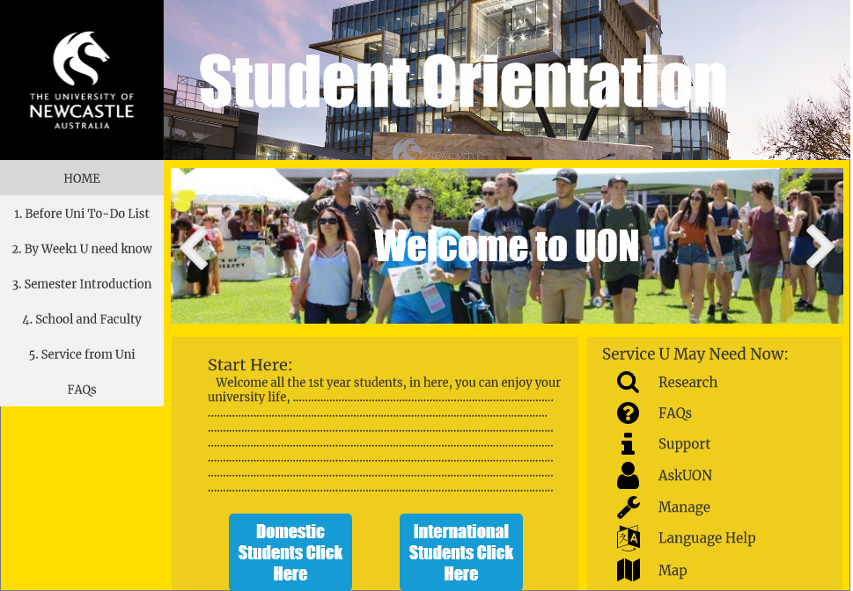

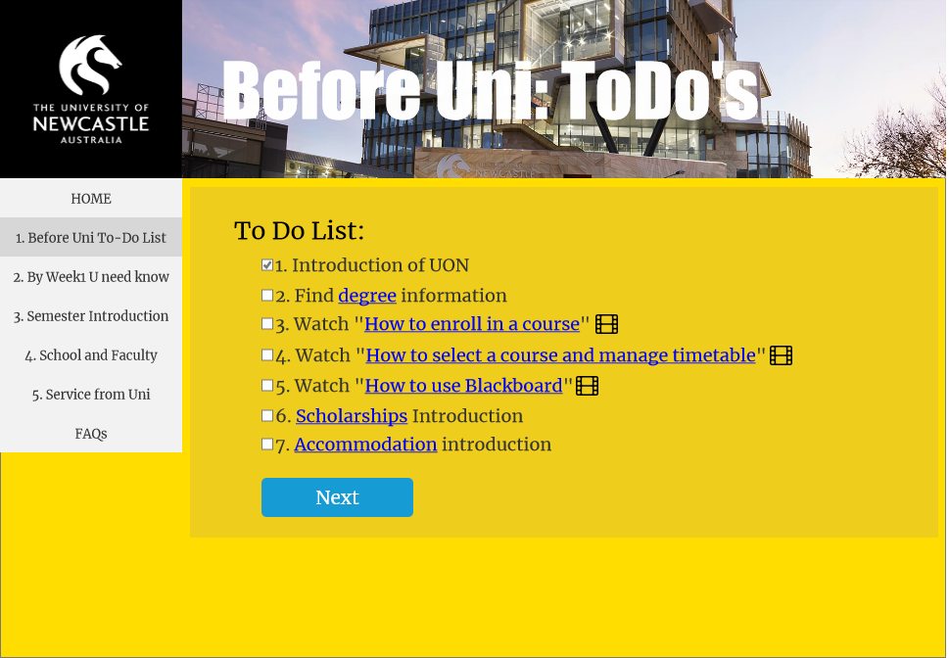

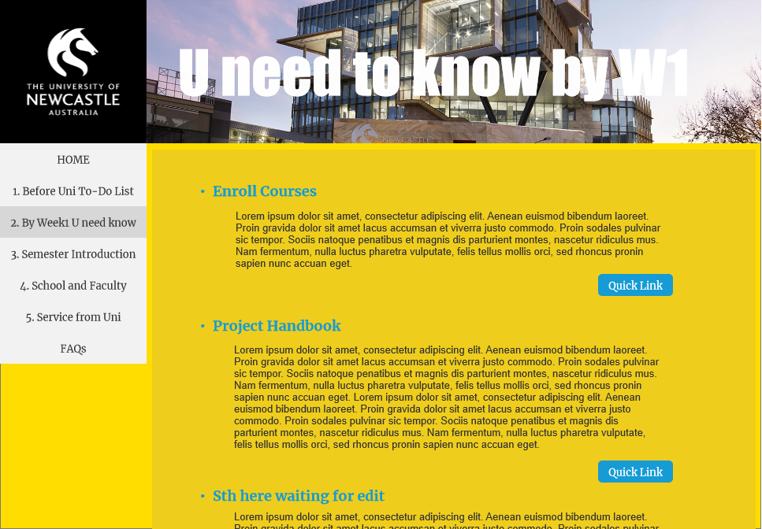

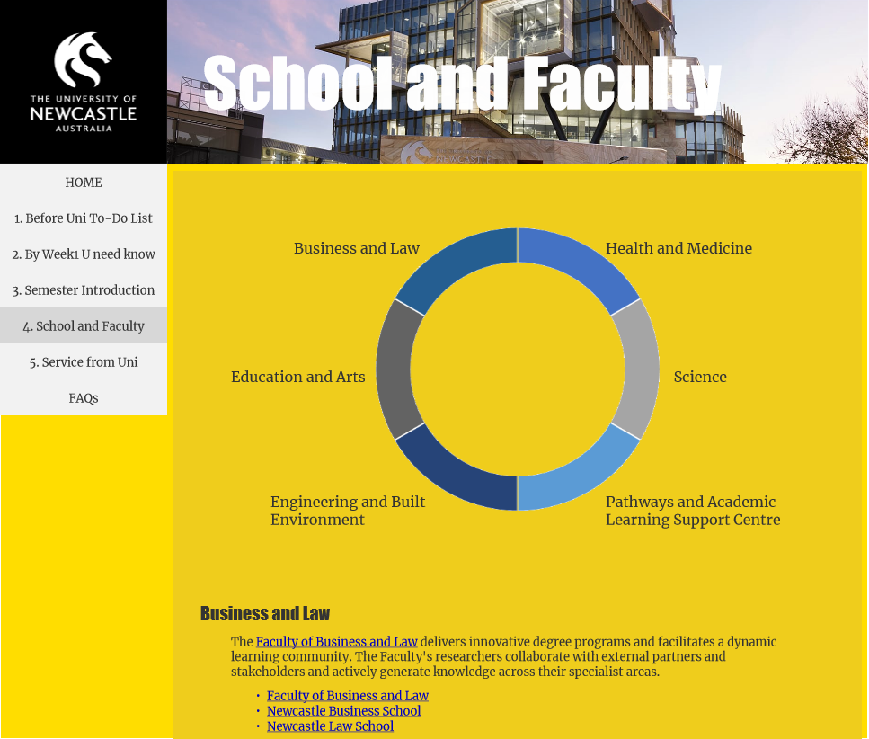

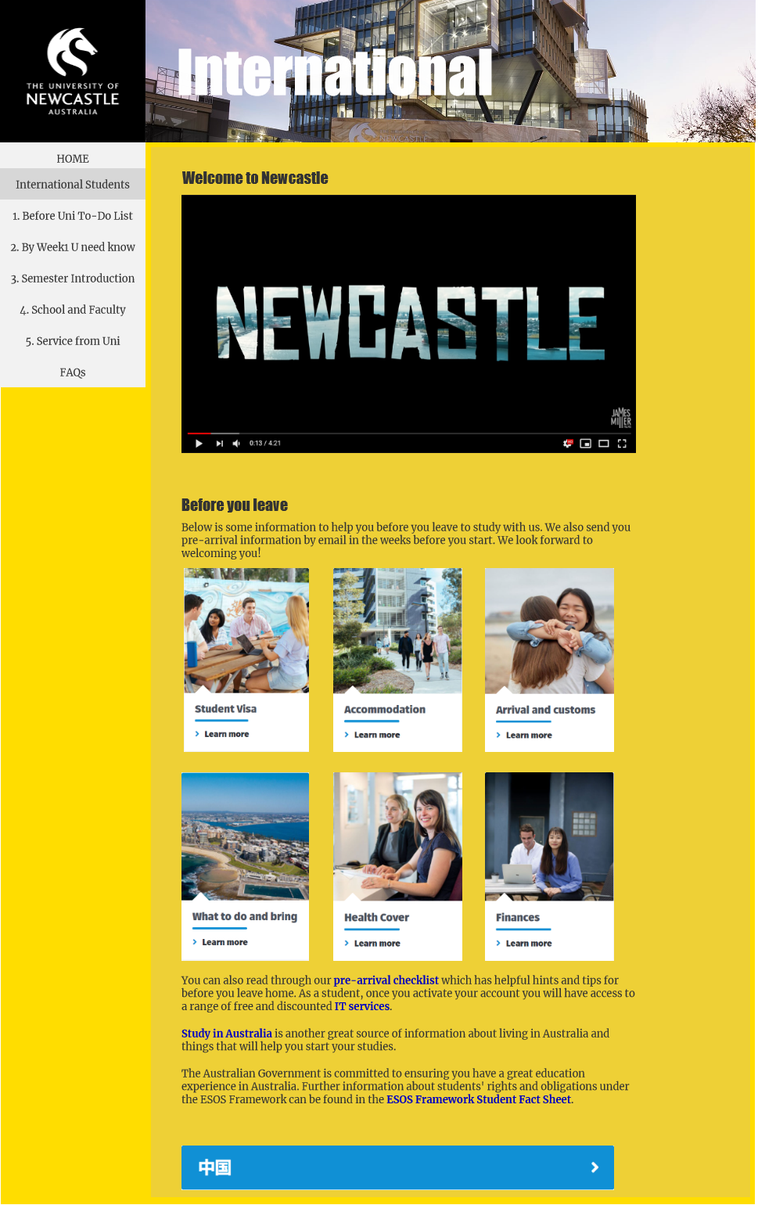

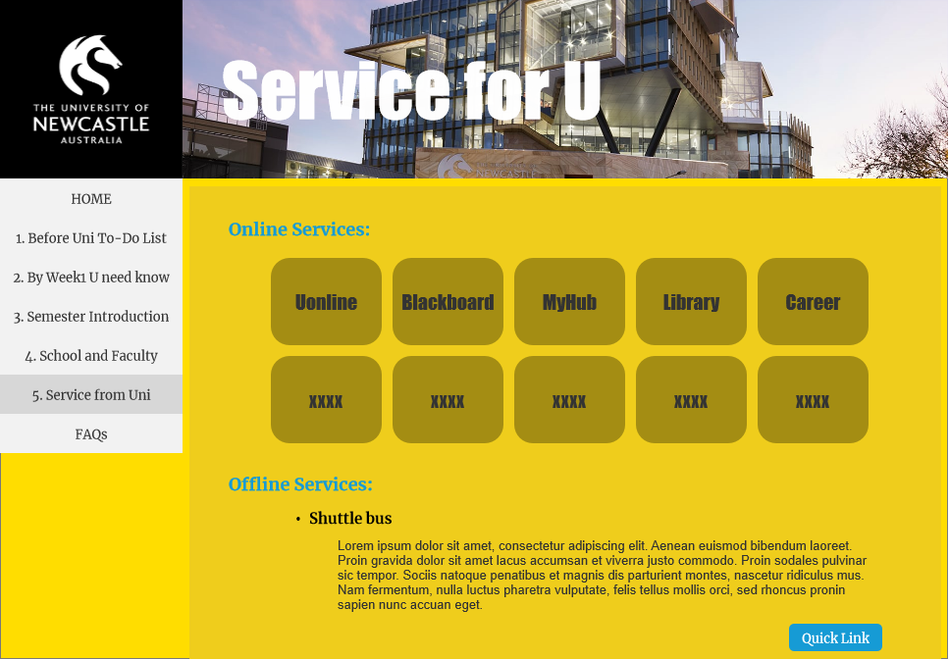

**Description & Analysis:**

There is navigation bar for students to identify the position of the page and an overall of the whole website. A topic title is also shown large in the pages. Text information is reduced so users may take more time on video and diagrams we provide, they are directly perceived through the senses so easier to understand. The style we selected is bright and youthful, its corresponding to university’s spirit.

We do not want users to be forced to take in so much information that they lose sight of what's really useful, so the information in the pages are limited, students must search on university official webpage so get more information, quick links and other buttons provide a easy access. As it contains most useful messages to students, the amount is not large, most of them are brief introduction and links, its performance is good.

The information we collect is and should be from official, especially official website currently and further, information received from the outside world should not be information on this page.

There is a home page to welcome new students and select if they are international or not, an additional “International” page will be shown if they select international. This page will provide contents especially for them like how they apply visa, where can they live, what about their health cover. Because we take consideration of gap between international students and domestic students, we do not want them to be divided into small groups, we want them to be treated as one, therefore, other information for them are same. All new students will follow rest parts to understand how the university works, what they are required be behave in semesters, how they complete the courses, what services university provide, what is unbearable in university and what activities will university hold.

This design is flexible to allow any additional tasks, additional page can be added in navigation bar or set relative link. For most of the websites that requires a lot of different aspects of information that need to be categorized, the design can be a template to them.

For IT staffs, the components and contents are alterable, and it does not involve complex functions like login or submit applications, this site is very easy to manage and update information.

**Limitations:**

* Firstly, we selected some testers for UI testing, we provided them with the user interface prototype, and recorded the problems and suggestions they encountered. Although this experiment is helpful to us, it still has certain limitations. The testers are not professional, and they cannot express the shortcomings of the system well. Besides, due to COVID-19 restrictions, we cannot guarantee that all testers are freshmen in the first year, so we can only guarantee that the UI meets the user experience but cannot guarantee that it meets all needs.
* Secondly, context in this website is limit, for more information, students must search in university website.
* Thirdly, this website does not consider the disabled’s usability. There will be difficulties if the disabled browse it.