**GROUP 12**

**LAB E3: CREATE NODEJS AND DEPLOY**

**TO HEROKU**

**STEP 1: CREATE PACKAGE.JSON FILE**

Create a new folder and open that folder in terminal

Open terminal and type: *npm init*

Keep hitting Enter to accept all default values

An example package.json could be like this

{

"name": "coolnodeapp",

"version": "1.0.0",

"description": "node app ",

"main": "app.js",

"scripts": {

"start": "node app.js"

},

"repository": {

"type": "git",

"url": ""

},

"author": "",

"license": "ISC",

"bugs": {

"url": ""

},

"homepage": ""

}

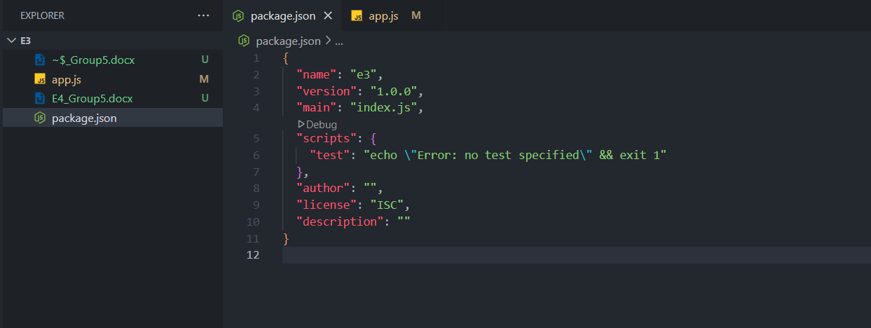

**STEP 2: ADD A FILE, APP.JS, AND PASTE THE BELOW CODE**

Notice: app.js and package.json in the same folder

const http = require('http');

const port = process.env.PORT || 3000

const server = http.createServer((req, res) => {

res.statusCode = 200;

res.setHeader('Content-Type', 'text/html');

res.end('<h1>Hello World</h1>');

});

server.listen(port,() => {

console.log(`Server running at port `+port);

});

You can test the app on local by typing at the terminal

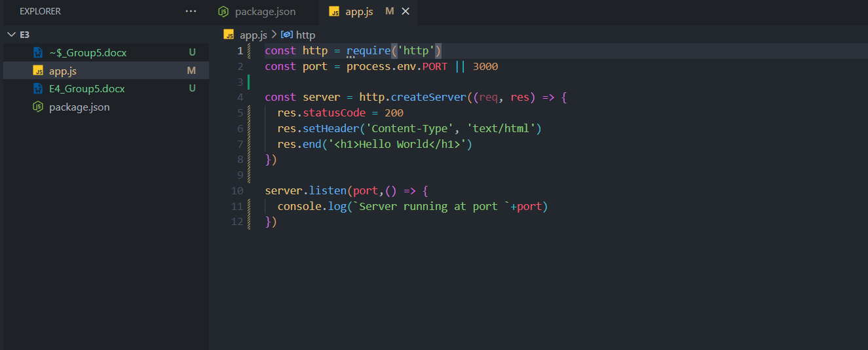

Run app.js at the terminal:

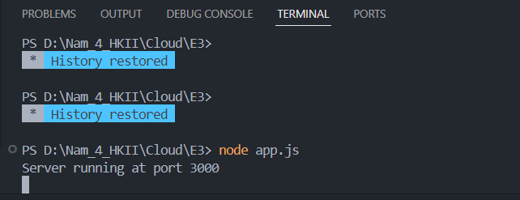

Open browser and go to localhost:3000

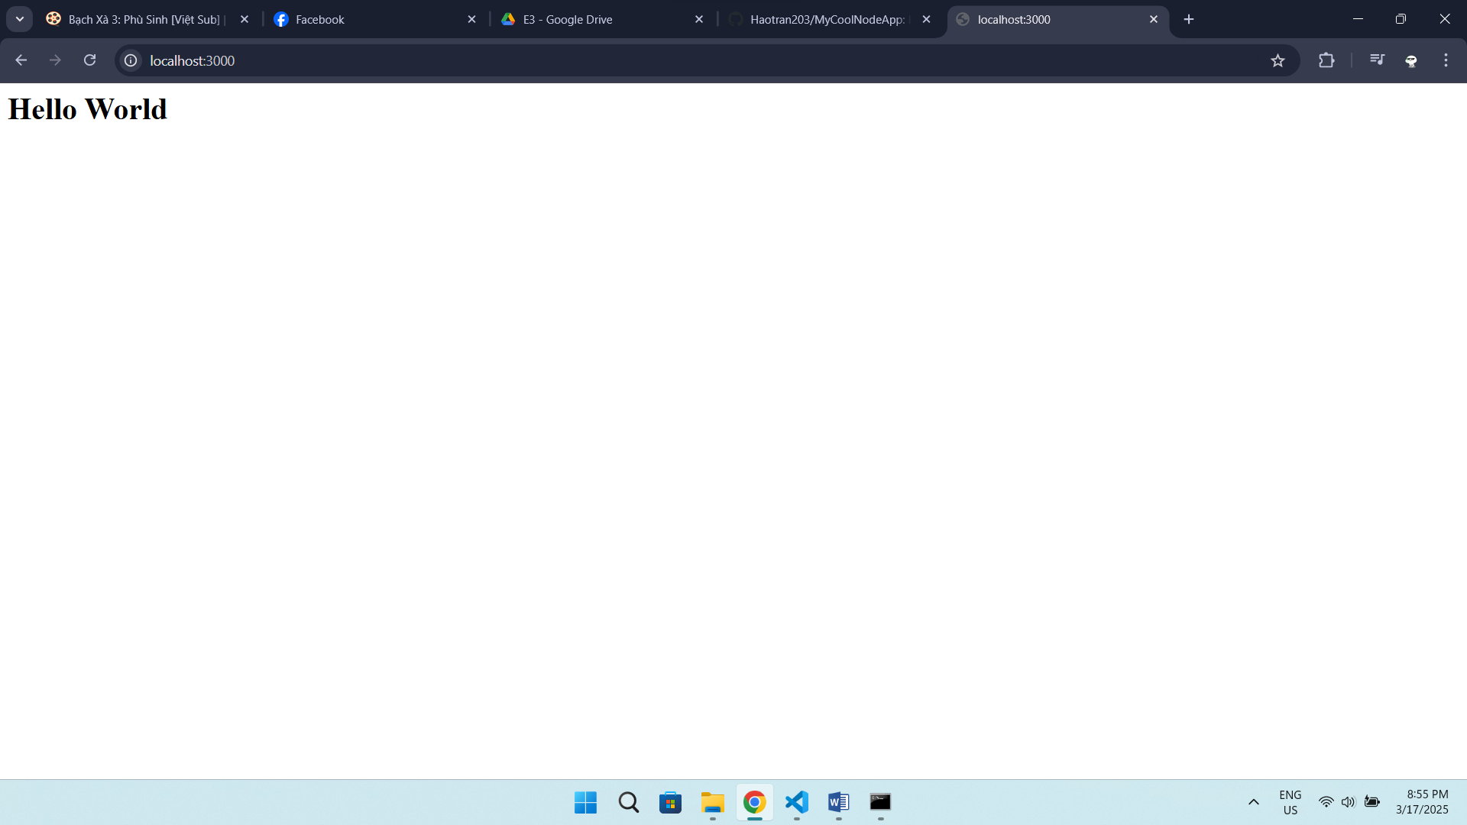

**STEP 3: PUSH TO GITHUB**

Go to Github and create a new repository like this

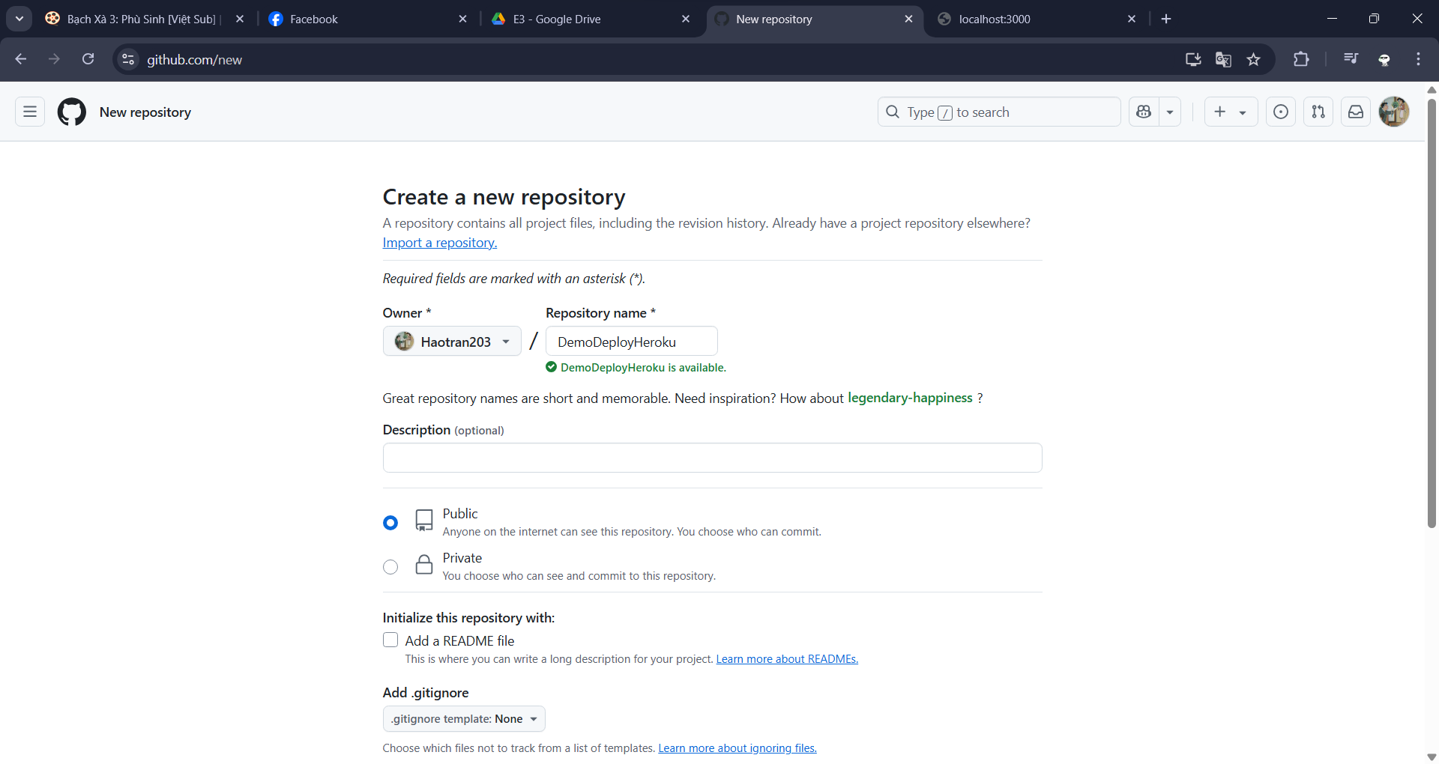

GitHub will create a repository and give you some commands that you can run locally so that you can clone your local folder with your GitHub repository.

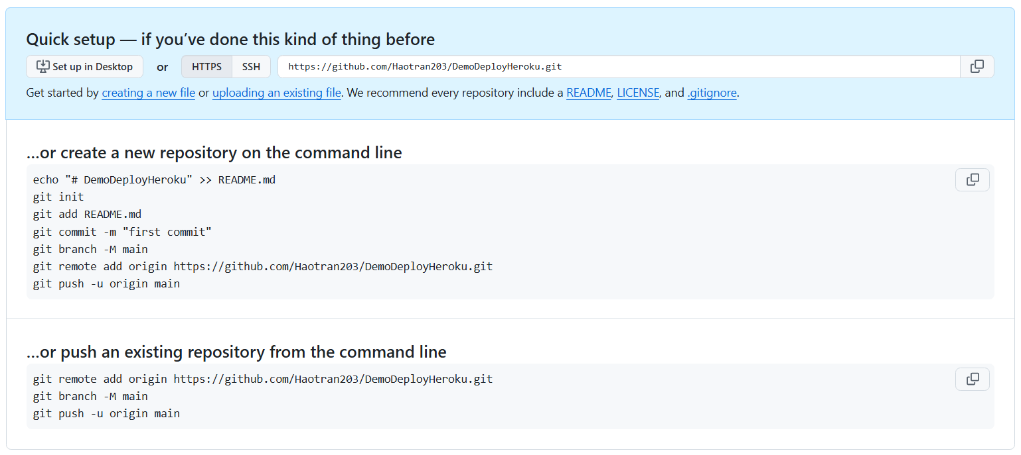

Run commands in terminal:

git init

git add .

git remote add tranquanghao https://github.com/Haotran203/DemoDeployHeroku.git

git push tranquanghao master

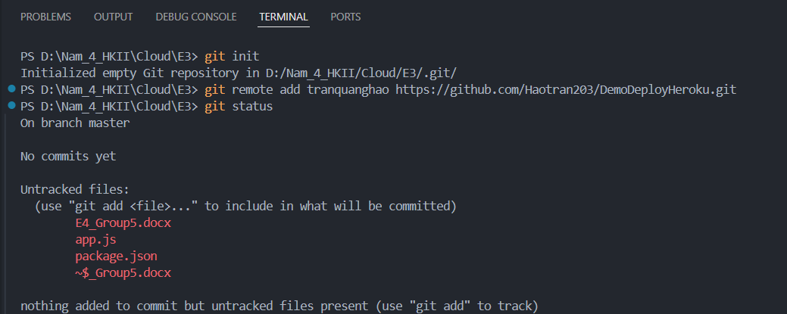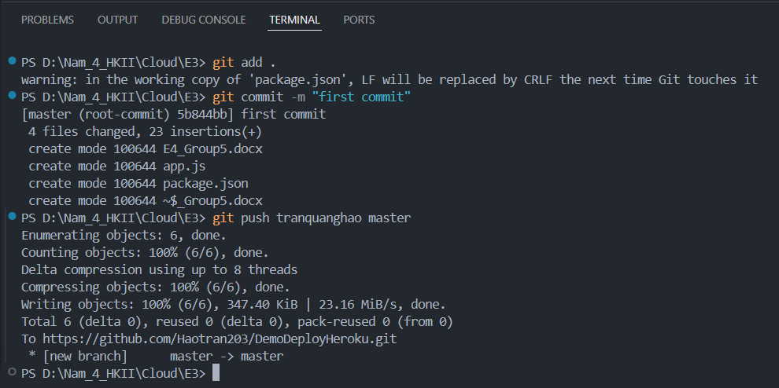

Now if you open GitHub and refresh the repository, you should be able to see the code.

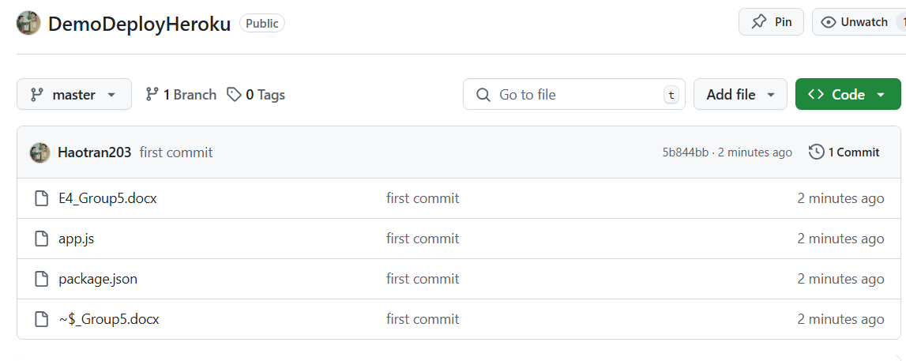

**STEP: 4 DEPLOY TO HEROKU**

If you don’t have an account with Heroku, you can open a free one by filling out this simple form.

(And here, you don’t need to provided Credit Card information)

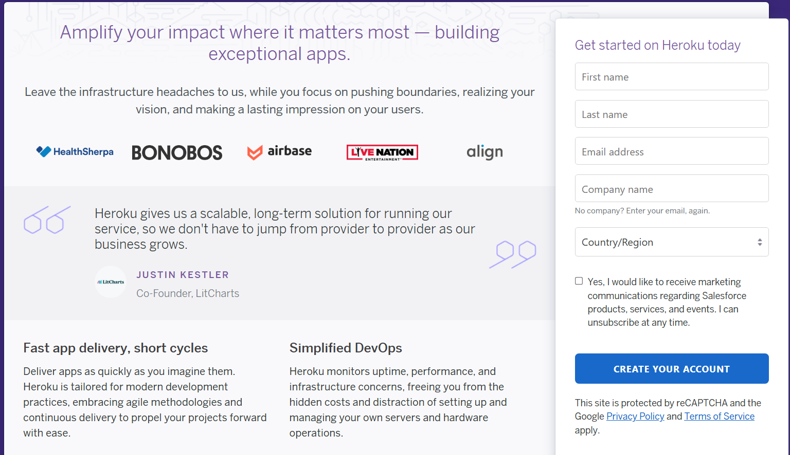

Login into your account created.

if heroku needs to verify identity using the mobile app, download the Authenticator app on CHplay/Appstore:

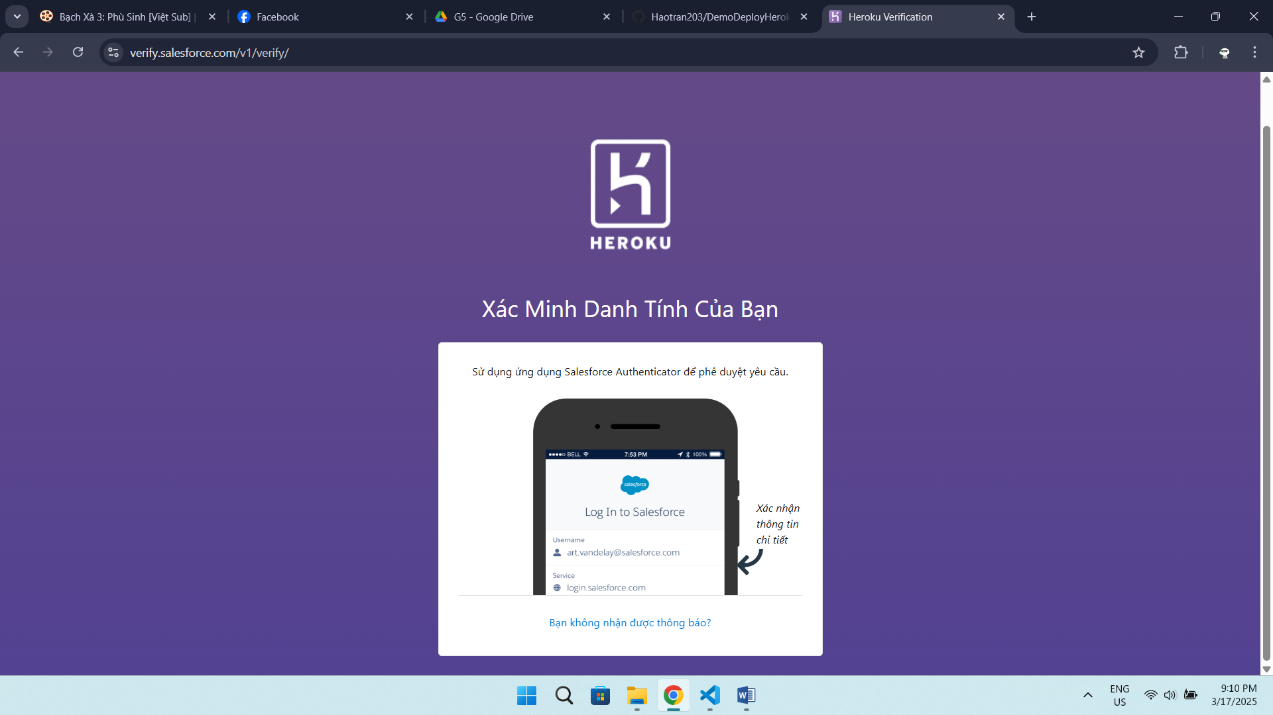

Authenticator app:

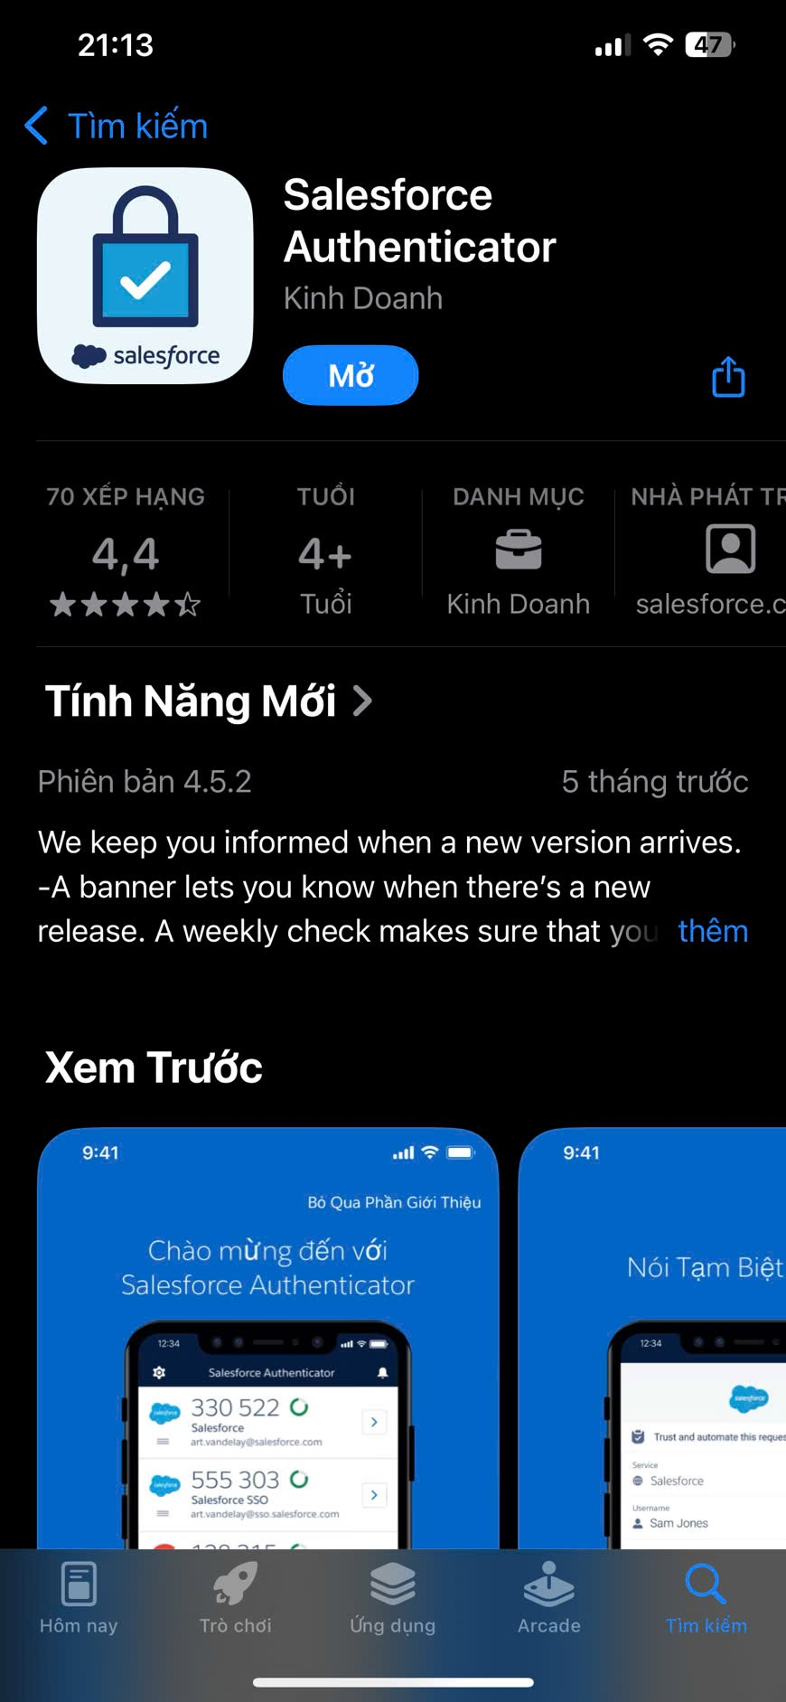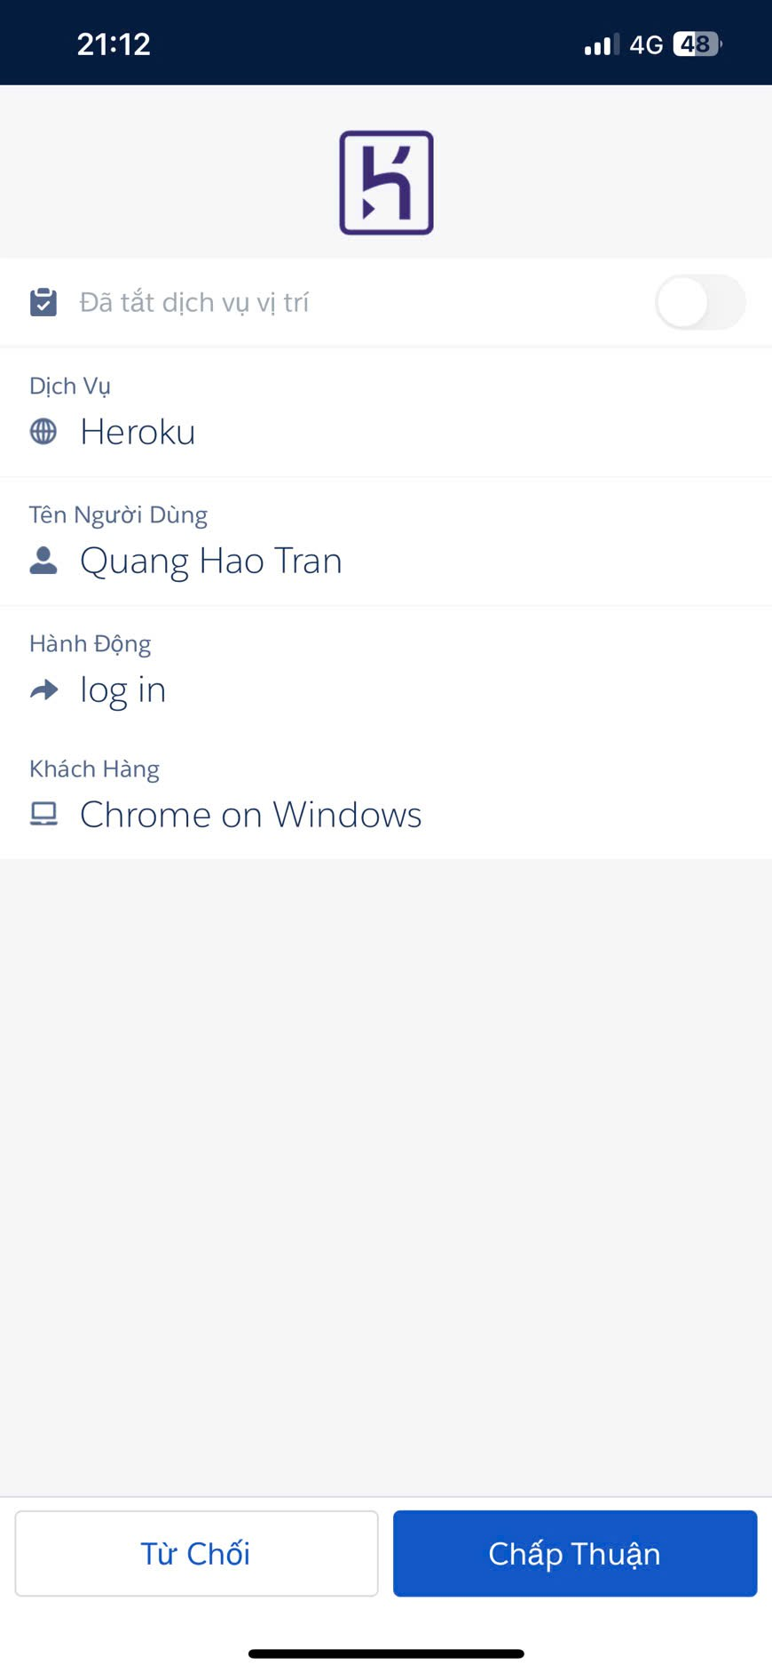

Now, click to Create new app:

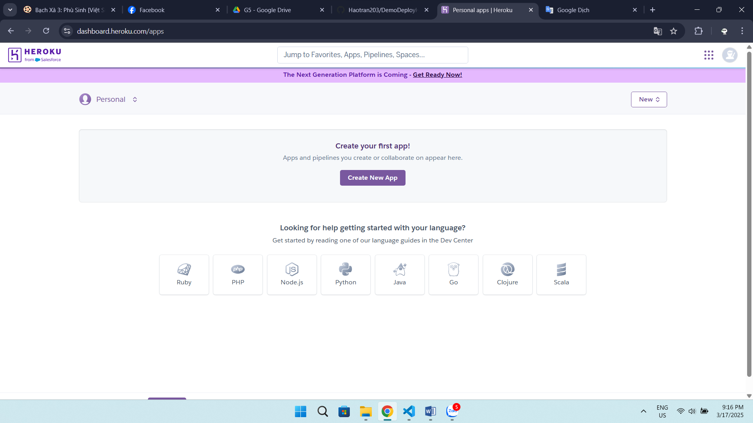

Fill in information and click create app:

