Class: Điện toán đám mây(8) TA

Group: 5

Lab E4: Nodejs and Handlebar

1. Create a project using npm init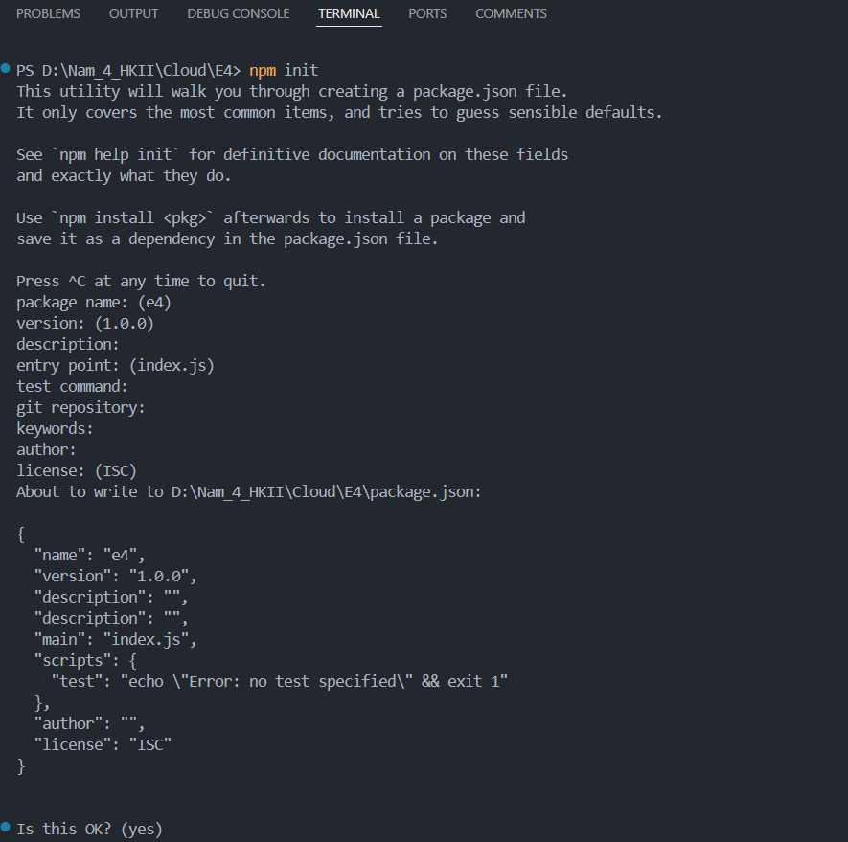
2. Install express and save it as a dependency using npm i --save express: 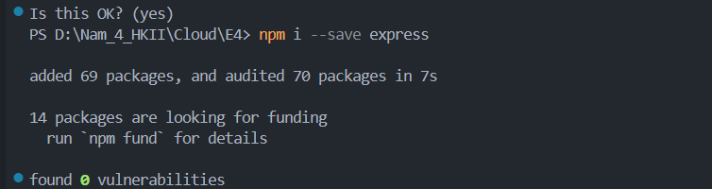
3. Install hbs and save it as a dependency using npm i --save hbs 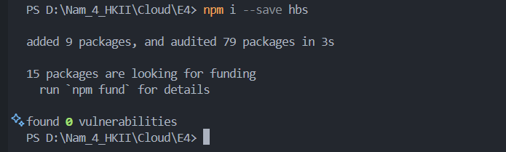
4. Final directory folder :

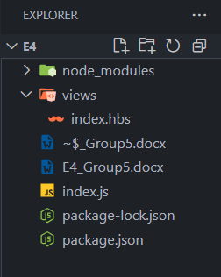

1. Code index.js file:

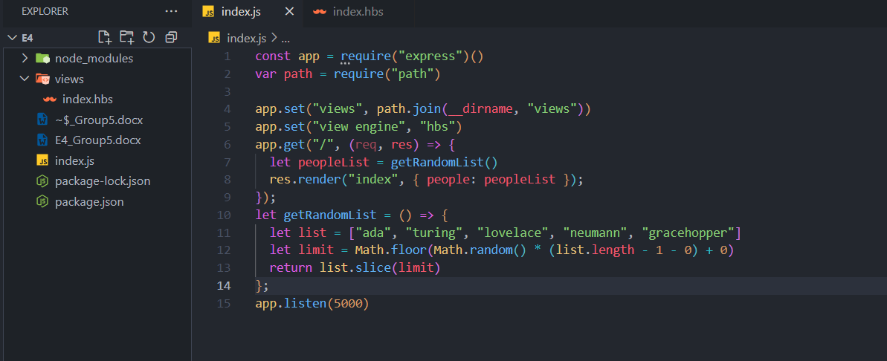

1. Code index.hbs file: 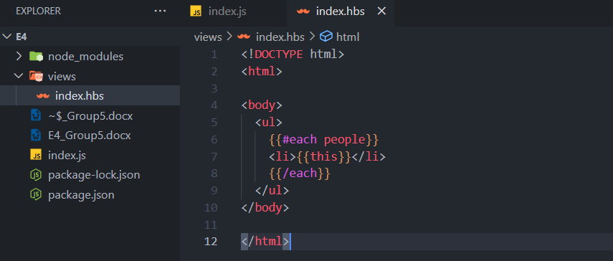
2. Result run program:

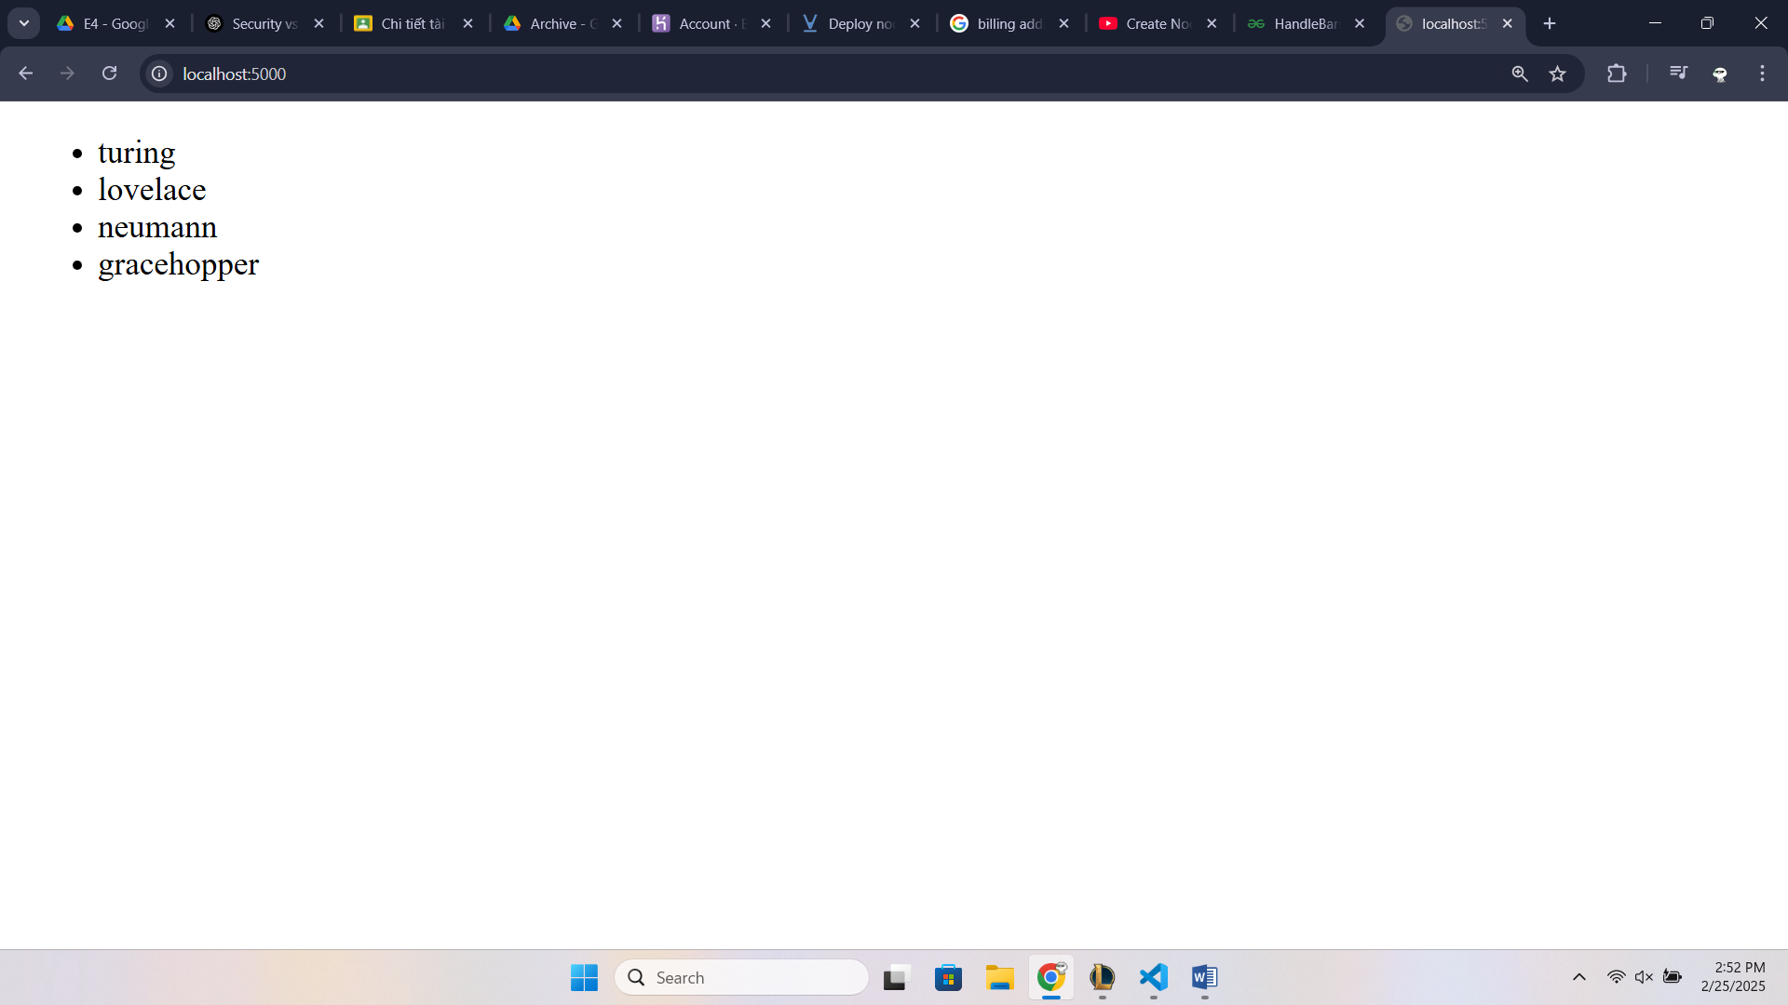

Thank you!