Author: 103403044 陳昊

OS：Ubuntu in windows(14.04)

Gcc: gcc (Ubuntu 4.8.5-2ubuntu1~14.04.1) 4.8.5

Compile command:

<decode : gcc ./Decode.c -lm -o ./decode.o>

<encode : gcc ./Encode.c -lm -o ./encode.o>

Testing script: test.sh

IO : argv0 = source argv1 = target argv2 = QF

Testing Baboon.raw

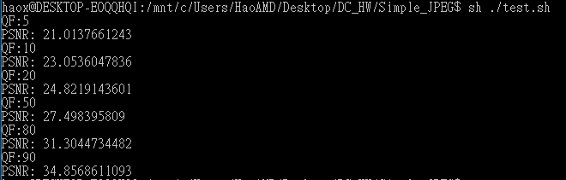

Testing Lena.raw

