

**Network Calculator** is a GUI based network analysis software implemented by Python, including three main functional modules for analysis, Network localization analysis, Random walking with restart and Network overlap analysis. Please unzip the software file after download and double click the “**Network Calculator.exe**”, then use Network Calculator by this interface as follows:

1. **Network localization analysis**
2. Input:

🞄A text file of total network with the format of gene-gene interaction pairs (one pair per row separated by “Tab”), or use our bulit-in network file “all_PPIs.txt” (The built-in file of total network was generated by integrating protein-protein interaction network from six databases including CORUM [1], BioPlex [2], CCSB [3], IntAct [4], BioGRID [5],and GeneMANIA [6].

🞄A text file with a column of gene list with human gene symbols or user customized genes.

1. Analysis parameters:

🞄Topological parameters (All edges, mean degree, largest sub-network, mean shortest distance, closeness centrality, betweeness centrality, and clustering coefficient);

🞄Permutation test of each parameter with customized random sampling times

1. Output:

🞄Network parameter calculation results

🞄Randomly sampling distribution figures

🞄Text files of network generated using inputting gene set which could be directly imported in to network visualizing software.

1. Users can perform this analysis according to the following procedures:

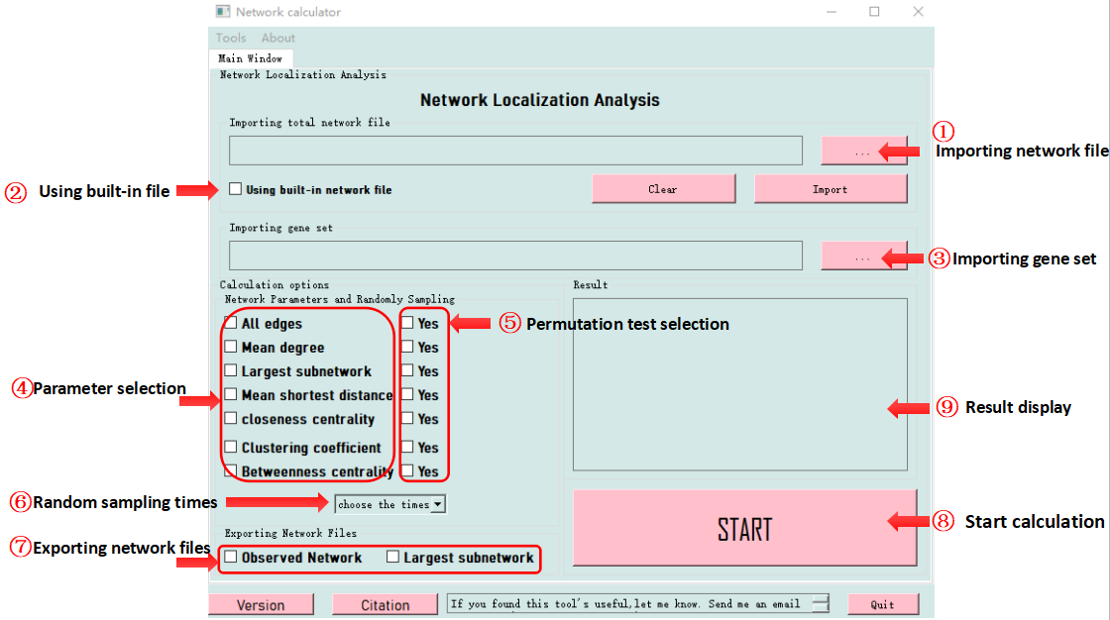

1. **Random walking with restart**
2. Input:

🞄A text file of network with the format of gene-gene interaction pairs and related weight separated by “Tab”(e.g. gene1 gene2 1), or use our bulit-in network file “all_PPIs_RWR.txt” (The built-in file of total network was generated by “all_PPIs.txt” with weight of each gene-gene interaction as 1.

🞄A text file with a column of gene list with human gene symbols or user customized genes as seed genes.

1. Analysis parameters:

🞄Restart probability: A value from 0 to 1.

1. Output:

🞄 Genes and related affinity scores (Users could display customized number of results in result panel or export all results file).

1. Users can perform this analysis according to the following procedures:

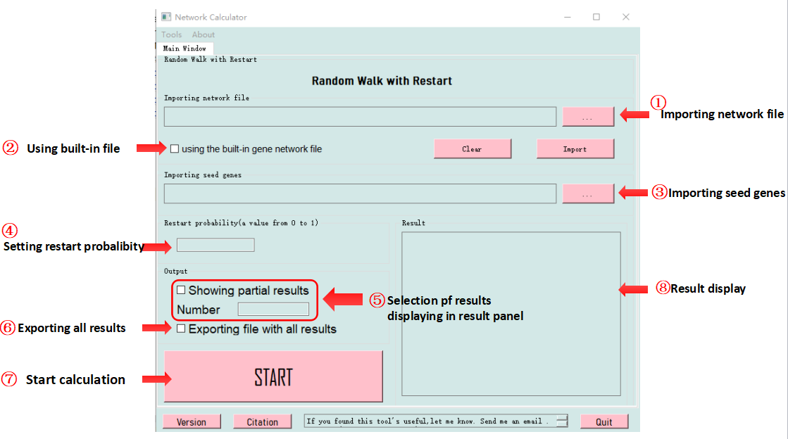

1. **Network overlap analysis**
2. Input:

🞄 A text file of total network (or use our bulit-in network file “all_PPIs.txt”[1-6])

🞄 A text file with a column of gene list with human gene symbols (gene set A) or user customized genes.

🞄 A text file with a column of gene list with human gene symbols (gene set B) or user customized genes.

1. Analysis parameters:

🞄Topological parameters:

Mean shortest distance of gene set A: d_A

Mean shortest distance of gene set B: d_B

Mean shortest distance between gene set A and gene set B:d_AB

Network proximity between gene set A and gene set B: S_AB=d_AB-(d_A+d_B)/2 [7]

🞄Permutation test of each parameter with customized random sampling times

1. Output:

🞄Network parameter calculation results

🞄Randomly sampling distribution figures

1. Users can perform this analysis according to the following procedures:

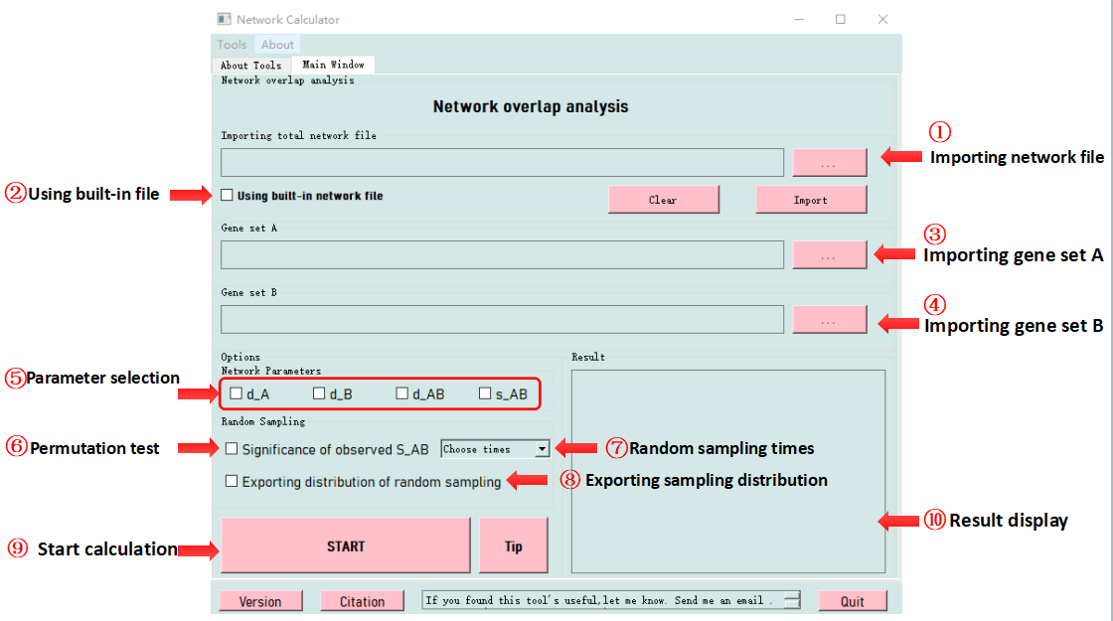

Any question about usage of Network Calculator, please contact gaolei_tsmu@163.com.

**Reference**

1. Andreas Ruepp, Brigitte Waegele, CORUM: the comprehensive resource of mammalian protein complexes –2009,Nucleic Acids Research , Volume 38,Issue suppl_1,1 January 2010,Pages D497-D501.
2. Edward L.Huttlin , Lily Ting, Raphael J.Bruckner,The BioPlex Network: A systematic exproration of the human interactome,ScienceDrect,Volume 162,Issue 2,July 2015,Page 425-440, doi: <https://doi.org/10.1016/j.cell.2015.06.043>.
3. Thomas Rolland, Murat Tasan, Benoit Charloteaux, A proteome-scale map of the human interactome network. PMD: 25416956,PMCID: PMC4266588, DOI : 10.1016/j.cell.2014.10.050.
4. Sandra Orchard, Mais Ammari, Bruno Aranda, The MintAct project—IntAct as a common curation platform for 11 molecular interaction databases.Nucleis Acids Research, Volume 42,Issue D1,January 2014, Pages D358-D363,https://doi/org/10.1093/nar/gkt1115
5. Andrew Chatr-aryamontri,Rose Oughtred,The BioGRID interaction database: 2017 update, Nucleic Acids Rearch, Volume 45, Issue D1, January 2007,Pages D369-D379,https://doi.org/10.1093/nar/gkw1102.
6. Khalid Zuberi, Max Franz, Harold Rodriguez, Jason Montojo, GeneMANIA Prediction Server 2013 Update, Nucleic Acids Research, Volume 41, Issue W1, 1 July 2013,Pages W115-W122,http://doi.org/10.1093/nar/gkt533
7. örg Menche, Amitabh Sharma,  Maksim Kitsak,  Susan Dina Ghiassian, Uncovering.

disease-disease relationships through the incomplete interactome, Science  20 Feb 2015:  
Vol. 347, Issue 6224, 1257601