1、opensees中最简单的支座模拟时用0长度单元模拟支座，6个方向分别取不同的刚度值。

2、Elastomeric Bearing Element(弹性支座)
可模拟支座的屈服后刚度。
This command is used to construct an elastomericBearing element object, which is defined by two nodes. The element can have zero length or the appropriate bearing height. The bearing has unidirectional (2D) or coupled (3D) plasticity properties for the shear deformations, and force-deformation behaviors defined by UniaxialMaterials in the remaining two (2D) or four (3D) directions. By default (sDratio = 0.5) P-Delta moments are equally distributed to the two end-nodes. To avoid the introduction of artificial viscous damping in the isolation system (sometimes referred to as "damping leakage in the isolation system"), the bearing element does not contribute to the Rayleigh damping by default. If the element has non-zero length, the local x-axis is determined from the nodal geometry unless the optional x-axis vector is specified in which case the nodal geometry is ignored and the user-defined orientation is utilized.
For a two-dimensional problem:
element elastomericBearing $eleTag $iNode $jNode $kInit $fy $alpha -P $matTag -Mz $matTag <-orient $x1 $x2 $x3 $y1 $y2 $y3> <-shearDist $sDratio> <-doRayleigh> <-mass $m>
For a three-dimensional problem:
element elastomericBearing $eleTag $iNode $jNode $kInit $fy $alpha -P $matTag -T $matTag -My $matTag -Mz $matTag <-orient <$x1 $x2 $x3> $y1 $y2 $y3> <-shearDist $sDratio> <-doRayleigh> <-mass $m>

$eleTag | unique element object tag
$iNode $jNode | end nodes
$kInit | initial elastic stiffness in local shear direction 初始水平剪切刚度
$fy | yield strength 屈服力
$alpha | post yield stiffness ratio 屈服系数
-P $matTag | tag associated with previously-defined UniaxialMaterial in axial direction
-T $matTag | tag associated with previously-defined UniaxialMaterial in torsional direction
-My $matTag | tag associated with previously-defined UniaxialMaterial in moment direction around local y-axis
-Mz $matTag | tag associated with previously-defined UniaxialMaterial in moment direction around local z-axis
$x1 $x2 $x3 | vector components in global coordinates defining local x-axis (optional)
$y1 $y2 $y3 | vector components in global coordinates defining local y-axis (optional)
$sDratio | shear distance from iNode as a fraction of the element length (optional, default = 0.5)
-doRayleigh | to include Rayleigh damping from the bearing (optional, default = no Rayleigh damping contribution)
$m | element mass (optional, default = 0.0)
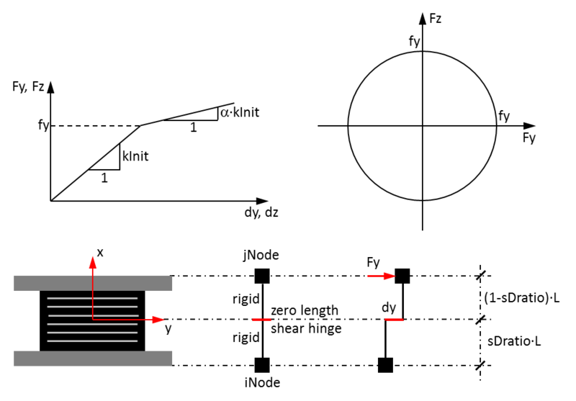
NOTE:
1) If the element has zero length and optional orientation vectors are not specified, the local element axes coincide with the global axes. Otherwise the local z-axis is defined by the cross product between the x- and y-vectors specified on the command line.
2) Elastomeric bearings are very stiff in compression, but not rigid. It is not a good idea to specify an extremely large axial stiffness (such as 1E10), because it can lead to problems with numerical sensitivity. Always specify a realistic value for the stiffness of the material that is assigned along the axial direction.
3) The valid queries to an elastomeric bearing element when creating an ElementRecorder object are 'force,' 'localForce,' 'basicForce,' 'localDisplacement,' 'basicDisplacement' and 'material $matNum matArg1 matArg2 ...' Where $matNum is the number associated with the material whose data is to be output.
EXAMPLES:
element elastomericBearing 1 1 2 20.0 2.50 0.02 -P 1 -Mz 2; # for a 2D elastomeric bearing
element elastomericBearing 1 1 2 20 2.50 0.02 -P 1 -T 2 -My 3 -Mz 4; # for a 3D elastomeric bearing

3、Flat Slider Bearing Element
可模拟四氟乙烯滑板支座以及板式支座的滑动现象。(并不用直接定义屈服力,通过摩擦系数及支座反力算得屈服力)
This command is used to construct a flatSliderBearing element object, which is defined by two nodes. The iNode represents the flat sliding surface and the jNode represents the slider. The element can have zero length or the appropriate bearing height. The bearing has unidirectional (2D) or coupled (3D) friction properties for the shear deformations, and force-deformation behaviors defined by UniaxialMaterials in the remaining two (2D) or four (3D) directions. To capture the uplift behavior of the bearing, the user-specified UniaxialMaterial in the axial direction is modified for no-tension behavior. By default (sDratio = 0.0) P-Delta moments are entirely transferred to the flat sliding surface (iNode). It is important to note that rotations of the flat sliding surface (rotations at the iNode) affect the shear behavior of the bearing. To avoid the introduction of artificial viscous damping in the isolation system (sometimes referred to as "damping leakage in the isolation system"), the bearing element does not contribute to the Rayleigh damping by default. If the element has non-zero length, the local x-axis is determined from the nodal geometry unless the optional x-axis vector is specified in which case the nodal geometry is ignored and the user-defined orientation is utilized.
For a two-dimensional problem:
element flatSliderBearing $eleTag $iNode $jNode $frnMdlTag $kInit -P $matTag -Mz $matTag <-orient $x1 $x2 $x3 $y1 $y2 $y3> <-shearDist $sDratio> <-doRayleigh> <-mass $m> <-iter $maxIter $tol>
For a three-dimensional problem:
element flatSliderBearing $eleTag $iNode $jNode $frnMdlTag $kInit -P $matTag -T $matTag -My $matTag -Mz $matTag <-orient <$x1 $x2 $x3> $y1 $y2 $y3> <-shearDist $sDratio> <-doRayleigh> <-mass $m> <-iter $maxIter $tol>
$eleTag | unique element object tag
$iNode $jNode | end nodes
$frnMdlTag | tag associated with previously-defined FrictionModel (用于定义摩擦系数)
$kInit | initial elastic stiffness in local shear direction 初始水平刚度
-P $matTag | tag associated with previously-defined UniaxialMaterial in axial direction
-T $matTag | tag associated with previously-defined UniaxialMaterial in torsional direction
-My $matTag | tag associated with previously-defined UniaxialMaterial in moment direction around local y-axis
-Mz $matTag | tag associated with previously-defined UniaxialMaterial in moment direction around local z-axis
$x1 $x2 $x3 | vector components in global coordinates defining local x-axis (optional)
$y1 $y2 $y3 | vector components in global coordinates defining local y-axis (optional)
$sDratio | shear distance from iNode as a fraction of the element length (optional, default = 0.0)
-doRayleigh | to include Rayleigh damping from the bearing (optional, default = no Rayleigh damping contribution)
$m | element mass (optional, default = 0.0)
$maxIter | maximum number of iterations to undertake to satisfy element equilibrium (optional, default = 20)
$tol | convergence tolerance to satisfy element equilibrium (optional, default = 1E-8)
NOTE:
1) If the element has zero length and optional orientation vectors are not specified, the local element axes coincide with the global axes. Otherwise the local z-axis is defined by the cross product between the x- and y-vectors specified on the command line.
2) Because the friction force is affected by both the axial force and the slip rate, the element can be sensitive numerically. It is recommended that for dynamic analysis a smaller time step is being used than what would be used for a comparable structure with no isolators.
3) If there is uplift (and therefore impact) in the bearing element, it can be helpful to use an integration method that provides numerical damping. Providing some viscous damping for the material that is assigned to the axial direction can also be helpful in dissipating impact energy.
4) The valid queries to a flat slider bearing element when creating an ElementRecorder object are 'force,' 'localForce,' 'basicForce,' 'localDisplacement,' 'basicDisplacement' and 'material $matNum matArg1 matArg2 ...' Where $matNum is the number associated with the material whose data is to be output.
EXAMPLES:
element flatSliderBearing 1 1 2 1 250.0 -P 1 -Mz 2 -orient 0 1 0 -1 0 0; # for a 2D flat slider bearing
element flatSliderBearing 1 1 2 1 250.0 -P 1 -T 2 -My 3 -Mz 4 -orient 0 0 1 -1 0 0; # for a 3D flat slider bearing

