3. (a)

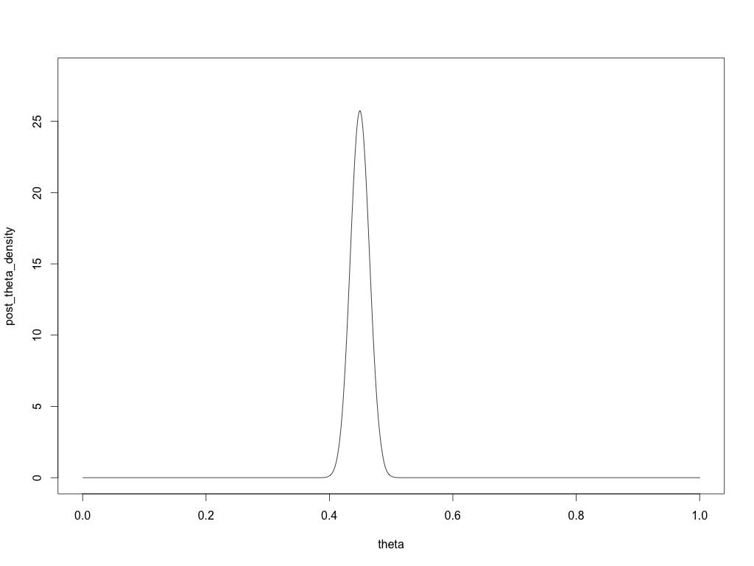

(b).

The posterior mean is 0.4495196 and the posterior variance is 0.0002376864

(c).

The posterior median is 0.449

(d).

The 95% central posterior interval is (0.419, 0.48).

library(triangle)

# The value of theta

thetas <- seq(0, 1, 0.001)

# Set prior P(theta), simulate the witch's hat distribution

prior_density <- 0.5 * dunif(thetas, 0, 1) + 0.5 * dtriangle(thetas, 0.385, 0.585)

names(prior_density) <- thetas

# Plot the Prior dist of theta

plot(prior_density ~ thetas, ylim = c(0, 6), type = 'l')

# The density of y|theta

likelihood <- lapply(thetas, function(x) {dbinom(437, size = 980, prob = x)})

likelihood <- unlist(likelihood)

names(likelihood) <- thetas

# The marginal dist of y

marginal_y <- sum(prior_density * likelihood)

# Posterior dist

post_theta_prob <- prior_density * likelihood / marginal_y

post_theta_density <- post_theta_prob / (0.001 * sum(post_theta_prob))

names(post_theta_prob) <- thetas

names(post_theta_density) <- thetas

# Plot of posterior density

plot(post_theta_density ~ thetas, ylim = c(0, 1.1 * max(post_theta_density)), type = 'l')

# posterior mean and variance

mean <- sum(thetas * post_theta_prob)

variance <- sum(thetas ^ 2 * post_theta_prob) - mean ^ 2

# posterior quantile function

quantile <- function(percentage) {

cummu_prob_1 <- 0

cummu_prob_2 <- 0

for (theta in thetas) {

cummu_prob_1 <- cummu_prob_1 + post_theta_prob[as.character(theta)]

if ((cummu_prob_1 > percentage) && (cummu_prob_2) < percentage ) {

print(theta)

break

} else {

cummu_prob_2 <- cummu_prob_2 + post_theta_prob[as.character(theta)]

}

}

}

# Posterior median

quantile(0.5)

# 95% central posterior interval

quantile(0.025)

quantile(0.975)

1.5(a)

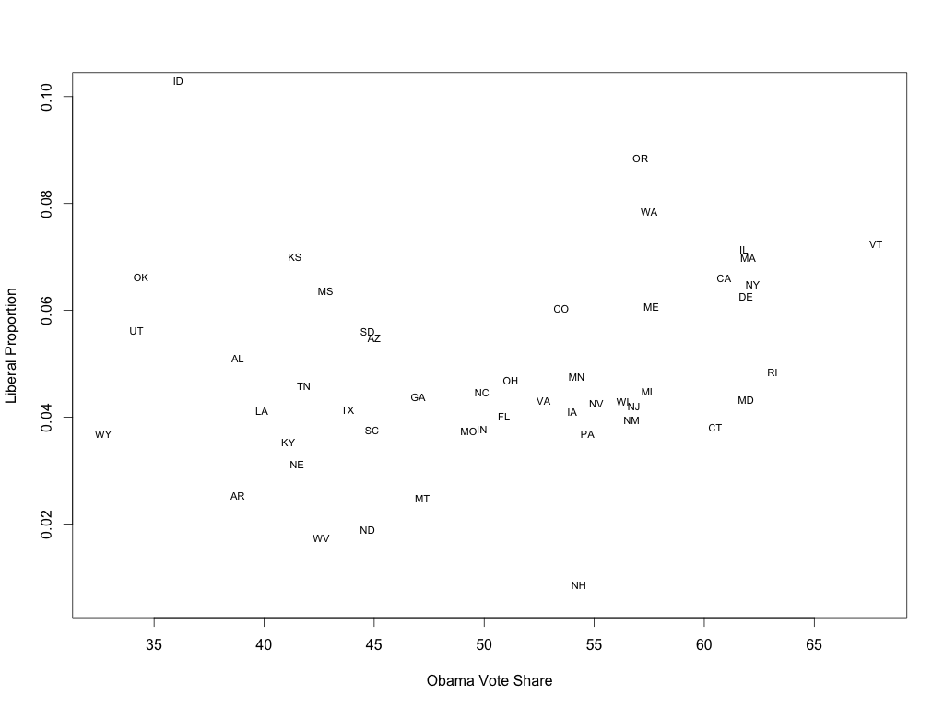

(b)

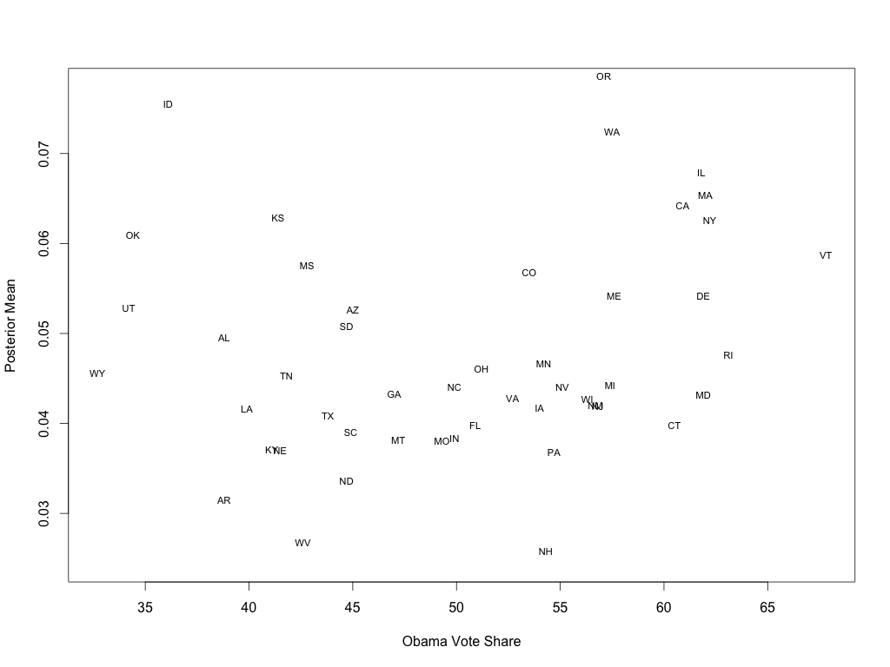

(c)

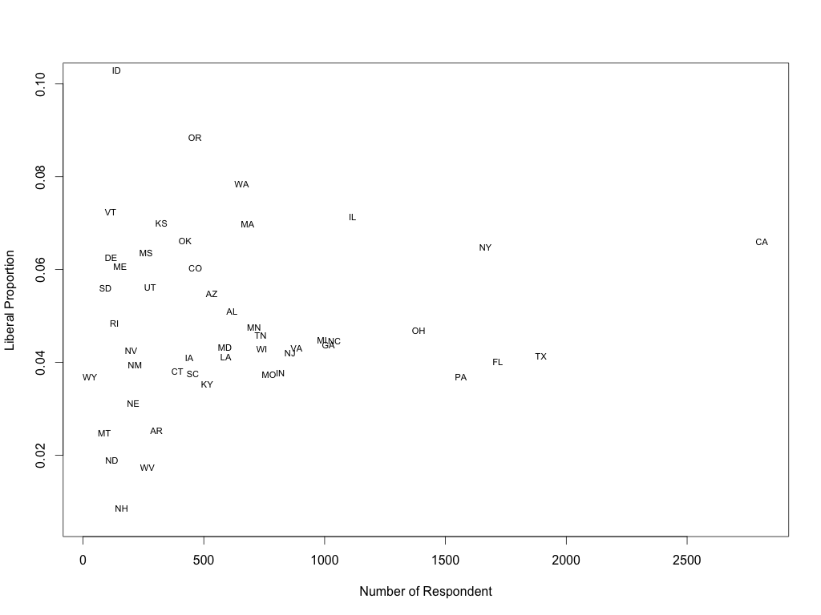

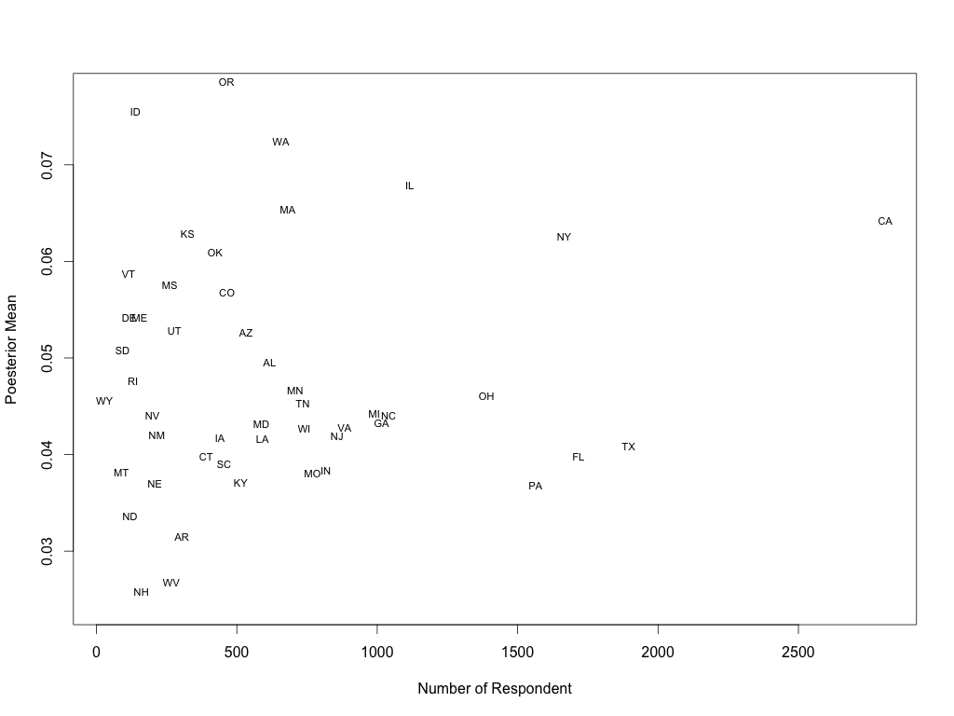

library(foreign)

library(plyr)

library(dplyr)

library(openintro)

# read data and select useful features

elect.data <- read.dta('pew_research_center_june_elect_wknd_data.dta')

Obama_votes <- read.csv('2008ElectionResult.csv')

elect.data <- elect.data[,c('ideo', 'state')]

Obama_votes <- Obama_votes[, c('state', 'vote_Obama_pct')]

# Exclude Alaska, Hawaii and Washington DC and rows with NA

elect.data <- filter(elect.data, !(state %in% c('alaska', 'washington dc', 'hawaii')))

elect.data <- elect.data[complete.cases(elect.data),]

#Transfer state name to state abbreviation

elect.data$state <- state2abbr(elect.data$state)

Obama_votes$state <- state2abbr(Obama_votes$state)

# split the election data by state, calculate the proportion of very liberal people

# and combine together

liberal_proportion <- ddply(elect.data, 'state', function(dataframe){

liberal_people <- dataframe[dataframe$ideo == 'very liberal',]

proportion <- nrow(liberal_people) / nrow(dataframe)

data.frame(liberal_people = nrow(liberal_people), total_people = nrow(dataframe), state_proportion = proportion)

})

# Combine liberal_probortion dataset and Obama_votes dataset by state abbreviation

liberal_proportion_vs_Obama_vote <- merge(liberal_proportion, Obama_votes, by = 'state')

# Plot the liberal proportion vs Obama vote

plot(liberal_proportion_vs_Obama_vote$vote_Obama_pct, liberal_proportion_vs_Obama_vote$state_proportion,

ylab = 'Liberal Proportion', xlab = 'Obama Vote Share', type = 'n')

text(liberal_proportion_vs_Obama_vote$vote_Obama_pct, liberal_proportion_vs_Obama_vote$state_proportion,

labels = liberal_proportion_vs_Obama_vote$state, cex = 0.7, pos = 3)

# Estimate the prior

prior_mean <- mean(liberal_proportion$state_proportion)

prior_var <- var(liberal_proportion$state_proportion)

alpha <- (prior_mean ^ 2) * (1 - prior_mean) / prior_var - prior_mean

beta <- alpha * (1 - prior_mean) / prior_mean

# Posterior Mean for each state

liberal_proportion_vs_Obama_vote$posterior_mean <- (alpha + liberal_proportion$liberal_people) / (alpha + beta + liberal_proportion$total_people)

# Plot the posterior mean vs Obama vote

plot(liberal_proportion_vs_Obama_vote$vote_Obama_pct, liberal_proportion_vs_Obama_vote$posterior_mean,

ylab = 'Posterior Mean', xlab = 'Obama Vote Share', type = 'n')

text(liberal_proportion_vs_Obama_vote$vote_Obama_pct, liberal_proportion_vs_Obama_vote$posterior_mean,

labels = liberal_proportion_vs_Obama_vote$state, cex = 0.7, pos = 3)

# Plot the liberal Mean vs number of respondents

plot(liberal_proportion_vs_Obama_vote$total_people, liberal_proportion_vs_Obama_vote$state_proportion,

ylab = 'Liberal Proportion', xlab = 'Number of Respondent', type = 'n')

text(liberal_proportion_vs_Obama_vote$total_people, liberal_proportion_vs_Obama_vote$state_proportion,

labels = liberal_proportion_vs_Obama_vote$state, cex = 0.7, pos = 3)

# Plot the liberal Mean vs Number of Respondents

plot(liberal_proportion_vs_Obama_vote$total_people, liberal_proportion_vs_Obama_vote$posterior_mean,

ylab = 'Poesterior Mean', xlab = 'Number of Respondent', type = 'n')

text(liberal_proportion_vs_Obama_vote$total_people, liberal_proportion_vs_Obama_vote$posterior_mean,

labels = liberal_proportion_vs_Obama_vote$state, cex = 0.7, pos = 3)