Haoyang Chen | hc2812 | W4640 | HW4

5.14

(a)

(b)

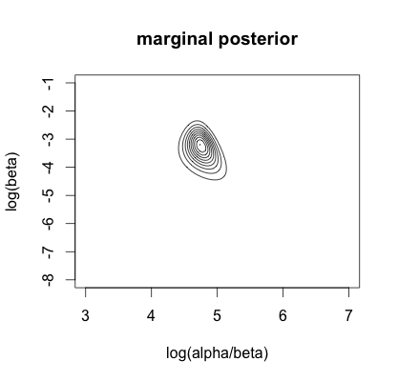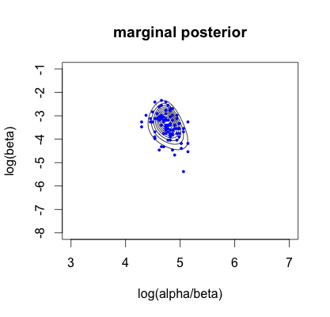

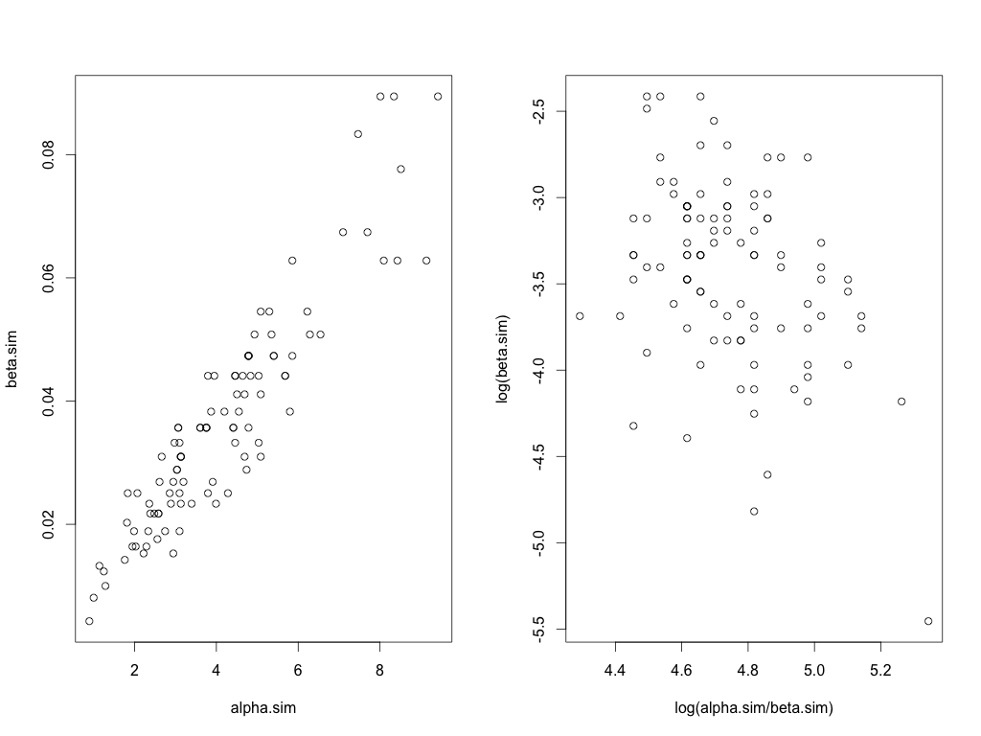

y <- c(16+58, 99, 58, 70, 19+103, 77, 18+86, 17+112, 35+273, 55+64)

n <- 100

log_alpha_over_beta <- seq(3,7, length.out=n)

log_beta <- seq(-8,-1,length.out=n)

log.m.post <- matrix(0,n,n)

phi<-0.001

for (i in 1:n){

for (j in 1:n){

beta <- exp(log_beta[j])

alpha <- exp(log_alpha_over_beta[i]) * b

su <- 0

for (s in 1:10){

su <- su + alpha * log(beta) - (alpha + y[s]) * log(beta+1) + lgamma(alpha + y[s]) - lgamma(alpha)

}

log.m.post[i,j] <- phi * (log(alpha * beta) - alpha - beta) + su

}

}

log.m.post <- log.m.post - max(log.m.post)

m.post <- exp(log.m.post)

contour(log_alpha_over_beta, log_beta, m.post,drawlabels=F,

xlab="log(alpha/beta)", ylab="log(beta)")

m <- 100

alpha.sim<-rep(0, m)

beta.sim<-rep(0, m)

log_alpha_over_beta.sim <- rep(0, m)

log_beta.sim <- rep(0, m)

dev.m.post <- rowSums(m.post)

for (s in 1:m){

i<-sample(m,1,prob=dev.m.post)

j<-sample(m,1,prob=m.post[i,])

log_alpha_over_beta.sim[s]<-log_alpha_over_beta[i]

log_beta.sim[s] <- log_beta[j]

beta.sim[s] <- exp(log_beta[j])

alpha.sim[s] <- exp(log_alpha_over_beta.sim[i]) * beta.sim[s]

}

points(log_alpha_over_beta.sim, log_beta.sim, pch=20, cex=0.6, col=4)

par(mfrow=c(1,2))

plot(beta.sim ~ alpha.sim)

plot(log_beta.sim ~ log_alpha_over_beta.sim)

(e)

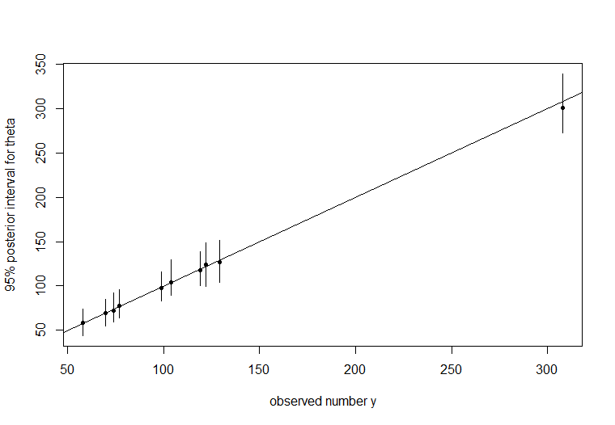

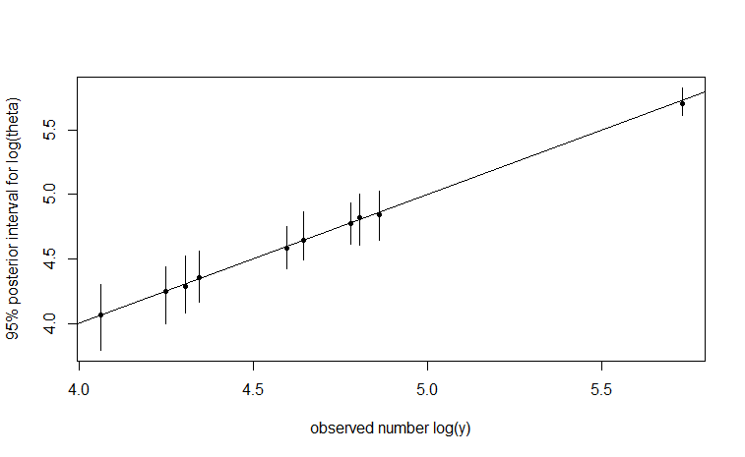

theta<-matrix(0,100,10)

for (i in 1:100){

for (j in 1:10){

theta[i,j]<-rgamma(1,a.sim[i]+y[j],b.sim[i]+1)

}

}

med<-apply(theta,2,median)

conf<-function(a){

quantile(a,c(0.025,0.975))

}

ci<-apply(theta,2,FUN=conf)

plot(med~y,type='p',pch=20,ylim=c(min(ci),max(ci)),

xlab='observed rate',ylab='95% posterior interval')

for (i in 1:10){

lines(x=c(y[i],y[i]),y=c(ci[1,i],ci[2,i]))

}

abline(a=0,b=1)

plot(log(med)~log(y),type='p',pch=20,ylim=c(log(min(ci)),log(max(ci))), xlab='observed number log(y)',ylab='95% posterior interval for log(theta)')

for (i in 1:10){

lines(x=c(log(y[i]),log(y[i])),y=c(log(ci[1,i]),log(ci[2,i])))

}

abline(a=0,b=1)

5.15

(a)

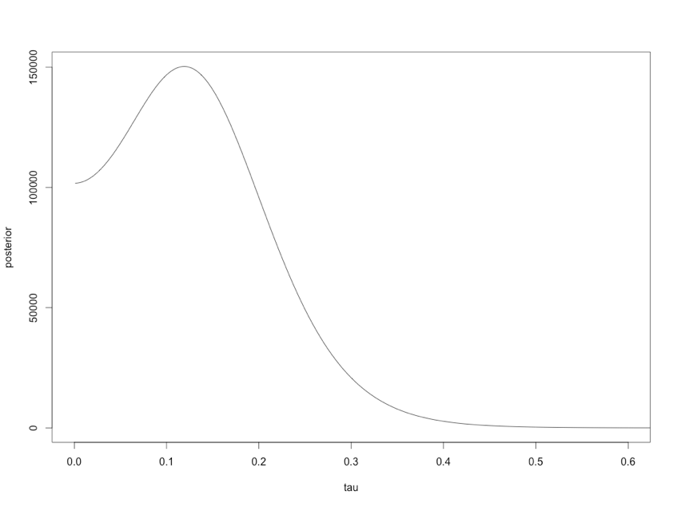

x <- read.table("meta.asc.txt", head = T)

x <- x[,-1]

y <- -log(x[,1]/(x[,2]-x[,1]))+log(x[,3]/(x[,4]-x[,3]))

sigma <- sqrt(1/x[,1]+1/(x[,2]-x[,1])+1/x[,3]+1/(x[,4]-x[,3]))

tau <- seq(0.001,2.0,0.001)

posterior <- vector()

mu <- vector()

for(i in 1:length(tau))

{

mu.est <- sum(y / (sigma^2 + tau[i]^2)) / sum(1 / (sigma^2 + tau[i]^2))

v.mu <- 1 / sum(1 / (sigma^2 + tau[i]^2))

prior <- 1

mu[i] <- rnorm(1, mean = mu.est, sd = sqrt(v.mu))

posterior[i] <- prior * sqrt(v.mu) * prod((sigma^2 + tau[i]^2) ^ (-0.5) * exp(-(y - mu.est) ^ 2 / (2 * (sigma^2 + tau[i]^2))))

}

plot(tau, posterior, type='l', xlim=c(0, 0.6))

(b)

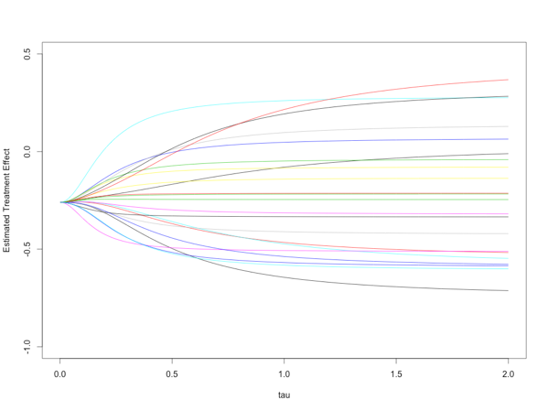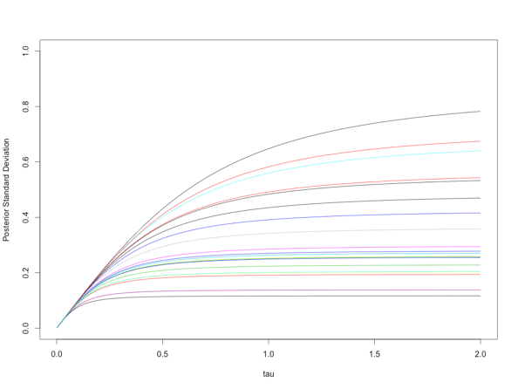

theta <- matrix(rep(NA, length(y) * length(tau)), length(y), length(tau))

theta.mean <- matrix(rep(NA, length(y) * length(tau)), length(y), length(tau))

theta.sd <- matrix(rep(NA, length(y) * length(tau)), length(y), length(tau))

for(i in 1:length(y))

for(j in 1:length(tau))

{

{

mu <- sum(y / (sigma^2 + tau[j]^2)) / sum(1 / (sigma^2 + tau[j]^2))

temp_mean <- (y[i] / sigma[i]^2 + mu / tau[j]^2) / (1 / sigma[i]^2 + 1 / tau[j]^2)

v<-1/(1/sigma[i]^2+1/tau[j]^2)

theta[i,j] <- rnorm(1,mean=temp_mean,sd=sqrt(v))

theta.mean[i,j] <- temp_mean

theta.sd[i,j] <- sqrt(v)

}

}

plot(tau,theta.mean[1,], type='l', ylim=c(-1,0.5),ylab="Estimated Treatment Effect")

for(i in 1:21)

{

lines(tau,theta.mean[(i+1),], col=i)

}

plot(tau,theta.sd[1,],type='l', ylim=c(0,1),ylab="Posterior Standard Deviation")

for(i in 1:21)

{

lines(tau,theta.sd[(i+1),],col=i)

}

(c)

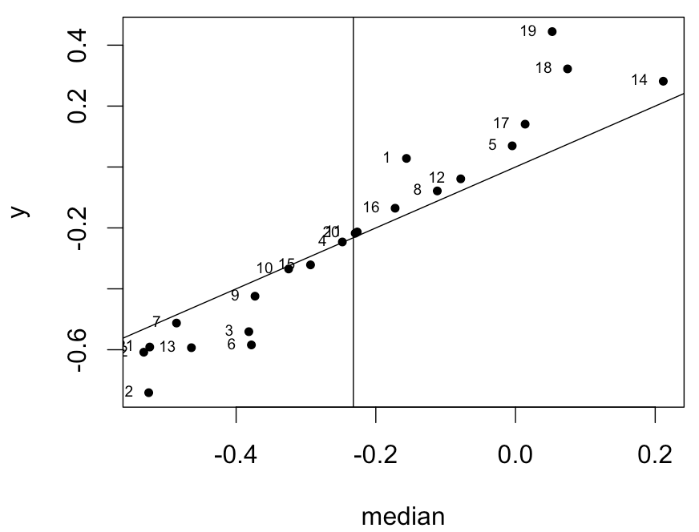

median<-apply(theta,1,median)

plot(median,y,pch=20)

text(median,y,1:J,pos=2,cex=0.6)

abline(a=0,b=1)

abline(v=mean(theta))

(d)

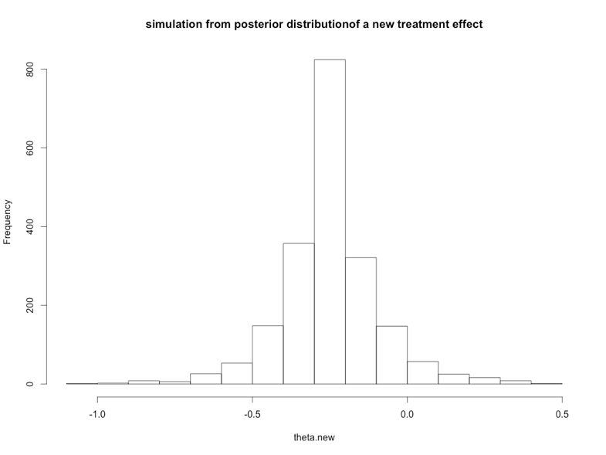

theta.new<-vector()

for(i in 1:length(tau)){

foo<-sample(length(posterior),1,prob=posterior)

tau.new<-tau[foo]

mu.new<-sum(y/(sigma^2+tau.new^2))/sum(1/(sigma^2+tau.new^2))

theta.new[i]<-rnorm(1,mean=mu.new,sd=tau.new)

}

hist(theta.new,main="simulation from posterior distributionof a new treatment effect",breaks=20)

6.6

(a)

(b)

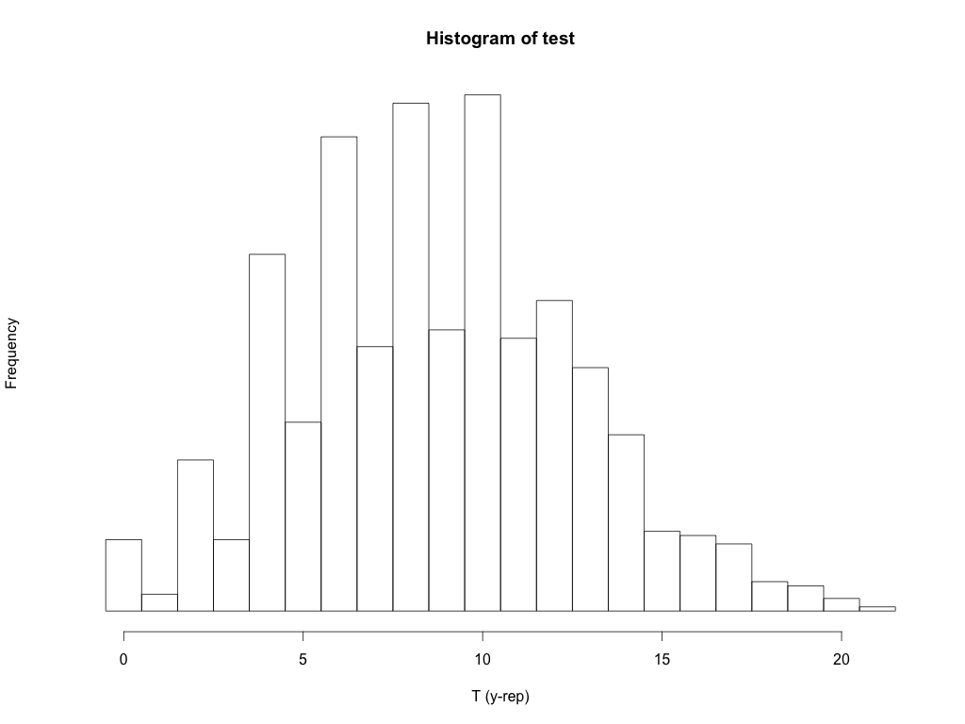

test<-vector()

for(i in 1:1000){

theta <- rbeta (1, 8, 14)

y.rep <- rbinom (1, 1, theta)

while(sum(y.rep==0) < 13){

y.rep <- c(y.rep, rbinom(1, 1, theta))

}

n.rep <- length(y.rep)

test[i] <- sum(y.rep[2:n.rep] != y.rep[1:(n.rep-1)])

}

hist (test, xlab="T (y-rep)", yaxt="n",

breaks=seq(-.5, max(test) + .5), cex = 2)

6.7

(a)

> mean(test > 8.1)

[1] 0.138

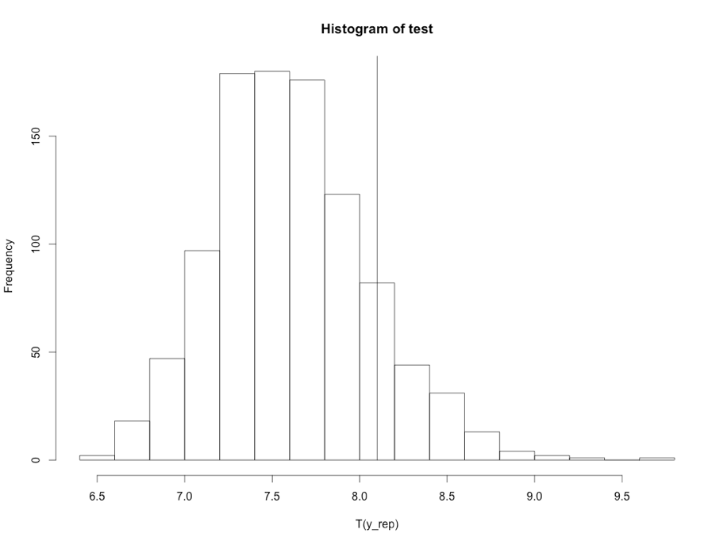

test <- vector()

for (i in 1:1000){

theta <- rnorm (1,5.1,0.1)

y.rep <- rnorm (100,theta,1)

test[i] <- max(abs(y.rep))

}

hist(test, breaks = 20, xlab = "T(y_rep)")

lines(rep(8.1,2), c(0,1000))

mean(test > 8.1)

(b)

(c)